List of Tables
Table 1: Dosing Schedule 3
Table 2: Overall summary of treatment emergent adverse events in healthy volunteer cohorts receiving placebo or 35, 100, 200, or 300 mg ARO-ANG3 (single ascending doses) and cohorts receiving placebo or 100, 200, or 300 mg ARO-ANG3 (multiple ascending doses) 6
Table 3: Treatment-emergent adverse events, occurring in >1 subject, in healthy volunteer single ascending dose cohorts receiving placebo or 35, 100, 200, or 300 mg ARO-ANG3 (A) and in healthy volunteers in cohorts receiving multiple ascending doses of 100, 200, or 300 mg ARO-ANG3 (B) 7
Table 4: Overall summary of treatment-emergent adverse events in hepatic steatosis cohort receiving placebo or 200 mg ARO-ANG3 8
Table 5: Demographic and metabolic baseline characteristics of subjects with hepatic steatosis receiving placebo or a repeat dose of 200 mg ARO-ANG3 9
Table 6: Pharmacodynamic measurements of lipid parameters: percent change from baseline at Day 85 and mixed model repeated measures analysis of change from baseline compared with placebo for apo CIII, total cholesterol, apo B, and apo AI for healthy volunteer single ascending doses of 35, 100, 200, or 300 mg ARO-ANG3 10
Table 7: Pharmacodynamic measurements of lipid parameters: percent change from baseline at Day 113 and mixed model repeated measures analysis of change from baseline compared with placebo for apo CIII, total cholesterol, apo B, and apo AI for healthy volunteers receiving escalating repeat doses of 100, 200, or 300 mg ARO-ANG3 12
Table 8: Pharmacodynamic measurements of lipid parameters: percent change from baseline at Day 113 and percent change from baseline compared with placebo for ANGPTL3, triglycerides, VLDL-C, non-HDL-C, LDL-C and HDL-C in subjects with hepatic steatosis receiving repeat doses of 200 mg ARO-ANG3 14
Table 9: Pharmacodynamic measurements of lipid parameters: percent change from baseline at Day 113 and mixed model repeated measures analysis of change from baseline compared with placebo for apo CIII, total cholesterol, apo B, apo AI, and Lp(a) in subjects with hepatic steatosis receiving repeat doses of 200 mg ARO-ANG3 16

List of Figures
Figure 1: Study Schema 3
Figure 2: Cohort Diagrams 4

Extended data:

Table 1: Dosing Schedule
Cohort | Population | Blinding | # Subjects | Dosing Schedule
1 | HVs TGs > 100 mg/dL (1.13 mmol/L), LDL-C > 70 mg/dL (1.81 mmol/L) | Double- blind | 10 (6 active: 4 PBO) | 35 mg on Day 1 only
2 | HVs TGs > 100 mg/dL (1.13 mmol/L), LDL-C > 70 mg/dL (1.81 mmol/L) | Double- blind | 10 (6 active: 4 PBO) | 100 mg Day 1 only
3 | HVs TGs > 100 mg/dL (1.13 mmol/L), LDL-C > 70 mg/dL (1.81 mmol/L) | Double- blind | 10 (6 active: 4 PBO) | 200 mg Day 1 only
4 | HVs TGs > 100 mg/dL (1.13 mmol/L), LDL-C > 70 mg/dL (1.81 mmol/L) | Double- blind | 10 (6 active: 4 PBO) | 300 mg Day 1 only
5 | Liver fat based on MRI-PDFF ≥ 10% | Double- Blind | 9 (6 active: 3 PBO) | 200 mg Day 1, 29
Abbreviations: HV=healthy volunteers; PDFF=proton density fat fraction; PBO=placebo; TG=triglycerides.

Figure 1: Study Schema
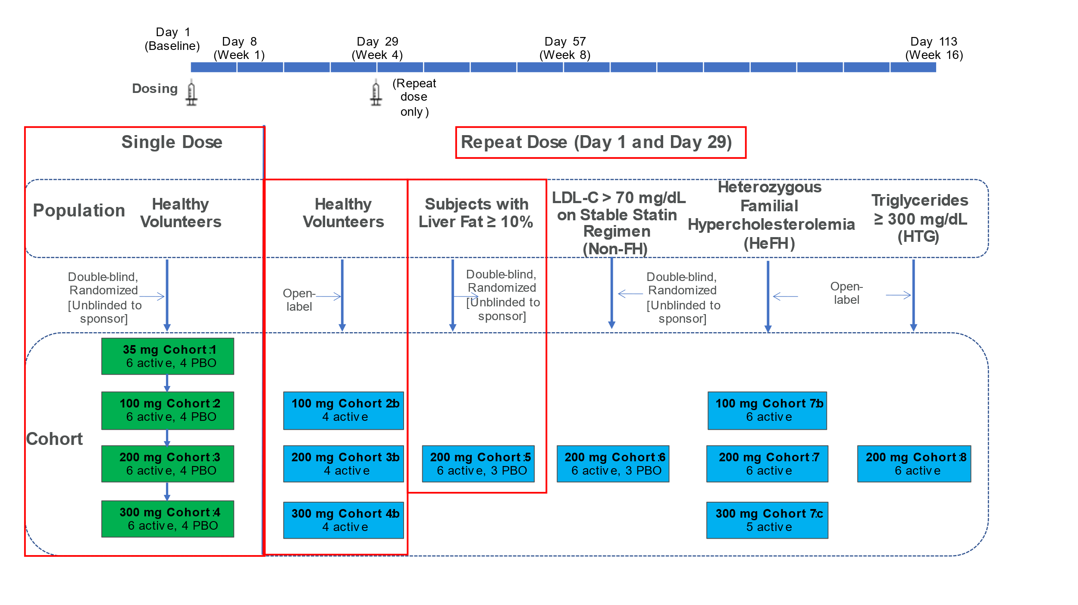
This schema reflects the basket trial approach taken in this Phase 1 study AROANG1001 to evaluate early proof of-concept, in which healthy volunteers (HV) and patients with various dyslipidemias were enrolled. In this report, we present the key results from this study showing the safety, tolerability, and pharmacodynamic effects of single ascending doses of ARO-ANG3 in healthy volunteer and multiple doses of ARO-ANG3 in both healthy volunteer and a cohort of patients with baseline hepatic steatosis. These cohorts are shown in red boxes.
Figure 2 reflects the subject allocation for the SAD and MAD HV cohorts (A) and dyslipidemic cohorts (B) in the Phase 1 AROANG1001 study. Please note the key results from this study are first reported for healthy volunteers and hepatic steatosis subjects.

Figure 2: Cohort Diagrams
A
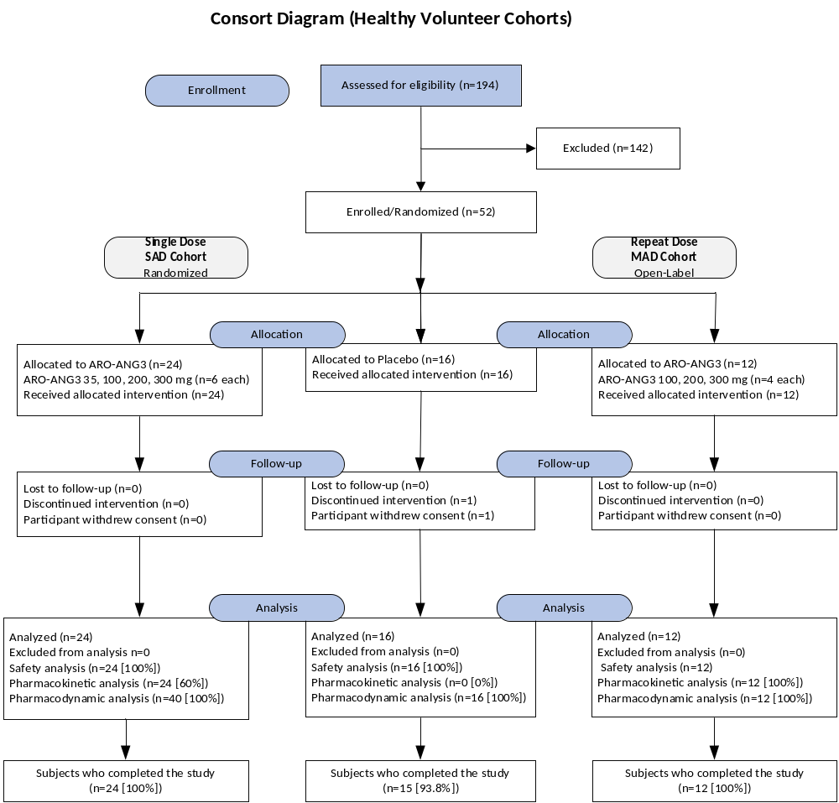
B
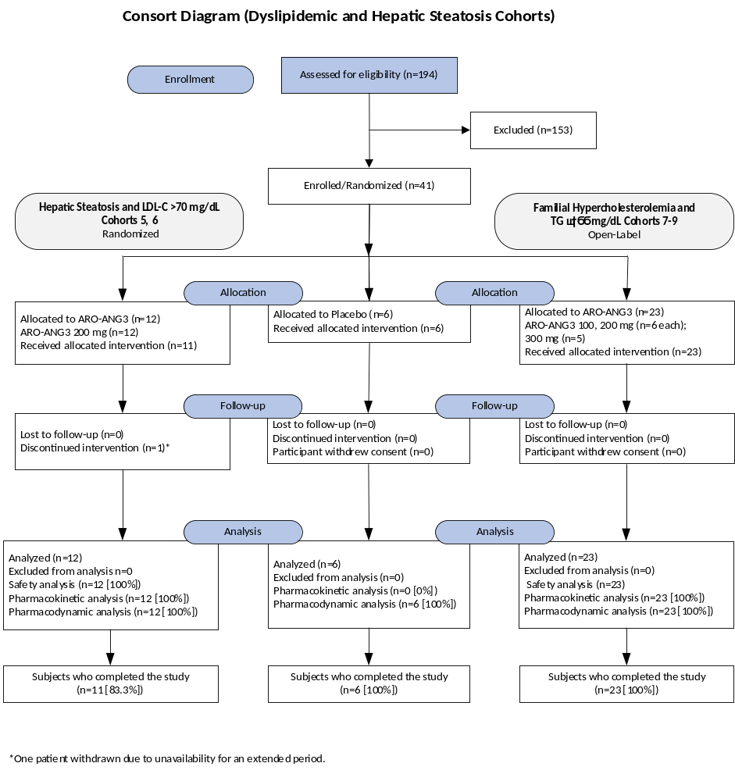

Table 2: Overall summary of treatment emergent adverse events in healthy volunteer cohorts receiving placebo or 35, 100, 200, or 300 mg ARO-ANG3 (single ascending doses) and cohorts receiving placebo or 100, 200, or 300 mg ARO-ANG3 (multiple ascending doses)
 | Healthy Volunteers (SAD) |  |  |  |  |  | Healthy Volunteers (MAD)
 | Pooled  Placebo  (N=16) | Pooled  Active  (N=24) | ARO-ANG3  (35 mg)  (N=6) | ARO-ANG3  (100 mg)  (N=6) | ARO-ANG3  (200 mg)  (N=6) | ARO-ANG3  (300 mg)  (N=6) | Pooled Active  (N=12) | ARO-ANG3  (100 mg)  (N=4) | ARO-ANG3  (200 mg)  (N=4) | ARO-ANG3  (300 mg)  (N=4)
Number of TEAEs | 34 | 65 | 12 | 13 | 23 | 17 | 44 | 17 | 6 | 21
TEAE | 14 (87.5%) | 22 (91.7%) | 5 (83.3%) | 6 (100%) | 6 (100%) | 5 (83.3%) | 10 (83.3%) | 4 (100%) | 2 (50.0%) | 4 (100%)
Serious TEAE | 1 (6.3%) | 0 | 0 | 0 | 0 | 0 | 0 | 0 | 0 | 0
Severe TEAE | 1 (6.3%) | 0 | 0 | 0 | 0 | 0 | 0 | 0 | 0 | 0
Related TEAE | 2 (12.5%) | 4 (16.7%) | 0 | 1 (16.7%) | 2 (33.3%) | 1 (16.7%) | 2 (16.7%) | 0 | 0 | 2 (50.0%)
Related Serious TEAE | 0 | 0 | 0 | 0 | 0 | 0 | 0 | 0 | 0 | 0
Related Severe TEAE | 0 | 0 | 0 | 0 | 0 | 0 | 0 | 0 | 0 | 0
TEAEs Leading to Drug/Study  Withdrawn | 0 | 0 | 0 | 0 | 0 | 0 | 0 | 0 | 0 | 0
Mild | 12 (75.0%) | 20 (83.3%) | 5 (83.3%) | 5 (83.3%) | 6 (100%) | 4 (66.7%) | 10 (83.3%) | 4 (100%) | 2 (50.0%) | 4 (100%)
Moderate | 5 (31.3%) | 5 (20.8%) | 1 (16.7%) | 1 (16.7%) | 1 (16.7%) | 2 (33.3%) | 0 | 0 | 0 | 0
Severe | 1 (6.3%) | 0 | 0 | 0 | 0 | 0 | 0 | 0 | 0 | 0
Not Related | 14 (87.5%) | 22 (91.7%) | 5 (83.3%) | 6 (100%) | 6 (100%) | 5 (83.3%) | 10 (83.3%) | 4 (100%) | 2 (50.0%) | 4 (100%)
Possibly | 2 (12.5%) | 3 (12.5%) | 0 | 1 (16.7%) | 1 (16.7%) | 1 (16.7%) | 1 (8.3%) | 0 | 0 | 1 (25.0%)
Probably | 0 | 1 (4.2%) | 0 | 0 | 1 (16.7%) | 0 | 1 (8.3%) | 0 | 0 | 1 (25.0%)
Abbreviations: N = number of participants allocated to the group; TEAE=treatment-emergent adverse event. Notes: MedDRA Version 21.1; Related = Possibly or Probably.

Table 3: Treatment-emergent adverse events, occurring in >1 subject, in healthy volunteer single ascending dose cohorts receiving placebo or 35, 100, 200, or 300 mg ARO-ANG3 (A) and in healthy volunteers in cohorts receiving multiple ascending doses of 100, 200, or 300 mg ARO-ANG3 (B)
 | - Single Dose Day 1 |  |  |  |  | - Repeat Dose Days 1 and 29
 | Healthy Volunteers (SAD) |  |  |  |  | Healthy Volunteers (MAD)
 |  | ARO-ANG3 |  |  |  | ARO-ANG3 | ARO-ANG3 | ARO-ANG3
 | Pooled  Placebo | 35 mg | 100 mg | 200 mg | 300 mg | 100 mg | 200 mg | 300 mg
Preferred Term | (N=16)  n (%) E | (N=6)  n (%) E | (N=6)  n (%) E | (N=6)  n (%) E | (N=6)  n (%) E | (N=4)  n (%) E | (N=4)  n (%) E | (N=4)  n (%) E
Upper respiratory tract infection | 3 (18.8%) 3 | 2 (33.3%) 2 | 1 (16.7%) 1 | 3 (50.0%) 6 | 4 (66.7%) 4 | 1 (25.0%) 1 | 1 (25.0%) 1 | 2 (50.0%) 3
Headache | 1 (6.3%) 1 | 3 (50.0%) 4 | 1 (16.7%) 1 | 2 (33.3%) 3 | 1 (16.7%) 1 | 1 (25.0%) 1 | 1 (25.0%) 1 | 3 (75.0%) 4
Diarrhea | 3 (18.8%) 3 | 0 | 1 (16.7%) 1 | 0 | 1 (16.7%) 1 | 0 | 0 | 2 (50.0%) 2
Dyspepsia | 1 (6.3%) 1 | 0 | 0 | 1 (16.7%) 1 | 1 (16.7%) 1 | 0 | 0 | 0
Lethargy | 0 | 0 | 0 | 0 | 0 | 1 (25.0%) 1 | 1 (25.0%) 1 | 0
Oropharyngeal pain | 1 (6.3%) 1 | 0 | 0 | 1 (16.7%) 1 | 1 (16.7%) 1 | 0 | 0 | 0
Soft tissue injury | 3 (18.8%) 3 | 0 | 0 | 0 | 0 | 0 | 0 | 0
Vascular access site pain | 1 (6.3%) 1 | 1 (16.7%) 1 | 1 (16.7%) 1 | 0 | 0 | 0 | 0 | 0
Vascular access site bruising | 0 | 0 | 0 | 0 | 0 | 1 (25.0%) 2 | 0 | 2 (50.0%) 3
Dermatitis contact | 0 | 0 | 1 (16.7%) 1 | 1 (16.7%) 1 | 0 | 0 | 0 | 0
Dizziness | 0 | 0 | 1 (16.7%) 1 | 1 (16.7%) 1 | 0 | 0 | 0 | 0
Injection site erythema | 0 | 0 | 1 (16.7%) 1 | 1 (16.7%) 1 | 0 | 0 | 0 | 0
Neuralgia | 1 (6.3%) 1 | 0 | 0 | 1 (16.7%) 1 | 0 | 0 | 0 | 0
Paresthesia | 0 | 0 | 0 | 1 (16.7%) 1 | 1 (16.7%) 1 | 0 | 0 | 0
Rectal hemorrhage | 2 (12.5%) 2 | 0 | 0 | 0 | 0 | 0 | 0 | 0
Tooth fracture | 0 | 0 | 1 (16.7%) 1 | 1 (16.7%) 1 | 0 | 0 | 0 | 0
Note: If a subject has multiple occurrences of a TEAE, the subject is presented only once in the Subject count (n) column for a given System Organ Class and Preferred Term. Occurrences are counted each time in the Events (E) column.
Percentages are based on the number of subjects in each cohort. AEs are sorted by decreasing frequency over all treatment cohorts by Preferred Term. N: number of subjects allocated to the cohort; AE: Adverse Event; TEAE: Treatment Emergent Adverse Event; MedDRA Version 19.1.

Table 4: Overall summary of treatment-emergent adverse events in hepatic steatosis cohort receiving placebo or 200 mg ARO-ANG3
 | Patients with Liver Fat ≥ 10% (MAD)
 | Placebo  (N=3) | ARO-ANG3  (200 mg)  (N=6)
Number of TEAEs | 8 | 22
Number of subjects reporting at
least one:
TEAE | 3 (100%) | 5 (83.3%)
Serious TEAE | 1 (33.3%) | 0
Severe TEAE | 0 | 0
Related TEAE | 0 | 2 (33.3%)
Related Serious TEAE | 0 | 0
Related Severe TEAE | 0 | 0
TEAEs Leading to Drug/Study  Withdrawn | 0 | 0
Number of subjects reporting TEAEs
by severity
Mild | 3 (100%) | 5 (83.3%)
Moderate | 1 (33.3%) | 3 (50.0%)
Severe | 0 | 0
Number of subjects reporting TEAEs by relationship to study treatment
Not Related | 3 (100%) | 5 (83.3%)
Possibly | 0 | 0
Probably | 0 | 2 (33.3%)
Abbreviations: N = number of participants allocated to the group; MAD=multiple ascending dose; TEAE=treatment-emergent adverse event.

Table 5: Demographic and metabolic baseline characteristics of subjects with hepatic steatosis receiving placebo or a repeat dose of 200 mg ARO-ANG3
 | Hepatic Steatosis Cohort
 | Placebo | ARO-ANG3  200 mg
Characteristicª | N=3 | N=6
Age^{b} (y)  (median) | 45.0 (45, 60) | 54.5 (44, 65)
Male sex – no. (%) | 2 (66.7%) | 3 (50.0%)
Female sex – no. (%) | 1 (33.3%) | 3 (50.0%)
Race^{c} – no (%)
White | 2 (66.7%) | 2 (33.3%)
Asian | 1 (33.3%) | 0
Native Hawaiian or Other Pacific Islander | 0 | 2 (33.3%)
Other | 0 | 2 (33.3%)
BMI (kg/m²) | 31.27 (8.57) | 33.67 (4.34)
ANGPTL3 (μg/L) | 77.77 (19.96) | 138.30 (38.55)
Triglycerides^{b} (mg/dL) (median) | 110.0 (102, 350) | 105.0 (75, 182)
Non-HDL-C (mg/dL) | 101.3 (26.4) | 130.0 (39.3)
VLDL-C (mg/dL) | 37.3 (28.3) | 23.3 (7.3)
LDL-C^{d} (mg/dL) | 64.0 (28.8) | 106.7 (37.3)
HDL-C (mg/dL) | 35.3 (2.1) | 50.0 (7.9)
MRI-PDFF | 20.427 (5.711) | 21.238 (6.716)
Abbreviations: BMI=body mass index; MRI=magnetic resonance imaging; PDFF= proton density fat fraction.
a Median (range) values noted for age and triglycerides
b No subjects identified as Black or African American, American Indian, Alaska Native, or Other
c Mean ± standard deviation was noted for BMI, ANGPTL3, non-HDL-C, HDL-C, and LDL-C.
d LDL-C derived using the Friedewald calculation.
Note: To convert the values for triglycerides to millimoles per liter, multiply by 0.01129. To convert the values for non-HDL-C and HDL-C to millimoles per liter, multiply by 0.02586.
Note: Medpace Reference Lab’s reference ranges were utilized.

Table 6: Pharmacodynamic measurements of lipid parameters: percent change from baseline at Day 85 and mixed model repeated measures analysis of change from baseline compared with placebo for apo CIII, total cholesterol, apo B, and apo AI for healthy volunteer single ascending doses of 35, 100, 200, or 300 mg ARO-ANG3
 | Pooled  Placebo | ARO-ANG3  (35 mg) | ARO-ANG3  (100 mg) | ARO-ANG3  (200 mg) | ARO-ANG3  (300 mg)
Apo CIII
Baseline
Mean (SD) mg/dL | 9.60 (4.92) | 9.58 (2.33) | 11.89 (4.10) | 12.96 (4.46) | 10.02 (3.39)
Absolute (mg/dL) and % Change from Baseline to Day 85
Mean (%) | -0.405 (2.1) | -2.372 (-22.3) | -5.225 (-41.8) | -7.755 (-60.4) | -6.418 (-65.6)
SD (%) | 3.371 (25.8) | 2.099 (19.9) | 4.667 (34.2) | 3.173 (19.1) | 3.177 (25.0)
MMRM Estimates % Change from Baseline to Day 85
LS Mean (SE) | 3.33 (7.22) | -8.85 (12.21) | -40.82 (11.80) | -64.31 (12.22) | -63.40 (11.60)
LS Mean of difference vs placebo (SE) |  | -12.18 (14.18) | -44.15 (13.83) | -67.65 (14.19) | -66.73 (13.66)
P-value |  | 0.398 | 0.004 | <.001 | <.001
Total Cholesterol
Baseline
Mean (SD) mg/dL | 198.1 (31.8) | 216.8 (49.8) | 245.5 (49.8) | 224.2 (52.2) | 218.8 (37.8)
Absolute (mg/dL) and % Change from Baseline to Day 85
Mean (%) | -6.2 (-2.3) | -38.2 (-15.9) | -54.5 (-22.4) | -32.3 (-15.7) | -49.2 (-21.5)
SD (%) | 22.1 (11.1) | 33.1 (14.7) | 23.6 (8.5) | 54.7 (26.3) | 41.9 (17.7)
MMRM Estimates % Change from Baseline to Day 85
LS Mean (SE) | -3.77 (4.24) | -15.23 (6.84) | -24.79 (6.89) | -13.69 (6.66) | -21.14 (6.64)
LS Mean of difference vs placebo (SE) |  | -11.47 (8.05) | -21.03 (8.09) | -9.92 (7.89) | -17.37 (7.88)
P-value |  | 0.163 | 0.014 | 0.218 | 0.035
Apo B
Baseline
Mean (SD) mg/dL | 95.88 (17.86) | 111.63 (28.77) | 122.95 (30.63) | 114.25 (29.09) | 105.82 (17.54)
Absolute (mg/dL) and % Change from Baseline to Day 85
Mean (%) | -2.36 (-1.0) | -24.76 (-21.9) | -29.25 (-23.1) | -6.00 (-6.7) | -14.43 (-12.4)
SD (%) | 15.18 (15.8) | 9.95 (10.9) | 16.97 (9.9) | 29.07 (27.1) | 24.41 (21.5)
MMRM Estimates % Change from Baseline to Day 85
LS Mean (SE) | -3.08 (4.74) | -19.11 (7.49) | -22.62 (7.62) | -5.78 (7.34) | -12.45 (7.25)
LS Mean of difference vs placebo (SE) | N/A | -16.02 (8.87) | -19.53 (8.98) | -2.70 (8.74) | -9.37 (8.67)
P-value | N/A | 0.080 | 0.037 | 0.759 | 0.288
Apo AI
Baseline
Mean (SD) mg/dL | 125.3 (16.8) | 130.8 (8.9) | 140.7 (20.4) | 128.0 (18.2) | 133.5 (23.5)
Absolute (mg/dL) and % Change from Baseline to Day 85
Mean (%) | 9.1 (8.2) | 5.0 (3.3) | -2.5 (-3.0) | -20.2 (-14.6) | -14.0 (-11.2)
SD (%) | 14.6 (13.0) | 21.4 (15.9) | 16.9 (12.4) | 21.7 (15.0) | 21.7 (16.5)
MMRM Estimates % Change from Baseline to Day 85
LS Mean (SE) | 6.79 (3.44) | 2.59 (5.59) | -3.76 (5.65) | -14.91 (5.42) | -11.16 (5.43)
LS Mean of difference vs placebo (SE) | N/A | -4.20 (6.57) | -10.55 (6.62) | -21.71 (6.42) | -17.96 (6.43)
P-value | N/A | 0.527 | 0.120 | 0.002 | 0.009
Abbreviations: MMRM=mixed model repeated measures; SD=standard deviation; SE=standard error of mean.

Table 7: Pharmacodynamic measurements of lipid parameters: percent change from baseline at Day 113 and mixed model repeated measures analysis of change from baseline compared with placebo for apo CIII, total cholesterol, apo B, and apo AI for healthy volunteers receiving escalating repeat doses of 100, 200, or 300 mg ARO-ANG3
MAD - HV | HV (SAD)  Pooled Placebo | ARO-ANG3  (100 mg) | ARO-ANG3  (200 mg) | ARO-ANG3  (300 mg)
 | Apo CIII
Baseline
Mean (SD) ng/mL | 9.60 (4.92) | 9.24 (2.05) | 9.63 (0.85) | 8.10 (4.83)
Absolute (ng/mL) and % Change from Baseline to Day 113
Mean (%) | 1.255 (11.8) | -5.930 (-61.4) | -7.198 (-75.8) | -7.170 (-87.9)
SD (%) | 3.681 (39.1) | 3.656 (38.3) | 2.208 (25.0) | 4.425 (6.5)
MMRM Estimates % Change from Baseline to Day 113
LS Mean (SE) | 9.55 (8.89) | -61.65 (17.42) | -75.98 (17.63) | -88.91 (17.52)
LS Mean of difference vs placebo (SE) | — | -71.20 (19.56) | -85.53 (19.74) | -98.46 (19.64)
—P-value | — | 0.001 | <.001 | <.001
 | Total Cholesterol
Baseline
Mean (SD) mg/dL | 198.06 (31.81) | 246.75 (35.79) | 203.00 (17.51) | 188.00 (36.36)
Absolute (ng/mL) and % Change from Baseline to Day 113
Mean (%) | 14.1 (8.1) | -86.8 (-35.3) | -90.5 (-43.8) | -78.8 (-42.2)
SD (%) | 25.0 (12.6) | 16.4 (5.2) | 40.6 (15.5) | 12.8 (5.1)
MMRM Estimates % Change from Baseline to Day 113
LS Mean (SE) | 7.04 (2.82) | -36.62 (6.35) | -43.67 (5.55) | -43.78 (5.67)
LS Mean of difference vs placebo (SE) | — | -43.66 (6.95) | -50.71 (6.22) | -50.82 (6.33)
P-value | — | <.001 | <.001 | <.001
 | Apo B
Baseline
Mean (SD) mg/dL | 95.88 (17.86) | 116.13 (29.60) | 96.30 (11.63) | 90.68 (21.18)
Absolute (ng/mL) and % Change from Baseline to Day 113
Mean (%) | 7.34 (9.1) | -36.55 (-30.7) | -38.63 (-39.0) | -25.60 (-28.4)
SD (%) | 14.20 (16.2) | 16.09 (7.6) | 17.15 (13.0) | 5.93 (4.0)
MMRM Estimates % Change from Baseline to Day 113
LS Mean (SE) | 7.99 (3.93) | -35.02 (8.25) | -37.87 (7.81) | -29.59 (7.93)
LS Mean of difference vs placebo (SE) | — | -43.00 (9.14) | -45.86 (8.74) | -37.58 (8.85)
P-value | — | <.001 | <.001 | <.001
 | Apo A1
Baseline
Mean (SD) mg/dL | 125.31 (16.83) | 146.75 (20.40) | 132.75 (10.90) | 124.00 (18.51)
Absolute (ng/mL) and % Change from Baseline to Day 113
Mean (%) | 9.3 (8.5) | -32.3 (-23.1) | -35.3 (-26.5) | -48.3 (-38.4)
SD (%) | 16.2 (14.1) | 12.1 (11.6) | 27.8 (20.0) | 18.6 (11.8)
MMRM Estimates % Change from Baseline to Day 113
LS Mean (SE) | 7.59 (3.24) | -28.23 (6.77) | -26.28 (6.44) | -38.76 (6.44)
LS Mean of difference vs placebo (SE) | — | -35.82 (7.51) | -33.88 (7.21) | -46.36 (7.21)
P-value | — | <.001 | <.001 | <.001
Abbreviations: HV=healthy volunteers; MMRM=mixed model repeated measures; SD=standard deviation; SE=standard error of mean.

Table 8: Pharmacodynamic measurements of lipid parameters: percent change from baseline at Day 113 and percent change from baseline compared with placebo for ANGPTL3, triglycerides, VLDL-C, non-HDL-C, LDL-C and HDL-C in subjects with hepatic steatosis receiving repeat doses of 200 mg ARO-ANG3
 | Placebo | ARO-ANG3  (200 mg)
ANGPTL3
Baseline
Mean (SD) ng/mL | 77.77 (19.96) | 138.30 (38.55)
Absolute (ng/mL) and % Change from Baseline to Day 113
Mean (%) | 10.73 (13.0) | -120.42 (-85.3)
SD (%) | 6.27 (4.7) | 42.30 (12.7)
MMRM Estimates % Change from Baseline to Day 113
LS Mean (SE) | 16.94 (13.13) | -82.50 (5.57)
LS Mean of difference vs placebo (SE) | — | -99.44 (14.26)
P-value | — | <.001
Triglycerides
Baseline
Median (min, max) mg/dL | 110.0 (102, 350) | 105.0 (75, 182)
Absolute (mg/dL) and % Change from Baseline to Day 113
Median (%) mg/dL | 91.0 (47.1) | -46.5 (-44.1)
(Min, max) (%) mg/dL | (9 [8.8], 165 [82.7]) | (-131 [-72.0], -14 [-13.7])
MMRM Estimates % Change from Baseline to Day 113
LS Mean (SE) | 10.05 (61.52) | -41.66 (43.77)
LS Mean of difference vs placebo (SE) | — | -51.71 (75.50)
P-value | — | 0.496
Non-HDL-Cholesterol
Baseline
Mean (SD) mg/dL | 101.3 (26.4) | 130.0 (39.3)
Absolute (mg/dL) and % Change from Baseline to Day 113
Mean (%) | -1.7 (0.2) | -46.2 (-36.7)
SD (%) | 15.0 (14.3) | 21.8 (15.0)
MMRM Estimates % Change from Baseline to Day 113
LS Mean (SE) | 7.63 (32.55) | -37.42 (20.41)
LS Mean of difference vs placebo (SE) | — | -45.04 (38.42)
P-value | — | 0.256
VLDL-Cholesterol
Baseline
Mean (SD) mg/dL | 37.3 (28.3) | 23.3 (7.3)
Absolute (mg/dL) and % Change from Baseline to Day 113
Mean (%) | 10.0 (45.9) | -10.8 (-43.5)
SD (%) | 11.3 (50.8) | 8.1 (20.8)
MMRM Estimates % Change from Baseline to Day 113
LS Mean (SE) | 43.51 (16.94) | -43.56 (9.79)
LS Mean of difference vs placebo (SE) | — | -87.07 (19.56)
P-value | — | <.001
LDL-Cholesterol
Baseline
Mean (SD) mg/dL | 64.0 (28.8) | 106.7 (37.3)
Absolute (mg/dL) and % Change from Baseline to Day 113
Mean (%) | -8.3 (-4.3%) | -35.3 (-34.6%)
SD (%) | 24.8 (29.3%) | 15.4 (14.1%)
MMRM Estimates % Change from Baseline to Day 113
LS Mean (SE) | -9.54 (16.73) | -35.66 (9.19)
LS Mean of difference vs placebo (SE) | — | -26.12 (19.09)
P-value | — | 0.204
 | HDL-Cholesterol
Baseline
Mean (SD) mg/dL | 35.3 (2.1) | 50.0 (7.9)
Absolute (mg/dL) and % Change from Baseline to Day 113
Mean (%) | -3.7 (-10.4) | -26.2 (-53.0)
SD (%) | 0.6 (2.1) | 4.8 (9.2)
MMRM Estimates % Change from Baseline to Day 113
LS Mean (SE) | -11.81 (38.55) | -57.52 (6.71)
LS Mean of difference vs placebo (SE) | — | -45.71 (39.12)
P-value | — | 0.292
Abbreviations: MMRM=mixed model repeated measures; SD=standard deviation; SE=standard error of mean.
Note: Friedewald calculation was used for LDL-C measurements, unless triglycerides were >400 mg/dl, wherein a direct LDL-C measurement was used.

Table 9: Pharmacodynamic measurements of lipid parameters: percent change from baseline at Day 113 and mixed model repeated measures analysis of change from baseline compared with placebo for apo CIII, total cholesterol, apo B, apo AI, and Lp(a) in subjects with hepatic steatosis receiving repeat doses of 200 mg ARO-ANG3
 | Placebo | ARO-ANG3  (200 mg)
Apo CIII
Baseline
Mean (SD) mg/dL | 9.69 (7.05) | 8.73 (1.83)
Absolute (mg/dL) and % Change from Baseline to Day 113
Mean (%) | 1.900 (21.3%) | -7.273 (-82.7%)
SD (%) | 1.365 (16.6%) | 2.399 (16.8%)
MMRM Estimates % Change from Baseline to Day 113
LS Mean (SE) | 18.54 (22.90) | -82.30 (16.20)
LS Mean of difference vs placebo (SE) | — | -100.84 (28.05)
P-value | — | 0.001
Total Cholesterol
Baseline
Mean mg/dL | 136.7 (24.8) | 180.0 (42.7)
Absolute (mg/dL) and % Change from Baseline to Day 113
Mean (%) | -5.3 (-3.1%) | -72.3 (-41.6%)
SD (%) | 15.4 (10.6%) | 21.5 (13.0%)
MMRM Estimates % Change from Baseline to Day 113
LS Mean (SE) | 7.33 (28.36) | -42.99 (15.31)
LS Mean of difference vs placebo (SE) | — | -50.32 (32.23)
P-value | — | 0.142
Apo B
Baseline
Mean (SD) mg/dL | 70.60 (13.52) | 87.70 (22.22)
Absolute (mg/dL) and % Change from Baseline to Day 113
Mean (%) | -1.03 (-0.9) | -18.27 (-20.5)
SD (%) | 6.26 (7.9) | 15.67 (15.4)
MMRM Estimates % Change from Baseline to Day 113
LS Mean (SE) | -5.01 (11.23) | -19.92 (6.44)
LS Mean of difference vs placebo (SE) | — | -14.90 (12.95)
P-value | — | 0.279
Apo AI
Baseline
Mean (SD) mg/dL | 123.7 (22.8) | 149.2 (11.8)
Absolute (mg/dL) and % Change from Baseline to Day 113
Mean (%) | 2.0 (2.6) | -69.0 (-46.5)
SD (%) | 11.1 (8.8) | 16.8 (11.9)
MMRM Estimates % Change from Baseline to Day 113
LS Mean (SE) | 1.98 (9.17) | -51.78 (6.19)
LS Mean of difference vs placebo (SE) | — | -53.75 (11.06)
P-value | — | <.001
Lp(a)
Baseline
Mean (SD) nmol/L | 66.73 (109.87) | 12.78 (18.52)
Absolute (nmol/L) and % Change from Baseline to Day 113
Mean (%) | -13.63 (-5.5%) | 1.77 (-17.1%)
SD (%) | 23.70 (19.3%) | 8.70 (36.5%)
MMRM Estimates % Change from Baseline to Day 113
LS Mean (SE) | -7.24 (21.49) | -4.48 (18.50)
LS Mean of difference vs placebo (SE) | — | 2.77 (28.35)
P-value | — | 0.924
Abbreviations: MMRM=mixed model repeated measures; SD=standard deviation; SE=standard error of mean.

