Supplementary Information

Plots for total bilirubin versus ALT at peak postdose values and at EOS are presented in Figure1A and 1B, respectively, for SAD cohorts. One subject in the pooled placebo cohort and 1 subject in the ARO-ANG3 35 mg cohort (purple solid triangle) experienced a TEAE associated with alanine transaminase (ALT) elevations >2× and >3× the ULN, respectively; neither TEAE was considered treatment-related (A). At EOS, ALT in both subjects had returned towards baseline and was <3× ULN (B). There were so Hy’s Law cases.

Figure 1: Peak post-dose and end of study total bilirubin vs ALT (SAD, Cohorts 1, 2, 3, and 4) (Safety Population)
A | 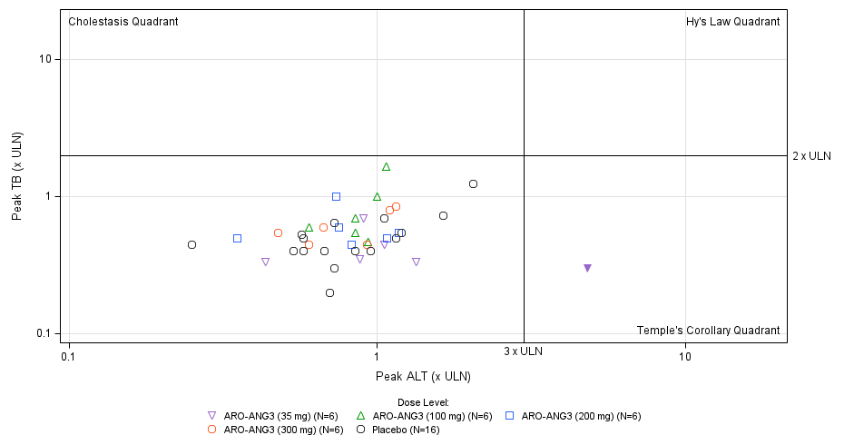
B | 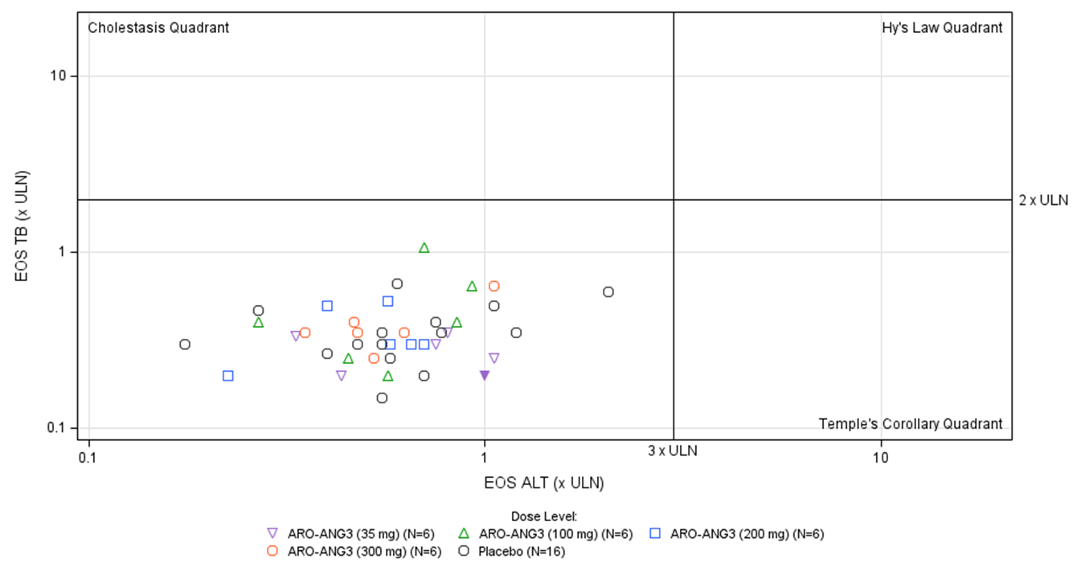
Abbreviations: ALT=alanine aminotransferase; SAD=single ascending dose; TB=total bilirubin; ULN=upper limit of normal.
Notes: Upper limit of normal is different for males and females.
Plots for total bilirubin versus ALT at peak postdose values and at EOS are presented in Figure 2A and 2B, respectively, for the hepatic steatosis cohort. One subject receiving 200 mg ARO-ANG3 (solid blue square) demonstrated a post-dose peak increase in ALT to >3× the ULN, which was transitory (A). At EOS, ALT had returned towards baseline and was <3× ULN (B). There were no Hy’s Law cases.

Figure 2: Peak post-dose and end of study total bilirubin vs alanine aminotransferase (hepatic steatosis subjects)
A | 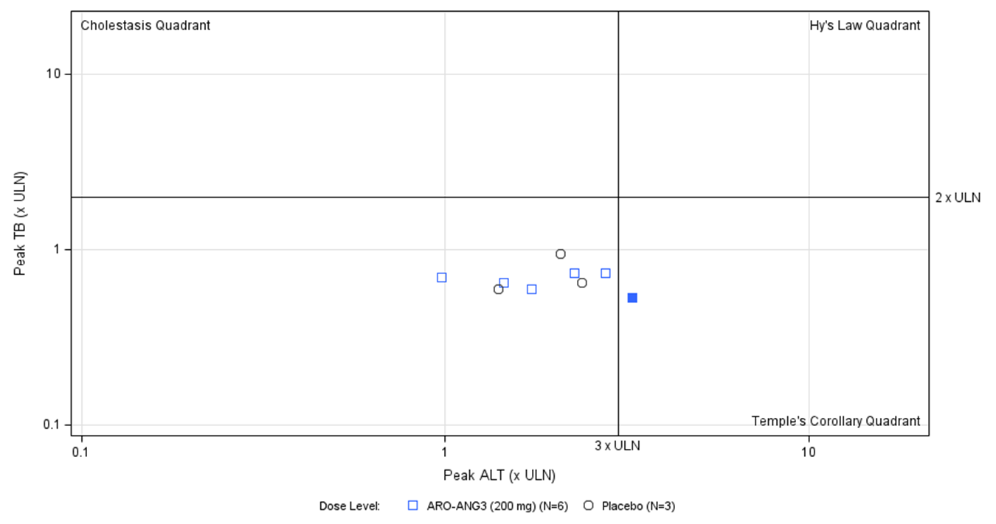
B | 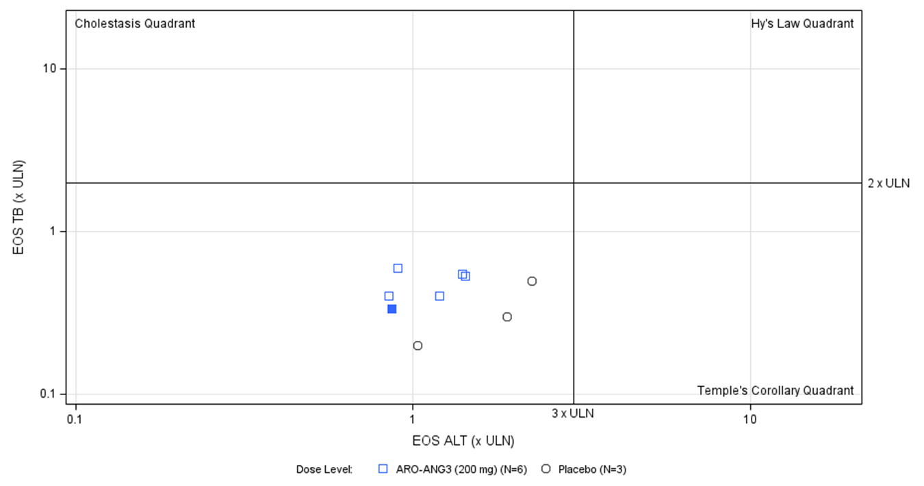
Abbreviations: ALT = Alanine aminotransferase; TB = Total bilirubin; ULN = Upper limit of normal.
Notes: Upper limit of normal is different for males and females.
Post-dose changes in hepatic function and platelets that met certain thresholds during the study period are presented in Table 1. At peak postdose values, 1 subject in the HV cohort and 1 subject in the hepatic steatosis cohort demonstrated a transient elevation in ALT to > 3× ULN. However, at EOS ALT in both subjects had returned towards baseline and was <3× ULN.
In the HV and hepatic steatosis cohorts, there were no adverse changes in hematology parameters which were considered clinically significant for any subject, regardless of dose level or treatment assignment. There were no TEAEs related to fall in platelet counts.

Table 1: Proportion of subjects with defined changes in serum aminotransferases, total bilirubin, and platelet count in the healthy volunteer cohorts and the patient cohort with elevated liver fat content, after administration of ARO-ANG3
Category | Healthy Volunteers (SAD)  Pooled Active  (N=24)  n (%) | Healthy Volunteers (MAD)  Pooled Active  (N=12)  n (%) | Patients with Liver Fat >= 10% (MAD)  ARO-ANG3 (200 mg)  (N=6)  n (%)
ALT > 3x ULN | 1 (4.2) | 0 (0.0) | 1 (16.7)
AST > 3x ULN | 0 | 0 | 0
TBILI >2x ULN | 0 | 0 | 0
Platelets < 150 | 1 (4.2) | 0 (0.0) | 0 (0.0)

Waterfall plots showing individual absolute changes in liver fat content, measured using magnetic resonance imaging-proton density fat fraction (MRI-PDFF,), at post-dose Days 71 (A) and 168 (B) for subjects with hepatic steatosis receiving repeat doses of 200 mg of ARO-ANG3 and receiving placebo (Figure 3).

Figure 3: Individual absolute changes in liver fat content measured using magnetic resonance imaging-proton density fat fraction at Days 71 (A) and 168 (B) post dose for subjects with hepatic steatosis receiving repeat doses of 200 mg of ARO-ANG3 or placebo
 | 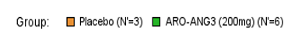
A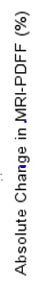 | 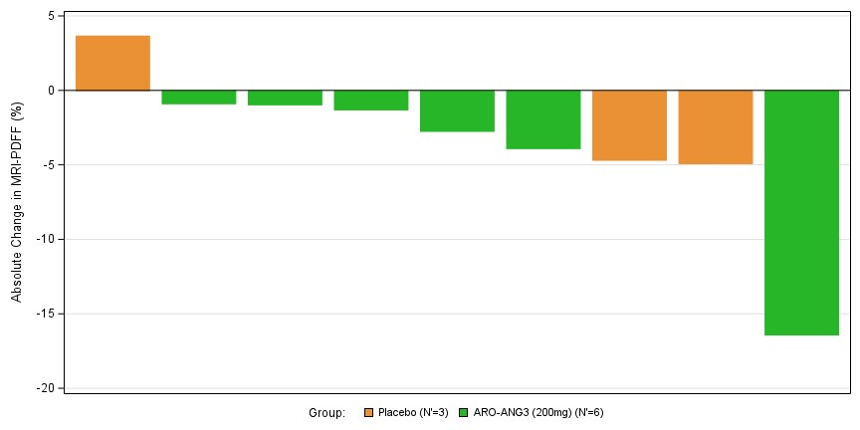
B | 