Effective adsorption of A-series chemical warfare agents on graphdiyne nanoflake; a DFT study

Hasnain Sajid#, Sidra Khan#, Khurshid Ayub, Tariq Mahmood*
Department of Chemistry, COMSATS University, Abbottabad Campus, Abbottabad-22060, Pakistan

*To whom correspondence can be addressed: E-mail: mahmood@cuiatd.edu.pk (T. M)
# Hasnain Sajid & Sidra Khan have equal contributions for first authorship

A-230  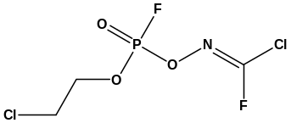 | A-232  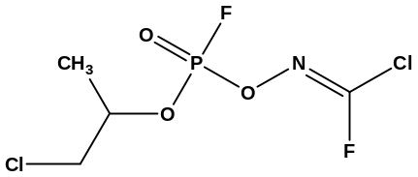 | A-234  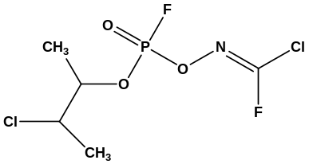
Fig. S1: Structure of A-series (A-230, A-232m A-234) reported by Hoenig.

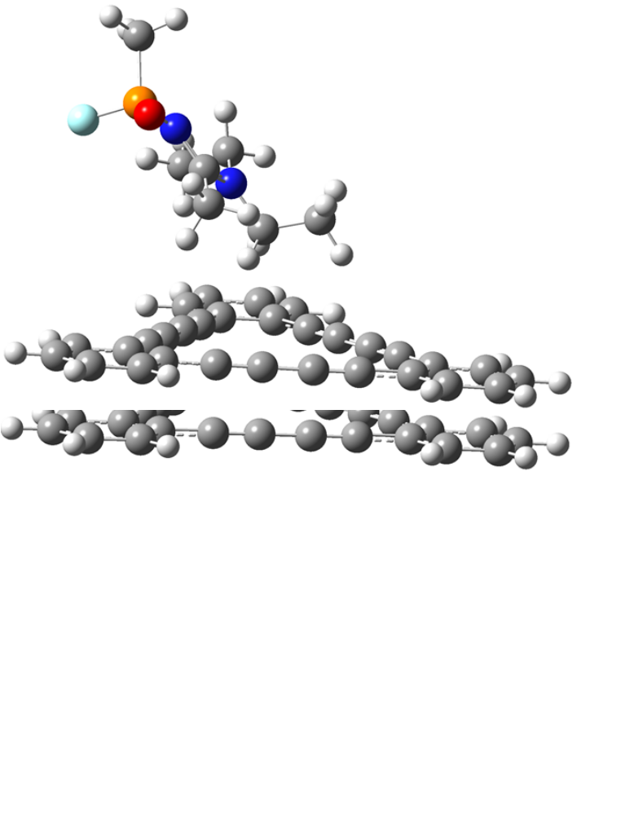
Fig S2a. All possible optimized geometries of A230@GDY complexes.
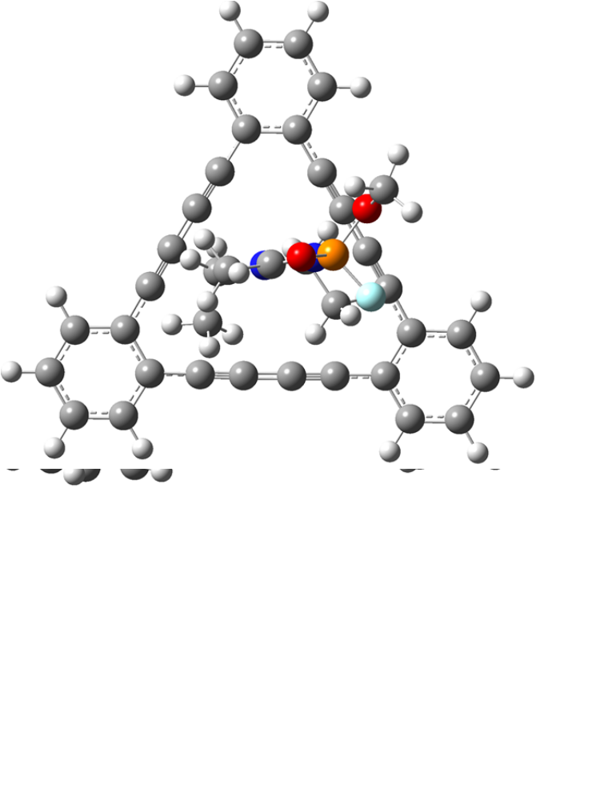
Fig S2b. All possible optimized geometries of A232@GDY complexes.
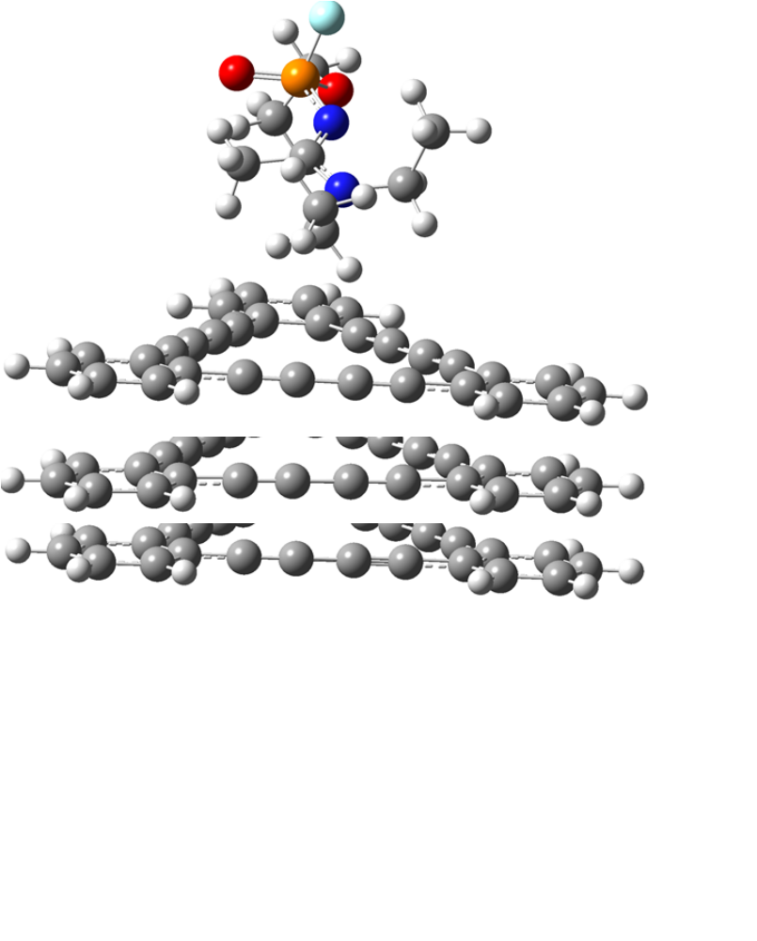
Fig S2c. All possible optimized geometries of A234@GDY complexes

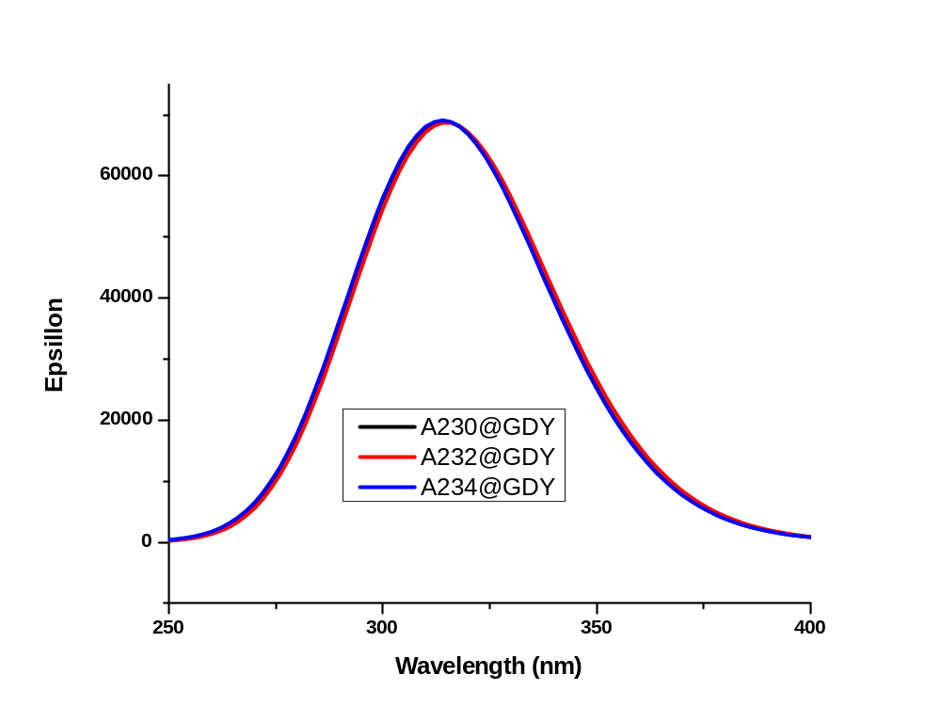
Fig S3. UV-Vis spectra of A-series analytes@GDY complexes.

