Supplementary Materials
Fungus-synthesized nanoparticles and their target and nontarget effects on stored bean pest beetles and their parasitoid

Eman Ahmed Mohamed Helmy^{1,2}, Phyu Phyu San^{2,3}, Yao Zhuo Zhang², Charles Adarkwah^{2,4,}*, Midori Tuda^{2,}*
¹ The Regional Centre for Mycology and Biotechnology (RCMB), Al-Azhar University, Cairo, Egypt
²Laboratory of Insect Natural Enemies, Institute of Biological Control, Faculty of Agriculture, Kyushu University, Fukuoka 819-0395, Japan
³ Department of Entomology and Zoology, Yezin Agricultural University, Naypyitaw, Myanmar
⁴ Department of Horticulture and Crop Production, School of Agriculture and Technology, Dormaa-Ahenkro Campus, University of Energy and Natural Resources, PO Box 214, Sunyani, Ghana

Corresponding authors: M. Tuda
tuda@grt.kyushu-u.ac.jp

Supplementary Table S1 Biosynthesized nanoparticle effects on insects. Non-exhaustive list of studies
nanoparticle | biosynthetic method | test subject | condition | exposure time | results | reference
Ag | plant extract, Euphorbia hirta (Malpighiales: Euphorbiaceae) | cotton bollworm, Helicoverpa armigera (Lepidoptera: Noctuidae) | 200–700 nm, 20, 40, 60, 80, 100 ppm | 24 h | Mortality of 1st instar larvae @ 20 (49%), 40(55%), 60(66%), 80(85%), 100(95) ppm, LC₅₀ = 33 ppm  Pupa @ 20(48%), 40(53%), 60(62%), 80(82%), 100(90%) ppm, LC₅₀ = 45 ppm | Devi et al. 2014
 | seaweed (brown algae) extract, Sargassum muticum (Fucales: Sargassaceae) | common castor, Ariadne merione (Lepidoptera: Nymphalidae) (syn. Ergolis merione | 42.3–98.6 nm,  10 μL injection to leg of 4th instar larvae | 2 h | LC₅₀ = 4.5 μl (95 ml 1mM AgNO₃ + 5 ml S. muticum aqueous extract)  Physiological and anatomical abnormalities in fourth instar larvae | Moorthi et al. 2015
 | seaweed (brown algae) extract, Sargassum muticum (Fucales: Sargassaceae) | Anopheles stephensi, Aedes aegypti, Culex quinquefasciatus (Diptera: Culicidae) | 43–79 nm, crystalline and spherical, 10, 20, 30, 40, 50 ppm | 24 h (larvicidal and pupicidal), 48 h (ovicidal, ovideterrent) | Mortality of Ae. aegypti, 1st instar @10 (32%) 20(51%), 30(70%), 40(81%), 50(94%), LC₅₀ = 20.2 ppm; pupa @10 (25%), 20(37%), 30(50%), 40(64%), 50(71%) ppm, LC₅₀ = 30.6 ppm  A. stephensi 1st instar @ 10 (40%) 20(57%), 30(73%), 40(87%), 50(96%), LC₅₀ = 16.2 ppm; pupa @ 10(26%), 20(38%), 30(52%), 40(67%), 50(74%), LC₅₀ = 28.9 ppm  C. quinquefasciatus 1st instar @ 10(30%) 20(44%), 30(60%), 40(76%), 50(90%), LC₅₀ = 23.1 ppm; pupa @ 10(23%), 20(35%), 30(48%), 40(59%), 50(69%), LC₅₀ = 32.6 ppm  Egg hatchability of Ae. aegypti @ 10(20%), 20(7%), 30(0%), 40(0%), 50(0%) ppm  A. stephensi @ 10(24%), 20(7%), 30(0%), 40(0%), 50(0%)  C. quinquefasciatus @ 10(21%), 20(7%), 30(0%), 40(0%), 50(0%)  Ovideterrent of Ae. aegypti @ 10(73 eggs = reduction by 75.8%), 20(64 = 81.8%), 30(55 = 86.6%), 40(42 = 89.9%), 50(32.4 = 92.5%) ppm  A. stephensi @ 10(69 = 77.5%), 20(52 = 84.3%), 30(42 = 89.3%), 40(32 = 92.2%), 50(25.4 = 94.0%)  C. quinquefasciatus @ 10(77 = 73.8%), 20(63 = 80.7%), 30(53 = 86.0%), 40(45 = 88.6%), 50(34 = 91.7%) | Madhiyazhagan et al. 2015
 | plant extract, Tinospora cordifolia (Ranunculales: Menispermaceae) | head louse, Pediculus humanus capitis (Phthiraptera: Pediculidae), 4th instar larvae of Anopheles subpictus, Culex quinquefasciatus (Diptera: Culicidae) | AgNP: 2.5, 5.0, 7.5, 10, 15, 20, 25 mg/L  T. cordifolia aqueous extract: 20, 40, 60, 80, 100 mg/L | 24 h | Mortality by AgNP:  P. humanus capitis @ 20(13%), 40(33%), 60(57%), 80(75%), 100(80%) mg/L, LC₅₀ = 52.1 mg/L  A. subpictus @ 20(12%), 40(24%), 60(49%), 80(86%), 100(91%) mg/L, LC₅₀ = 53.9 mg/L  C. quinquefasciatus @ 20(13%), 40(26%), 60(56%), 80(62%), 100(76%) mg/L, LC₅₀ = 59.4 mg/L  Mortality by T. cordifolia:  P. humanus capitis @ 5(19%), 10(36%), 15(69%), 20(86%), 25(100%) mg/L, LC₅₀ = 12.5 mg/L  A. subpictus @ 2.5(19%), 5.0(27%), 7.5(59%), 10(92%), 20(100%) mg/L, LC₅₀ = 6.34 mg/L  C. quinquefasciatus @ 2.5(12%), 5.0(20%), 7.5(49%), 10(85%), 20(100%) mg/L, LC₅₀ = 6.96 mg/L | Jayaseelan et al. 2011
 | plant extract, Euphorbia prostrata (Malpighiales: Euphorbiaceae) | Sitophilus oryzae (Coleoptera: Curculionidae) | 50, 100, 150, 200, 250 mg/kg | 1, 3, 5, 7, 14 d | Mortality @ 14th d 50(71%), 100(80%), 150(91%), 200(97%), 250(100%),  LD₅₀ = 44.7 mg/kg | Zahir et al. 2012
 | plant extract, Avicennia marina (Lamiales: Acanthaceae) | Sitophilus oryzae (Coleoptera: Curculionidae) | 15–25 nm,  AgNP: 25, 50, 75, 100 mg/mL  Aqueous extract: 250, 500, 750, 1000 mg/mL | 12–96 h | Mortality after 96 h  AgNP: @ 25(100%), 50(100%), 75(80%), 100(80%) mg/mL  Aqueous extract: @ 250 (30%), 500(40%), 750(20%), 1000(20%) mg/mL | Sankar and Abideen 2015
 | seaweed (red algae) extract, Hypnea musciformis (Gigartinales: Cystocloniaceae) | Aedes aegypti (Diptera: Culicidae) and Plutella xylostella (Lepidoptera: Plutellidae) | 10–50 ppm | 24 h | Ae. aegypti adult longevity (male, female) after 24 h @ 10(13, 25), 20(11, 23), 30(9, 22), 40(7, 20), 50(5, 17) ppm; Fecundity @ 10(141), 20(132), 30(125), 40(115), 50(98) ppm  P. xylostella. adult longevity (male, female) after 24 h @ 10(11, 24), 20(9, 22), 30(7.9, 18), 40(5, 16), 50(5, 15) ppm; Fecundity @ 10(720), 20(533), 30(311), 40(203), 50(98) ppm | Roni et al. 2015
 | plant extract, Arachis hypogaea (Fabales: Fabaceae) | Aedes aegypti and Anopheles stephensi (Diptera: Culicidae) | 1.25, 2.25, 5, 10, 15 ppm | 24 h | Mortality of A. stephensi @ 1.25(27%), 2.25(46%), 5(61%), 10(87%), 15(100%) ppm, LC₅₀ = 3.13 ppm  A. aegypti @ 1.25(34%), 2.25(57%), 5(75%), 10(92%), 15(100%) ppm, LC₅₀ = 1.85 ppm  Reduced the population of both species | Velu et al. 2015
 | plant oils, Ricinus communis (Malpighiales: Euphorbiaceae) and Citrus x paradisi (Sapindales: Rutaceae) | Tribolium castaneum (Coleoptera: Tenebrionidae) | 100, 200, 300 ppm | 24, 48, 72, 96 h | R. communis AgNP:  Adult mortality after 24–96 h @ 100(19%, 19%, 22%, 26%), 200(28%, 29%, 32%, 33%), 300(32%, 34%, 37%, 41%) ppm  Repellency after 24 h @ 100(50%), 200(56%), 300 (68%) ppm  C. paradisi AgNP:  Adult mortality after 24–96 h @ 100(18%, 20%, 22%, 23%), 200(30%, 32%, 32%, 33%), 300(26%, 28%, 35%, 39%) ppm  Repellency after 24 h @ 100 (37%), 200(42%), 300(48%) ppm | Shahzadi et al. 2019
 | plant extract, Ocimum basilicum (Lamiales: Lamiaceae) | Tobacco cutworm, Spodoptera litura (Lepidoptera: Noctuidae) | 464.2 nm, 100, 500, 1000, 1500 mg/L | 72 h | Mortality rates of 2nd instar larvae @ 100(21.7%) 500(41.7%), 1000(63.3%), 1500(96.7%, 78.3%) & 5th instar @ 1500(78.3%) mg/L, LC₅₀ = 436.3 (2nd instar) & 858.1 (5th instar) mg/L | Jafir et al. 2021
 | fungus extract, Beauveria bassiana (Hypocreales: Cordycipitaceae) | Aedes aegypti (Diptera: Culicidae) | 36.9–60.9 nm, spherical,  0.06, 0.12, 0.25, 0.50, 1.00 ppm | 24 h | Mortality of 4th instar larvae after 24 h @ 0.06(52%), 0.12(60%), 0.25(69%), 0.50(76%), 1.00(83%) ppm, LC₅₀ = 0.79 ppm | Banu and Balasubramanian 2014a
 | fungus extract, Beauveria bassiana (Hypocreales: Cordycipitaceae) | 1–4 instar larvae of Aedes aegypti, Anopheles stephensi, Culex quinquefasciatus (Diptera: Culicidae) | 20.4–34.2 nm, spherical, 50, 100, 150, 200, 250, 300 μg/mL | 24 h | Mortality of 1st instar larvae of Ae. aegypti @ 50(69%), 100(73%), 150(83%), 200(90%), 250(98%), 300(100%), LC₅₀ = 34.7 μg/mL; 4th instar larvae @ 50(67%), 100(72%), 150(83%), 200(91%), 250(93%), 300(98%), LC₅₀ = 22.5 μg/mL  Mortality of 1st instar larvae of A. stephensi @ 50(67%), 100(71%), 150(75%), 200(86%), 250(95%), 300(100%), LC₅₀ = 45.8 μg/mL; 4th instar larvae @ 50(63%), 100(73%), 150(80%), 200(90%), 250(97%), 300(100%), LC₅₀ = 30.8 μg/mL  Mortality of 1st instar larvae C. quinquefasciatus @ 50(68%), 100(74%), 150(85%), 200(92%), 250(98%), 300(100%), LC₅₀ = 49.4 μg/mL; 4th instar larvae @ 50(88%), 100(91%), 150(92%), 200(95%), 250(98%), 300(100%), LC₅₀ = 1.5 μg/mL | Prabakaran et al. 2016
 | fungus extract, Isaria fumosorosea (Hypocreales: Cordycipitaceae) | Aedes aegypti, Culex quinquefasciatus (Diptera: Culicidae) | 51.3–111.0 nm, spherical,  0.03, 0.06, 0.09, 0.12, 0.15, 0.25, 0.50, 1.00 ppm | 24 h | Mortality of 1st instar larvae of C. quinquefasciatus @ 0.03(6%), 0.06(10%), 0.09(18%), 0.12(28%), 0.15(40%), 0.25 (56%), 0.50(76%), 1.00(82%) ppm, LC₅₀ = 0.07 ppm  4th instar larvae @ 0.03(0%), 0.06(2%), 0.09(3%), 0.12(6%), 0.15(13%), 0.25(24%), 0.50(42%), 1.00(60%) ppm, LC₅₀ = 0.14 ppm  Mortality of 1st instar larvae of Ae. aegypti @ 0.03(39%), 0.06(47%), 0.09(52%), 0.12(60%), 0.15(72%), 0.25(78%), 0.50(85%), 1.00(100%) ppm, LC₅₀ = 0.24  4th instar larvae @ 0.03(26%), 0.06(31%), 0.09(38%), 0.12(43%), 0.15(50%), 0.25(61%), 0.50(77%), 1.00(92%) ppm, LC₅₀ = 0.65 ppm | Banu and Balasubramanian 2014b
 | fungus extract, Trichoderma harzianum (Hypocreales: Hypocreaceae) | Aedes aegypti (Diptera: Culicidae) | 10–20 nm, irregular,  AgNP: 0.05, 0.10, 0.15, 0.20, 0.25%  T. harzianum extracellular filtrate: 0.2, 0.4, 0.6, 0.8, 1.0% | 24 h | T. harzianum extracellular filtrate:  1st @ 0.2(12%), 0.4(22%), 0.6(24%), 0.8(34%), 1.0(48%), LC₅₀ = 1.08%  4th @ 0.2(14%), 0.4(26%), 0.6(36%), 0.8(42%), 1.0(54%), LC₅₀ = 0.91  Pupa @ 0.2(40%), 0.4(50%), 0.6(62%), 0.8(72%), 1.0(80%), LC₅₀ = 0.39  Biosynthesized AgNP:  1st @ 0.2(46%), 0.4(54%), 0.6(64%), 0.8(78%), 1.0(92%), LC₅₀ = 0.079%  4th @ 0.2(50%), 0.4(58%), 0.6(70%), 0.8(82%), 1.0(100%), LC₅₀ = 0.068  Pupa @ 0.2(76%), 0.4(82%), 0.6(90%), 0.8(96%), 1.0(100%), LC₅₀ = 0.026 | Sundaravadivelan and Padmanabhan 2014
CuO | plant extract, Tridax procumbens (Asterales: Asteraceae) | Aedes aegypti (Diptera: Culicidae) | 16 nm,  1, 2.5, 5, 7.5, 10 mg/L | 24 h | Mortality @ 1(17%), 2.5(37%), 5(53%), 7.5(78%), 10(100%)  LC₅₀ = 4.21 mg/L | Selvan et al. 2018
Cu | cell-free extract, copper-resistant bacteria Pseudomonas fluorescens (Gammaproteobacteria: Pseudomonadaceae) MAL2 | Tribolium castaneum (Coleoptera: Tenebrionidae) | 10–70 nm, spherical  50, 100, 150, 200, 250, 300 µg/mL | 5 d | Adult mortality @ 1, 3, 5 d @ 50(3, 43, 67%), 100(7, 43,70%), 150(10, 47, 73%), 200(17, 50, 83%), 250(20. 60, 93%), 300(20, 67, 100%) µg/mL, LC₅₀ = 693.7, 130.5, 36.9 µg/mL, | El-Saadony et al. 2020
NiO | plant extract, Rauvolfia serpentine (Gentianales: Apocynaceae) | Callosobruchus maculatus (Coleoptera: Chrysomelidae) | 4.9–20.0 nm,  5, 10, 20, 40 ppm | 3 d | Fecundity @ 5(30.1), 10(27.8), 20(28.5), 40(25.9) ppm;  development period @ 5(32.3 d), 10(32.2 d), 20(34.9 d), 40(35.2 d) ppm;  adult emergence @ 5(72%), 10(73%), 20(70%), 40(63%) ppm;  adult longevity: male/female @ 5(15.5/13.5 d), 10(15.5/13.4 d), 20(15.6/13.6 d), 40(15.4/13.8 d) ppm  Seed germination reduced @ 40 ppm (79.1%) | Rahman et al. 2021
Pb | plant extract, Avicennia marina (Lamiales: Acanthaceae) | Sitophilus oryzae (Coleoptera: Curculionidae) | PbNP: 25, 50, 75, 100 mg/mL  Aqueous extract: 250, 500, 750, 1000 mg/mL | 12–96 h | Mortality after 96 h  PbNP: @ 25(100%), 50(100%), 75(90%), 100(90%) mg/mL  Aqueous extract: @ 250 (30%), 500(40%), 750(20%), 1000(20%) mg/mL | Sankar and Abideen 2015
Se | plant extract, Cupressus sempervirens (Pinales: Cupressaceae) | Culex pipiens (Diptera: Culicidae) | 11–55 nm for MW (20 min); 21–75 nm for G (@40 KGy); 20, 40, 60, 80, 100 mg/L | 9 d | SeNP-MW (microwave): 2nd 3rd, 4th instar after 9 d @ LC₅₀ = 44.5, 28.3, 37.6 mg/L  SeNP-G (gamma radiation): 2nd, 3rd, 4th instar after 9 d @ LC₅₀ = 98.0, 31.3, 53.6 mg/L | Fadl et al. 2021
 | fungus extract, Trichoderma sp. (Hypocreales: Hypocreaceae) | Spodoptera litura (Lepidoptera: Noctuidae) | 40–100 nm  25–100 μg/mL | 48 h | Mortality 3rd instar larvae @ 25(13%), 50(27%), 75(57%), 100(63%), LC₅₀ = 39.7 ppm; highest antifeedant activity @ 100 μg/mL | Arunthirumeni et al. 2022
TiO₂ | plant extract, Moringa oleifera (Brassicales: Moringaceae) | Larvae of red palm weevil, Rhynchophorus ferrugineus (Coleoptera: Rhynchophoridae) | 20.5–39.2 nm, 50, 75, 100, 150, 200 mg/L | 2, 4, 6, 8, 10 d | Mortality at day 2 @ 50(19%), 75(40%), 100(15%), 150(23%), 200(31%),  day 10 @ 50(92%), 75(100%), 100(95%), 150(90%), 200(85%) mg/L | Al-Barty and Hamza 2015
 | plant extract, Coleus amboinicus (syn. C. aromaticus) (Lamiales: Lamiaceae) | Aedes aegypti (Diptera: Culicidae) | 12–33 nm  10–50 mg/L | 24 h | Mortality of 1st instar larvae @ 10(57%), 20(62%), 30(72%) 40(79%), 50(82%), LC₅₀ = 15.2 mg/L  Mortality of 4th instar larvae @ 10(28%), 20(31%), 30(39%) 40(43%), 50(48%), LC₅₀ = 52.3 mg/L  [Antibacterial against Enterococcus faecalis (inhibition region 33 mm), followed by Shigella boydii (30 mm) @ 30 mg/L] | Narayanan et al. 2021
ZnO | plant extract, Scadoxus multiflorus (Asparagales: Amaryllidaceae) | Aedes aegypti (Diptera: Culicidae) | 31 ± 2 nm,  15, 30, 60, 120 ppm | 14 d | Egg mortality rate @15 (36%), 30 (47%), 60(64%) 120 (96%), LC₅₀ = 32.7 ppm  Larval mortality @ 15(29%), 30 (42%), 60(82%) 120 (98%), LC₅₀ = 34.0 ppm | Al-Dhabi and Valan Arasu 2018
 | plant extract, Pongamia pinnata (Pp) (Fabales: Fabaceae) | Callosobruchus maculatus (Coleoptera: Chrysomelidae) | 21.3 nm, hexagonal wurtzite structure,  Vigna radiata treated with 5, 10, 15, 20, 25 μg/mL | - | Number of eggs laid reduced to 88% & 24% @ 5 & 25 µg/mL of Pp-ZnO NP; 65% and 42% @ 25 μg/mL of uncoated ZnO NP and Pp extract, respectively  Adult mortality with uncoated ZnO NP, Pp extract, Pp-ZnO NP @25 μg/mL: 30%, 82%, 100%, LC₅₀ = 40.5, 14.1, 10.9 μg/mL  Development period with uncoated ZnO NP, Pp extract, Pp-ZnO NP @25 μg/mL: 31, 34, 37 d  Reduce activity of mid-gut α-amylase, cysteine protease, α-glucosidase, β-glucosidase, glutathione S-transferase and lipase @25 μg/mL | Malaikozhundan and Vinodhini 2018
 | Bacillus thuringiensis (Bt) (Bacillales: Bacillaceae) | Callosobruchus maculatus (Coleoptera: Chrysomelidae) | 20 nm, hexagonal wurtzite structure,  Vigna radiata treated with 5, 10, 15, 20, 25 µg/mL | - | Number of eggs laid reduced to 82% & 18% @ 5 & 25 µg/mL of Bt-ZnO NP; to 58% and 36% @ 25 μg/mL of uncoated ZnO NP and Bt extract, respectively  @25 µg/mL:  Egg hatchability with uncoated ZnO NP, Bt extract Bt-ZnO NP: 72.4%, 61.1%, 22.2%  Adult mortality with uncoated ZnO NP, Bt extract, Bt-ZnO NP: 16%, 78%, 100%, LC₅₀ = 40.7, 18.2, 10.7 µg/mL  Development period with uncoated ZnO NP, Bt extract, Bt-ZnO NP: 30, 33, 35 d  Reduce activity of mid-gut α-amylase, cysteine protease, α-glucosidase, glutathione S-transferase | Malaikozhundan et al. 2017

Supplementary Table S2 Effect of nanoparticle on stored product insects
order | species | nano type | feeding type | size | setting | dosages | exposure time | stage used | results | reference
Coleoptera | Callosobruchus maculatus | SiO₂, Ag | internal seed feeder | 20–60 nm | lab. | 1, 1.5, 2, 2.5 g/kg cowpea | 48 h for larvae, 1, 2, 4, 7, 14 d for adult | 1st instar larva, < 2 weeks old adult | Adult mortality for 2 d and 14 d: SiO₂ @ 1(28, 78%), 1.5(33, 92%), 2(63, 100%), 2.5(72, 100%) g/kg; Ag @ 1(3.3, 33%), 1.5(6.7, 43%), 2(8.3, 55%), 2.5(12, 75%) g/kg  Larval mortality for 2 d: SiO₂ @ 1(37%), 1.5(52%), 2(61%), 2.5(65%) g/kg; Ag @ 1(33%), 1.5(58%), 2(71%), 2.5(73%) g/kg  SiO₂ (LC₅₀ = 0.68 g/kg on adults, 1.03 g/kg on larvae), Ag (LC₅₀ = 2.06 g/kg on adults, 1.00 g/kg on larvae) | Rouhani et al. 2013
Coleoptera | Callosobruchus maculatus | SiO₂ | internal seed feeder | 12 nm | lab. | 500, 600, 700, 800, 900, 1000 ppm | 4 d | adult | Treated Caj. cajan (0 eggs laid) most effective, followed by Vigna mungo (LC₅₀ = 418 ppm), Macrotyloma uniflorum (LC₅₀ = 446 ppm), Ci. arietinum (LC₅₀ = 576 ppm), V. radiata (LC₅₀ = 515 ppm), V. unguiculata (LC₅₀ = 982 ppm) | Arumugam et al. 2016
Coleoptera | Sitophilus oryzae | Si | internal/external seed feeder | 15–30 nm | lab. | 0.5, 1, 2 g/kg | 1, 2, 4, 7, 14 d | adult | Mortality exposed for 1 d @ 0.5(14%), 1(67%), 2(86%) g/kg  7th d @ 0.5(35%), 1(95%), 2(97%) g/kg | Debnath et al. 2011
Coleoptera | Sitophilus oryzae and Tribolium confusum | SiO₂ | internal/external seed feeder, flour feeder | 2–4 nm | lab. | 15.4 g/m² paraffin screen (S200-0-P), (1000 ppm) | 72 h | larva, adult | Mortality of T. confusum larvae = 8.3% @ 1–7 d  Highest mortality of S. oryzae adults = 68.3% @ 7th d | Faliagka et al. 2021
Coleoptera | Sitophilus oryzae, Tribolium castaneum and Rhizopertha dominica | SiO₂ | internal/external seed feeder (S. oryzae, R. dominica), flour feeder (T. castaneum) | 100 nm | lab. | 0.75, 1.25, 2.5, 5 ppm | 7, 12, 24 h | adult | Reduction of progeny of S. oryzae @ 0.75 (98%), 1.25(99%), 2.5(100%), 5(100%) ppm  T. castaneum @ 0.75(89%), 1.25(92%), 2.5(99%), 5(99%)  R. dominica @0.75(91%), 1.25(96%), 2.5(98%), 5(99%)  Morality after 48 h with SiNP+Qs302 mixture increased from 19–94%, 13–92% & 17–89% with S. oryzae, T. castaneum & R. dominica, respectively | El-Samahy et al. 2015
Coleoptera | Sitophilus granarius | SiO₂, Zn | internal/external seed feeder | SiO_{2,} 25 nm; Zn, 34 nm | lab. | 1, 2, 3 g/kg wheat | 1, 2, 4, 7, 14 d for adults, 2 d for larvae | 1 d old 1st instar larva, adult | Adult mortality after 2 d and 14 d:  SiO₂ NP, 0(0.0, 3.0%), 1(5.7, 16.3%), 2(7.3, 20.0%), 3(11.3, 20.0%) g/kg  Zn NP, 0(0.0, 3.0%), 1(0.0, 7.7%), 2(2.0, 9.3%), 3(2.3, 12.0%) g/kg  Larva mortality after 2 d:  SiO₂ NP, 0(0.4%), 1(7.4%), 2(10.4%), 3(12.2%) g/kg  Zn NP, 0(0.4%), 1(6.6%), 2(11.6%), 3(14.2%) g/kg | Rouhani et al. 2019
Coleoptera | Sitophilus oryzae and Tribolium castaneum | peppermint oil (PO) encapsulated chitosan (CS) | internal/external seed feeder (S. oryzae), flour feeder (T. castaneum) | < 563.3 nm | lab. | 0.05, 0.10, 0.15, 0.20 μL/mL air | 24 h | adult | Fumigant toxicity of PO & CS/PO NP against S. oryzae after 24 h: PO, LC₅₀ = 56.5; CS/PO, LC₅₀ = 28.6 μL/L air  T. castaneum PO@ LC₅₀ = 62.9, CS/PO @ LC₅₀ = 34.8 μL/L air  In-vivo inhibition of AChE (acetylcholine esterase) activity of S. oryzae after 24 h: PO = 29.7%, CS/PO = 52.4%; T. castaneum, PO = 20.7 %, CS/PO = 37.8% | Rajkumar et al. 2020
Coleoptera | Tribolium castaneum | Ag | flour feeder | 16.2– 42.4 nm | lab. | 27.0 nm,  Adult mortality, 12.5, 25, 50 mg  Oviposition deterrent effect, 50 ppm  Repellent activity, 50, 100, 150 ppm  Antifeedant activity, 50, 75, 100 ppm | 1, 3, 4, 7, 9 d | adult | Adult mortality with AgNP:  1st d @12.5(10%), 25(15%), 50(25%) mg, LC₅₀ = 92.3 mg  5th d @12.5(25%), 25(45%), 50(60%) mg, LC₅₀ = 36.8 mg  9th d @12.5(45%), 25(65%), 50(75%) mg, LC₅₀ = 13.7 mg  AgNP+malathion:  1st d @12.5(15%), 25(30%), 50(25%) mg, LC₅₀ = 140 mg  5th d @12.5(55%), 25(65%), 50(80%) mg, LC₅₀ = 5.4 mg  9th d @12.5(70%), 25(90%), 50(100%) mg, LC₅₀ = 4.7 mg  Oviposition reduction with AgNP = 32.3%; AgNP+malathion = 71.5%  Repellent activity after 2 h, 10 h with AgNP @ 50(60%, 47%), 100(67%, 40%), 150(93%, 53%) ppm; AgNP+malathion @ 50(80% 80%), 100(100%, 100%), 150(100%, 100%) ppm  Feeding deterrent index with AgNP @ 50(27.3%), 75(39.9%), 100(45.1%) ppm; AgNP+malathion@ 50(41.2%), 75(54.8%), 100(69.8%) ppm | Alif and Thangapandiyan 2019
Coleoptera | Sitophilus oryzae | Al₂O₃ | internal/external seed feeder | 350 nm | lab. | 62.5, 125, 250, 500 ppm powder application to wheat kernels | 7 d | adult | Adult mortality after 7 d @ 62.5(25%), 125(70%), 250(95%), 500(100%), LC₅₀ = 79.9 ppm | Stadler et al. 2017
Coleoptera | Sitophilus oryzae | Al₂O₃ | internal/external seed feeder | 45 nm | lab. | 250, 500 ppm dry dust application to wheat kernels | 7, 14, 21, 63 d | adult | Parental survival after 7, 14, 21 d @ 0 (< 8.4%), 250 (36%, 13%, 0%), 500 (20%, 0%, 0%) ppm  Number of progeny after 63 d @ 0(2171), 250(306), 500(214) ppm | López-García et al. 2018
Coleoptera | Tribolium castaneum | Al₂O₃, ZnO | flour feeder | 10+2nm | lab | 0.125, 0.25, 0.5, 1, 2 g/kg crushed wheat | 6, 15, 60 d | adult | Al₂O₃, adult mortality after 6 & 15 d @ 0.125(8% & 19%), 0.25(11% & 28%), 0.5(18% & 40%), 1(21% & 51%), 2(31% & 69%), Reduction of emergence after 60 d @ 0.125(49%), 0.25(55%), 0.5(54%), 1(58.1%), 2(69%)  ZnO, adult mortality after 6 & 15 d @ 0.125(10% & 20%), 0.25(13% & 29%), 0.5(20% & 42%), 1(26% & 55%), 2(37% & 70%), Reduction of emergence after 60 d @ 0.125(54%), 0.25(58%), 0.5(65%), 1(69%), 2(75%) | Abd-El-Salam et al. 2015
Coleoptera | Tribolium castaneum | TiO₂, ZnO | flour feeder | < 100 nm | lab. | 0.5, 1, 2 g/kg crushed grains (wheat) | 1, 3, 5, 14 d | adult | Adult mortality after 1, 5 d:  TiO₂ @ 0.5(10, 20%), 1(12, 26%), 2(15, 30%) g/kg  ZnO @ 0.5(13, 25%), 1(16, 30%), 2(20, 34%) g/kg | Hilal et al. 2021
Coleoptera | Sitotroga cerealella and Sitophilus oryzae | ZnO | internal seed feeder (S. cerealella), internal/external seed feeder (S. oryzae) | 4 nm | lab. | 50, 100, 150 ppm dry dust application to wheat grains | 1, 2, 3, 7, 14, 60 d | adult | Mortality of S. oryzae after 1 d @ 150(22%), 3 d @ 50(17%), 100(28%), 150(33%); 14 d @ 150(89%); Reduction of progeny emergence after 60 d @ 50(41%), 100(68%), 150(76%) ppm  Mortality of S. cerealella after 1 d @ 50, 100, 150 ppm (< 32.4%), 2 d @ 50(40%), 100(51%), 150(71%), 7 d @ 50(100%), 100(100%), 150(100%); Reduction of progeny emergence after 60 d @ 50(52%), 100(81%), 150(86%) ppm | Ibrahim et al. 2022

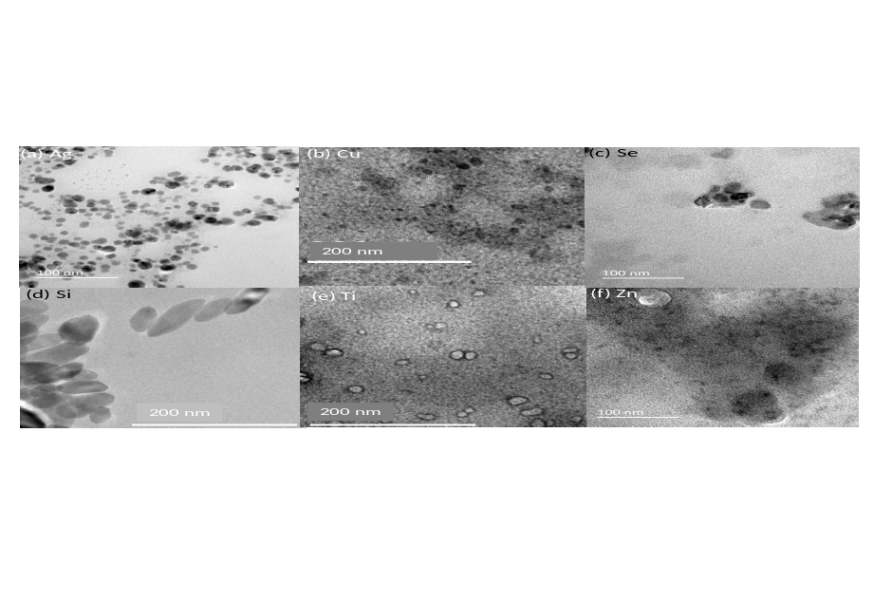
Supplementary Fig. S1 TEM photographs of (a) Ag nanoparticles, (b) CuO nanoparticles, (c) Se nanoparticles, (d) SiO₂ nanoparticles, (e) TiO₂ nanoparticles and (f) ZnO nanoparticles, all biosynthesized by the extract from the fungus Fusarium solani.

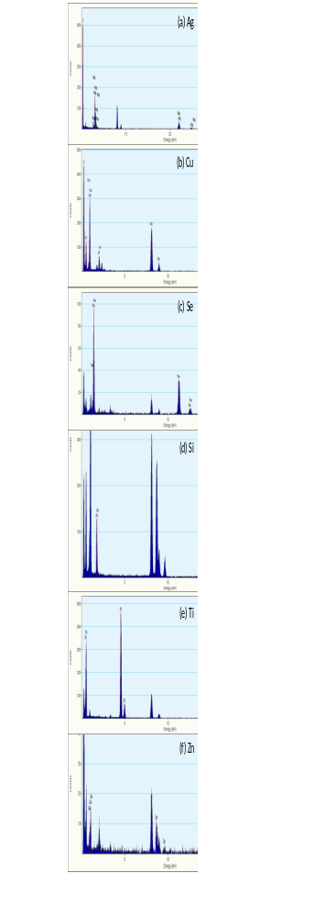 | Supplementary Fig. S2 Energy-dispersive X-ray spectrum (EDX) of (a) Ag nanoparticles, (b) CuO nanoparticles, (c) Se nanoparticles, (d) SiO₂ nanoparticles, (e) TiO₂ nanoparticles and (f) ZnO nanoparticles, all biosynthesized by the extract from the fungus Fusarium solani

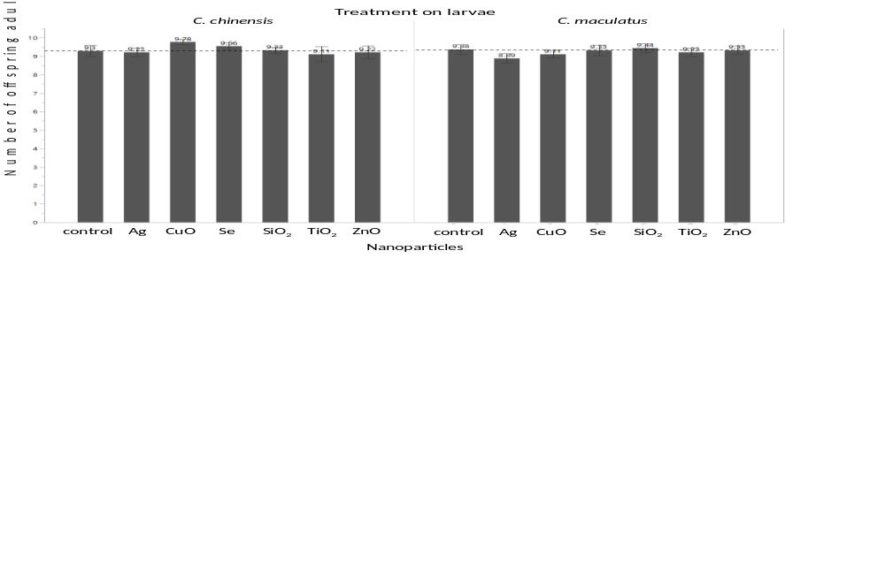
Supplementary Fig. S3 Emerged adults (mean ± SE) of the beetles Callosobruchus chinensis and Callosobruchus maculatus when larvae inside beans were treated with different nanoparticles biosynthesized by the extract from the fungus Fusarium solani. Horizontal broken lines show mean values of the control. The numbers on the bar indicate the mean values.

References

Abd-El-Salam SA, Amal MH, El-Taweelah NM (2015) Aluminum and zinc oxides nanoparticles as a new method for controlling the red flour beetle, Tribolium castaneum (Herbbst) compared to malathion insecticides. J Plant Prot Pathol Mansoura Univ 6(1):129–137.
Al-Dhabi NA, Valan Arasu M (2018) Environmentally-friendly green approach for the production of zinc oxide nanoparticles and their anti-fungal, ovicidal, and larvicidal properties. Nanomaterials 8(7):500
Alif Alisha AS, Thangapandiyan S (2019) Comparative bioassay of silver nanoparticles and malathion on infestation of red flour beetle, Tribolium castaneum. J Basic Appl Zool 80(1):55. doi:10.1186/s41936-019-0124-0
Arumugam G, Velayutham V, Shanmugavel S, Sundaram J (2015) Efficacy of nanostructured silica as a stored pulse protector against the infestation of bruchid beetle, Callosobruchus maculatus (Coleoptera: Bruchidae). Appl Nanosci, 6(3):445–450. doi:10.1007/s13204-015-0446-2
Arunthirumeni M, Veerammal V, Shivakumar MS (2022) Biocontrol Efficacy of Mycosynthesized Selenium Nanoparticle Using Trichoderma sp. on Insect Pest Spodoptera litura. J Cluster Sci 33:1645–1653. doi:10.1007/s10876-021-02095-4
Banu AN, Balasubramanian, C (2014a) Myco-synthesis of silver nanoparticles using Beauveria bassiana against dengue vector, Aedes aegypti (Diptera: Culicidae). Parasitol Res 113(8):2869–2877. https://doi.org/10.1007/s00436-014-3948-z
Banu AN, Balasubramanian C (2014b) Optimization and synthesis of silver nanoparticles using Isaria fumosorosea against human vector mosquitoes. Parasitol Res 113:3843–3851. http://dx.doi.org/10.1007/s00436-014-4052-0.
Debnath N, Das S, Seth D, Chandra R, Bhattacharya SC, Goswami A (2011) Entomotoxic effect of silica nanoparticles against Sitophilus oryzae (L.). J Pest Sci 84(1):99–105. doi:10.1007/s10340-010-0332-3
Devi GD, Murugan K, Panneerselvam C (2014) Green synthesis of silver nanoparticles using Euphorbia hirta (Euphorbiaceae) leaf extract against crop pest of cotton bollworm, Helicoverpa armigera (Lepidoptera:Noctuidae). J Biopestic 7:54–66
El-Saadony MT, Abd El-Hack ME, Taha AE, Fouda MMG, Ajarem JSN, Maodaa S, Elshaer N (2020) Ecofriendly Synthesis and Insecticidal Application of Copper Nanoparticles against the Storage Pest Tribolium castaneum. Nanomaterials 10(3):587. doi:10.3390/nano10030587
El-Samahy MFM, Amal MM, Asmaa Hamza MM, El-Ghobary (2015) A new silica nanoparticles formulation as stored product protectant. Egy J Plant Pro Res 3(2):88–103
Fadl AM, El-Kholy EMS, Abulyazid I, et al. (2021) Radiation-Assisted Green Synthesis and Characterization of Selenium Nanoparticles, and Larvicidal Effects on Culex pipiens complex. J Clust Sci. https://doi.org/10.1007/s10876-021-02174-6
Faliagka S, Germani R, Agrafioti P, Xidas P, Athanassiou CG, Katsoulas N (2021) SiO₂ Applications as an Alternative to Insect Control in Greenhouses. Biol Life Sci Forum 3:32. https://doi.org/10.3390/IECAG2021-09720
Hilal SM, Mohmed AS, Barry NM, Ibrahim MH (2021) Entomotoxicity of TiO₂ and ZnO nanoparticles against adults Tribolium castaneum (Herbest) (Coleoptera: Tenebrionidae). Earth Environ Sci 910: 012088. https://doi.org/10.1088/1755-1315/910/1/012088
Ibrahim SS, Elbehery HH, Samy, (2022) Insecticidal Activity of ZnO NPs Synthesized by Green Method Using Pomegranate Peels Extract on Stored Product Insects. Egypt J Chem 65(4):135–145.
Jafir M, Ahmad JN, Arif MJ, Ali S, Ahmad, SJN (2021) Characterization of Ocimum basilicum synthesized silver nanoparticles and its relative toxicity to some insecticides against tobacco cutworm, Spodoptera litura Feb. (Lepidoptera; Noctuidae). Ecotoxicol Environ Saf 218:112278. https://doi.org/10.1016/j.ecoenv.2021.112278.
Jayaseelan C, Rahuman AA, Rajakumar G, Vishnu Kirthi A, Santhoshkumar T, Marimuthu S, Elango G (2011) Synthesis of pediculocidal and larvicidal silver nanoparticles by leaf extract from heartleaf moonseed plant, Tinospora cordifolia Miers. Parasitol Res 109(1):185–194. https://doi.org/10.1007/s00436-010-2242-y
López-García GP, Buteler M, Stadler T (2018) Testing the insecticidal activity of nanostructured alumina on Sitophilus oryzae (L.) (Coleoptera: Curculionidae) under laboratory conditions using galvanized steel containers. Insects 9:87. https://doi.org/10.3390/insects9030087.
Madhiyazhagan P, Murugan K, Kumar AN, Nataraj T, Dinesh D, Panneerselvam C, Benelli GS (2015) Argassum muticum-synthesized silver nanoparticles: An effective control tool against mosquito vectors and bacterial pathogens. Parasitol Res 114(11):4305–4317. https://doi.org/10.1007/s00436-015-4671-0
Malaikozhundan B, Vinodhini J (2018) Nanopesticidal effects of Pongamia pinnata leaf extract coated zinc oxide nanoparticle against the Pulse beetle, Callosobruchus maculatus. Mater Today Commun 14:106–115, https://doi.org/10.1016/j.mtcomm.2017.12.015
Malaikozhundan B, Vaseeharan B, Vijayakumar S, Thangaraj MP (2017) Bacillus thuringiensis coated zinc oxide nanoparticle and its biopesticidal effects on the pulse beetle, Callosobruchus maculatus. J Photochem Photobiol B: Biol 174:306–314. doi:10.1016/j.jphotobiol.2017.08.014
Moorthi PV, Balasubramanian, C, Mohan S (2015). An Improved Insecticidal Activity of Silver Nanoparticle Synthesized by Using Sargassum muticum. Appl Biochem Biotechnol 175(1):135–140. doi:10.1007/s12010-014-1264-9
Narayanan M, Vigneshwari P, Natarajan D, Kandasamy S, Alsehli M, Elfasakhany A, Pugazhendhi A (2021) Synthesis and characterization of TiO2 NPs by aqueous leaf extract of Coleus aromaticus and assess their antibacterial, larvicidal, and anticancer potential. Environ Res 200:111335. doi:10.1016/j.envres.2021.111335
Prabakaran K, Ragavendran, C, Natarajan D (2016) Mycosynthesis of silver nanoparticles from Beauveria bassiana and its larvicidal, antibacterial, and cytotoxic effect on human cervical cancer (HeLa) cells. RSC Adv 6(51):44972–44986. https://doi.org/10.1039/C6RA08593H.
Rahman MA, Parvin A, Khan MSH., War AR, Lingaraju K, Prasad R, Bhattacharyya A (2021) Efficacy of the green synthesized nickel-oxide nanoparticles against pulse beetle, Callosobruchus maculatus (F.) in black gram (Vigna mungo L.). Int J Pest Manag 67(4):306–314. https://doi.org/10.1080/09670874.2020.1773572
Rajkumar V, Gunasekaran C, Paul CA, Dharmaraj J (2020) Development of encapsulated peppermint essential oil in chitosan nanoparticles: characterization and biological efficacy against stored-grain pest control. Pesticide Biochem Physiol 170:104679. doi:10.1016/j.pestbp.2020.104679
Roni M, Murugan K, Panneerselvam C, Subramaniam J, Nicoletti M, Madhiyazhagan P, Benelli G (2015) Characterization and biotoxicity of Hypnea musciformis-synthesized silver nanoparticles as potential eco-friendly control tool against Aedes aegypti and Plutella xylostella. Ecotoxicol Environ Saf 121:31–38. https://doi.org/10.1016/j.ecoenv.2015.07.005
Rouhani M, Samih A, Kalantari S (2013) Insecticidal effect of silica and silver nanoparticles on the cowpea seed beetle, Callosobruchus maculatus F. (Col.: Bruchidae). J Entomol Res 4:297–305
Rouhani M, Samih A, Zarabi M, Beiki K, Gorji M, Aminizadeh MR (2019) Synthesis and entomotoxicity assay of zinc and silica nanoparticles against Sitophilus granarius (Coleoptera: Curculionidae). J Plant Prot Res 59:26–31
Sankar MV, Abideen S (2015) Pesticidal effect of green synthesized silver and lead nanoparticles using Avicennia marina against grain storage pest Sitophilus oryzae. Int J Nanomat Biostruct 5(3), 32–39.
Selvan SM, Anand KV, Govindaraju K, Tamilselvan S, Kumar VG, Subramanian KS, Kannan M, Raja K (2018) Green synthesis of copper oxide nanoparticles and mosquito larvicidal activity against dengue, zika and chikungunya causing vector Aedes aegypti. IET Nanobiotech 12:1042-1046, https://doi.org/10.1049/iet-nbt.2018.5083
Shahzadi K, Bashir F, Nazir K, Seemab S, Shaker MAA, Waheed I, Shehzaib A, Fatima K (2019) Impacts of green synthesized silver-nanoparticles against Tribolium castaneum (Coleoptera: Tenebrionidae). Int J Entomol Res 4(6):114–117
Stadler T, Garcia GPJ, Gitto JG, Buteller M (2017) Nanostructured alumina: Biocidal properties and mechanism of action of a novel insecticide powder. Bull Insectol 70 (1):17–25.
Sundaravadivelan C, Padmanabhan MN (2014) Effect of mycosynthesized silver nanoparticles from filtrate of Trichoderma harzianum against larvae and pupa of dengue vector Aedes aegypti L. ESPR 21(6):4624-4633. https://doi.org/10.1007/s11356-013-2358-6.
Velu K, Elumalai D, Hemalatha P, Janaki A, Babu M, Hemavathi M, Kaleena, PK (2015) Evaluation of silver nanoparticles toxicity of Arachis hypogaea peel extracts and its larvicidal activity against malaria and dengue vectors. ESPR 22(22):17769–17779. https://doi.org/10.1007/s11356-015-4919-3.
Zahir AA, Rahuman AA (2012) Evaluation of different extracts and synthesised silver nanoparticles from leaves of Euphorbia prostrata against Haemaphysalis bispinosa and Hippobosca maculata. Vet Parasitol 187(3-4):511–520. https://doi.org/10.1016/j.vetpar.2012.02.001

