Extended Data
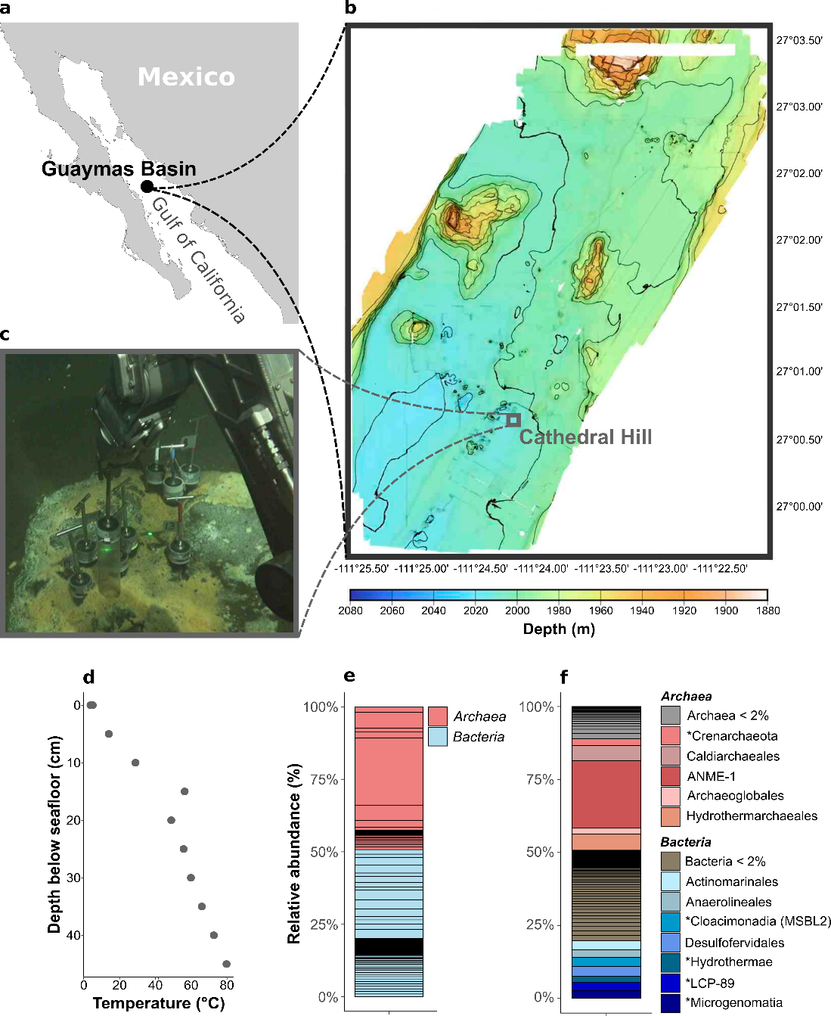
Extended Data Figure 1 | Sampling site in the Guaymas Basin and microbial community in the original sediment slurry. a, Location of the Guaymas Basin in the Gulf of California. b, Bathymetry of the southern end of the Southern Trough of the Guaymas Basin with the location of the Cathedral Hill hydrothermal vent area. c, Sampling of the push core that was used for anoxic cultivations in an area densely covered by orange sulfur-oxidizing Beggiatoa mats. d, Depth-temperature profile in the sampling site. The temperature was measured using Alvin’s heatflow probe. Push cores reached about 30 cm into the sediment, where the temperature approached about 60°C (sampling site photograph and temperature data courtesy of the Woods Hole Oceanographic Institution, from RV Atlantis cruise AT42-05). e,f, Microbial community in the anoxic sediment slurry prepared from core 4991-15 before anoxic incubations based on 16S fragments recruited from the metagenome. e, On the domain level, archaea and bacteria each make up around 50%. f, Taxonomic groups on order level. For groups with unknown order assignment marked with *, the next known higher taxonomic levels are indicated. An ANME-1 group is abundant within the archaeal fraction while the bacterial fraction is very diverse.
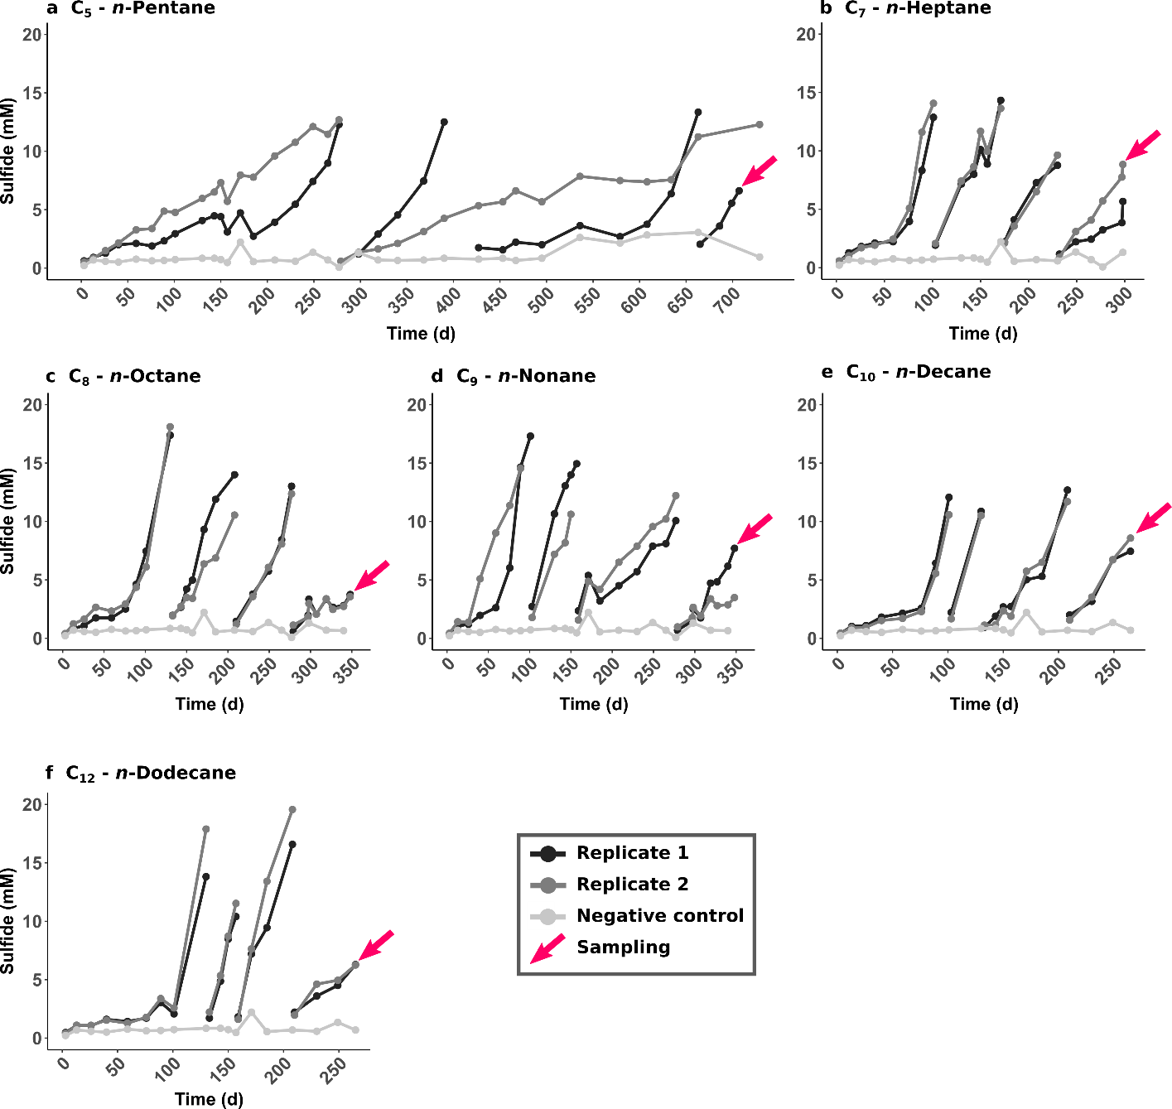
Extended Data Figure 2 | Sulfide production in anaerobic C₅-C₁₂ n-alkane-degrading cultures at 70°C up to the third dilution. Each culture was set up as a duplicate, with the replicates indicated by light and dark blue lines. Gaps in sulfide level indicate dilution steps. Pink arrows indicate sulfide levels at which samples for metagenome and -transcriptome sequencing were taken. The gray line corresponds to a negative control consisting of a sediment slurry without added substrate.
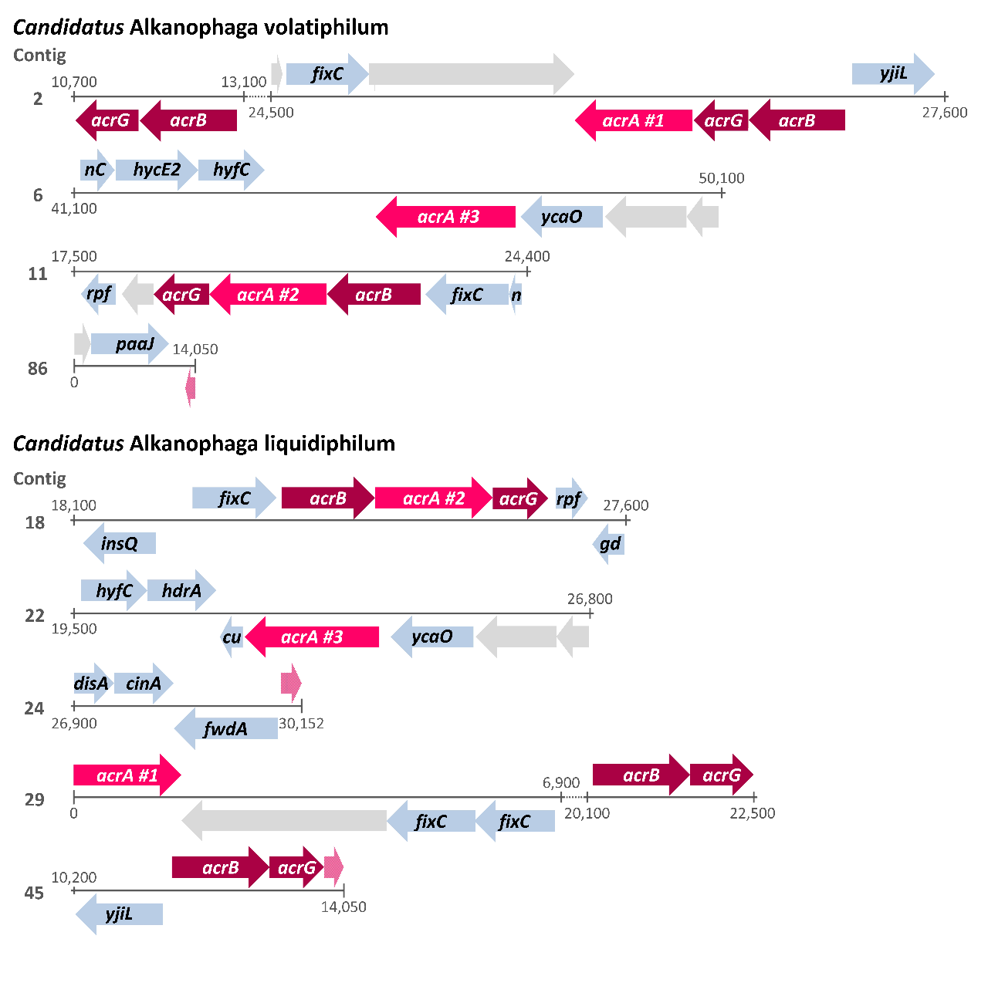
Extended Data Figure 3 | Organization of acr genes in Candidatus Alkanophaga MAGs. Partial acrA genes are shown in light pink. Unannotated genes are depicted in light gray. Some gene names were shortened to fit the arrows. Genes: acrA: alkyl-coenzyme M reductase, alpha subunit; acrB: alkyl-coenzyme M reductase, beta subunit; acrG: alkyl-coenzyme M reductase, gamma subunit; fixC: dehydrogenase (flavoprotein); yjiL: Activator of 2-hydroxyglutaryl-CoA dehydratase (HSP70-class ATPase domain); nC: nuoC- NADH:ubiquinone oxidoreductase 27 kD subunit (chain C); hycE2: Ni,Fe-hydrogenase III large subunit; hyfC: formate hydrogenlyase; ycaO: ribosomal protein S12 methylthiotransferase accessory factor; rpf: rpf1-rRNA maturation protein; n: nuoI-formate hydrogenlyase subunit 6/NADH:ubiquinone oxidoreductase 23 kD subunit (chain I); paaJ: acetyl-CoA acetyltransferase; insQ: transposase; gd: gdb1-glycogen debranching enzyme (alpha-1,6-glucosidase); hdrA: heterodisulfide reductase, subunit A (polyferredoxin); cu: cutA1-divalent cation tolerance protein; disA: c-di-AMP synthetase; cinA: ADP-ribose pyrophosphatase domain of DNA damage- and competence-inducible protein CinA; fwdA: formylmethanofuran dehydrogenase subunit A.
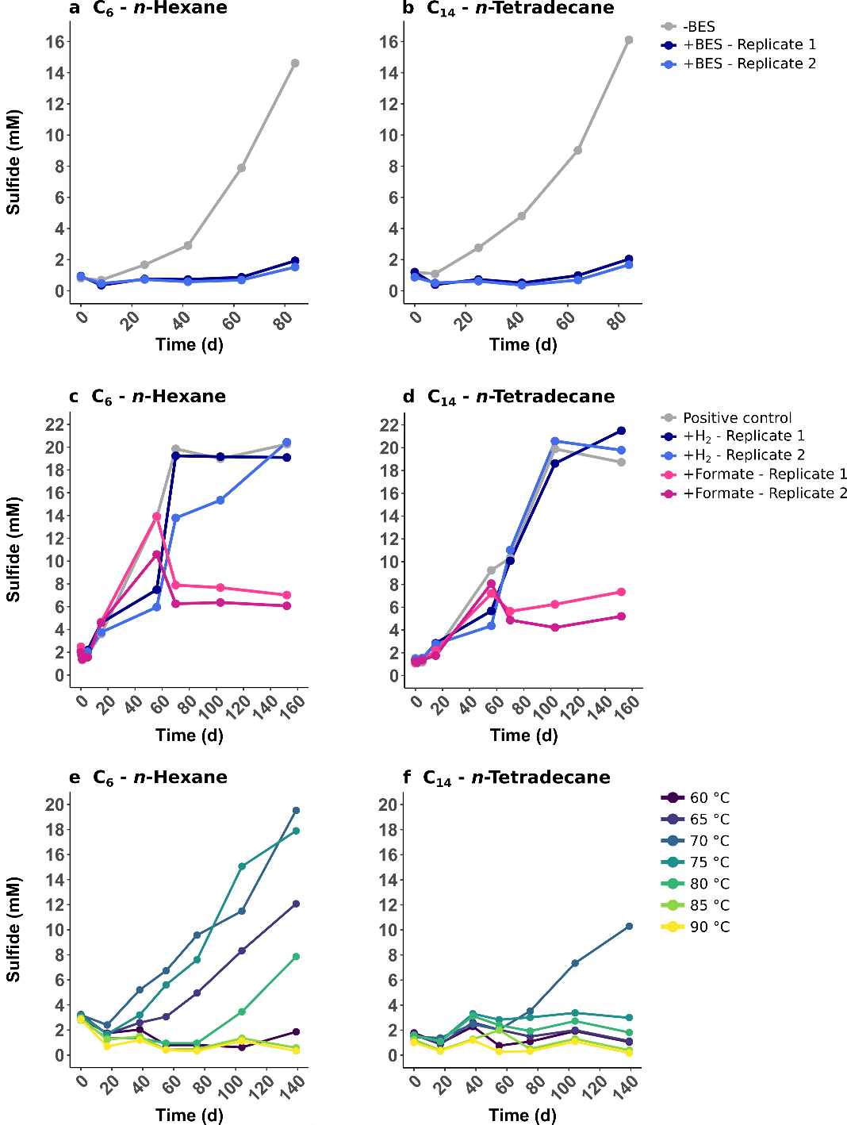
Extended Data Figure 4 | Sulfide production in n-hexane (C₆)- and n-tetradecane (C₁₄)-degrading cultures under different conditions. a,b, Treatment with bromoethanosulfonate (BES). BES (5 mM final concentration) was added to two replicates of C₆- and C₁₄-cultures (+BES). A control culture (-BES) did not receive BES. The inhibition of alkane oxidation by BES, an analogue to coenzyme M, corroborates an ACR-based substrate activation. c,d, Addition of hydrogen or formate. All cultures were supplied with the original substrate. The addition of 10% H₂ into the headspace or 10 mM sodium formate into the medium did not accelerate sulfide production compared to the positive controls. e,f, Incubation at temperatures between 60°C and 90°C. The C₆-degrading culture grows optimally at 70°C and 75°C, while it still shows some activity at slightly lower (65°C) and slightly higher (80°C) temperatures. The activity of the C₁₄-degrading culture seems to be limited to 70°C.
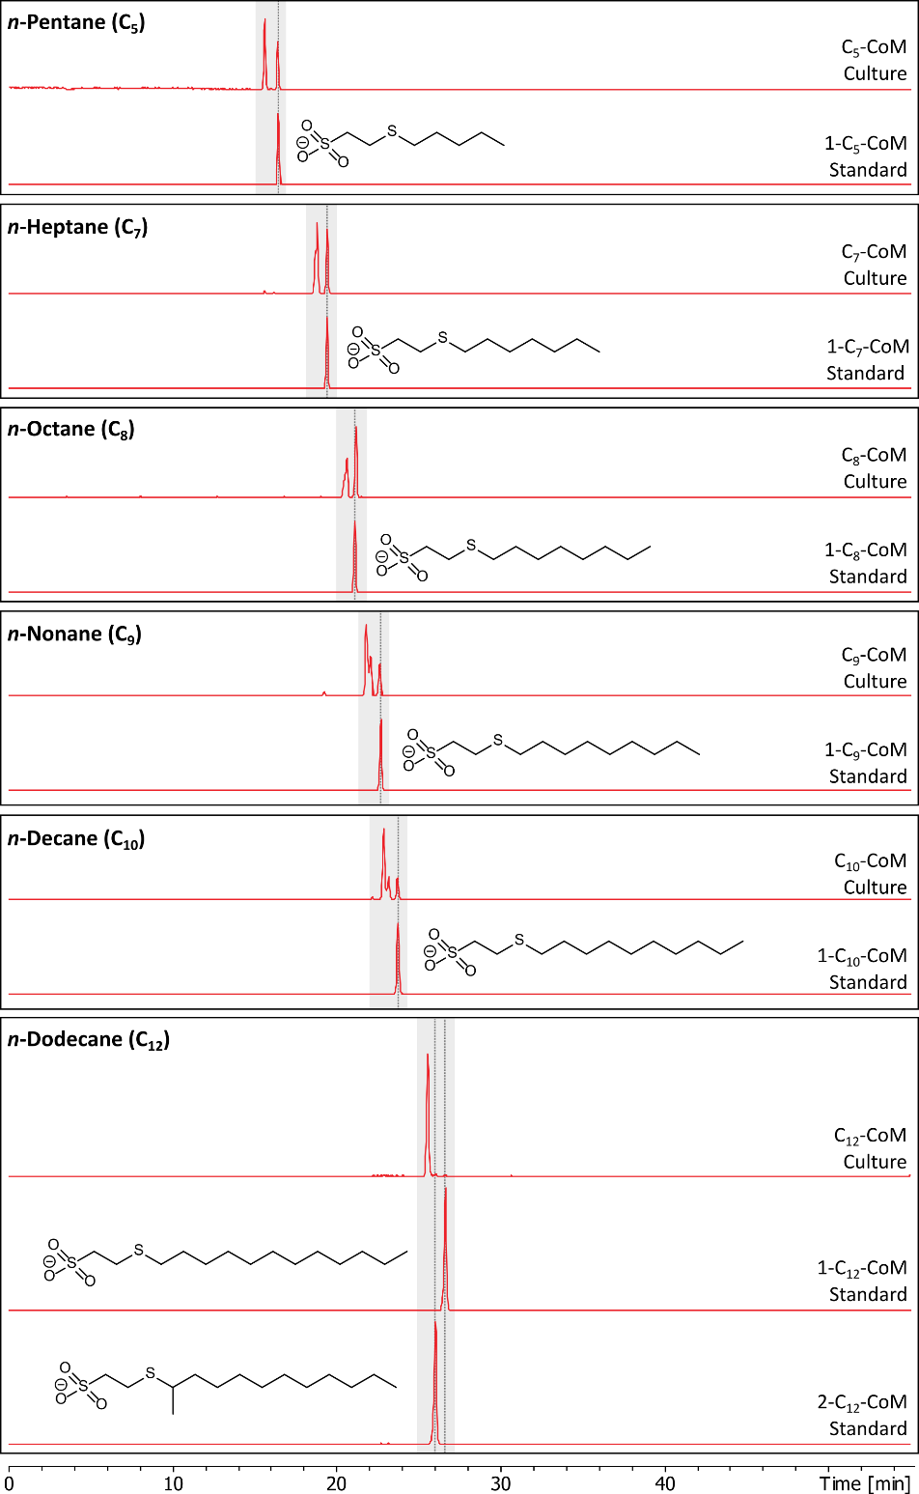
Extended Data Figure 5 | Detection of alkyl-CoM derivates in n-alkane-degrading cultures. Alkyl-CoM derivates were separated by liquid chromatography and extracted ion chromatograms (EICs) based on the exact mass of deprotonated ions and a window of ±10 mDa were created. Masses used for creation of EICs are: C₅-CoM: m/z 211.0468; C₇-CoM: m/z 239.0781; C₈-CoM: m/z 253.0938; C₉-CoM: m/z 267.1094; C₁₀-CoM: m/z 281.1251; C₁₂-CoM: m/z 309.1564. Panels show detection of alkyl-CoM in culture extracts together with corresponding synthetic standards. Peaks with mass-to-charge ratios corresponding to the alkyl-CoMs were detected in all cultures. All culture extract analyses show several peaks, corresponding to the activation at different carbon atoms. While the shorter alkanes are activated at the first and most likely the second and third carbon, longer alkanes are predominantly activated at non-terminal carbon atoms.
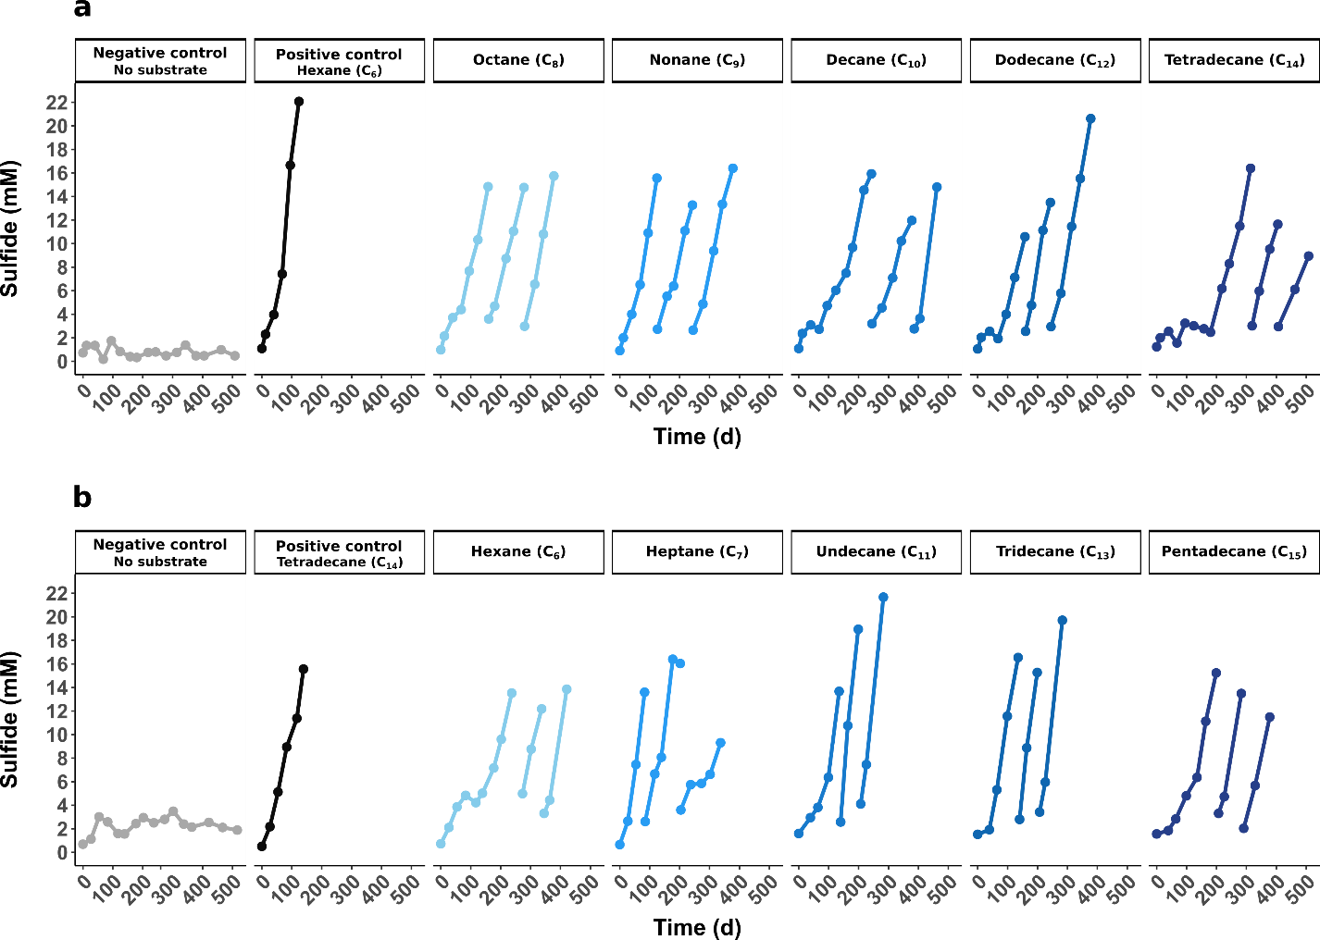
Extended Data Figure 6 | Substrate spectra of originally (a) n-hexane- and (b) n-tetradecane-oxidizing enrichment cultures. The cultures were diluted into fresh sulfate-reducer medium and supplemented with other n-alkanes between C₃ and C₂₀. Only active cultures are shown. No activity was observed for cultures supplied with C₃, C₄, C₁₆, C₁₈, or C₂₀.
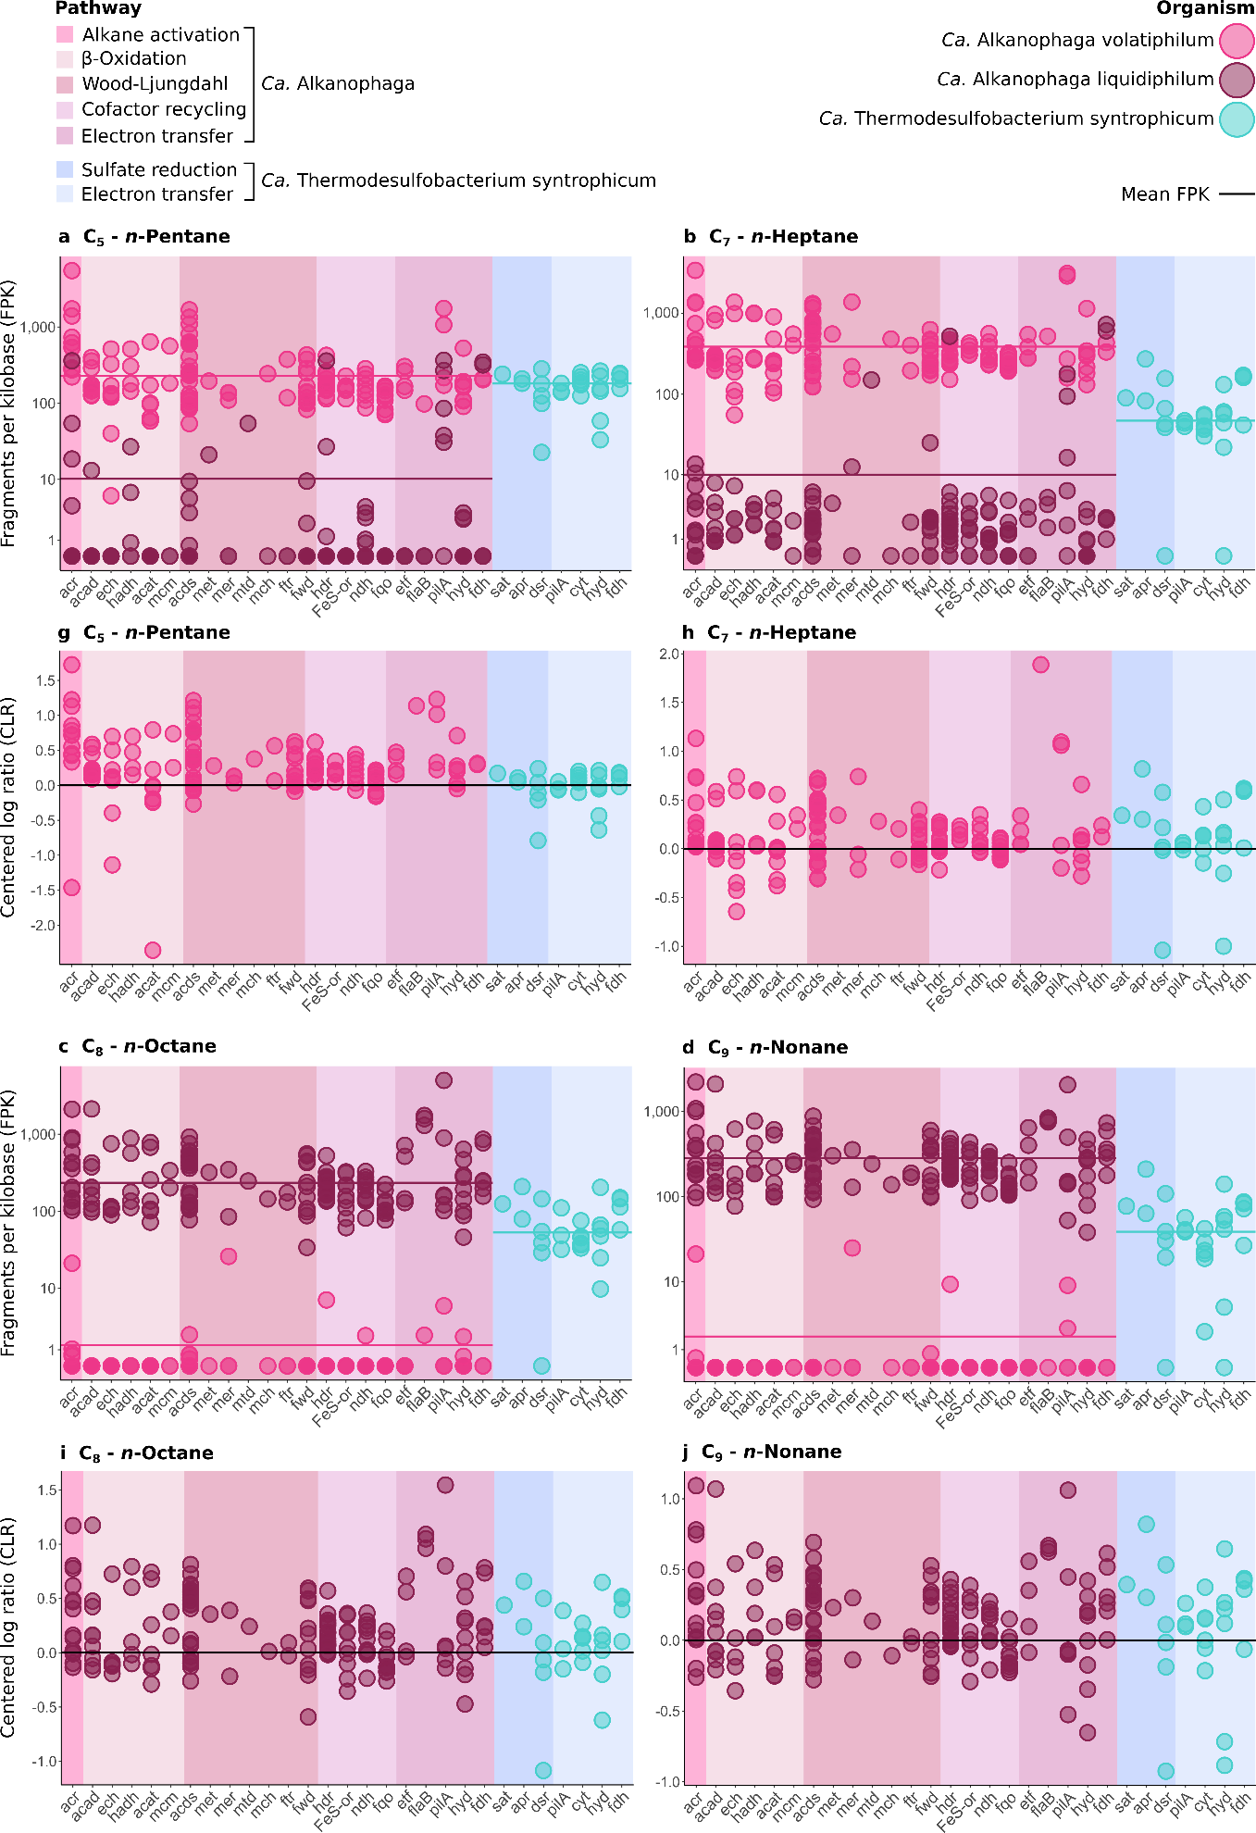
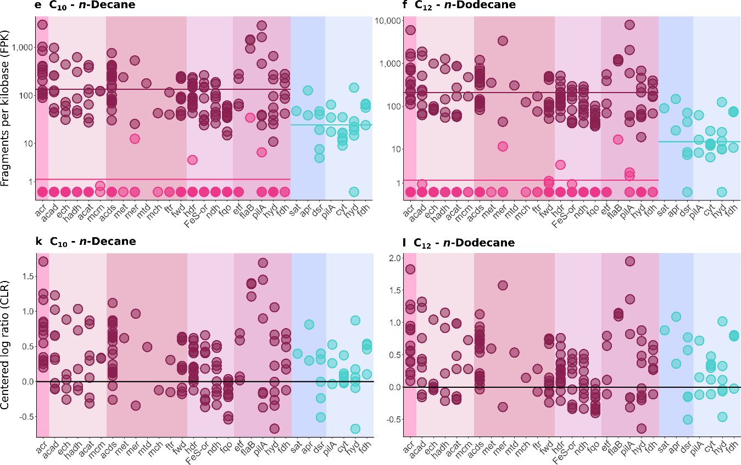
Extended Data Figure 7: Expression of alkane oxidation, sulfate reduction, and related genes in C₅-C₁₂ n-alkane-oxidizing cultures. Transcriptome reads were mapped to the MAGs of the two Candidatus Alkanophaga species and to Ca. Thermodesulfobacterium syntrophicum. a-f, Fragment counts normalized to gene length (fragments per kilobase - FPK) using a logarithmic y axis. The mean FPK value is indicated as a horizontal line in the color belonging to the corresponding organism. g-l, Fragment counts normalized as centered log ratio (CLR). Only the values of the more active Ca. Alkanophaga species are depicted. The x-axis shows the following genes: acr: alkyl-CoM reductase, acad: acyl-CoA dehydrogenase, ech: enoyl-CoA hydratase, hadh: hydroxyacyl-CoA dehydrogenase, acat: acetyl-CoA acetyltransferase, mcm: methylmalonyl-CoA mutase, acds: acetyl-CoA decarbonylase/synthase, met: 5,10-methylene tetrahydrofolate reductase, mer: 5,10-methylene tetrahydromethanopterin (H₄MPT) reductase, mtd: methylene-H₄MPT dehydrogenase, mch: methenyl-H₄MPT cyclohydrolase, ftr: formylmethanofuran-H₄MPT formyltransferase, fwd: tungsten-containing formylmethanofuran dehydrogenase, hdr: heterodisulfide reductase, FeS-or: [FeS]-oxidoreductase, ndh: NADH dehydrogenase, fqo: F₄₂₀H₂:quinone oxidoreductase, etf: electron transfer flavoprotein, flaB: flagellin B, pilA: type IV pilin, hyd: [NiFe]-hydrogenase, fdh: formate dehydrogenase, sat: ATP-sulfurylase, apr: APS-reductase, dsr: dissimilatory sulfite reductase, cyt: multi-heme c-type cytochrome.

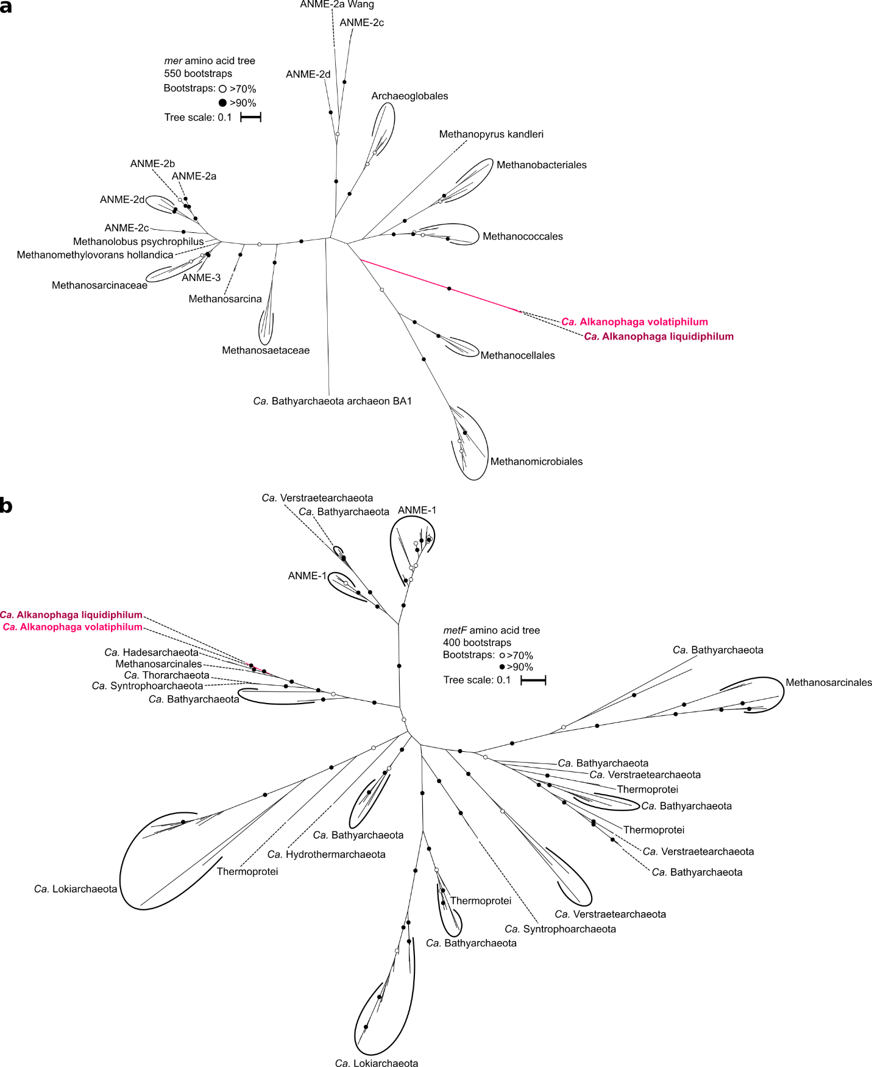
Extended Data Figure 8 | Phylogenetic placement of (a) 5,10-methylene-H₄MPT reductase (mer) and (b) methylenetetrahydrofolate reductase (metF) sequences recovered from Ca. Alkanophaga MAGs.
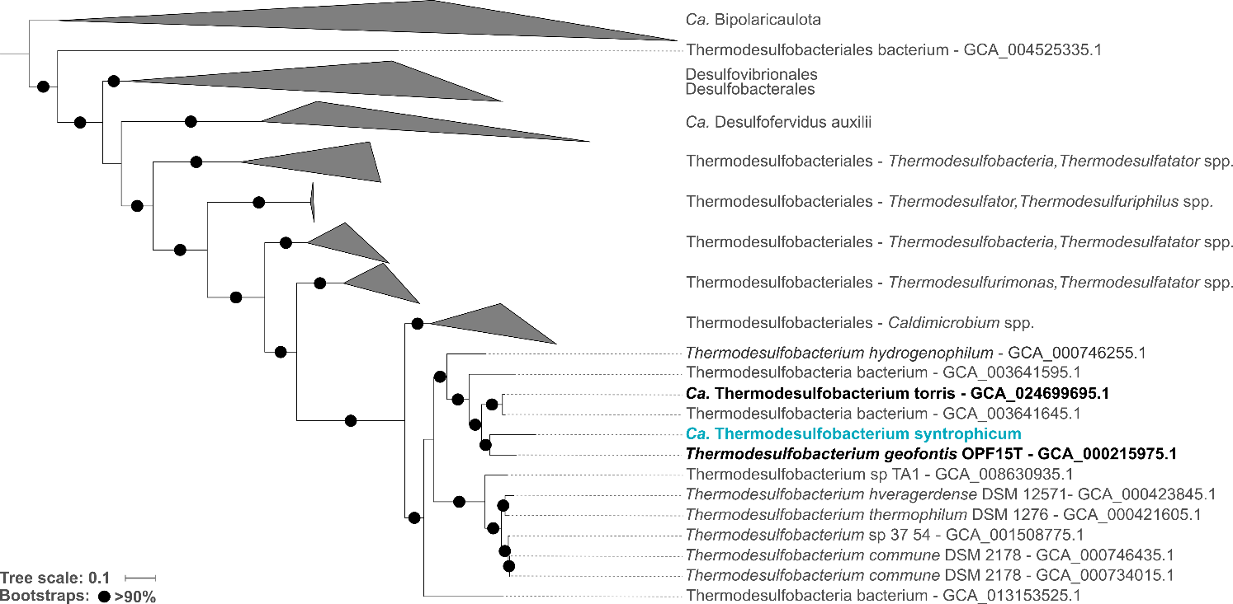
Extended Data Figure 9 | Phylogenomic placement of Candidatus Thermodesulfobacterium syntrophicum based on the concatenated alignment of 71 bacterial single copy core genes. Ca. T. syntrophicum is closely related to the already cultured Thermodesulfobacterium geofontis (OPF15T) and to Ca. Thermodesulfobacterium torris, which functions as partner bacterium in the thermophilic anaerobic oxidation of methane. The outgroup consists of members of the candidate phylum Bipolauricaulota. The tree scale bar indicates 10% sequence divergence.
Extended Data Table 1 | Properties of metagenome-assembled genomes (MAGs) of Candidatus Alkanophaga and Ca. Thermodesulfobacterium syntrophicum. Completeness, redundancy, and strain heterogeneity were calculated with CheckM. All other statistics were extracted with anvi’o.
 | Candidatus Alkanophaga volatiphilum (MAG 4) | Candidatus  Alkanophaga liquidiphilum (MAG 1) | Candidatus Thermodesulfobacterium syntrophicum (MAG 24)
Size (base pairs) | 1,850,367 | 1,914,207 | 1,624,405
Contigs | 89 | 89 | 12
Contig N50 (bp) | 41,546 | 37,182 | 232,863
GC content (%) | 52.17 | 50.51 | 32.40
Genes | 1,909 | 1,995 | 1,666
16S rRNAs | 2 | 1 | 1
23S rRNAs | 2 | 1 | 2
Completeness (%) | 89.71 | 91.83 | 98.75
Redundancy (%) | 1.31 | 0.65 | 1.67
Strain heterogeneity (%) | 0 | 0 | 0
Extended Data Table 2 | Clusters of acrA sequences in Candidatus Alkanophaga MAGs and their amino acid identity, as well as similarity to acrAs of Ca. Syntrophoarchaeales as indicated by BLASTp.
acrA # | MAG 4 Gene ID | MAG 1 Gene ID | Amino acid identity (%) | Closest related acrA from  Ca. Syntrophoarchaeaum  caldarius (identity [%]) | Closest related acrA from  Ca. Syntrophoarchaeaum  butanivorans (identity [%])
1 | 174 | 1375 | 89.15 | OFV67773.1 (≥ 63) | OFV65760.1 (≥ 66)
2 | 814 | 1019 | 94.95 | OFV68281.1 (≥ 59) | OFV65745.1 (≥ 60)
3 | 514 | 1178 | 90.24 | OFV67773.1 (≥ 40) | OFV67021.1 (≥ 57)
Extended Data Table 3 | Comparison of genomic and metabolic features of Candidatus Alkanophaga with their close relatives ANME-1 and Ca. Syntrophoarchaeum of the class Syntrophoarchaeia. Filled green rectangles indicate presence, while red rectangles indicate absence. mcrA: alpha subunit of methyl-coenzyme M reductase; acrA: alpha subunit of alkyl-coenzyme M reductase; mer: 5,10-methylene-H₄MPT reductase; metF: methylenetetrahydrofolate reductase.
 | Canonical mcrA | acrA  (# copies) | Multi-heme cytochromes | mer | metF | n-alkane substrate(s)
Ca. Alkanophaga |  | (3) |  |  |  | Pentane (C₅) - Tetradecane (C₁₄)
ANME-1 |  |  |  |  |  | Methane (C₁)
Ca. Syntrophoarchaeum |  | (4) |  |  |  | Propane (C₃), Butane (C₄)

