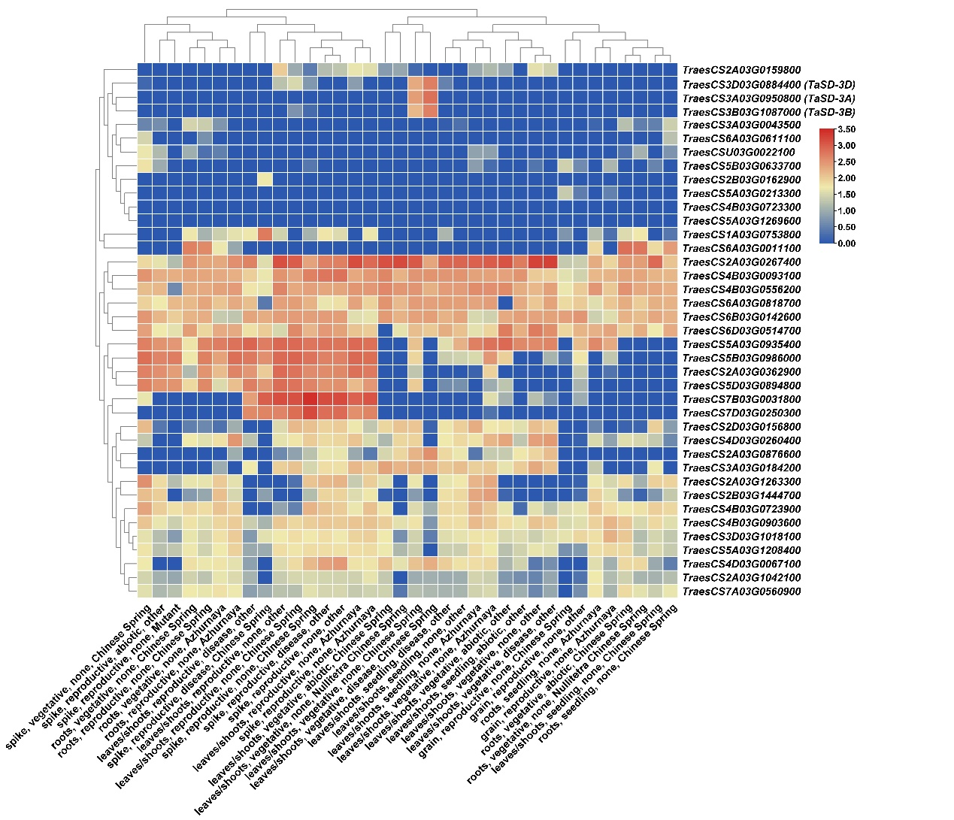
Figure S1 The expression patterns of candidate genes from the expVIP database. Gene ID was retrieved from the IWGSC RefSeq V2.1. Blue and red rectangles indicate low and high expression levels of candidate genes, respectively.

