SUPPLEMENTARY MATERIAL

Model components are scored as shown in the following tables:
CRB score[1]
Variables | Puntos | Comentarios
Mental confusion | 1
Tachypnea > 30 rpm | 1
Arterial hypotension | 1 | Systolic < 90 mmHg or diastolic =< 60 mmHg

Age-Adjusted Charlson index[2]
Variable | Points | Comments
Myocardial infarction | 1 | One or more previous AMI
Congestive heart failure | 1
Peripheral vascular disease | 1 | Including aortic aneurysm (diameter > 6 cm)
Cerebrovascular disease or transient ischemic attack | 1 | With minor or no sequelae
Dementia | 1 | -
Chronic obstructive pulmonary disease | 1 | -
Connective tissue disease | 1 | -
Peptic ulcer disease | 1 | -
Mild liver disease | 1 | Chronic hepatitis or cirrhosis without portal hypertension
Uncomplicated diabetes | 1 | -
Hemiplegia | 2 | Hemiplegia or paraplegia from any cause, including cerebrovascular disease
Moderate to severe chronic kidney disease | 2 | Severe: with dialysis, transplanted or uremia.  Moderate: creatinine > 0.27 mmol/L.
Diabetes with end-organ damage | 2 | -
Localized solid tumor | 2 | -
Leukemia | 2 | including chronic and polycythemia vera
Lymphoma | 2 | including mieloma
Moderate to severe liver disease | 3 | Cirrhosis with portal hypertension
Metastatic solid tumor | 6 | -
AIDS | 6
Age | 1 point for every decade starting at 50 años, until >= 80: 0 point if age =< 49 years, 1 point from 50 to 59, … , until 4 points if >=80.

Baseline SpO₂
Baseline SpO₂ < 90% | 1

Figure S1. Daily flow of patients: admissions, discharges, hospitalised. First wave COVID-19 pandemic. HUVV.

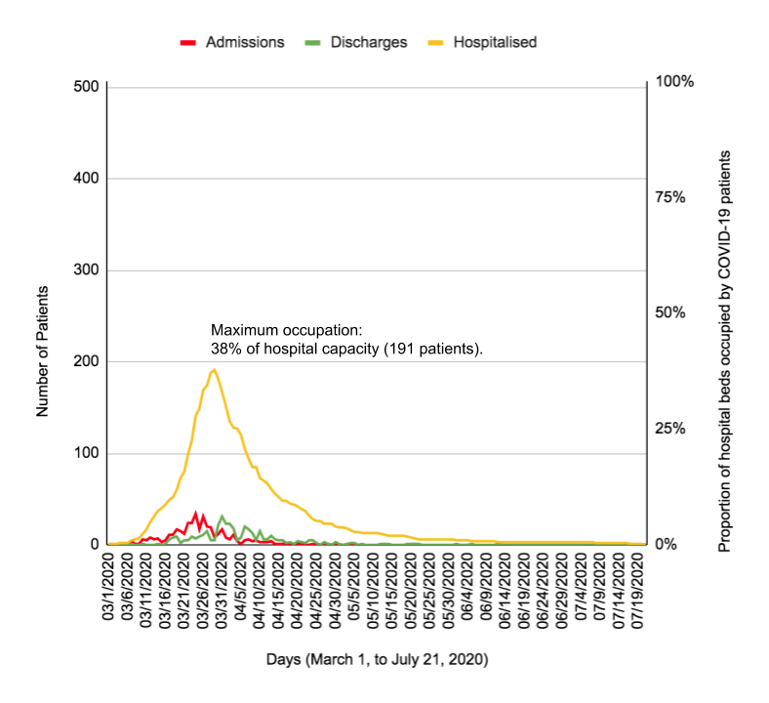

Table S1. Multivariate model for the prediction of severe disease; with the same variables of the Clinical Model (Charlson-Age, CRB and SPO2) plus the two laboratory variables that are statistically significant: high CRP and LDH.

 |  |  |  | 95%CI for OR
 | B | Sig | OR | Lower | Upper
Charlson-Age | 0.252 | <0.001 | 1.287 | 1.153 | 1.436
CRB | 1.192 | <0.001 | 3.295 | 1.710 | 6.350
Baseline SpO2 < 90% | 1.636 | <0.001 | 5.132 | 2.512 | 10.487
CRP | 1.527 | 0.053 | 4.603 | 0.977 | 21.677
LDH | 0.748 | 0.029 | 2.113 | 1.080 | 4.134
Constant | -4.549 | <0.001 | 0.011

Figure S2: ROC Curve of the clinical-analytical predictive model of severe disease.
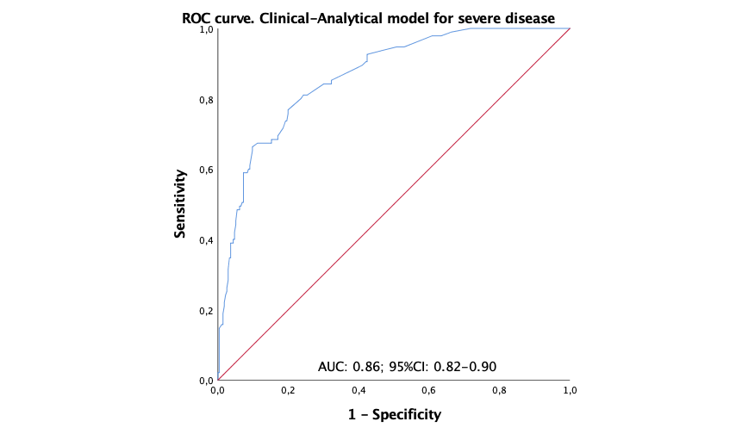

Table S2. Multivariate model for prediction of death, with the same variables of the Clinical Model (Charlson-Age, CRB and SPO2) plus the two laboratory variables that are also statistically significant: high LDH and lymphocyte count.
 | B | Sig. | OR | 95%CI OR
 |  |  |  | Lower | Upper
Charlson-Age | 0.405 | <0.001 | 1.500 | 1.285 | 1.751
CRB | 1.094 | 0.002 | 2.988 | 1.498 | 5.959
Baseline SpO2 < 90% | 1.486 | <0,001 | 4.418 | 1.991 | 9.802
Lymphocytes (x10²/mL) | -0.079 | 0.036 | 0.924 | 0.858 | 0.995
LDH | 1.117 | 0.028 | 3.055 | 1.130 | 8.261
Constant | -4.420 | <0.001 | 0.012

Figure S3. ROC curve. Clinical-Analytical model for mortality prediction
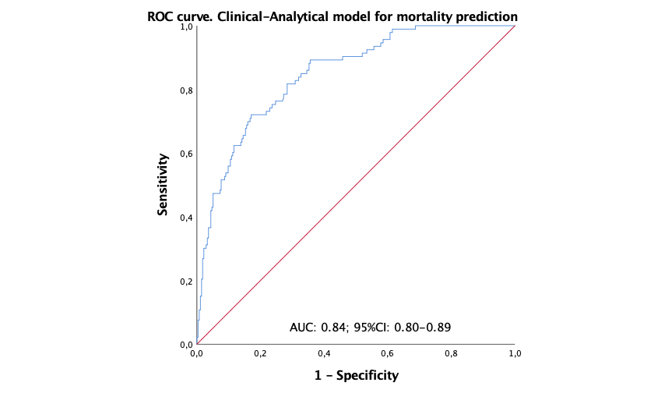

How to calculate the probability of an outcome for a specific patient.

- Numerically

For any specific patient, the expected probability of developing the outcome can be calculated from the equation of the multivariate model. In the model equation

$$Ln\left(\frac{p}{1 - p}\right)=Constant + {β_{Charlson-Age}×CharlsonAge + {β_{CRB}×CRB + {β_{SpO2}×{SpO}_{2} }_{}}_{}}_{}$$

First substitute "Charlson-Age", "CRB" and "SpO2" by the values of the patient, and Constant and 𝛃 coefficients by their respective values from the tables of the model (Table 6 of severe disease, or Table 7 for death), then clearing the p.

Example 1. A patient of 48 years without comorbidity, that getting to the emergency room is oriented without tachypnea nor hypotension, and has a SpO2 of 95%, has 0 points in all predictors (Charlson-Age, CRB and SpO2), the expected probability of developing severe illness or death is:

$$p_{Severe Disease} =\frac{{ e}^{-2.676 + 0.253×0 + 1.427×0 + 1.866×0 }}{1 +{ e}^{-2.676 + 0.253×0 + 1.427×0 + 1.866×0 }}=6.4\%$$

$$p_{Death} =\frac{{ e}^{-4.609 + 0.424×0 + 1.091×0 + 1.636×0 }}{1 +{ e}^{-4.609 + 0.424×0 + 1.091×0 + 1.636×0 }}=0.9\%$$

Example 2. The average patient in the series has 2 points in Charlson-Age, and 0 in CRB scale and SpO2, so the expected probability of severe illness is 10%, and of dying 2%.

$$p_{Severe Disease} =\frac{{ e}^{-2,676 + 0,253×2 + 1,427×0 + 1,866×0 }}{1 +{ e}^{-2,676 + 0,253×2 + 1,427×0 + 1,866×0 }}=10,2\%$$

$$p_{Death} =\frac{{ e}^{-4,609 + 0,424×2 + 1,091×0 + 1,636×0 }}{1 +{ e}^{-4,609 + 0,424×2 + 1,091×0 + 1,636×0 }}=2,2\%$$

- Graphically, with nomograms

With the following nomograms, we could calculate a particular patient's probability for developing severe disease or eventually die. Firstly, translate the punctuation of the two scores and pulse oximetry to risk points in the upper axis (labelled ‘Points’), then sum them up (axis labelled 'Total Points'), and finally, look for the risk corresponding to that total in the lower axis ('Risk of …).

  - Nomogram to calculate the risk of developing disease
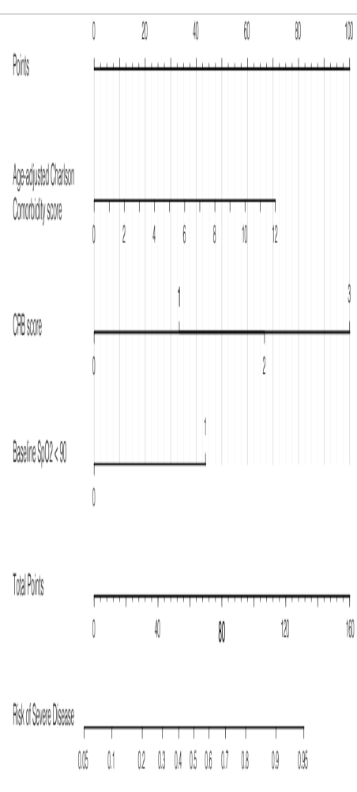

  - Nomogram to calculate the risk of death

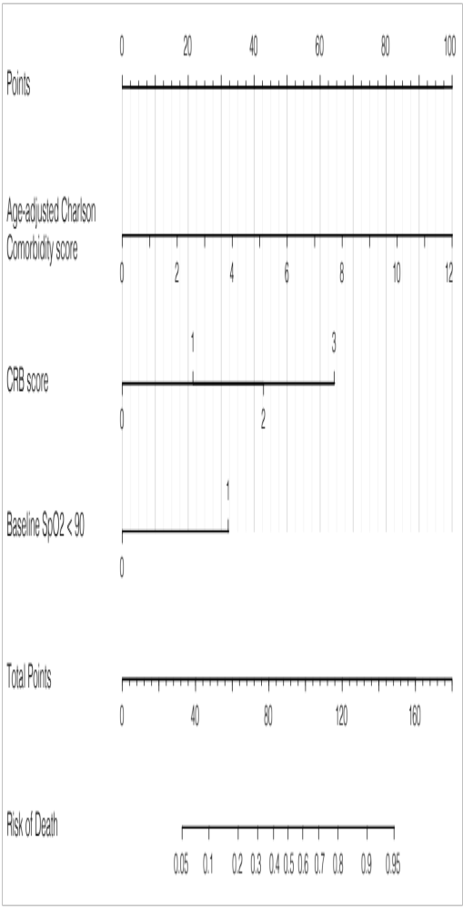

TRIPOD Checklist: Prediction model development.[3]
Section/Topic | Item | Checklist Item | Page
Title and abstract
Title | 1 | Identify the study as developing and/or validating a multivariable prediction model, the target population, and the outcome to be predicted. | 1
Abstract | 2 | Provide a summary of objectives, study design, setting, participants, sample size, predictors, outcome, statistical analysis, results, and conclusions. | 2
Introduction
Background and objectives | 3a | Explain the medical context (including whether diagnostic or prognostic) and rationale for developing or validating the multivariable prediction model, including references to existing models. | 3
Background and objectives | 3b | Specify the objectives, including whether the study describes the development or validation of the model or both. | 3
Methods
Source of data | 4a | Describe the study design or source of data (e.g., randomized trial, cohort, or registry data), separately for the development and validation data sets, if applicable. | 3
Source of data | 4b | Specify the key study dates, including start of accrual; end of accrual; and, if applicable, end of follow-up. | 3
Participants | 5a | Specify key elements of the study setting (e.g., primary care, secondary care, general population) including number and location of centres. | 3
Participants | 5b | Describe eligibility criteria for participants. | 3
Participants | 5c | Give details of treatments received, if relevant. | NA
Outcome | 6a | Clearly define the outcome predicted by the model, how and when assessed. | 3, 4
Outcome | 6b | Report any actions to blind assessment of the outcome to be predicted. | -
Predictors | 7a | Clearly define all predictors used in developing or validating the multivariable prediction model, including how and when they were measured. | 4
Predictors | 7b | Report any actions to blind assessment of predictors for the outcome and other predictors. | -
Sample size | 8 | Explain how the study size was arrived at. | 3
Missing data | 9 | Describe how missing data were handled (e.g., complete-case analysis, single imputation, multiple imputation) with details of any imputation method. | 5
Statistical analysis methods | 10a | Describe how predictors were handled in the analyses. | 5
Statistical analysis methods | 10b | Specify type of model, all model-building procedures (including any predictor selection), and method for internal validation. | 5
Statistical analysis methods | 10d | Specify all measures used to assess model performance and, if relevant, to compare multiple models. | 5
Risk groups | 11 | Provide details on how risk groups were created, if done. | 5
Results
Participants | 13a | Describe the flow of participants through the study, including the number of participants with and without the outcome and, if applicable, a summary of the follow-up time. A diagram may be helpful. | 5 & Fig-1
Participants | 13b | Describe the characteristics of the participants (basic demographics, clinical features, available predictors), including the number of participants with missing data for predictors and outcome. | Tab-1, -2, -3, -4
Model development | 14a | Specify the number of participants and outcome events in each analysis. | 17
Model development | 14b | If done, report the unadjusted association between each candidate predictor and outcome. | Tab-1, -2, -3, -4, -5
Model specification | 15a | Present the full prediction model to allow predictions for individuals (i.e., all regression coefficients, and model intercept or baseline survival at a given time point). | 17
Model specification | 15b | Explain how to the use the prediction model. | 20 & Sup
Model performance | 16 | Report performance measures (with CIs) for the prediction model. | 17
Discussion
Limitations | 18 | Discuss any limitations of the study (such as nonrepresentative sample, few events per predictor, missing data). | 20
Interpretation | 19b | Give an overall interpretation of the results, considering objectives, limitations, and results from similar studies, and other relevant evidence. | 18-20
Implications | 20 | Discuss the potential clinical use of the model and implications for future research. | 20
Other information
Supplementary information | 21 | Provide information about the availability of supplementary resources, such as study protocol, Web calculator, and data sets. | Supp
Funding | 22 | Give the source of funding and the role of the funders for the present study. | NA
In the “Item” colummun, in green background those items successfully completed, in yellow those non accomplished, and in white those non-applicable.

REFERENCES
1. Bauer TT, Ewig S, Marre R, Suttorp N. CRB‐65 predicts death from community‐acquired pneumonia. J Intern Med. 2006. Available: https://onlinelibrary.wiley.com/doi/abs/10.1111/j.1365-2796.2006.01657.x
2. Charlson M, Szatrowski TP, Peterson J, Gold J. Validation of a combined comorbidity index. J Clin Epidemiol. 1994;47: 1245–1251. doi:10.1016/0895-4356(94)90129-5
3. Collins GS, Reitsma JB, Altman DG, Moons KGM. Transparent Reporting of a multivariable prediction model for Individual Prognosis Or Diagnosis (TRIPOD): the TRIPOD Statement. Br J Surg. 2015;102: 148–158. doi:10.1002/bjs.9736

