Supplementary Material
(Buchmann, C.M., Dreyling, L., Constantin, M., Schurr, F.M.: What acceleration data from wildlife collars and animal body mass tell us about seed dispersal)

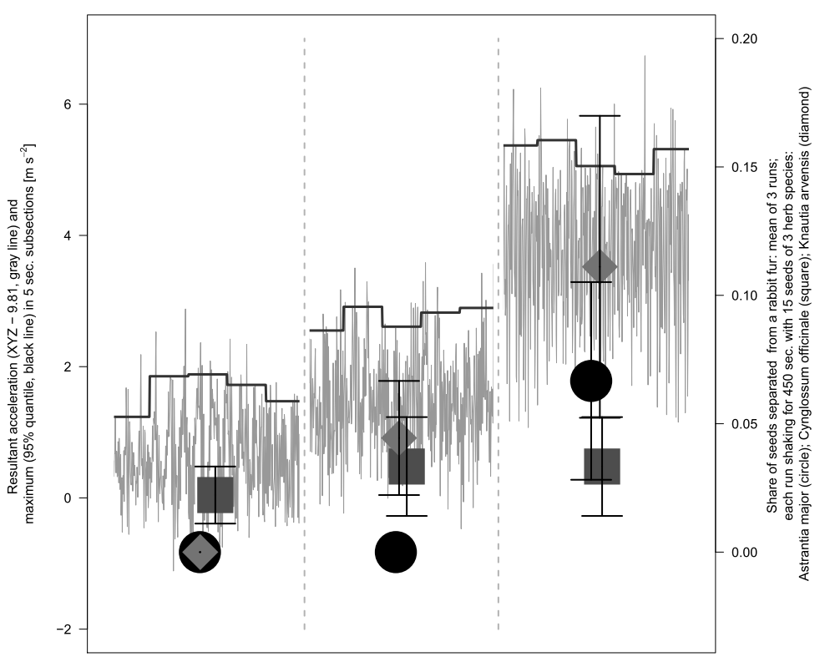
FIGURE S1: Acceleration (grey lines) measured on a laboratory shaker running at three different intensities (160, 200 and 240 revolutions/min.) for 25 seconds, and maximum acceleration (black lines), quantified as the 95% quantile of the resultant acceleration in subsections of five seconds (same method as in the main manuscript). Symbols show the proportion of three herb seeds that were separated from a rabbit fur (fixed upside down to the laboratory shaker) after running in each intensity for 450seconds (mean +/-S.E. of three runs, each with 15 seeds of any species placed on the fur). Note: some noise is added to the x-coordinates of the symbols to improve readability.
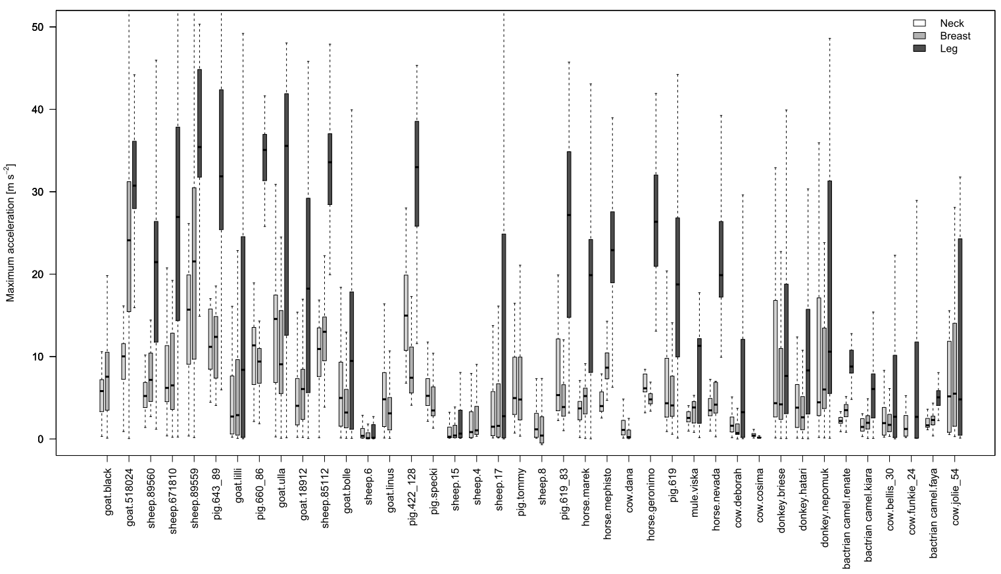
FIGURE S2: Boxplots showing maximum acceleration (95% quantile of resulting acceleration) determined for five second subsections of acceleration data measured at the neck, breast and leg of 40 individuals of 13 breeds of 8 mammal species; ordered after individual body mass. Outliers are omitted for clarity.

