Sorption of long-lived ⁹⁴Nb on magnetite: Spectroscopic and electrochemical investigation of the associated mechanism
M. Ghoshª, A. K. Yadav^{b}, A. K. Debnath^{c}, M. K. Deyª, K. K. Swain^{a,d*}
ªAnalytical Chemistry Division, Bhabha Atomic Research Centre, Mumbai-400085, India
^{b}Atomic & Molecular Physics Division, Bhabha Atomic Research Centre, Mumbai-400085, India
^{c}Technical Physics Division, Bhabha Atomic Research Centre, Mumbai-400085, India
^{d}Homi Bhabha National Institute, Mumbai-400094, India
Phone No.: 91-22-25590320; Fax: 91-22-25505331
* E-mail of the corresponding author: kallola@barc.gov.in

Supplementary Information
Table S1
Results of solvent extraction study of Nb sorbed magnetite at different pH conditions
System | Condition | Nb(IV) fraction (%) | Nb(V) fraction (%)
Nb tracer | N₂ atmosphere | 0.84 | 99.16
Nb(V)-Fe₃O₄ at pH 1.4 | N₂ atmosphere | 0.90 | 99.10
Nb(V)-Fe₃O₄ at pH 6.6 | N₂ atmosphere | 0.97 | 99.03
Nb(V)-Fe₃O₄ at pH 10.4 | N₂ atmosphere | 1.20 | 98.80

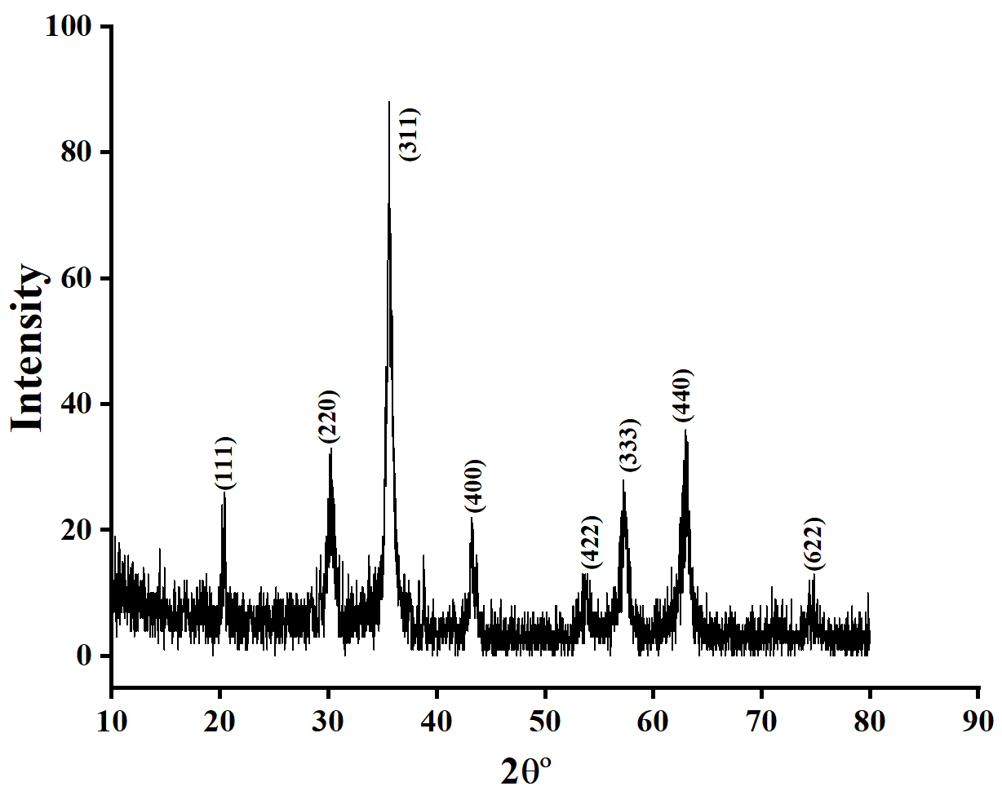
Fig. S1: XRD pattern of synthesized iron oxide
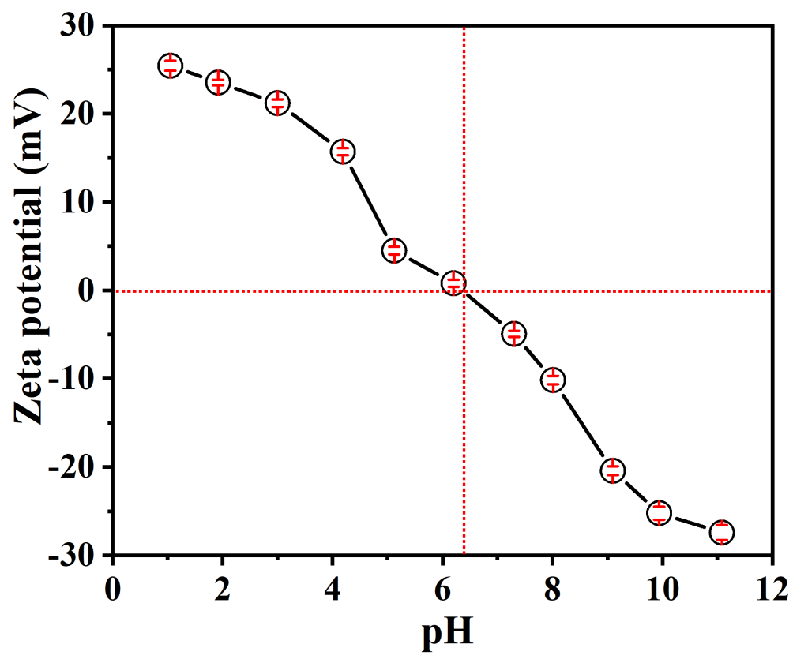
Fig. S2: Surface charge of magnetite as a function of solution pH (Magnetite conc. 2 mg mL⁻¹, Ionic strength: 0.05 M NaClO₄, Nitrogen gas purged to avoid CO₂ interference during the sample preparation)
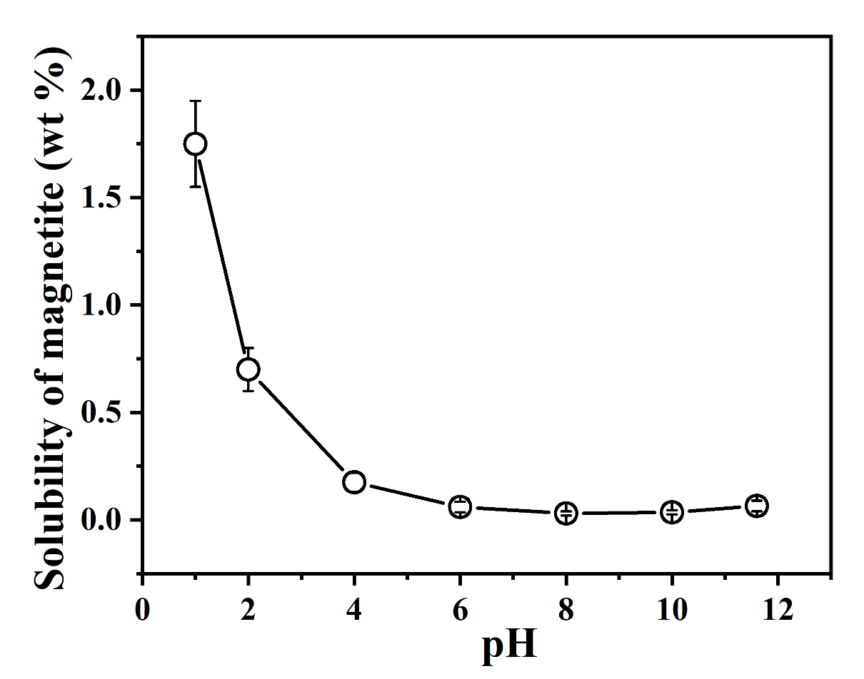
Fig. S 3: Dissolution of magnetite with variation of pH of the medium (Initial amount of magnetite: 50 mg and volume of the solution: 25 mL)

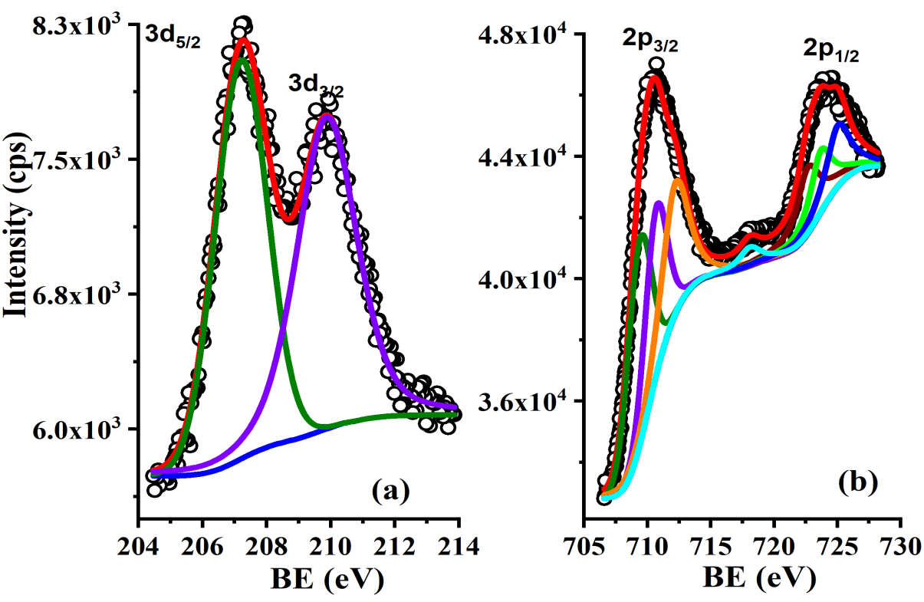
Fig. S4: (a) Nb 3d peaks and (b) Fe 2p peaks in XPS measurement of Nb sorbed magnetite at pH 6.6 medium

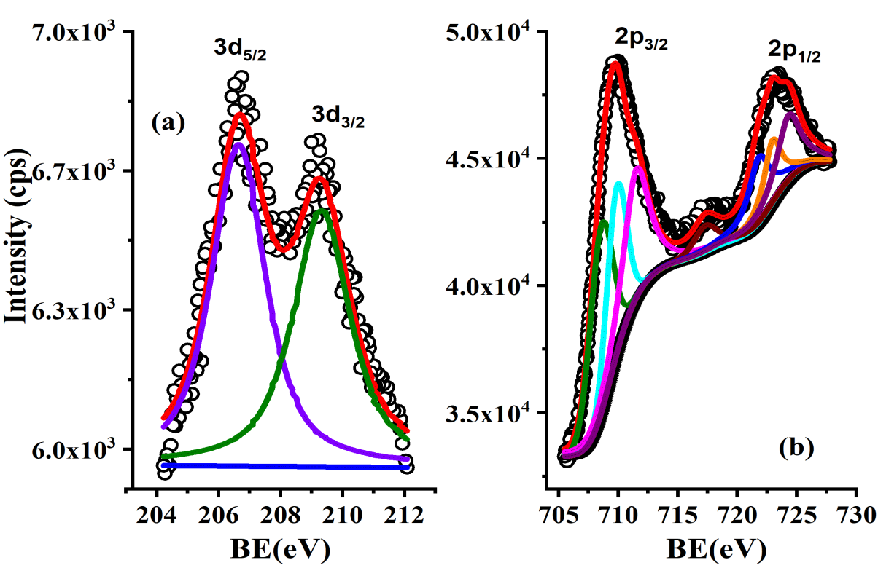
Fig. S5: (a) Nb 3d peaks and (b) Fe 2p peaks in XPS measurement of Nb sorbed magnetite at pH 10.4 medium

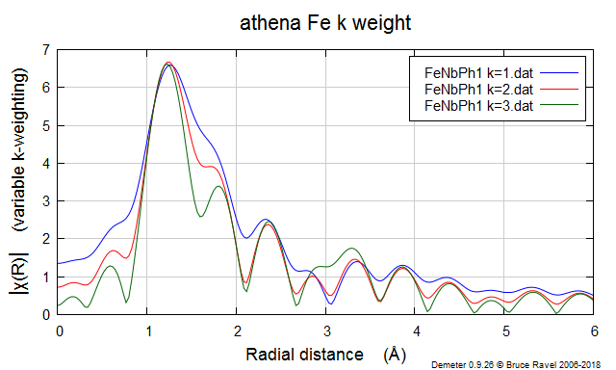
Fig. S6: Fe K weight test (weighted factor: 1,2,3) for Nb sorbed magnetite at pH 1
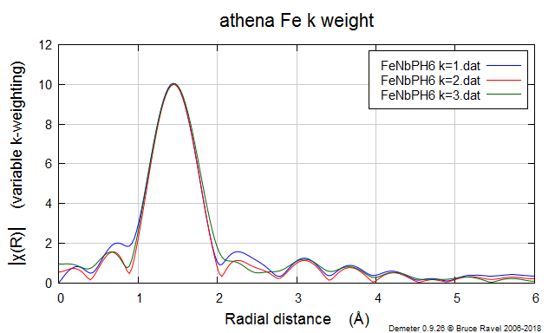
Fig. S7: Fe K weight test (weighted factor: 1,2,3) for Nb sorbed magnetite at pH 6

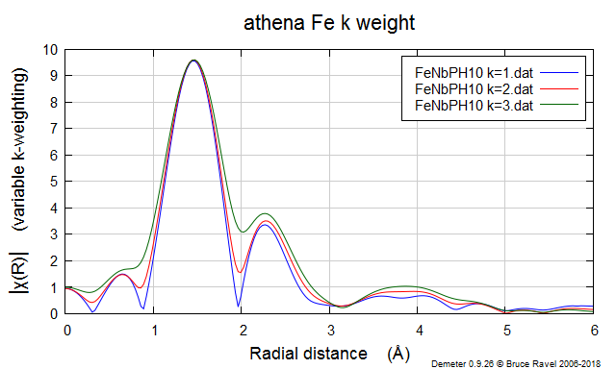
Fig. S8: Fe K weight test (weighted factor: 1,2,3) for Nb sorbed magnetite at pH 10

