Supplementary Material

Characteristics of the Space Adventure Task
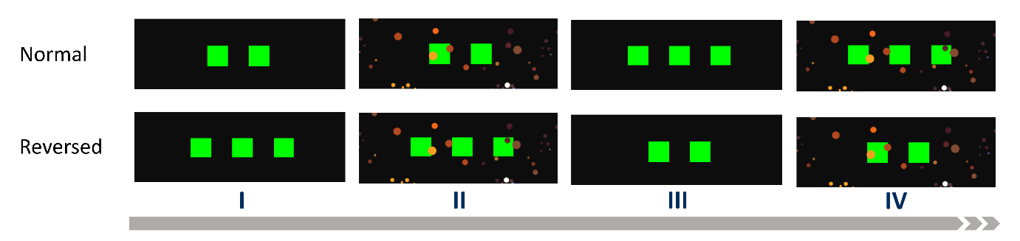
Figure S1 Schematic illustration of counterbalancing in the Space Adventure Task. Each participant had to solve 100 mini-blocks with varying number of actions (two-step and three-step) indicated by the number of green boxes and varying level of uncertainty for the transition of the jump action where high uncertainty was indicated by small asteroids. Participants experienced these conditions in a blocked manner, i.e. the experiment was divided into four phases of 25 mini-blocks with equal number of steps and noise level indicated by the roman numerals. The order of the steps condition was counterbalanced between subjects, i.e. half of them started with two-step mini-blocks ('Normal' order) while the other half started in 'Reversed' order with three-step mini-blocks first.
The Value Iteration Algorithm
The value iteration algorithm (Sutton & Barto, 2018) is a dynamic programming algorithm for finding the optimal policy $π^{*}$ (a policy is a state-action mapping and can be considered to be the plan how to act in the current and possible future states) in a fully observable Markov decision process. Each mini-block of the Space Adventure Task is such a Markov decision process with a finite horizon of two or three steps depending on the experimental condition. A mini-block can thus be defined as a tuple:
 | $$\left(T,S,R,r\left(s\right),A,C,c\left(a\right),p\left(s_{t+1} | s_{t},a_{t}\right)\right),$$ | (S1)
where
- $T$ denotes the number of trials for the mini-block (the horizon or step size) with:
$$T=\left\{\begin{aligned}2, \text{for two-step mini-blocks,} \\ 3, \text{for three-step mini-blocks,}\end{aligned}\right.$$hence $t=1,…,T$.
- $S=\left\{0,...,5\right\}$ denotes the set of task states, i.e. the six positions of the planet configuration.
- $R=\left\{-20,-10,0,10,20\right\}$ denotes the set of rewards.
- $r\left(s\right)$ denotes the immediate reward in each state, i.e. the planet type in each position of the planet configuration (this is equivalent to the reward probability $p\left(r | s\right)$ if reward would be given probabilistically).
- $A=\left\{0,1\right\}$ denotes the set of possible actions, where 0 corresponds to moving clockwise and 1 to jumping.
- $C=\left\{-2,-5\right\}$ denotes the set of action costs where jumping has higher costs.
- $c\left(a\right)$ denotes the immediate costs of executing action $a$.
- $p\left(s_{t+1} | s_{t},a_{t}\right)$ denotes the transition probability, i.e. the probability to reach a subsequent state $s_{t+1}$ from a given state $s_{t}$ by executing action $a_{t}$.

The value iteration algorithm can be thought of as solving the problem of finding the optimal action sequence by breaking it down into single decision problems for each planning step and going backwards through the chain of decisions thereby reducing the exponential complexity to not more than polynomial complexity ^{2; as illustrated in Figure S2}
Concretely, the procedure starts with considering the last action decision to be made for all possible states and choosing the best action for being in each of these states. This decision yields the optimal value (maximum expected value) for each state in that period, i.e. the state-value $V[s|d]$, with initial planning depth $d=1$. In the following iteration, the case of being in the next-to-last step is considered for all the possible states. Once again, the best action is chosen, given that the optimal values of being in various states at the next time period is now known. This yields new optimal state-values for $d=2$. This process is continued until the present step or the maximum planning depth is reached.
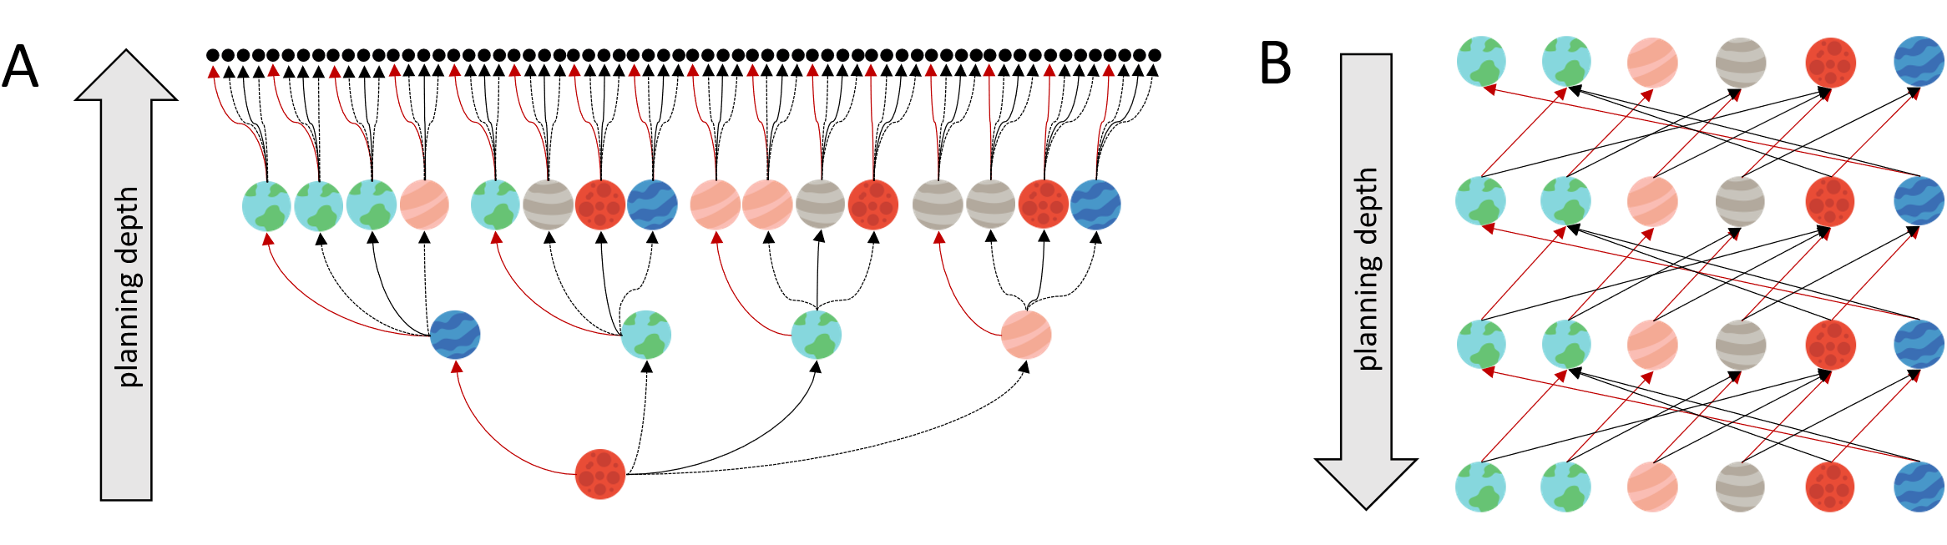
Figure S2 Illustration of Forward Planning Complexity. This figure illustrates the forward planning complexity of exhaustive search (A) versus value iteration (B) by taking the example of the mini-block depicted in Figure 1 B. Red and black arrows indicate moves and jumps, respectively. Dashed lines represent transition failures of the probabilistic jump action (omitted in B for better readability).
The value iteration algorithm with planning depth $d ϵ \left\{1,2,3\right\}$ is mathematically defined by:
 | $$Q\left(s_{t},a_{t},d\right)=\sum_{s_{t+1}}{p\left(s_{t+1} | s_{t},a_{t}\right) \left[c\left(a_{t}\right)+r\left(s_{t+1}\right)+γV\left(s_{t+1}|d\right)\right]}$$ |  | (S2)
 | $$V\left[s_{t} | d\right]\left(s_{t} | d\right)=\left\{\begin{aligned}0 \\ \max_{a_{t}}{Q}\left(s_{t},a_{t},d\right)\end{aligned}\right.$$ | $$,for t>\min\left(T,d\right) \\ ,otherwise$$ | (S3)
Here, $Q\left(s,a\right)$ denotes state-action values and $V\left(s_{t},d\right)$ state-values. Setting $V\left(s_{t}|d\right)$ to zero serves as the starting point of the backward induction. This is the case when either the planning depth $d$ or the number of steps $T$ is reached. The parameter $γ$ denotes the discounting rate of future outcomes. Note that we considered $γ=1$ as this parameter is not simultaneously identifiable with planning depth. For some forward planning algorithms in machine learning, $γ$ is explicitly transformed to limited planning depth, e.g. by $d=\frac{1}{1-γ}$, ³¹.

Parameter Inference
For the inference of free model parameters $γ=\left(g_{1},g_{2},g_{3}\right)=\left(logit^{-1}\left(α\right),\ln\left(β\right),θ\right)$ and the trial dependent planning depth $d_{t}$, we used the following hierarchical generative model:
 | $$p\left(G\left|λ\right.\right)\prod_{n=1}^{N}{p\left(γ_{n}\left|G\right.\right)p\left(r_{n}\left|α\right.\right)\prod_{b=1}^{100}{p\left(a_{b}^{n}\left|s_{b}^{n},r_{n,f\left(b\right)},γ_{n}\right.\right)}},$$ | (S4)
where $n$ denotes participant's number, $b$ the mini-block, $G$ the group level hyper-priors and $θ=\left(λ,α_{1}α_{2}\right)$ the set of hyper-parameters (see below). $r_{n,f\left(b\right)}$ denotes the participant specific prior over a planning depth, dependent on the current mini-block, that is, the maximum number of trials of the experiment. The function $f\left(b\right)∈\left\{1,2,3,4\right\}$ maps the current mini-block to corresponding value dependent on the phase of the experiment, hence:
 | $$f\left(b\right)=\left\{\begin{aligned} 1, for T=2 \\ 2,for T=2∧noisy \\ {3, for T=3 \atop 4, for T=3∧noisy}\end{aligned}\right.$$ | (S5)
where $p\left(d_{b,t=1}^{n}=d | r_{n,f\left(b\right)}\right)=r_{n,f\left(b\right),d}$ and $\sum_{d}{r_{n,f\left(b\right),d}}=1$.
Given the generative model, we approximate the true posterior as follows:
 | $P\left(G,γ_{1:N},r_{1:N}\left|A_{n},S_{n},θ\right.\right)≈Q\left(G\right)\prod_{n=1}^{N}{Q\left(γ_{n}\right)Q\left(r_{n,1}\right)Q\left(r_{n,2}\right)}$, | (S6)
where $A_{n}$, $S_{n}$ denote set of all responses and states (stimuli) of the nth participant.

Hierarchical Prior Distribution
The group level hyper-prior over $γ_{n}$ was defined as a normal-inverse-gamma distribution for each free parameter:
 | $$p\left(G\left|λ\right.\right)=\prod_{k=1}^{3}{N}-Γ^{-1}\left(g_{k},σ_{k}^{2};m_{k},l_{k},w_{k},b_{k}\right)$$ | (S7)
thus, $λ=\left(m_{1:3},l_{1:3},w_{1:3},b_{1:3}\right)$. The subject level prior was defined as a (multivariate) normal distribution:
 | $$p\left(γ_{n}\left|G\right.\right)=\prod_{k=1}^{3}{N\left(γ_{n,k};g_{k},σ_{k}^{2}\right)}.$$ | (S8)
Finally, the prior over planning depth corresponded to a Dirichlet distribution, where
 | $$p\left(r_{n}\left|α\right.\right)=\prod_{i=1}^{4}{Dir\left(r_{n,i}\left|α_{i}\right.\right)}$$ | (S9)
where $i$ denotes different phases of the experiment.

Variational Approximation
The approximate posterior $Q$ was factorised as follows:
 | $$Q\left(G,γ_{1:n},r_{1:n,1:4}\right)=Q\left(G\right)\prod_{n=1}^{N}{Q\left(γ_{n}\right)\prod_{i=1}^{4}{Q\left(r_{n,i}\right)}},$$ | (S10)
where
 | $$Q\left(G\right)=Q\left(g_{1},g_{2},g_{3},σ_{1}^{2},σ_{2}^{2},σ_{3}^{2}\right)=\frac{1}{8σ_{1}^{2}σ_{2}^{2}σ_{3}^{2}}N_{6}\left(μ,Σ\right)$$ | (S11)
 | $$Q\left(γ_{n}\right)=N_{3}\left(m_{n},Y_{n}\right)\left(\right)\left(\right)$$ | (S12)
and
 | $$Q\left(r_{n,i}\right)=Dir\left(α_{n,i}^{'}\right)$$ | (S13)
The approximate posterior estimate of relevant model parameters is obtained as the minimiser of the variational free energy, with respect to the sufficient statistics of the factorised approximate posterior $φ=\left(μ,Σ,m_{1:N},Y_{1:N},α_{1:N,1:2}^{'}\right)$, where we at the same time optimise the generative model with respect to the hyper-parameters $θ$, effectively performing empirical Bayes estimate with respect to hyper-parameters. The whole optimisation procedure rests upon stochastic variational inference scheme implemented in Pyro ^{21, v.1.5.2}, a Python based probabilistic programming library built on PyTorch (more details on this can be found at https://github.com/pyro-ppl/pyro).

Stochastic variational inference
Starting with the definition of the variational free energy
 | $$F\left(φ,θ\right)=E_{Q}\left[\ln{\frac{Q\left(G,γ_{1:N},r_{1:N,1:2}\left|φ\right.\right)}{P\left(A_{1:N},G,γ_{1:N},r_{1:N,1:2}\left|S_{1:N},θ\right.\right)}}\right]$$ | (S14)
we obtain the minimum of the free energy with respect to parameter sets $\left(φ,θ\right)$ using stochastic
gradient descent. Hence, for $K$ samples from the approximate posterior $Q$ the stochastic gradient steps are obtained as
 | $$Δθ=η_{t}^{θ}\frac{1}{K}\sum_{k=1}^{K}{∇_{θ}}P\left(A_{1:N},G^{k},γ_{1:N}^{k},r_{1:N,1:2}^{k}\left|S_{1:N},θ\right.\right)$$ | (S15)
for optimising free energy with respect to the parameters of the generative model $\left(θ\right)$, and
$$Δφ=-η_{t}^{φ}\frac{1}{K}\sum_{k=1}^{K}{\left(\ln{\frac{Q\left(G^{k},γ_{1:N}^{k},r_{1:N,1:2}^{k}\left|φ\right.\right)}{P\left(A_{1:N},G^{k},γ_{1:N}^{k},r_{1:N,1:2}^{k}\left|S_{1:N},θ\right.\right)}}+1\right)∇_{φ}\ln{Q\left(G^{k},γ_{1:N}^{k},r_{1:N,1:2}^{k}\left|φ\right.\right)}}$$ | (S16)
for minimizing free energy with respect to the parameters of the approximate posterior $\left(φ\right).$ In practice, we use the Adam optimiser for estimating the direction of the stochastic gradient for individual parameters in the two sets. More details on this can be found at https://pyro.ai/examples/svi_part_iii.html.

Planning Depth Posterior
We obtain the conditional posterior over planning depth (at trial $t$ of a mini-block $b$) as
 | $$Q\left(d_{t,b}^{n} | γ_{n},r_{n,f\left(b\right)}\right)=\frac{p\left(a_{t,b}^{n}\left|s_{t,b}^{n},d_{t,b}^{n},γ_{n}\right.\right)p\left(d_{t,b}^{n}\left|r_{n,f\left(b\right)}\right.\right)}{p\left(a_{t,b}^{n}\left|s_{t,b}^{n},r_{n,f\left(b\right)},γ_{n}\right.\right)}$$ | (S17)
Hence for a given approximate marginal posterior distribution $Q\left(γ_{n},r_{n}\right)=Q\left(γ_{n}\right)\prod_{i=1}^{4}{Q\left(r_{n,i}\right)}$, we obtain the marginal (approximate) posterior over planning depths (at trial $t$ of a mini-block $b$) as:
 | $$Q\left(d_{t,b}^{n}\right)=\frac{1}{K}\sum_{k=1}^{K}{\frac{p\left(a_{t,b}^{n}\left|s_{t,b}^{n},d_{t,b}^{n},γ_{n}^{k}\right.\right)p\left(d_{t,b}^{n}\left|r_{n,f\left(b\right)}^{k}\right.\right)}{p\left(a_{t,b}^{n}\left|s_{t,b}^{n},r_{n,f\left(b\right)}^{k},γ_{n}^{k}\right.\right)}} ,$$ | (S18)
where $K$ denotes the number of posterior samples from the marginal posterior distribution $Q\left(γ_{n},r_{n}\right)$ of the $n$th participant.

Data Analysis

Linear Mixed Effects Model of Mean Planning Depth
We analysed mean planning depths with a linear mixed effects (LME) model. The analysis was performed using the MIXED command of the software SPSS (version 28) with an alpha level of 0.05. The model was formulated as follows:
 | $${Y\left(Mean Planning Depth\right)}_{ij}=b_{00}+ b_{01}*{group}_{j}+b_{10}*{noise}_{ij}+b_{20}*{steps}_{ij}+b_{30}*group*{noise}_{ij}+b_{40}*group*{steps}_{ij}+η_{j}^{b_{00}}+η_{j}^{b_{10}}+η_{j}^{b_{20}}+r_{ij}$$ | (S15)
Here, the mean planning depth of participant _{j} at condition _{i} is indicated as Y_{ij}, respectively. The model includes an intercept as well as the effect of age as indicated by the group indicator which was set to 0 for younger adults and 1 for older adults. On the condition level, the model includes effects for the noise level and number of steps. Furthermore, we included condition-by-group interaction terms. All these fixed effects are depicted by the corresponding coefficient b; r_{ij} represents the residuals. Individual variation of effects around the fixed effect, i.e., random effects, are depicted by η_{j}, i.e. the random intercept and random slopes for the effects of the noise and steps condition. As covariance structure we used the variance components option assuming no correlation between the estimated covariance parameters, i.e. random effects. Fitting the model with minimal assumptions (unstructured covariance matrix) did not significantly improve the model fit. To conduct hypothesis tests for the fixed effects, we used standardized parameter estimates (Estimate / SE_{Estimate}) which follow a t-distribution with approximated degrees of freedom ³³.

Model | Fixed Effects | Random Effects | Number of Parameters | Covariance Structure | -2 LL | AIC
1 | 6 | 3 | 10 | Variance Components | -203.175 | -183.175
Table S1 LME Model Summary

Parameter | Estimate | SE | df | t | p | 95% CI
 |  |  |  |  |  | LL | UL
Intercept | 1.74 | .05 | 53.90 | 34.52 | .000 | 1.628 | 1.836
Group | -.36 | .07 | 53.90 | -5.09 | .000 | -.464 | -.176
Noise | .01 | .01 | 104.43 | .52 | .932 | -.025 | .023
Steps | .69 | .05 | 52.14 | 14.93 | .000 | .573 | .782
Group*Noise | .02 | .02 | 104.43 | 1.16 | .249 | -.015 | .057
Group*Steps | .05 | .06 | 52.14 | .74 | .465 | -.081 | .175
Table S2 Estimates of Fixed Effects. CI = confidence interval; LL = lower limit; UL = upper limit.

Parameter | Estimate | SE | Wald Z | p | 95% CI
 |  |  |  |  | LL | UL
Residual | .004 | .001 | 7.23 | .000 | .003 | .006
Intercept | .061 | .012 | 4.93 | .000 | .041 | .090
Noise | .000 | .000 | - | - | - | -
Steps | .049 | .010 | 4.69 | .000 | .032 | .074
Table S3 Estimates of Covariance Parameters. The covariance parameter for Noise was redundant as interindividual variance was too small. The test statistic and confidence interval could not be computed by SPSS. CI = confidence interval; LL = lower limit; UL = upper limit.

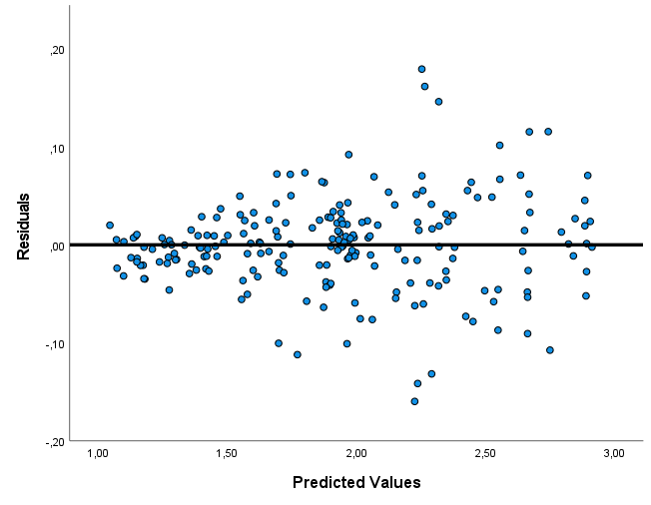
Figure S3 LME Model Residual Plot. Scatterplot of residuals against predictive values of the linear mixed effects (LME) model of mean planning depth. The plot shows slightly higher residuals variance for higher predicted values. This is expected due to the larger range of possible values for mean planning depth in the 3-step condition which should not violate the assumption of homoscedasticity.
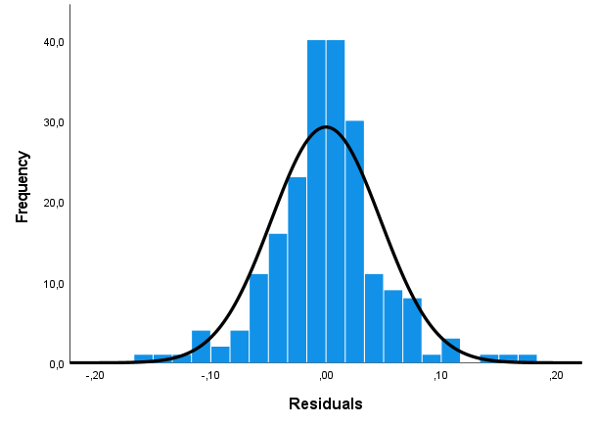
Figure S4 LME Model Histogram of Residuals. The plots shows the histogram of residuals of the linear mixed effects (LME) model of mean planning depth. The plot shows all residuals, i.e. for both groups. The fitted normal curve in black shows that residuals are approximately normally distributed.

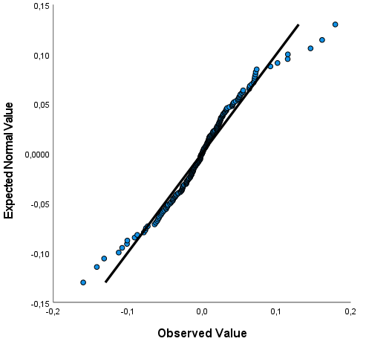
Figure S5 LME Model Normal Q-Q Plot of Residuals. This graph illustrates deviance of residuals of the linear mixed effects (LME) model of mean planning depth from normality (black line). There is no indication for a violation of the normality assumption.

Linear Regression Covariate Analysis
In a second analysis, we used backwards stepwise linear regression to identify predictors of subject-wise mean planning depths. For the initial model, we included performance in fluid cognitive abilities, i.e. performance in the IDP and the SWM, as well as SAT reaction time and a group indicator as predictors.

Model | R | R² | Adj. R² | SE | Change Statistics
 |  |  |  |  | R² Change | F Change | df1 | df2 | p
1 | .641 | .410 | .360 | .2578 | .410 | 8.179 | 4 | 47 | .000
2 | .640 | .410 | .373 | .2552 | .000 | .014 | 1 | 47 | .908
3 | .640 | .409 | .385 | .2528 | -.001 | .082 | 1 | 48 | .776
Table S4 Linear Regression Model Summary

Model |  | Unstandardized Coefficients |  | Standardized Coefficients | t | p | 95% CI for b
 |  | b | SE | Beta | t | p | LL | UL
1 | Intercept | 1.797 | .285 |  | 6.309 | .000 | 1.224 | 2.370
1 | Group | -.253 | .107 | -.396 | -2.367 | .022 | -.468 | -.038
1 | SAT_RT (s) | .038 | .011 | .399 | 3.356 | .002 | .015 | .061
1 | IDP_PER (%) | .000 | .004 | -.021 | -.116 | .908 | -.009 | .008
1 | SWM_PER (%) | .001 | .002 | .043 | .306 | .761 | -.004 | .006
2 | Intercept | 1.774 | .206 |  | 8.594 | .000 | 1.359 | 2.190
2 | Group | -.245 | .080 | -.383 | -3.047 | .004 | -.407 | -.083
2 | SAT_RT (s) | .038 | .011 | .400 | 3.412 | .001 | .016 | .061
2 | SWM_PER (%) | .001 | .002 | .036 | .286 | .776 | -.004 | .005
3 | Intercept | 1.828 | .089 |  | 2.485 | .000 | 1.648 | 2.007
3 | Group | -.254 | .073 | -.398 | -3.497 | .001 | -.401 | -.108
3 | SAT_RT (s) | .039 | .011 | .406 | 3.568 | .001 | .017 | .060
Table S5 Linear Regression Coefficients. CI = confidence interval; LL = lower limit; UL = upper limit.

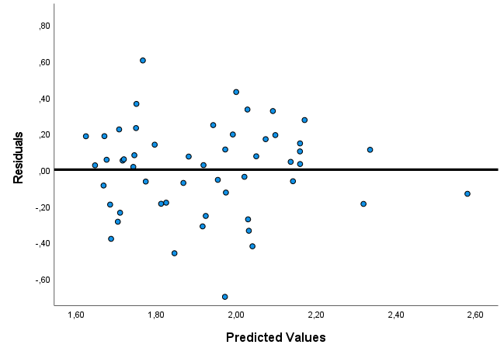
Figure S6 Linear Regression Model 3 Residual Plot. Scatterplot of residuals against predictive values of the linear regression model 3 of mean planning depth. There is no indication for a violation of the homoscedasticity assumption of residuals.
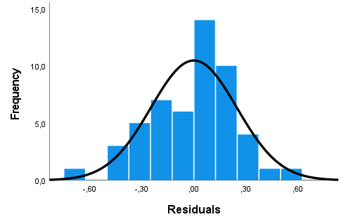
Figure S7 Linear Regression Model 3 Histogram of Residuals. The plots shows the histogram of residuals of the linear regression model of mean planning depth. The plot shows all residuals, i.e. for both groups. The fitted normal curve in black shows that residuals are approximately normally distributed.

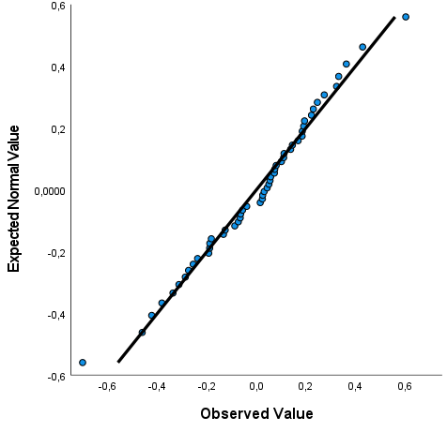
Figure S8 Linear Regression Model 3 Normal P-P Plot of Residuals. This graph illustrates deviance of residuals of the linear regression model of mean planning depth from normality (black line). It plots cumulative probabilities of model residuals (x-axis) againt expected normal cumulative probabilities (y-axis). There is no indication for a violation of the normality assumption of residuals.

Linear Regression of SAT Performance
In a third analysis, we used linear regression to predict subject-wise task performance with the parameters of the computational Model.

Model | R | R² | Adj. R² | SE
1 | .939 | .882 | .872 | 6.877
Table S6 Linear Regression Model Summary

Model |  | Unstandardized Coefficients |  | Standardized Coefficients | t | p | 95% CI for b
 |  | b | SE | Beta | t | p | LL | UL
1 | Intercept | -31.777 | 7.287 |  | -4.361 | .000 | -46.438 | -17.117
1 | alpha | -1.903 | 26.070 | -.022 | -.418 | .678 | -63.350 | 41.544
1 | beta | 13.415 | 1.830 | .500 | 7.331 | .000 | 9.734 | 17.097
1 | theta | -1.136 | 2.084 | -.031 | -.545 | .588 | -5.329 | 3.057
1 | MeanPD | 31.475 | 4.582 | .528 | 6.870 | .000 | 22.258 | 4.692
Table S7 Linear Regression Coefficients. CI = confidence interval; LL = lower limit; UL = upper limit; MeanPD = mean planning depth; alpha = learning rate, beta = inverse temperature; theta = response bias.
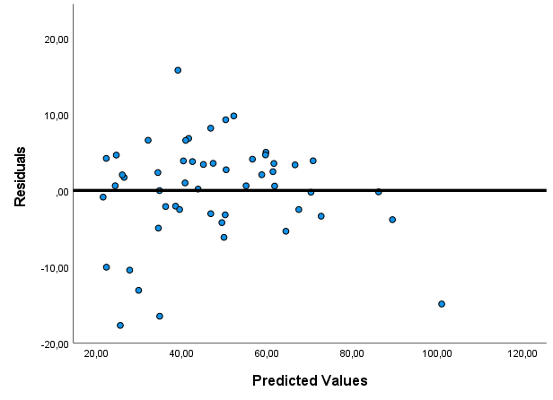
Figure S9 Linear Regression Model Residual Plot. Scatterplot of residuals against predictive values of the linear regression of performance in the Space Adventure Task. There is no indication for a violation of the homoscedasticity assumption of residuals.
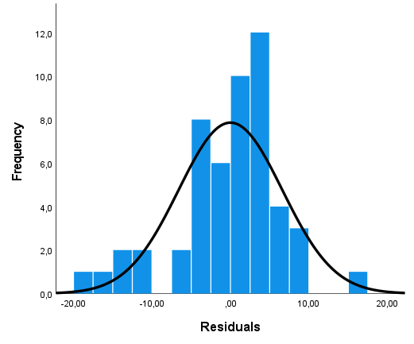
Figure S10 Linear Regression Model Histogram of Residuals. The plots shows the histogram of residuals of the linear regression of performance in the Space Adventure Task. The plot shows all residuals, i.e. for both groups. The fitted normal curve in black shows that residuals are approximately normally distributed

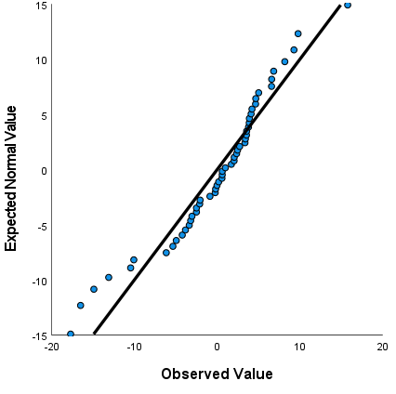
Figure S11 Linear Regression Model Normal P-P Plot of Residuals. This graph illustrates deviance of residuals of the linear regression model of performance in the Space Adventure Task from normality (black line). It plots cumulative probabilities of model residuals (x-axis) againt expected normal cumulative probabilities (y-axis). There is no indication for a violation of the normality assumption of residuals.

