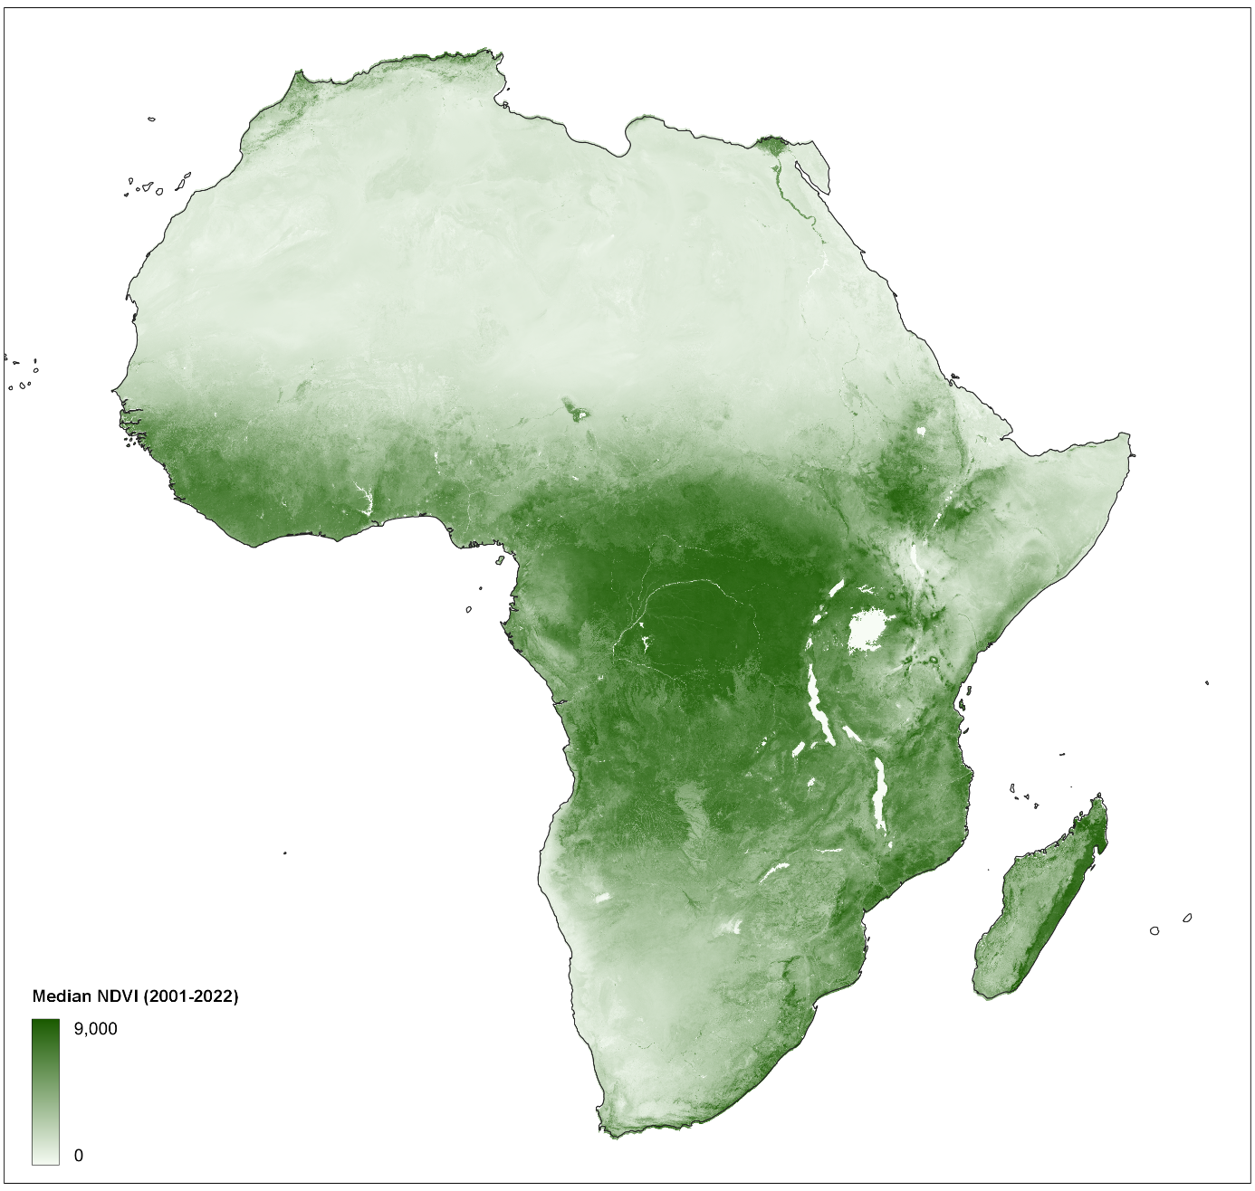
Extended Data Fig. 1 | Spatial distribution of NDVI. Median Normalized Difference Vegetation Index from MODIS, calculated for 2001-01-01 to 2022-01-01.
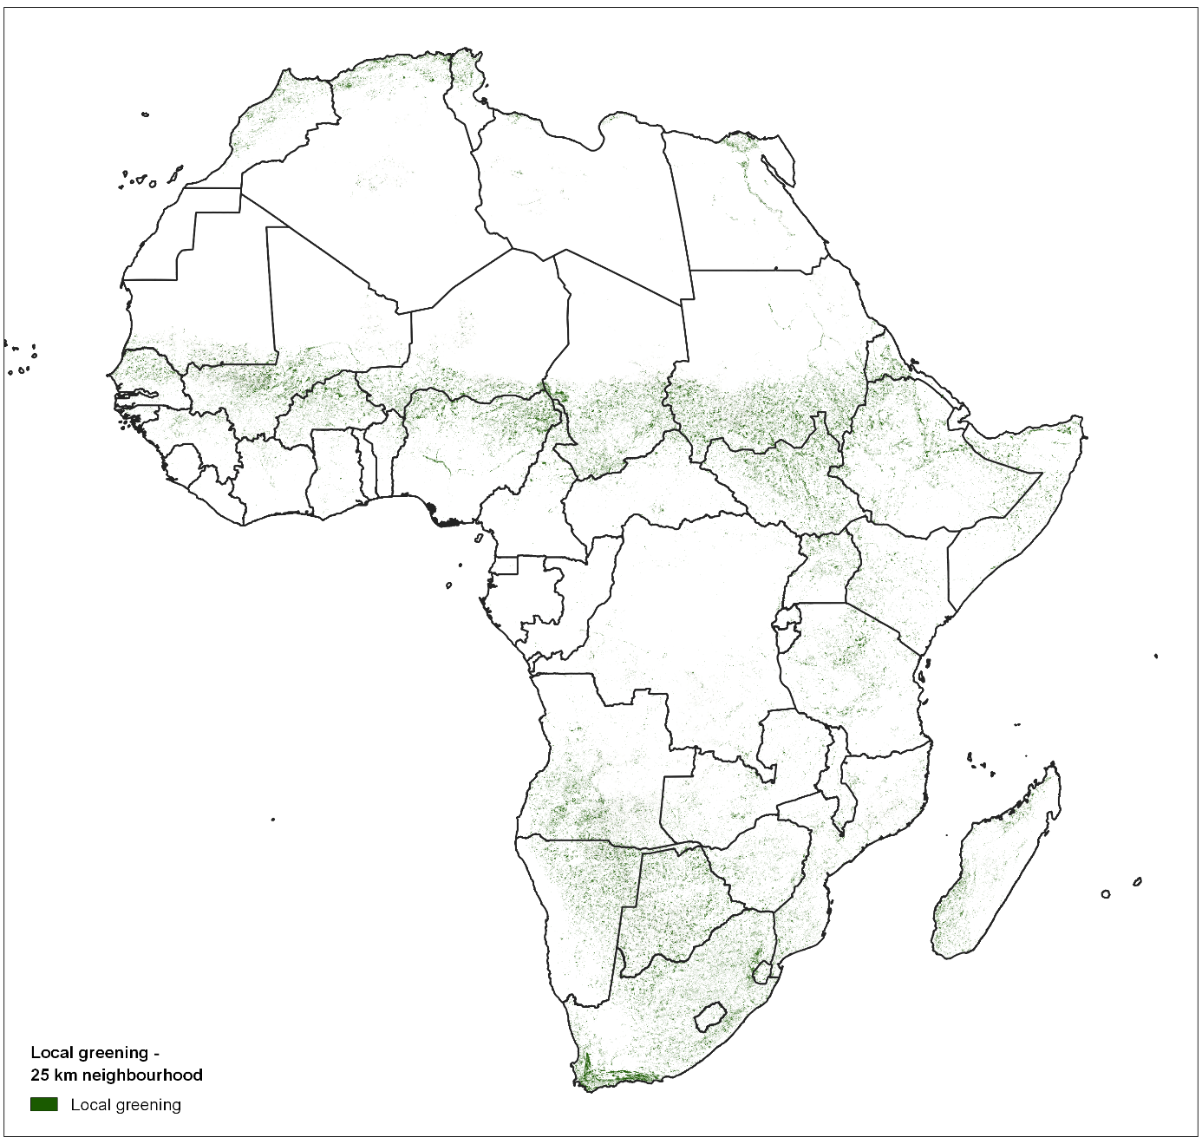
Extended Data Fig. 2 | Spatial distribution of local greening. Local greening, calculated with the spatial-context method and a 25 km neighbourhood at a 250 m resolution. Only significant trends are shown (p=0.05).
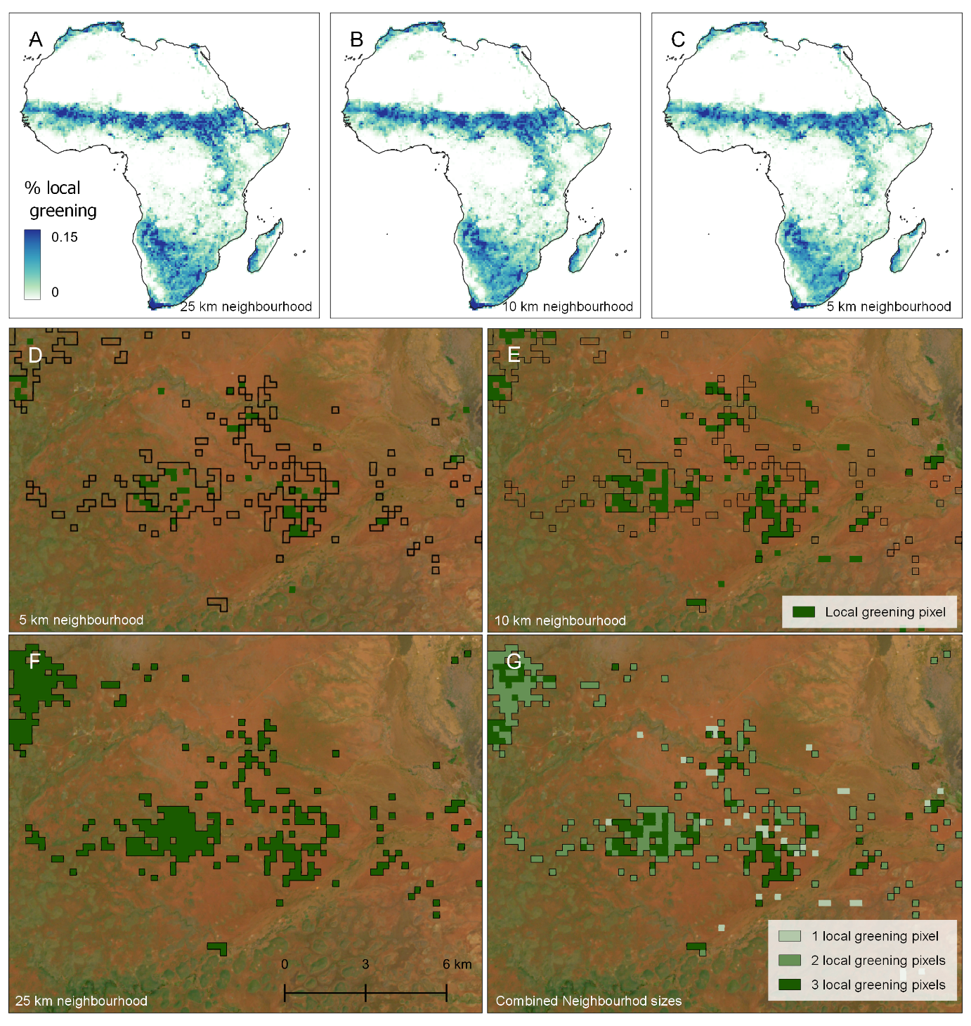Extended Data Fig. 3 | Sensitivity analysis of local greening pixels to neighbourhood size. The figures show local greening pixels with (A) a 25 km neighbourhood radius, (B) a 10 km neighbourhood radius and (C) a 5 km neighbourhood radius. We calculated local greening pixels with a NDVI spatial-context method. In all three figures, only significant trends are considered (p=0.05). For visualization purposes, the figures are downscaled to a 50 km resolution. Each downscaled pixel now shows the fraction of 250 m resolution local greening pixels. The bottom figures show local greening pixels in Kenya (37.8˚E, 2.9˚S) with (D) a 5 km neighbourhood radius, (E) a 10 km neighbourhood radius and (F) a 25 km neighbourhood radius. (G) shows a combination of the other three maps, where the amount of local greening pixels of the different neighbourhood sizes are shown.

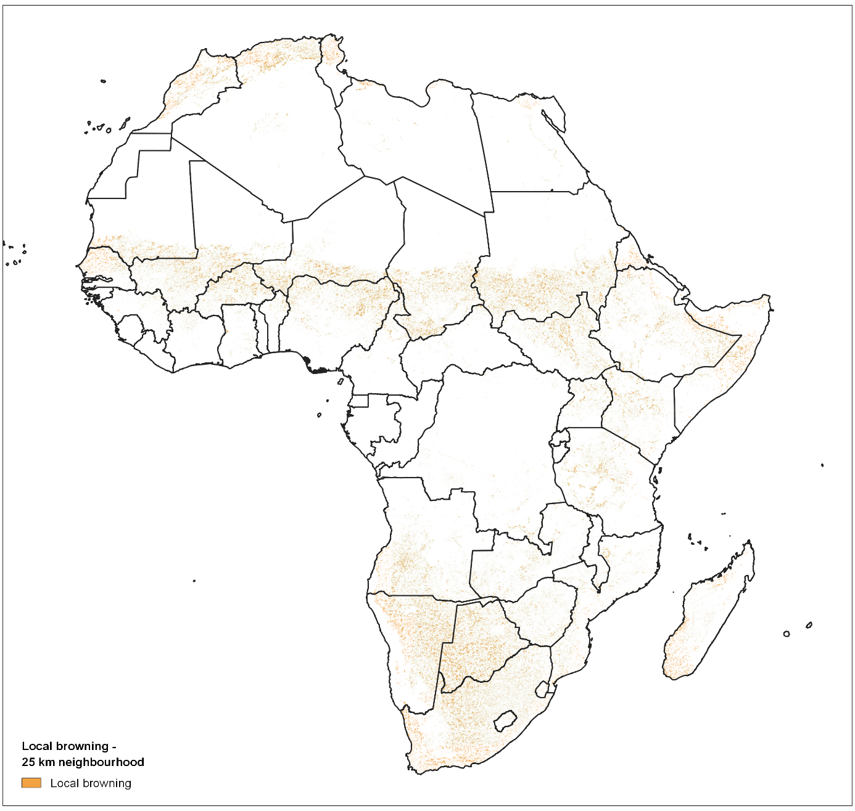
Extended Data Fig. 4 | Spatial distribution of local browning pixels. The local browning pixels calculated in the same way as the local greening pixels, with the spatial context method and a 25 km neighbourhood, but the pixels should show a negative trend after a breakpoint in the spatially corrected time series as well the original NDVI time series. Using this method, 3.0% of the study area shows this type of local browning.
Extended Data Table 1 | Distribution of greening pixels over land cover type and aridity index classes. Percentages indicate the area of local greening per class divided over the total greening area. The row and column “Total” shows the total percentage of local greening over the row or column (e.g. the percentage of local greening that occurs in semi-arid areas). In the last row and column, the fraction of cells of each class over the entire study area is given.
 | Hyper arid | Arid | Semi-arid | Dry subhumid | Humid | Total | % of total area
Evergreen Needleleaf Forest | 0.00% | 0.00% | 0.00% | 0.00% | 0.06% | 0.1% | 0.0%
Evergreen Broadleaf Forest | 0.00% | 0.00% | 0.08% | 0.12% | 0.82% | 1.0% | 11.8%
Deciduous Needleleaf Forest | 0.00% | 0.00% | 0.00% | 0.00% | 0.00% | 0.0% | 0.0%
Deciduous Broadleaf Forest | 0.00% | 0.00% | 0.11% | 0.08% | 0.55% | 0.7% | 1.8%
Mixed Forest | 0.00% | 0.00% | 0.00% | 0.00% | 0.21% | 0.2% | 1.0%
Closed Shrublands | 0.00% | 0.02% | 1.18% | 0.14% | 0.19% | 1.5% | 0.9%
Open Shrublands | 0.22% | 5.00% | 6.01% | 0.38% | 0.23% | 11.8% | 7.5%
Woody Savannas | 0.00% | 0.00% | 0.09% | 0.12% | 1.34% | 1.6% | 6.4%
Savannas | 0.02% | 0.03% | 0.91% | 1.45% | 9.54% | 11.9% | 22.6%
Grasslands | 0.19% | 6.70% | 31.17% | 9.59% | 9.22% | 56.9% | 38.0%
Permanent wetlands | 0.00% | 0.01% | 0.07% | 0.03% | 0.19% | 0.3% | 0.4%
Croplands | 0.33% | 0.38% | 4.48% | 2.76% | 3.09% | 11.0% | 6.9%
Urban | 0.03% | 0.03% | 0.13% | 0.03% | 0.07% | 0.3% | 0.2%
Cropland and Natural | 0.01% | 0.12% | 0.46% | 0.03% | 0.57% | 1.2% | 1.4%
Permanent Snow and Ice | 0.00% | 0.00% | 0.00% | 0.00% | 0.00% | 0.0% | 0.0%
Barren | 0.44% | 0.71% | 0.15% | 0.01% | 0.01% | 1.3% | 0.8%
Water | 0.00% | 0.00% | 0.01% | 0.02% | 0.04% | 0.1% | 0.1%
Total | 1.2% | 13.0% | 44.8% | 14.8% | 26.1%
% of total area | 0.5% | 8.4% | 25.8% | 10.1% | 55.2%

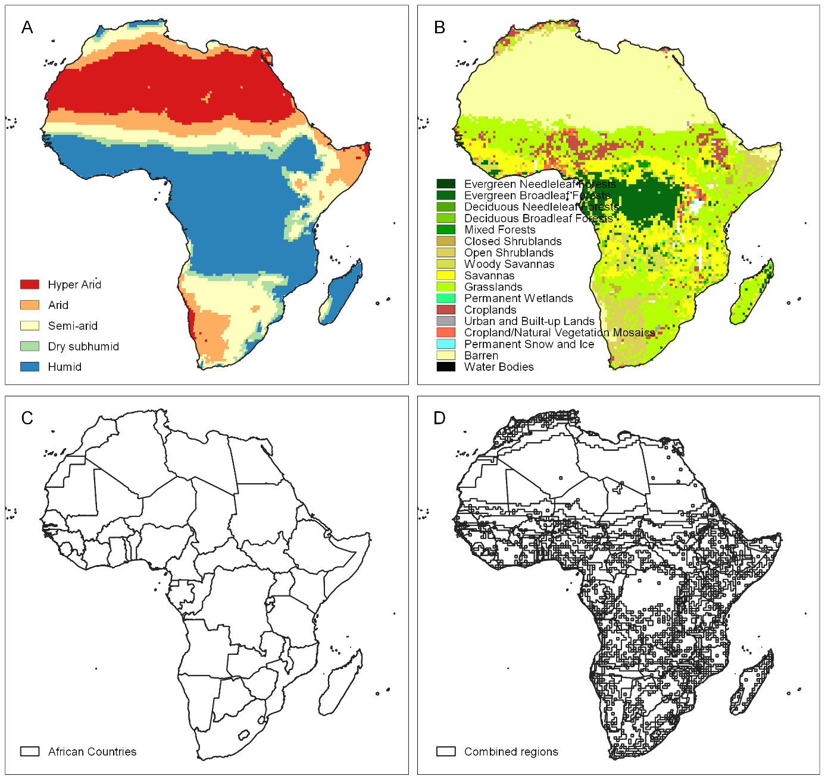
Extended Data Fig. 5 | Surface properties used for the analysis of local greening pixels and the evaluation of sustainable land management projects: (A) Aridity Index, (B) MODIS land cover for 2001, (C) Countries in Africa and (D) combined regions with the same aridity index, land cover and country values.
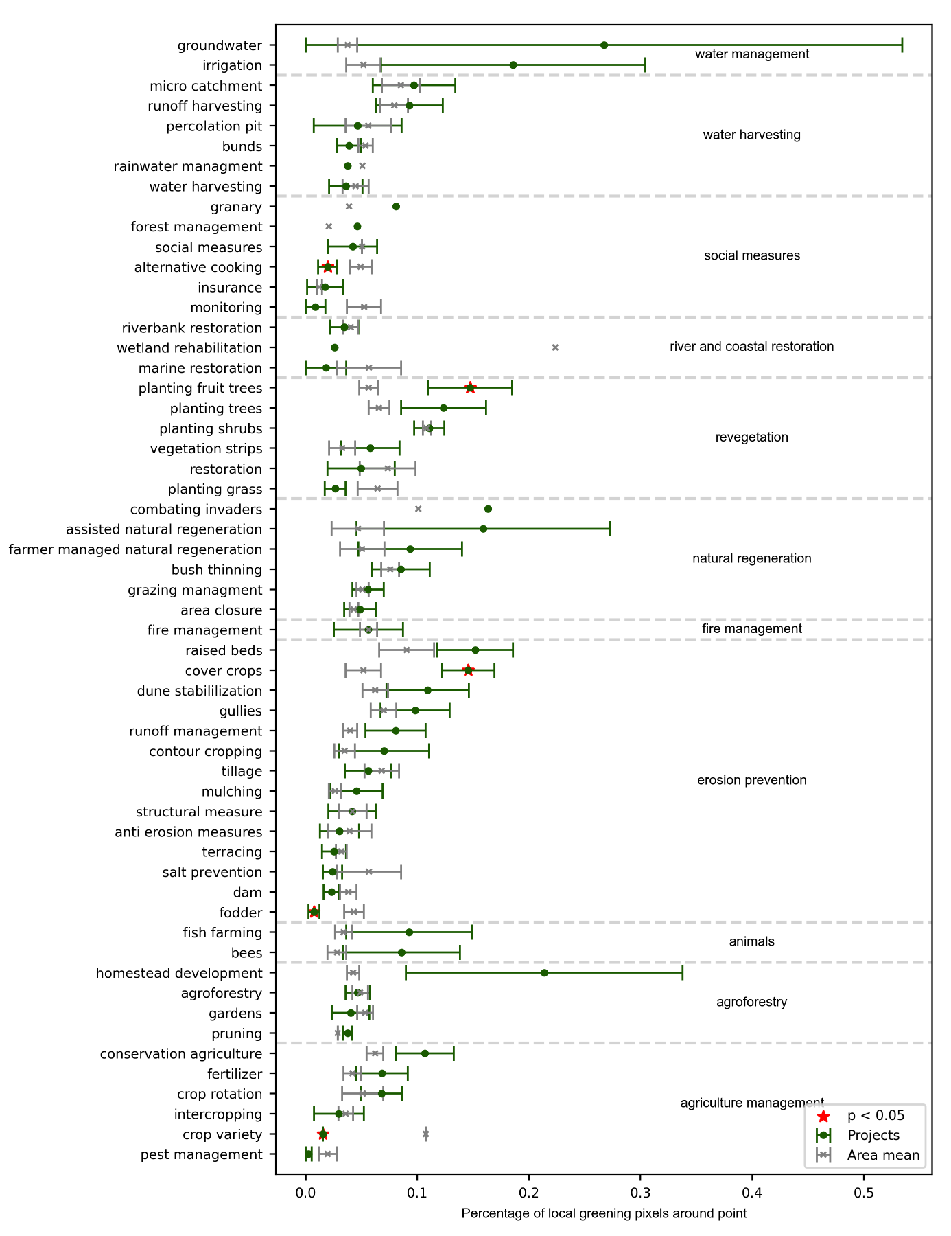
Extended Data Fig. 6 | Comparison of sustainable land management types with regional averages. The error plot shows the mean and standard error of the percentage of local greening pixels (Fig. 1A) within 2000 m around the WOCAT SLM project point. The projects area categorized by type of land management and compared to the mean percentage of local greening pixels in an area with the same aridity index, land cover type and country (Extended Data Fig. 3). Significant differences are marked with a star (p = 0.05).

