Supplemental Information for
Van der Waals heterostructure mid-infrared emitters with electrically controllable polarization states and spectral characteristics

Po-Liang Chen¹, Tian-Yun Chang¹, Pei-Sin Chen¹, Alvin Hsien-Yi Chan², Adzilah Shahna Rosyadi², Yen-Ju Lin^{1, 3}, Pei-Yu Huang⁴, Jia-Xin Li¹, Wei-Qing Li¹, Chia-Jui Hsu¹, Neil Na³, Yao-Chang Lee⁴, Ching-Hwa Ho², Chang-Hua Liu^{1, 5, 6*}
1. Institute of Photonics Technologies, National Tsing Hua University, Hsinchu 30013,
Taiwan
2. Graduate Institute of Applied Science and Technology, National Taiwan University of
Science and Technology, Taipei 10607, Taiwan
3. Artilux Inc., Zhubei City, Hsinchu 30288, Taiwan
4. National Synchrotron Radiation Research Center, Hsinchu 30076, Taiwan
5. Department of Electrical Engineering, National Tsing Hua University, Hsinchu 30013,
Taiwan
6. College of Semiconductor Research, National Tsing Hua University, Hsinchu 30013,
Taiwan
Correspondence to: chliu@ee.nthu.edu.tw

Contents:
S1 Raman and EDX characterizations of used MoS₂, BP, b-As_{0.25}P_{0.75} and b-
As_{0.46}P_{0.54} crystals
S2 The setup of mid-IR spectrometer
S3 Polarization-resolved PL spectra of BP and b-As_{0.25}P_{0.75}
S4 Thicknesses and crystal orientations of vdW flakes used in the BP_{t}/MoS₂/BP_{b}
heterostructure emitter
S5 Short-circuit photoresponses of the BP/MoS₂ heterointerface
S6 Bias dependence of EL spectra measured from the BP_{t}/MoS₂/BP_{b} heterostructure
emitter
S7 Calibration of the output power and extrinsic QE of vdW heterostructure
emitters
S8 Thicknesses and crystal orientations of vdW flakes used in the BP/MoS₂/b-
As_{0.46}P_{0.54} heterostructure emitter
S9 Short-circuit photoresponses from the b-As_{0.46}P_{0.54}/MoS₂ heterointerface
S10 Bias dependence of EL spectra measured from the BP/MoS₂/b-As_{0.46}P_{0.54}
heterostructure emitter
S11 Electric field distribution of the biased heterostructures and materials
parameters used in the finite element simulations

Supplementary Section 1.
Raman and EDX characterizations of the used MoS₂, BP, b-As_{0.25}P_{0.75} and b-As_{0.46}P_{0.54} crystals
Raman characterizations:
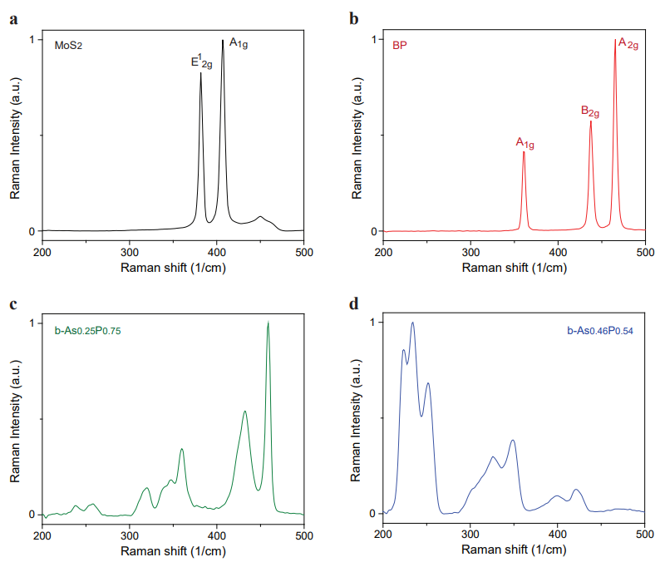
Figure S1 a. Raman spectrum of the MoS₂ flake deposited on a SiO₂/Si substrate. The two characteristic Raman vibration modes, including in-plane E¹_{2g} and out-of-plane A_{1g} are identified. b. Raman spectrum of the BP flake deposited on a SiO₂/Si substrate. The three characteristic Raman vibration modes, including out-of-plane A_{1g}, in-plane B_{2g} and in-plane A_{2g} are identified. c-d. Raman spectrum of the (c) b-As_{0.25}P_{0.75} and (d) b-As_{0.46}P_{0.54} flakes deposited on SiO₂/Si substrates. The peaks within the low wavenumbers (below 300 cm⁻¹), medium wavenumbers (300 cm⁻¹ to 380 cm⁻¹) and high wavenumbers (380 cm⁻¹ to 500 cm⁻¹) regimes are correlated with the vibrational properties of homoatomic arsenic–arsenic, heteroatomic arsenic–phosphorus and homoatomic phosphorus–phosphorus bonds, respectively. When increasing As/P ratio, we could see that peaks within the low and medium wavenumbers regimes dominate the spectra, in agreement with the result reported in literature¹. All Raman spectra were acquired with a 532 nm laser excitation.

EDX characterizations:
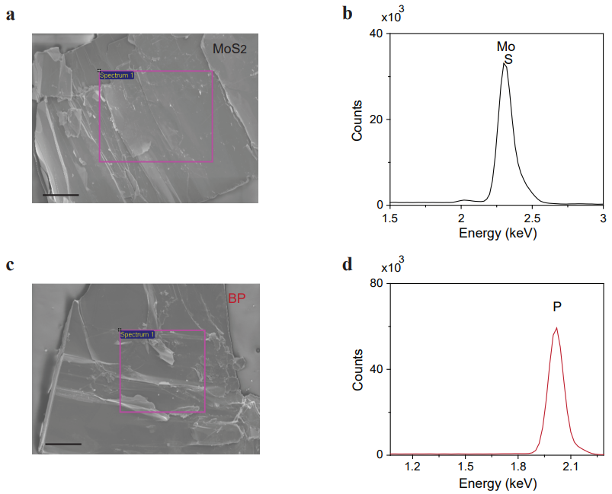
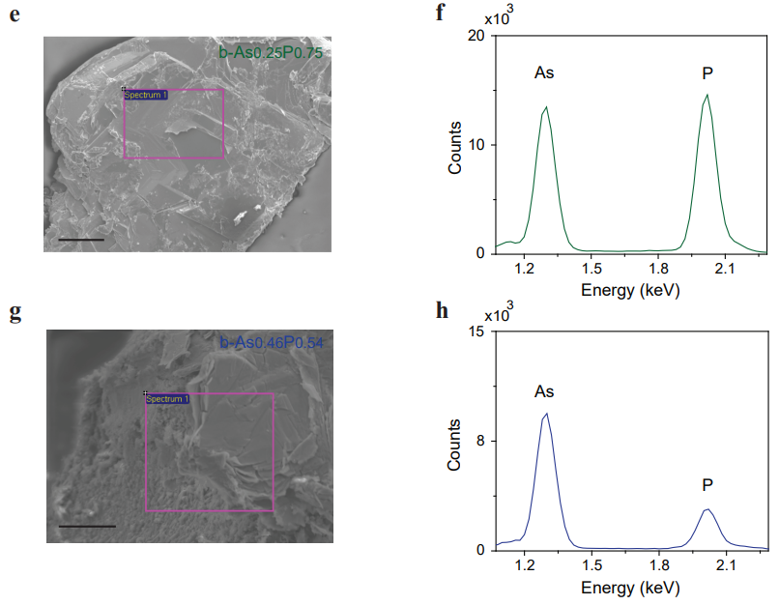
Figure S2 a-b. SEM image (scalar bar: 100 µm) and EDX spectrum of the bulk MoS₂ crystals. c-d. SEM image (scalar bar: 100 µm) and EDX spectrum of the bulk BP crystals. e-f. SEM image (scalar bar: 100 µm) and EDX spectrum of the bulk b-As_{0.25}P_{0.75} crystals. g-h. SEM image (scalar bar: 50 µm) and EDX spectrum of the bulk b-As_{0.46}P_{0.54} crystals.

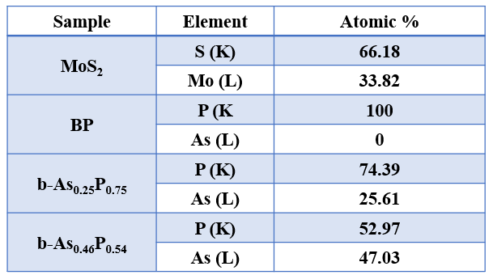
Table S1 Quantitative element analysis of MoS₂, BP, b-As_{0.25}P_{0.75} and b-As_{0.46}P_{0.54}.

Supplementary Section 2.
The setup of mid-IR spectrometer
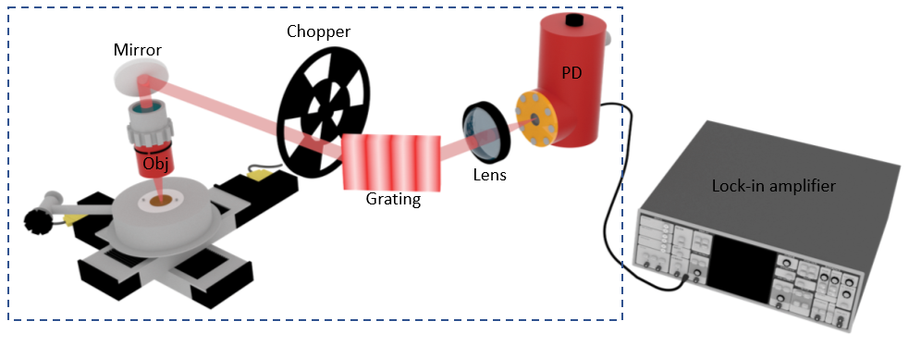

Figure S3 Schematic illustration of the setup for measuring mid-IR PL and EL. The luminescence signal generated from a sample is collected by an objective (Obj) and then is directed onto a mid-IR ruled reflective diffraction grating. By rotating the grating, different ranges of wavelength can be sequentially focused onto a liquid nitrogen cooled InSb photodetector (PD). The generated photovoltage was measured by a lock-in amplifier to resolve the spectral characteristic of the luminescence signal. The region enclosed by the blue dashed lines is under a dry nitrogen purged environment.

Supplementary Section 3.
Polarization-resolved PL spectra of BP and b-As_{0.25}P_{0.75}
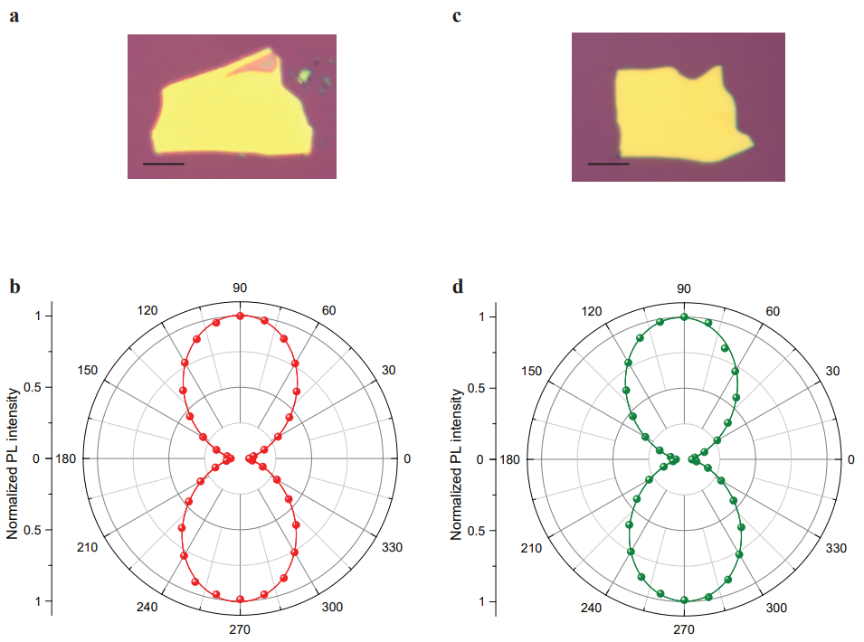

Figure S4 a. Optical image of the 40-nm-thick BP flake on a SiO₂/Si substrate. Scalar bar: 10 µm. b. Normalized integrated PL intensity of BP as a function of emission polarization angle, where the polarization angle of 90° corresponds to the armchair crystal axis and 0° corresponds to the zigzag crystal axis. The red line is the fitted curve to the data (red dots) using the function a×sin²θ + b×cos²θ. The results were taken from the BP flake shown in panel (a). c. Optical image of the 50-nm-thick b-As_{0.25}P_{0.75} flake on a SiO₂/Si substrate. Scalar bar: 10 µm. d. Normalized integrated PL intensity of b-As_{0.25}P_{0.75} as a function of emission polarization angle, where the polarization angle of 90° corresponds to the armchair crystal axis and 0° corresponds to the zigzag crystal axis. The green line is the fitted curve to the data (green dots) using the function a×sin²θ + b×cos²θ. The results were taken from the BP flake shown in panel (c).

Supplementary Section 4.
Thicknesses and crystal orientations of vdW flakes used in the BP_{t}/MoS₂/BP_{b} heterostructure emitter
Thicknesses of the used materials:
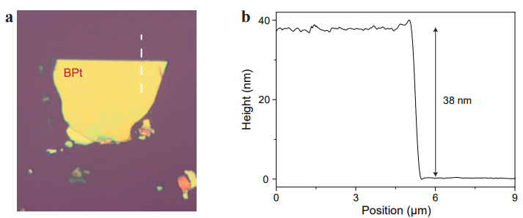
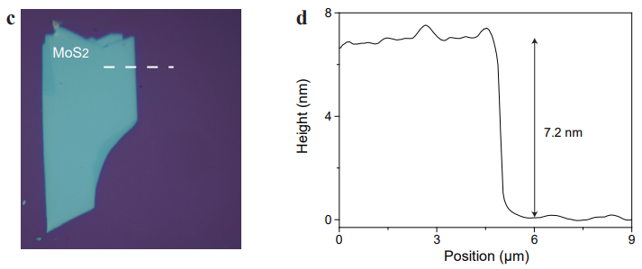
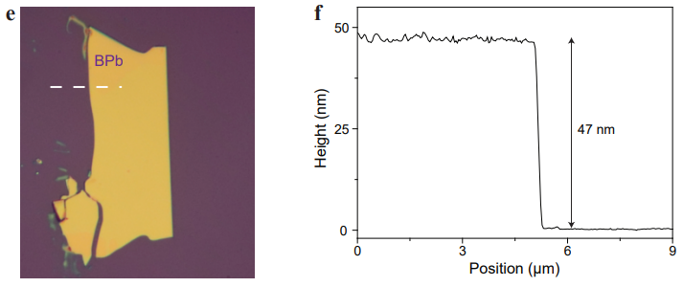
Figure S5 a. Optical microscope image of the used BP_{t}. b. AFM height profile along the white dashed line shown in panel (a). c. Optical microscope image of the used MoS₂. d. AFM height profile along the white dashed line shown in panel (c). e. Optical microscope image of the used BP_{b}. f. AFM height profile along the white dashed line shown in panel (e).

Crystal orientations of the used BP_{b} and BP_{t}:
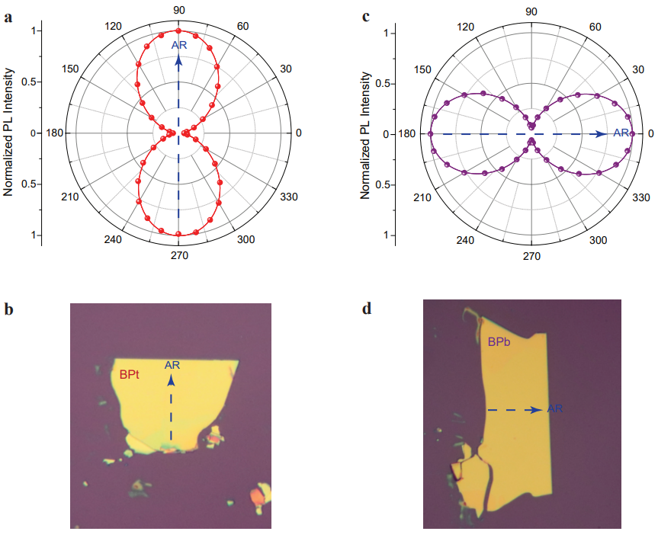
Figure S6 a. Normalized integrated PL intensity of BP_{t}, as a function of emission polarization angle. The red line is the fitted curve to the data (red dots) using the function a×sin²θ + b×cos²θ. The excitation wavelength is 2.5 µm. b. Based on the result shown in panel (a), we could identify the armchair direction of the used BP_{t} flake, as indicated by the blue arrow. c. Normalized integrated PL intensity of BP_{b}, as a function of emission polarization angle. The purple line is the fitted curve to the data (purple dots) using the function a×sin²θ + b×cos²θ. The excitation wavelength is 2.5 µm. d. Based on the result shown in panel (c), we could identify the armchair direction of the used BP_{b} flake, as indicated by the blue arrow.

Supplementary Section 5.
Short-circuit photoresponses of the BP/MoS₂ heterointerface

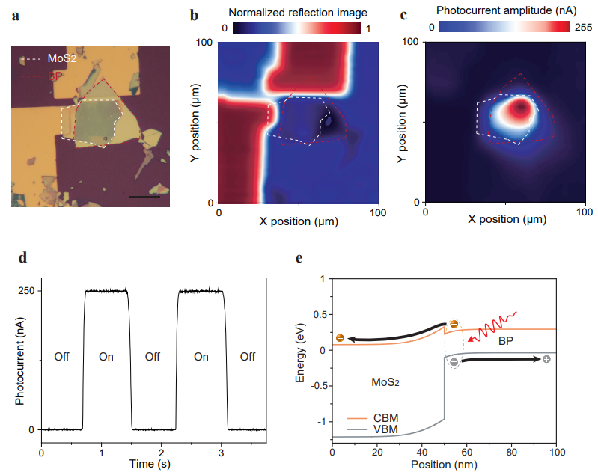
Figure S7 a. Optical microscope image of the BP/MoS₂ heterostructures, used to investigate the short-circuit photoresponses. The regions of BP and MoS₂ are outlined by the red and white dashed lines respectively. Scale bar, 10 μm. b-c. The spatially resolved (b) reflection image, and (c) photocurrent image. The results were obtained by scanning the focused laser spot (λ=3.4 μm) across the BP/MoS₂ heterostructures, operated at the short-circuit condition with BP grounded, and the generated photocurrent was detected by using the lock-in technique². The regions of BP and MoS₂ are defined by the red and white dashed lines, respectively. By comparing these two images, we could confirm that photocurrent is generated from the BP/MoS₂ heterointerface. d. DC short-circuit photoresponse of the BP/MoS₂ heterointerface. When illuminating the heterointerface with λ=3.4 μm light, we can see that the polarity of generated photocurrent is positive. This indicates that the generated electron-hole pairs could be separated at the interface and the separated electrons would transport from BP to MoS₂. e. Simulated energy band diagram of the BP/MoS₂ heterointerface, operated at the short circuit condition, and illustration of photocarrier transport.

Supplementary Section 6.
Bias dependence of EL spectra measured from the BP_{t}/MoS₂/BP_{b} heterostructure emitter
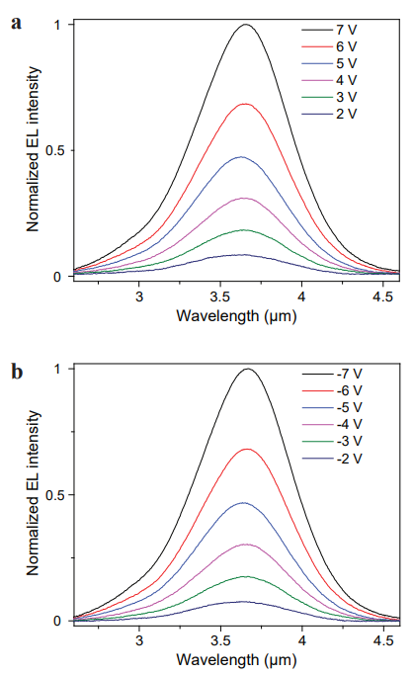
Figure S8 a. EL spectra obtained by applying different positive bias voltages to the BP_{t}/MoS₂/BP_{b} heterostructure emitter. b. EL spectra obtained by applying different negative bias voltages to the BP_{t}/MoS₂/BP_{b} heterostructure emitter. In these experiments, the bias voltage was applied across BP_{b} and BP_{t} with BP_{b} connected to the ground.

Supplementary Section 7.
Calibration of the output power and extrinsic QE of vdW heterostructure emitters
The measurement setup shown in Fig. S9a was exploited to quantify the output power (P) and extrinsic QE of emitters. Specifically, we used an objective (NA = 0.67) to collect the light generated from the emitter. The collected light was then passed through a mechanical chopper and focused onto a liquid nitrogen cooled InSb detector. The generated photovoltage (V_{photo}) from the InSb detector was measured by using the lock-in technique. Figure S9b shows the change of photovoltage when applying different bias voltages onto the BP_{t}/MoS₂/BP_{b} heterostructure emitter.
With the measurement result, we could calculate the output power of the BP_{t}/MoS₂/BP_{b} emitter (Fig. 2i, main text) by:
P= V_{photo} × $\frac{1}{R}$ × $\frac{1}{η_{path}}$ × $\frac{1}{η_{obj}}$
, where R is the responsivity of the InSb detector; $η_{path}$ is the loss induced by mirrors, focusing lenses, and an optical chopper in the optical circuit; and $η_{obj}$ is the collection efficiency of the objective. The responsivity of the detector was found to be ~600 µV/nW, calibrated by sending different powers of mid-IR laser (λ=3.6 µm) into the InSb detector. The $η_{path}$ was determined to be 0.2, obtained by coupling the mid-IR laser (λ=3.6 µm) into the optical circuit and using a power meter to measure the loss of each optical component. The collection efficiency of the objective is 0.129, quantified by the equation: $η$_{obj} =$\frac{1}{2}\left(1-\sqrt{1-{\left(NA\right)}^{2}}\right)$.
After calibrating the output power, we could then calculate the extrinsic QE of the emitter (Fig 2i, main text) by:
Extrinsic QE = e𝑁/𝐼
, where e is the electron charge; N is the number of photons emitted into the free space per second; and I is the injected current (Fig. 2e, main text).
To quantify the output power generated from the BP/MoS₂/b-As_{0.46}P_{0.54} emitter and its extrinsic QE, we again measured the photovoltages generated from the InSb detector as a function of bias voltages applied onto the BP/MoS₂/b-As_{0.46}P_{0.54} heterostructure emitter (Fig. S9c). Then, we used λ=4.6 µm mid-IR laser to recalibrate the responsivity of the InSb detector as well as $η_{path}$, and followed the same steps described above to do the calculations.

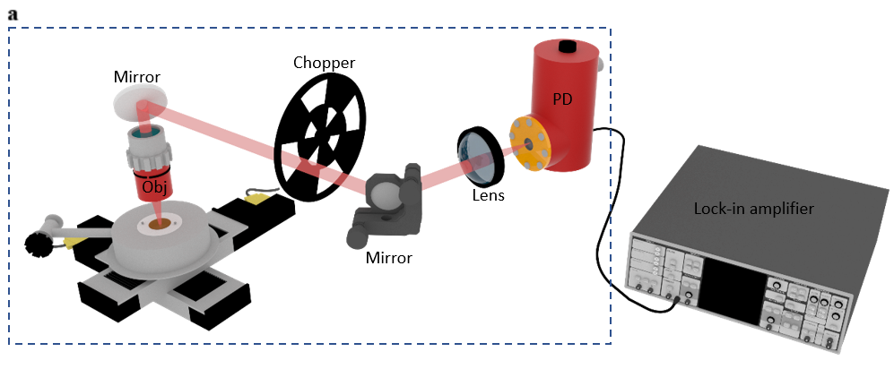
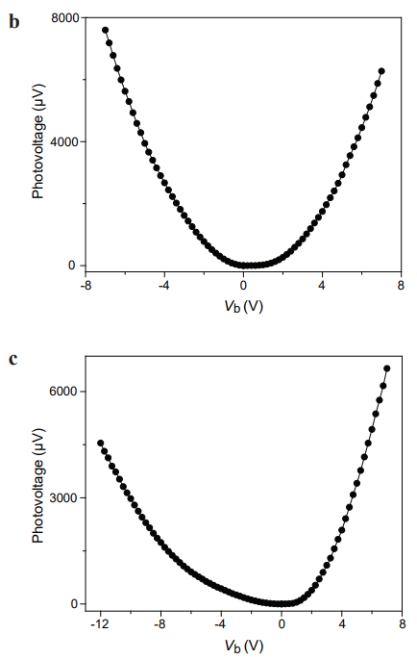

Figure S9 a. Schematic illustration of the experimental setup for quantifying the output powers of heterostructure emitters. The region enclosed by blue dashed lines is under a dry nitrogen purged environment. b. The measured photovoltage as the function of bias voltage applied onto the BP_{b}/MoS₂/BP_{t} heterostructure emitter. c. The measured photovoltage as the function of bias voltage applied onto the BP/MoS₂/b-As_{0.46}P_{0.54} heterostructure emitter.

Supplementary Section 8.
Thicknesses and crystal orientations of vdW flakes used in the BP/MoS₂/b-As_{0.46}P_{0.54} heterostructure emitter

Thicknesses of the used materials:
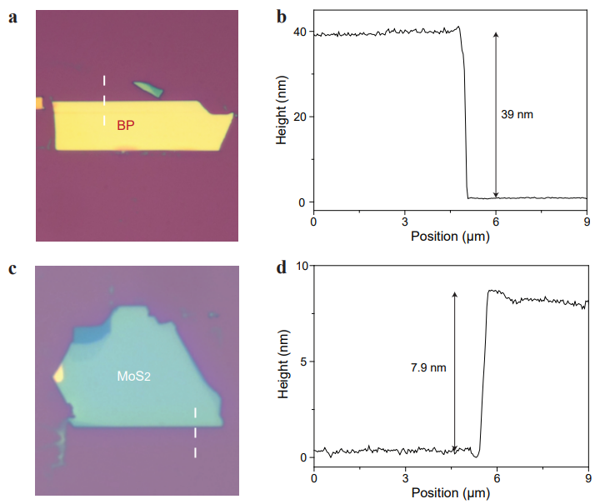
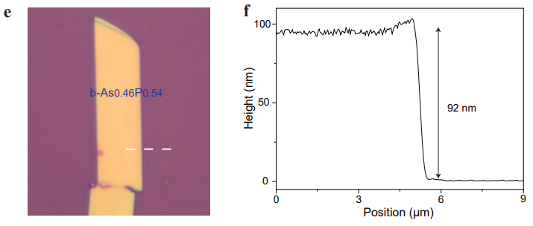
Figure S10 a. Optical microscope image of the used BP. b. AFM height profile along the white dashed line shown in panel (a). c. Optical microscope image of the used MoS₂. d. AFM height profile along the white dashed line shown in panel (c). e. Optical microscope image of the used b-As_{0.46}P_{0.54}. f. AFM height profile along the white dashed line shown in panel (e).

Crystal orientations of the used BP and b-As_{0.46}P_{0.54}:
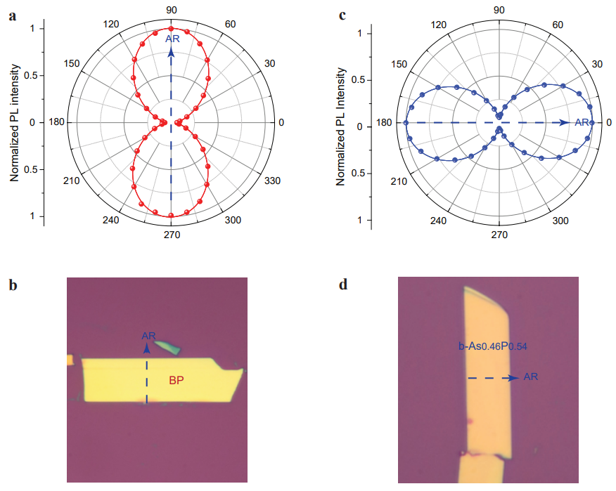
Figure S11 a. Normalized integrated PL intensity of BP, as a function of emission polarization angle. The red line is the fitted curve to the data (red dots) using the function a×sin²θ + b×cos²θ. The excitation wavelength is 2.5 µm. b. Based on the result shown in panel (a), we could identify the armchair direction of the used BP flake, as indicated by the blue arrow. c. Normalized integrated PL intensity of b-As_{0.46}P_{0.54}, as a function of emission polarization angle. The blue line is the fitted curve to the data (blue dots) using the function a×sin²θ + b×cos²θ. The excitation wavelength is 2.5 µm. d. Based on the result shown in panel (c), we could identify the armchair direction of the used b-As_{0.46}P_{0.54} flake, as indicated by the blue arrow.

Supplementary Section 9.
Short-circuit photoresponses from the b-As_{0.46}P_{0.54}/MoS₂ heterointerface

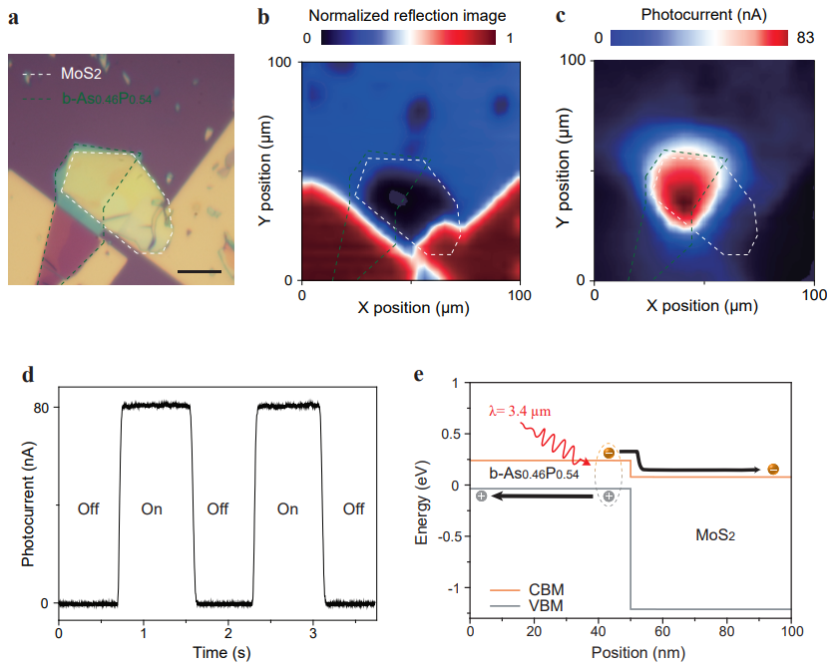
Figure S12 a. Optical microscope image of the b-As_{0.46}P_{0.54}/MoS₂ heterointerface, used to investigate the short-circuit photoresponses. The regions of b-As_{0.46}P_{0.54} and MoS₂ are outlined by the green and white dashed lines respectively. Scale bar, 10 μm. b-c. The spatially resolved (b) reflection image, and (c) photocurrent image. The results were obtained by scanning the focused laser spot (λ=3.4 μm) across the b-As_{0.46}P_{0.54}/MoS₂ heterostructures, operated at the short-circuit condition with b-As_{0.46}P_{0.54} grounded, and the generated photocurrent was detected by using the lock-in technique². The regions of b-As_{0.46}P_{0.54} and MoS₂ are defined by the green and white dashed lines, respectively. By comparing these two images, we could confirm that photocurrent is generated from the b-As_{0.46}P_{0.54}/MoS₂ heterointerface. d. DC short-circuit photoresponse of the b-As_{0.46}P_{0.54}/MoS₂ heterointerface. When illuminating the heterointerface with λ=3.4 μm light, we can see that the polarity of generated photocurrent is positive. This indicates that the generated electron-hole pairs could be separated at the interface and the separated electrons would transport from b-As_{0.46}P_{0.54} to MoS₂. e. Simulated energy band diagram of the b-As_{0.46}P_{0.54}/MoS₂ heterointerface, operated at the short circuit condition, and illustration of photocarrier transport.

Supplementary Section 10.
Bias dependence of EL spectra measured from the BP/MoS₂/b-As_{0.46}P_{0.54} heterostructure emitter
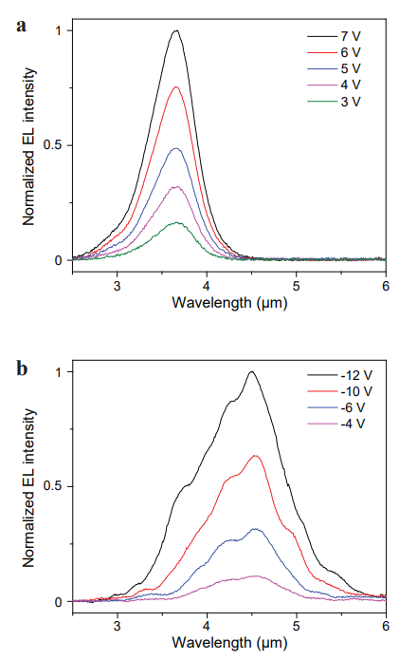
Figure S13 a. EL spectra obtained by applying different positive bias voltages onto the BP/MoS₂/b-As_{0.46}P_{0.54} heterostructure emitter. b. EL spectra obtained by applying different negative bias voltages onto the BP/MoS₂/b-As_{0.46}P_{0.54} heterostructure emitter. In these experiments, the bias voltage was applied across BP and b-As_{0.46}P_{0.54} with b-As_{0.46}P_{0.54} connected to the ground.

Supplementary Section 11.
Electric field distribution of the biased heterostructures and materials parameters used in the finite element simulations
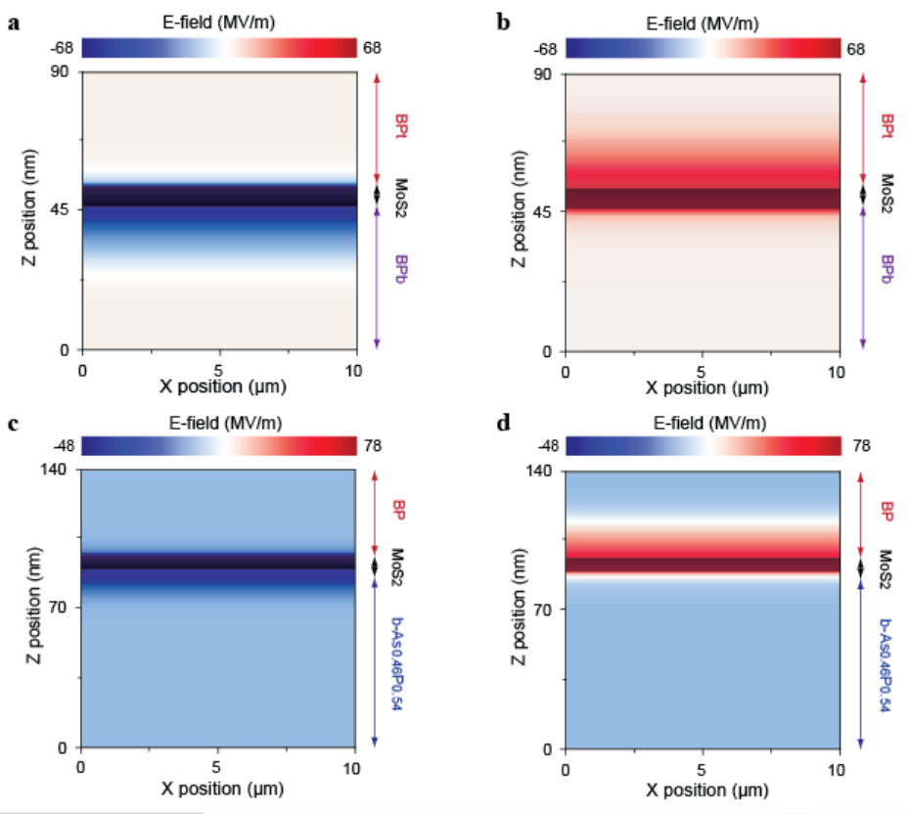
Figure S14 a-b. Electric field distribution of the (a) positively biased, and (b) negatively biased BP_{t}/MoS₂/BP_{b} heterostructure emitter. The corresponding energy band diagrams are shown in Fig. 2c-d (main text). c-d. Electric field distribution of the (c) positively biased, and (d) negatively biased BP/MoS₂/b-As_{0.46}P_{0.54} heterostructure emitter. The corresponding energy band diagrams are shown in Fig. 3c-d (main text).

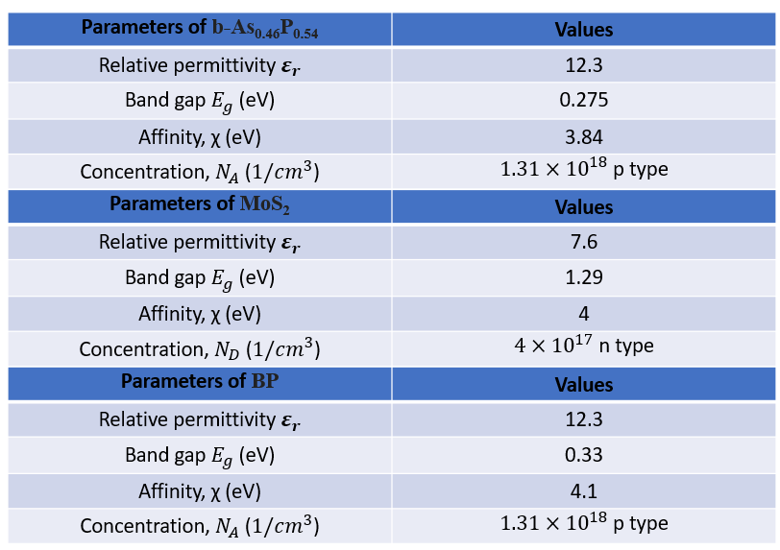
Table S2 Materials constants used in the finite element simulations. Band gap energies of BP and b-As_{0.46}P_{0.54} were taken from our PL measurements, and other materials parameters were taken from the literature³⁻⁹.

References:
1 Liu, B. L. et al. Black arsenic-phosphorus: layered anisotropic infrared semiconductors with highly tunable compositions and properties. Adv. Mater. 27, 4423-4429 (2015).
2 Chang, T. Y. et al. Ultra-broadband, high speed, and high-quantum-efficiency photodetectors based on black phosphorus. ACS Appl. Mater. & Interfaces 12, 1201-1209 (2020).
3 Li, D. H. et al. Electric-field-induced strong enhancement of electroluminescence in multilayer molybdenum disulfide. Nat. Commun. 6, 7509 (2015).
4 Mak, K. F., Lee, C., Hone, J., Shan, J. & Heinz, T. F. Atomically thin MoS₂: a new direct-gap semiconductor. Phys. Rev. Lett. 105, 136805 (2010).
5 Bhaskar, P., Achtstein, A. W., Vermeulen, M. J. W. & Siebbeles, L. D. A. Radiatively dominated charge carrier recombination in black phosphorus. J. Phys. Chem. C 120, 13836-13842 (2016).
6 Liu, M. Q. et al. High yield growth and doping of black phosphorous with tunable electronic properties. Mater. Today 36, 91-101 (2020).
7 Chen, Y. F. et al. Unipolar barrier photodetectors based on van der Waals heterostructures. Nat. Electron. 4, 357-363 (2021).
8 Chen, C. et al. Bright mid-infrared photoluminescence from thin-film black phosphorus. Nano Lett. 19, 1488-1493 (2019).
9 Li, D. et al. Nonvolatile floating-gate memories based on stacked black phosphorus-boron nitride-MoS₂ heterostructures. Adv. Fun. Mater. 25, 7360-7365 (2015).

