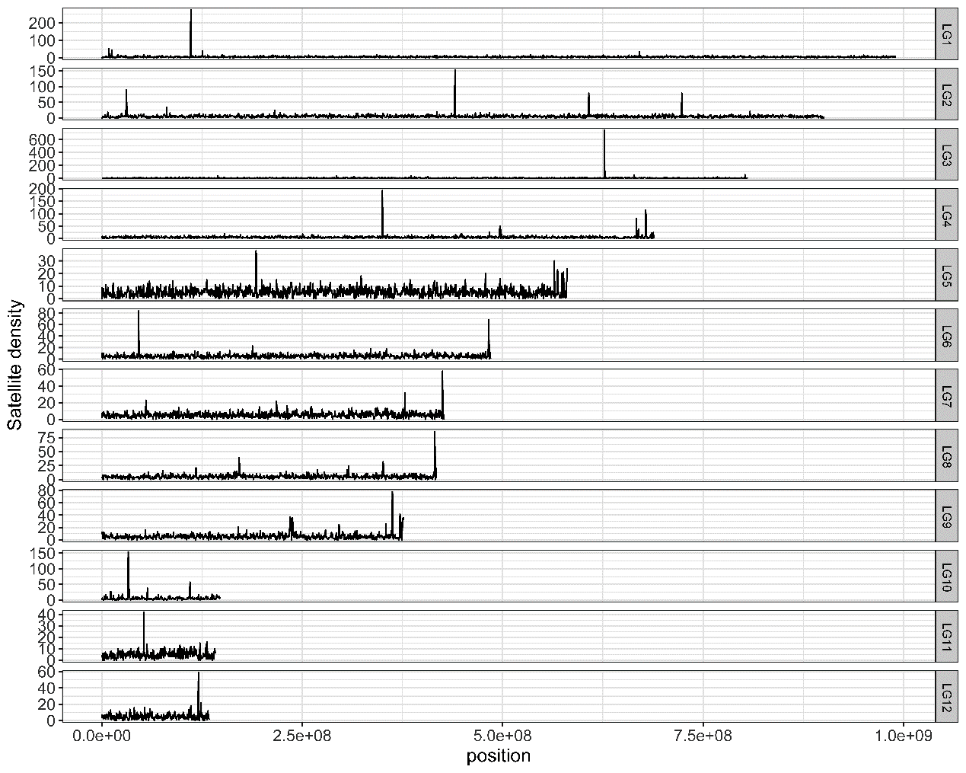
Fig S1. Satellite distribution along chromosomes in the migratory locust genome.

a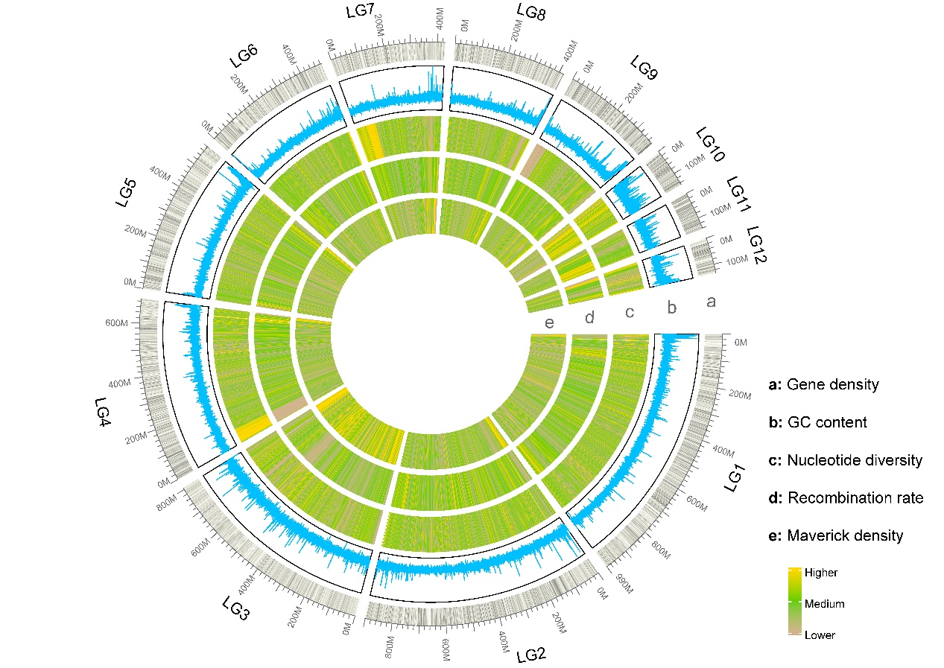
b
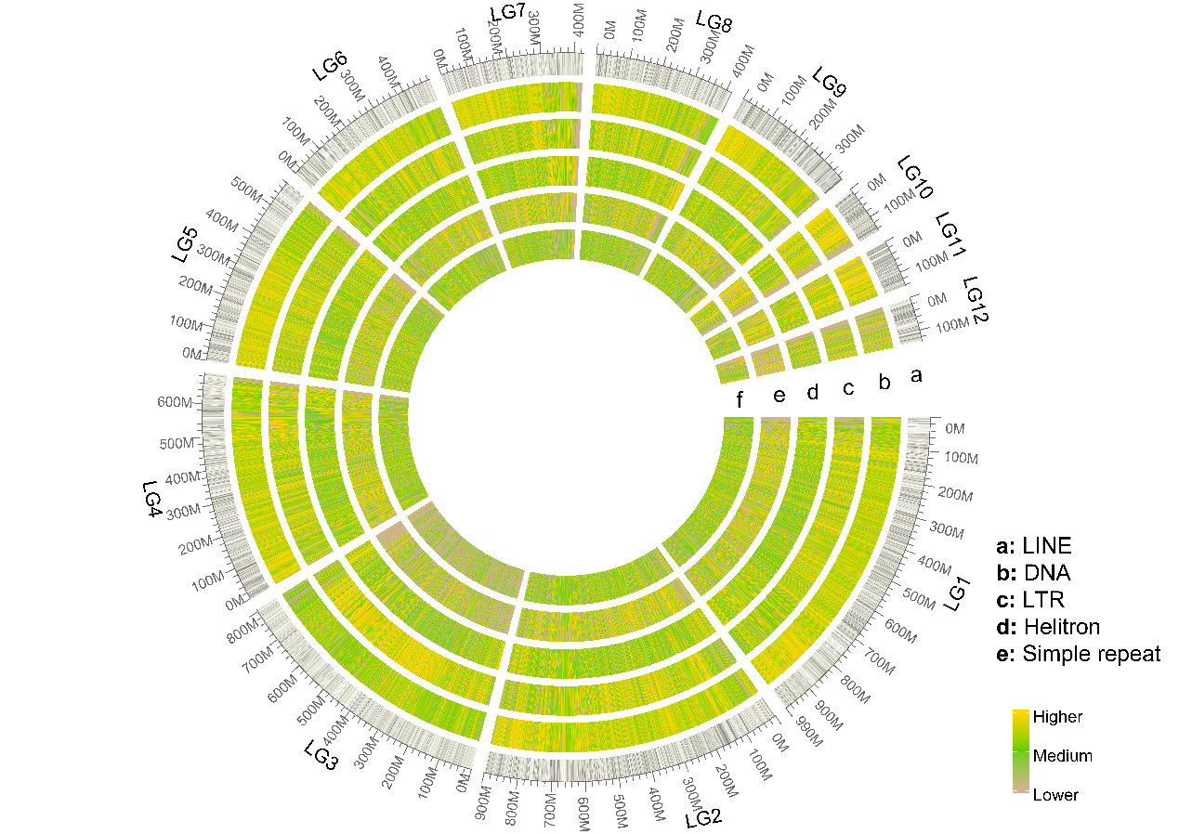

Fig S2. Genomic features along migratory locust chromosomes. a, gene density, GC content, nucleotide diversity, recombination rate; b, TE profile including LINE, DNA, LTR, Helitron transposons and simple repeat.
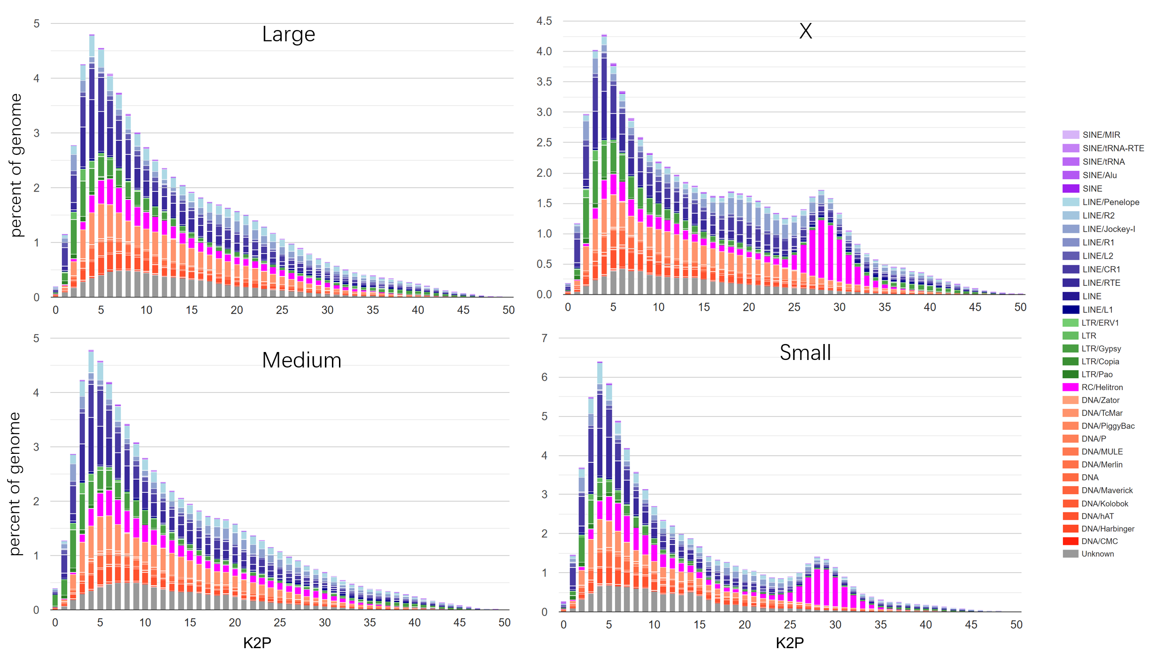
Fig S3. TE percentage and K2P profile. According to the size, chromosomes were classified into four categories: Large, Medium, Small and X.

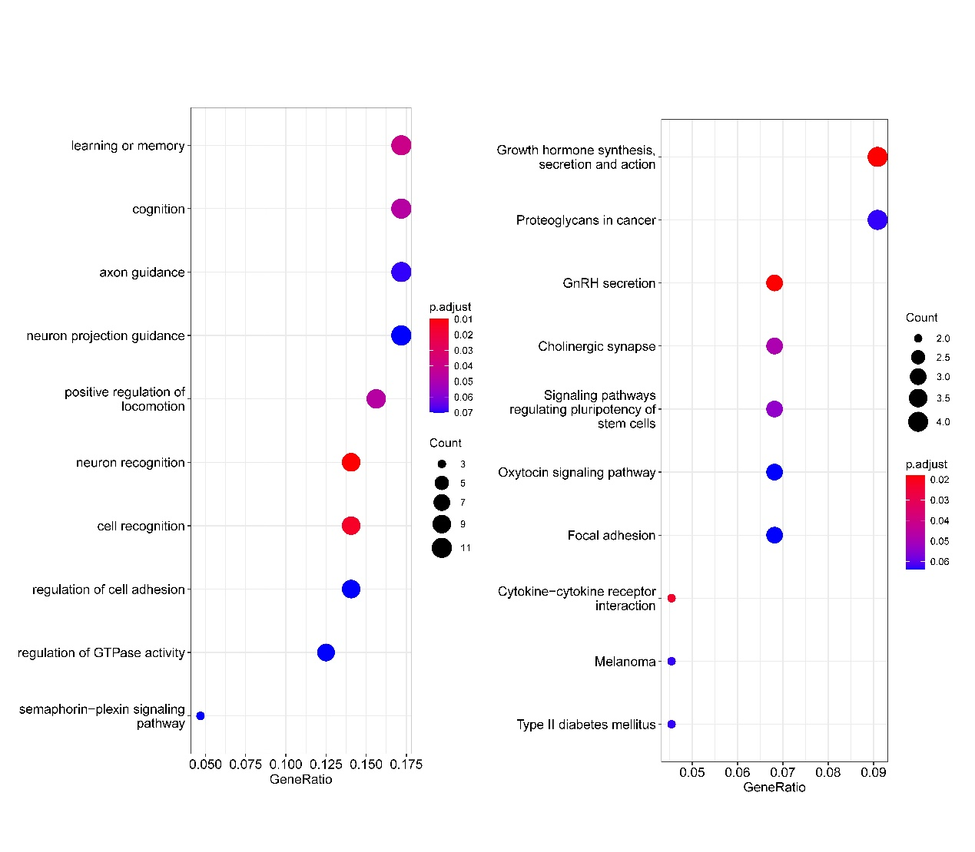
Fig S4. Functional enrichment of conservative X-linked genes. Left is GO terms, right is KEGG terms.

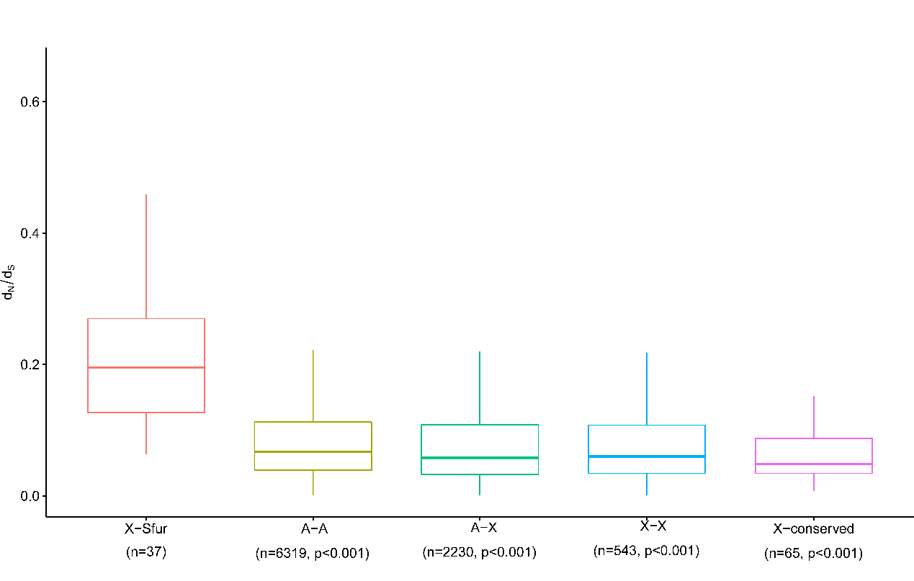
Fig S5. dN/dS analysis in true bugs. P values were calculated between X-Sfur and others by 1000 replicates bootstrapping.

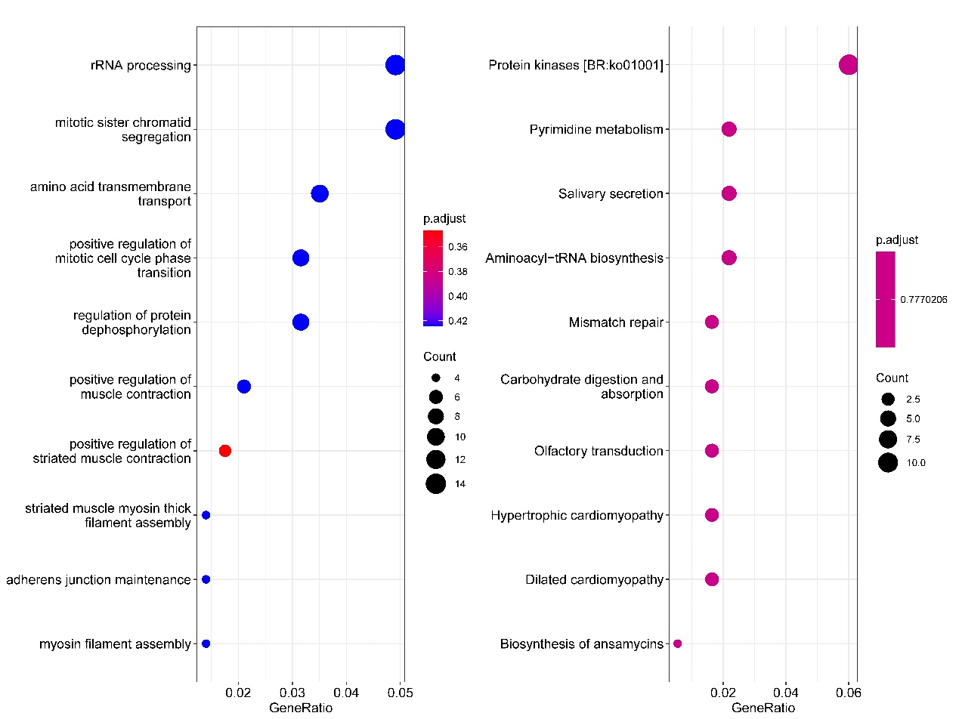
Fig S6. Function enrichment of positive selected genes. Left is GO terms; right is KEGG terms.

Table S1. Gene number, gene density and intron length of each chromosome.
chr | length | gene number | gene density | mean intron length
LG1 | 991018619 | 3157 | 3.19E-06 | 15383
LG2 | 901651818 | 3040 | 3.37E-06 | 15174
LG3/X | 806237231 | 1985 | 2.46E-06 | 18258
LG4 | 689659731 | 2247 | 3.26E-06 | 15184
LG5 | 581103692 | 1850 | 3.18E-06 | 15713
LG6 | 485803872 | 1439 | 2.96E-06 | 16076
LG7 | 427868946 | 1218 | 2.85E-06 | 16448
LG8 | 418016564 | 1421 | 3.40E-06 | 15127
LG9 | 377406850 | 2047 | 5.42E-06 | 15032
LG10 | 148047574 | 732 | 4.94E-06 | 16256
LG11 | 142112905 | 638 | 4.49E-06 | 13794
LG12 | 134840001 | 493 | 3.66E-06 | 12899

Table S2. d_{N}, d_{S} and d_{N}/d_{S} values of different categories.
Category |  | d_{N} | d_{S} | d_{N}/d_{S}
X-conserved |  | 0.015714^{d} | 0.137885^{d} | 0.101397e
A-X |  | 0.028111^{c} | 0.190683^{c} | 0.144579^{d}
X-X |  | 0.028380^{c} | 0.166257^{d} | 0.159734^{c}
A-A |  | 0.041803^{b} | 0.213579^{b} | 0.190432^{b}
X-Lmig |  | 0.103788ª | 0.290710ª | 0.372944ª

