Supplementary file 5
Preliminary induction of the StSPS protein
The result showed that the StSPS1 protein was expressed as an inclusion body, and the concentration of 1.0 mM IPTG could achieve the best induction effect.
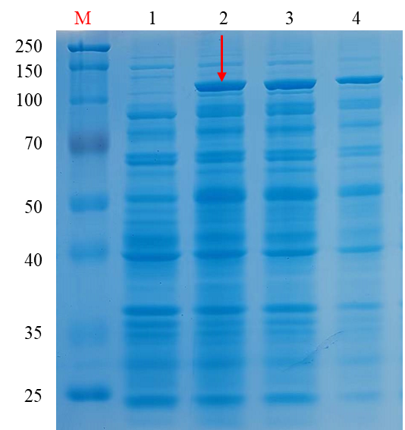
Lane '1' represents the band before induction. Lane '2 / 3 / 4' represent the sediment band induced by 1.0mM, 0.5mM and 0.1mM IPTG respectively. The red arrow points to the best induction band.

