Supplementary Information

Polyfluorinated Crosslinker-based Solid Polymer Electrolytes for Long-Cycling 4.5 V Lithium Metal Batteries
Lingfei Tang^{1,2†}, Bowen Chen^{1,2†}, Changqi Ma^{1,2†}, Zhonghan Zhang^{3,4}, Junchao Chen⁵, Fengrui Zhang^{1,2}, Qingyu Dong², Guoyong Xue^{1,2}, Daiqian Chen², Chenji Hu⁵, Shuzhou Li⁴, Zheng Liu^{3,4}, Yanbin Shen^{1,2}, Qi Chen^{1,2}*, Liwei Chen^{2,5,6}*

¹ School of Nano-Tech and Nano-Bionics, University of Science and Technology of China, Hefei 230026, China

² i-Lab, Suzhou Institute of Nano-Tech and Nano-Bionics, Chinese Academy of Sciences, Suzhou 215123, China

³ CNRS-International-NTU-Thales Research Alliance, Nanyang Technological University, Research Techno Plaza 50 Nanyang Drive, Border X Block, Level 6. Singapore 637553

⁴ School of Materials Science and Engineering, Nanyang Technological University, 50 Nanyang Ave, #01-30 General Office, Block N4.1, Singapore 639798

⁵ School of Chemistry and Chemical Engineering, In situ Center for Physical Sciences, Shanghai Electrochemical Energy Device Research Center, and Frontiers Science Center for Transformative Molecules, Shanghai Jiao Tong University, Shanghai 200240, China

⁶ Solid-State Battery Research Center, Global Institute of Future Technology, Shanghai Jiao Tong University, Shanghai 200240, China

Author Contributions
† These authors contributed equally to this work.

Corresponding authors
*E-mail: qchen2011@sinano.ac.cn; lwchen2018@sjtu.edu.cn

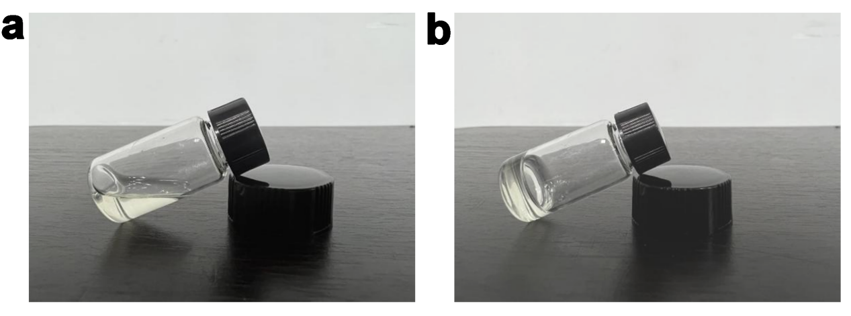
Supplementary Fig. 1 Photographs of P(IL-OFHDODA-VEC) before (a) and after (b) polymerization.

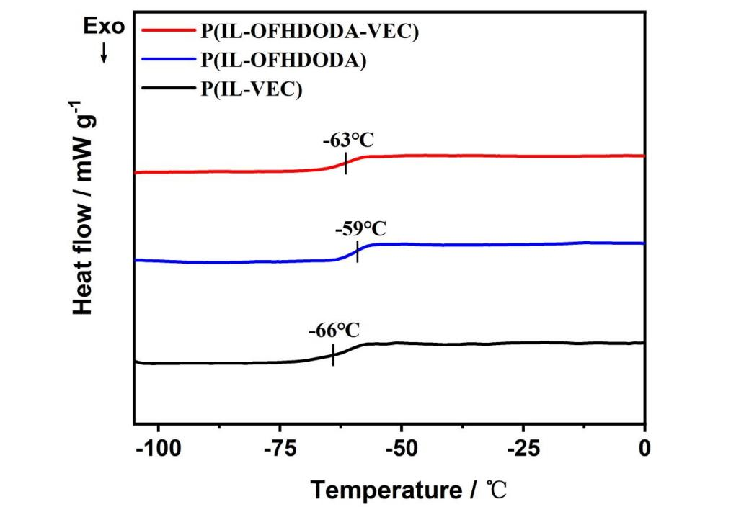
Supplementary Fig. 2 DSC curves of the P(IL-VEC), P(IL-OFHDODA) and P(IL-OFHDODA-VEC).

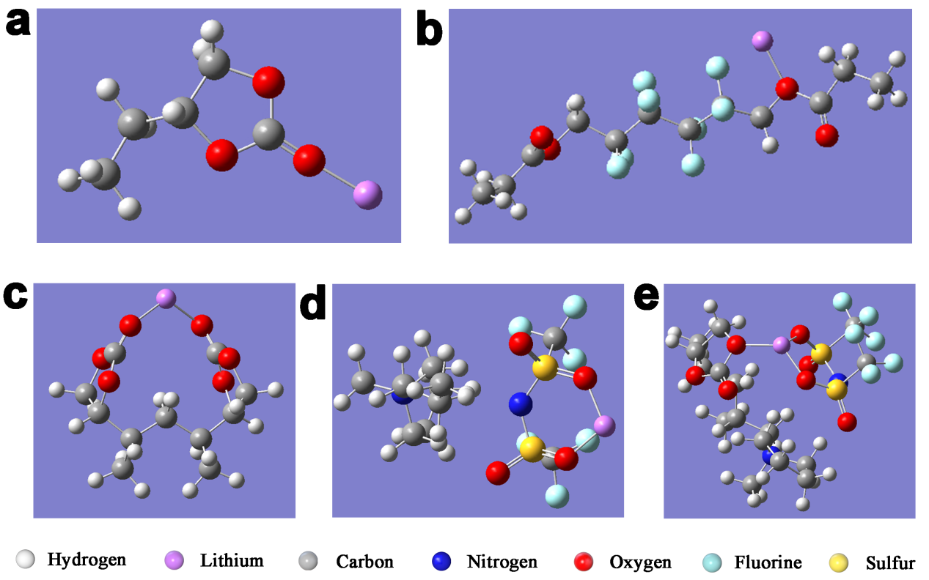
Supplementary Fig. 3 Adsorption energy of Li⁺ on O of geometrically optimized monomers or dimers of SPE via DFT calculation. a Li⁺-O in the VEC monomer. b Li⁺-O in the OFHDODA monomer. c O-Li⁺-O in the VEC-VEC dimer. d O-Li⁺-O in the IL monomer. e O-Li⁺-O in the VEC-IL dimer.

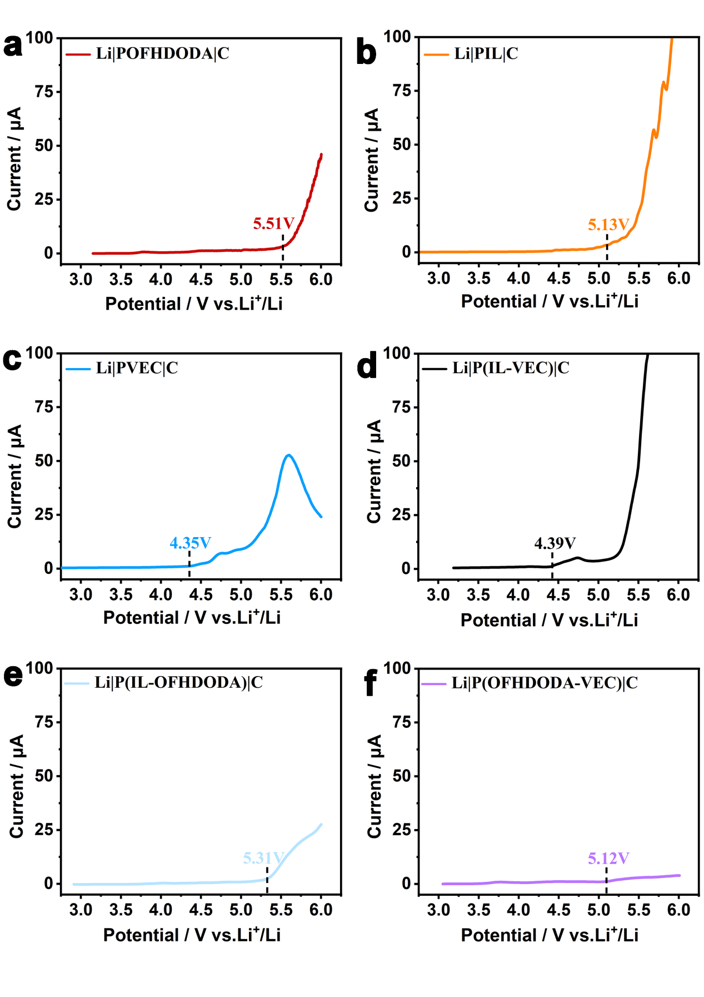
Supplementary Fig. 4 LSV curves of POFHDODA (a), PIL (b), PVEC (c), P(IL-VEC) (d), P(IL-OFHDODA) (e) and P(OFHDODA-VEC) (f).

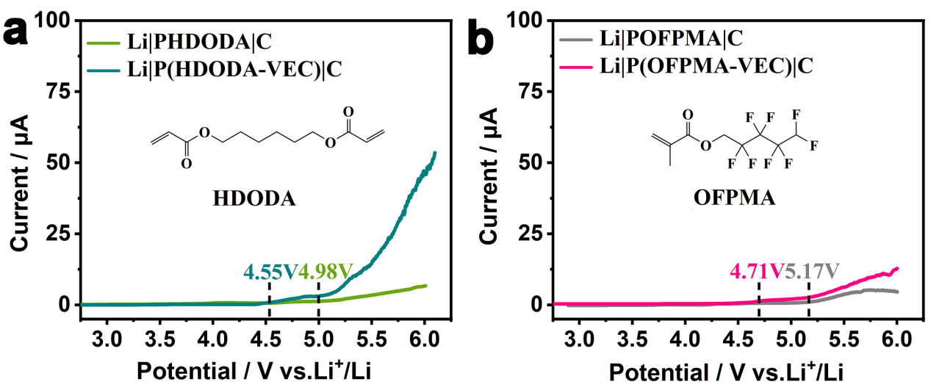
Supplementary Fig. 5 LSV curves of PHDODA and P(HDODA-VEC) (a), POFPMA and P(OFPMA-VEC) (b).

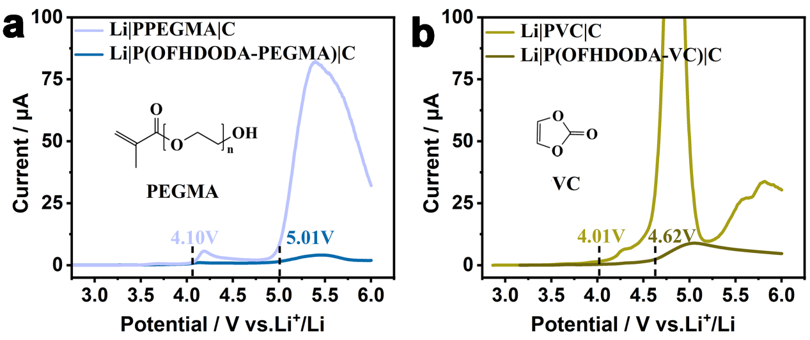
Supplementary Fig. 6 LSV curves of PPEGMA and P(OFHDODA-PEGMA) (a), PVC and P(OFHDODA-VC) (b).

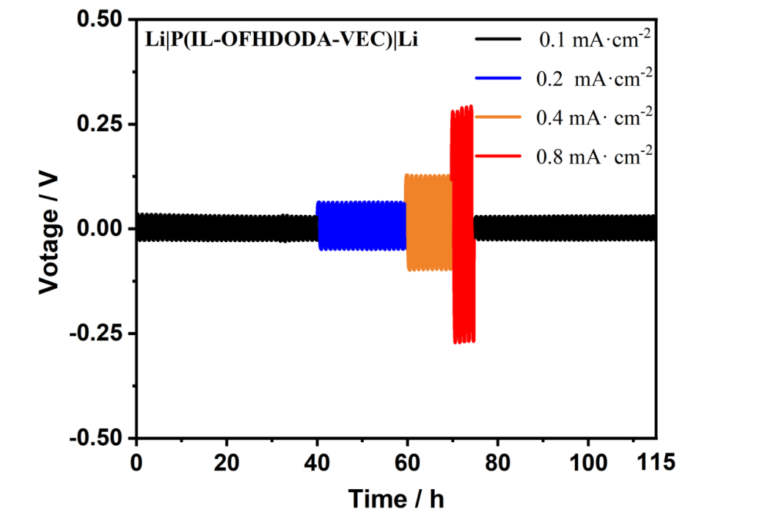
Supplementary Fig. 7 Galvanostatic cycling of the lithium symmetric cells with P(IL-OFHDODA-VEC) under current densities range from 0.1 to 0.8 mA cm⁻².

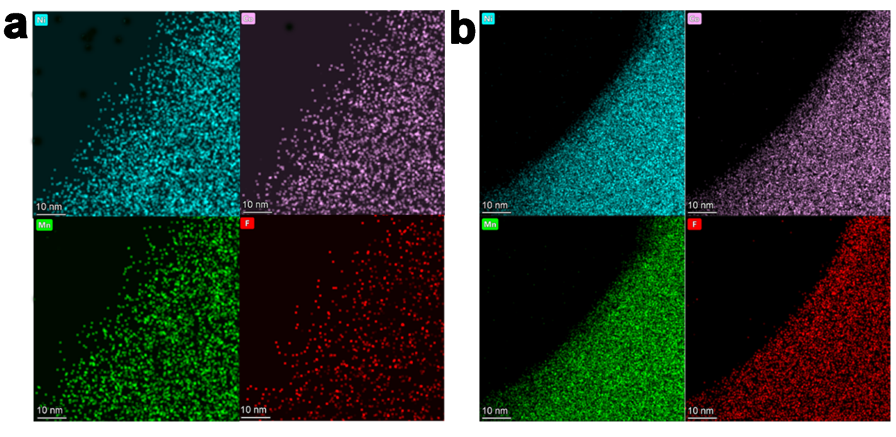
Supplementary Fig. 8 HRTEM corresponding EDS mappings of Ni, Co, Mn and F elements of uncycled (a) and cycled (b) NCM523 cathode particles.

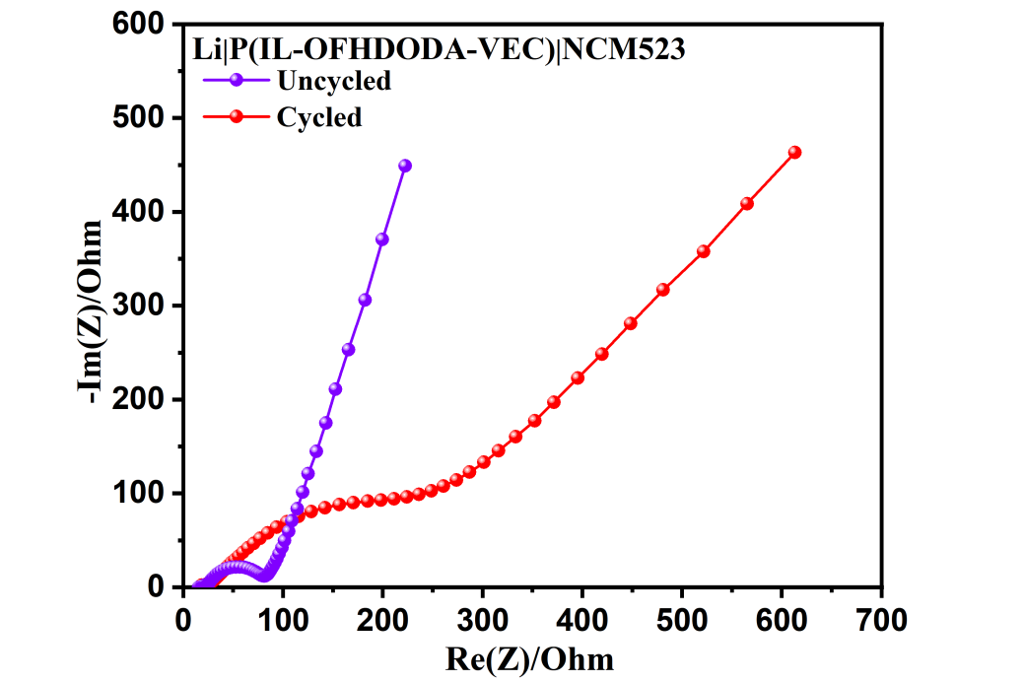
Supplementary Fig. 9 EIS of the Li|P(IL-OFHDODA-VEC)|NCM523 battery before and after 200 cycles.

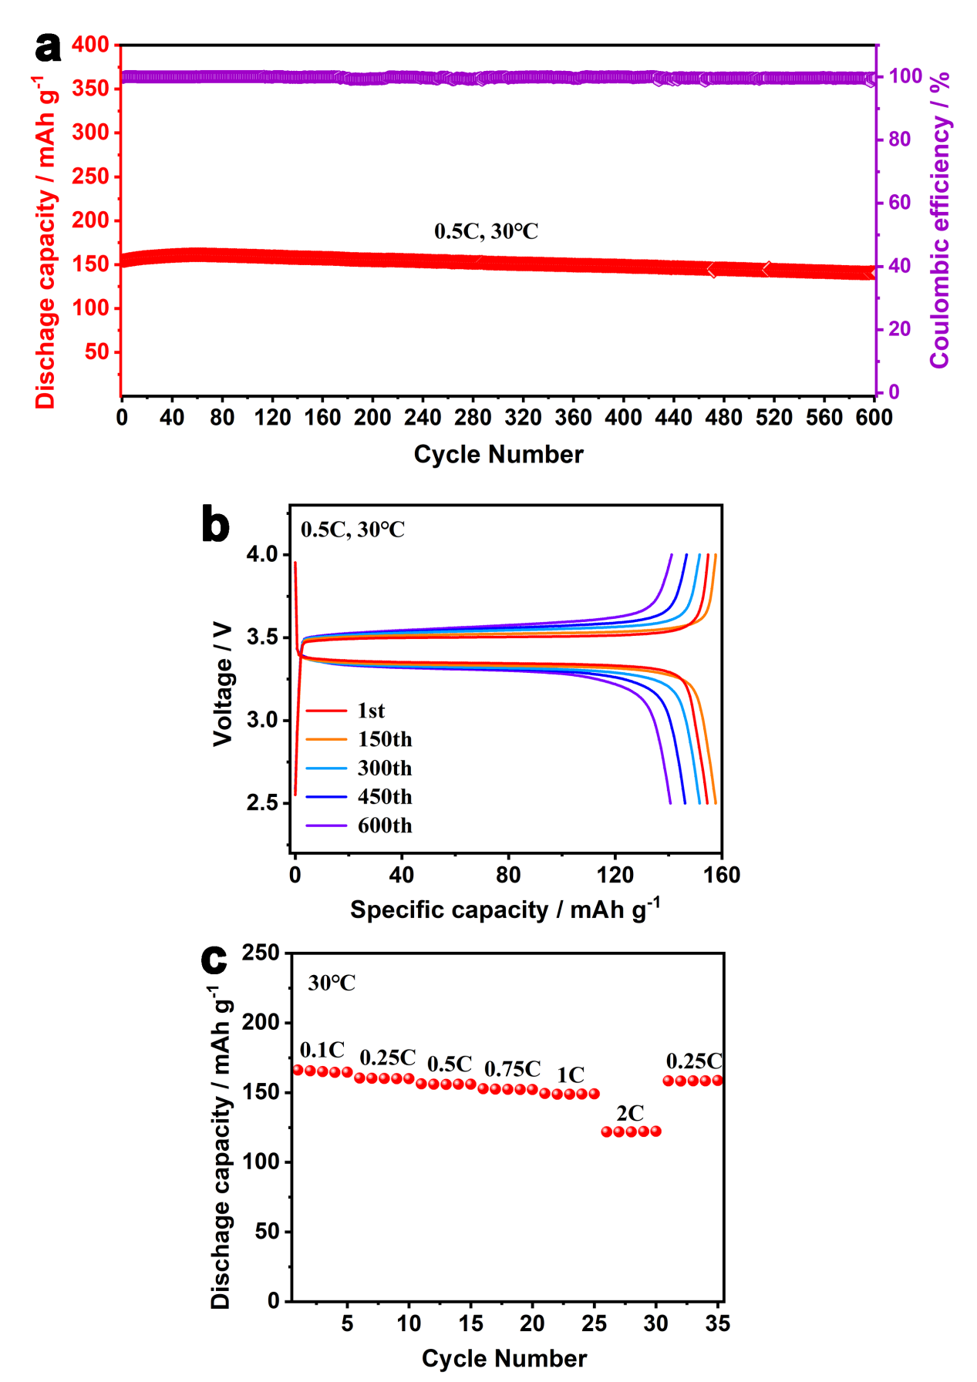
Supplementary Fig. 10 a Cycling performance of Li|P(IL-OFHDODA-VEC)|LFP full cell at 0.5C. b 1-600th charge and discharge curves of Li|P(IL-OFHDODA- VEC)|LFP full cell. c Rate performance of Li|P(IL-OFHDODA-VEC)|LFP full cell.

Supplementary Table 1 Adsorption energy of Li⁺ on O of different monomers and dimers of SPE via DFT calculation.
Monomer or dimer | Adsorption type | Adsorption energy  kJ mol⁻¹
VEC monomer | Li⁺-O_{VEC} | -238.47
OFHDODA monomer | Li⁺-O_{OFHDODA} | -262.46
VEC-VEC dimer | O_{VEC}-Li⁺-O_{VEC} | -363.59
IL monomer | O_{IL}-Li⁺-O_{IL} | -369.43
VEC-IL dimer | O_{VEC}-Li⁺-O_{IL} | -431.37

Supplementary Table 2 Summary of state-of-the-art Li|SPE|NCM full cell performance
SPE based LMBs | Conductivity of SPE  mS cm⁻¹ | Rate  C | Initial discharge  mAh g⁻¹ | Cutoff voltage  V | Cycle | Capacity retention  % | Ref.
Li|P(IL-OFHDODA-VEC)|NCM523 | 1.37@25℃ | 0.5 | 164 | 4.5 | 200@30℃ | 90 | This work
Li|s-CPEG|NCM523 | 0.18@30℃ | 0.1 | 135 | 4.2 | 17@60℃ | 92 | 1
Li|PT-PEO-PT|NCM523 | 0.11@40℃ | 0.2 | 111 | 4.2 | 75@40℃ | 80 | 2
Li|FB|NCM523 | 0.15@70℃ | 0.1 | 124 | 4.2 | 10@70℃ | 97 | 3
Li|PEM|NCM523 | 1.99@30℃ | 0.5 | 142 | 4.3 | 50@40℃ | 89 | 4
Li|PEGDME-4|NCM523 | 0.15@60℃ | 0.2 | 165 | 4.5 | 200@N/A | 59 | 5
Li|PDADMA FSI|NCM111 | 0.07@80℃ | 0.05 | 188 | 4.3 | 50@80℃ | 68 | 6
Li|poly-DOL|NCM622 | 1.10@25℃ | 0.1 | 160 | 4.2 | 5@N/A | 96 | 7
Li|DLPE|NCM622 | 0.01-0.05@70℃ | 0.05 | 160 | 4.2 | 80@70℃ | 80 | 8
Li|XPEEC-1|NCM622 | 0.02@25℃ | 0.1 | 141 | 4.3 | 100@25℃ | 90 | 9
Li|P-P(20)|NCM811 | 0.45@60℃ | 0.1 | 162 | 4.2 | 50@60℃ | 75 | 10
Li|FMC-ASPE-Li|NCM811 | 0.64@80℃ | 0.44 | 112 | 4.2 | 100@70℃ | 87 | 11
Li|FPCSPE3-40|NCM811 | 0.05@25℃ | 0.1 | 218 | 4.5 | 200/300@25℃ | 85/70 | 12

Reference
1. Zhao, Y., et al. Polymer electrolyte with dual functional groups designed via theoretical calculation for all-solid-state lithium batteries. J. Power Sources 450, 227614 (2020).
2. Zheng, J., et al. Double Ionic-Electronic Transfer Interface Layers for All-Solid-State Lithium Batteries. Angew. Chem. Int. Ed. 60, 18448-18453 (2021).
3. Jia, M., et al. Fluorinated Bifunctional Solid Polymer Electrolyte Synthesized under Visible Light for Stable Lithium Deposition and Dendrite‐Free All‐Solid‐State Batteries. Adv. Funct. Mater. 31, 2101736 (2021).
4. Liu, F., et al. Polymer Electrolyte Membrane with High Ionic Conductivity and Enhanced Interfacial Stability for Lithium Metal Battery. ACS Appl. Mater. Interfaces 12, 22710-22720 (2020).
5. Yang, X., et al. Determining the limiting factor of the electrochemical stability window for PEO-based solid polymer electrolytes: main chain or terminal –OH group? Energy Environ. Sci. 13, 1318-1325 (2020).
6. Wang, X., et al. Poly(Ionic Liquid)s-in-Salt Electrolytes with Co-coordination-Assisted Lithium-Ion Transport for Safe Batteries. Joule 3, 2687-2702 (2019).
7. Zhao, Q., Liu, X., Stalin, S., Khan, K. & Archer, L. A. Solid-state polymer electrolytes with in-built fast interfacial transport for secondary lithium batteries. Nat. Energy 4, 365-373 (2019).
8. Arrese-Igor, M., et al. Toward High-Voltage Solid-State Li-Metal Batteries with Double-Layer Polymer Electrolytes. ACS Energy Lett. 7, 1473-1480 (2022).
9. Jung, Y. C., Park, M. S., Kim, D. H., Ue, M., Eftekhari, A. & Kim, D. W. Room-Temperature Performance of Poly(Ethylene Ether Carbonate)-Based Solid Polymer Electrolytes for All-Solid-State Lithium Batteries. Sci. Rep. 7, 17482 (2017).
10. Yang, L., et al. The plasticizer-free composite block copolymer electrolytes for ultralong lifespan all-solid-state lithium-metal batteries. Nano Energy 100, 107499 (2022).
11. Su, Y., et al. Rational design of a topological polymeric solid electrolyte for high-performance all-solid-state alkali metal batteries. Nat. Commun. 13, 4181 (2022).
12. Wang, Y., Chen, S., Li, Z., Peng, C., Li, Y. & Feng, W. In-situ generation of fluorinated polycarbonate copolymer solid electrolytes for high-voltage Li-metal batteries. Energy Storage Mater. 45, 474-483 (2022).

