Figure S3 : Survival curves based on weighted Kaplan-Meier estimates in locations where MDA has been implemented (MDA locations, in red) and where it has not (non MDA locations, in blue), before and after the first round of MDA (October, 1 2020) in Angumu health zone, Ituri province, DRC, March 2021.
- All causes mortality
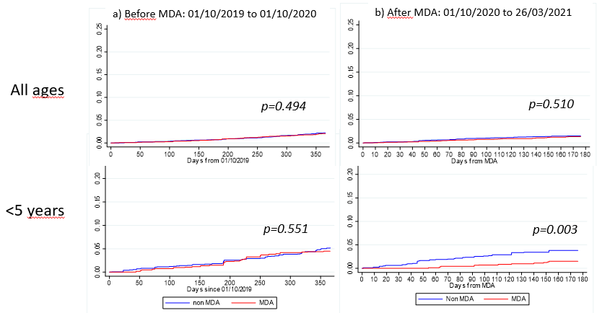

- Malaria-specific mortality
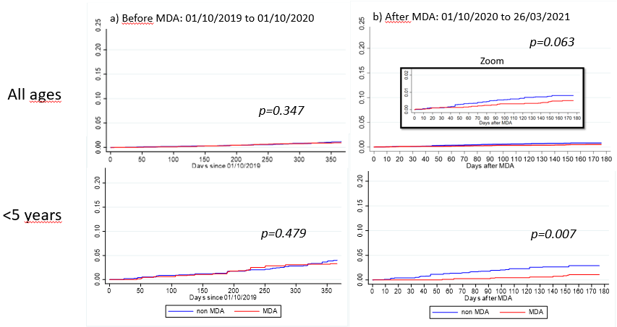
P value are based on log-rank tests and are considered significant if p<0.05.

