Supplementary Information.
Table 1: Baseline laboratory investigations in an infant with severe COVID-19.
Microbiological | Haematological and biochemical | Inflammatory markers
- SARS-CoV-2 PCR: positive (oro/nasopharyngeal specimens and urine; equivocal in blood)  - Blood cultures: negative | - Haemoglobin: 136 g/L  (NR 95 - 135)  - Platelets: 79 x10e9/L  (NR 150 - 400)  - Total white cell count: 3.9 x10e9/L (NR 6.0 - 18.0)  - Lymphocytes: 0.43x10e9/L  (NR 4.0 - 10.0)  - Neutrophils: 3.24 (NR 1 - 8.5x10e9/L)  - Urea: 3.7 mmol/L  (NR 1.3 - 6.6)  - Creatinine: 17 µmol/L  (NR 10 - 30)  - Alanine aminotransferase: 133 IU/L (NR <50) | - Ferritin: 9487 µg/L (NR 11-87)  - Lactate dehydrogenase: 2060 U/L (NR 120-246)  - Procalcitonin: 16 µg/L (NR <0.06)  - D-dimer: 5.86 µg/mL (NR<0.5)  - Troponin: 0.7 ng/mL (NR <0.034)
NR=normal range
Table 2: Viral load inferred from cycle threshold (Ct) values from nasopharyngeal/oropharyngeal (NOP) and urine samples demonstrating rapid reduction in viral load over the course of the illness.
Time-point (from admission to intensive care) | Date of collection | Cycle threshold (Ct value) | Quantification cycle (Cq) and viral load (copies/ml) in urine samples
Time-point (from admission to intensive care) | Date of collection | Cycle threshold (Ct value) | RdRp# | E^ | RdRp^
Day -2 | 12/6 | 8.81*
Day 3 (T1) | 17/6 | 18.45 | 32.877  59375.582 | 33.692  9464.104 | 37.03  5858.09
Day 5 (T2) | 19/6 | 25.8 | Not detected | Not detected | Not detected
Day 6 | 20/6 | 28.57 | - | - | -
Day 10 (T3) | 24/6 | 33.47 | Not detected | Not detected | Not detected
Day 15 | 29/6 | 32.88 | - | - | -
Day 22 | 6/7 | 33.6 | - | - | -
Day 28 (T4) | 12/7 | Not detected | Not detected | Not detected | Not detected
Day (T5) | 29/9 | Not detected | Not detected | Not detected | Not detected

Cycle threshold values from the TibMolbiol LightMix Modular SARS-CoV(COVID19) E-gene for day 5-28 samples. *Day 0 sample performed on initial presentation performed at a different hospital laboratory using AusDiagnostics High-Plex system utilising Multiplex Tandem PCR (MT-PCR).
# Chan, J. F. et al. Improved Molecular Diagnosis of COVID-19 by the Novel, Highly Sensitive and Specific COVID-19-RdRp/Hel Real-Time Reverse Transcription-PCR Assay Validated In Vitro and with Clinical Specimens. Journal of clinical microbiology 58, doi:10.1128/JCM.00310-20 (2020).¹¹
^ Corman VM, Landt O, Kaiser M, Molenkamp R, Meijer A, Chu DK, Bleicker T, Brünink S, Schneider J, Schmidt ML, Mulders DG, Haagmans BL, van der Veer B, van den Brink S, Wijsman L, Goderski G, Romette JL, Ellis J, Zambon M, Peiris M, Goossens H, Reusken C, Koopmans MP, Drosten C. 2020. Detection of 2019 novel coronavirus (2019-nCoV) by real-time RT-PCR. Euro Surveill 25. doi: 10.2807/1560 7917.ES.2020.25.3.2000045. ¹²
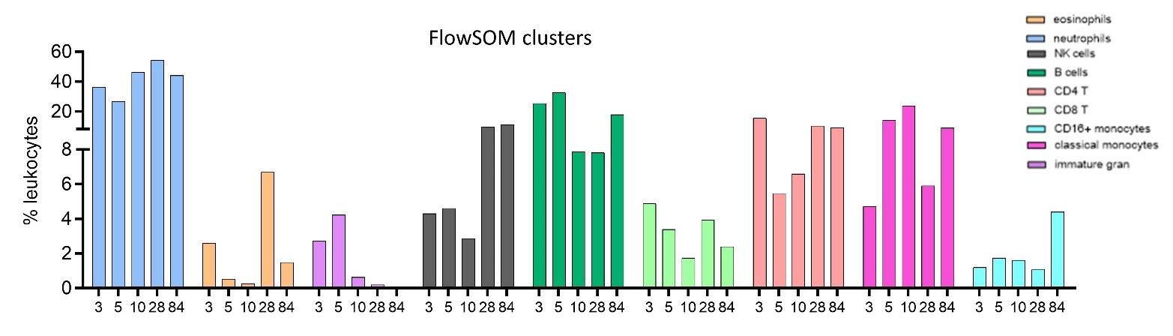

Supplementary Figure 1. Unsupervised analysis of whole blood flow cytometry data. Annotated FlowSOM cluster frequencies for neutrophils, eosinophils, immature granulocytes, NK cells, B cells, CD8 T cells, CD4 T cells, classical monocytes and CD16+ monocytes as
proportion of leukocytes (CD45+ live single cells).
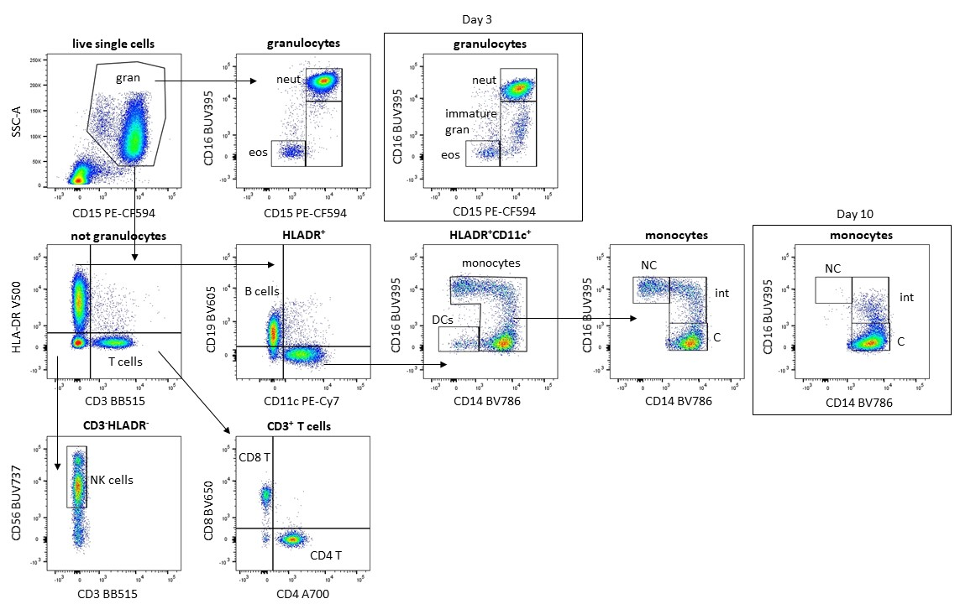

Supplemental Figure 2. Whole blood flow cytometry gating strategy. Granulocytes were selected within CD45⁺ leukocytes based on their SSC profile and CD15 expression. Neutrophils were CD15⁺CD16⁺ and eosinophils were CD15⁺CD16⁻. Intermediate granulocytes were identified during the first 10 days, represented here at day 3. Within the non-granulocyte fraction, CD3 T cells were identified and classified into CD4 and CD8 T cells. B cells were identified based on CD19 and HLA-DR expression. CD11c⁺CD14⁺ monocytes and their subsets were gated based on CD16 expression (NC: non classical, int: intermediate and C: classical). Total dendritic cells were HLADR⁺CD11c⁺CD14⁻ and NK cells were HLADR⁻CD3⁻CD56⁺ cells
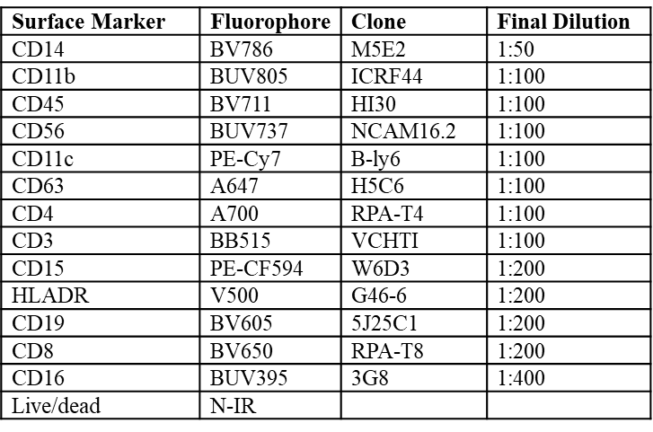
Supplementary Table 3. Flow cytometry antibody cocktail for whole blood phenotyping

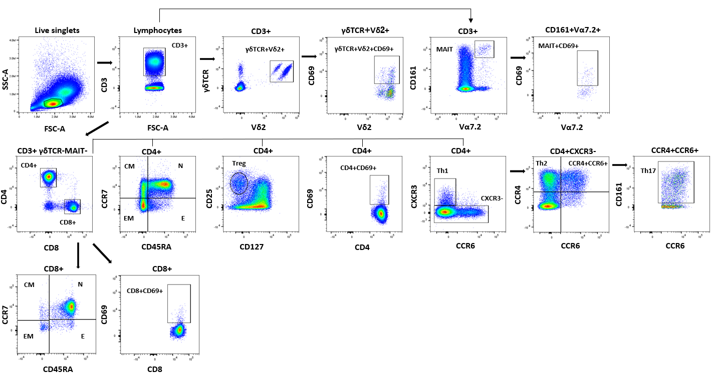
Supplementary Figure 3. Peripheral blood mononuclear cells gating strategy. T-cells were identified by CD3+ expression on live single lymphocytes. T-cells were further categorised into CD4+, CD8+, γδTCR+Vδ2+ and CD161+Vα7.2+ (MAIT cells). γδTCR+ cells and MAIT cells were gated out from CD4+ and CD8+ T-cells. From the CD4+ T-cells we further identified their subsets. CXCR3+ cells were considered Th1, CXCR3-CCR4+CCR6- cells were considered Th2, CXCR3-CCR4+CCR6+CD161+ cells were considered Th17 and CD25^{hi}CD127^{lo} cells were considered Tregs. CCR7 and CD45RA were used to discriminate CD4+ and CD8+ cells into their memory subsets (Central memory (CM), effector memory (EM), naïve (N) and effector (E)). To determine activation status, CD69 was gated from all T-cell subsets, CD4+, CD8+, γδTCR+Vδ2+ and MAIT cells.
Supplementary Table 4. Flow cytometry antibody cocktail for peripheral blood mononuclear cell phenotyping

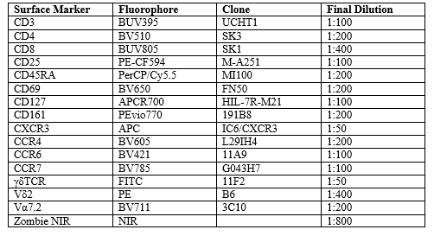

Supplementary Figure 4: Additional cytokines/chemokines upregulated following SARS-CoV-2 stimulated of peripheral blood mononuclear cells at Day 84. Following stimulation for 4 days we observed upregulation of IL-1β, IL-1ra, IL-8, eotaxin, FGF basic, G-CSF, GM-CSF, MCP-1, MIP-1α, MIP-1β, RANTES, PDGF and VEGF in the SARS-COV2 infected patient but not in the control.

