Supplementary Data
Targeting the p53 pathway to treat Malignant Rhabdoid and Atypical Teratoid Rhabdoid Tumors

Hyekyung P. Cho¹*@, Jennifer Stripay²*, Alaa Refaat¹, Kaley Blankenship⁸, Justin Williams², Kimberly S. Mercer², Michele Connelly¹, Debolina Ganguly^{2$}, Sarah Robinson², Sandeep K. Dhanda⁸, Clinton F. Stewart⁴, Burgess B. Freeman III⁵, Charles W.M. Roberts⁶, Christopher Tinkle⁷, Elizabeth A. Stewart^{3,8}, Santhosh A. Upadhyaya⁸, Anang A. Shelat^{1#&}, Martine F. Roussel^{2#&}

Departments of ¹Chemical Biology and Therapeutics, ²Tumor Cell Biology, ³Developmental Neurobiology, ⁴Pharmacy and Pharmaceutical Sciences, ⁵Preclinical Pharmacokinetic Shared Resource, ⁶Molecular Oncology, ⁷Radiation Oncology, and ⁸Oncology, St. Jude Children’s Research Hospital
*co-first authors
#co-last authors
@new address: Warren Center for Neuroscience Drug Discovery, Vanderbilt University School of Medicine, Franklin, TN, 37067
$new address: AstraZeneca, 1Medimmune Way, Gaithersburg, MD 20878, USA

&to whom requests should be submitted:
Martine F. Roussel, PhD, Department of Tumor Cell Biology, DTRC MS#350, St Jude Children’s Research Hospital, 262 Danny Thomas Place, Memphis, TN, 38105

Anang A. Shelat, PhD, Department of Chemical Biology and Therapeutics, Pinkel Tower MS#1000, St Jude Children’s Research Hospital, 262 Danny Thomas Place, Memphis, TN, 38105

Key words: P53, ATRT, MRT, Rhabdoid Tumors, XPO1, MDM2, selinexor, idasanutlin

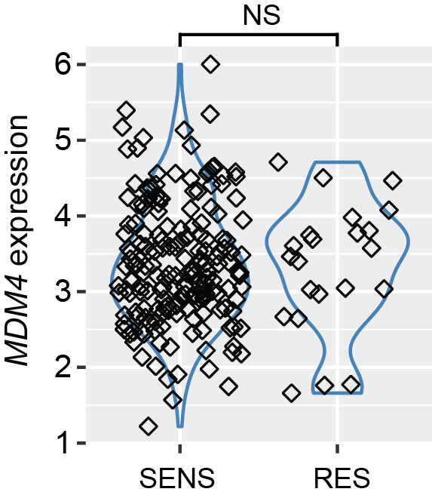

Fig. S1. (A) Violin plot of MDM4 expression in MDM4 resistant (RES) and MDM4 sensitive (SENS) cell lines.
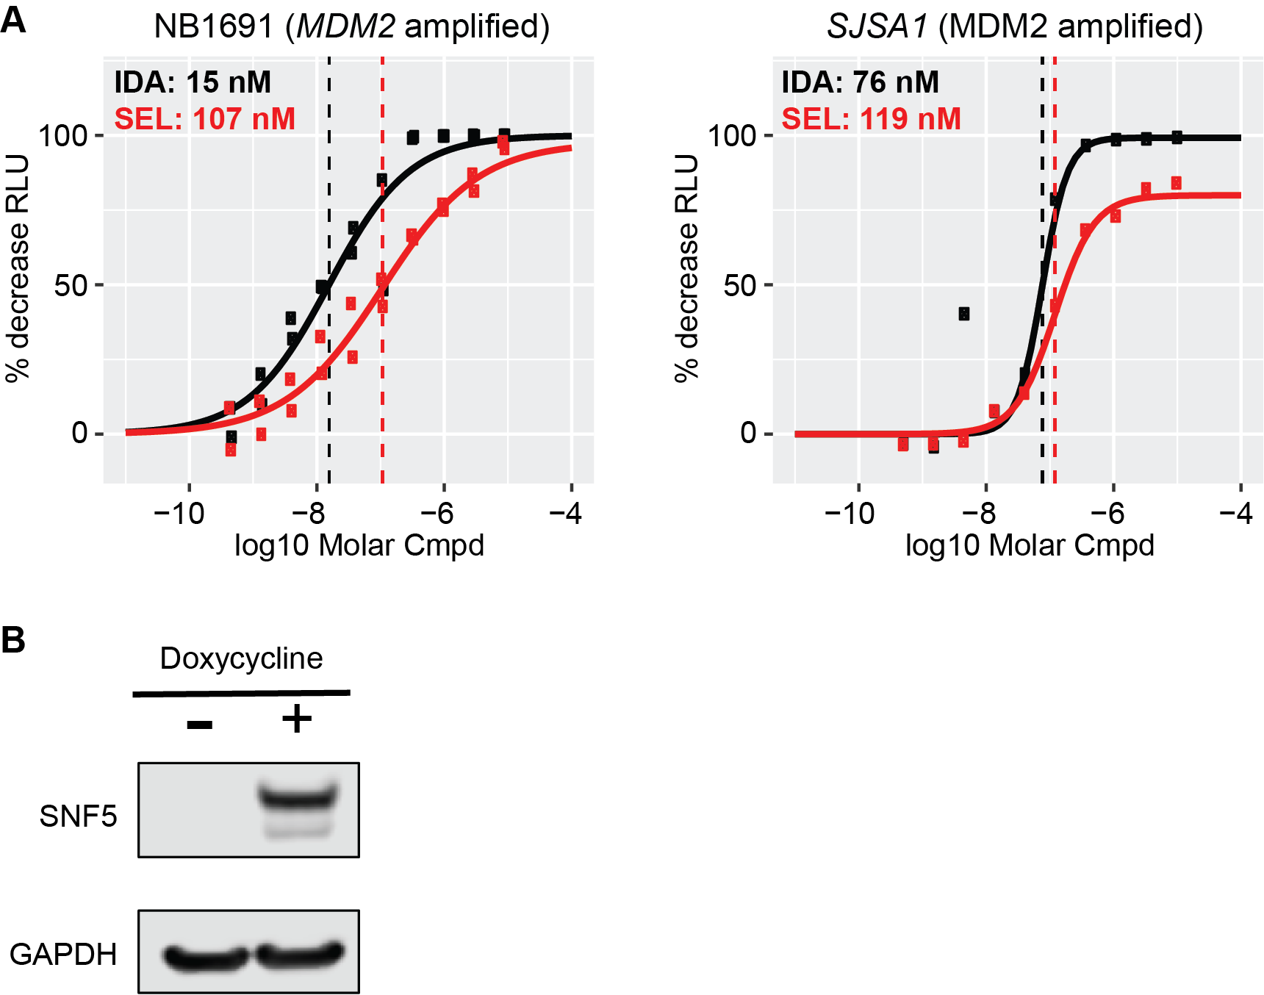

Fig. S2. (A) CellTiter-Glo (CTG) assay assessing cell viability in the neuroblastoma cell line NB1691 and the osteosarcoma cell line SJSA1 96 h after treatment with varying concentration of idasanutlin (black) or selinexor (red). Data are presented as % decrease of CTG relative light units (RLU) with DMSO vehicle set to zero and staurosporine (20 μM) set to maximum inhibition. EC50 values are reported and indicated in the plot by a dotted line (n ≥ 2). (B) Representative Western blot of SNF5 (SMARCB1) in TTC642-SNF5 cells 72 h after treatment with vehicle or with 1 μg/ml doxycycline.
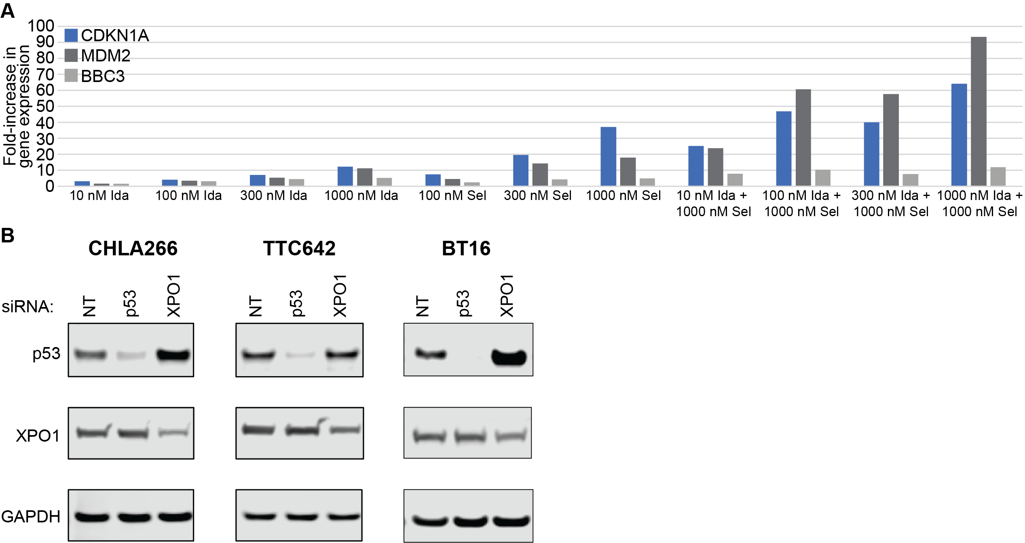
Fig. S3. (A) Quantification of the fold-increase in gene expression of CDKN1A, MDM2, and BBC3 relative to vehicle (DMSO) in SJ148191 cells 24 h after treatment with a dose-response of idasanutlin, selinexor, or the combination of each agent. Values reflect the average from two biological replicates. (B) Representative Western blot of p53 and XPO1 in cells treated with non-targeting siRNA (NT) or siRNA targeting TP53 or XPO1.

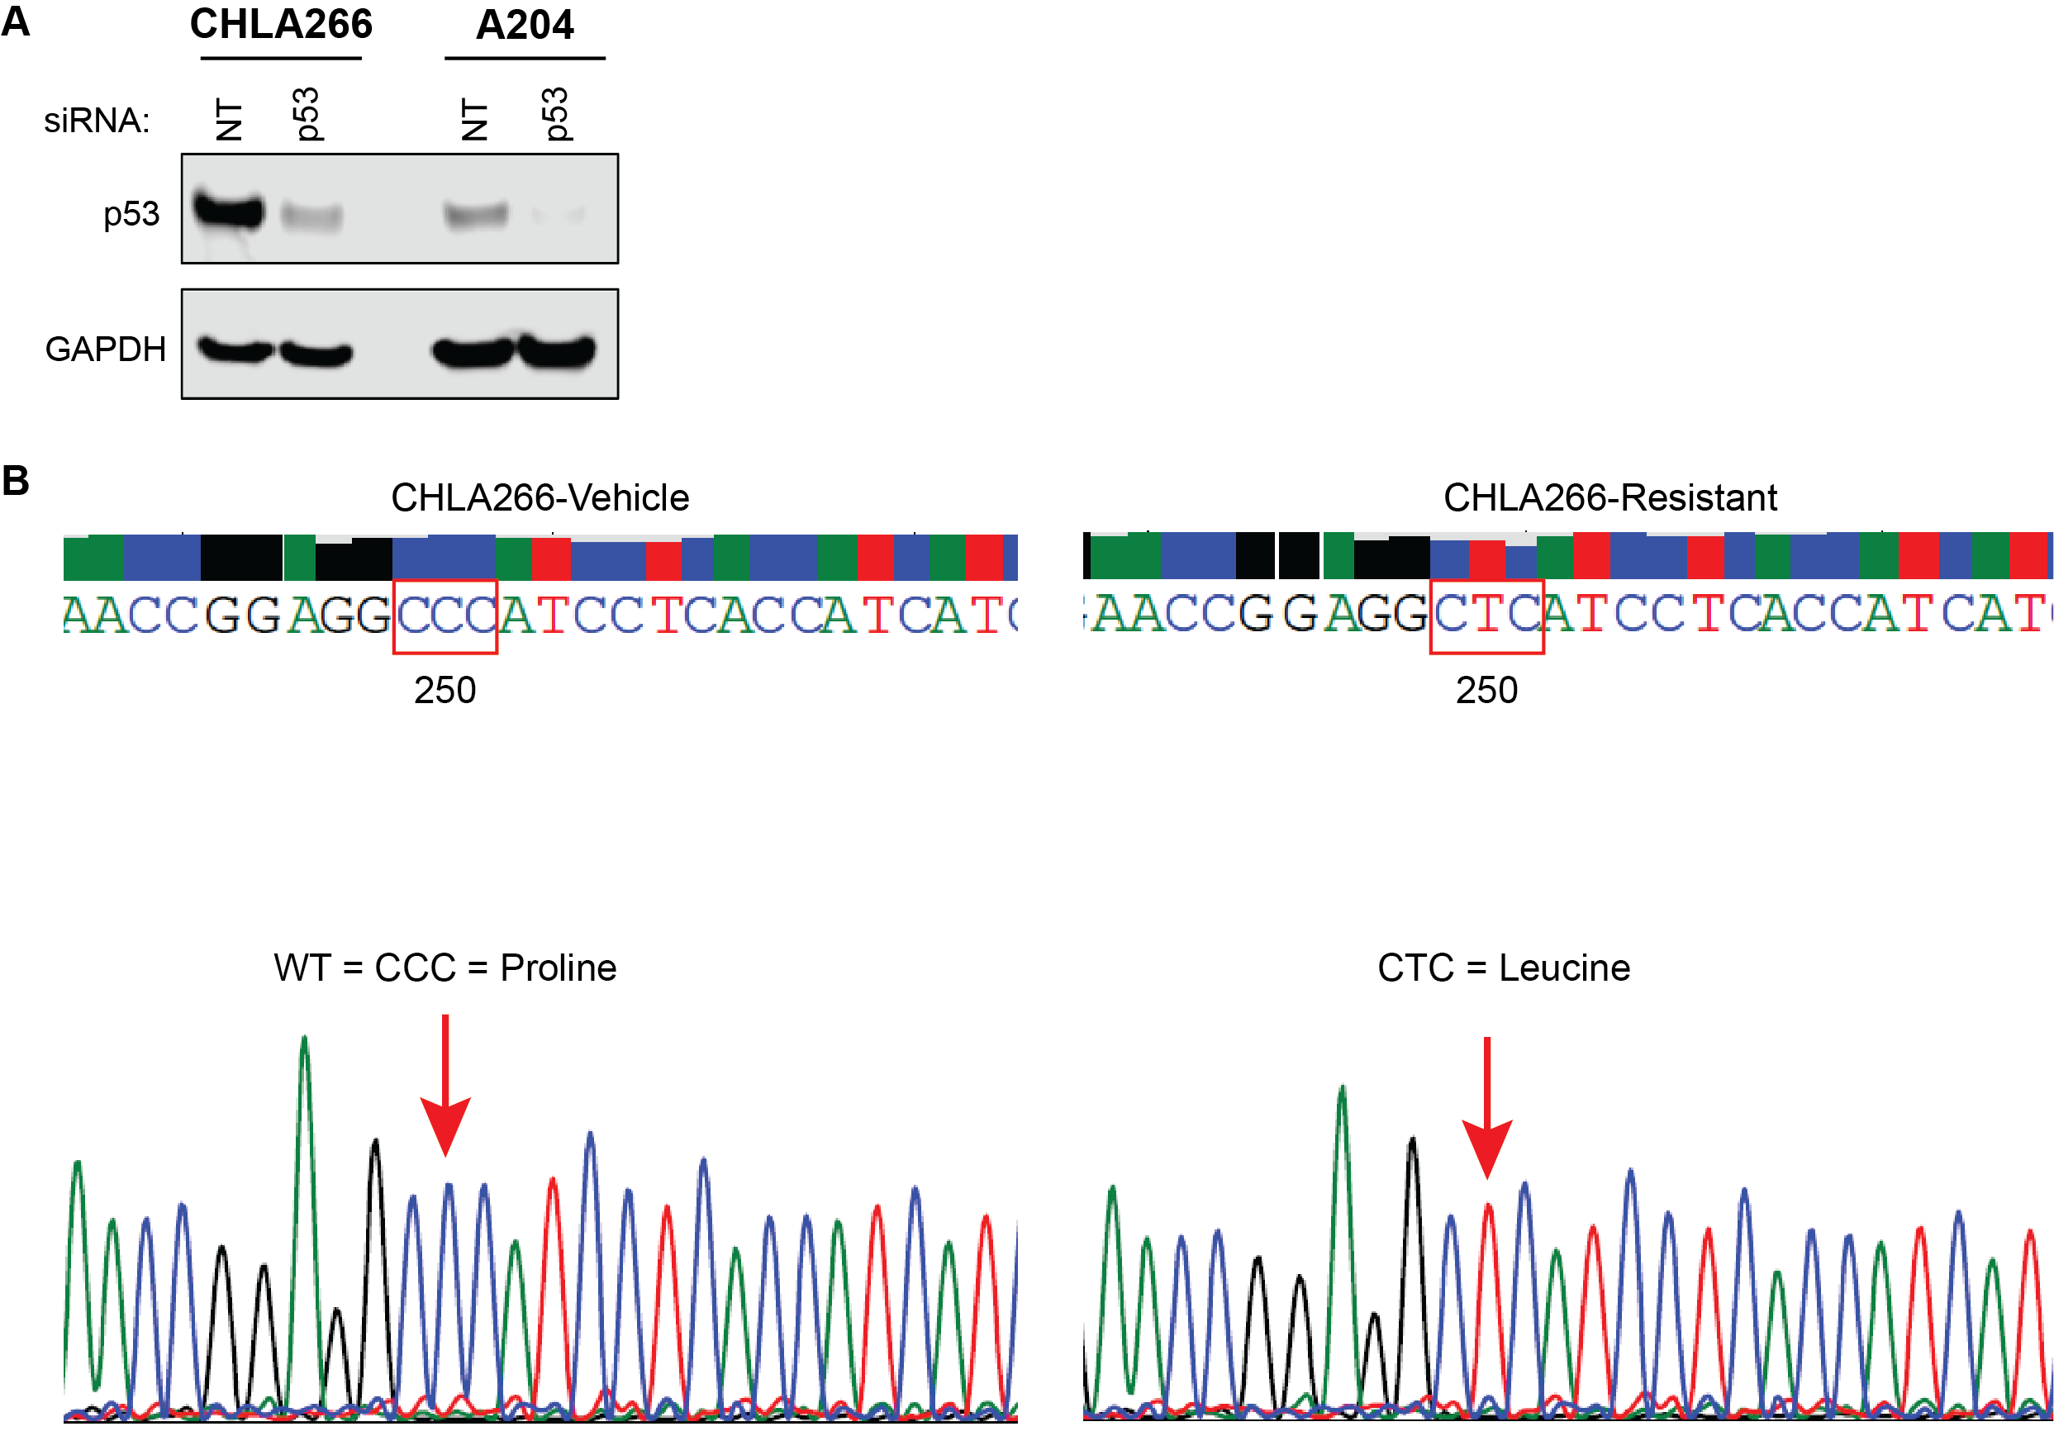

Fig. S4. (A) Representative Western blot of p53 in cells treated with non-targeting siRNA (NT) or siRNA targeting TP53. (B) Sanger sequencing chromatograph of CHLA266-DMSO and CHLA266-Resistant cells highlighting the proline to leucine mutation at position 250.

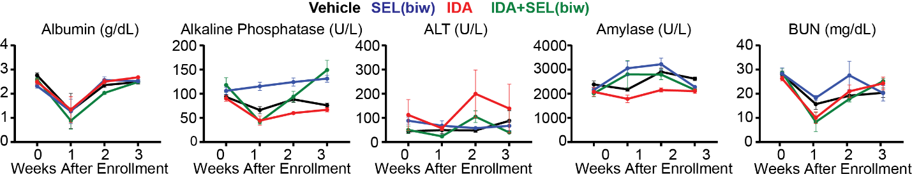

Fig. S5. In vivo toxicity studies in non-tumor bearing mice. Blood chemistry results from non-tumor bearing CD-1 nude mice treated with selinexor 10 mg/kg (biw), idasanutlin, and the combination of the two drugs.

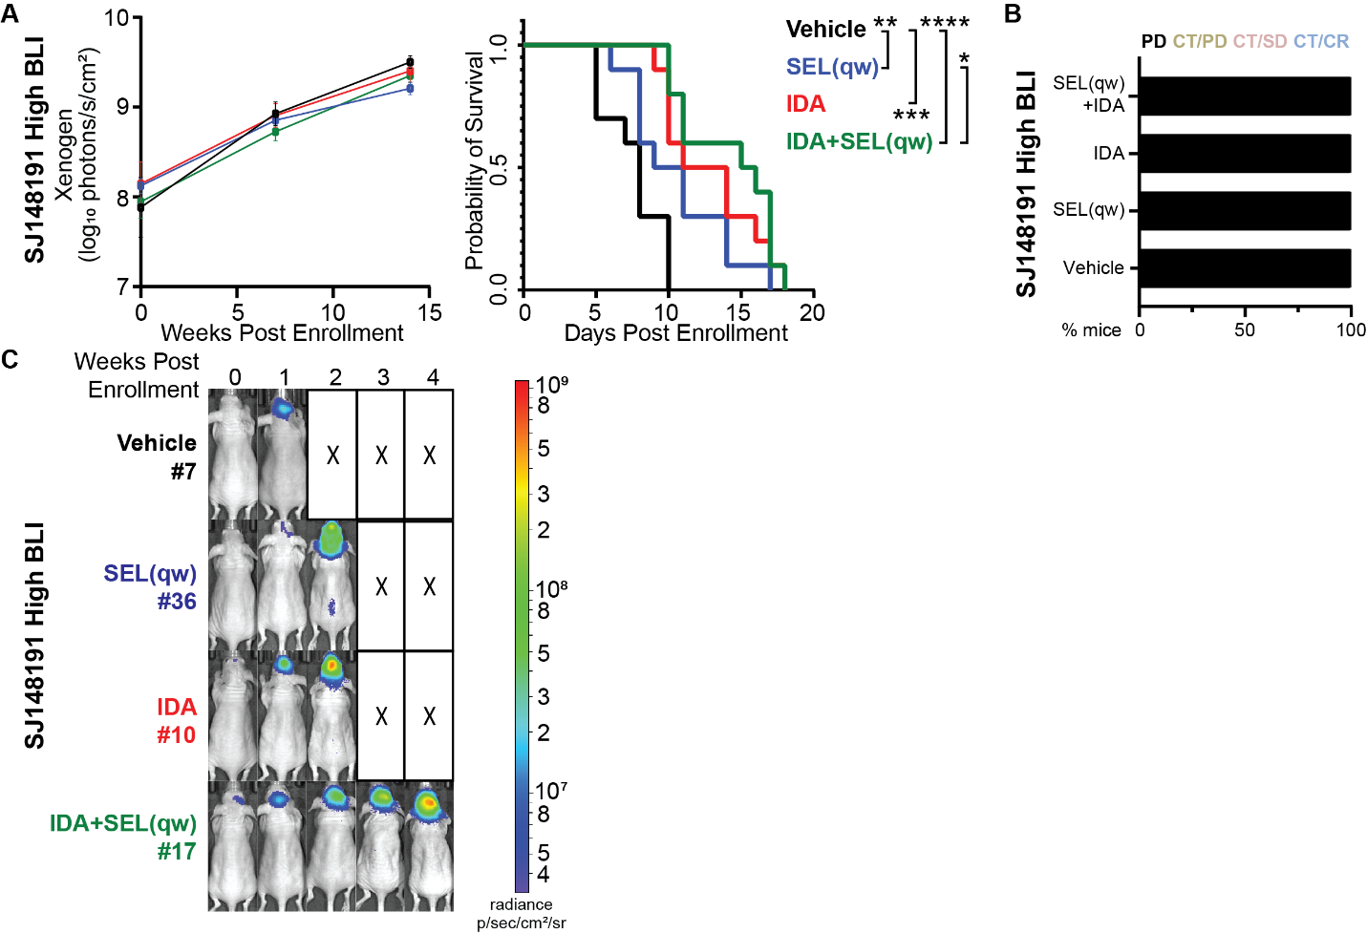

Fig. S6. In vivo efficacy of idasanutlin and selinexor in AT/RT SJ148191 orthotopic xenografts enrolled at high tumor burden (BLI signal ~10⁸ photons/s). (A) Average tumor burden over time as measured by bioluminescence imaging (left) and Kaplan–Meier survival curves (right) for SJ148191 xenograft bearing mice treated as indicated. Xenogen signal is presented as the mean ± SEM. (B) Summary of treatment outcomes for SJ148191 xenograft bearing mice treated as indicated. (C) Representative bioluminescence images of SJ148191 xenograft bearing mice treated as indicated. *, P < 0.05; **, P < 0.01; ***, P < 0.001; ****, P < 0.0001; progressive disease (PD); completed therapy with progressive disease (CT/PD); completed therapy with stable disease (CT/SD); completed therapy with complete response (CT/CR).

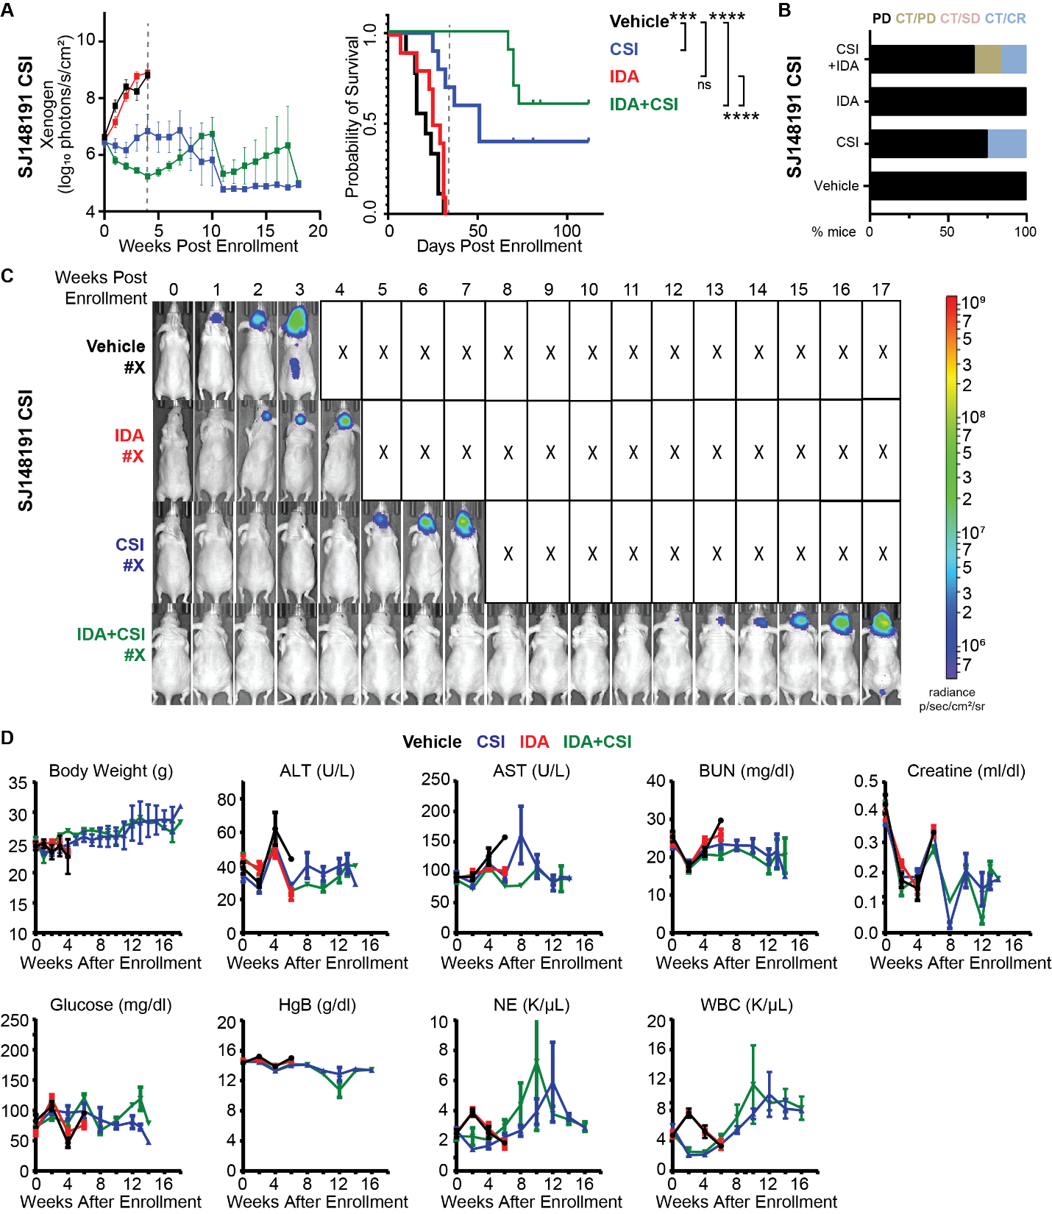

Fig. S7. In vivo efficacy and tolerability of CSI and idasanutlin in AT/RT SJ148191 orthotopic xenografts. (A) Average tumor burden over time as measured by bioluminescence imaging (left) and Kaplan–Meier survival curves (right) for SJ148191 xenograft bearing mice treated as indicated. Xenogen signal is presented as the mean ± SEM. The dotted line marks the end of treatment (1 complete cycle of therapy). (B) Summary of treatment outcomes for SJ148191 xenograft bearing mice treated as indicated. (C) Representative bioluminescence images of SJ148191 xenograft bearing mice treated as indicated. (D) Body weight, select blood chemistry results, and select blood count results from SJ148191 xenograft bearing mice treated as indicated. ***, P < 0.001; ****, P < 0.0001; ns, not significant; progressive disease (PD); completed therapy with progressive disease (CT/PD); completed therapy with stable disease (CT/SD); completed therapy with complete response (CT/CR).

