* A B C
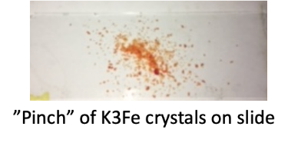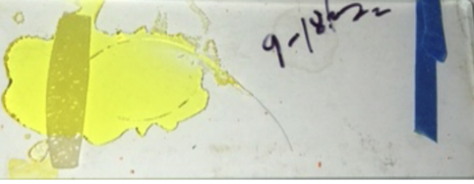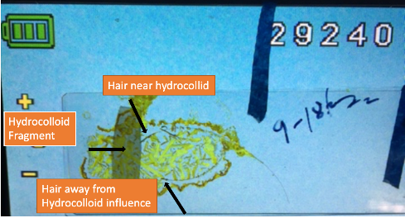
Glass slide prior to K3Fe solution evaporation. Glass slide post K3Fe evaporation.

TO APPRECIATE DETAILS
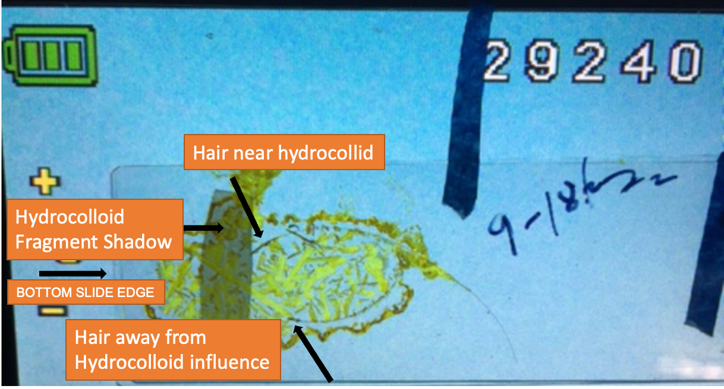AMPLIFIED EXHIBIT I POST K3FE EVAPORATION (C ABOVE)



ADDITIONAL NOTE:
The diluted drops on a slide must be plumb level, this to avoid unwanted liquid shifting on slide. In the experiments herein presented, notice a left sided placement of the WD; this to compensate for a slight surface inclination.

