Additional File 2

Figure A. Panel A- American Association of Population Outcomes Research (AAPOR) 2016 Response Rate 1 by age-category and gender for the National Sample; Panel B - AAPOR 2016 Response Rate 1 by age-category and gender for the Non-Western Migrant Sample

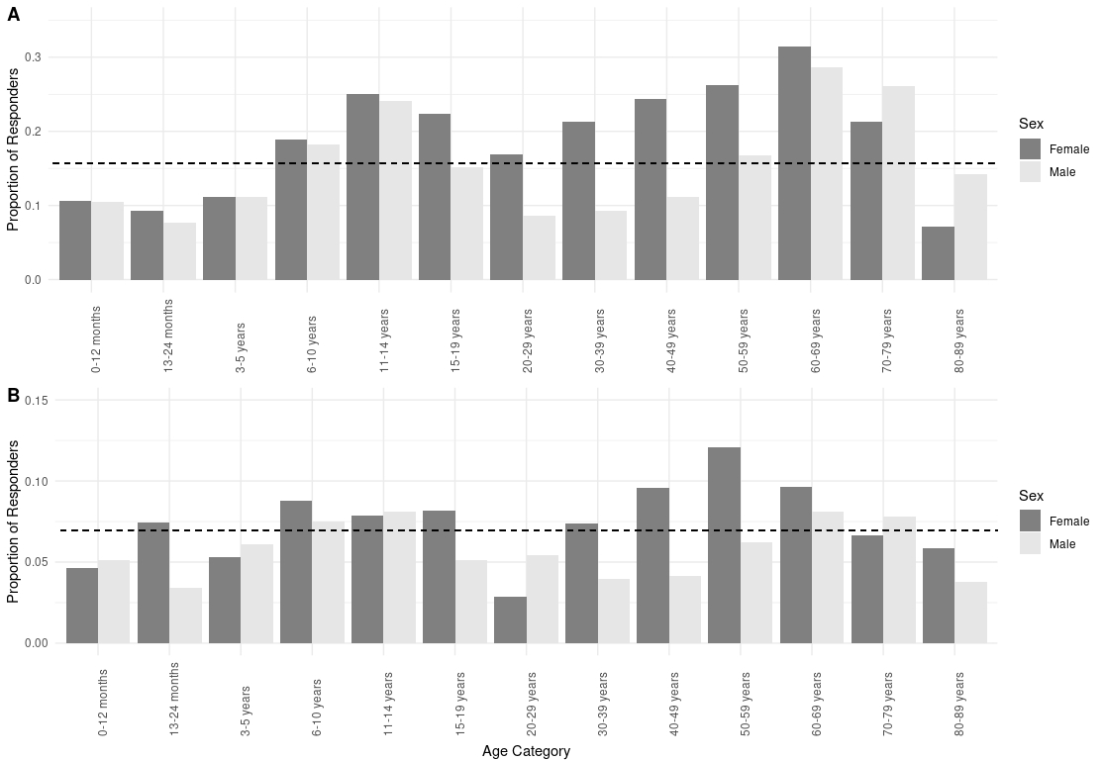

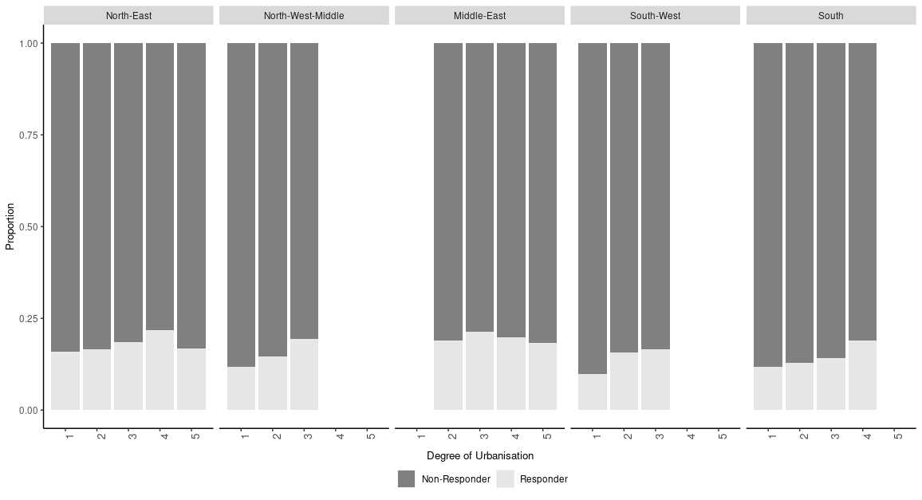
Figure B. AAPOR 2016 Response Rate 1 in each of the 5 regions, by urbanisation – include proportion of population in each urb by region for the National Sample

