Machine learning screening of bile acid-binding peptides in a peptide database derived from food proteins

Kento Imai^{1,2}, Kazunori Shimizu¹, Hiroyuki Honda¹*
¹Department of Biomolecular Engineering, Graduate School of Engineering, Nagoya University, Nagoya 464-8603, Japan
²Japan Society for the Promotion of Science, Research Fellowship for Young Scientists, Chiyoda-ku, Tokyo, Japan

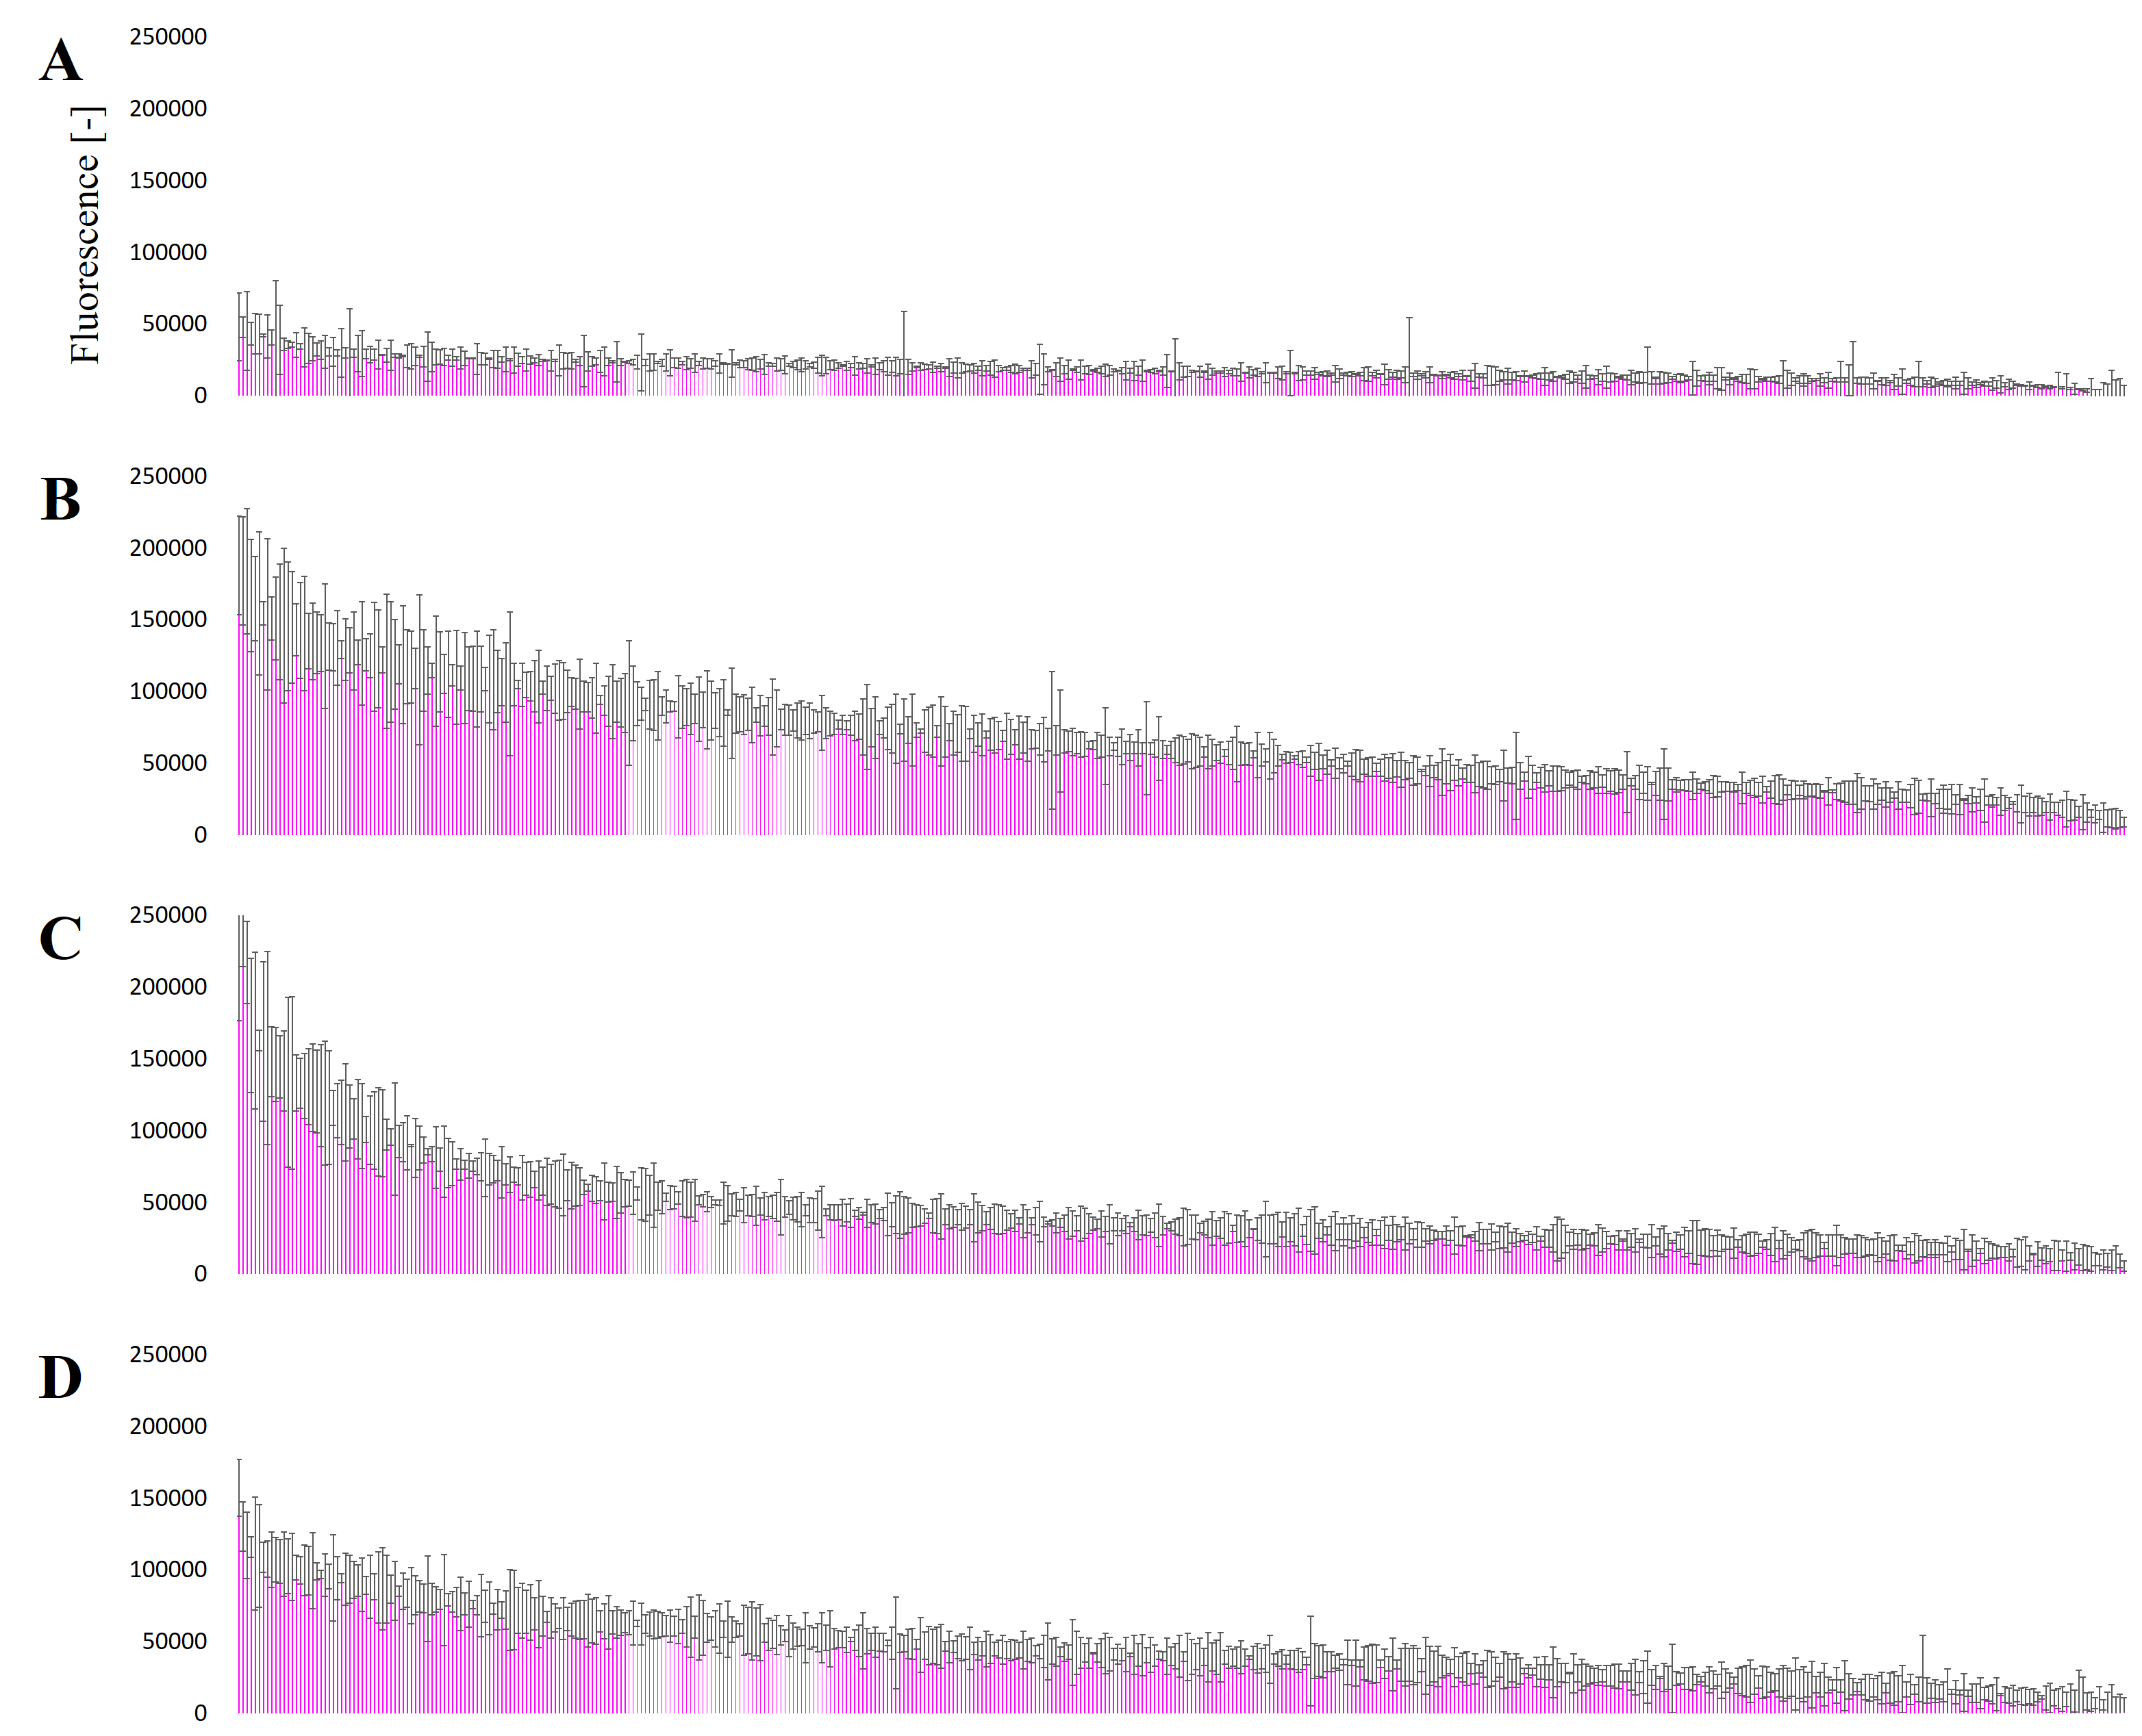
Figure S1: The fluorescent intensities for the training datasets according to a peptide array to detect acid bile binding activity.
The intensities are shown for 4-mer (A), 5-mer (B), 6-mer (C), and 7-mer (D) synthetic peptides.

Table S1: Features used to construct the model.
Table S2: All florescence intensities used to generate training datasets.
Table S3: Selected features of the RF prediction model for bile acid binding activity.
Bold type: features related to molecular weight, underlined: features related to isoelectric point, both bold type and underlined: features related to ‘aromatic amino acids’.
Table S4: The number of peptides that were predicted as positive or negative for bile acid binding activity in the database.
Table S5: Sequences of peptides that were synthesized for the evaluation of the model.
P-positive and N-negative
Table S6: The details of the peptides synthesized in Table S5.

