Supplementary figure C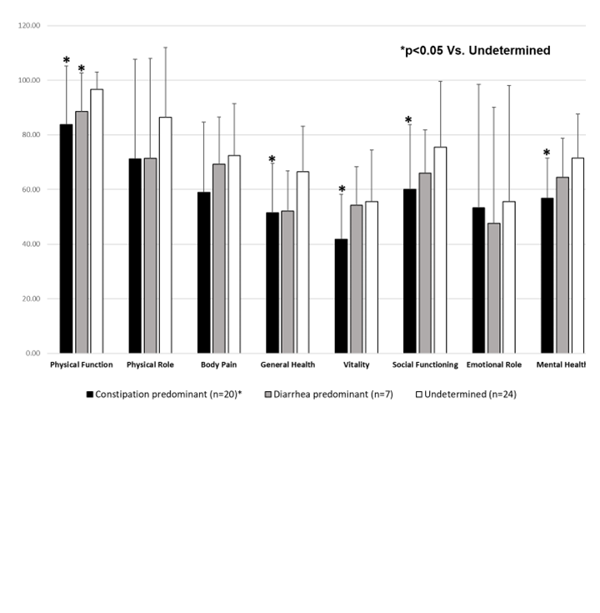 Supplementary figure C. General Quality of life (SF-36) of women with irritable bowel syndrome (IBS) compared by subtypes.

