Supplementary Figure D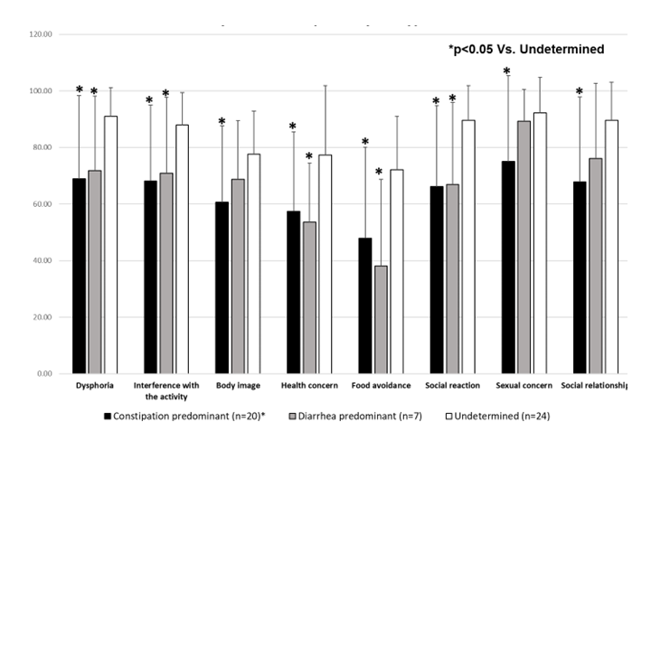 Supplementary figure D. Specific Quality of Life (IBS-QOL) in women with irritable bowel syndrome (IBS) compared by subtypes

