Supplemental information

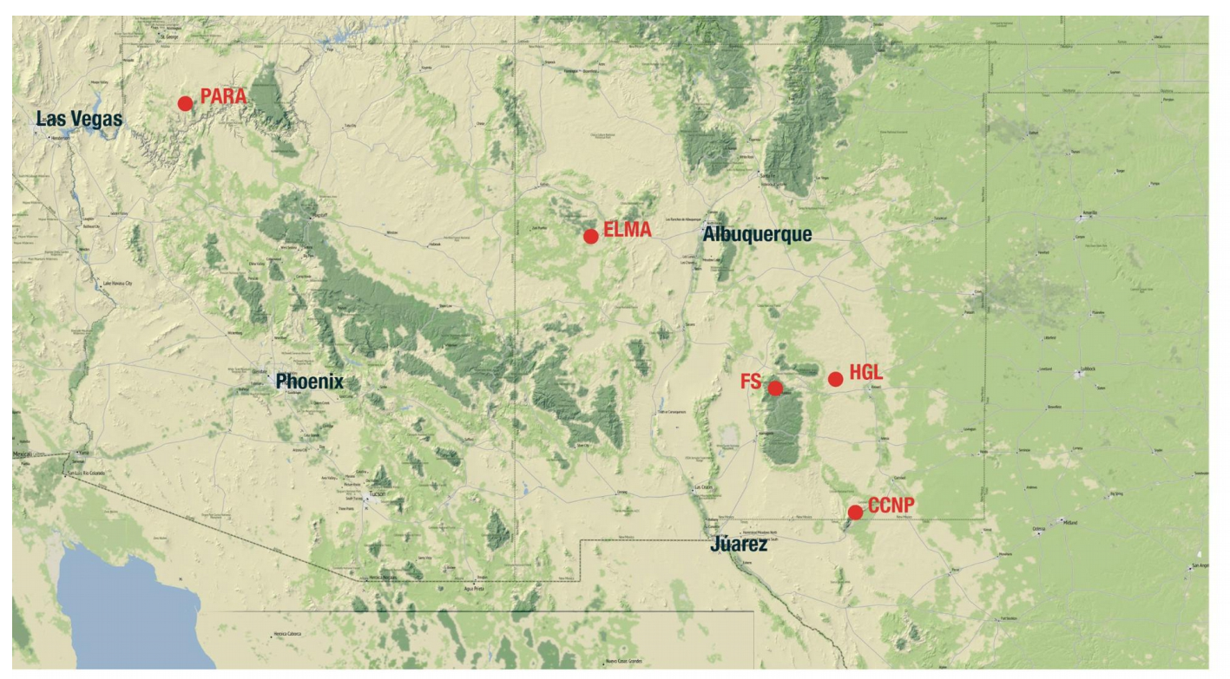
SI Figure 1- map of the American Southwest (Arizona and New Mexico) showing the five locations sampled in this study.

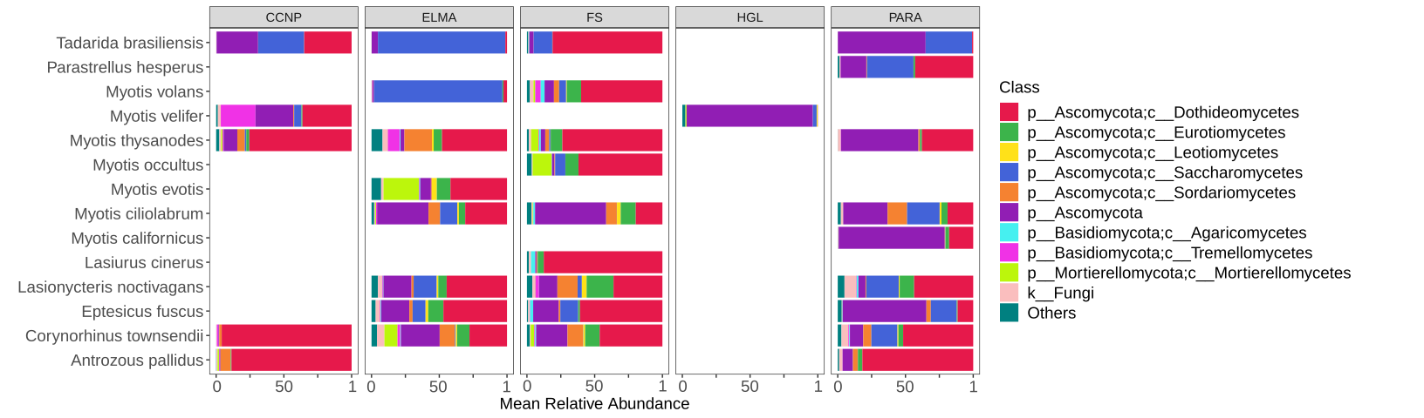
SI FIgure 2- stacked bar plot of the top ten fungal classes found on bat skin. The category ‘others’ comprises class not depicted and <1% overall relative abundance

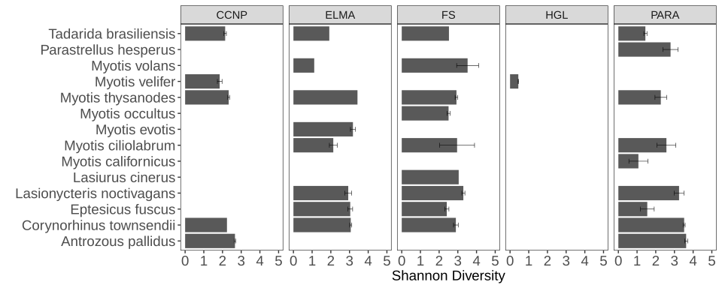
SI Figure 3- bar plot of Shannon Diversity values of the 14 species of bats sampled in this study. Bars represent means and error bars are standard error of the mean.

SI Table 1- List of bat species, sites, and site characteristics presented in this study. Numbers bolded are surface caught bats and numbers in parentheses are surface caught bats when a species is caught in both ways.
 | CCNP |  | ELMA | FS | HGL | PARA
Antrozous pallidus |  | 3 |  |  |  |  | 2
Corynorhinus townsendii | 1 |  | 20 | 8 |  | 4 | 3
Eptesicus fuscus |  |  | 9 | 11 |  |  | 3
Lasionycteris noctivagans |  |  | 1 (6) | 6 |  |  | 3
Lasiurus cinerus |  |  |  | 1
Myotis californicus |  |  |  |  |  |  | 3
M. ciliolabrum |  |  | 7 | 1 (1) |  |  | 3
M. evotis |  |  | 9
M. occultus |  |  |  | 4
M. thysanodes |  | 6 | 1 | 4 |  |  | 2
M. velifer | 1 | 4 |  | 19 | 19
M. volans |  |  | 1 | 4
Parastrellus hesperus |  |  |  |  |  |  | 2
Tadarida brasiliensis | 4 | 1 | 1 | 1 |  |  | 4
Elevation (m) | 1108 | 1293 | 2305.04 | 1944.19 | 1433.6 | 708 | 1794.88
Mean precip. (cm) | 25.08 | 27.4 | 29.91 | 33.32 | 25.76 | 15.25 | 30.64
NPP | 0.18 | 0.17 | 0.23 | 0.23 | 0.16 | 0.12 | 2.49

SI Table 2- results of generalized mixed effects modeling of bacterial diversity (OTUs observed).

 | Mean | MCSE | SD
Intercept | -108.76 | 7.35 | 345.70
latitude | 5.82 | 0.22 | 10.10
species: Antrozous pallidus | 11.58 | 0.25 | 15.30
species: Corynorhinus townsendii | 9.94 | 0.23 | 12.83
species: Eptesicus fuscus | 1.66 | 0.16 | 9.89
species: Lasionycteris noctivagans | 18.74 | 0.25 | 12.81
species: Lasiurus cinerus | 2.63 | 0.23 | 16.69
species: Myotis californicus | -13.05 | 0.25 | 15.18
species: Myotis ciliolabrum | 12.16 | 0.21 | 12.09
species: Myotis evotis | -4.18 | 0.22 | 13.47
species: Myotis occultus | -7.55 | 0.19 | 13.51
species: Myotis thysanodes | -0.12 | 0.22 | 14.88
species: Myotis velifer | -15.58 | 0.35 | 16.56
species: Myotis volans | 1.39 | 0.18 | 13.85
species: Parastrellus hesperus | 5.34 | 0.23 | 15.92
species: Tadarida brasiliensis | -21.92 | 0.32 | 14.19
Diet: generalist | -1.60 | 0.16 | 9.63
Diet: generalist-beetles | 2.38 | 0.16 | 8.89
Diet: moths | 4.01 | 0.19 | 10.74
Diet: moths-beetles | -3.25 | 0.18 | 10.32
Feeding/Flight behavior: Aerial hawking | -20.39 | 0.34 | 19.08
Feeding/Flight behavior: Gleaner | 30.89 | 0.44 | 23.24
Feeding/Flight behavior: Gleaner-Aerial hawking-Sit & wait | 10.25 | 0.41 | 24.20
Site: CCNP | 2.17 | 0.45 | 23.34
Site: ELMA | 16.42 | 0.33 | 16.21
Site: FS | 12.73 | 0.30 | 16.29
Site: HGL | -23.56 | 0.36 | 19.68
Site: PARA | -8.08 | 0.51 | 24.21
Location caught: Cave | -5.23 | 0.38 | 19.47
Location caught: Surface | 5.83 | 0.37 | 19.23
Sex :Female | 4.04 | 0.36 | 16.84
Sex: Male | -2.90 | 0.36 | 16.75
Sigma | 35.07 | 0.03 | 2.04
Sigma species: Intercept,Intercept | 391.76 | 7.98 | 328.55
Sigma Diet: Intercept,Intercept | 175.40 | 8.03 | 425.54
Sigma Feeding/Flight behavior: Intercept,Intercept | 1231.49 | 27.77 | 1498.01
Sigma Site: Intercept,Intercept | 903.32 | 27.35 | 1341.63
Sigma Location caught: Intercept,Intercept | 856.29 | 34.59 | 1926.36
Sigma Sex: Intercept,Intercept | 707.74 | 33.53 | 1848.65
Mean PPD | 81.61 | 0.06 | 3.94
Log-posterior | -884.16 | 0.21 | 6.25

