Supplementary Material

Novel magnetic graphoxide/biochar composite derived from tea for multiple SAs and QNs antibiotics removal in water

Wei Pang ^{a,b}, Yonghui Wang ^{b}, Shuang Li ^{b}, Yuanyuan Luo ^{b}, Guanyu Wang ^{b}, Jian Hou ^{b}, Tie Han ^{b}, Zhixian Gao ^{b} , Qingbin Guo ª , Huanying Zhou ^{b ,*}
ª State Key Laboratory of Food Nutrition and Safety, Tianjin University of Science & Technology, Tianjin 300457, China
^{b} Tianjin Institute Environmental and Operational Medicine, Tianjin 300050, China.

* Corresponding Authors.
E-mail addresses:zhouhytj@163.com (Huanying Zhou)

Text S1 Synthesis of mGO and mTBC
The mGO and mTBC samples used for comparative studies were synthesized as follows: GO was prepared by modified Hummers’ method. The mGO was synthetized on basis of Tang (Tang et al. 2019). A mixture of 0.2g GO in 50 mL water was ultrasonicated for 3h. Then, 0.1g EDC and 0.025g NHS were added into the solution and vortex in dark conditions for 20 minutes. Next, 0.2g Fe₃O₄ was synthesized according to our previous work (Liu et al. 2022) and was added under swirl for 4-8 hour. MGO was collected by magnetic separation and washed with water several times. The magnetic composites were dried under vacuum at 60℃ and stored at room temperature. 1.2 g mGO was dispersed in 60 mL deionized water. The dried mGO are stored at room temperature. mTBC was synthesized as follow: TBC and Fe₃O₄ were mixed at ratio 1:1 and stirred continuously for 6-8 h. The following steps were the same as for mGO/TBC preparation.

Text S2 Materials characterization
The crystal morphology of the material was recorded by scanning electron microscopy (SEM) (Merlin compact, Germany). For elemental analysis, the microscope was coupled to an energy dispersive spectroscopy (EDS) detector (Oxford-Xplore, UK). X-ray photoelectron spectroscopy (XPS) measurements were performed on a Thermo Escalab 250XI electron spectrometer (USA). The magnetic property of the sample was determined by vibrating sample magnetometer (VSM, Quantum Design, USA). The generated radicals were investigated by an electron spin resonance spectrometer (ESR, Bruker A300, Germany). The surface functional groups were analyzed by an Is5 fourier transform infrared spectrometer (FTIR, Thermo Corp, USA). The specific surface area (SSA), total pore volume (PVs) and mean pore diameter (Dp) of biochar were analyzed with a surface area analyzer (Micromeritics ASAP 2020, USA) using N2 gas as the adsorbate at 77 K. BET and t-plot model were applied to calculate the specific surface area of biochar. The powder X-ray diffraction analysis was performed to identify the samples’ mineral phases and crystal structure with CuKα radiation using an X-ray diffractometer system (XRD, Empyrean, Panalytical, Netherland).

Equations S1, S2 and S3.
The adsorption curve of mGO/TBC to SAs and QNs was fitted with fitted first/second-order kinetics and the intra-particle diffusion model with the following equations.
ln (Q_{e}-Q_{t} )= ln Q_{e} - k₁t (1)
(2)
(3)
Where Q_{t} (mg/g) was the adsorption capacity at time t (min), k₁ (min⁻¹) and k₂ (g/(min·mg)) were rate constants of pseudo-first/second order models, respectively. The k₃ was the adsorption rate constant of the intra-particle diffusion model equation and C was the constant.
After fitting, the adsorption kinetics and isotherm parameters after regression were listed in Table S2 and Table S3, respectively.
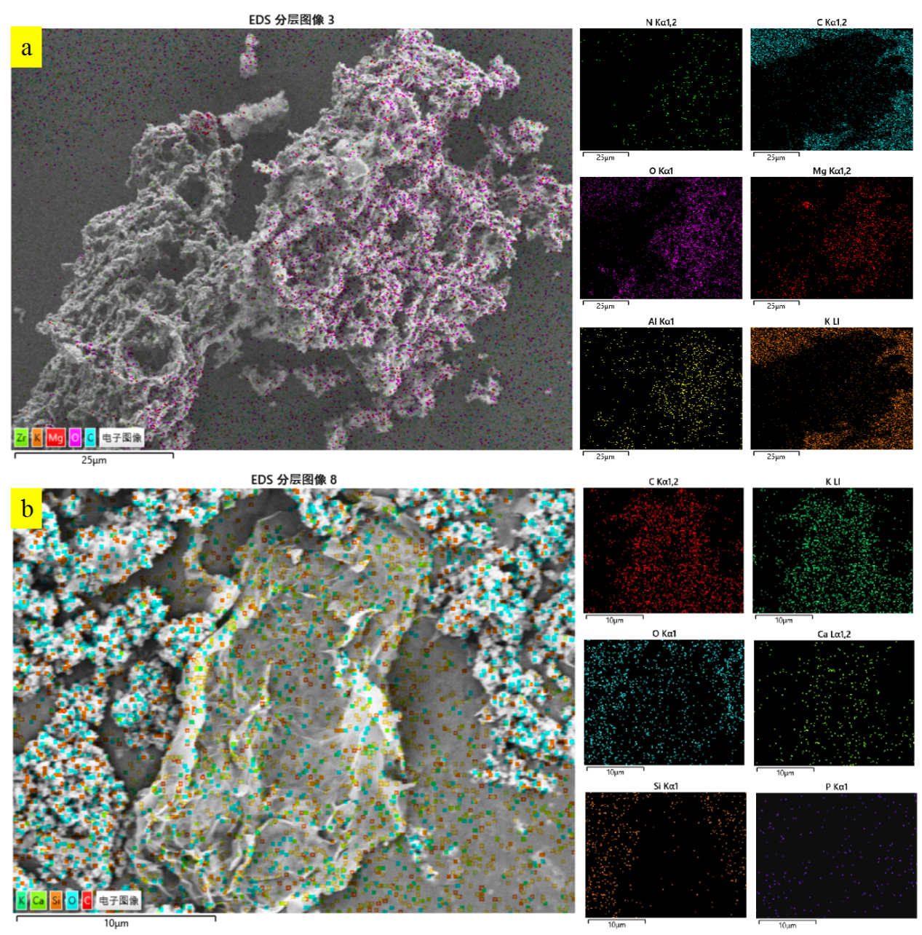
Fig. S1 Element mapping images of TBC (a) and mGO (b).

Fig. S2 XRD patterns of mGO/TBC before and after reaction.

Table S1 The BET surface area and pore volume of the samples.
Sample | BET Surface Area (m²/g) | Pore Volume (cm³/g) | Average Pore Size (nm)
TBC | 7.917 | 0.036 | 15.757
mTBC | 13.160 | 0.072 | 28.254
mGO | 28.471 | 0.159 | 18.852
mGO/TBC | 27.142 | 0.109 | 10.471

Table S2 Adsorption kinetic parameters for the adsorption of SAs and QNs on the prepared adsorbent.
Antibiotic | First-order-model |  |  |  | Second-order-model
Antibiotic | Q_{e1}  (mg/g) | K_{l}  (min⁻¹) | R² |  | Q_{e2}  (mg/g) | K₂  (g/(mg·min)) | R²
CZP | 149.710 | 0.7279 | 0.9804 |  | 150.397 | 0.0447 | 0.9805
ENR | 152.876 | 0.4962 | 0.9658 |  | 155.564 | 0.0114 | 0.9693
SAR | 157.923 | 0.4767 | 0.9735 |  | 160.377 | 0.0115 | 0.9740
SPD | 166.869 | 0.0292 | 0.9602 |  | 197.353 | 0.5301 | 0.9849
SMM | 128.483 | 0.0447 | 0.9582 |  | 144.459 | 6.5305 | 0.9823
SCP | 199.586 | 0.0683 | 0.9503 |  | 219.264 | 7.5960 | 0.9849
SDX | 110.626 | 0.0252 | 0.9644 |  | 133.504 | 1.3285 | 0.9808
SDM | 109.740 | 0.0336 | 0.9476 |  | 127.892 | 3.9696 | 0.9628

Table S3 Adsorption isotherm parameters for the adsorption of SAs and QNs on the prepared adsorbent.
Antibiotic | Langmuir isotherm |  |  |  | Freundlich isotherm
Antibiotic | Q_{m}  (mg/g) | K_{l}  (L/mg) | R² |  | K_{F}  (mg/g) | 1/n | R²
CZP | 330.697 | 0.152 | 0.9725 |  | 51.126 | 0.379 | 0.9596
ENR | 210.778 | 0.221 | 0.9721 |  | 55.752 | 0.321 | 0.8902
SAR | 289.471 | 0047 | 0.9985 |  | 56.268 | 0.322 | 0.8936
SPD | 351.048 | 0.102 | 0.9979 |  | 43.264 | 0.426 | 0.9774
SMM | 220.832 | 0.036 | 0.9831 |  | 33.468 | 0.375 | 0.9186
SCP | 334.155 | 0.453 | 0.9917 |  | 104.066 | 0.230 | 0.9233
SDX | 108.090 | 0.151 | 0.9907 |  | 25.093 | 0.267 | 0.9698
SDM | 133.014 | 0.085 | 0.9831 |  | 26.371 | 0.308 | 0.9378

Table S4 Effect of different quenchers on the SAs and QNs degradation after 60 min reaction time.
Quencher | The removal efficiency of analytes (%)
Quencher | CZP | ENR | SAR | SPD | SMM | SCP | SDX | SDM
Control | 96.673 | 98.397 | 95.781 | 98.612 | 98.355 | 99.476 | 95.397 | 96.358
MeOH | 78.516 | 82.148 | 75.881 | 97.837 | 74.487 | 98.124 | 87.244 | 51.289
TBA | 41.351 | 97.444 | 91.478 | 42.399 | 41.290 | 50.364 | 57.127 | 46.266
FFA | 86.247 | 86.991 | 85.294 | 80.236 | 79.929 | 79.504 | 73.130 | 83.817
References
Liu, X. L., Y. H. Wang, S. Y. Ren, S. Li, Y. Wang, D. P. Han, K. Qin, Y. Peng, T. Han, Z. X. Gao, J. Z. Cui, and H. Y. Zhou. (2022). Fabrication of Magnetic Al-Based Fe(3)O(4)@MIL-53 Metal Organic Framework for Capture of Multi-Pollutants Residue in Milk Followed by HPLC-UV, Molecules 27. http://doi.org/10.3390/molecules27072088
Tang, Hong-zhi, Yong-hui Wang, Shuang Li, Jin Wu, Jun-wen Li, Huan-ying Zhou, and Zhi-xian Gao. (2019). Graphene oxide composites for magnetic solid-phase extraction of twelve quinolones in water samples followed by MALDI-TOF MS, Anal. Bioanal. Chem. 411:7039-7049. http://doi.org/10.1007/s00216-019-02081-w

