Supplementary Information for
Pulsatile therapy for perovskite solar cells
Kiwan Jeong^{1†}, Junseop Byeon^{1,2†}, Jihun Jang¹, Namyoung Ahn¹*,and Mansoo Choi^{1,2}*

† These authors contributed equally to this work
*Corresponding author E-mail: mchoi@snu.ac.kr, nyny92@gmail.com

This material includes:

Supplementary Text, Section A-E
Figures S1 to S7
Tables S1 to S2

Contents:

A. Previously reported mechanisms for degradation of perovskite materials and devices
B. Design of pulsatile therapy
C. Mechanism of pulsatile therapy and defect healing process
D. Calculation of total gain
E. Circuit modeling for peculiar I-V curves in the case of MPPT
Section A. Previously reported mechanisms for degradation of perovskite materials and devices ¹⁻¹⁵
It is well known that perovskite materials can be easily decomposed in the presence of H₂O and O₂. However, those gas molecules were found to not cause irreversible degradation by only themselves¹⁻³. For example, high relative humidity resulted in a hydrated state of perovskite, but it returned reversibly under low humidity, or by heating^{2,3}. Irreversible degradation requires external stress factors like light illumination and electric field. It has been confirmed that photo-generated charges by light illumination and ion instabilities by electric field are mainly responsible for the irreversible degradation³⁻¹⁵. Here, we summarize on degradation mechanisms of perovskite materials caused by trapped charges and ion instability that were suggested before.
A-1 Chemical decomposition of perovskite by trapped charges, H₂O, and O₂ ³⁻⁵
Light illumination generates electron-hole pairs that could lead the charges to be accumulated along interfaces and grain boundaries in polycrystalline perovskite films under the given electric field. Such charge trapping induces irreversible chemical degradation with reactive gas molecules (H₂O, O₂) although in the absence of trapped charges, no decomposition occurs even in the presence of reactive gas molecules. Ahn et al.³ showed that decomposition of perovskite material under reactive gas molecules occurred only when the nitrogen gas ions (positive charge) were accumulated on the perovskite surface and the degradation started along grain boundaries where the charges were preferentially accumulated. Locally-intensified E-field by the trapped charges could induce distortion of perovskite crystals forming pathway for penetration of gas molecules³. It was suggested that with these trapped charges, perovskites would be irreversibly decomposed into stable Lead halide and volatile deprotonated cation as expressed below³.

MAPbX₃(or FAPbX₃) +H₂O+ Trapped charge (e- or h+)
→ MA(↑) (or FA(↑))+PbX₂ (s)+H₃O⁺+X⁻(aq)

MAPbX₃(or FAPbX₃) +1/4O₂ +H₂O+ Trapped charge (e- or h+)
→ MA(↑) (or FA(↑))+PbX₂ (s)+1/2X₂ +1/2 H₂O

Atomic-scale mechanism of trapped-charge driven degradation was studied based on Ab initio molecular dynamics simulation ^{4,5}. Those studies verified that trapped charges activated chemical interaction between perovskite surface and gas molecules and, without trapped charges, the existence of oxygen and water vapor molecules did not activate any chemical reaction with perovskite material. The deprotonation of cation that was suggested as a degradation pathway ³ was computationally confirmed in the presence of H₂O molecules and trapped charges. From the calculations, in the case of oxygen molecules, trapped charge in perovskite weakens the Pb–I bond while strengthening the I–O and Pb–O bonds towards oxide formation. Also, the combination of H₂O and O₂ was found to lead to the formation of hydroxide species to cause fast decomposition of perovskite materials³⁻⁵.
A-2 Ion migration (instabilities) induced degradation ⁶⁻¹³
Since perovskite materials have ion-conducting properties, ion constituents can be easily migrated by electric field, and even under light illumination. Activation energy of migration is depending on species of ion and the organic cation, and halide anion species having low activation energy were found to be easily migrated⁶. Ion migration of perovskite was experimentally confirmed from photoluminescence quenching in perovskite under applied bias and light illumination^{7,8}, and the migration of ion species such as iodine was identified by various measurements including EDX, EIS and TOF-SIMS^{7,8}. Iodine anions move to an anode, whereas organic cations go to a cathode. In the case of electro-lysis, I⁻ anions occupied in the structure of PbI₃⁻ are oxidized, producing I₂, and PbI₂ in anode. Meanwhile, in the cathode, reduction of hydrogen ions in CH₃NH₃⁺ could result in generation of volatile species such as H₂ and CH₃NH₂. Due to those redox reactions between ions, perovskites can be decomposed into lead halide and volatile species (CH₃NH₂, H₂ and I₂) as expressed below⁹.
2(PbI₂)●I⁻ → 2PbI₂ + I₂ +2e⁻ (Anode)
2 (CH₃NH₂)●H⁺ +2e⁻ → H₂ + 2CH₃NH₂ (Cathode)
2 CH₃NH₃PbI₃ → I₂ + H₂ +2PbI₂ + 2CH₃NH₂ (overall reaction)

Photolysis occurred in PbI₂ due to the reaction of photo-induced electron transfer from I⁻ to Pb²⁺. This reaction results in producing unstable Pb⁺ and I⁰. The generated unstable Pb⁺ ions can be oxidized back to Pb²⁺ and H⁺ from CH₃NH₃⁺ can be reduced⁹.
- Pb²⁺+ I⁻ → Pb⁺ + I⁰ (under light)
- Pb⁺ + H⁺ → Pb²⁺ + H⁰ (under light)
- 2 CH₃NH₃PbI₃ → I₂ + H₂ +2PbI₂ + 2CH₃NH₂ (photolysis)

Additionally, light-induced halide segregation and amorphization was pointed out as the degradation mechanism in the case of mixed halide perovskite^{10,11}. It was reported that phase segregation occurred due to aggregation of iodide near grain boundaries while the accumulation of bromide happened in the in-grain. Iodide-rich perovskite domains make charge generation worse, leading to performance drop and material degradation. Amorphization is also a possible reason of perovskite degradation. This may impede light absorption, carrier generation, and even charge transport, which will result in performance degradation^{10,11}. Furthermore, it has been reported that the synergetic effect of charges and ions in perovskite materials aggravate device stability. For example, excess carriers could reduce coulombic force between the ion and ion vacancies, which could lead to facilitate ion migration and accelerate perovskite degradation¹²⁻¹³.

A-3 Experimental studies showing the charges as a cause for degradation of perovskite solar cell devices¹⁴⁻¹⁷.
Light illumination generates electron-hole pairs, leading charges and ion to be accumulated along grain boundaries in perovskite solar cells. At perovskite/charge transporting layer interfaces, high concentrations of carriers and ions accumulates to compensate internal electric field. Interfacial charge accumulation act as electron energy barriers at the interface between perovskite and CTL, which causes I-V hysteresis and could initiate device degradation.¹⁴ Furthermore, in the case of continuous bias or light illumination, some of accumulated ions near the perovskite/charge transporting layer interface can infiltrate into charge selective contact, resulting in performance loss of perovskite solar cells¹⁵⁻¹⁷ Ions such as MA⁺, I⁻ penetrate into the ETL and HTL due to the E- field under illumination. These ion infiltration process could induce degradation of perovskite solar cell¹⁵⁻¹⁷.
In summary, many studies conclude that fundamental reasons of perovskite degradation are charge carriers and ions. When perovskite solar cells operate under electrical bias and light illumination, localization of both carriers and ions will always happen and easily spoil device performance no matter which degradation mechanism is involved.
Section B. Design of pulsatile therapy
As discussed in Section A, charges, ions, and their interplay are mainly responsible for fast degradation of perovskite solar cells. Those will be localized at interfaces and grain boundaries during device operation under electrical bias and light illumination. The result of their localization is observed in I-V characteristics of perovskite solar cells. It is the hysteresis of I-V curves, in which a shape of I-V curve looks very different depending on scan direction (whether dV/dt is positive or negative). The hysteretic I-V curves can be easily explained by capacitive currents (CdV/dt), of which a sign is opposite for different scan direction. Severe hysteresis of I-V curves originates from large capacitance current, which is indicative of accumulation (or relaxation) of charged ones inside a device. The device with severe hysteresis showed bad stability as compared to the device with no hysteresis^{3,14,17}. This correlation is well consistent with the fact that degradation occurs rapidly with a lot of accumulation of charges and ions ^{3-5,14,17}.
Our simple modeling (see an electrical circuit below) for perovskite solar cells in which a capacitor is added as an electrical element parallel to diode and shunt resistance can account for hysteretic I-V curves and capacitive characteristics of perovskite solar cells. The parallel capacitor generates time-transient current when an applied bias is changed for the I-V scan. It was reported that the capacitance has an exponential function of voltage in perovskite solar cells (C~exp(V))¹⁸telling that more charges accumulate at a higher voltage.
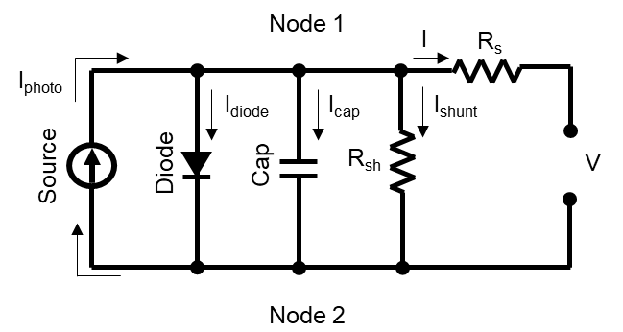
Figure S1. A simple equivalent circuit including a parallel capacitor to model accumulation of charged ones.

We exploited this modeling to design an amplitude of reverse pulse in our PT which enables effective relaxation of charges and ions. Since the capacitor is a direct consequence of accumulation of charges and ions and must be a main problem of device stability, the best design of PT would be to neutralize the capacitor by applying an appropriate reverse bias. Its neutralization requires no electrical potential difference between Node 1 and 2. Based on that, we finally obtained an amplitude for reverse pulses by solving Kirchhoff’s law of the equivalent circuit. Detailed calculation steps are described below.
The electrical potential between node 1 and 2, $∆V_{12}$.
$$∆V_{12}=IR_{s}+V$$
For no electrical potential difference,
$$IR_{s}+V=0, V=-IR_{s}$$
The photocurrent at a reverse bias (not far from 0V) is very similar to the short-circuit current due to high shunt resistance. The I-V curve is flat around short-circuit condition. We can assume
$$I≈I_{sc}$$
Finally, we can obtain the value of the reverse bias voltage for no potential difference
$$V=-I_{sc}R_{S}$$
The reverse bias can neutralize accumulation of charged ones by erasing the effect of capacitance in the circuit model. Also, the value is not large (normally around -0.2V), which makes power consumption small. Our PT system automatically updates an amplitude ($-I_{sc}R_{S}$) of a reverse pulse from recently-recorded I-V characteristics and our modeling equation.

To validate our modeling and find the voltage bias to neutralize the capacitance, we conducted charge extraction measurements for a perovskite solar cell. The quantity of charge accumulation can be measured through four steps as shown in Figure S2a. During step 1, the device is short-circuited in dark condition to remove all charge accumulation inside the device. Light illuminates the device with a specific voltage bias during step 2, in which a cluster of white LEDs with a power density of 100 mW cm⁻² is used as the light source. Different quantities of charge will be accumulated in this step 2 for different applied biases. After step 3 for delay in dark condition, the device is again short-circuited in the dark condition to extract charge accumulation during step 2. The current is recorded by using an electrochemical workstation (Autolab 320N, Metrohm, Switzerland) with an Autolab LED Driver Kit (Metrohm, Switzerland). Integration of extracted currents with time gives the quantity of charge accumulation in the device. We compared the quantity of charge accumulation (extracted charge) as a function of voltage bias as shown in Figure S2b. The minimum value of the extracted charge was obtained when -0.2 V was applied to the device. The voltage bias (-0.2V) is very similar to the value of $-I_{sc}R_{S}$ of the device as mentioned above, which means that the bias (reverse bias) applied in our pulsatile therapy could effectively neutralize the capacitor. Figure S2c shows the extracted current versus time. The charge extraction occurred very rapidly within 5 seconds. That indicates the reverse bias with short duration can effectively extract charge accumulation. Based on this, we set up the duration of reverse pulses below 30 seconds in our pulsatile therapy.

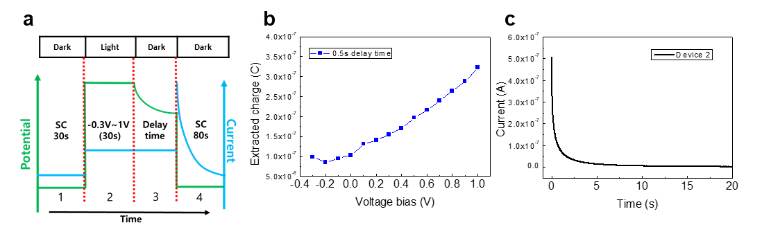
Figure S2. (a) Process of charge extraction measurement. (b) Quantity of extracted charges as a function bias voltage for SnO₂/MAPbI₃-device. Delay time is 0.5 second. (c) Current profile of SnO₂/MAPbI₃-device at 4th step in charge extraction measurement.
Section C. Mechanism of pulsatile therapy and defect healing process
C-1 Dynamics of carriers and ions during pulsatile therapy
The operational phase of pulsatile therapy consists of two steps; 1. MPPT step for power harvesting, 2. RP step for device stabilization and healing. If a fresh device starts to operate under light illumination at MP, charged particles will start to move by diffusion-drift model. Cations, anions, and vacancies are always present even in a fresh perovskite film because their formation energies are low enough to be formed at room temperature. Some of charge carriers remain in the device by the forward bias, thereby internal photo voltage is formed across the device. Photo-voltage induced electric field facilitates the transfer of cations like Pb_{i}²⁺ to the ETL interface, while anions like I_{i}⁻ are transferred to the HTL interface. After reaching a steady-state, distributions of carriers and ions are no longer uniform across the perovskite layer. Both carriers and ions could be localized at both interfaces while the device is working at MP condition. Those not only induce irreversible trapped charge driven degradation³ in the presence of H₂O and O₂, but also cause ion defect formation and its resulting degradation^{6,13} (even without H₂O and O₂) as evidenced by the reduction of photocurrent and Photoluminescence as shown in Fig. 4b. Interfaces were found as a place where the degradation initiateed^{3,14}. The degradation continues as long as the MP operation is maintained. Unlike standard MPPT operation, the PT has special steps for releasing carriers and ions accumulated at interfaces. The relaxation process was observed during the RP as shown in Fig. 4c. The detailed relaxation process can be described as below.
Both photocurrent (PC) and photoluminescence (PL) dynamics during RP are well fitted by bi-exponential fitting, with similar time-constants (see Extended Data Table.1). The fast one (0.593 sec of time constant) could result from capacitive current due to discharging of carriers that have been accumulated during previous MPPT operation. Both PC and PL are higher than their value after the dynamics associated to the fast time constant (t~2s), indicating relaxation of accumulated charges by external circuit and radiative recombination. The slow one (34.23 sec of time constant) indicates field-induced ion redistribution. During previous MPPT operation, ions get polarized, for example, I_{i}⁻ ions could accumulate near HTL and I_{i}⁺ ions could accumulate near ETL. These I_{i}⁻ ⁽I_{i}⁺) ions near HTL (ETL) attract hole (electron) by Columbic interaction. As a result, charge extraction gets enhanced as ions accumulate near transporting layer, with this effect known as ion-screening effect¹⁹⁻²⁰. During RP, ion-screening effect decreases as ions migrate and redistribute, resulting ionic de-polarization. PC decrease and PL increase during this dynamics (2s < t < 30s) indicates loss of enhancement in extraction and thus increase of recombination, respectively, due to decrease of ion-screening effect. Some of interstitial ions and vacancies can recombine in the process of ion redistribution that weakens ionic polarization, which is here called the defect annihilation¹³. It is the one of defect healing mechanisms we can expect during PT. (We will discuss possible defect healing mechanisms in the next section.) Thus, the increase of PL shown in RP process would be attributed to both ion-redistribution and defect healing.
When returning to MP after the RP step, a device will show mitigated conditions with respect to ion and carrier accumulation. It would be easily understood from the trapped charge driven degradation mechanism³ that the removal of accumulated charges via RP could slow down the irreversible degradation caused by chemical reactions with H₂O and O₂, which is one of the important efficacies of our PT. The more intriguing efficacy of our PT is the restoration of the degraded photocurrents via RP somewhat in a reversible way as shown in Figure 3c, which could be interpreted as defect healing. Our customized in-situ PL set-up revealed that after the RP, both photocurrent and photoluminescence intensity were slightly recovered (Fig. 4d). The recovery maintained for a much longer time than time constants of charging and ion-redistribution, which means that the recovery should be not any transient artefact by charging and ionic polarization. This recovery due to defect healing can be explained based on previously reported defect dynamics¹³ (see below a scenario for defect healing induced by PT). The overall process of the PT is simply illustrated in Figure S3.
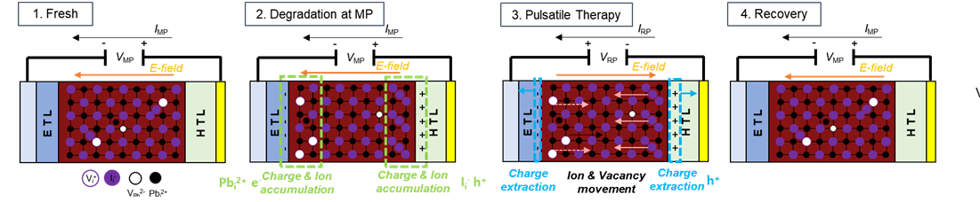Figure S3. A schematic illustration for operational steps of pulsatile therapy. The MP step is for power harvesting, which accompanies degradation. During the RP step, device healing happens by mitigating accumulation of both carriers and ions. The whole process of PT is considered as N cycles of MP-RP.

C-2 Possible scenarios for defect healing induced by pulsatile therapy
In this section, we discuss a possible mechanism of defect healing during pulsatile therapy. As stated above, the defect annihilation is one of possible mechanisms for defect healing. Ion redistribution by reverse pulses may lead to recombination of interstitial ions and corresponding vacancies. (Frenkel pair defect annihilation). Since this process requires spatial matching of the pair, it will happen at in-grain sites during ion redistribution rather than grain boundaries. However, according to our SEM measurements as can be seen in Figure S4, these healing processes by PT look effective for grain boundaries and interfaces. Also, it was confirmed as a consequence of charge extraction and ion redistribution (Fig. 4). Therefore, we suggest integrated mechanism for defect healing based on the nature of charge-state transition of defects. In this scenario, charges, ions, and defects will be comprehensively considered.
Our experimental results showed the therapeutic effects in both MA-rich and FA-rich perovskite solar cells as shown in Fig. 3 and Extended Data Fig.5, which indicates that our PT works for widely-used compositions regardless of the kind of organic cations. Also, as energetically-favorable defects with respect to organic cations occupy intra-band and shallow trap states²¹, they cannot play a critical role in device performance due to the nature of defect tolerance in perovskites. On the other hand, halide anions and lead cations can strongly affect device performance as a result of the formation of deep-level traps²². So, dynamics of those ions would be likely involved in the process of degradation and healing in perovskite devices during the PT. If a perovskite device starts to operate under light illumination at MP, charge carriers, ions, and defects in a perovskite film will start to move by drift-diffusion model²³. Carriers will be transferred to corresponding transporting layer by diffusion, resulting accumulation of trapped carriers at the interface (trapped electron near PSK/ETL interface, trapped hole near PSK/ HTL interface). At the same time, Frenkel and Schottky defect pairs could be formed by external energy resulting in easy ion migration through vacancies¹³. At interfaces, high concentrations of ions will be accumulated to compensate internal electric field. For example, I_{i}⁻ will move toward an anode or a hole-transporting layer, whereas Pb_{i}²⁺ (or I_{i}⁺) will move toward a cathode or an electron-transporting layer and accumulate there. Iodine anion will move more aggressively due to its low activation energy of migration^{6,24}. Meanwhile, accumulated I_{i}⁻ ions near HTL and I_{i}⁺ ions near ETL attract hole and electron by Coulombic interaction, respectively^{23,25}. As a result, hole and electron concentration near HTL and ETL gets even higher, respectively. In this condition, the formation energies of I_{i}⁰ and Pb_{i}⁰ become lower than those of I_{i}⁻¹ and Pb_{i}²⁺, which means that charge-state transition can energetically be available as the following reaction^{13,26,27}.
$$I_{i}^{-}+h^{+}↔I_{i}^{0} I_{i}^{+}+e^{-}↔I_{i}^{0}…(1)$$
$${Pb}_{i}^{+2}+{2e}^{-}↔{Pb}_{i}^{0}…(2)$$
Such reactions happen slowly, but steadily during MP operation. This is the degradation process through an interplay between charges, ions, and defects. If overall carrier densities increase, for example under strong light illumination or forward bias, these reactions will happen more rapidly due to the decrease of activation energy ¹³. The neutral interstitial defects occupy deep-level states within bandgap, which is why non-radiative recombination increased (PL intensity decreased) during MP operation (Fig. 4)^{13, 26}. These harmful defects will not only confine carriers for a long time, but also cause further chemical reactions to form I₂ and PbI₂^{13, 27}. Stable products like PbI₂ cannot return back (irreversible degradation), which is why deep-level defects for long-lived charges are critical to degradation speed. Interestingly, MA_{i}⁰ or FA_{i}⁰ can be formed in a similar way, but the states of those defects are still shallow²⁰. They will not significantly affect PL intensity and PC.
If a RP is instantaneously applied during our PT, carriers and ions will reversely move from the previous MP step. As a result, the charge-state transition will occur adversely because the neutral interstitial defects are no longer energetically favorable when electrons or holes rapidly vanish out by the RP. (see above reaction 1 and 2) Therefore, deep-level defects gradually disappear as reverse reactions happen, which would be an essence of defect healing process in our PT. This process is illustrated in Figure S4. In the scenario, charge accumulation and relaxation play a decisive role in charge-state transitions and healing process, which is consistent with previous studies regarding the effect of charge accumulation on degradation. Along with mitigation of charge accumulation, PT also redistribute ion accumulations at both interfaces. According to reaction 1 and 2, reduced ion concentrations at interfaces suppress formation of deep-level defects. This is consistent with SEM images where these healing processes by PT look effective for interfaces (Figure S5).

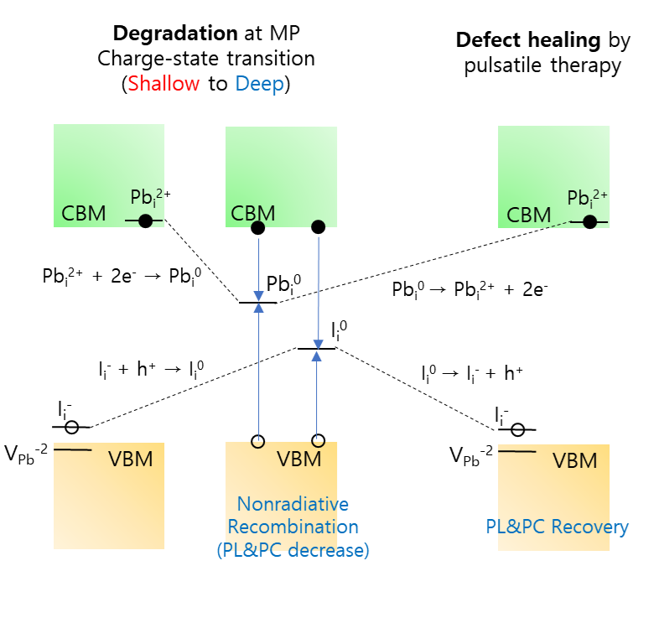
Figure S4. A schematic scenario for defect healing process based on the nature of defect dynamics reported. In this scenario, deep-level defects that are formed during MP could be converted into shallow-level defects as a result of charge-state transition.
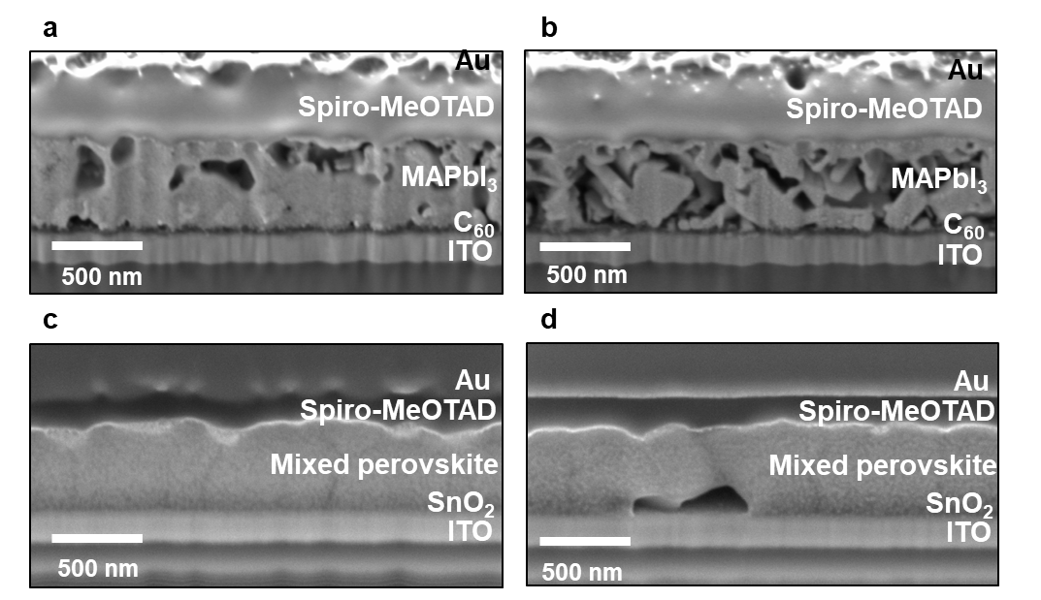
Figure S5. Cross-sectional SEM images of MA-rich devices operated by (a) pulsatile therapy (PT) and (b) MPPT after 50 h of continuous operation. Cross-sectional SEM images of FA-rich perovskite devices operated by (c) pulsatile therapy (PT) and (d) MPPT after the light induced degradation after 500 h of continuous operation.

Section D. Calculation of total gain
Each cell has slightly different initial power conversion efficiency. To fairly evaluate improvement of total energy harvested from each cell, normalized power of each cell is used. The normalized power P_{norm} is calculated by
$$P_{norm}(t)=\frac{P\left(t\right)}{P\left(0\right)}$$
where P(t) is an electrical power harvested by a device at operation time t and P(0) is an initial electrical power.
We calculated integration of normalized power over time to estimate normalized total energy during total operation time (including pulse period) as the following equation.
$$E_{norm}(T)=\int_{0}^{T}{P_{norm}}\left(t\right)dt$$
To calculate how much the normalized total energy of the cell working by pulsatile therapy has improved over the normalized total energy of the MPPT case, we defined total gain (G) as the following equation.
$${G\left(\%\right)=100*(E}_{norm,PT}-E_{norm,MPPT})/E_{norm,MPPT}$$
When G(%) is equal to zero, normalized total energy of the therapy is said to be the same as that of the MPPT. The time dependent total gain should be negative at early times due to the power consumptions needed to apply reverse biases in our PT, but later become positive since our PT stabilizes the device and even restores the degraded performance causing the normalized powers to become larger than those of MPPT.

Section E. Circuit modeling for peculiar I-V curves in the case of MPPT
The shape of I-V curves of solar cells normally has a single diode curve which can be explained by a general equivalent circuit of a solar cell. (Figure S6a) In the curve, a single defection appears around MPP when a diode in a circuit gets activated. If a device experiences degradation by device operation, its I-V curve and corresponding photovoltaic parameters will keep changing due to degradation because the parameters like short-circuit current, open-circuit voltage, and fill factor go down. Regardless of those changes in photovoltaic parameters, the shape of the I-V curves will maintain its original shape with the single deflection if there is no significant change in the equivalent circuit. However, we observed two deflections in one I-V curve when the device was tested for over 200 h under MPPT operation, while only single deflection was observed in I-V curves of the device working for 500 h under PT. (Figs. 5e-g) The observation indicates that the long-term operation under MPPT operation induces considerable changes in the equivalent circuit. On the contrary, PT operation does not affect the electrical circuit of the target device. To gain insight into those results, we performed a new circuit modeling for peculiar I-V curves observed only in the case of long-term MPPT.
The idea of our modeling is introducing an additional shunt diode (d₂) and serial resistance (R₂) in the equivalent circuit to take an additional recombination pathway into consideration as shown in Figure S6b. Note that the capacitor between node 1 and 2 was eliminated because the averaged I-V curves (time-transient characteristics were removed) were used for this circuit modeling. The peculiar I-V curves were simulated based on the new equivalent circuit as can be seen in Figures S6d and S6f, in which RMSE values (root-mean-square error) were very low, indicating excellent accuracy of the modeling. We also simulated I-V curves based on the original equivalent circuit with a single diode in order to compare the modeling accuracy. (Figures S6a, S6c, and S6e) It was clearly confirmed that RMSE values (root-mean-square error) based on the single diode model are much larger than those based on our new modeling for both 200 h and 500 h cases. In other words, the peculiar I-V curves with two deflections should be considered as a result of the equivalent circuit based on double diode.
In our modeling, the additional diode (d₂) supports a new non-radiative recombination pathway and reciprocal of the resistance (1/R₂) indicates a chance of the corresponding non-radiative recombination^{28,29}. Figure S7 shows the effect of two important parameters regarding the diode and the resistance on the peculiar shape. As the resistance decreases, the deflection shape becomes clearer because the slope of mid-plateau regime between two deflection points is affected by the resistance. (Figure S7a) This means that the peculiar shape appears when the resistance is sufficiently low to allow current flowing through the additional diode. Another critical parameter for the peculiar shape is the turn-on voltage of the additional diode (V_{on2}) as shown in Figure S7b. The turn-on voltage determines the point where the additional deflection appears due to the activation of the additional diode. As a new non-radiative recombination pathway can happen more easily as a result of degradation, the two parameters get smaller, leading to emergence of the peculiar shape and conductance-flat region in the I-V curve (Figure S7c and S7d). Table S2 shows the fitting parameters used in our I-V curve simulation for 500 h-MPPT devices, in which the two critical parameters become smaller with time. From the modeling, we confirmed that the peculiar shape could be explained by the emergence of the new non-radiative recombination pathway. Also, the chance of the new recombination pathway increased with device degradation.
The emergence of the additional diode for non-radiative recombination pathway can be attributed to the trap-assisted SRH recombination³⁰⁻³². The hypothesis seems reasonable for our modeling because trap densities will increase with device degradation. Also, only MPPT case showed the peculiar shape, while there was no significant change in the circuit for the PT case. Our experimental observations in Fig. 4 make the hypothesis more plausible from the fact that the PT can suppress the formation of defects. The MPPT case could not prevent the defect formation or heal any defects at all, which leads to the increase of trap density and the high chance of trap-assisted SRH recombination. As a result, the peculiar shape with two deflections caused by increased trap-assisted recombination must be observed from the device working by MPPT for over 100 h. Our circuit modeling again supports the efficacy of our PT that can heal defects and suppress defect formation, which is clearly consistent with all other measurements in the present work. Please note that, in our simulation, we used 1 of ideality factor to consider the additional diode as the source of SRH recombination. (see Table S2)

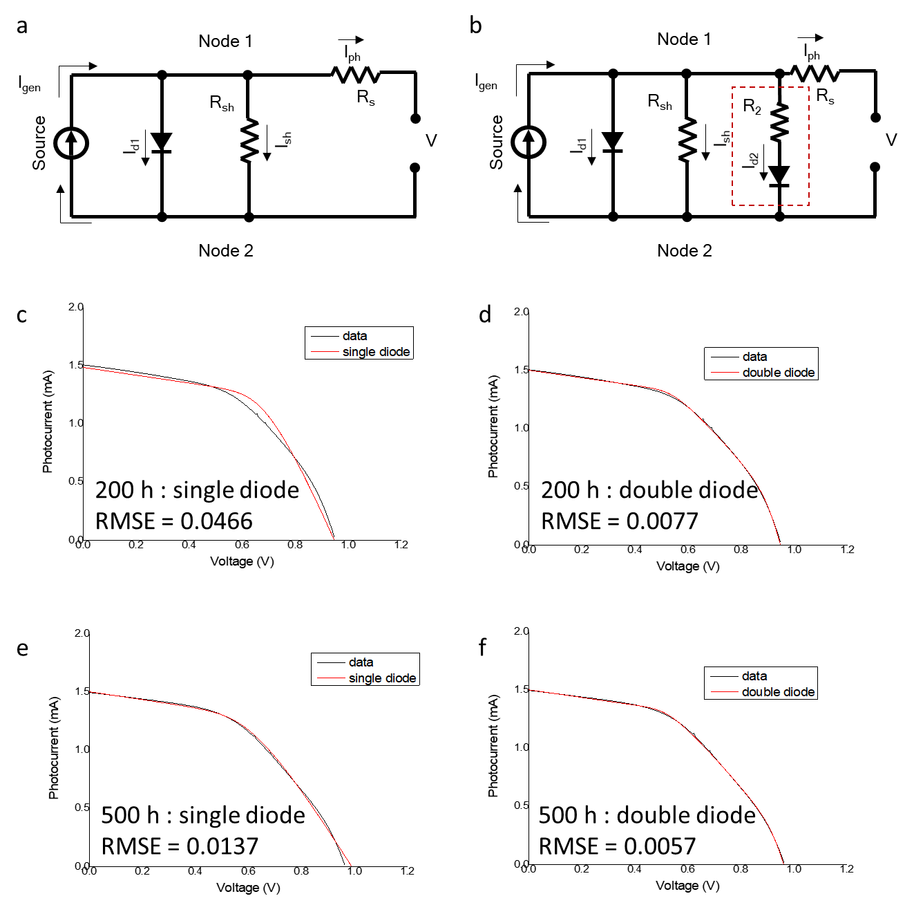
Figure S6. Equivalent circuit based on (a) single diode and (b) double diode modeling. I_{gen}, R_{s}, I_{ph}, R_{sh}, I_{sh}, and I_{d1} stands for source current, series resistance, photocurrent, shunt resistance, shunt current and diode current, respectively. In the I-V simulation, turn-on voltage of diode 1 (V_{on1}) was put as parameter. R₂ and I_{d2} stands for resistance and diode current of secondary shunt pathway, respectively. For the secondary diode, turn-on voltage (V_{on2}) was put as parameter (On-current for both diode (I_{on}) were set as 0.1mA). Both observed and simulated I-V curves for (c) 200 h : single diode, (d)200 h : double diode, (e)500 h : single diode and (f) 500 h : double diode. Fitting parameters for IV simulation can be found in Table S1.
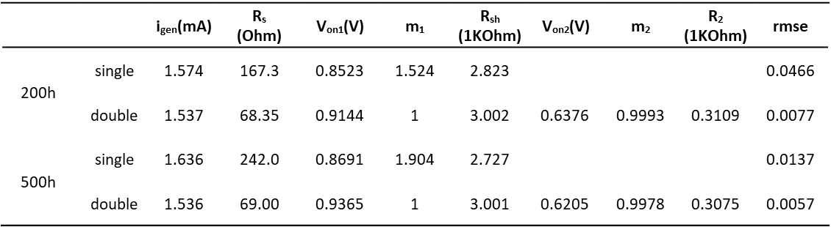
Table S1. Fitting parameter of single/double diode modeling for MPPT case, 200h and 500h.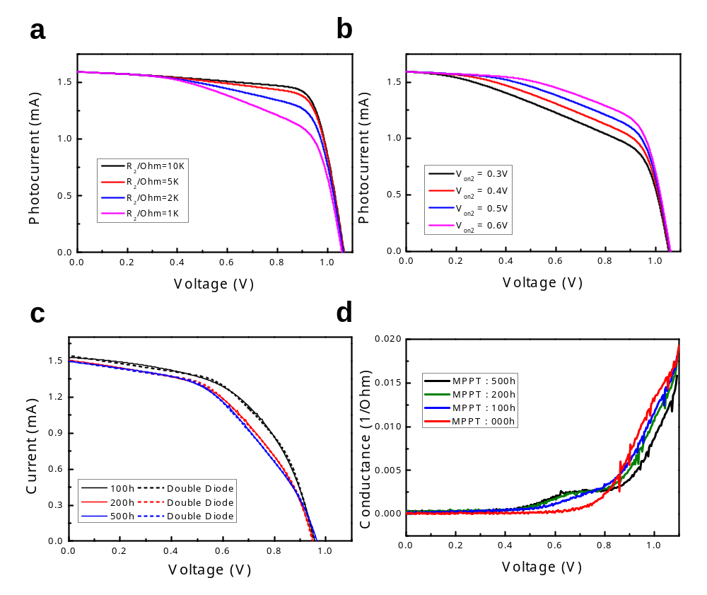
Figure S7. Simulated I-V curves depending on (a) R₂ and (b) V_{on2}. Other parameters were set as : i_{gen} = 1.6 mA, R_{s} = 50 Ohm, V_{on1} (turn-on voltage of diode 1)= 1 V, m₁ (ideality factor of diode 1) = 1, R_{sh} = 10 KOhm, V_{on2} (turn-on voltage of diode 2)= 0.5 V, m₂ (ideality factor of diode 1)= 2 and R₂ = 1 KOhm. Evolution of (c)I-V curve and (d)Conductance-V curve of MPPT case. On-current for diode (I_{on}) were set as 0.1mA.
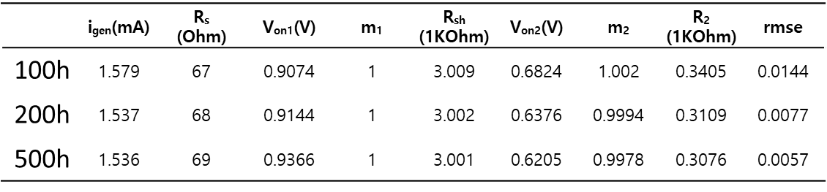
Table S2. Fitting parameter of double diode modeling for MPPT case, 100h/200h and 500h.
Reference
1. D. Bryant et al., Light and oxygen induced degradation limits the operational stability of methylammonium lead triiodide perovskite solar cells. Energy Environ. Sci.9, 1655-1660 (2016).
2. Song, Z. et al. Perovskite Solar Cell Stability in Humid Air: Partially Reversible Phase Transitions in the PbI₂-CH₃NH₃I-H₂O System. Adv.Energy Mater. 6, 1600846 (2016).
3. N. Ahn et al., Trapped charge-driven degradation of perovskite solar cells. Nat. Commun. 7, 13422 (2016).
4. M.-c. Kim et al., Degradation of CH3NH3PbI3 perovskite materials by localized charges and its polarity dependency. J. Mater. Chem. A 7, 12075-12085 (2019).
5. K. Kwak et al., An atomistic mechanism for the degradation of perovskite solar cells by trapped charge. Nanoscale 11, 11369-11378 (2019).
6. Eames, C. et al. Ionic transport in hybrid lead iodide perovskite solar cells. Nat. Commun.6, 7497 (2015).
7. DeQuilettes, D. W. et al. Photo-induced halide redistribution in organic-inorganic perovskite films. Nat. Commun. 7, 11683, (2016).
8. Li, C. et al. Real-Time Observation of Iodide Ion Migration in Methylammonium Lead Halide Perovskites. Small 13,1701711 (2017).
9. Frolova, L. A., Dremova, N. N. & Troshin, P. A. The chemical origin of the p-type and n-type doping effects in the hybrid methylammonium-lead iodide (MAPbI3) perovskite solar cells. Chem Commun (Camb) 51, 14917-14920, (2015).
10. Tang, X. et al. Local Observation of Phase Segregation in Mixed-Halide Perovskite. Nano Lett. 18, 2172-2178, (2018).
11. Di Girolamo, D. et al. Ion Migration‐Induced Amorphization and Phase Segregation as a Degradation Mechanism in Planar Perovskite Solar Cells. Adv. Energy Mater. 10, 2000310 (2020).
12. Y. Lin et al., Excess charge-carrier induced instability of hybrid perovskites. Nat. Commun. 9, 4981 (2018).
13. S. G. Motti et al., Controlling competing photochemical reactions stabilizes perovskite solar cells. Nat. Photonics 13, 532-539 (2019).
14. J. Byeon et al , Charge transport layer dependent electronic band bending in perovskite solar cells and its correlation to device degradation, ACS Energy Lett. 5, 2580-2589 (2020)
15.Lee, H. & Lee, C. Analysis of Ion-Diffusion-Induced Interface Degradation in Inverted Perovskite Solar Cells via Restoration of the Ag Electrode. Adv. Energy Mater 8,1702197 (2018).
16.Zhao, Y. et al. Mobile-Ion-Induced Degradation of Organic Hole-Selective Layers in Perovskite Solar Cells. J. Phys. Chem. C 121, 14517-14523, (2017).
17. Chen, B. et al. Impact of Capacitive Effect and Ion Migration on the Hysteretic Behavior of Perovskite Solar Cells. J. Phys. Chem. Lett. 6, 4693-4700,(2015).
18. I. Zarazua, J. Bisquert, G. Garcia-Belmonte, Light-Induced Space-Charge Accumulation Zone as Photovoltaic Mechanism in Perovskite Solar Cells. J. Phys. Chem. Lett. 7, 525-528 (2016).
19. S. Melon. et al. Ionic polarization-induced current-voltage hysteresis in CH₃NH₃PbX₃ perovskite solar cells. Nat. Commun. 7,10334 (2016)
20. Y. Yuan, J. Huang , Ion Migration in Organometal Trihalide Perovskite and Its Impact on Photovoltaic Efficiency and Stability. Acc. Chem. Res 49, 286-293 (2016).
21. A. Buin et al., Materials processing routes to trap-free halide perovskites. Nano Lett. 14, 6281-6286 (2014).
22. D. Meggiolaro et al., Iodine chemistry determines the defect tolerance of lead-halide perovskites. Energy Environ. Sci.11, 702-713 (2018).
23 S. van Reenen, M. Kemerink, H. J. Snaith, Modeling Anomalous Hysteresis in Perovskite Solar Cells. J. Phys. Chem. Lett. 6, 3808-3814 (2015).
24. Y. Yuan, J. Huang, Ion Migration in Organometal Trihalide Perovskite and Its Impact on Photovoltaic Efficiency and Stability. Acc. Chem. Res 49, 286-293 (2016).
25. Zhang, T. et al. Understanding the relationship between ion migration and the anomalous hysteresis in high-efficiency perovskite solar cells: A fresh perspective from halide substitution. Nano Energy 26, 620-630, (2016).
26. X. Zhang, M. E. Turiansky, J.-X. Shen, C. G. Van de Walle, Iodine interstitials as a cause of nonradiative recombination in hybrid perovskites. Physical Review B 101, (2020).
27. L. D. Whalley, R. Crespo-Otero, A. Walsh, H-Center and V-Center Defects in Hybrid Halide Perovskites. ACS Energy Lett. 2, 2713-2714 (2017).
28. Bandana Khanna. et al. A three diode model for industrial solar cells and estimation of solar cell parameters using PSO algorithm. Renew. Energy 78 , 105-113 (2015)
29. Kensuke Nishiokaa, Nobuhiro Sakitanib, Yukiharu Uraokab, Takashi Fuyukib. Analysis of multicrystalline silicon solar cells by modified 3-diode equivalent circuit model taking leakage current through periphery into consideration. Sol. Energy Mater. Sol. Cells 91 ,1222–1227(2007)
30. R.N.Hall. Electron-hole recombination in germanium. Physical Review Letters 87,387(1952)
31. W.Shockley, W.T.Read,Jr. Statistics of the recombinations of holes and electrons. Physical Review Letters 87,835(1952)
32. Sachit Grover. et al. Reformulation of solar cell physics to facilitate experimental separation of recombination pathways. Appl. Phys. Lett. 103, 093502 (2013)

