Supplementary Information

Nanoscopic investigation of C9orf72 poly-GA oligomers on nuclear membrane disruption by photoinducible platform

Authorship
Hung-Ming Chien,^{1,2,3} Ruei-Yu He,¹ Chi-Chang Lee¹, Yung-An Huang,^{1,4} ,I-Ju Hung,^{1,5} Kai-Ting Hou,¹ Jye-Chian Hsiao,¹ Po-Chao Lu,^{1,3,6} Diksha Agnihotri,⁷ Eric Hwang⁴ and Joseph Jen-Tse Huang^{1 ,3, 8, 9 *}

¹Institute of Chemistry, Academia Sinica, Nankang, Taipei City, Taiwan.
²Department of Chemistry, National Taiwan University, Taipei City, Taiwan
³Chemical Biology and Molecular Biophysics Program in Drug Discovery and Biotechnology Taiwan International Graduate Program, Academia Sinica and National Taiwan University, Taipei City, Taiwan
⁴Department of Biological Science and Technology, Institute of Bioinformatics and Systems Biology, and Institute of Molecular Medicine and Bioengineering, National Chiao Tung University, Hsinchu City, Taiwan
⁵Department of Chemical Engineering, National Taiwan University of Science and Technology, Taipei City, Taiwan
⁶Department and Graduate Institute of Pharmacology, National Taiwan University, Taipei City, Taiwan
⁷Taiwan International Graduate Program in Interdisciplinary Neuroscience, National Taiwan University and Academia Sinica, Taipei, Taiwan
⁸Department of Applied Chemistry, National Chiayi University, Chiayi City, Taiwan
⁹Neuroscience Program of Academia Sinica, Academia Sinica, Taipei, Taiwan
Corresponding author e-mail address
jthuang@gate.sinica.edu.tw

Supplementary Methods
Turbidity measurement, circular dichroism and dye-binding assay.
Peptide solution containing ADP-1 (50 μM) or ADP-3 (50 μM), were prepared in low salt PBS (0.05 M NaCl, 0.0027 M KCl, 0.01 M Na₂HPO₄, 0.002 M KH₂PO₄, pH = 7.4) either irradiated with UV light (365nm, power density: 32mW/cm², duration: 1 min) or not. Peptide containing solutions were incubated at 37 °C for following measurements. The turbidity of ADP-1 and ADP-3 solutions was recorded with a 1 cm quartz cuvette on the DU800 spectrophotometer (Beckman, U.S.A.). All turbidity data were collected at 600 nm. The CD spectra of the resulting (GA)₁₂ solutions from ADP-1 were measured with a 1 mm quartz cuvette on the J-815 CD spectrometer (JASCO, Japan). All data were collected from 195 to 260 nm with a scanning speed of 200 nm/min. Ten scans were averaged for each sample. For Thioflavin T binding assay, ThT working solution (50 μM ThT in PBS) was freshly prepared and filtered through a 0.22 μm Millipore filter. A 40 μL aliquot of the ADP-1 solution was mixed with 40 μL of the ThT working solution for 5 min at room temperature. The fluorescence emission spectra at 480 nm were taken in a 3 mm path length rectangular fluorescence quartz cuvette on an F-4500 spectrofluorimeter (Hitachi, Japan) with excitation at 442 nm.

Transmission electron microscopy.
For peptide TEM analysis, ADP-1, ADP-3, (GA)₃, (GA)₁₂ and (GA)₂₀ (50μM) were prepared in low salt PBS buffer (0.05 M NaCl, 0.0027 M KCl, 0.01 M Na₂HPO₄, 0.002M KH₂PO₄, pH = 7.4) irradiated with or without UV, respectively (365 nm, 1200μw/cm², duration: 1 min) followed by 37 °C incubation at the indicated time points. The resulting aliquots of peptide solutions (5 μL) were applied on glow-charged 300 mesh Formvar- and carbon-coated copper grids and stained with 1% uranyl acetate. After drying overnight, all samples were analyzed using a JEM-2011 electron microscope (JEOL, Japan). For cellular TEM imaging , cos-7 cells treated with ADP-1 and irradiated were fixed by 4 % glutaraldehyde in PBS. Cell membrane of cos-7 was stained with osmium tetroxide (1% in PBS). After cell dehydration with alcohol, cell samples were ultracut using diamond knife to acquire thin section of cell. The thin cell sections were then put on the grid and stained with 1% uranyl acetate. The cellular TEM image capture was essentially same as described above.

Dot blot analysis
ADP-1 and ADP-3 (100 μM) were freshly prepared in low salt PBS buffer (0.05 M NaCl, 0.0027 M KCl, 0.01 M Na₂HPO₄, 0.002 M KH₂PO₄, pH = 7.4) irradiated with or without UV (365 nm, 1200 μw/cm², duration: 1 min), and then incubated at 37 °C until the time indicated. 2 μL aliquot of incubated solution was applied on the nitrocellulose blotting membrane. membrane was dried, blocked with 5 % bovine serum albumin in tris-buffer saline with 0.1 % Tween 20, and stained with A11 antibody (AHB0052, ThermoFisher) and GA repeat antibody (24492-1-AP, Proteintech), respectively.

Direct stochastic optical reconstruction microscopy.
dSTORM images were captured with ELYRA superresolution microscope (Zeiss). For an appropriate blinking buffer condition of thiol reduction for dSTORM, mercaptoethylamine and 2-mercaptoethanol at 75 mM were used for optimized blinking duty cycles and duration. Glucose oxidase (160 mg/mL) and catalase (0.5 mg/mL) was used to prevent photolysis of excited dyes. All the dSTORM imaging was performed with an Elyra PS.1 superresd into imaging buffer combining 10% of glucose to scavenge oxygen and avoid oxygen-induced solution microscope. The region of interest (ROI) was selected with a 100x, NA 1.46, plan-APO objective. An EMCCD Andor iXon 897 (pixel size 16 µm; Optovar lens, magnification 1.6x, along with the 100x objective lens yielded a final pixel size of 100nm) was used as the camera detector. With laser illumination at 488nm and an emission filter was matched to A488 emission spectrum, 50000 raw images of blinking molecules were acquired with EPI or TIRF microscopy mode. The dSTORM images were reconstructed with a pixel size of 10 nm. For the cellular images, SH-SY5Y and Cos-7 were cultured, treated with ADP-2 and photoinitiated as aforementioned. Cells were fixed and stained with corresponding antibodies as indicated. The Cell samples were immersed in the blinking buffer and 50000 raw images of blinking molecules were collected and reconstructed to acquired dSTORM images as described above.

Cell maintenance, peptide treatment, and photoinitiation.
Human neuroblastoma SH-SY5Y was maintained in DMEM/F12 medium and monkey kidney Cos-7 cells were cultured in Dulbecco’s modified Eagle’s medium (Invitrogen) respectively supplemented with 2 mM glutamine, 10% heat-inactivated fetal bovine serum, and 100 U/mL penicillin−streptomycin (Invitrogen) at 37 °C in a humidified atmosphere with 5 % CO₂. Peptides were prepared by dissolving the lyophilized powder in fresh cell culture medium. To photoinitiate ADP peptides in cells, cells were pre-loaded with polypeptide-containing medium for 6 h, washed, and UV-illuminated (mercury lamp with 345−385 nm bandpass filter; average power: 8.24 mW/cm²; duration: 1 min).

Dynamic light scattering measurements.
To measure the size distribution of GA DPRs oligomers, ADP-1 (100 μM in low salt PBS buffer was UV-irradiated followed by 2 hours incubation at 37 °C using DynaPro NanoStar (Wyatt technology, U.S.A.). Samples were measured at 25°C, and more than 15 times measures were averaged to acquire correlation function curve. The correlation function curve was later fitted with regularization fitting. The results with sum of squares (SOS) larger than 100 will be excluded.

Immunostaining and confocal microscopy.
For TDP-43, Ran, Importin-β and Lamin B1 immunohistochemistry experiments, 2 × 10⁵ of SH-SY5Y or Cos-7 cells on a 30 mm square coverslip were treated with ADP-1, 2, or 3 peptides basically as described above. The photoinitiated cells were incubated for an additional 24 hrs and then fixed with 4 % paraformaldehyde. For immunostaining, anti-TDP-43 antibody (Abcam, ab104223), anti-Ran antibody (Abcam, ab155103), anti-importin-β antibody (Abcam, ab2811), anti-Lamin B1 antibody (Abcam, ab16048) and anti-Nup153 antibody (Abcam, ab24700) were used respectively. The coverslips with the immunostained cells were sealed using mounting media (Invitrogen, ProLong™ Diamond Antifade Mountant). Confocal images of the resulting samples were captured with LSM 780 & LSM 880 (Zeiss). Cytoplasmic TDP-43 and Ran staining were defined as protein mislocalization, whereas importin-β apart from perinuclear region was defined as protein diffusion. For scoring nuclear Invagination, was described as the intrusion of Lamin B1 inside the nucleoplasm (longer than 1 μm).¹ And the abnormal distribution of lamin was define as the Lamin B1 puncta observed in the nucleoplasm.

TIRF imaging for quantitation of sGFP distribution.
TIRF and epifluorescence images were collected using a Nikon TiE microscope, where shuttling GFP (sGFP) were excitated by 488nm filter set with 130w mercury lamp. For transfection of sGFP on SH-SY5Y cells, 1.5 ug of DNA (NES-eGFP-NLS) were mixed with lipofectamine 3000 reagents according to manufacturer’s instruction (ThermoFisher) and then added to the 5 × 10⁵ of SH-SY5Y cells on the 30 mm square coverslip. After 24 hours, cells were treated with peptides and illumination according to aforementioned descriptions. Quantitation of sGFP distribution was carried out using ImageJ for evaluation flourescence intensity in cytoplasm and nucleus. The nuclear-to-cytoplasmic ratio of sGFP was acquired by fluorescence intensity in nucleus over the fluorescence intensity in cytoplasm. More than 35 cells were analyzed in each experimental group (N=3).

ADP-1 treatment in mouse cortical neurons, immunofluorescence staining, and neurite fragmentation analysis.
Primary culture of dissociated mouse cortical neurons isolated from the brains of E17.5 (embryonic 17.5) mouse pups was carried out as previously described.² The ADP-1 peptide (final concentration 1 μM) was dissolved in the pre-equilibrated B27-supplemented neurobasal medium containing 50% of the old cultured medium. The 21 days in vitro (21DIV) cortical neurons were incubated with null or ADP-1 -containing medium for 8 hours. To completely remove ADP-1 from the culture medium, the washing process, involving replacement with 500 μL of pre-equilibrated B27-supplemented neurobasal medium, was applied once. Cortical neurons were then UV irradiated for 2 minutes using a Nikon Intensilight epi-fluorescence light source, a Semrock filter FF01-357/44-25, and a 10x 0.45 N.A. Plan Apochromat objective lens. 24 hours after UV irradiation, cortical neurons were fixed with 3.7% formaldehyde in 1× PBS at 37 °C for 15 min, followed by membrane permeabilization with 0.25 % Triton X-100 for 5 min at room temperature. Cells were then blocked with 10% bovine serum albumin (BSA) in 1× PBS for 30 min at 37 °C followed by 1 hour of incubation at 37 °C with primary antibodies (anti-TDP-43, 1:1000, Abcam, ab104223; anti-β-III-tubulin, 1:200, Abcam, ab18207) in 2% BSA. Cells were washed 3 times with 1× PBS and subjected to 1 hour of incubation with AlexaFluor 488-labeled (anti-mouse) and 568-labeled (anti-rabbit) secondary antibodies (1:1000, Thermo Fisher Scientific) at 37 °C in the dark. Immunofluorescence stained neurons were acquired on a Nikon Eclipse-Ti inverted microscope equipped with a 60× 1.49 N.A. Plan Apochromat objective lens, an Intensilight epi-fluorescence light source, a Photometrics CoolSNAP HQ2 camera, and Nikon NIS-Elements software 4.13.05. To quantify the fragmentation of neurites, ImageJ (http://imagej.nih.gov/ij/) was used to process and analyze the neurite signal in the β-III-tubulin channel. Briefly, the total neurite area was obtained from the original β-III-tubulin image using Subtract Background → Gaussian Blur → Phansalkar auto local threshold. The fragmented neurite area was obtained using the analyze particles function with a particle size less than 50 pixels.

Statistical Analysis
Statistical data were analyzed by one-way ANOVA or student-t test.

Supplementary Table and Figures

Name | Sequence* | Calc. Mass | Observed Mass
(GA)₃ | (GA)₃-NH₂ | 401.4 | 424.2 (M+Na)⁺
(GA)₁₂ | (GA)₁₂-NH₂ | 1554.6 | 1576.8 (M+Na)⁺
(GA)₂₀ | (GA)₂₀-NH₂ | 2578.2 | 2601.5 (M+Na)⁺
ADP-1 | C-(GA)₁₂-#PL-K₈-NH₂ | 2963.4 | 2963.7
ADP-2 | AF 488 C5 Maleimide-C-(GA)₁₂-#PL-K₈-NH₂ | 3661.0 | 3661.2
ADP-3 | C-(GA)₃-#PL-K₈-NH₂ | 1809.9 | 1811.0
ADP-4 | AF 488 C5 Maleimide-C-(GA)₃-#PL-K₈-NH₂ | 2507.5 | 2509.1 (M+H)⁺
Table S1. List of peptides, sequence, and mass of the peptide used in this work. *Sequence was written in the direction from N-terminus to C-terminus. #PL stands for the photolabile linker.

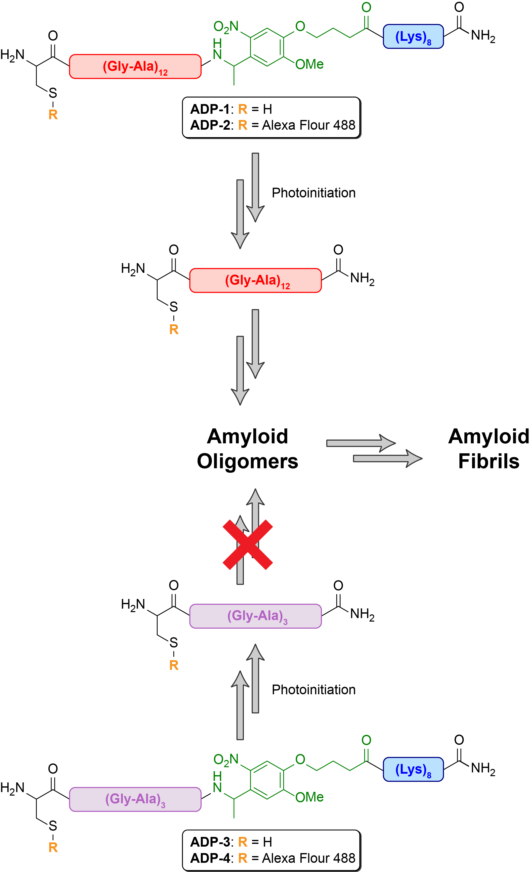
Figure S1. Schematic figure for ADP probes.
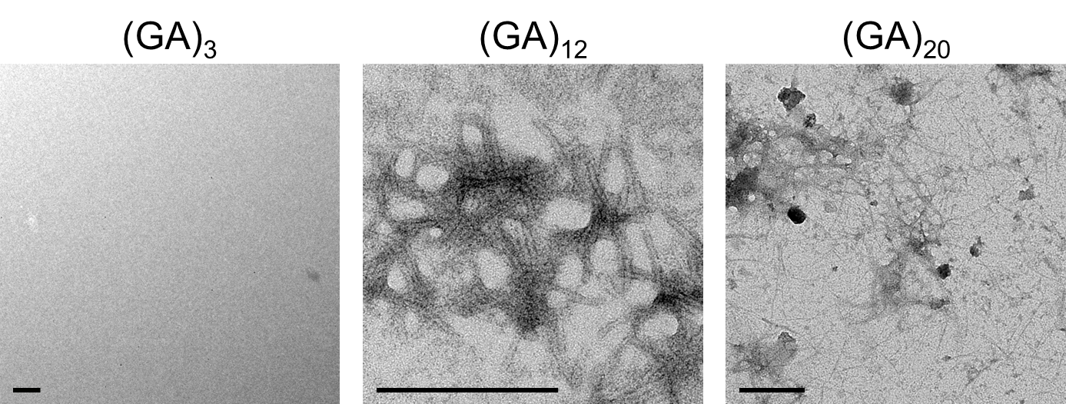
Figure S2. TEM images of GA DPRs with varied chain length. Peptides (50 μM) were prepared in the low salt phosphate buffer saline (0.05M NaCl, 0.0027M KCl, 0.01M Na₂HPO₄, 0.002M KH₂PO₄, pH = 7.4) and incubated at 37 °C for one day. Scale bar indicates 200 nm.
(A)
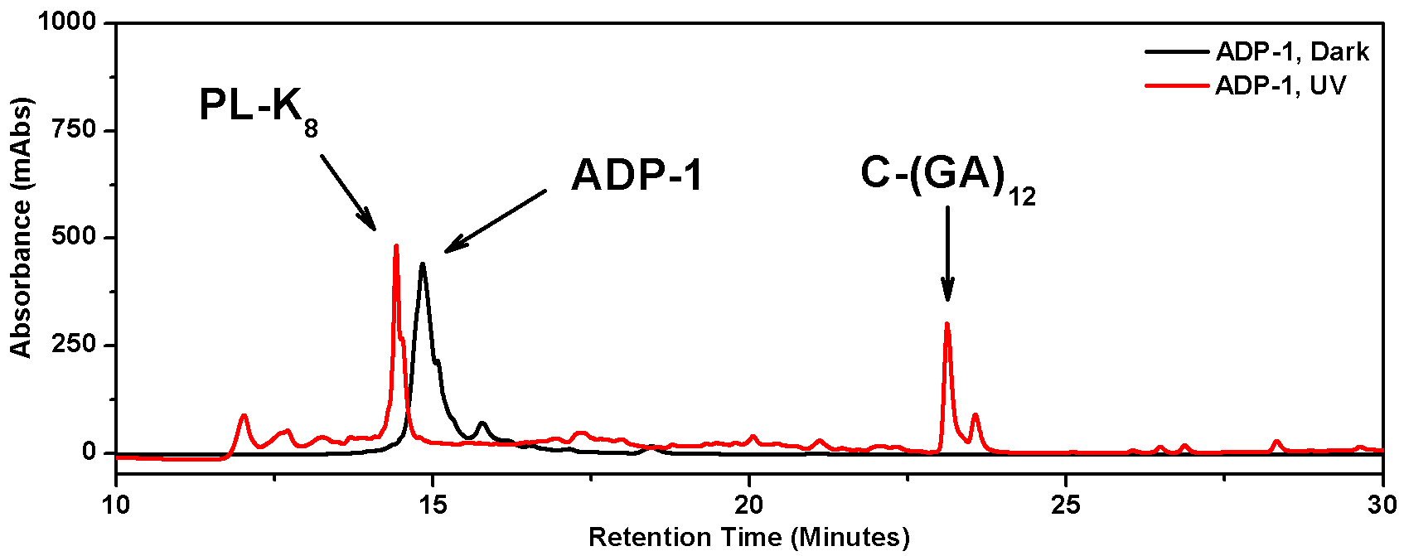
(B)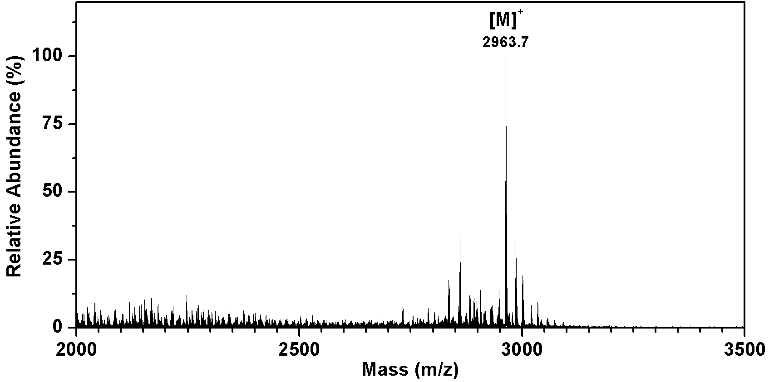
(C)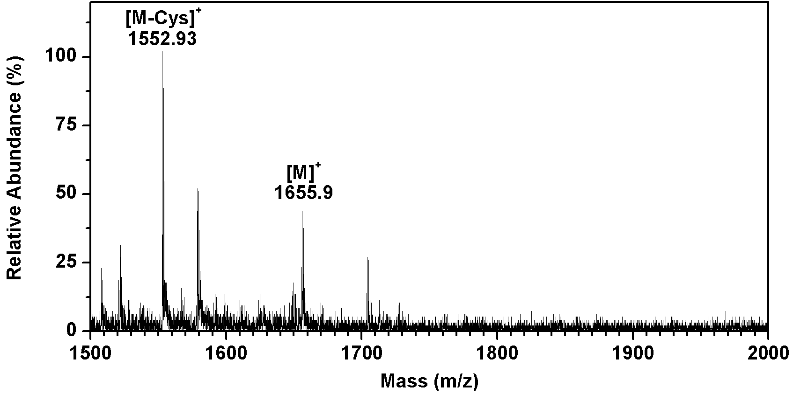
(D)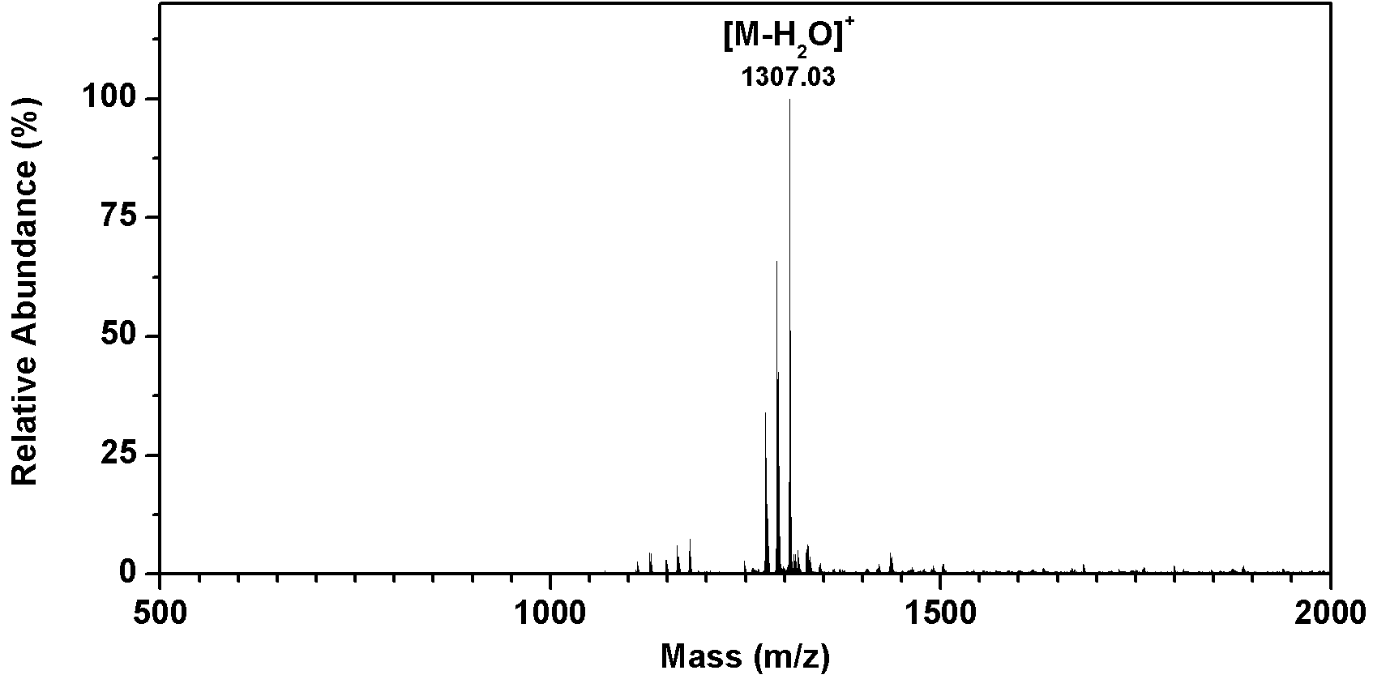
Figure S3. HPLC and MS spectra of ADP-1. (A) High performance liquid chromatography spectra of unirradiated and irradiated ADP-1. The first red peak with retention time around 14 minute is the photolinker-octalysine segment as we confirmed by mass in Figure S2D, whereas the other red peak with retention time about 23 minute is the GA DPRs fragment as we identified by mass in Figure S2C. (B) Matrix-assisted laser desorption/ionization-time of flight mass spectra of ADP-1, calc. mass: 2963.7; observed: 2963.7. ([M]⁺) (C) Matrix-assisted laser desorption/ionization-time of flight mass spectra of GA DPRs fragment from the photoinitiated ADP-1, calc. mass: 1657; observed:1655.9 ([M]⁺) (D) Matrix-assisted laser desorption/ionization-time of flight mass spectra of octalysine fragment from the photoinitiated ADP-1, calc. mass: 1324.3 ; observed:1307.03 ([M-H₂O]⁺)

(A)
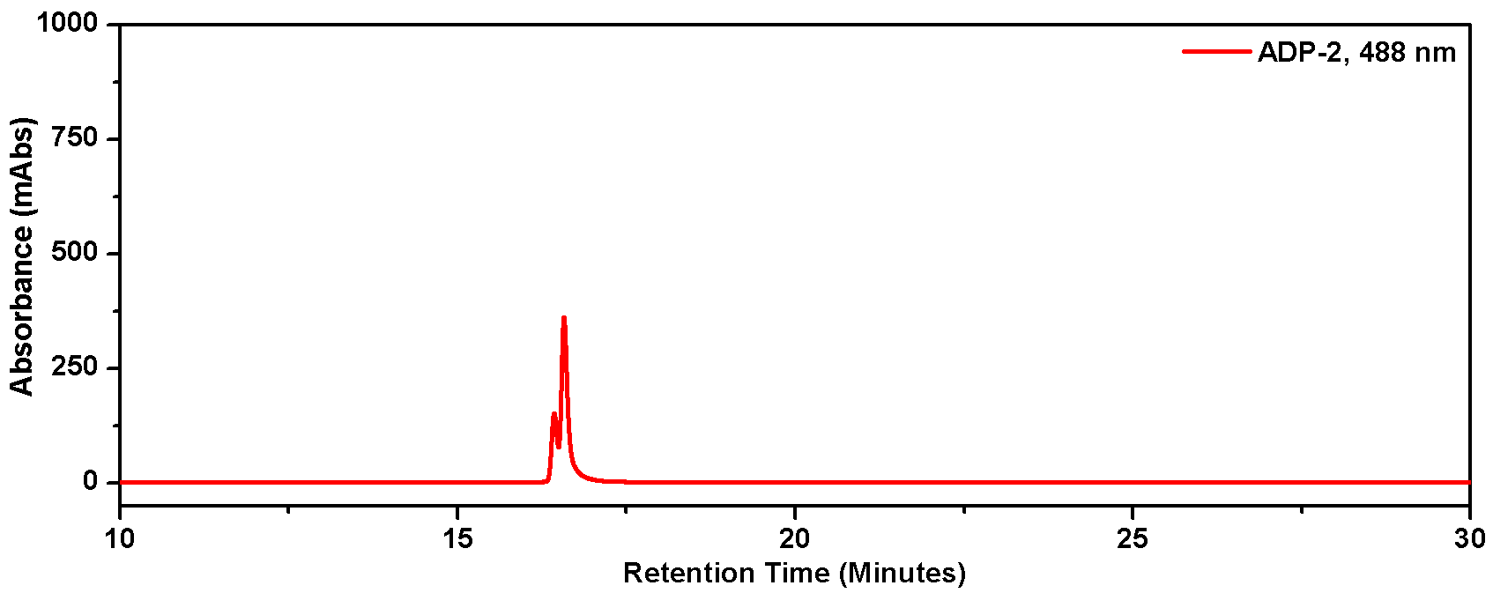
(B)
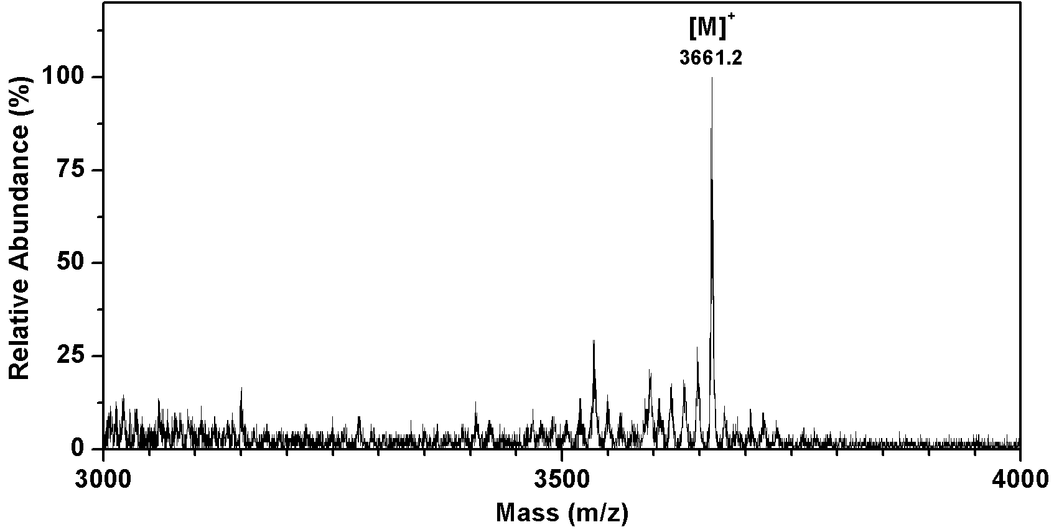
Figure S4. HPLC and MS spectra of ADP-2. (A) High performance liquid chromatography spectra of ADP-2 (B) Matrix-assisted laser desorption/ionization-time of flight mass spectra of ADP-2, calc. mass: 3661.0; observed: 3661.2. ([M]⁺)

(A)
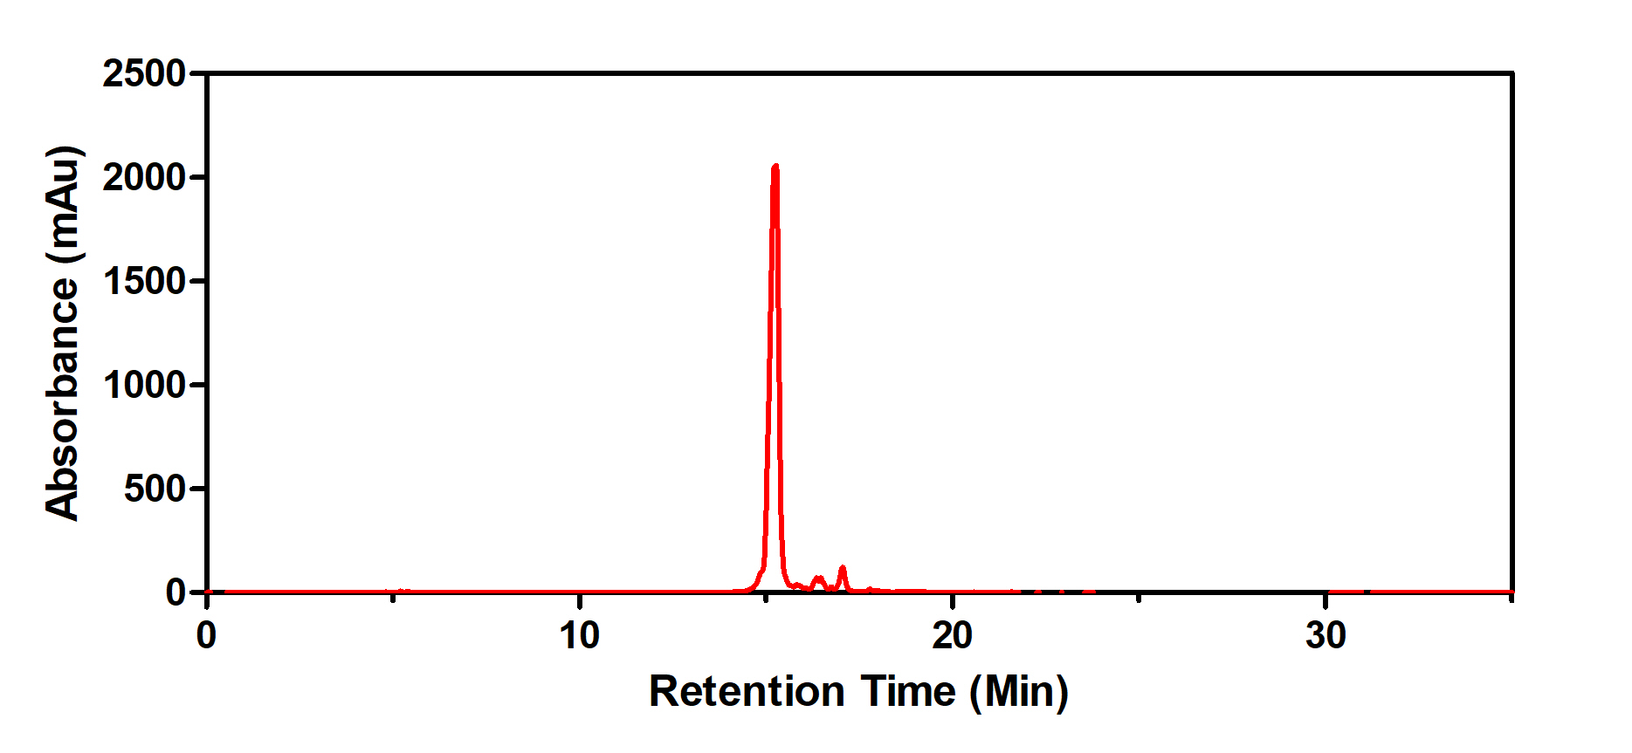
(B)
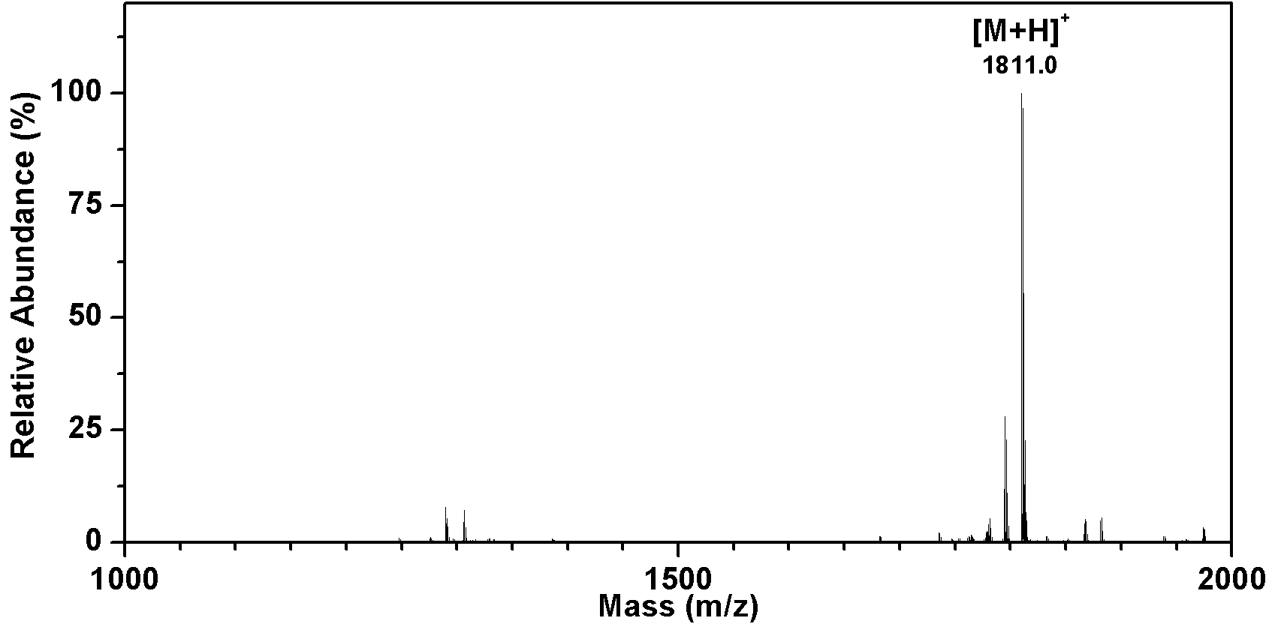

Figure S5. HPLC and MS spectra of ADP-3. (A) High performance liquid chromatography spectra of ADP-3 (B) Matrix-assisted laser desorption/ionization-time of flight mass spectra of ADP-3, calc. mass: 1809.9; observed: 1811.0 ([M+H]⁺)

(A)
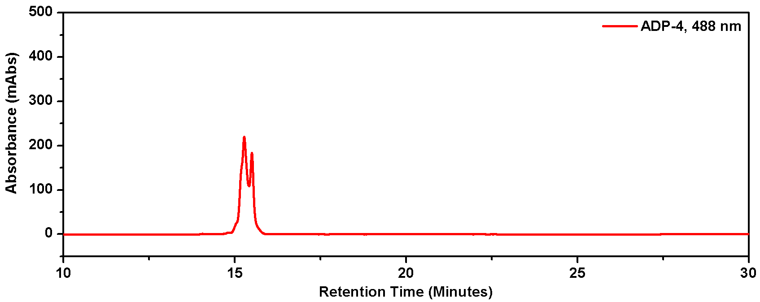
(B)
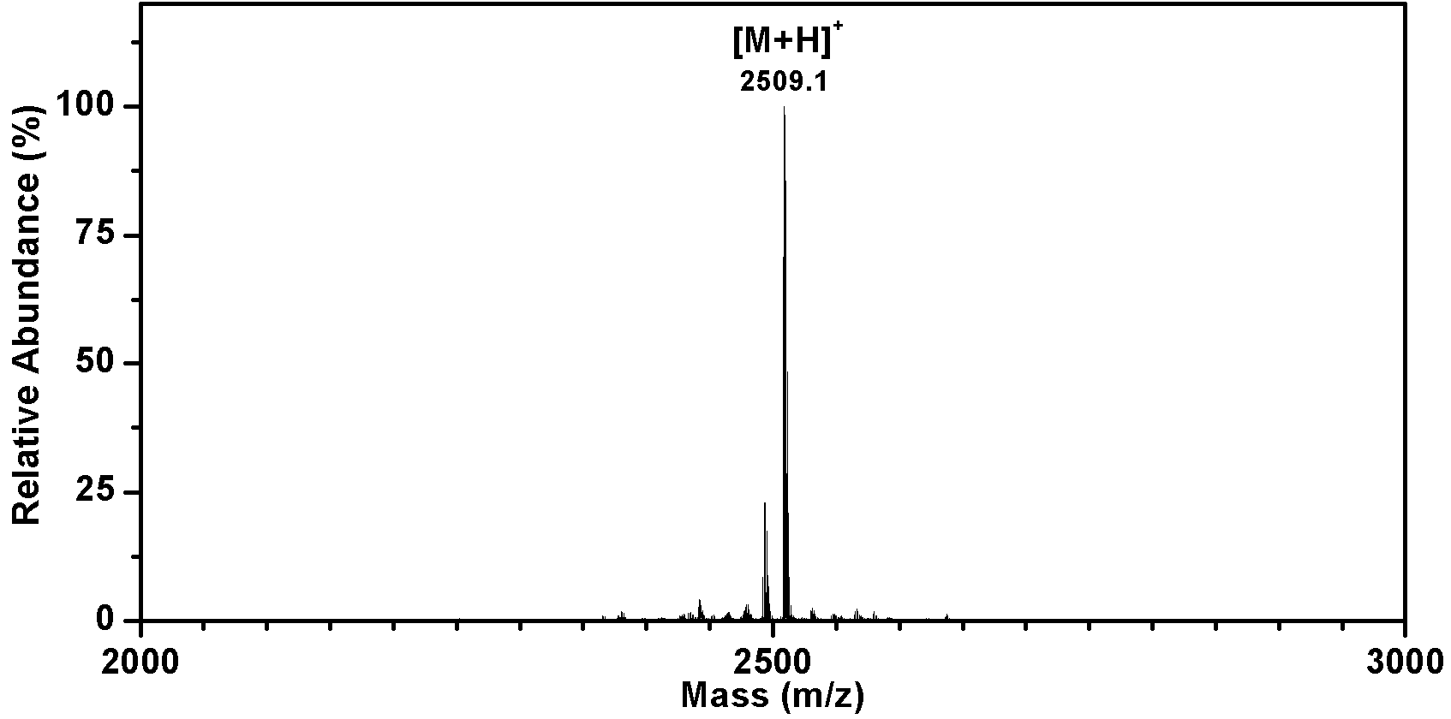
Figure S6. HPLC and MS spectra of ADP-4. (A) High performance liquid chromatography spectra of ADP-4 (B) Matrix-assisted laser desorption/ionization-time of flight mass spectra of ADP-4, calc. mass: 2507.5; observed: 2509.1 ([M+H]⁺)

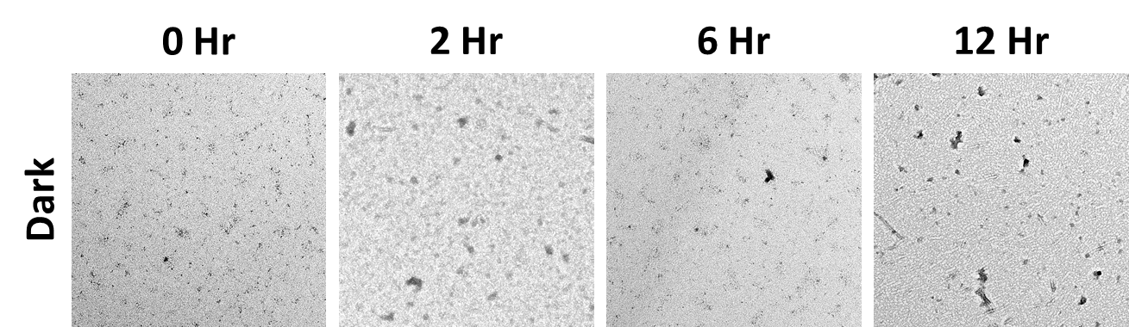
Figure S7. TEM images of the incubated ADP-1 without UV irradiation. ADP-1 (50 μM) were prepared in the low salt phosphate buffer saline (0.05M NaCl, 0.0027M KCl, 0.01M Na₂HPO₄, 0.002M KH₂PO₄, pH = 7.4) and incubated at 37 °C for different time points as indicated. The Dark in the legend indicated the unirradiated condition.

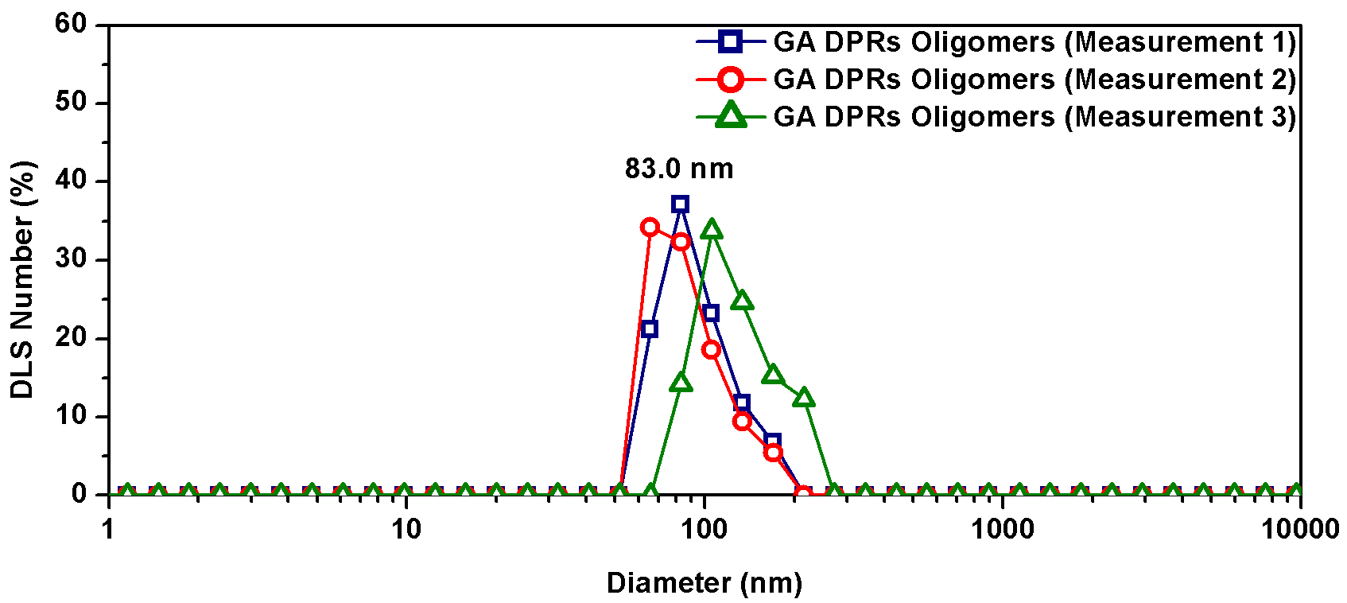
Figure S8. Size distribution diagram of ADP-1 oligomers by dynamic light scattering. ADP-1 (100 μM) were irradiated with UV light and incubated for 2 hours before measurements.
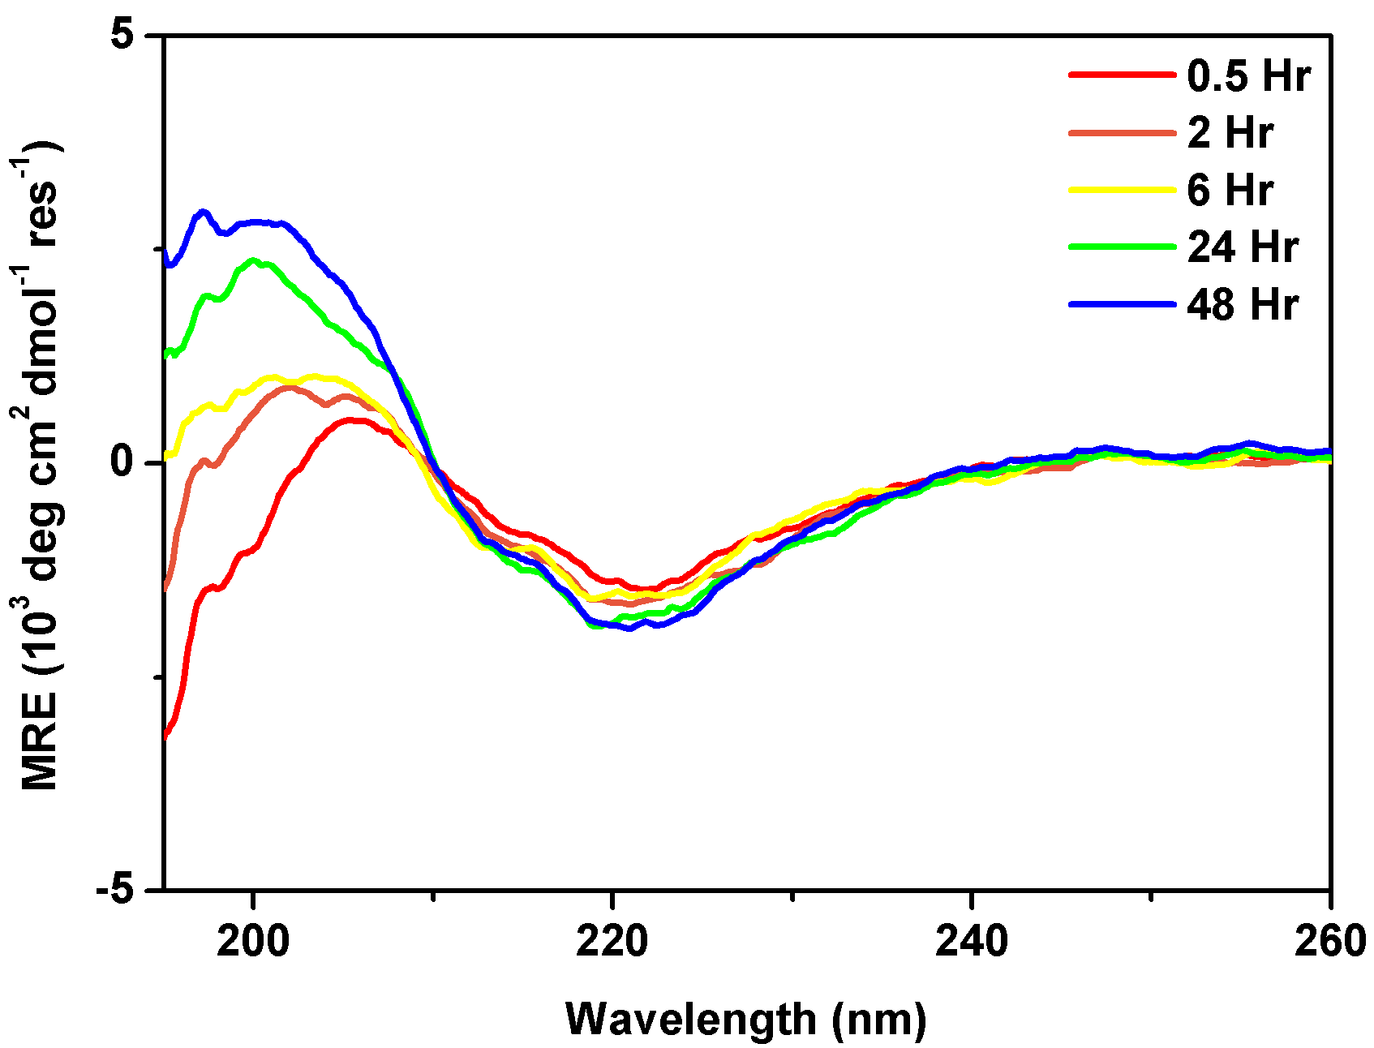
(A)
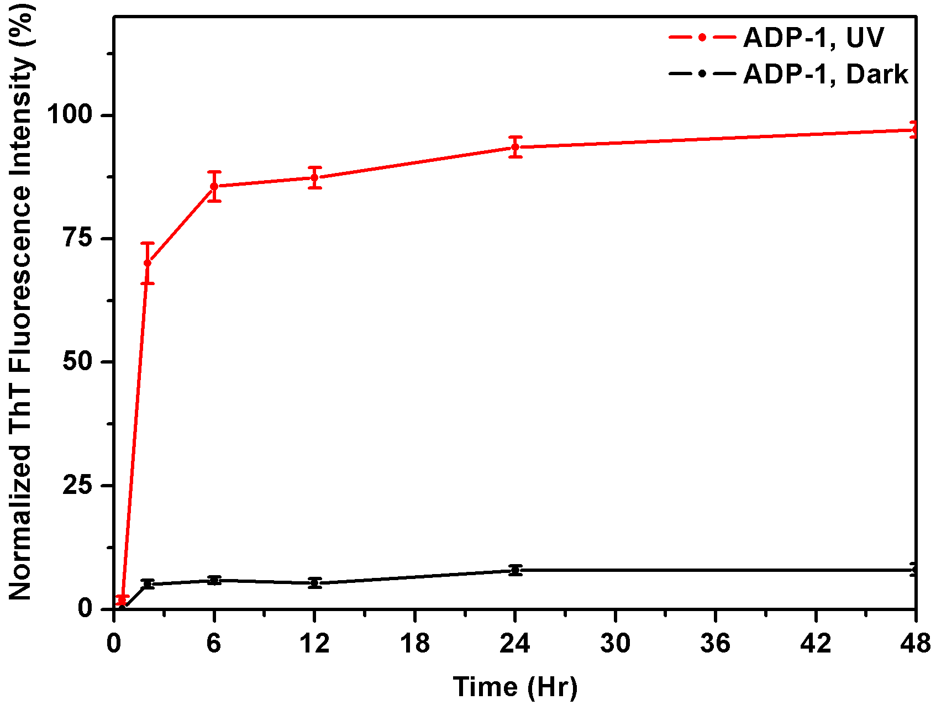
(B)
Figure S9. Biophysical characterization and thioflavin-binding assay of the GA DPRs from ADP-1. (A) Time-course circular dichroism spectrum of photoinitiated ADP-1 (50 μM) in low salt PBS (0.05M NaCl, 0.0027M KCl, 0.01M Na₂HPO₄, 0.002M KH₂PO₄, pH = 7.4). (B) Normalized fluorescence intensity (484 nm) of Thioflavin-T (ThT) mixed with either irradiated or unirradiated ADP-1 (50 μM) in the low-salt PBS. Both ThT and ADP-1 concentration equals to 25 μM in the solution.
(A)
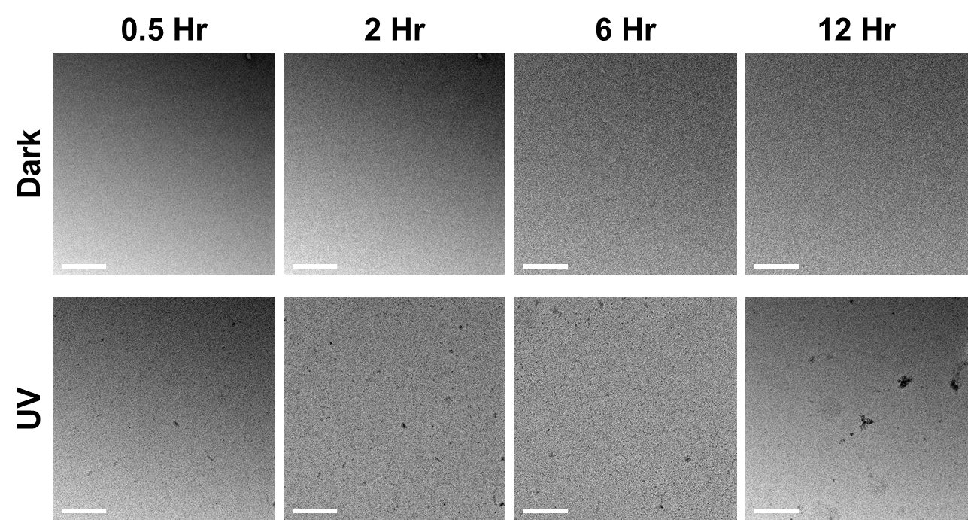
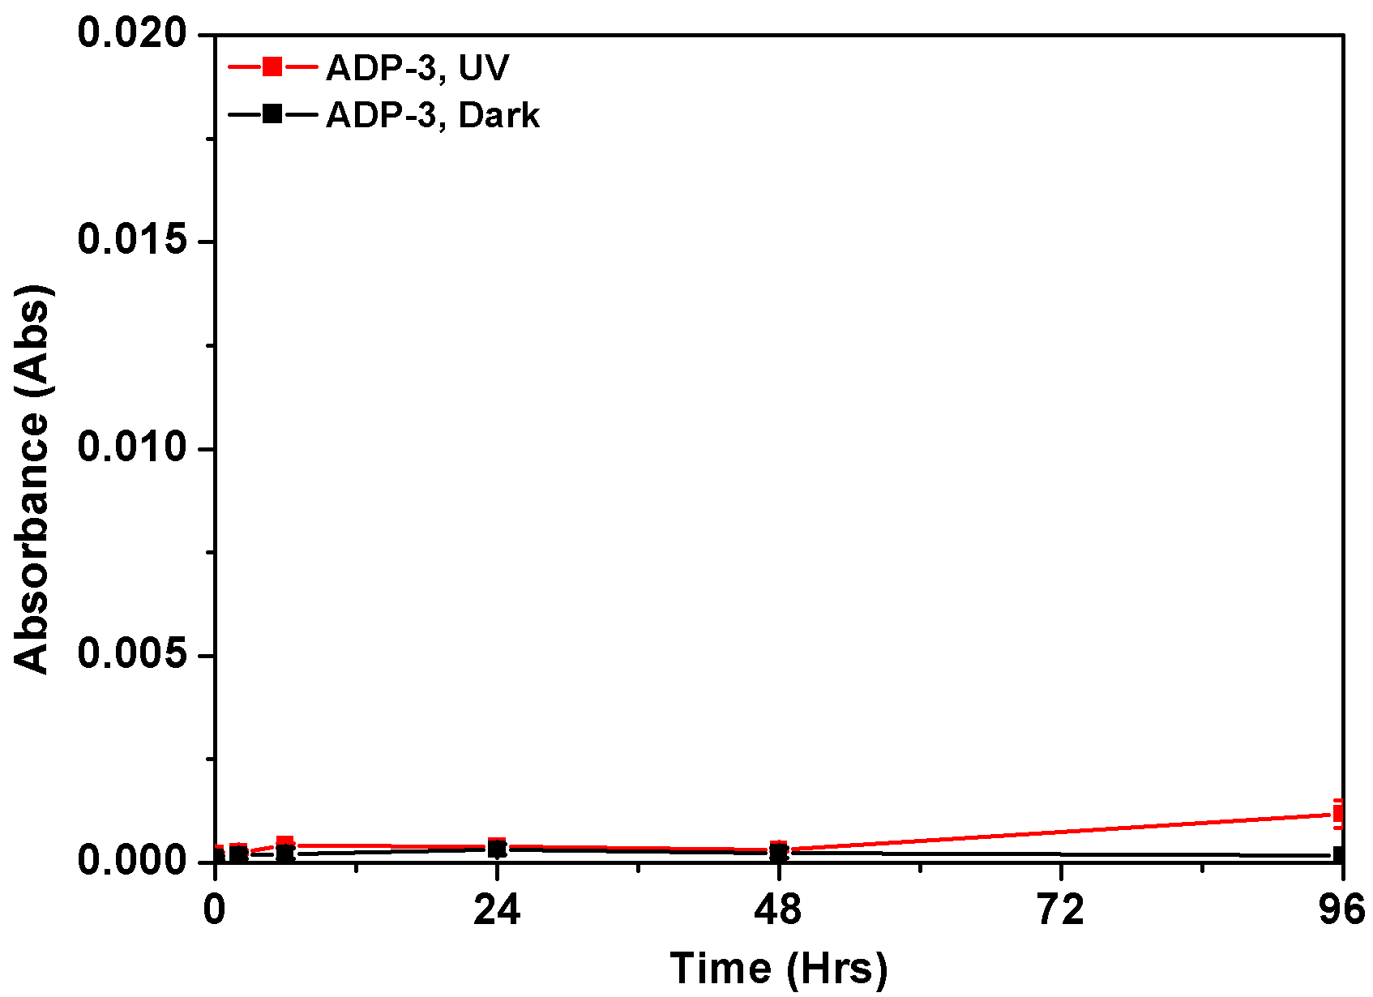
(B)
Figure S10. Time-course transmission electron microscopy and turbidity measurements of ADP-3. (A) ADP-3 (50 μM) were prepared in the low salt phosphate buffer saline and incubated at 37 °C for different periods. (B) ADP-3 (50 μM) were prepared in the low salt phosphate buffer saline either irradiated with UV light or not. The resultant samples were incubated at 37 °C. The Dark in the legend indicated the unirradiated condition.

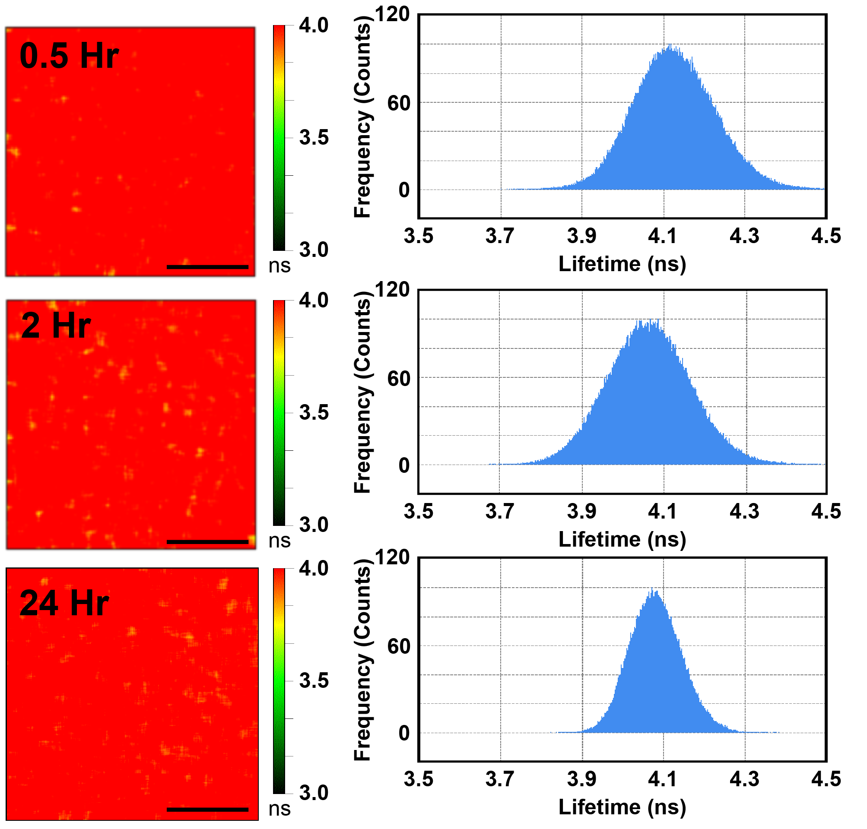
Figure S11. Fluorescence-lifetime images and histogram of photointiated ADP-4. ADP-4 (5 μM) were photoinitiated and then incubated to the indicated time. Images were taken at the 0.5th, 2nd, and 24th hour after photoinitiation. Scale bars indicate 5 µm.

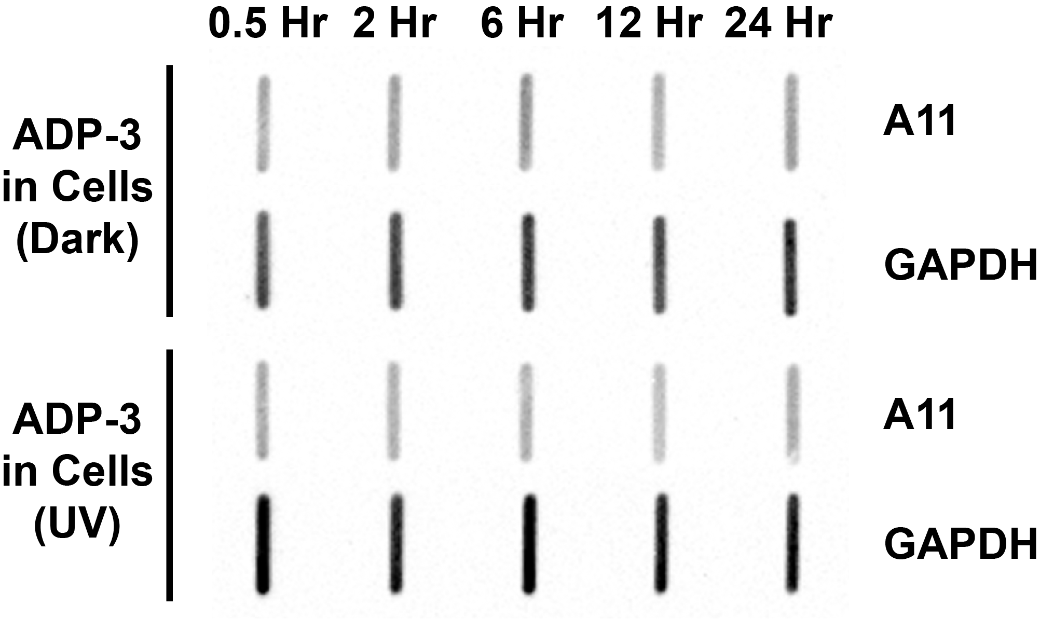
(A)
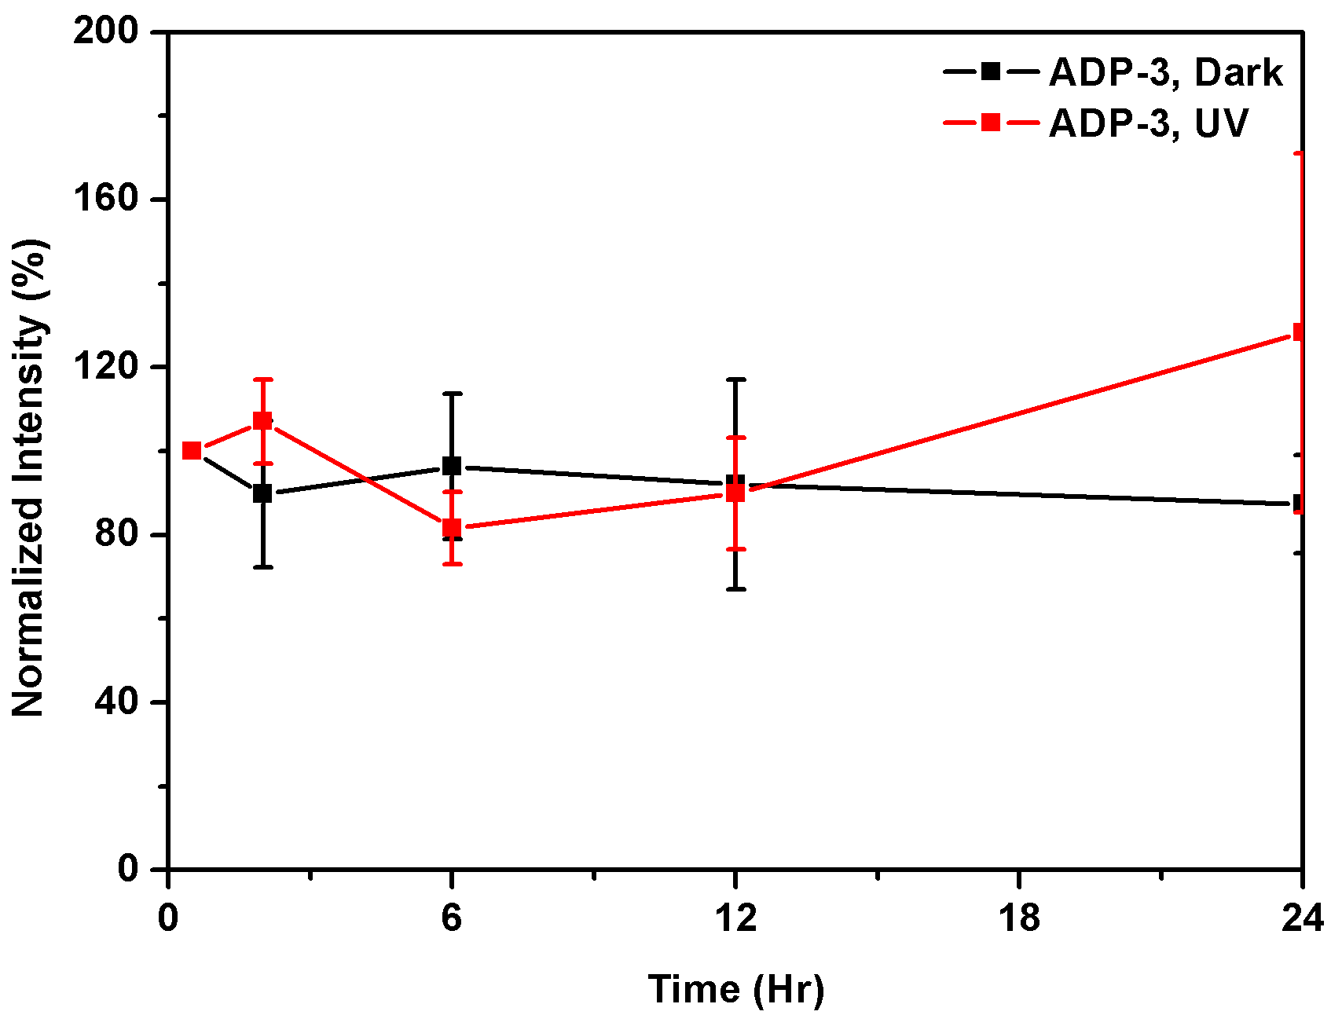
(B)
Figure S12. A11 immunoblot and quantification analysis on ADP-3 treated SH-SY5Y cell lysate. (A) immunoblotting of A11 staining on cell lysate from SH-SY5Y cells receiving ADP-3 (1µM) treatment with either photoinitiation or not. Cell lysates at different time points were harvested and analyzed. (B) Quantification analysis of A11 immunoblot of SH-SY5Y cell lysate. The signal of A11 staining was first normalized to that of the GAPDH staining and then compared to signal at 0.5 hour incubation. Three indepedent experiements were carried out.
(A)
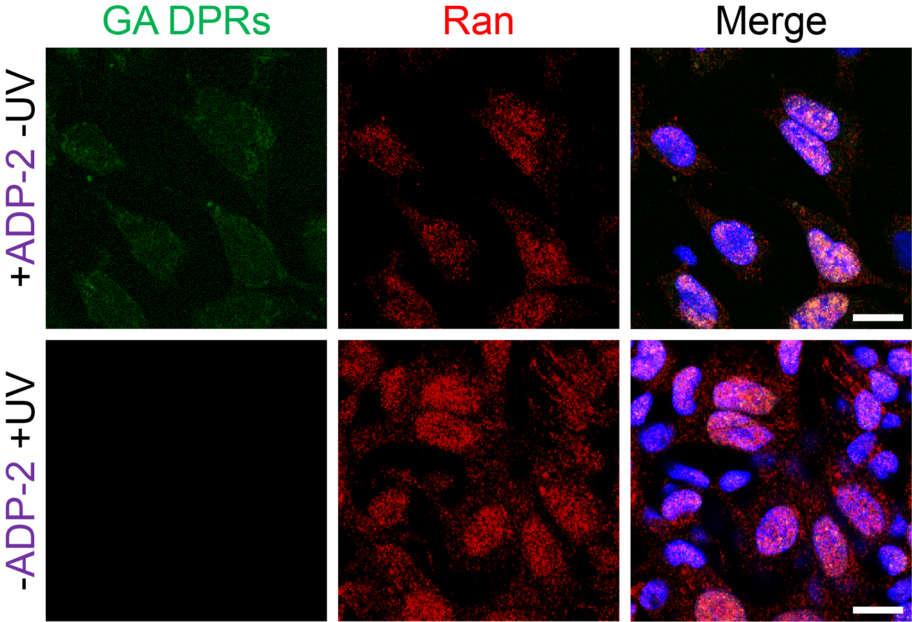
(B)
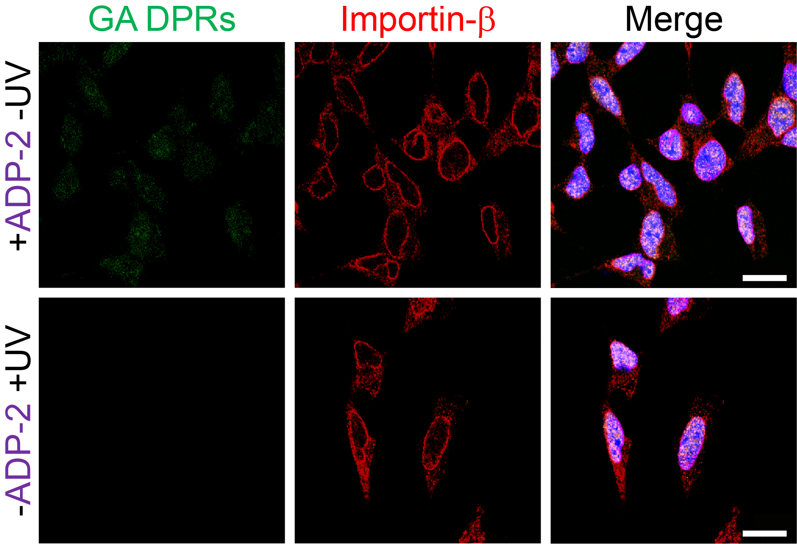
Figure S13. Representative images of transport-relevant proteins in SH-SY5Y cells. (A) Immunofluorescence images of Ran protein (red) in GA DPRs aggregates (green)-rich SH-SY5Y cells. Cells were treated with ADP-2 (1 μM) and then exposure to UV light. Scale bars indicate 10 µm. (B) Immunofluorescence images of Importin-β (red) in SH-SY5Y after ADP-2 (1 μM) and irradiation treatment. Scale bars indicate 10 µm.
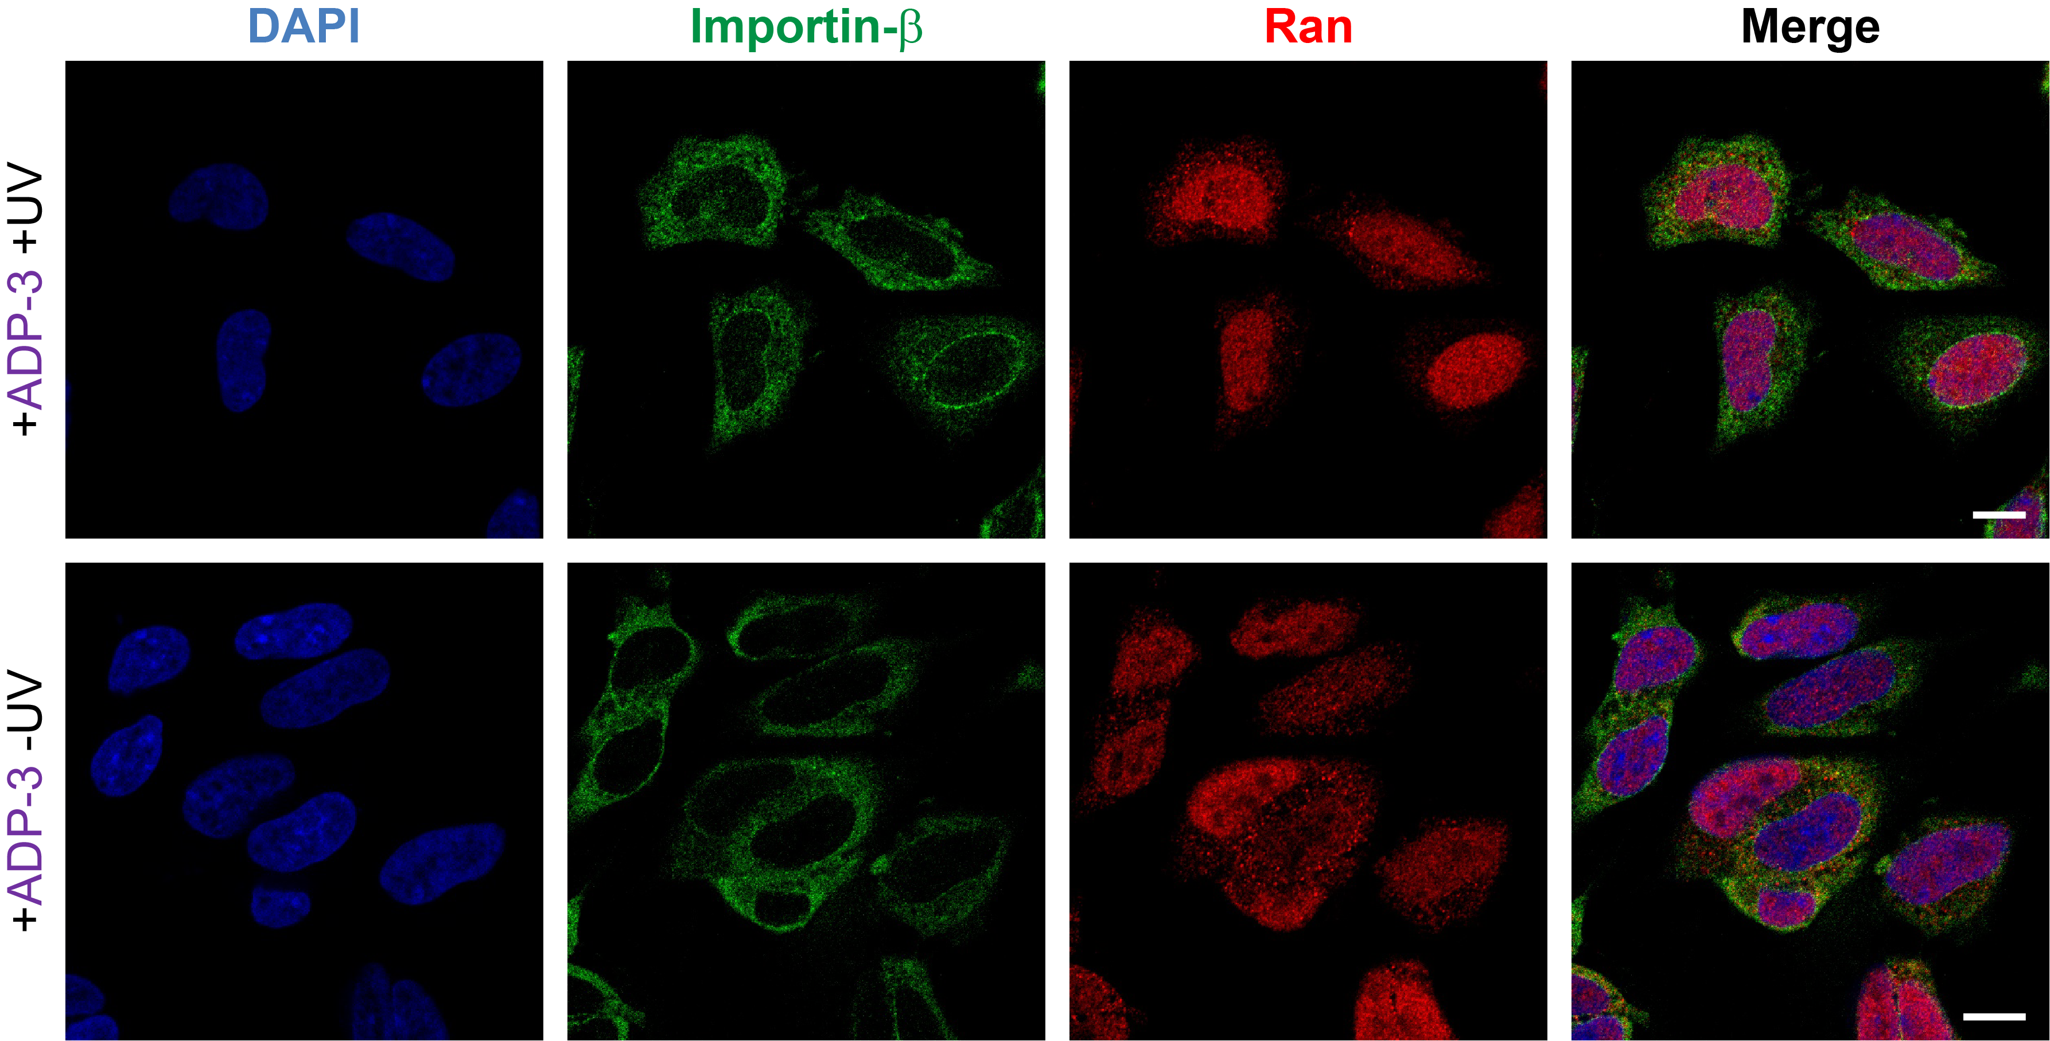
Figure S14. Representative image of Ran protein and importin-β in the SH-SY5Y cells treated with ADP-3. Immunofluorescence images of Ran protein (red) and importin-β (green) in SH-SY5Y cells. Cells were treated with ADP-3 (1 μM), and then photoinitiated or not. Scale bars indicate 10 µm.

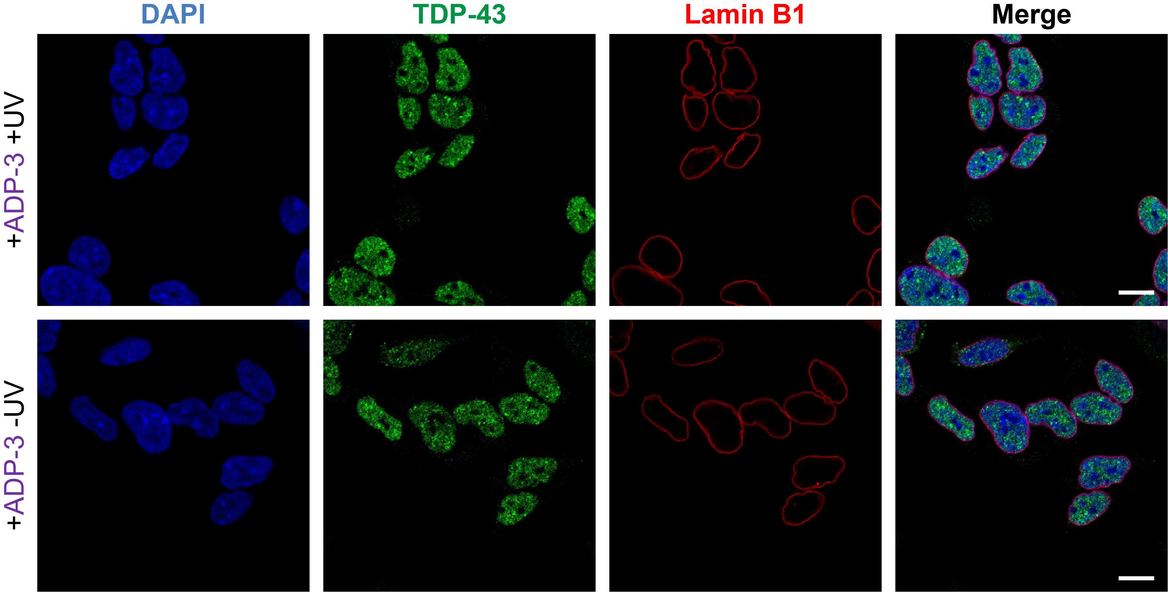
Figure S15. Representative image of TDP-43 and Lamin B1 in the SH-SY5Y cells treated with ADP-3. Immunofluorescence images of Lamin B1 (red) and TDP-43 (green) in SH-SY5Y cells. Cells were treated with ADP-3 (1 μM), and then photoinitiated or not. Scale bars indicate 10 µm.

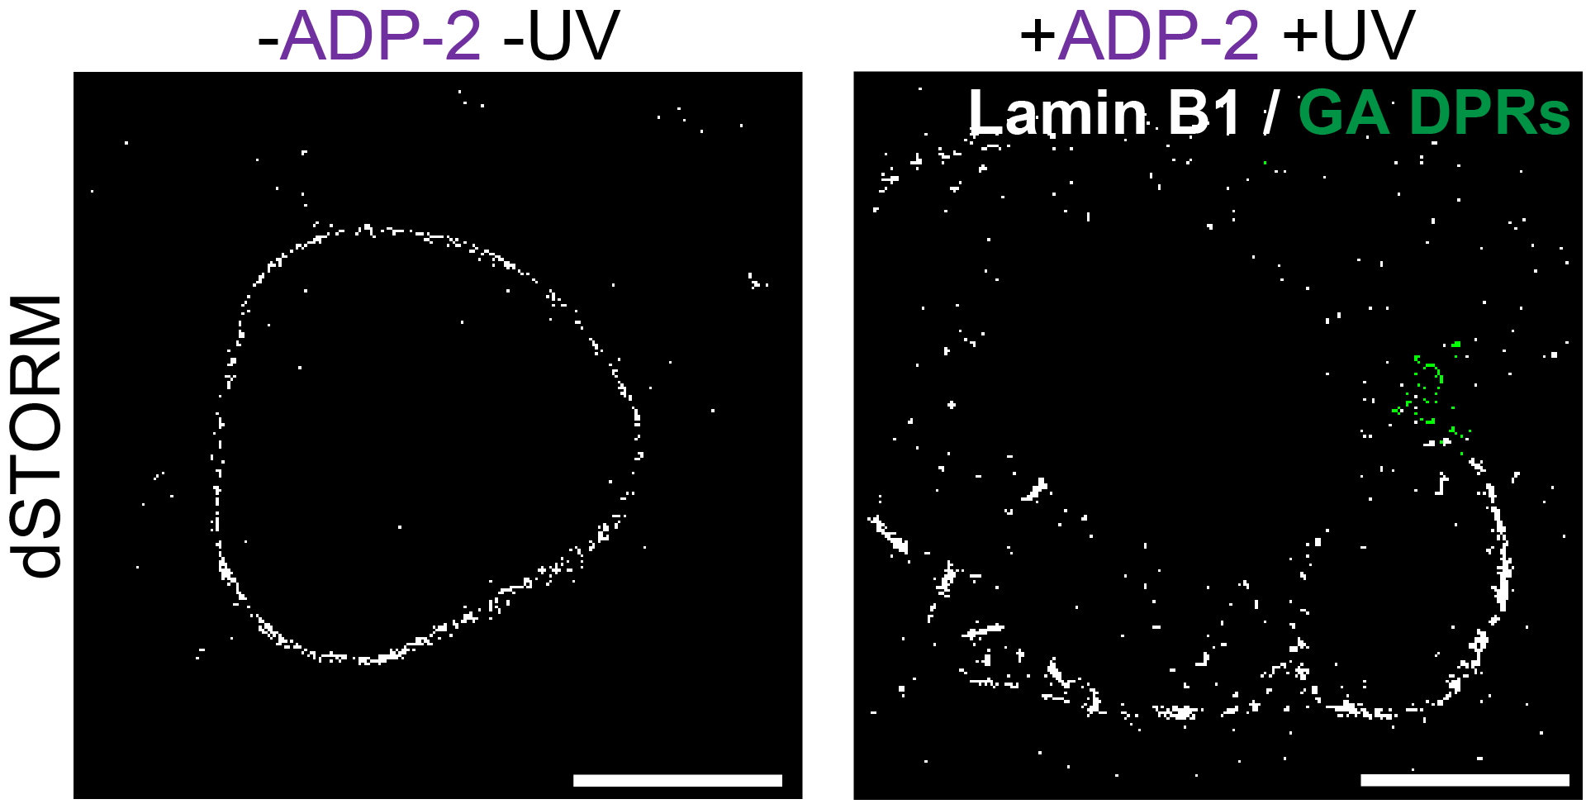
Figure S16. Representative images of nuclear membrane structure in COS-7 cells. (A) Immunofluorescence images of lamin B1 (red) in control or ADP-2 (2 µM) treatedCOS-7 cells. Scale bar indicate 10 µm. (B) dSTORM images of lamin B1 and GA DPRs in control or ADP-2 (2 µM) photoinitiated COS-7 cells. Scale bar indicate 10 µm.

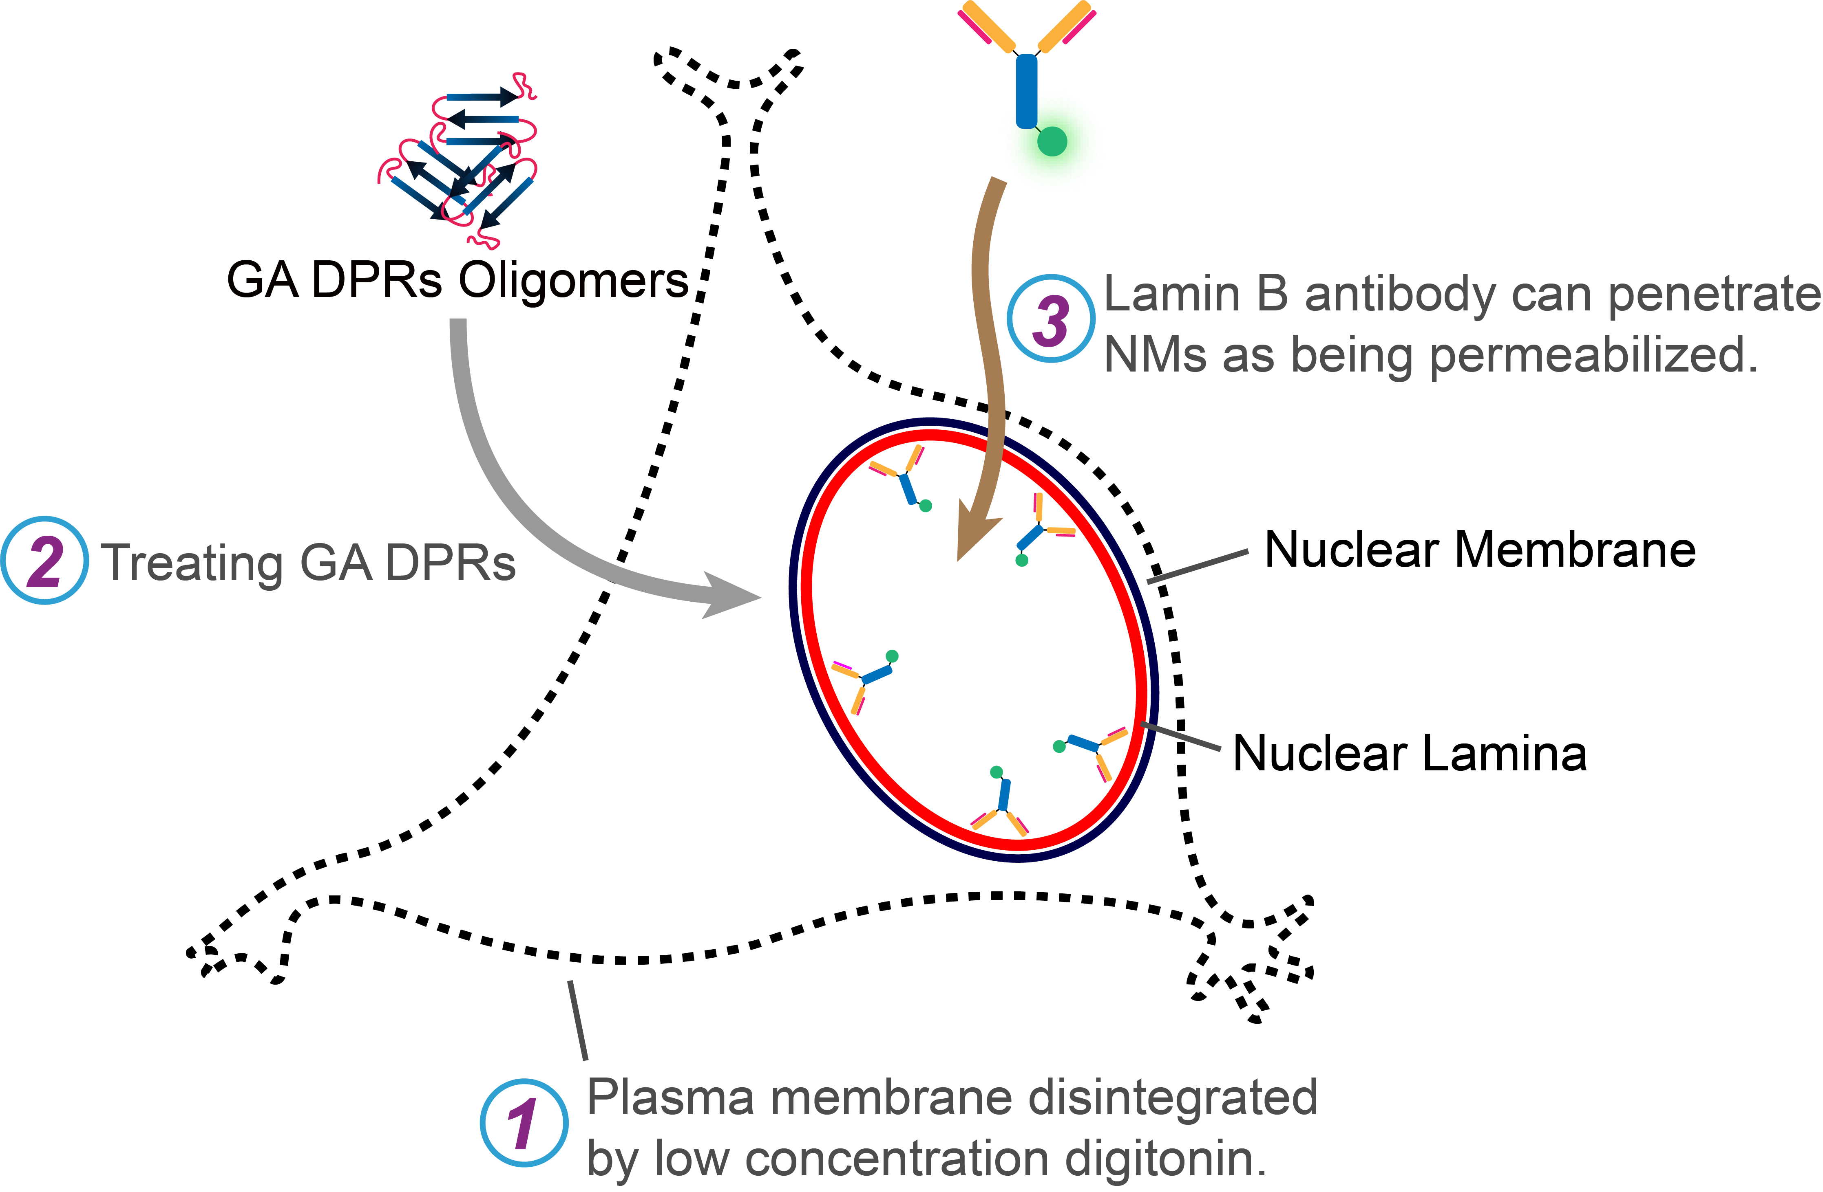
Figure S17. Illustration for antibody-accessibility assay experiment. SH-SY5Y cells were first treated with digitonin in PBS to remove their cytoplasmic membrane, followed by GA DPRs treatment for 2 hours. The exposed nuclei were then fixed and stained with lamin B1 antibody and the revealed nuclear lamina structures were observed using confocal microscopy.

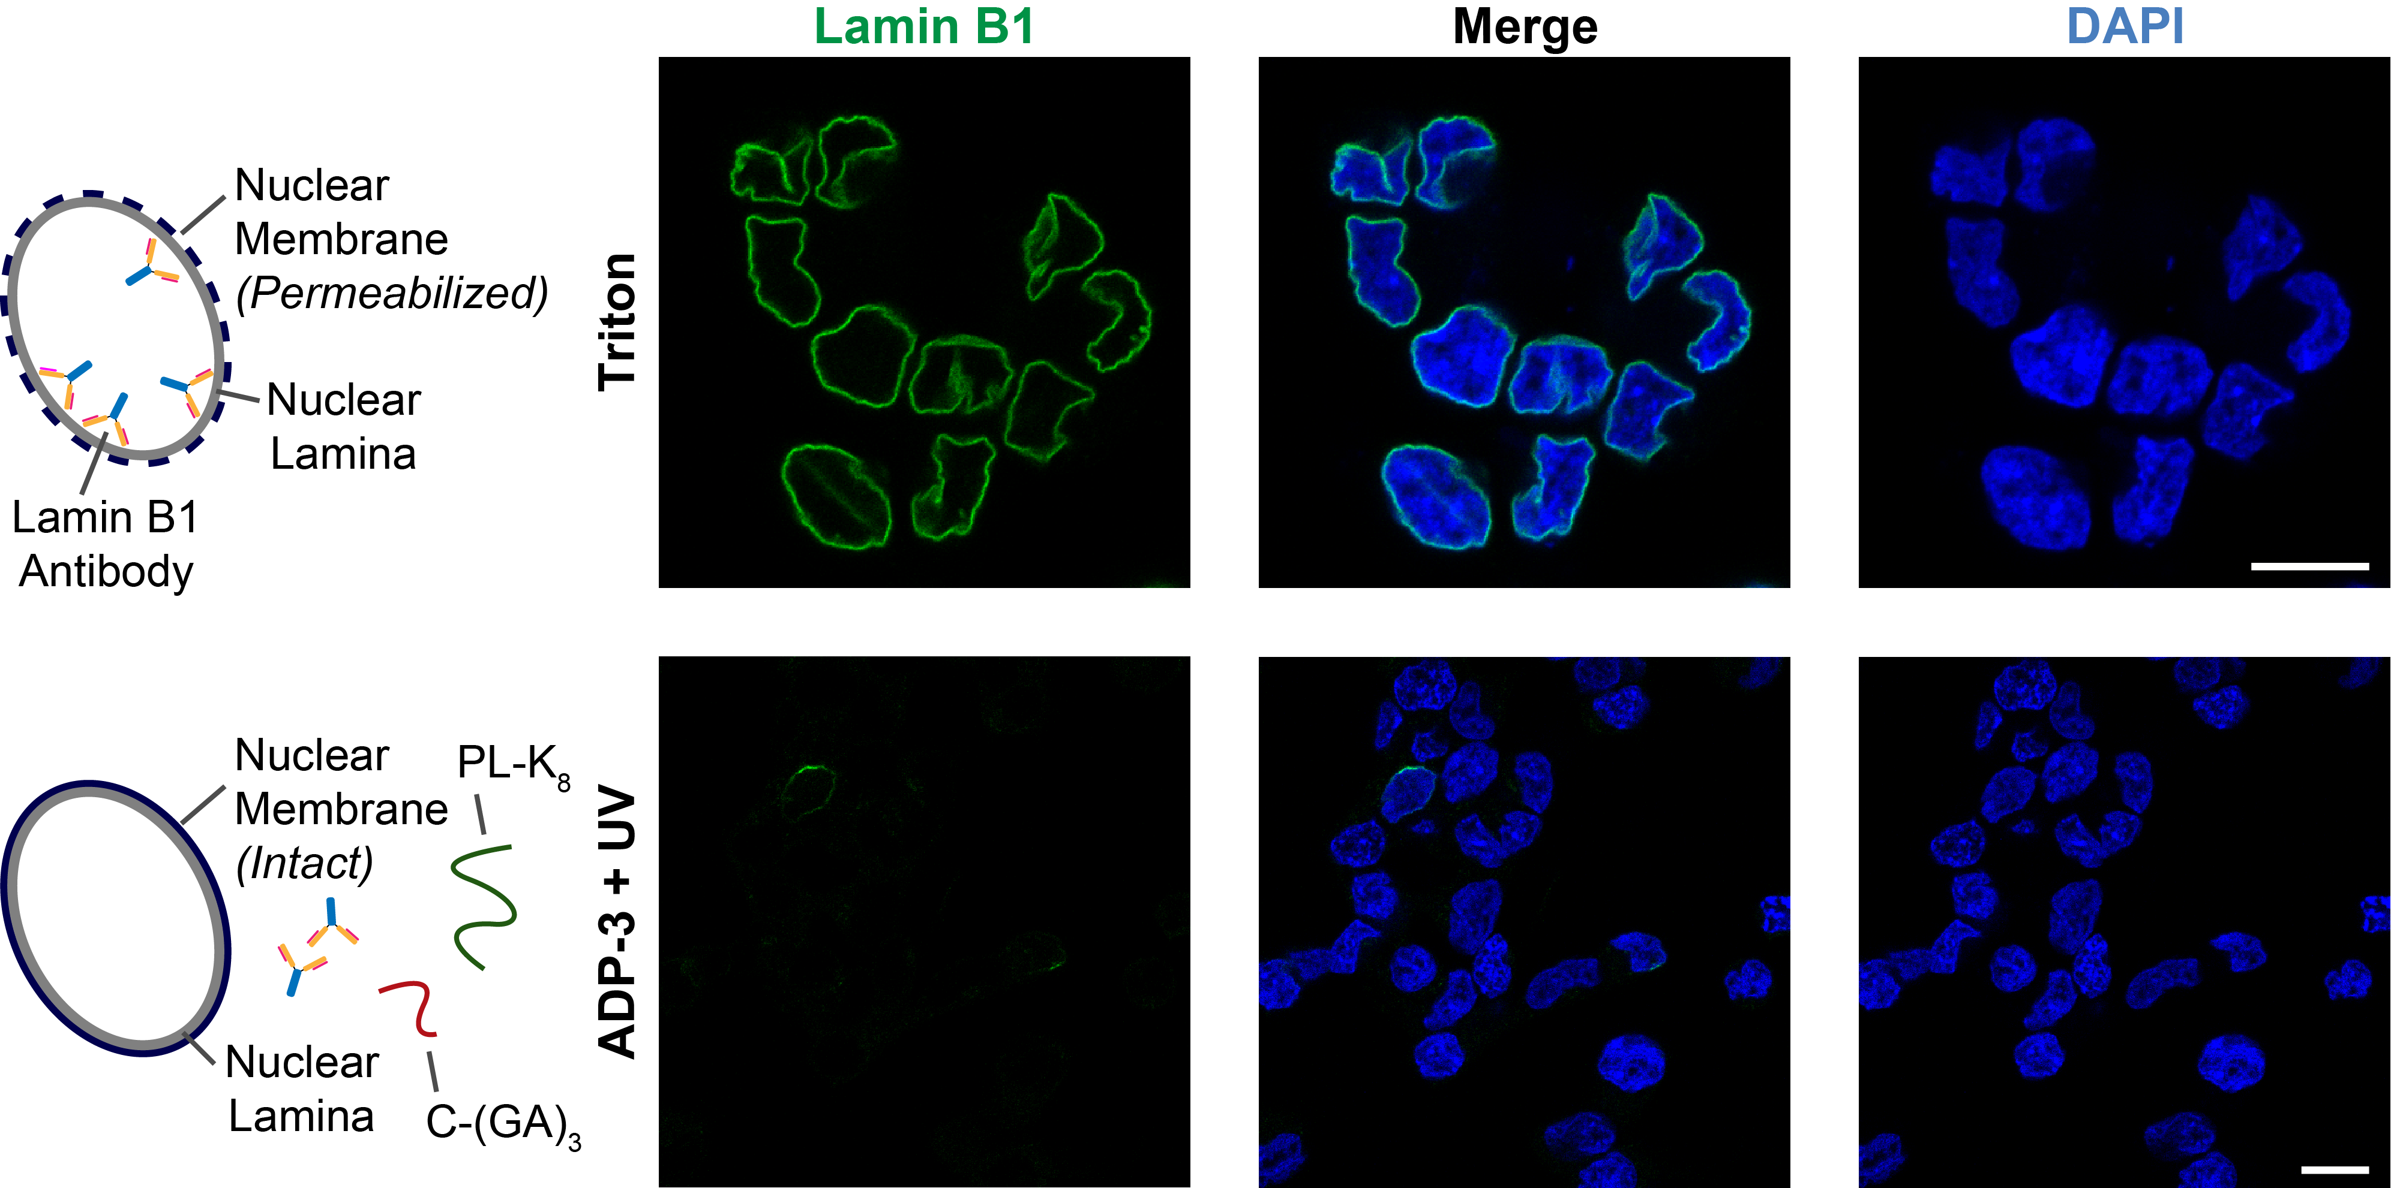
Figure S18. Nuclear membrane permeability evaluation using triton and ADP-3 treatment. SH-SY5Y cells were first treated with digitonin in PBS to permeablize their cytoplasmic membrane, followed by triton (positive control) or ADP-3 treatment (negative control). The resulting exposed nuclei were stained with lamin B1 antibody and counterstained with DAPI. The nuclear lamina structures were observed by confocal microscopy. Scale bars indicate 10 µm.

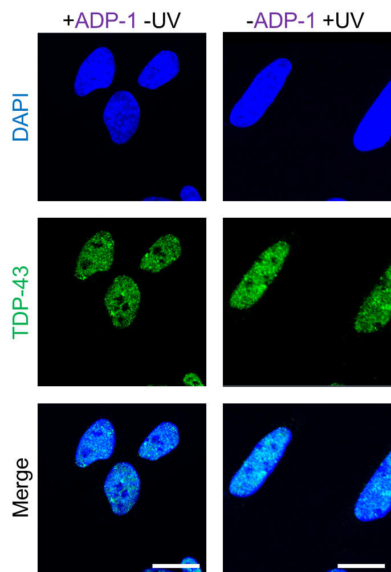
Figure S19. Immunofluorescence image of TDP-43 protein in SH-SY5Y cells treated either ADP-1 only or UV light irradiation only. (A) Immunofluorescence of TDP-43 protein (green) in SH-SY5Y cells. Cells were either treated with ADP-1 (1 μM) or exposure to UV light (wavelength: 335-379 nm, power density: ≤8.24 mW/cm², duration: 1 minute). Scale bars indicate 10 µm.

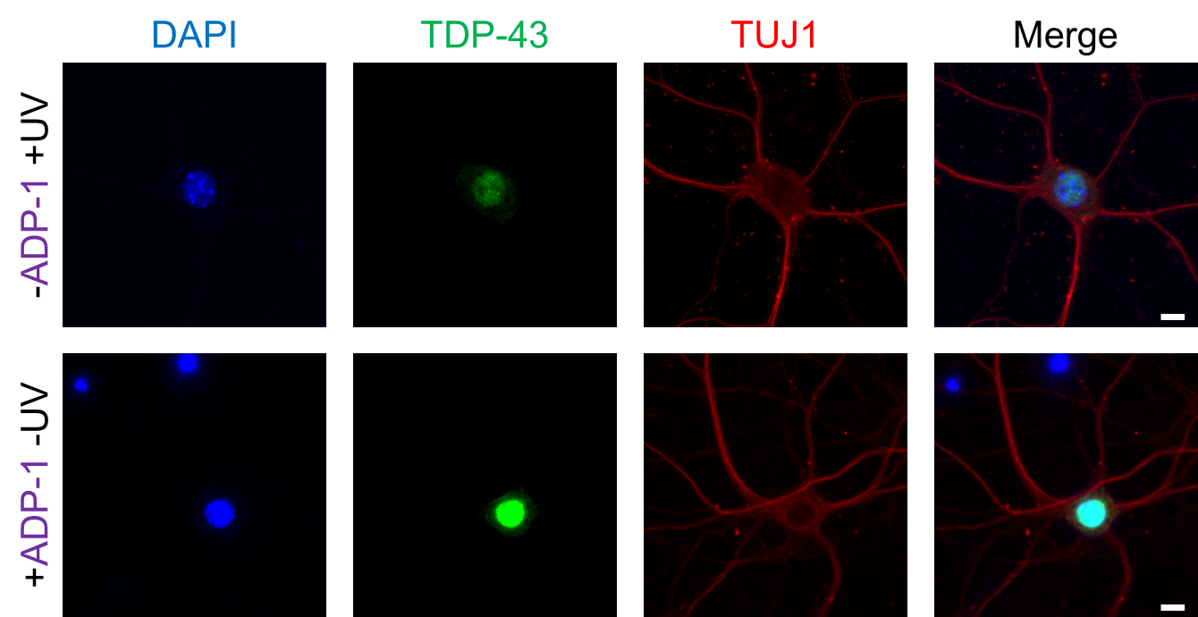
Figure S20. Both ADP-1 treatment only and UV irradiation only do not cause severe degeneration of mouse cortical neurons. Representative images of 22DIV mouse cortical neurons immunofluorescence stained with antibody against β-III-tubulin (red) and TDP-43 (green) treated either with without 1 μM ADP-1 or 2 minutes of UV irradiation. The DNA counter stain DAPI (blue) was included to identify the location of the nucleus. Scale bar indicated 10 µm.

Reference
1. M. Shimojima, S. Yuasa, C. Motoda, G. Yozu, T. Nagai, S. Ito, M. Lachmann, S. Kashimura, M. Takei, D. Kusumoto, A. Kunitomi, N. Hayashiji, T. Seki, S. Tohyama, H. Hashimoto, M. Kodaira, T. Egashira, K. Hayashi, C. Nakanishi, K. Sakata, M. Yamagishi and K. Fukuda, Scientific Reports, 2017, 7, 44312.
2. W.-S. Chen, Y.-J. Chen, Y.-A. Huang, B.-Y. Hsieh, H.-C. Chiu, P.-Y. Kao, C.-Y. Chao and E. Hwang, Sci. Rep., 2017, 7, 42297.

