Supplementary information

Supplementary Figures

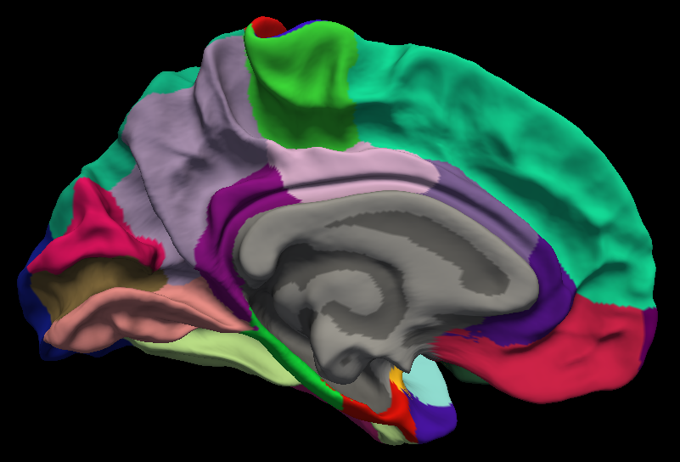
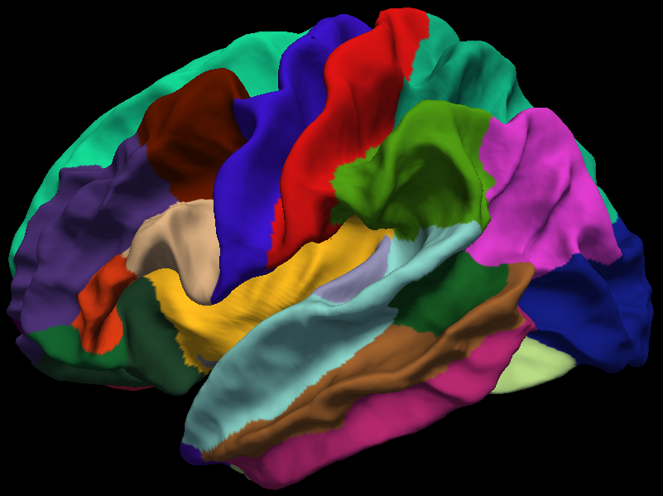
paracentral (C)
temporal pole (L)
medial orbital frontal (L)
precentral (C)
caudal middle frontal (C)
pars opercularis (C, L)
superior temporal (L)
postcentral (C)
superior parietal (C)
supramarginal (C)
inferior parietal (C)
middle temporal (L)

Supplementary figure 1. Cortical regions from the Desikan–Killiany atlas²⁶ with the regions labeled where cortical thinning is noted. The letters C and L in parenthesis represent regions where cross-sectional difference and longitudinal change (respectively) are noted in the t-test.

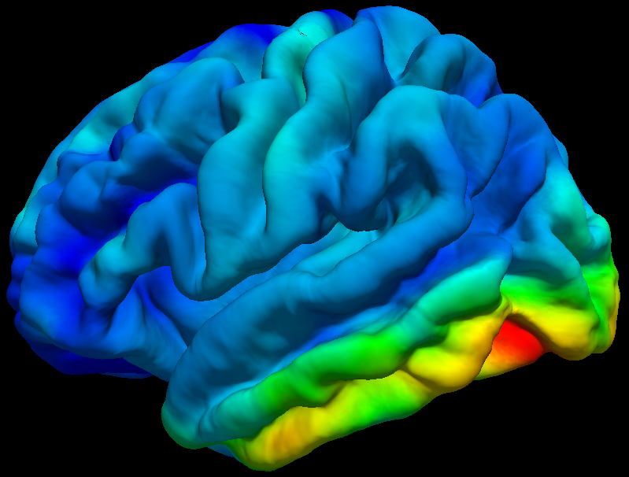
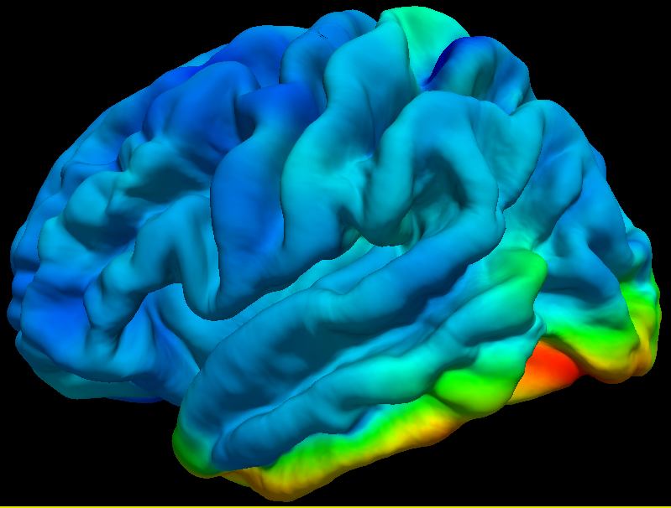
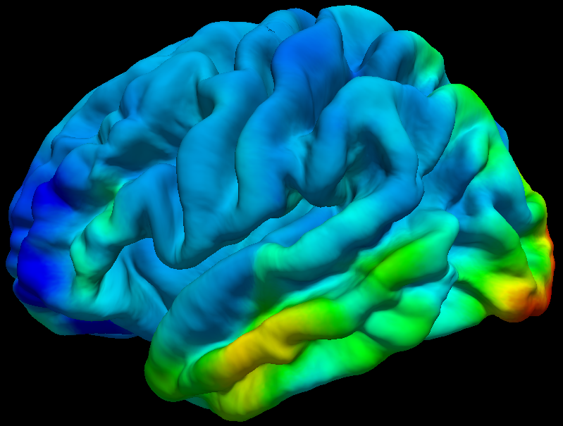
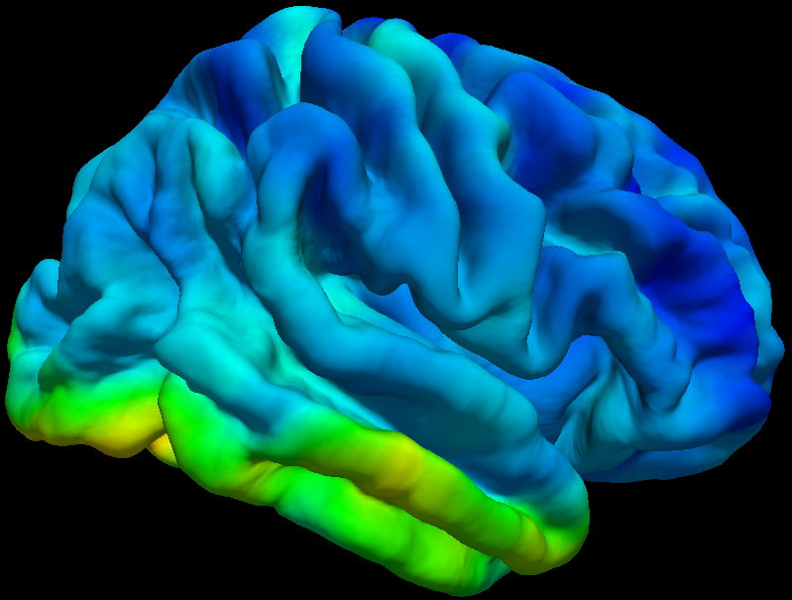
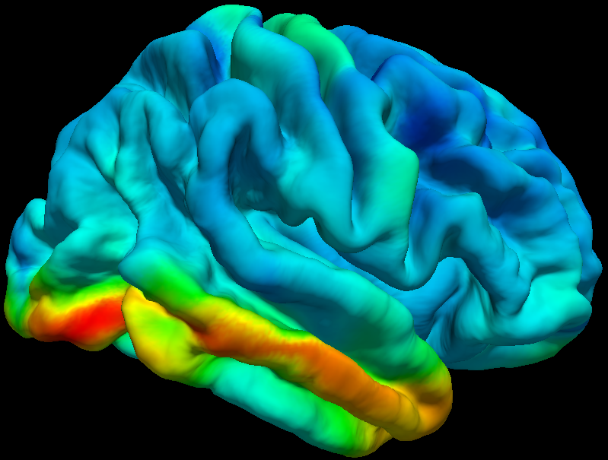
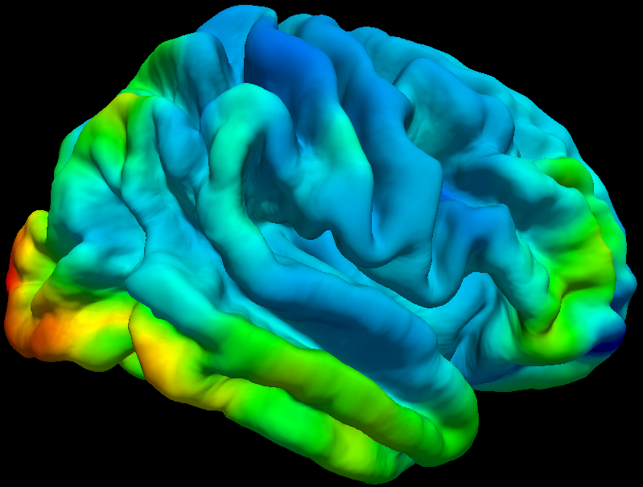
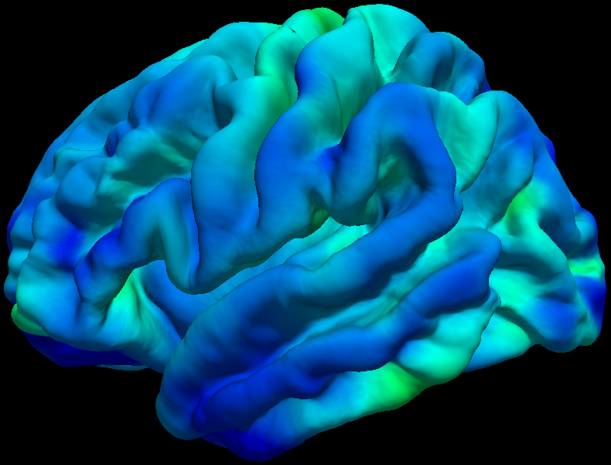
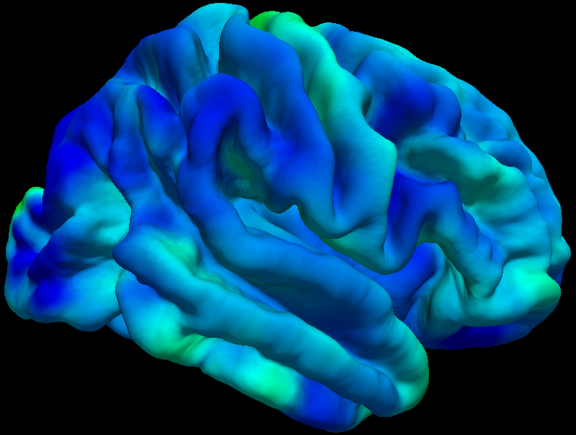
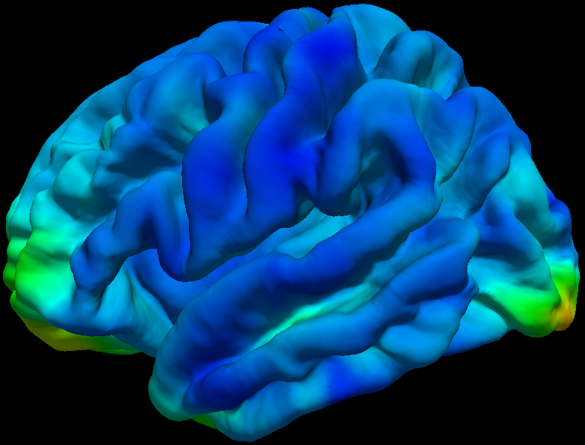
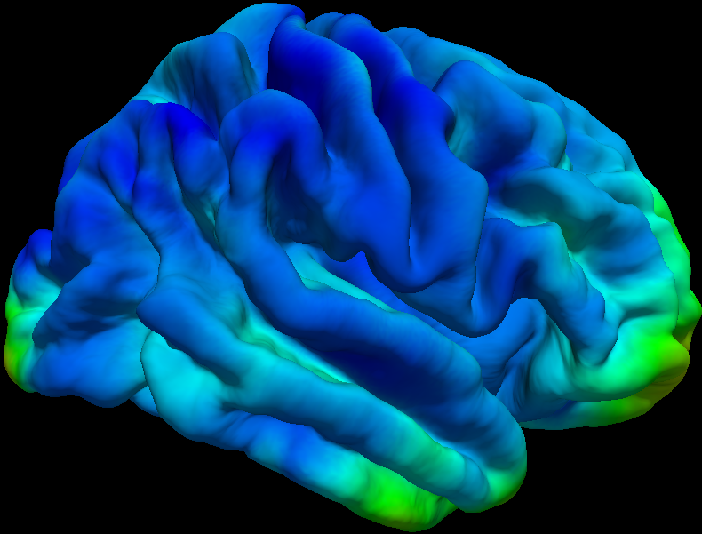
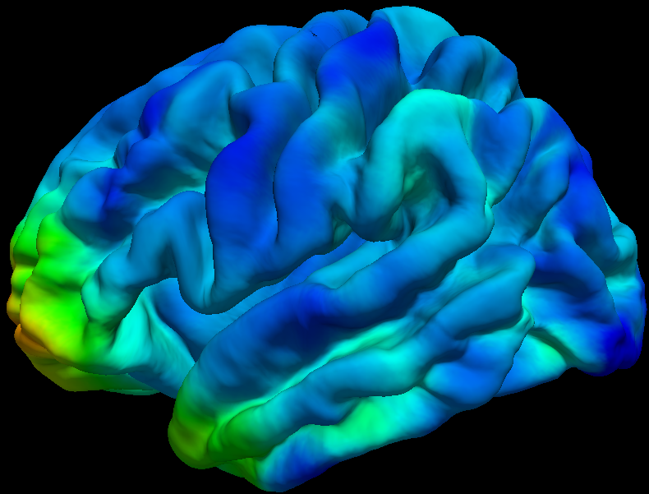
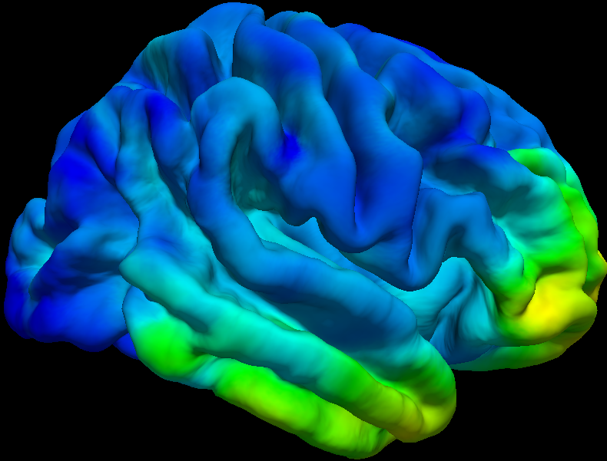
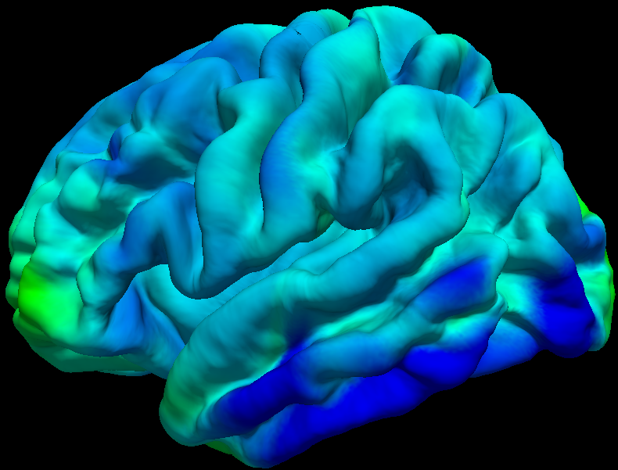
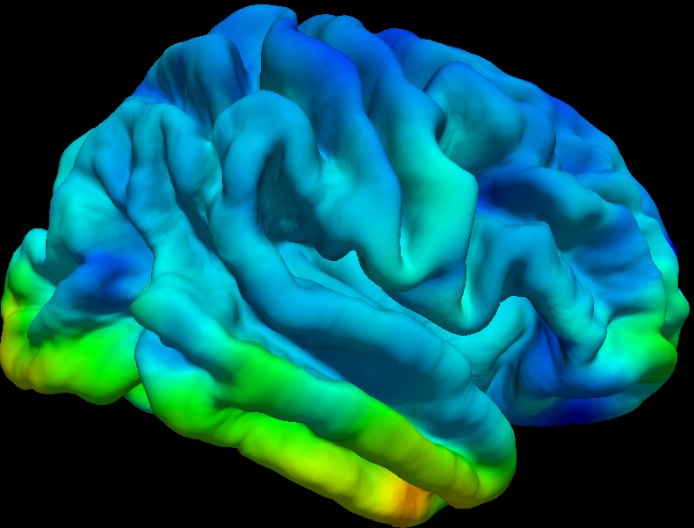
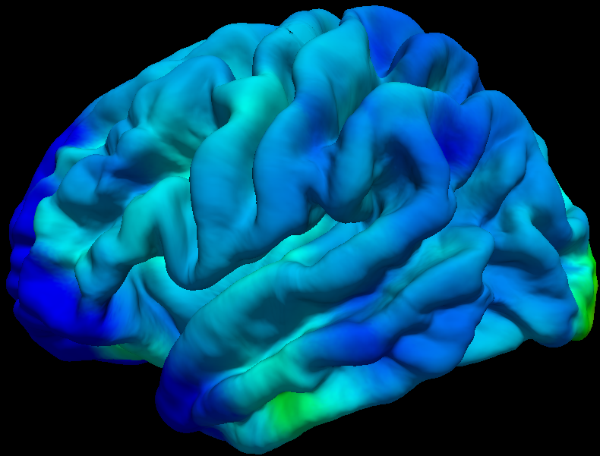
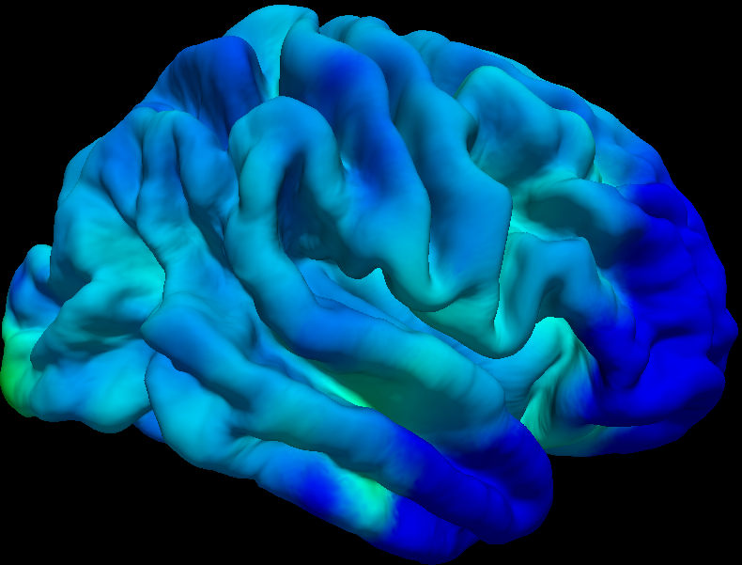
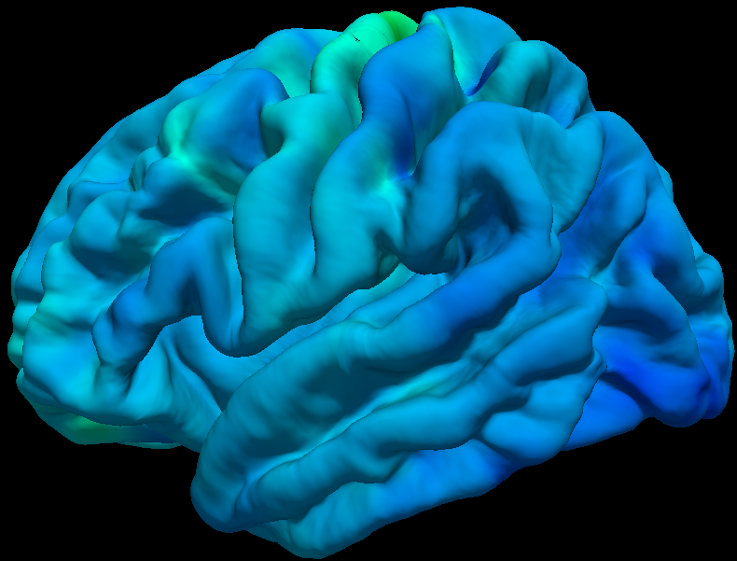
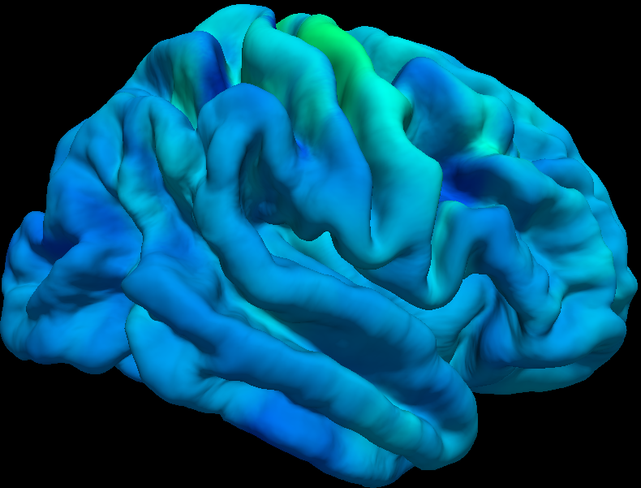
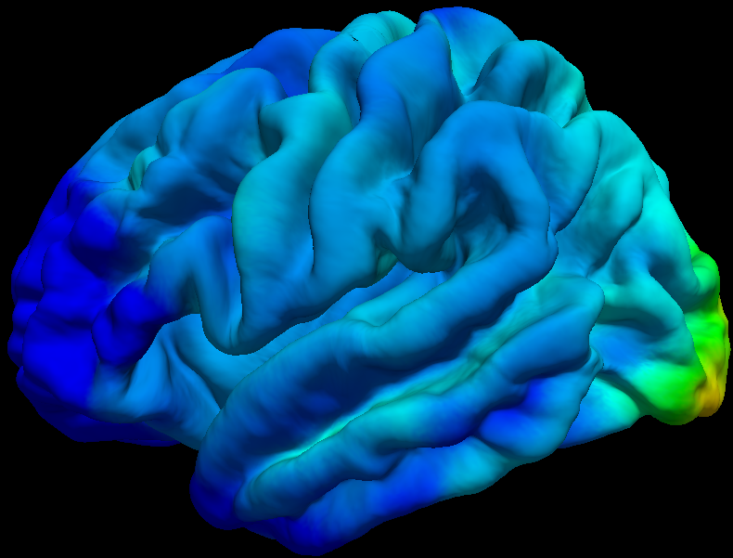
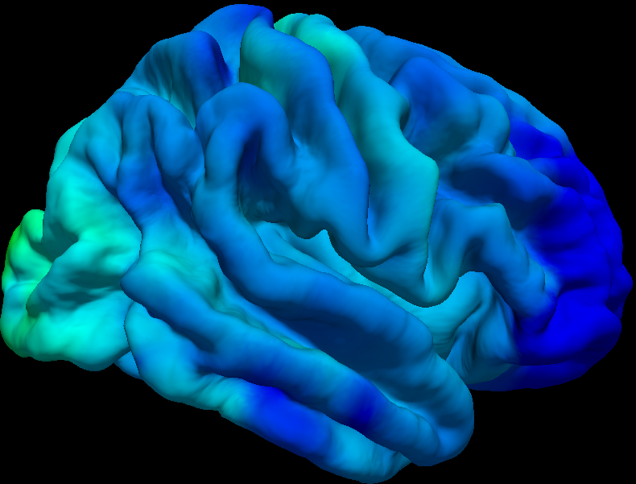
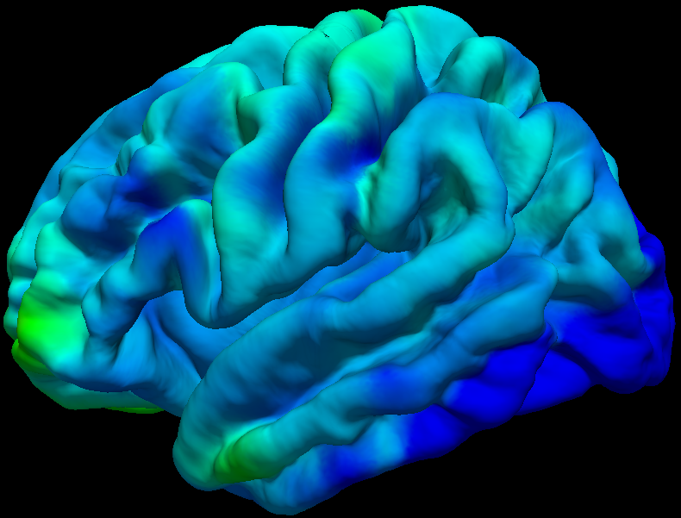
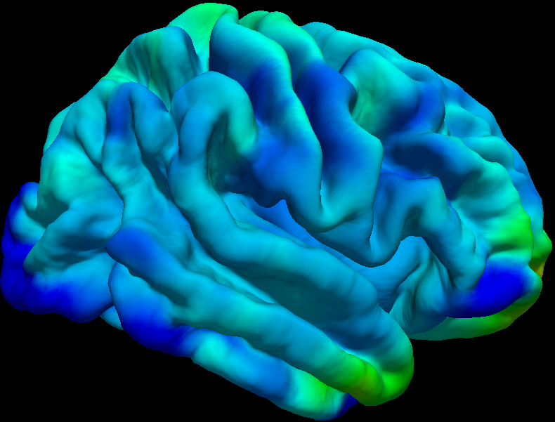
+15%
-15%
-45%
-75%

Supplementary figure 2. Left and right views of longitudinal change (baseline vs. one-year) in cortical thickness in the 11 ALS participants. The change is expressed as a percentage of the cortical thickness at the initial scan. Negative sign represents cortical thinning over one-year, and the negative values convey the percent thinning at a given cortical location.

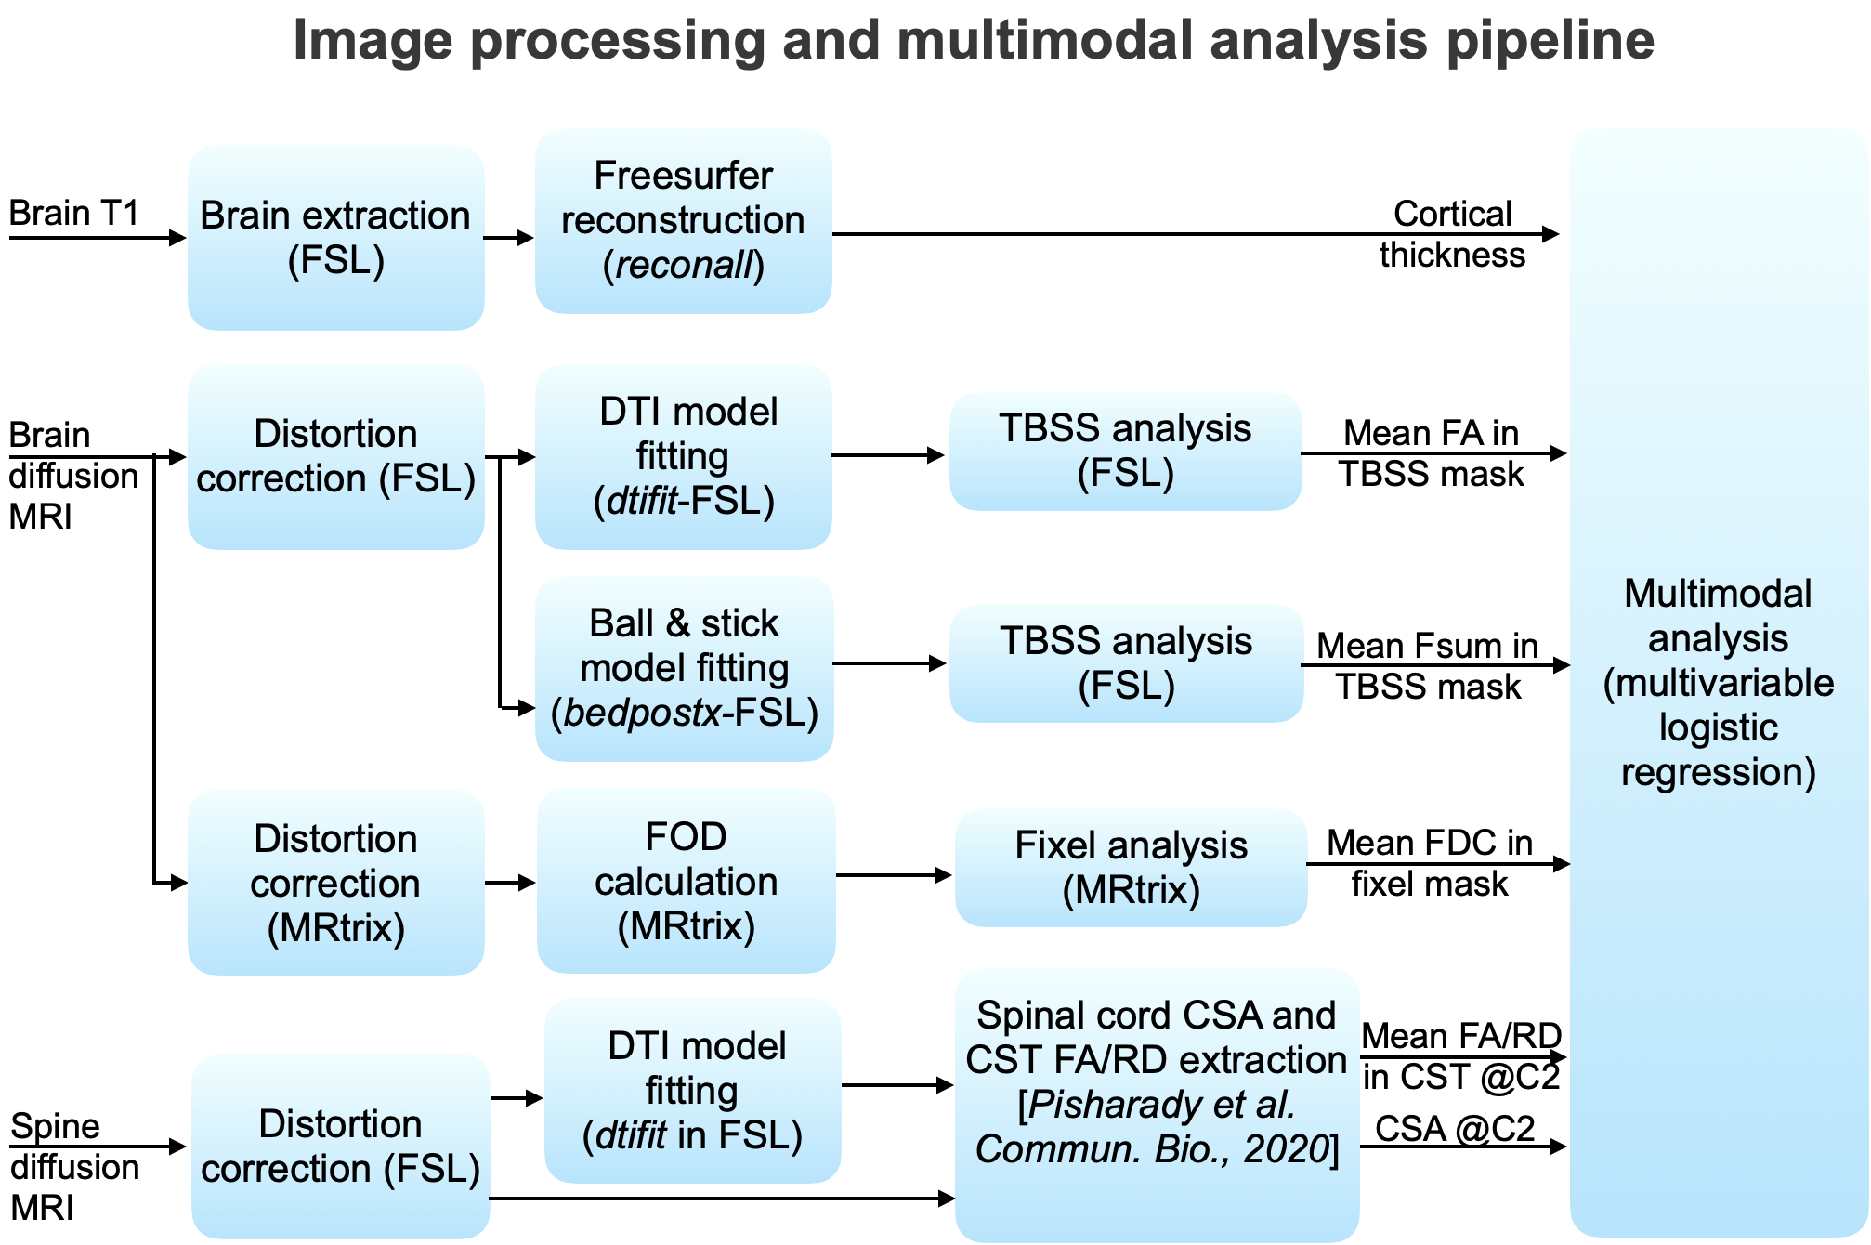

Supplementary figure 3. Flow diagram depicting the image processing and multimodal analysis pipeline (DTI - diffusion tensor imaging, TBSS - tract-based spatial statistics, FA - fractional anisotropy, RD - radial diffusivity, Fsum - sum of fiber volume fractions, FOD - fiber orientation distribution, FDC - fiber density and cross-section, CST - corticospinal tract, CSA - cross-sectional area).

