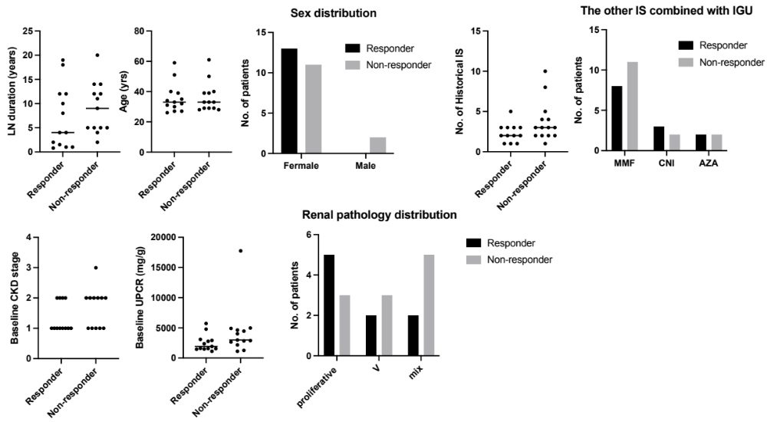
Supplementary figure. Subgroup analysis between CRR and non-CRR patients on age, sex, LN duration, renal pathology type, previous IS number, as well as baseline UPCR, and the stage of CKD. None of these statistics are significant.
CRR, complete renal response; UPCR, urine protein/creatinine ratio; CKD, chronic kidney disease; LN, lupus nephritis; IS, immunosuppressants.

