Supplementary Information
Low-temperature Liquid Exfoliation of Milligram-scale Single Crystalline Few-layer β₁₂-Borophene Sheets as Efficient Electrocatalysts for Lithium–Sulfur Batteries

Lin et al.

SUPPLEMENTARY NOTE 1: THE EFFECT OF SOLVENTS ON THE LTLE GROWTH OF BOROPHENE SHEETS
To find the optimal solvent to prepare borophene sheets by LTLE way, we have attempted to use N,N-Dimethylformamide (DMF), isopropyl alcohol (IPA), and N-methyl-2-pyrrolidone (NMP) solvents, respectively. Supplementary Fig. 1a gives the photographs of the as-grown products using these three different solvents. The color of the DMF-solution is seen to be nearly transparent and there are clearly some black precipitants on the bottom, revealing only a few borophene sheets were synthesized in the DMF solvent by LTLE. Different from the DMF solution, the color of the IPA or the NMP solutions are respectively dark-brown and dark-black, suggesting a considerable number of borophene sheets have been synthesized and dissolved into these solvents. Further SEM images of the products are shown in Supplementary Fig. 1b-g, in which the products’ morphology differs with the solvents. When DMF was used as solvent, a lot of bulk boron blocks can be found instead of borophene sheets. The as-grown products are observed to be mainly consisted of 2D borophene sheets if IPA or NMP solvents were used. The average size of borophene sheets using IPA was smaller than 500 nm, and the yield of 2D sheets was calculated to be about 9 % by UV-vis spectroscopy. As seen in Supplementary Fig. 1d, e, there are some nanometer or micrometer particles coexisted with transparent borophene sheets in the IPA solution. But if we adopted the NMP solvent, the mean sheet size increased to about 3 μm and the yield of 2D sheets significantly enhanced to over 20 %, as observed in Supplementary Fig. 1f, g. Moreover, only transparent 2D sheets were found in the NMP solution without any particles. Therefore, NMP is believed as the most effective solvent for massive production of borophene sheets by LTLE in comparison with other solvents.
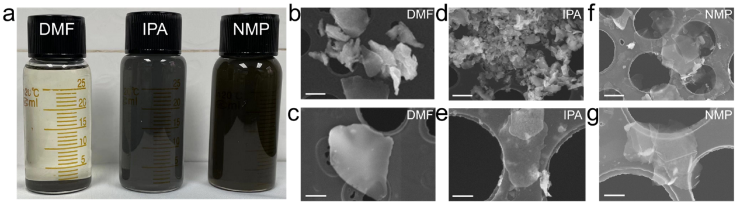
Supplementary Figure 1. Typical morphology of products by using different solvents. (a) Photographs of the as-grown products using different solvents. (b, c) The products using DMF. (d, e) The products using IPA. (f, g) The products using NMP. Scale bar: (b, d ,f) 1 $μ$m, and (c, e, g) 500 nm.

SUPPLEMENTARY NOTE 2: UV-VIS ABSORPTION SPECTRA OF BOROPHENE SHEETS IN DIFFERENT SOLVENTS
Representative UV-vis absorption spectra of borophene sheets in IPA and NMP solutions and their corresponding curves of optical absorption to the sheet concentration are respectively given in Supplementary Fig. 2a, b. No absorbance peaks are found in these two UV-vis absorption spectra, revealing that the as-synthesized few-layer β₁₂-borophene sheets are metallic. By modulating the sheet-concentrations of IPA and NMP solutions, the extinction coefficient (α) of few-layer β₁₂-borophene sheets can be obtained by calculating the slope of the curves of A/l to 2D sheets concentration (C), where A is the optical absorption intensity under 550 nm-irradiation for IPA and NMP, l=1 cm is the normalized cell length in experiments. As found in Supplementary Fig. 2b, the curves of A/l versus C exhibit a nice linearity and the experimental square deviation (R²) from the theoretical curves reaches as high as 0.999 for NMP, suggesting the experiment results are in good agreement with the Lambert−Beer law of A/l = αC¹. Moreover, the extinction coefficient (α) of borophene sheets arrives at 1667.92 ml/mg/m in NMP solution, which is nearly 2 times larger than that (about 900 ml/mg/m) of borophene sheets by other ways^{2,3}. But when we used IPA as the solvent, the values of R² and α for borophene sheets rapidly reduces to 0.968 and 404 ml/mg/m, respectively. Therefore, it comes to a conclusion that the dispersion and solubility of borophene sheets in NMP are much higher than them in IPA, which again proves that NMP is more suitable solvent for massive production of borophene sheets by LTLE way.
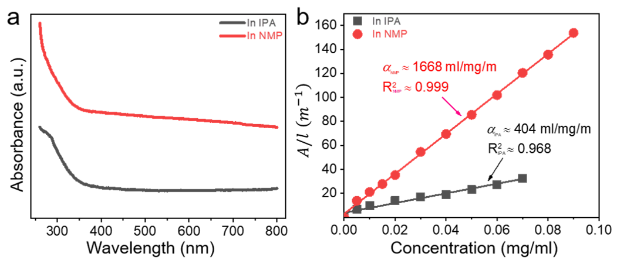
Supplementary Figure 2. Comparison of the UV-vis absorption spectra of borophene sheets using different solvents. (a) UV-vis absorption spectra of the as-prepared borophene sheets in IPA and NMP, respectively. (b) Linear relationship between the sheet concentration (C) and A/l, where A is the optical absorption intensity under 550 nm-irradiation and l=1 cm is the normalized cell length.

SUPPLEMENTARY NOTE 3: XRD PATTERNS OF BOROPHENE SHEETS AND PRISTINE BORON POWDER
XRD patterns of pristine boron powder and borophene sheets are respectively shown in Supplementary Fig. 3. The sources are indexed as β-rhombohedral boron (JCPDS No. 00-031-0207). Clearly different from bulk boron powder, the characteristic peaks of 2D sheets well match with theoretical XRD peaks of β₁₂-borophene by DFT calculations. Moreover, there are narrower low full width at half maximum (FWHM) and sharper diffraction peaks for the β₁₂-borophene sheets, suggesting they are high-quality single crystals.
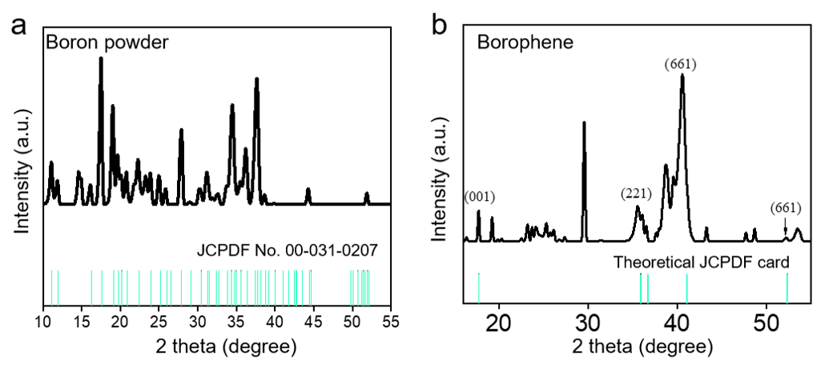
Supplementary Figure 3. XRD patterns of (a) pristine boron powder and (b) borophene sheets.

SUPPLEMENTARY NOTE 4: EELS MAPPING STUDY OF THE BOROPHENE SHEETS PRESERVED FOR A WEEK IN AIR
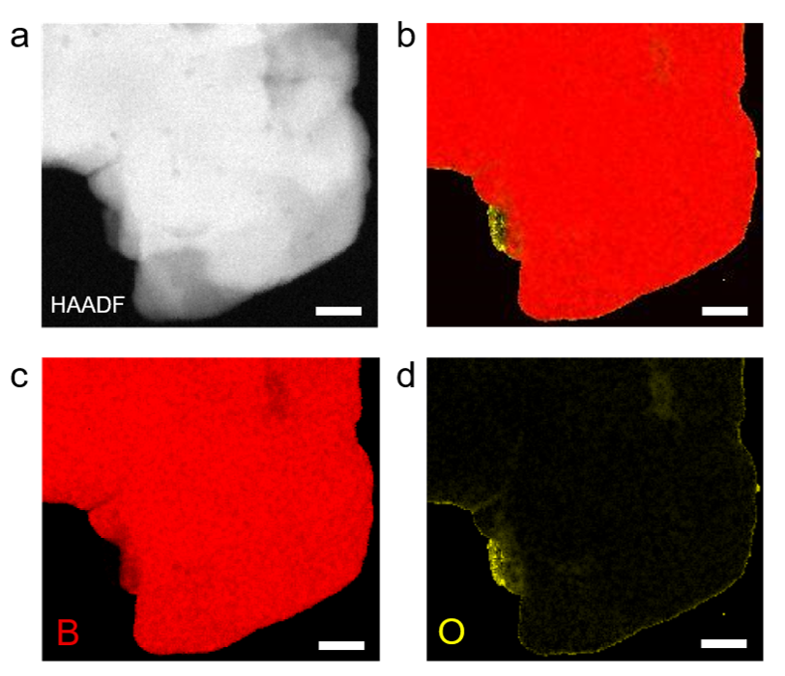
Supplementary Figure 4. EELS mapping of the borophene sheets, which were taken out of the NMP solution and preserved for a week in air. (a) HAADF-STEM image of a borophene sheet. (b-d) Corresponding EELS mapping images of the borophene sheet, revealing the slight oxidation occurred at the edge of the sheets after a week’s preservation. The scale bar corresponds to 50 nm.

SUPPLEMENTARY NOTE 5: THICKNESS DISTRIBUTION AND LATTICE STRUCTURE OF FEW-LAYER β₁₂-BOROPHENE SHEETS
Supplementary Fig. 5a shows the statistical thickness distribution of the borophene sheets by LTLE way. It is clearly seen that the ratio of the borophene sheets with a thickness of less than 3 nm reaches 36 % and that of the borophene sheets with a thickness less than 5 nm is over 68 %, revealing 2D few-layer nature based on density functional theory (DFT) calculations. There is a strong peak located at ~197.1 eV in Supplementary Fig. 5b, assigned as the boron K-shell peak excitation from B 1s to σ*⁴. Moreover, the B content is over 98 % according to the electron energy loss spectrum (EELS) of the sheet, and the sheet exhibits a clear few-layer appearance (inset). It is suggested that the 2D sheets should be consisted of boron atoms and they have a planar sp² bonding configuration close to graphene⁵. From Supplementary Fig. 4c, e, there are usually two typical exposed surfaces for the 2D sheets, corresponding to different surface configurations. According to the DFT model (Supplementary Fig. 5e, f), these two crystalline planes can be respectively indexed as the (001) and (104) planes of few-layer β₁₂-borophene sheets. As seen in Supplementary Fig. 5c, the unit cell is a hexagon for (001) plane, where both of the lattice constants are the same (a = b = 2.77 Å). For the (104) plane, the unit cell is a rectangle in Supplementary Fig. 5d, where the two lattice constants are different (a ≈ 5.06 Å and b ≈ 3.15 Å). Both of the HRTEM results of (001) and (104) planes well coincided with the DFT model of few-layer β₁₂-borophene sheets, unveiling that the as-grown 2D sheets should be few-layer single crystalline β₁₂-borophene.
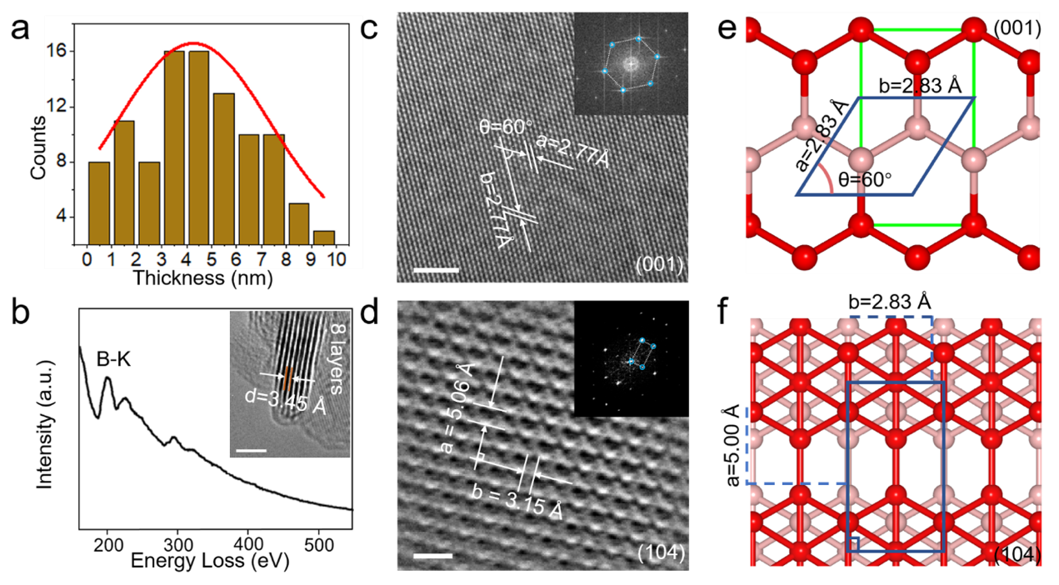
Supplementary Figure 5. Thickness distribution and lattice structure of few-layer β₁₂-borophene sheets. (a) The statistical thickness distribution of the borophene sheets by LTLE method. (b) Representative EELS spectrum of a borophene sheet, and the inset gives the cross-sectional TEM image of the (104) face of β₁₂-borophene sheet (scale bar: 2 nm). (c, d) HRTEM images and SAED patterns of the (001) and (104) planes of a few-layer β₁₂-borophene sheet, respectively. (e, f) Their corresponding lattice structures by DFT calculations. Scale bar: (c) 2 nm, and (d) 1 nm.

SUPPLEMENTARY NOTE 6: COMPARISON OF THE SYNTHESIS METHODS OF BOROPHENE SHEETS
Supplementary Table 1 summarizes the synthesis ways of borophene sheets. In comparison with other methods, the LTLE way is a more facile, low-cost and high-yield method for scalable production of few-layer single crystalline β₁₂-borophene sheets.
Supplementary Table 1. Comparison between the LTLE and other synthesis ways for borophene sheets.

Method | Temperature (K) | Surface configuration | Thickness (solution) | Mean size | Crystallinity | Refs.
LTLE | 248~253 | few-layer β₁₂-B₅ | ~4 nm (NMP) | ~3.0 $μm$ | High-quality single crystal | This work
MBE | 500~800 | $β_{12}$ & $χ_{3}$ | ~0.4 nm | ~500 nm | Polycrystal | 6
MBE | 500~910 | $$χ_{3}$$ | ~0.4 nm | ~100 μm | Single crystal | 7
MBE | 723~973 | $$δ_{6}$$ | ~0.4 nm | ~100 nm | High-quality single crystal | 8
MBE | ~500 | $$δ_{3}$$ | ~0.4 nm | ~200 nm | High-quality single crystal | 9
MBE | 823 | $$χ_{6}$$ | ~0.4 nm | ~20 nm | High-quality single crystal | 10
CVD | 773~873 | c-B₄₈ | ~6.9 nm | ~200 nm | High-quality single crystal | 11
CVD | 1373 &1273 | γ-B₂₈ | ~0.8 nm | ~10 μm | Single crystal | 12
MR | ~298 | α | ~4.0 nm | ~1.0 μm | Single crystal | 13
PSTOE | 283~298 | β-rhombohedral boron | ~3.0 nm (NMP&EA) | ~110 nm | Single crystal | 14
PS & BS | 283~298 | β-rhombohedral boron | ~20.0 nm (IPA) | ~251 nm | Single crystal | 15
PS | 283~298 | β-rhombohedral boron | ~57.0 nm  (2-butanol) | ~200 nm | Single crystal | 16
PS | 283~298 | β-rhombohedral boron | ~4.5 nm (DMF/IPA) | ~600 nm | High-quality single crystal | 2
PS | 283~298 | β-rhombohedral boron | ~54.0 nm (IPA) | ~200 nm | High-quality single crystal | 17
BS | 283~298 | β₁₂ & $χ_{3}$ | ~8.0 nm (acetone) | ~1.0 μm | Polycrystal | 18
PSBM | 283~298 | $χ_{3}$& β-rhombohedral boron | ~10.0 nm (EG) | ~500 nm | Single crystal | 19
MBE: molecular beam epitaxy, CVD: chemical vapor deposition, MR: mechanical resonance, PSTOE: probe sonication assisted with thermal oxidation etching, PS: probe sonication, BS: bath sonication, EA: ethyl alcohol, PSBM: probe sonication assisted with ball milling, EG: ethylene glycol.

SUPPLEMENTARY NOTE 7: THE SURFACE MORPHOLOGY OF THE CNT/B CATHODE IN LI-S CELLS
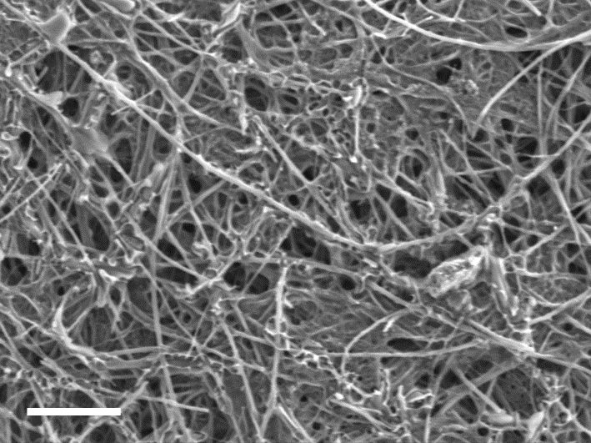
Supplementary Figure 6. SEM image of the CNT/B cathode in Li-S cells (scale bar: 5 $μ$m).

SUPPLEMENTARY NOTE 8: THE GALVANOSTATIC CHARGE/DISCHARGE PROFILES OF CNT/B- AND BARE CNT-BASED CELLS
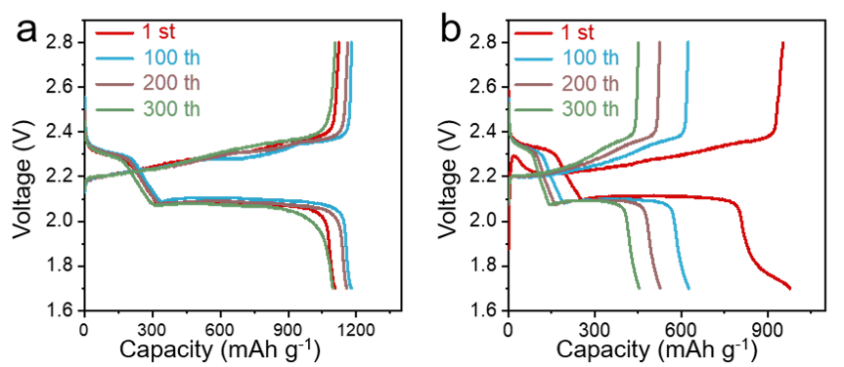
Supplementary Figure 7. The galvanostatic charge/discharge curves of the (a) CNT/B electrode and (b) bare CNT electrode-based Li-S cell at 0.5 C for different cycles.

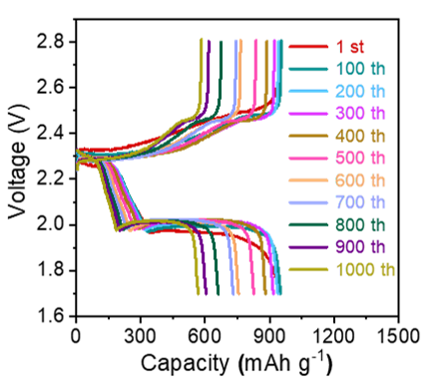
Supplementary Figure 8. The galvanostatic charge/discharge curves of CNT/B-based Li-S battery at 5 C for different cycles.

SUPPLEMENTARY NOTE 9: HIGH/LOW PLATEAU DISCHARGE CAPACITIES OF CNT/B- AND BARE CNT-BASED CELLS
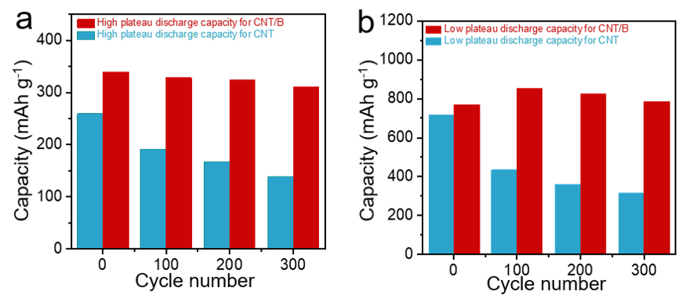
Supplementary Figure 9. (a) High-plateau and (b) low-plateau discharge capacities for CNT/B- and bare CNT- based batteries at 0.5 C for different cycles, respectively.

SUPPLEMENTARY NOTE 10: BAND STRUCTURES AND DENSITY OF STATES OF MONOLAYER Β₁₂-BOROPHENE SHEET WITH DIFFERENT POLYSULFIDE ADSORPTION
Supplementary Fig. 10a shows that the lowest energy structures of S₈ and Li₂S_{n} (n = 1, 2, 4, 6, 8) using comprehensive genetic algorithm (CGA) code²⁰ combined with DFT calculations. From Supplementary Fig. 10b, the unit cell parameters of the optimized monolayer β₁₂-borophene sheets are respectively 5.06 Å and 2.94 Å, which also agree with the HRTEM results of β₁₂-borophene sheets (Supplementary Fig. 5d). The energy-band structure and density of states (DOS) of β₁₂-borophene sheets by DFT calculations are respectively indicated in Supplementary Fig. 10c and 10d. They are found to have metallic properties, in good consistent with the UV-vis results (Supplementary Fig. 2a). As a result, β₁₂-borophene sheets as ideal electrode materials can effectively improve the conductivity of the Li-S batteries and lead to the fast reaction kinetic for polysulfides.
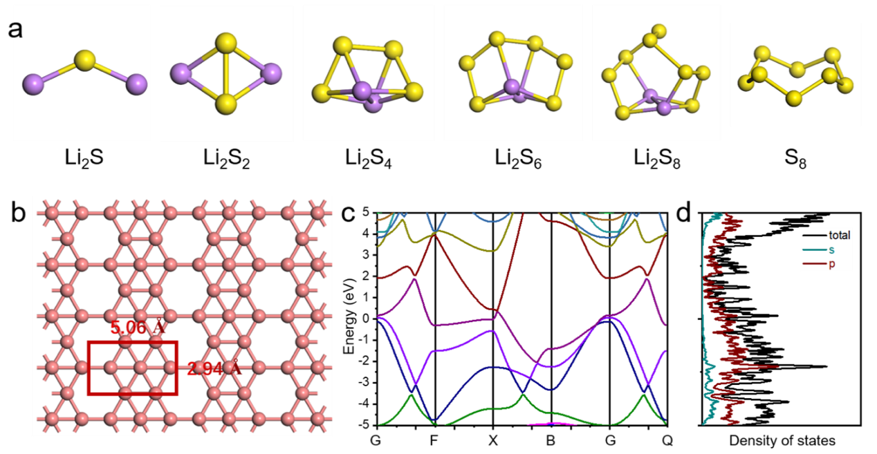
Supplementary Figure 11. Band structure of β₁₂-borophene before polysulfide adsorption. (a) The optimized lowest-energy structures of S₈ and Li₂S_{n} (n = 1, 2, 4, 6, 8) clusters. (b) The optimized $3×4×1$ supercell of β₁₂-borophene phase. (c) and (d) are the corresponding energy-band structures and density of states (DOS) by DFT calculations, respectively.

Supplementary Fig. 11 present the partial density of states (PDOS) of polysulfides on monolayer β₁₂-borophene. As seen in Supplementary Fig. 11, the adsorption energy of S₈ on borophene is only 1.23 eV and the weakest among these polysulfides. Moreover, the adsorption energy of Li₂S_{n} on monolayer β₁₂-borophene will gradually increases with the progression of the polysulfides’ lithiation and eventually arrives as 3.8 eV for the fully-lithiated Li₂S, which is far higher than those on CNT.
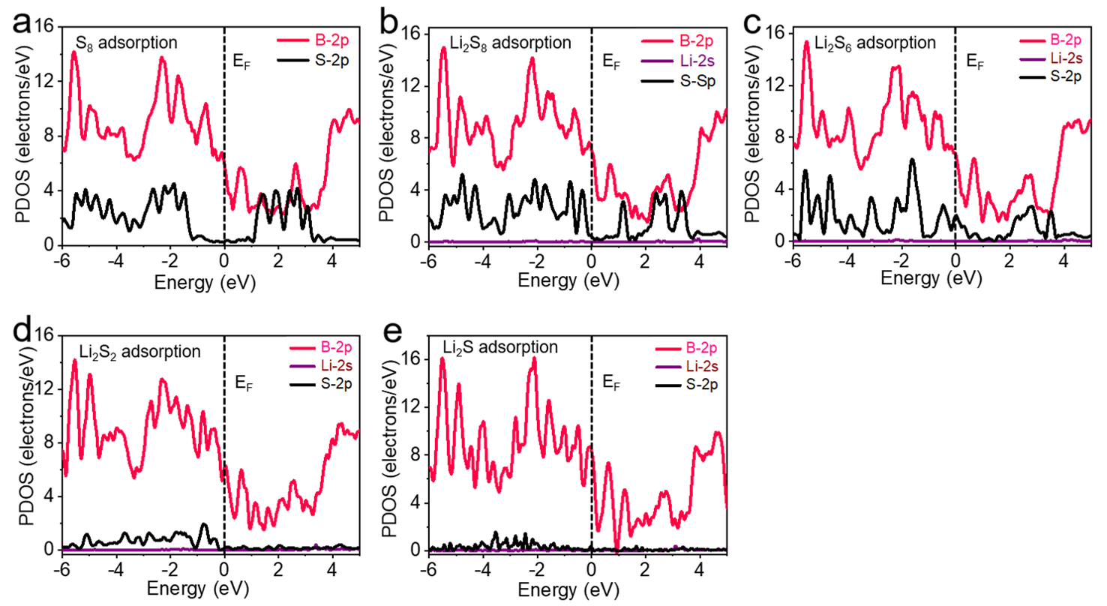
Supplementary Figure 11. The PDOS of S₈ and Li₂S_{n} on a monolayer β₁₂-borophene. (a) S₈ adsorption. (b) Li₂S₈ adsorption. (c) Li₂S₆ adsorption. (d) Li₂S₂ adsorption. (e) Li₂S adsorption.

SUPPLEMENTARY NOTE 11: TYPICAL PHOTOGRAPHS OF BOROPHENE, CNT AND LI₂S₄ IN DOL/DME SOLUTION
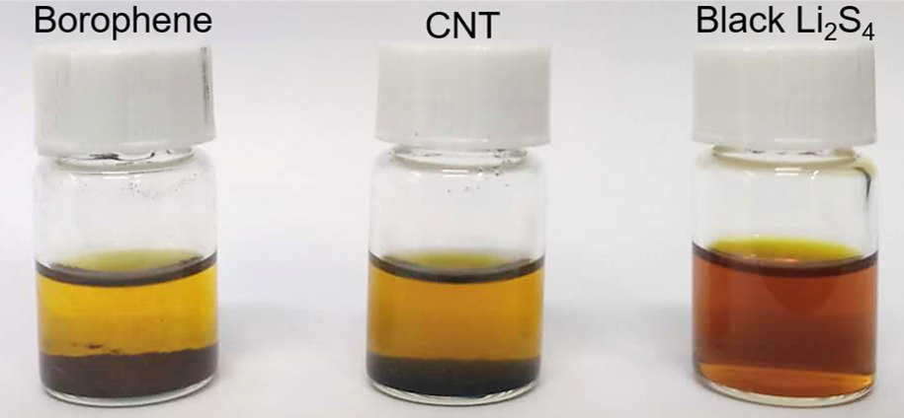
Supplementary Figure 12. The digital images of borophene, CNT and Li₂S₄ in 1,3-dioxolane (DOL)/ 1,2-dimethoxyethane (DME) solution after a standing time of 24 h.

SUPPLEMENTARY NOTE 12: THE ADSORPTION ENERGY AND DIFFUSION BARRIER OF POLYSULFIDE ON MONOLAYER CNT BY DFT CALCULATIONS
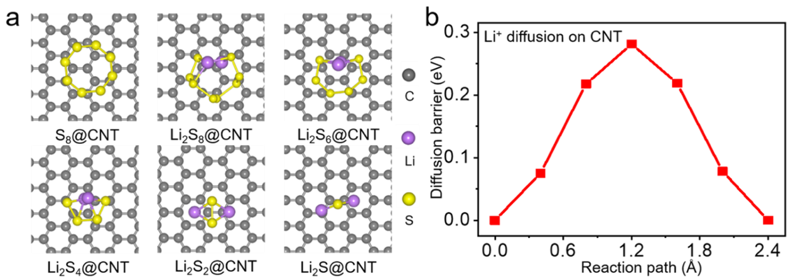
Supplementary Figure 13. DFT calculations on the adsorption and energy barrier of polysulfide on monolayer CNT. (a) The optimized adsorption configurations of S₈ and Li₂S_{n} (n = 1, 2, 4, 6, 8) on a monolayer CNT. (b) The diffusion energy barrier of Li⁺ on monolayer CNT.

SUPPLEMENTARY NOTE 13: THE COMPARABLE TABLE OF 2D NANOMATERIAL-BASED LI-S CELLS
Supplementary Table 2. Comparison table between the electrochemical performances of β₁₂-borophene sheets and those of other 2D materials for Li-S batteries.

2D Materials | Rate (mAh g⁻¹) | Capacity (mAh cm⁻²) | Decay rate (%) | Refs.
$β_{12}$-borophene | 8 C (721) | 5.2 (7.8 mg cm⁻²) | 0.039 (1000 cycles) | This work
N-doped Graphene | 2 C (988) | 4.5 (5.7 mg cm⁻²) | 0.042 (1000 cycles) | 21
Phosphorene | 3 C (785) | - | 0.053 (500 cycles) | 22
MXene | 0.5 C (900) | 5 (5.5 mg cm⁻²) | 0.043 (1200 cycles) | 23
BN | 5 C (400) | - | 0.0067 (1000 cycles) | 24
C₃N₄ | 4 C (340) | 3.3 (4.0 mg cm⁻²) | 0.5 (200 cycles) | 25
Siloxene | 4 C (919) | 3.6 (4.2 mg cm⁻²) | 0.045 (500 cycles) | 26
MoS₂ | 1 C (550) | - | 0.083 (600 cycles) | 27
Carbon nanosheet | 5 C (529) | 4.0 (4.2 mg cm⁻²) | 0.028 (1000 cycles) | 28
WS₂ | 3 C (448) | - | 0.031 (500 cycles) | 29
Ni(OH)₂ | 2 C (523) | - | 0.04 (1000 cycles) | 30
MnO₂ | 1 C (690) | 4.1 (3.5 mg cm⁻²) | - | 31
Graphene | 2 C (700) | - | 0.5 (70 cycles) | 32
N doped MXene | 2 C (770) | 4.2 (5.1 mg cm⁻²) | 0.044 (500 cycles) | 33
V₂O₅ | 1 C (751) | - | 0.16 (150 cycles) | 34
rGO | 2 C (505) | - | 0.23 (100 cycles) | 35

References
1. Coleman, J. N. et al. Two-Dimensional Nanosheets Produced by Liquid Exfoliation of Layered Materials. Science 331, 568-571 (2011).
2. Li, H. et al. Scalable Production of Few-Layer Boron Sheets by Liquid-Phase Exfoliation and Their Superior Supercapacitive Performance. ACS Nano 12, 1262-1272 (2018).
3. Fan, Q. et al. High-yield production of few-layer boron nanosheets for efficient electrocatalytic N-2 reduction. Chem. Commun. 55, 4246-4249 (2019).
4. Stephan, O. et al. Doping graphitic and carbon nanotube structures with boron and nitrogen. Science 266, 1683-1685 (1994).
5. Nishino, H. et al. Formation and Characterization of Hydrogen Boride Sheets Derived from MgB2 by Cation Exchange. J. Am. Chem. Soc. 139, 13761-13769 (2017).
6. Feng, B. et al. Experimental realization of two-dimensional boron sheets. Nat. Chem. 8, 564-569 (2016).
7. Wu, R. et al. Large-area single-crystal sheets of borophene on Cu(111) surfaces. Nat. Nanotechnol. 14, 44-50 (2019).
8. Mannix, A. J. et al. Synthesis of borophenes: Anisotropic, two-dimensional boron polymorphs. Science 350, 1513-1516 (2015).
9. Li, W. et al. Experimental realization of honeycomb borophene. Sci. Bull. 63, 282-286 (2018).
10. Vinogradov, N. A., Lyalin, A., Taketsugu, T., Vinogradov, A. S. & Preobrajenski, A. Single-Phase Borophene on Ir(111): Formation, Structure, and Decoupling from the Support. ACS Nano 13, 14511-14518 (2019).
11. Wu, Z., Tai, G., Shao, W., Wang, R. & Hou, C. Experimental realization of quasicubic boron sheets. Nanoscale 12, 3787-3794 (2020).
12. Tai, G. et al. Synthesis of Atomically Thin Boron Films on Copper Foils. Angew. Chem. Int. Ed. 54, 15473-15477 (2015).
13. Zhang, Z. et al. Few-Layer Borophene Prepared by Mechanical Resonance and Its Application in Terahertz Shielding. ACS Appl. Mater. Interfaces 12, 19746-19754 (2020).
14. Ji, X. et al. A Novel Top-Down Synthesis of Ultrathin 2D Boron Nanosheets for Multimodal Imaging-Guided Cancer Therapy. Adv. Mater. 30, 1803031 (2018).
15. Ma, D. et al. A self-powered photodetector based on two-dimensional boron nanosheets. Nanoscale 12, 5313-5323 (2020).
16. Wang, X. et al. Bandgap Engineering of Hydroxy-Functionalized Borophene for Superior Photo-Electrochemical Performance. Angew. Chem. Int. Ed. 59, 1-6 (2020).
17. Guo, Q. et al. Boron Nanosheets for Efficient All-Optical Modulation and Logic Operation. Adv. Optical Mater. 7, 1900322 (2019).
18. Ranjan, P. et al. Freestanding Borophene and Its Hybrids. Adv. Mater. 31, 1900353 (2019).
19. Qi, P. et al. The potential role of borophene as a radiosensitizer in boron neutron capture therapy (BNCT) and particle therapy (PT). Biomater. Sci. 8, 2778-2785 (2020).
20. Zhao, J., Shi, R., Sai, L., Huang, X. & Su, Y. Comprehensive genetic algorithm forab initioglobal optimisation of clusters. Mol. Simulat. 42, 809 (2016).
21. Kong, L. et al. Porphyrin-Derived Graphene-Based Nanosheets Enabling Strong Polysulfide Chemisorption and Rapid Kinetics in Lithium-Sulfur Batteries. Adv. Energy Mater. 8, 1800849 (2018).
22. Li, L. et al. Phosphorene as a Polysulfide Immobilizer and Catalyst in High-Performance Lithium-Sulfur Batteries. Adv. Mater. 29, 1602734 (2017).
23. Liang, X., Rangom, Y., Kwok, C. Y., Pang, Q. & Nazar, L. F. Interwoven MXene Nanosheet/Carbon-Nanotube Composites as Li-S Cathode Hosts. Adv. Mater. 29, 1603040 (2017).
24. Fan, Y. et al. Functionalized Boron Nitride Nanosheets/Graphene Interlayer for Fast and Long-Life Lithium-Sulfur Batteries. Adv. Energy Mater. 7, 1602380 (2017).
25. Huangfu, Y. et al. Facile fabrication of permselective g-C₃N₄ separator for improved lithium-sulfur batteries. Electrochim. Acta 272, 60-67 (2018).
26. Wang, Y. et al. Highly Stable Lithium−Sulfur Batteries Promised by Siloxene: An Effective Cathode Material to Regulate the Adsorption and Conversion of Polysulfides. Adv. Funct. Mater. 30, 1910331 (2020).
27. Ghazi, Z. A. et al. MoS₂/Celgard Separator as Efficient Polysulfide Barrier for Long-Life Lithium-Sulfur Batteries. Adv. Mater. 29, 1606817 (2017).
28. Li, J. et al. Polysulfide Confinement and Highly Efficient Conversion on Hierarchical Mesoporous Carbon Nanosheets for Li–S Batteries. Adv. Energy Mater. 9, 1901935 (2019).
29. Lei, T. et al. Multi-Functional Layered WS₂ Nanosheets for Enhancing the Performance of Lithium-Sulfur Batteries. Adv. Energy Mater. 7, 1601843 (2017).
30. Dai, C. et al. Uniform α-Ni(OH)₂ hollow spheres constructed from ultrathin nanosheets as efficient polysulfide mediator for long-term lithium-sulfur batteries. Energy Storage Mater. 8, 202-208 (2017).
31. Li, Z., Zhang, J. & Lou, X. Hollow Carbon Nanofibers Filled with MnO₂ Nanosheets as Efficient Sulfur Hosts for Lithium-Sulfur Batteries. Angew. Chem. Int. Ed. 54, 12886-12890 (2015).
32. Fei, L. et al. Graphene/Sulfur Hybrid Nanosheets from a Space-Confined "Sauna" Reaction for High-Performance Lithium-Sulfur Batteries. Adv. Mater. 27, 5936-5942 (2015).
33. Bao, W. et al. Facile Synthesis of Crumpled Nitrogen-Doped MXene Nanosheets as a New Sulfur Host for Lithium-Sulfur Batteries. Adv. Energy Mater. 8, 1702485 (2018).
34. Wang, C. et al. Rapid gas-assisted exfoliation promises V₂O₅ nanosheets for high performance lithium-sulfur batteries. Nano Energy 67, 104253 (2020).
35. Huang, J. et al. Permselective Graphene Oxide Membrane for Highly Stable and Anti-Self-Discharge Lithium-Sulfur Batteries. ACS Nano 9, 3002-3011 (2015).

