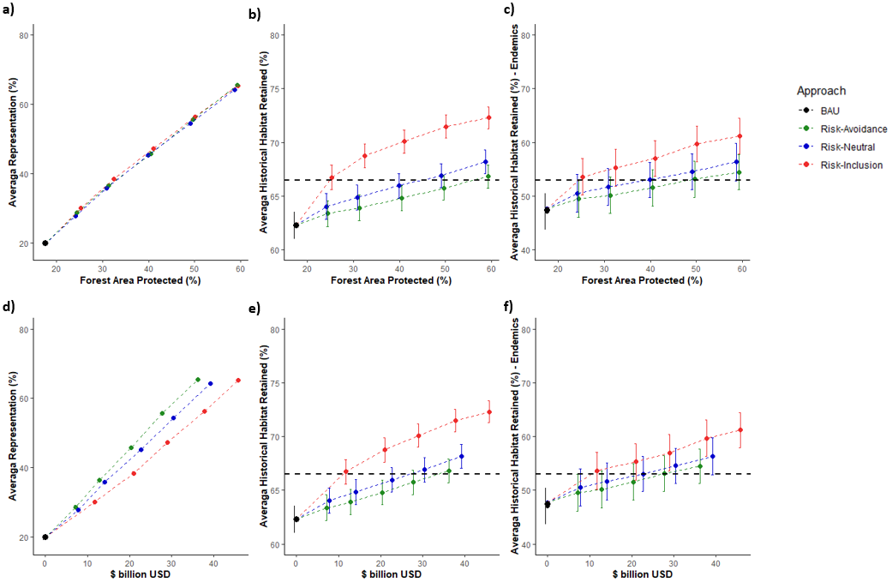
Supplementary information:

SI Figure 1. Amount and cost of forest area protected and the (a & d) average habitat protected for 550 forest dependent bird species in Colombia by 2050 under a BAU scenario of no PA expansion (black) and three different approaches of PA expansion. Favouring the selection of areas of low deforestation (green), favouring the selection of areas of high deforestation (red) and not taking into account deforestation pressure (blue). The green, blue and red dots represent the amount and cost of PA needed under each scenario to meet the prioritization representation targets (20, 30, 40, 50 and 60% of each species habitat protected). The black dot represents the amount and cost of PA in Colombia by 2015. (b & e) Average proportion of 550 forest dependent species historical habitat retained in Colombia by 2050 under the three different approaches of PA expansion. (c & f) Average proportion of 69 regionally-endemic forest dependent species historical habitat retained in Colombia by 2050 under the three different approaches of PA expansion. Horizontal bars show the standard error.

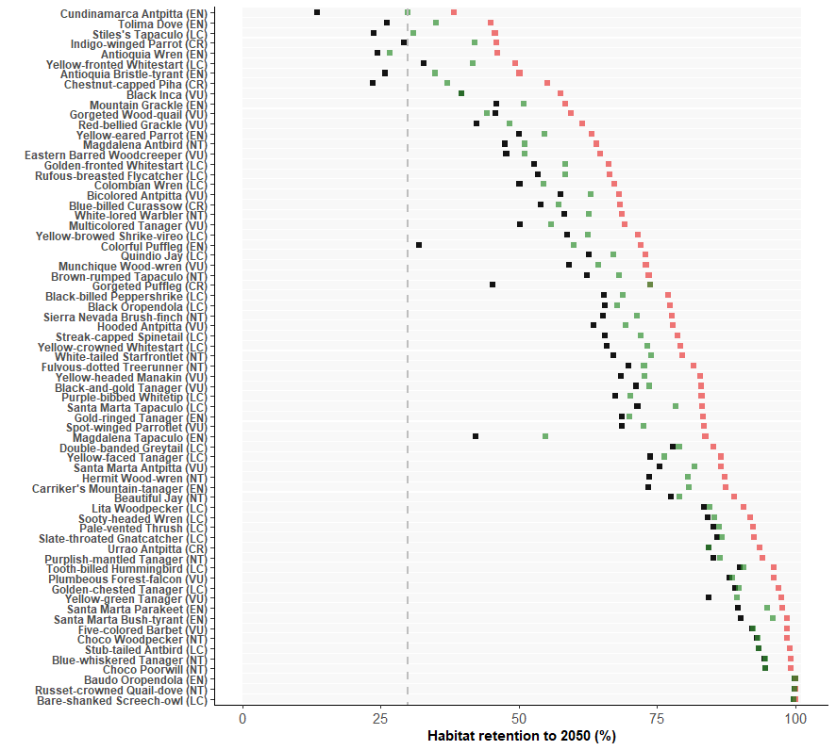

SI Figure 2. Current Habitat (2015) retained by 69 regionally-endemic forest-dependent species by 2050 under three different PA expansion scenarios to protect at least 30% of the habitat of each species. Green represents an scenario where the expansion is done favouring the selection of areas of low deforestation, and red favouring the selection of areas of high deforestation. Black represents a business as usual scenario of no PA expansion. The vertical dashed line shows a 30% retention threshold.

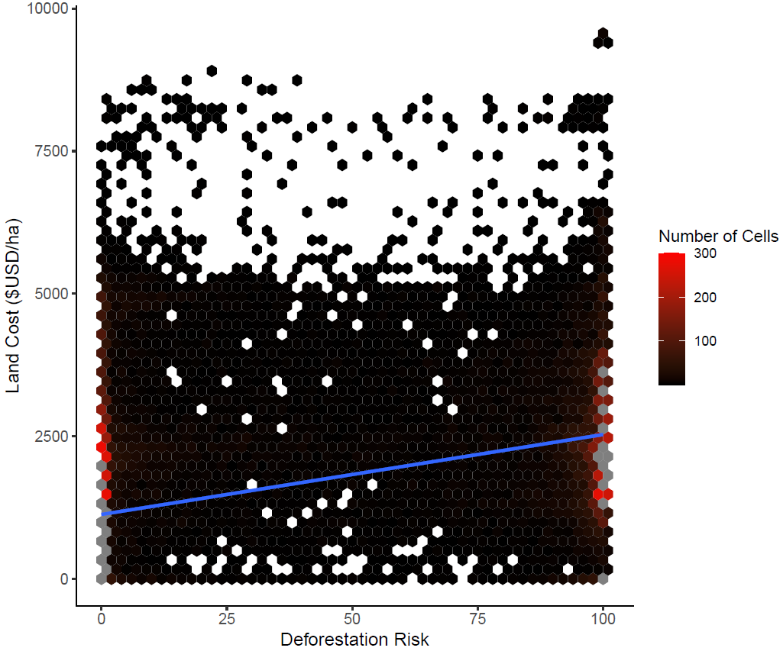

SI Figure 3. Deforestation risk (x axis) versus the average per-hectare cost of land (y axis) for each 1 km² forested cell. Because of the large number of overlapping points, values have been grouped into hexagonal bins, with brighter-red bins containing more forested cells. Bins with more than 300 forested cells are depicted in grey. In blue a regression line (Estimate= 0.013, intercept=0.2). Pearson coefficient= 0.43.

