A simple pressure-assisted method for MicroED specimen preparation
Jingjing Zhao¹, Hongyi Xu^{1*}, Hugo Lebrette³, Marta Carroni^{2,3}, Helena Taberman^{4,5}, Martin Högbom³ & Xiaodong Zou^{1*}
¹Department of Materials and Environmental Chemistry, Stockholm University, Stockholm, Sweden
²Science for Life Laboratory, Stockholm University, Solna, Sweden
³Department of Biochemistry and Biophysics, Stockholm University, Stockholm, Sweden
⁴Max-Delbrück-Centrum for Molecular Medicine, Berlin, Germany
⁵Macromolecular Crystallography, Helmholtz-Zentrum Berlin für Materialien und Energie, Berlin, Germany
*e-mail: hongyi.xu@mmk.su.se, xzou@mmk.su.se

Supplementary protocol
Preassis is widely applicable for MicroED specimen preparation, including crystals grown in low-viscous buffer conditions to highly-viscous PEG-rich crystallization conditions. It must be noted that different crystal samples grown in different conditions and with different sizes or shapes behave differently. The parameters for the method described here may need to be fine tuned accordingly. Furthermore, the pressure range also depends on the size of the Büchner flask and the type of pump machine. Therefore, the parameters applied here for different types of protein crystal samples may need to be adjusted for a new setup. The specimen preparation comprises the following steps:
- providing an EM grid;
- applying a sample suspension onto the EM grid;
- providing a pressure gradient through the EM grid in order to pull a portion of the liquid through the grid while removing the excess liquid with a filter paper on the other side of the grid;
- plunging the specimen into a cryogenic bath.
Details of the setup and the specimen preparation procedure are described below.
Equipment
- Micropipette and tips, 0.5-10 μL (Eppendorf Research plus variable micropipette, #3116000015 or similar; Eppendorf tips 0.1-10 μL, # Z741098-960EA or similar)
- Tweezers (Dumont Tweezer, style5 #72705-01or similar)
- Filter paper (Munktell, #110067 or similar)
- Quantifoil holey carbon grids (R 1.2/1.3, R 2.0/1, R 3.5/1, R2/2, or similar)
- Glow-discharge (PELCO easiGlowTM 9100 or similar)
- Cryo grid box (CGB4-1 SWISSCI Cryo grid box or similar)
- FEI coolant container
- Ethane and liquid nitrogen
- Vacuum aspirator or pump machine (PC 3001 VARIO)
- Polymer hose (hose, PVC-/latex-, 6 $×$ 9 mm)
- Pressure meter (PELCO^{R} 2245 Minl Hot Vac. if a vacuum aspirator is used)
- Büchner flask (GLASSCO 500 mL, or similar)
Procedure
1. Prepare liquid ethane using the FEI coolant container.
2. Glow discharge the grids (current 20 mA, glow 60 s, hold 10 s; can be changed if necessary). The hole size of the grid should be slightly smaller than the crystal size if possible. For very viscous samples, grids with large hole sizes are recommended, such as Quantifoil R 3.5/1 grids.
3. Put a filter paper on top of the flask.
4. Use a pair of tweezers to pick up a glow discharged grid and put it onto the center of the filter paper with the carbon side facing up.
5. Turn on the tap (if a vacuum aspirator is used) or start the vacuum pump. If a vacuum aspirator is used, a pressure meter needs to be installed to measure the pressure. For non-viscous samples, typical pressures used for MicroED specimen preparation are around 20 mbar if a Quantifoil R1.2/1.3 is used (the pressure is not always necessary when a grid with larger hole size is used, e.g. Quantifoil R2/1 and R3.5/1). For viscous samples, a pressure of 70 mbar or higher may be needed even for grids with large hole sizes, e.g. Quantifoil R3.5/1.
6. Use a micropipette to take 3 μl of the sample, apply it onto the grid. The droplet will be dispersed through the grid immediately. Pick the grid up and plunge freeze it within 5 to 10 s. For very viscous samples, one can decrease the sample volume to 1 or 2 μl, use a grid with large hole size (e.g. Quantifoil R 3.5/1), increase the pressure strength, or wait for a slightly longer time before picking up the grid.
7. Cryotransfer the grid into a cryo-grid box.
In this setup, a vacuum aspirator with water-flow or a vacuum pump machine (recommended) can be used to produce the pressure/suction. In principle, the suction time can also influence the thickness of the vitrified ice. However, the time is less controllable compare with the other two parameters at the current stage. We noticed that the hole size and pressure play more important roles on the ice thickness. We admit that there is a small deviation between specimens prepared using the same parameters, which may result from the manual picking, time controlling, and also the contact between the grid and filter paper. If we handle the process properly, the deviation is small and will not affect the overall results. In the future, new implementations, such as automation development and humidity chamber, may improve the throughput and reproducibility of the specimen preparation by Preassis.

Supplementary Figures
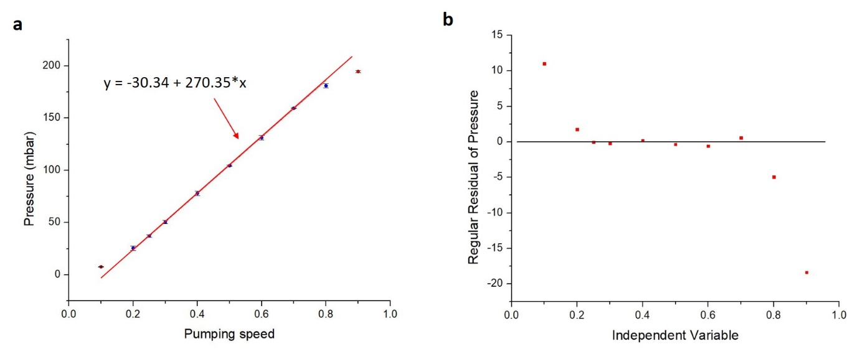

Supplementary Fig. 1
Relationship between the pumping speed and the resulting pressure of the pumping machine (PC 3001 VARIO).
a-b, The pressure is almost linearly related to the pumping speed in the region where the pumping speed is between 20% and 80%. The regular residual of the pressure in b is defined by the difference between the predicted value by y = -30.34+ 270.35*x in a and the experimental value.

Supplementary Fig. 2
Comparison of EM grids prepared by Preassis and Vitrobot under different humidity using a mixture of ZSM-5 microcrystals with 40% PEG 400.
a, MicroED specimens prepared by Preassis with pressure of 78 mbar (5 s) and b, Vitrobot with 0 blotting force (5 s). These two specimens were prepared under room humidity (35% - 45%) and temperature (ca 20 °C). c, Specimen prepared by Vitrobot under 100% humidity and room temperature. This comparison illustrates that Preassis is more efficient in removing liquid comparing with Vitrobot. High humidity reduces the liquid removal efficiency as caused by the decrease of the liquid adsorption ability of filter paper. R 2/1 grids were used for these three experiments. Because of the lens distortion at such low magnification, the images are distorted especially at the edges.

Supplementary Fig. 3
Reproducibility of specimen preparation by Preassis using tetragonal lysozyme crystal sample.
a-c, Low magnification TEM images of MicroED specimens prepared by Preassis using the same experimental parameters: 3 μl droplet, Quantifoil grid R 1.2/1.3, 37.2 mbar pressure, suction time ca 5 s, and room temperature (ca 20 °C) and humidity (35% - 45%). Because of the lens distortion at such low magnification, the images are distorted especially at the edges. d-f, TEM images taken from those three repeated grids showing the local ice conditions.

Supplementary Fig. 4
Ice thickness distribution across the grid prepared by Preassis from the tetragonal lysozyme crystal sample.
a, Low magnification image showing the inhomogeneous distribution of ice thickness on the entire TEM grid. Because of the lens distortion at such low magnification, the image is distorted especially at the edges. b-c and d-e, Two representative examples of areas with relatively thick (b-c) and thin (d-e) ice layers. The crystals marked by red arrows in image e are suitable for MicroED data collection.

Supplementary Figure 5
Influence of pressure on MicroED specimen prepared from a non-viscous buffer by Preassis using a tetragonal lysozyme crystal sample.
a and b, Low magnification images and high magnification images taken from the specimens prepared with pressure of 37.2 mbar and 0 mbar, respectively. For these specimens, tetragonal lysozyme crystal sample and Quantifoil grid R 1.2/1.3 were used. Because of the lens distortion at such low magnification, the image is distorted especially at the edges.

Supplementary Figure 6
Influence of pressure and hole size on MicroED specimens prepared by Preassis using crystal suspensions with different viscosity.
a and e, Low magnification TEM images taken from the specimens prepared from a crystal suspension with 15% PEG 6000 using Quantifoil grids R 1.2/1.3 with 181 and 0 mbar pressure, respectively. b-d and f-h, Low magnification TEM images taken form the specimens prepared by Preassis from crystal suspensions with different viscosity (15%, 25%, and 35% PEG 6000) using Quantifoil grids R 3.5/1 at 181 and 0 mbar pressure, respectively. The crystal suspensions with different viscosities were made by mixing ZSM-5 microcrystals with different concentration of PEG 6000.

Supplementary Video
The video was generated from a MicroED data of R2lox. The specimen used for this data collection was prepared by Preassis with 30.7 mbar pressure and a Quantifoil grid R 3.5/1. The data was collected on a JEOL JEM-2100 (200 kV) microscope using selected-area electron diffraction mode. The data collection was done by continuously rotating the crystal with a rotation speed of 0.45 °s⁻¹ and exposure time of 2 s, and ED frames were simultaneously recorded by a fast Timpix hybrid pixel detector in a movie mode.

