Supplementary Information
Uncovering new global risks from commercial chemicals in air
Qifan Liu^{1,5}, Li Li^{2,5}, Xianming Zhang^{1,3}, Amandeep Saini¹, Wenlong Li¹, Hayley Hung¹, Chunyan Hao³, Kun Li^{1,†}, Patrick Lee¹, Jeremy J. B. Wentzell¹,Chunyan Huo¹, Shao-Meng Li⁴, Tom Harner^{1,}* & John Liggio^{1,}*
1. Air Quality Processes Research Section, Environment and Climate Change Canada, Toronto, Ontario M3H 5T4, Canada
2. School of Community Health Sciences, University of Nevada Reno, Reno, NV 89557-274, United States
3. Laboratory Services Branch, Ontario Ministry of the Environment, Conservation and Parks, 125 Resources Road, Toronto, ON, M9P 3V6, Canada
4. College of Environmental Sciences and Engineering, Peking University, Beijing, 100871 China
5. These authors contributed equally: Qifan Liu, Li Li
†Present address: Laboratory of Atmospheric Chemistry, Paul Scherrer Institute (PSI), 5232 Villigen, Switzerland
*correspondence to: john.liggio@canada.ca; tom.harner@canada.ca

Supplementary Note 1: Target-analysis of parent OPFRs
Target-analysis of OPFRs parent compounds in GAPS-MC samples was performed on a Waters Acquity I-class Ultra Performance Liquid Chromatograph coupled with a Xevo TQ-S triple quadrupole Mass Spectrometer (UPLC-MS/MS; Waters, Boston, MS, USA). Further, a Waters Acquity (Waters, Boston, MS) BEH C18 reversed phase analytical column (50mm, 2.1mm i.d., 1.6 μm particle size) was used to achieve separation of parent compounds. Ions were monitored using multiple reaction monitoring (MRM) mode and target transitions for parent OPFRs had been reported previously.²
Supplementary Note 2: Non-target analysis of OPFR transformation products
For the GAPS-MC field data analysis, the identification of chlorinated transformation products was based upon their retention time, mass peaks, and isotopic patterns. If the species detected in the GPAS-MC field samples possessed the same retention times, mass peaks, and isotopic patterns as those detected from the OFR samples, then these chemicals were considered to be identified transformation products. Here, we use a mass uncertainty of 20 ppm as the criteria for the molecular identification of products.⁶² Chlorinated products also exhibit distinct isotopic patterns due to the presence of ³⁷Cl, (i.e., ³⁷Cl isotopic peaks differ from the molecular ion M by 1.997 amu). For example, if a species contains 2 Cl atoms, then the relative signal intensity of its isotopic peaks should be M⁺: [M+1.997]⁺ : [M+3.994]⁺ = 100 : 64 : 10. This isotopic pattern was clearly observed for product TCPP-21 (chemical formula C₆H₁₃PO₄Cl₂), as shown in Extended Data Fig. 3 (TCPP-21 was detected as [M+H]⁺ in GC-APCI-TOFMS; measured [M+H]⁺: [M+H+1.997]⁺ : [M+H+3.994]⁺ = 100 : 61 : 8). In the case of non-chlorinated products, their identification was based upon retention time, and mass peaks. The volume normalized signal intensity (counts m^{–3}) is calculated on the basis of the measured GC-APCI-TOFMS signal intensity (counts) and calculated sampling air (m³; see Sampling volume in Methods).
Among the 11 identified transformation products in the GAPS-MC field samples, TCEP-1 and TCPP-25 are structural isomers and hence very difficult to distinguish from each other. This is because authentic standards and the physicochemical properties for these two chemicals are not available.
It should be noted that, in theory, some of the products formed from reaction channel 2 in Extended Data Fig. 2 (e.g., TCEP-10 and TCPP-21) may be formed through hydrolysis reactions. However, previous work has clearly suggested that the hydrolysis rate for OPFRs in water was negligible.⁶³ For example, no significant degradation was observed for aqueous-phase TCEP, TCPP, TDCPP, and TBEP at pH 7–11 over a period of 35 days. Hence, the OH oxidation, rather than hydrolysis reaction, should account for the formation of TCEP-10 and TCPP-21, particularly since the relative humidity in ambient air is typically below 100%. In addition, the seasonal variations for the volume normalized signal intensity of OPFR products in Fig. 3b clearly demonstrate that the identified products here are directly linked to photooxidation. Taken together, these results indicate that the 11 identified products are formed through photooxidation.
Supplementary Note 3: Oxidation flow reactor experiments
Reagents. Tris(2-chloroethyl) phosphate (#119660), tris(1,3-dichloro-2-propyl) phosphate (#57603), tris(2-butoxyethyl) phosphate (#130591), triphenyl phosphate (#241288), tricresyl phosphate (#268917), diphenyl phosphate (#850608), tris-2-ethylhexyl phosphate (#289922), ammonium sulfate (#A4915), sodium iodide (#383112), and acetonitrile (#50387) were purchased from Sigma-Aldrich. 2-ethylhexyl diphenyl phosphate (#P1021) was purchased from TCI Chemicals. Tris(2-chloroisopropyl) phosphate (#G1059281) was purchased from LGC Standards. CO gas (0.1% in air) was purchased from Air Liquide. O₃ was produced by an O₃ generator (Ozone Solutions, model TG-10) supplied with high grade O₂ (Air Liquide, 99.999%).
Oxidation flow reactor (OFR). The total flow rate through the OFR was 0.9 L min^{–1} with a residence time of 60 s. The temperature of the reactor was maintained at 298 K by circulating water through an outer jacket of the reactor. The (NH₄)₂SO₄ particles (mode mobility diameter 73 nm) were generated via atomization (TSI, model 3706), dried through a diffusion drier (TSI, model 3062), and then passed through the headspace of a temperature-controlled Pyrex tube (343–363 K) containing a pure OPFR, to generate coated particles with a calculated coating thickness of 15 nm (calculated based upon the shift in the peak of the particle size distribution). For TCEP and TCPP, organic particles were generated by sending an aqueous solution of each organic through a TSI atomizer and drawn through a diffusion drier. Upon achieving a steady-state concentration of OPFR under 254 nm UV light irradiation (Jelight, #82-3309-9), O₃ (0–2 ppm) was introduced into the OFR. The RH in the OFR was constantly maintained at 35% by controlling the flow of dry and wet zero air into the OFR. The UV lamp inside the reactor was surrounded by a quartz sheath tube, which was purged with compressed air to cool the lamp. The O₃ concentration, RH, particle size distribution, and particulate OPFR mass concentration were measured with an O₃ monitor (2B Technology, model 202), a RH sensor (Vaisala Inc., model HMP60), a scanning mobility particle sizer (SMPS, TSI), and an Aerodyne HR-TOF-AMS, respectively.
OH exposure measurement. The OH exposure (molecules cm^{–3} s), which is the product of OH concentration (molecules cm^{–3}) and residence time (s) in the reactor, was determined by measuring the loss of CO as a function of O₃ concentration in offline calibrations:
$OH exposure=-\frac{1}{k_{CO}}ln\frac{{[CO]}_{t}}{[{CO]}_{0}}$ (Equation S1)
where k_{CO} is the second-order rate constant of CO at 298 K (1.54× 10⁻¹³ cm³ molecules^{–1} s^{–1}),³⁶ [CO]_{t} is the CO concentration measured by a CO monitor (LGR, model 23r) in the presence of O₃, [CO]₀ (1.5 ppm) is the measured CO concentration in the absence of O₃. The measured OH exposures ranged from 1.2×10¹¹ to 1.6×10¹² molecules cm^{–3} s.
Sample collection. We collected unreacted and reacted OPFR samples (the five most abundant OPFRs in GAPS-MC samples, i.e., TCEP, TCPP, TDCPP, TBEP, and TPhP) from OFR experiments to aid the identification of OPFR transformation products in ambient samples. For water-soluble OPFRs (TCEP, TCPP, TDCPP, and TBEP), organic particles were generated by sending an aqueous solution of a mixture containing the four OPFR compounds through a TSI atomizer. The water-insoluble OPFR (TPhP) was coated onto (NH₄)₂SO₄ seed particles (see above) and collected by a Teflon filter (Savillex Inc., #950–450–1192).
Supplementary Note 4: Heterogeneous OH oxidation kinetics of particulate OPFRs
The rate constant of heterogeneous oxidation is quantified by measuring the loss of the particulate OPFR, as estimated by a selected marker ion from the HR-TOF-AMS or EESI-TOFMS spectrum. The heterogeneous kinetics of TDCPP, TBEP, TPhP, EHDP, TCP, TEHP, and DPhP have been reported previously.^{35,64,65} In the current study, the molecular-ion peaks at m/z 306.94 and m/z 348.99 ([M+Na⁺]; measured with an EESI-TOFMS) were selected as marker ions for TCEP and TCPP, respectively. The observed rate constant k_{obs} (cm³ molecule⁻¹ s⁻¹) for the heterogeneous OH oxidation of OPFRs can be determined using Eq. S2:
$ln\frac{\left[OPFR\right]}{{[OPFR]}_{0}}=ln\frac{I}{I_{0}}=-k_{obs}[OH]t$ (Equation S2)
where [OPFR]₀, [OPFR], and [OH]t are the initial OPFR concentration (molecules cm⁻³), the measured OPFR concentration (molecules cm⁻³) at a given OH exposure, and the OH exposure (molecules cm⁻³ s), respectively. The terms I₀ and I represent the EESI-TOFMS signal intensities for the selected marker ions (proportional to the OPFR concentration) in the absence and presence of OH radicals. By fitting an exponential function to the I/I₀ vs. OH exposure data, k_{obs} can be determined. The value of k_{obs} was further corrected for OH gas-phase diffusion using a previously developed empirical formula⁶⁶ to obtain an effective rate constant (k_{eff}). The values of k_{eff} for TCEP and TCPP are calculated to be (0.72±0.10)×10^{–12} and (0.88±0.09)×10^{–12} cm³ molecule⁻¹ s⁻¹, respectively (Supplementary Table 6). Supplementary Table 6 also summarizes the heterogeneous kinetics results for TDCPP, TBEP, TPhP, EHDP, TCP, TEHP, and DPhP.
In general, the atmospheric persistence modelling assumes the photooxidation of OPFRs only occurs in the gas-phase, while ignoring the particle-phase photooxidation. We further explore the impact of particle-phase photooxidation on the atmospheric persistence of OPFRs with our experimentally measured heterogenous OH oxidation rate constants. As shown in Supplementary Table 6, neglecting the particle-phase photooxidation process would overestimate the atmospheric persistence of OPFRs with relatively low-volatilities (e.g., TBEP, EHDP, TCP, and TEHP; for their log K_{OA} values, see Extended Data Fig.6). The overestimation is more pronounced with a higher particulate concentration (300 μg m^{–3}), as a higher fraction of OPFRs resides in the particle-phase with an increased particulate concentration.
Supplementary Note 5: OH oxidation mechanisms of OPFRs
Below we describe the detailed photooxidation mechanisms for one chlorinated OPFR (TCPP) and one non-chlorinated OPFR (EHDP). TCPP is the most abundant OPFR in the ambient air.¹³ Non-chlorinated OPFRs are typically aryl or alkyl OPFRs. Here we use EHDP as an example to demonstrate the oxidation mechanism for non-chlorinated OPFRs since it has both phenyl and alkyl groups.
TCPP. Based upon the EESI-TOFMS measurements during photooxidation of TCPP (Supplementary Fig. 8), the oxidation mechanism was proposed, as shown in Supplementary Fig. 1. In channel 1, TCPP oxidation is initiated by OH attack on the C–Cl bond, leading to the formation of an alcohol (product TCPP-1). Further oxidation of TCPP-1 would generate a dialcohol (product TCPP-4), carbonyls (product TCPP-2, TCPP-5, and TCPP-6), and carboxylic acids (TCPP-3, TCPP-7, TCPP-8, and TCPP-9). The “OH + C–Cl” pathway is in good agreement with previously proposed mechanisms for the OH oxidation of chlorinated OPFRs (e.g., TCEP and TCPP) in water.^{67,68} In addition, H-abstraction of the methyl group in the presence of O₂ would produce an alkylperoxy radical, which further reacts with HO₂ to form a hydroperoxide (product TCPP-10). TCPP-10 can then undergo two different reaction pathways. First, OH attacks the C–Cl bond of TCPP-10, producing a carbonyl (TCPP-11) and a carboxylic acid (TCPP-12). Second, TCPP-10 transforms to TCPP-13 and TCPP-16 through the well-established Russell mechanism.⁶⁹ With continued OH oxidation, TCPP-13 and TCPP-16 can be converted to TCPP-14 and TCPP-15, and TCPP-17 and TCPP-18, respectively. Given that the “peroxide” pathway presented here has not been reported in previous photooxidative chemistry studies for aqueous-phase chlorinated OPFRs,^{67,68} the current proposed mechanism advances our understanding of the environmental transformations of OPFRs and thus provide a more comprehensive picture for TCPP oxidation chemistry specifically.
Channel 2 involves a two-step reaction, i.e., OH addition to the central phosphorus atom, followed by the cleavage of a side chain from the phosphoric center to generate product TCPP-21. Such a transformation pathway has also been reported in the OH oxidation of TCPP in water.⁶⁸ TCPP-21 can further generate products TCPP-22 – TCPP-24 through the “OH+ C–Cl” pathway, or generate products TCPP-25 – TCPP-32 through the “peroxide” pathway.
Channel 3 presents a photodecomposition channel. With photolysis and decomposition reactions, product TCPP-29 would be converted to smaller-chain carbonyls (TCPP-34) and carboxylic acids (TCPP-33, and TCPP-35 – TCPP-37). The key step in channel 3 is the decomposition of carbonyl hydroperoxides (which leads to the formation of smaller-chain molecules). This is consistent with previously reported photodecomposition mechanisms for alkane-derived carbonyl hydroperoxides.⁷⁰
EHDP. The oxidation mechanism of EHDP has been reported previously.³⁵ In channel 1, products EHDP-1 and EHDP-2 are formed (Supplementary Fig. 2), which are indicative of OH-addition to the phenyl ring and is consistent with the chemical mechanism of OH oxidation of benzene.⁷¹ Channel 2 involves a two-step reaction, i.e., OH addition to the central phosphorus atom, followed by the cleavage of an alkoxy or a phenoxy group from the phosphoric center to generate product EHDP-3 and EHDP-4 (accompanied by the formation of phenol), respectively. Such a transformation pathway has also been reported in the OH oxidation of other OPFRs (e.g., TCEP) in water.⁶⁷ Further oxidation of phenol (ring opening reactions) would result in the formation of product a and b (Supplementary Fig. 2), which have been frequently detected in the OH oxidation of aqueous-phase phenol processes.⁷²
In channel 3, oxidation begins with H-abstraction by OH from the alkyl group of EHDP, producing an alkylperoxy radical, which further reacts with HO₂ to yield a hydroperoxide (product EHDP-5). EHDP-5 can then undergo three different reaction pathways. First, EHDP-5 reacts with OH to generate a dihydroperoxide, which then transforms to a carbonyl hydroperoxide (EHDP-6) through the Russell mechanism.⁶⁹ The second pathway involves the formation of an alkoxy radical through the photolysis of EHDP-5, which subsequently transforms to a 1,4-hydroxy hydroperoxide (product EHDP-7) via a 1,4-isomerization mechanism.⁷⁰ With continued photolysis and isomerization processes, E₇ would be converted to a hydroxy carbonyl (product EHDP-8). In the third pathway, E₅ is converted to a carbonyl (product EHDP-9) according to the above-mentioned Russell mechanism,⁶⁹ which can further react with OH to form a carboxylic acid (product EHDP-10), and a peracid (product EHDP-11). Such a complex mechanism presented above (channel 3) is in good agreement with a previously proposed mechanism for the photooxidation of alkanes.⁷⁰
Channel 3 presented here represents a general mechanism for the photooxidation of EHDP as OH can attack various carbon atoms of the alkyl group, with the potential for other isomers to form. For example, several carbonyl hydroperoxides, which are isomers of EHDP-11 (see the dashed box in Supplementary Fig. 2), can also be formed through channel 3. Such isomers can undergo photodecomposition reactions, resulting in the formation of smaller-chain carbonyls (product EHDP-12− EHDP-14). Further oxidation of these three carbonyls (EHDP-12−EHDP-14) would lead to the generation of a carbonyl hydroperoxide (product EHDP-15), a short-chain carbonyl (product EHDP-16), and carboxylic acids (product EHDP-17 and EHDP-18). All these potential products formed from EHDP experiments (product EHDP-1 − EHDP-18) are summarized in Supplementary Table 1.
Summary. In summary, for both chlorinated and non-chlorinated OPFRs, they undergo similar OH oxidation channels, i.e., OH addition to the substituents attached to the phosphate center (channel 1), OH addition to the phosphate center (channel 2), and photodecomposition of early-generation products (channel 3), as shown in Extended Data Fig. 2.
Supplementary Note 6: Other aspects of PBT modelling results
Relative hazards of transformation products. The hazard of each transformation product in this work relative to its corresponding parent compound is quantified using unitless quotients of their P_{OV}, BCF and LD₅₀ values: for P_{OV} and BCF, we calculate quotients by dividing the values of a transformation product by those of its parent compound, whereas for LD50 we use a reciprocal. Therefore, in all cases a quotient greater than 1 indicates that the transformation product exhibits a higher hazard than its parent compound.
Relationship between partition coefficients and multimedia mass distribution. Octanol is used as a surrogate for non-polar organic phases (e.g., soil, sediment, and animal lipids) in environmental chemistry. The octanol-water (K_{OW}) partition coefficient is defined as the ratio between a chemical’s solubility in octanol to that in water. The octanol-air (K_{OA}) partition coefficient is defined as the ratio between a chemical’s solubility in octanol to its saturated liquid vapor pressure. K_{OW} and K_{OA} indicate the preference of a chemical for an environmental compartment. For instance, a chemical with a low K_{OW} but high K_{OA} has a preference of water > octanol > air, which means it is not present substantially in the atmosphere and it does not accumulate in animal lipids to a large extent.
Other conditions being equal, chemicals rich in oxygen-containing functional groups (hydroxyl, carbonyl, and carboxyl groups), e.g., OPFR transformation products, are more polar than chemicals with chlorine, aliphatic, and aromatic groups, e.g., parent OPFRs. A well-known example is the high relative polarity of phenol (0.7) compared to chlorobenzene (0.19) and toluene (0.099).⁷³ Polar chemicals are much more soluble in water and less soluble in octanol than non-polar chemicals. However, the solubility in octanol differs less than an order of magnitude between non-polar chemicals.
In addition, other conditions being equal, chlorinated neutral chemicals tend to be more volatile than chemicals with oxygen-containing functional groups, which are even more volatile than those with aromatic groups. For instance, chlorobenzene (12 mmHg) has a higher vapor pressure than phenol (0.4 mmHg), which is higher than biphenyl (0.00893 mmHg), according to experimental data documented in the U.S. EPA’s CompTox Chemicals Dashboard database.
For the above reasons, we can expect that OPFR transformation products will tend to possess lower K_{OW} than parent OPFRs. Meanwhile, atmospheric photooxidation changes K_{OA} in two divergent directions: the relatively more volatile and octanol soluble chlorinated OPFRs are converted to less volatile and less octanol soluble photooxidation products, with an increase in K_{OA}, whereas the relatively less volatile and similarly octanol soluble non-chlorinated OPFRs are converted to slightly more volatile and less octanol soluble photooxidation products, with a decrease in K_{OA} (Extended Data Fig. 6).
Toxicity of OPFR transformation products. We compare the oral rat LD50 of transformation products with the well-accepted WHO criteria⁷⁴: (1) extremely hazardous, LD50 < 5 mg/kg/d; (2) highly hazardous, LD50: 5-50 mg/kg/d; (3) moderately hazardous, LD50: 50-2000 mg/kg/d; (4) slightly hazardous, LD50 > 2000mg/kg/d. We note that 1 product is highly hazardous (TCPP-29), 97 products are moderately hazardous, and 88 products are slightly hazardous. We also note that, for the 11 identified products in the GAPS-MC samples, most of them (9 products) are moderately hazardous. These results suggest that the health risks posed by transformation products should not be ignored when assessing the risks of airborne OPFRs.
PBT differences between isomers. Note that when positional isomers exist, only a single isomer is selected for the in-silico PBT assessment in this work for simplicity. However, the QSAR tools used in this work (OPERA, IFS, and TEST) can give isomer-specific predictions of chemical properties and toxicity (LD50), to which the RAIDAR model can be applied for isomer-specific predictions of P_{OV} and BCF. We performed additional simulations for other positional isomers (Supplementary Fig. 7). Positional isomers are considered for hydroxylation in different branches (compounds A1 and A2), different arene substitution patterns (ortho-, meta-, and para-substitutions) (compounds B1, B2 and B3), and different positions of the carbonyl group (compounds C1−C7). The results show that for transformation products of both chlorinated and non-chlorinated OPFRs, the modelled PBT properties vary generally within a factor of 1.5 between isomers (up to a factor of 6 for bioconcentration factor only between isomers of EHDP transformation products). This variability is smaller than the fold changes in PBT (see Fig. 4) for most transformation products relative to their parents. Therefore, ignoring inter-isomer variabilities does not cause an unacceptable bias to the conclusion in this work.
Uncertainty analysis. The modeled P_{OV} and BCF values are subject to uncertainty propagated from the inherent uncertainty in individual QSAR predictions. For instance, earlier external validations show that the OPERA predictions of K_{OW}, K_{OA}, the rate constant of environmental reactions with OH radicals, and biodegradation rate constant are subject to uncertainty (expressed in the root-mean-square error or RMSE) of 0.79, 0.68, 1.23, and 0.38 log units,⁷⁵⁻⁷⁷ and the IFS predictions of fish biotransformation rate constant are subject to uncertainty (expressed in the root-mean-square error or RMSE) of 0.58 log units.⁵⁶ Here, we assume the uncertainty is additive and can be expressed using the following Eq. S3:⁷⁸
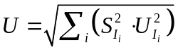 (Equation S3)
where S_{Ii} is the sensitivity of a modeled result (P_{OV} or BCF) to an input parameter predicted by QSAR tools (I_{i}), given by Eq. S4;⁷⁸ U_{Ii} is the uncertainty associated with the input parameter (I_{i}).
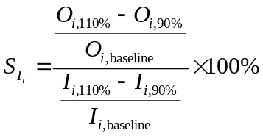 (Equation S4)
where O_{i,baseline}, O_{i,110%}, and O_{i,90%} represent the modeled result (P_{OV} or BCF) when an input parameter is assigned the QSAR predicted value (baseline), 110% the baseline, and 90% the baseline, i.e., I_{i,baseline}, I_{i,110%}, and I_{i,90%}. We perform this uncertainty analysis for a hypothetical chemical, with a K_{OA} of 10⁹, K_{OW} of 10, a rate constant of environmental reactions with OH radicals corresponding to a half-life of 10 hours, a biodegradation rate constant corresponding to a half-life of 100 hours, and a fish biotransformation rate constant corresponding to a half-life of 20 hours. These numbers are representative of the central tendencies of values of the investigated OPFRs and transformation products. Our calculation shows that the modeled P_{OV} for this hypothetical chemical is most sensitive to the biodegradation rate constant (S=2.4), followed by the rate constant of environmental reactions with OH radicals (S=0.6) and K_{AW} (S=0.3). The modeled BCF for this hypothetical chemical is most sensitive to K_{OW} (S=1.4) and minimally sensitive to the fish biotransformation rate constant (S=0.026).
According to Eq. S3, the overall uncertainty is calculated to be 118% for P_{OV} and 108% for BCF. That is, RAIDAR has the confidence to distinguish between two chemicals differing in P_{OV} with a factor of 1.18 and differing in BCF with a factor of 1.08, even if uncertainty exists in input parameters. Note that the above results are for a hypothetical chemical with all parameters being the central tendencies of the investigated OPFRs and transformation products, and the uncertainty may vary between specific chemicals. Therefore, for simplification, we use ±10% as a cut-off to determine whether there is a meaningful difference between a transformation product and its parent compound.
Supplementary references
62 Ieda, T., Hashimoto, S., Isobe, T., Kunisue, T. & Tanabe, S. Evaluation of a data-processing method for target and non-target screening using comprehensive two-dimensional gas chromatography coupled with high-resolution time-of-flight mass spectrometry for environmental samples. Talanta 194, 461-468 (2019).
63 Su, G., Letcher, R. J. & Yu, H. Organophosphate flame retardants and plasticizers in aqueous solution: pH-dependent hydrolysis, kinetics, and pathways. Environ. Sci. Technol. 50, 8103-8111 (2016).
64 Liu, Y. et al. Heterogeneous OH initiated oxidation: a possible explanation for the persistence of organophosphate flame retardants in air. Environ. Sci. Technol. 48, 1041-1048 (2014).
65 Liu, Q., Liggio, J., Li, K., Lee, P. & Li, S.M. Understanding the impact of relative humidity and coexisting soluble iron on the OH-initiated heterogeneous oxidation of organophosphate flame retardants. Environ. Sci. Technol. 53, 6794-6803 (2019).
66 Worsnop, D., Morris, J., Shi, Q., Davidovits, P. & Kolb, C. A chemical kinetic model for reactive transformations of aerosol particles. Geophys. Res. Lett. 29 (2002).
67 Liu, J., Ye, J., Chen, Y., Li, C. & Ou, H. UV-driven hydroxyl radical oxidation of tris (2-chloroethyl) phosphate: Intermediate products and residual toxicity. Chemosphere 190, 225-233 (2018).
68 Son, Y., Lee, Y.-M. & Zoh, K.D. Kinetics and degradation mechanism of tris (1-chloro-2-propyl) phosphate in the UV/H₂O₂ reaction. Chemosphere 260, 127461 (2020).
69 Miyamoto, S., Martinez, G. R., Medeiros, M. H. & Di Mascio, P. Singlet molecular oxygen generated from lipid hydroperoxides by the Russell mechanism: studies using ¹⁸O-labeled linoleic acid hydroperoxide and monomol light emission measurements. J. Am. Chem. Soc. 125, 6172-6179 (2003).
70 Yee, L. et al. Effect of chemical structure on secondary organic aerosol formation from C 12 alkanes. Atmos. Chem. Phys. 13, 11121-11140 (2013).
71 Volkamer, R. et al. OH-initiated oxidation of benzene Part I. Phenol formation under atmospheric conditions. Phys. Chem. Chem. Phys. 4, 1598-1610 (2002).
72 Liotta, L., Gruttadauria, M., Di Carlo, G., Perrini, G. & Librando, V. Heterogeneous catalytic degradation of phenolic substrates: catalysts activity. J. Hazard. Mater. 162, 588-606 (2009).
73 Reichardt, C. & Welton, T. Solvents and solvent effects in organic chemistry. (John Wiley & Sons, 2011).
74 World Health Organizaiton The WHO Recommended Classification of Pesticides by Hazard. https://www.who.int/ipcs/publications/pesticides_hazard_rev_3.pdf (WHO, 2006).
75 Mansouri, K. OPERA-model for octanol/air partition coefficient (Q17-18-0018). (QSAR Model Reporting Format (QMRF) JRC QSAR Database). (Brussels: Joint Research Centre, 2016).
76 Mansouri, K. OPERA-model for abiotic degredation in air (Q17-22b-0024). (QSAR Model Reporting Format (QMRF) JRC QSAR Database). (Brussels: Joint Research Centre, 2016).
77 Mansouri, K. OPERA-model for biodegradation half-life (Q17-23b-0022). (QSAR Model Reporting Format (QMRF) JRC QSAR Database). (Brussels: Joint Research Centre, 2016).
78 MacLeod, M., Fraser, A. & Mackay D. Evaluating and expressing the propagation of uncertainty in chemical fate and bioaccumulation models. Environ. Toxicol. Chem. 21,70-709 (2002).
79 Prinn, R. et al. Evidence for substantial variations of atmospheric hydroxyl radicals in the past two decades. Science 292, 1882-1888 (2001).

Supplementary Fig. 1 | Proposed mechanism for the photooxidation of particulate TCPP. The particulate products specifically measured by the EESI-TOFMS are indicated in the solid boxes.
Supplementary Fig. 2 | Proposed mechanism for the photooxidation of particulate EHDP. The particulate products specifically measured by the EESI-TOFMS are indicated in the solid boxes.

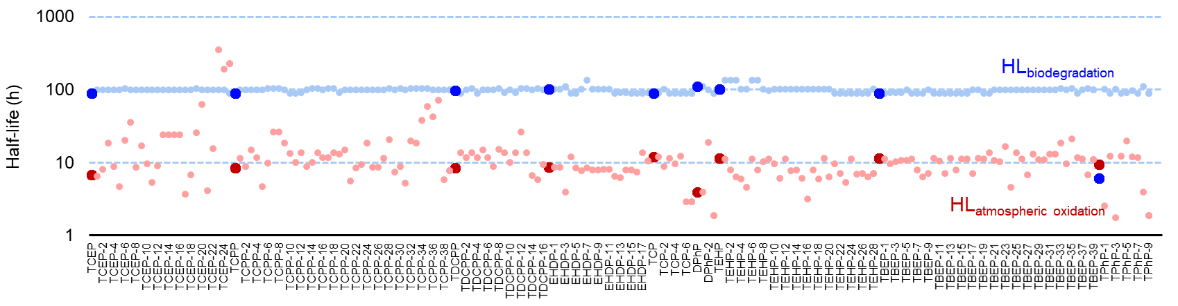
Supplementary Fig. 3 | Comparison between reaction half-lives of atmospheric photooxidation (red) and biodegradation in surface media (blue) (as an example of surface compartments) of OPFRs (dark colors) and their transformation products (light colors). Reaction half-lives were calculated based on the RAIDAR model (see Methods).
Supplementary Fig. 4 | Mass spectra of 9 unidentified OPFR transformation products in GAPS-MC samples.

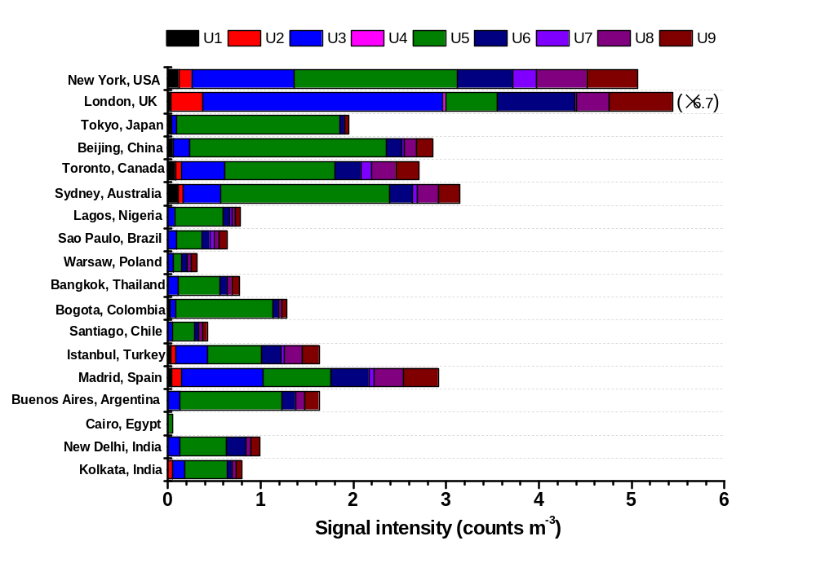Supplementary Fig. 5 | The volume normalized signal intensities of 9 unidentified OPFR transformation products (see Supplementary Table 3) in 18 megacities. For London, the signal intensity equals the value shown in the figure × 6.7.

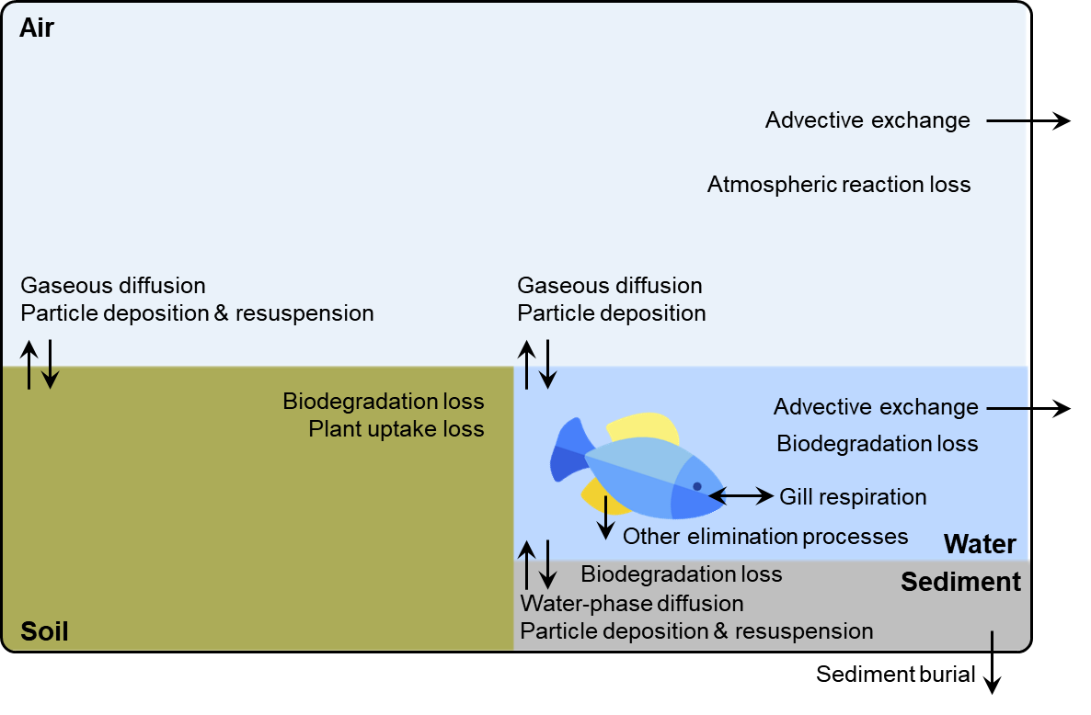
Supplementary Fig. 6 | The physical environment (compartments of air, surface water, soil, and sediment) and fish described in the RAIDAR model. Arrows indicate main processes governing chemical fate and exposure.

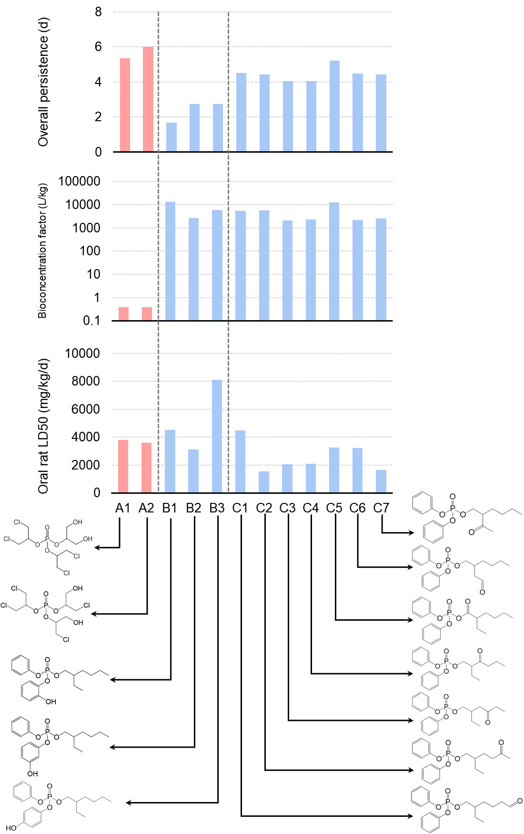
Supplementary Fig. 7 | Modelled persistence, bioaccumulation, and toxicity of positional isomers (transformation products of chlorinated OPFRs are in red; transformation products of non-chlorinated OPFRs are in blue). A1: TDCPP-9; B1: EHDP-1; C1: EHDP-9.

Supplementary Fig. 8 | The differential aerosol mass spectra for OPFRs (oxidized−unreacted) as measured by the EESI-TOF-MS: a, TCEP at an OH exposure of 9.6×10¹¹ molecules cm⁻³ s. b, TCPP at an OH exposure of 9.1×10¹¹ molecules cm⁻³ s. c, TDCPP at an OH exposure of 8.2×10¹¹ molecules cm⁻³ s. d, TBEP at an OH exposure of 3.4×10¹¹ molecules cm⁻³ s. e, TPhP at an OH exposure of 3.8×10¹¹ molecules cm⁻³ s. f, TEHP at an OH exposure of 3.1×10¹¹ molecules cm⁻³ s. Positive and negative values indicate the m/z ions that are enhanced (formed products) and reduced (degraded parent molecules) for OPFRs upon OH exposure, respectively. For clarity, the [(NaI)_{x}(CH₃CN)_{y}(H₂O)_{z}]Na⁺ clusters (x=0–3, y=0–2, z=0–2) are removed.

Supplementary Table 1 | Identified transformation products from EESI-TOFMS in the OFR photooxidation of particulate OPFR experiments.
ID | Chemical formula | M | M + Na | Proposed chemical structure
TCEP | C₆H₁₂PO₄Cl₃ | 283.95 | 306.94 | 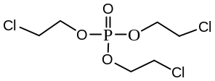
TCEP-1 | C₆H₁₃PO₅Cl₂ | 265.99 | 288.98 | 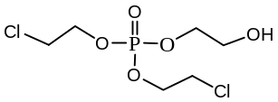
TCEP-2 | C₆H₁₁PO₅Cl₂ | 263.97 | 286.96 | 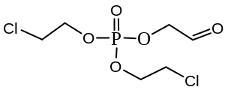
TCEP-3 | C₆H₁₁PO₆Cl₂ | 279.97 | 302.96 | 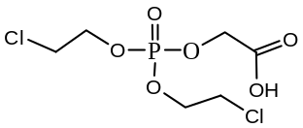
TCEP-4 | C₆H₁₂PO₆Cl | 246.01 | 269.00 | 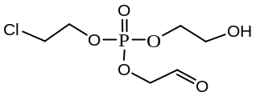
TCEP-5 | C₆H₁₀PO₆Cl | 243.99 | 266.98 | 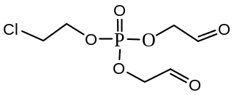
TCEP-6 | C₆H₁₀PO₇Cl | 259.99 | 282.98 | 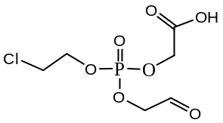
TCEP-7 | C₆H₁₀PO₈Cl | 275.98 | 298.97 | 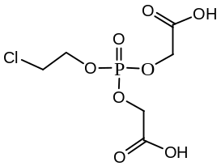
TCEP-8 | C₆H₁₂PO₆Cl₃ | 315.94 | 338.93 | 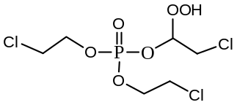
TCEP-9 | C₆H₁₀PO₅Cl₃ | 297.93 | 320.92 | 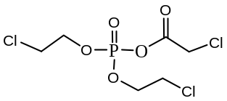
TCEP-10 | C₄H₉PO₄Cl₂ | 221.96 | 244.95 | 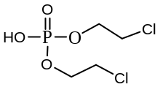
TCEP-11 | C₄H₁₀PO₅Cl | 204.00 | 226.99 | 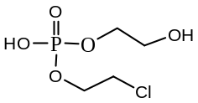
TCEP-12 | C₄H₈PO₅Cl | 201.98 | 224.97 | 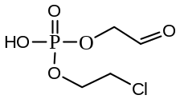
TCEP-13 | C₄H₈PO₆Cl | 217.97 | 240.96 | 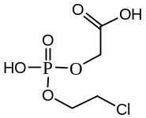
TCEP-14 | C₄H₉PO₇ | 200.01 | 223.00 | 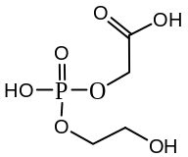
TCEP-15 | C₄H₇PO₇ | 197.99 | 220.98 | 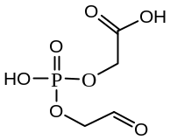
TCEP-16 | C₄H₇PO₅Cl₂ | 235.94 | 258.93 | 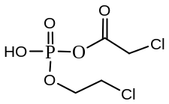
TCEP-17 | C₄H₉PO₅Cl₂ | 237.96 | 260.95 | 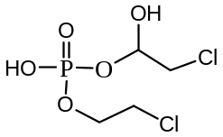
TCEP-18 | C₄H₉PO₆Cl₂ | 253.95 | 276.94 | 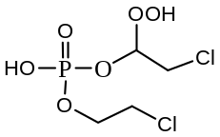
TCEP-19 | C₄H₇PO₇Cl₂ | 267.93 | 290.92 | 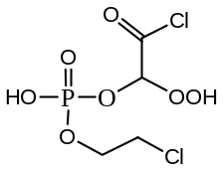
TCEP-20 | C₃H₆PO₅Cl | 187.96 | 210.95 | 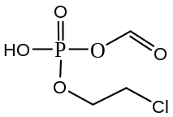
TCEP-21 | C₂H₆PO₄Cl | 159.97 | 182.96 | 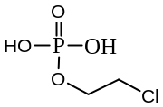
TCEP-22 | C₂H₅PO₅ | 139.99 | 162.98 | 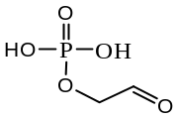
TCEP-23 | C₂H₅PO₆ | 155.98 | 178.97 | 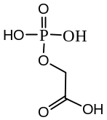
TCEP-24 | C₂H₄PO₅Cl | 173.95 | 196.94 | 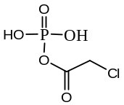
TCEP-25 | CH₃PO₅ | 125.97 | 148.96 | 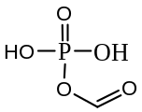
TCPP | C₉H₁₈PO₄Cl₃ | 326.00 | 348.99 | 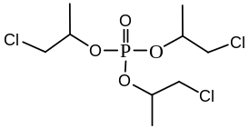
TCPP-1 | C₉H₁₉PO₅Cl₂ | 308.03 | 331.02 | 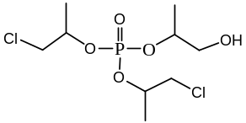
TCPP-2 | C₉H₁₇PO₅Cl₂ | 306.02 | 329.01 | 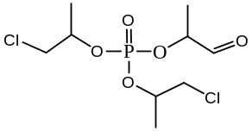
TCPP-3 | C₉H₁₇PO₆Cl₂ | 322.01 | 345.00 | 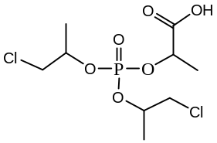
TCPP-4 | C₉H₂₀PO₆Cl | 290.07 | 313.06 | 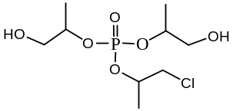
TCPP-5 | C₉H₁₆PO₆Cl | 286.04 | 309.03 | 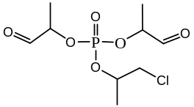
TCPP-6 | C₉H₁₆PO₇Cl | 302.03 | 325.02 | 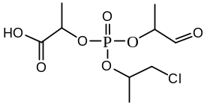
TCPP-7 | C₉H₁₆PO₈Cl | 318.03 | 341.02 | 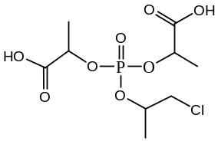
TCPP-8 | C₉H₁₇PO₉ | 300.06 | 323.05 | 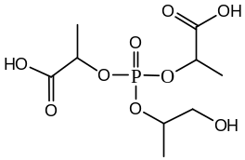
TCPP-9 | C₉H₁₅PO₉ | 298.05 | 321.04 | 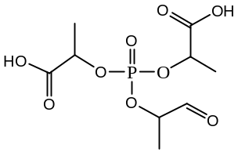
TCPP-10 | C₉H₁₈PO₆Cl₃ | 357.99 | 380.98 | 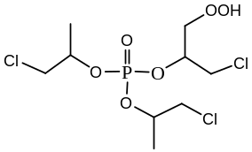
TCPP-11 | C₉H₁₇PO₇Cl₂ | 338.01 | 361.00 | 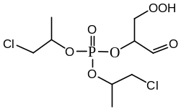
TCPP-12 | C₉H₁₇PO₈Cl₂ | 354.00 | 376.99 | 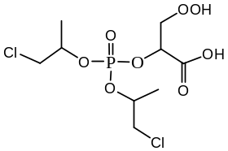
TCPP-13 | C₉H₁₆PO₅Cl₃ | 339.98 | 362.97 | 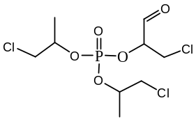
TCPP-14 | C₉H₁₇PO₆Cl₂ | 322.01 | 345.00 | 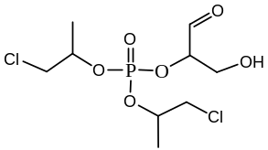
TCPP-15 | C₉H₁₅PO₇Cl₂ | 335.99 | 358.98 | 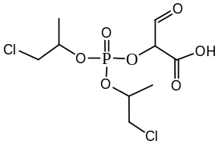
TCPP-16 | C₉H₁₈PO₅Cl₃ | 342.00 | 364.99 | 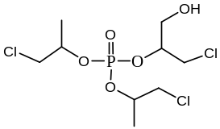
TCPP-17 | C₉H₁₉PO₆Cl₂ | 324.03 | 347.02 | 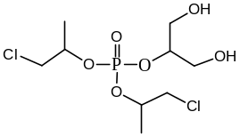
TCPP-18 | C₉H₁₇PO₇Cl₂ | 338.01 | 361.00 | 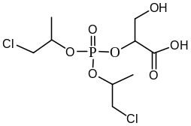
TCPP-19 | C₉H₁₆PO₇Cl₃ | 371.97 | 394.96 | 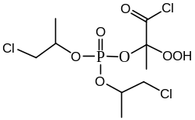
TCPP-20 | C₈H₁₅PO₅Cl₂ | 292.00 | 314.99 | 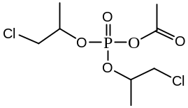
TCPP-21 | C₆H₁₃PO₄Cl₂ | 249.99 | 272.98 | 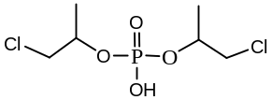
TCPP-22 | C₆H₁₄PO₅Cl | 232.03 | 255.02 | 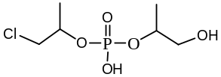
TCPP-23 | C₆H₁₂PO₅Cl | 230.01 | 253.00 | 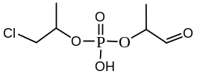
TCPP-24 | C₆H₁₂PO₆Cl | 246.01 | 269.00 | 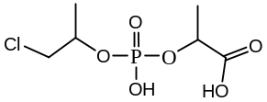
TCPP-25 | C₆H₁₃PO₅Cl₂ | 265.99 | 288.98 | 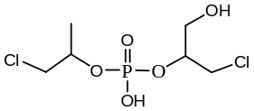
TCPP-26 | C₆H₁₄PO₆Cl | 248.02 | 271.01 | 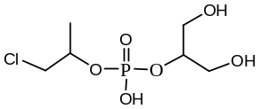
TCPP-27 | C₆H₁₃PO₆Cl₂ | 281.98 | 304.97 | 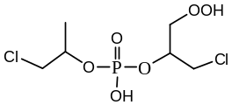
TCPP-28 | C₆H₁₂PO₈Cl | 278.00 | 300.99 | 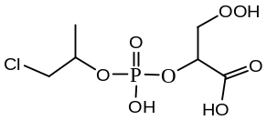
TCPP-29 | C₆H₁₁PO₅Cl₂ | 263.97 | 286.96 | 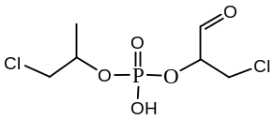
TCPP-30 | C₆H₁₂PO₆Cl | 246.01 | 269.00 | 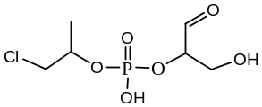
TCPP-31 | C₆H₁₀PO₆Cl | 243.99 | 266.98 | 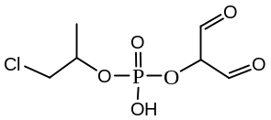
TCPP-32 | C₆H₁₀PO₇Cl | 259.99 | 282.98 | 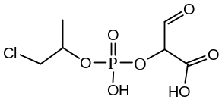
TCPP-33 | C₅H₁₁PO₇ | 214.02 | 237.01 | 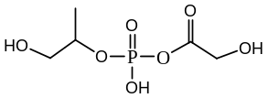
TCPP-34 | C₅H₉PO₇ | 212.01 | 235.00 | 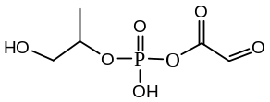
TCPP-35 | C₅H₉PO₈ | 228.00 | 250.99 | 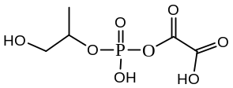
TCPP-36 | C₅H₇PO₈ | 225.99 | 248.98 | 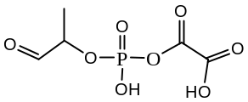
TCPP-37 | C₅H₇PO₉ | 241.98 | 264.97 | 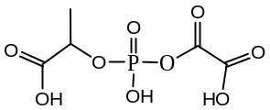
TCPP-38 | C₃H₈PO₄Cl | 173.98 | 196.97 | 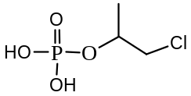
TCPP-39 | C₃H₆PO₅Cl | 187.96 | 210.95 | 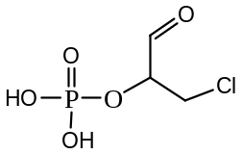
TDCPP | C₉H₁₅PO₄Cl₆ | 427.88 | 450.87 | 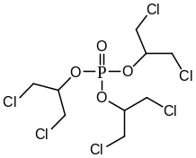
TDCPP-1 | C₉H₁₅PO₆Cl₆ | 459.87 | 482.86 | 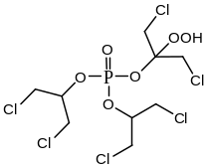
TDCPP-2 | C₉H₁₅PO₅Cl₆ | 443.88 | 466.87 | 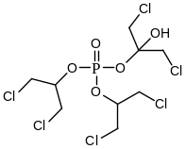
TDCPP-3 | C₉H₁₃PO₅Cl₆ | 441.86 | 464.85 | 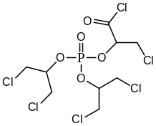
TDCPP-4 | C₉H₁₆PO₆Cl₅ | 425.91 | 448.90 | 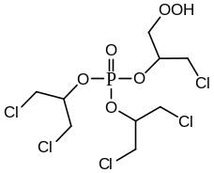
TDCPP-5 | C₉H₁₄PO₆Cl₅ | 423.90 | 446.89 | 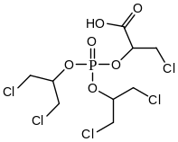
TDCPP-6 | C₉H₁₆PO₅Cl₅ | 409.92 | 432.91 | 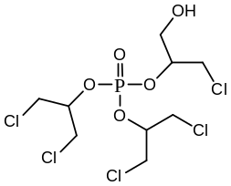
TDCPP-7 | C₉H₁₄PO₅Cl₅ | 407.90 | 430.89 | 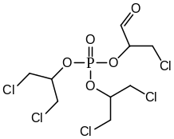
TDCPP-8 | C₈H₁₂PO₅Cl₅ | 393.89 | 416.88 | 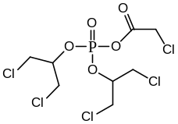
TDCPP-9 | C₉H₁₇PO₆Cl₄ | 391.95 | 414.94 | 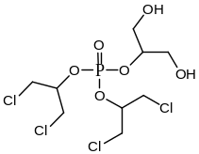
TDCPP-10 | C₉H₁₅PO₆Cl₄ | 389.94 | 412.93 | 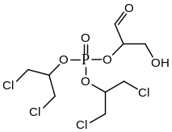
TDCPP-11 | C₉H₁₉PO₈Cl₂ | 356.02 | 379.01 | 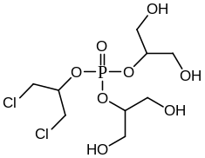
TDCPP-12 | C₈H₁₃PO₉Cl₂ | 353.97 | 376.96 | 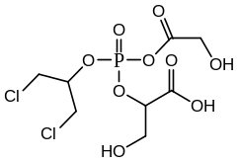
TDCPP-13 | C₈H₁₅PO₈Cl₂ | 339.99 | 362.98 | 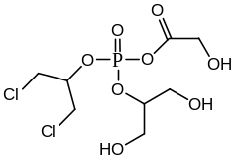
TDCPP-14 | C₆H₁₁PO₄Cl₄ | 317.91 | 340.90 | 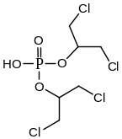
TDCPP-15 | C₉H₁₅PO₁₀ | 314.04 | 337.03 | 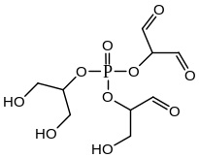
TDCPP-16 | C₆H₁₀PO₅Cl₃ | 297.93 | 320.92 | 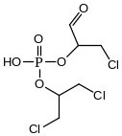
TBEP | C₁₈H₃₉PO₇ | 398.24 | 421.23 | 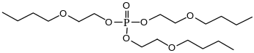
TBEP-1 | C₁₈H₃₉PO₁₁ | 462.22 | 485.21 | 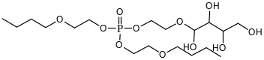
TBEP-2 | C₁₈H₃₇PO₁₁ | 460.21 | 483.20 | 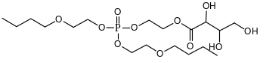
TBEP-3 | C₁₈H₃₅PO₁₁ | 458.19 | 481.18 | 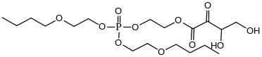
TBEP-4 | C₁₈H₃₃PO₁₁ | 456.18 | 479.17 | 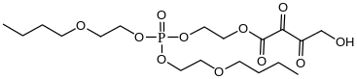
TBEP-5 | C₁₈H₃₁PO₁₁ | 454.16 | 477.15 | 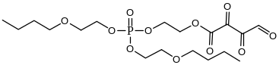
TBEP-6 | C₁₈H₃₉PO₁₀ | 446.23 | 469.22 | 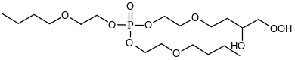
TBEP-7 | C₁₈H₃₇PO₁₀ | 444.21 | 467.20 | 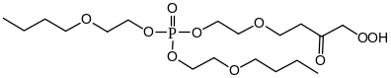
TBEP-8 | C₁₈H₃₅PO₁₀ | 442.20 | 465.19 | 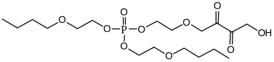
TBEP-9 | C₁₈H₃₃PO₁₀ | 440.18 | 463.17 | 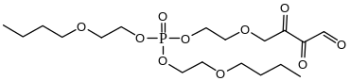
TBEP-10 | C₁₈H₃₉PO₉ | 430.23 | 453.22 | 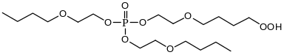
TBEP-11 | C₁₈H₃₇PO₉ | 428.22 | 451.21 | 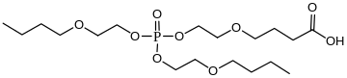
TBEP-12 | C₁₈H₃₅PO₉ | 426.20 | 449.19 | 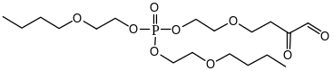
TBEP-13 | C₁₈H₃₉PO₈ | 414.24 | 437.23 | 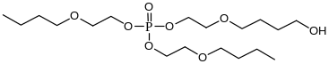
TBEP-14 | C₁₈H₃₇PO₈ | 412.22 | 435.21 | 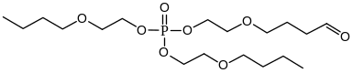
TBEP-15 | C₁₅H₃₁PO₁₀ | 402.17 | 425.16 | 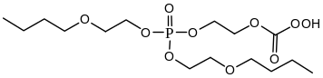
TBEP-16 | C₁₅H₃₁PO₉ | 386.17 | 409.16 | 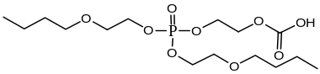
TBEP-17 | C₁₅H₂₉PO₉ | 384.16 | 407.15 | 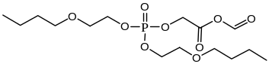
TBEP-18 | C₁₅H₃₃PO₈ | 372.19 | 395.18 | 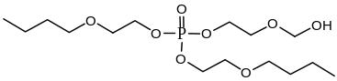
TBEP-19 | C₁₅H₃₁PO₈ | 370.18 | 393.17 | 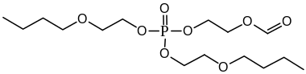
TBEP-20 | C₁₄H₃₁PO₈ | 358.18 | 381.17 | 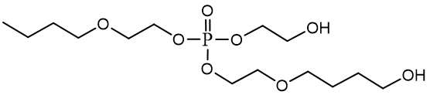
TBEP-21 | C₁₂H₂₃PO₁₀ | 358.10 | 381.09 | 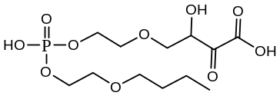
TBEP-22 | C₁₄H₂₉PO₈ | 356.16 | 379.15 | 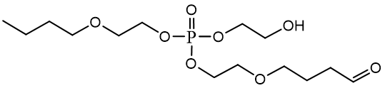
TBEP-23 | C₁₂H₂₁PO₁₀ | 356.08 | 379.07 | 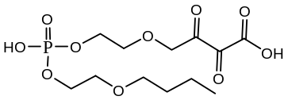
TBEP-24 | C₁₃H₂₃PO₉ | 354.11 | 377.10 | 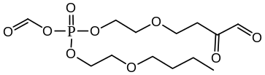
TBEP-25 | C₁₃H₂₉PO₈ | 344.16 | 367.15 | 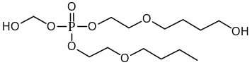
TBEP-26 | C₁₃H₂₇PO₈ | 342.14 | 365.13 | 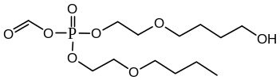
TBEP-27 | C₁₃H₂₅PO₈ | 340.13 | 363.12 | 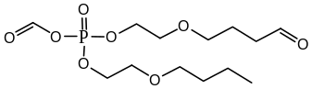
TBEP-28 | C₁₁H₂₃PO₉ | 330.11 | 353.10 | 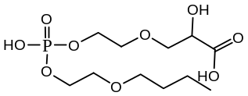
TBEP-29 | C₁₁H₂₁PO₉ | 328.09 | 351.08 | 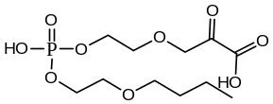
TBEP-30 | C₁₃H₂₇PO₇ | 326.15 | 349.14 | 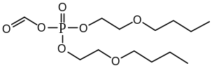
TBEP-31 | C₁₀H₂₁PO₉ | 316.09 | 339.08 | 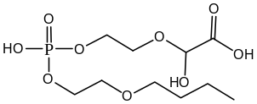
TBEP-32 | C₁₁H₂₃PO₈ | 314.11 | 337.10 | 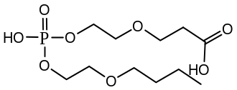
TBEP-33 | C₉H₁₅PO₁₀ | 314.04 | 337.03 | 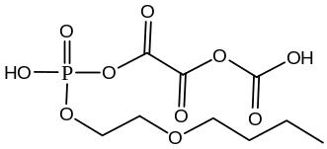
TBEP-34 | C₁₂H₂₅PO₇ | 312.13 | 335.12 | 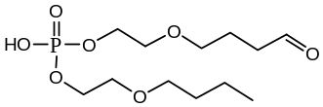
TBEP-35 | C₁₀H₁₇PO₉ | 312.06 | 335.05 | 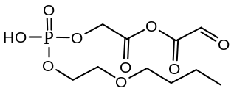
TBEP-36 | C₁₂H₂₇PO₆ | 298.15 | 321.14 | 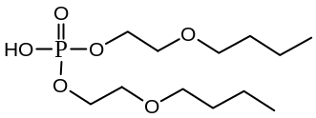
TBEP-37 | C₉H₁₉PO₈ | 286.08 | 309.07 | 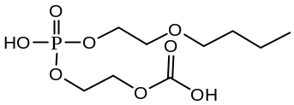
TBEP-38 | C₉H₁₇PO₈ | 284.07 | 307.06 | 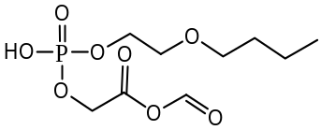
TBEP-39 | C₉H₁₉PO₇ | 270.09 | 293.08 | 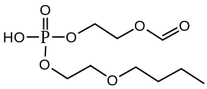
TPhP | C₁₈H₁₅PO₄ | 326.07 | 349.06 | 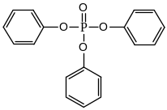
TPhP-1 | C₁₈H₁₇PO₇ | 376.07 | 399.06 | 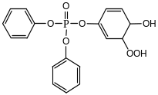
TPhP-2 | C₁₈H₁₅PO₇ | 374.06 | 397.05 | 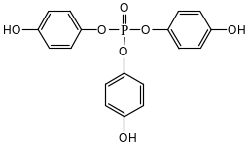
TPhP-3 | C₁₈H₁₇PO₆ | 360.08 | 383.07 | 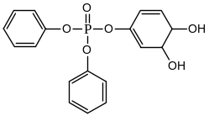
TPhP-4 | C₁₈H₁₅PO₆ | 358.06 | 381.05 | 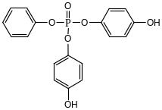
TPhP-5 | C₁₈H₁₃PO₆ | 356.05 | 379.04 | 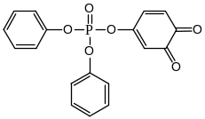
TPhP-6 | C₁₈H₁₅PO₅ | 342.07 | 365.06 | 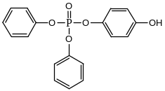
TPhP-7 | C₁₂H₁₁PO₅ | 266.03 | 289.02 | 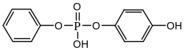
TPhP-8 | C₁₂H₁₁PO₄ | 250.04 | 273.03 | 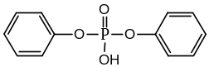
TPhP-9 | C₆H₇PO₄ | 174.01 | 197.00 | 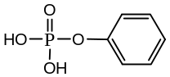
EHDP | C₂₀H₂₇PO₄ | 362.16 | 385.15 | 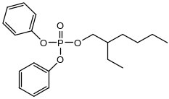
EHDP-1 | C₂₀H₂₇PO₅ | 378.16 | 401.15 | 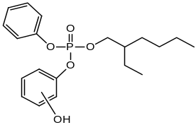
EHDP-2 | C₂₀H₂₇PO₆ | 394.16 | 417.14 | 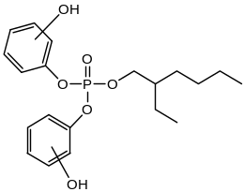
EHDP-3 | C₁₂H₁₁PO₄ | 250.04 | 273.03 | 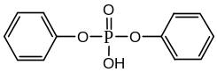
EHDP-4 | C₁₄H₂₃PO₄ | 286.13 | 309.12 | 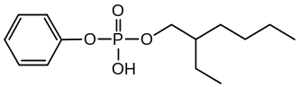
EHDP-5 | C₂₀H₂₇PO₆ | 394.15 | 417.14 | 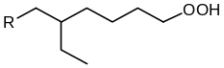  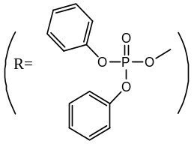
EHDP-6 | C₂₀H₂₅PO₇ | 408.13 | 431.12 | 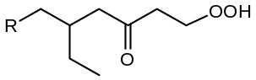
EHDP-7 | C₂₀H₂₇PO₇ | 410.15 | 433.14 | 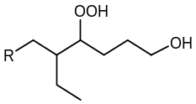
EHDP-8 | C₂₀H₂₅PO₆ | 392.14 | 415.13 | 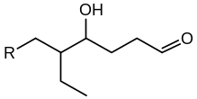
EHDP-9 | C₂₀H₂₅PO₅ | 376.14 | 399.13 | 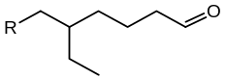
EHDP-10 | C₂₀H₂₅PO₆ | 392.14 | 415.13 | 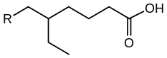
EHDP-11 | C₂₀H₂₅PO₇ | 408.13 | 431.12 | 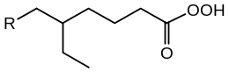
EHDP-12 | C₁₆H₁₇PO₅ | 320.08 | 343.07 | 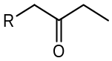
EHDP-13 | C₁₇H₁₉PO₅ | 334.10 | 357.09 | 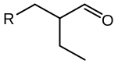
EHDP-14 | C₁₈H₂₁PO₅ | 348.11 | 371.10 | 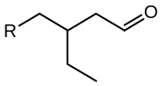
EHDP-15 | C₁₆H₁₇PO₇ | 352.07 | 375.06 | 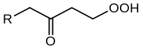
EHDP-16 | C₁₄H₁₃PO₅ | 292.05 | 315.04 | 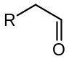
EHDP-17 | C₁₄H₁₃PO₆ | 308.05 | 331.04 | 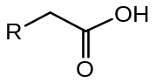
EHDP-18 | C₁₇H₁₉PO₆ | 350.09 | 373.08 | 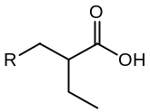
a | C₃H₄O₄ | 104.01 | 127.00 | 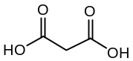
b | C₄H₆O₄ | 118.03 | 141.02 | 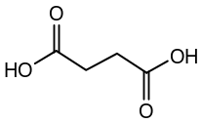
TCP | C₂₁H₂₁PO₄ | 368.12 | 391.11 | 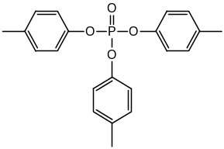
TCP-1 | C₂₁H₂₁PO₅ | 384.44 | 407.10 | 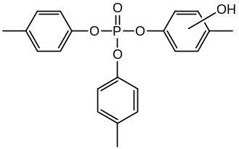
TCP-2 | C₂₁H₂₁PO₅ | 384.44 | 407.10 | 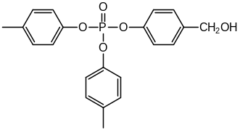
TCP-3 | C₂₁H₁₉PO₅ | 382.10 | 405.09 | 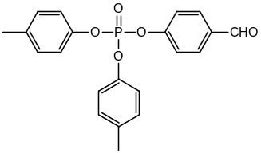
TCP-4 | C₁₆H₁₅PO₆ | 334.06 | 357.05 | 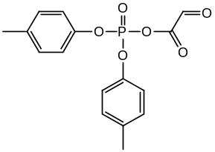
TCP-5 | C₁₄H₁₅PO₄ | 278.07 | 301.06 | 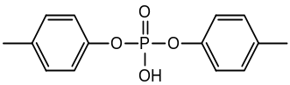
TCP-6 | C₇H₉PO₄ | 188.02 | 211.01 | 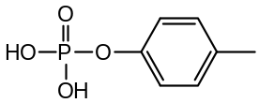
TCP-7 | C₇H₉PO₅ | 204.02 | 227.01 | 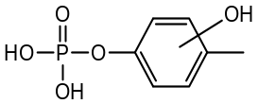
TEHP | C₂₄H₅₁PO₄ | 434.35 | 457.34 | 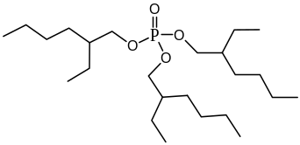
TEHP-1 | C₂₄H₅₁PO₈ | 498.33 | 521.32 | 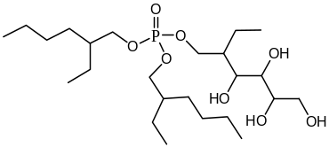
TEHP-2 | C₂₄H₄₉PO₈ | 496.32 | 519.31 | 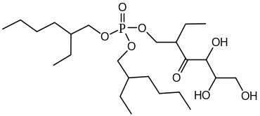
TEHP-3 | C₂₄H₄₇PO₈ | 494.30 | 517.29 | 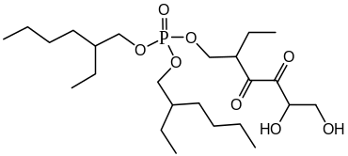
TEHP-4 | C₂₄H₄₅PO₈ | 492.29 | 515.27 | 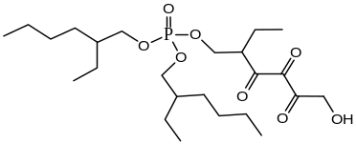
TEHP-5 | C₂₄H₄₃PO₈ | 490.27 | 513.26 | 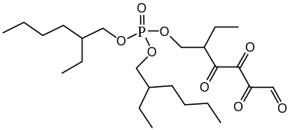
TEHP-6 | C₂₄H₅₁PO₇ | 482.34 | 505.33 | 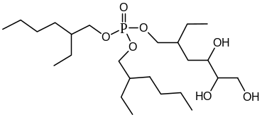
TEHP-7 | C₂₄H₄₉PO₇ | 480.32 | 503.31 | 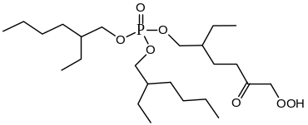
TEHP-8 | C₂₄H₄₇PO₇ | 478.31 | 501.30 | 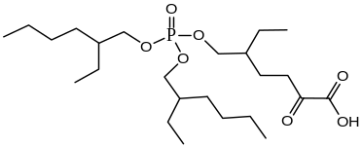
TEHP-9 | C₂₄H₅₁PO₆ | 466.34 | 489.33 | 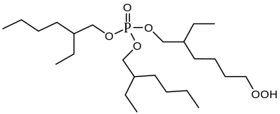
TEHP-10 | C₂₄H₄₉PO₆ | 464.33 | 487.32 | 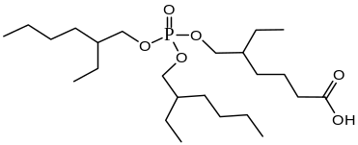
TEHP-11 | C₂₄H₄₇PO₆ | 462.31 | 485.30 | 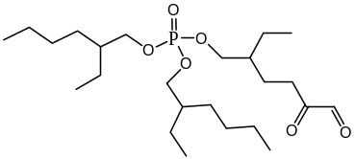
TEHP-12 | C₂₄H₅₁PO₅ | 450.35 | 473.34 | 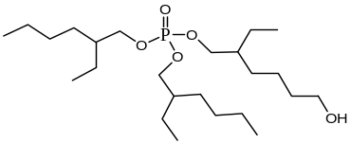
TEHP-13 | C₂₄H₄₉PO₅ | 448.33 | 471.32 | 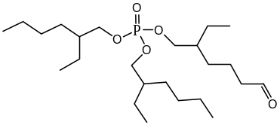
TEHP-14 | C₂₀H₄₁PO₇ | 424.26 | 447.25 | 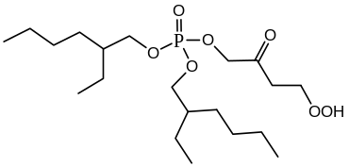
TEHP-15 | C₂₀H₃₉PO₇ | 422.24 | 445.23 | 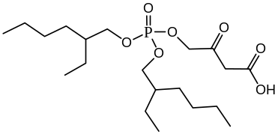
TEHP-16 | C₂₁H₄₁PO₆ | 420.26 | 443.25 | 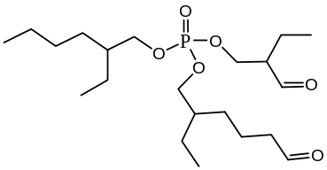
TEHP-17 | C₂₀H₄₁PO₆ | 408.26 | 431.25 | 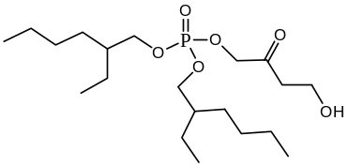
TEHP-18 | C₂₀H₃₉PO₆ | 406.25 | 429.24 | 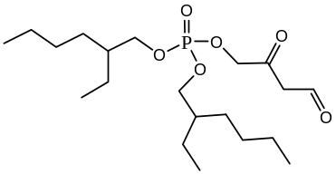
TEHP-19 | C₂₀H₄₃PO₅ | 394.29 | 417.28 | 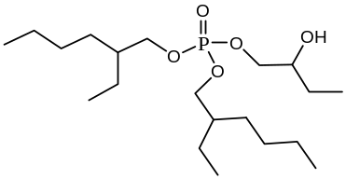
TEHP-20 | C₂₀H₄₁PO₅ | 392.27 | 415.26 | 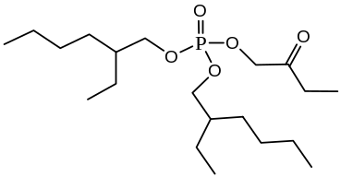
TEHP-21 | C₁₇H₃₅PO₇ | 382.21 | 405.20 | 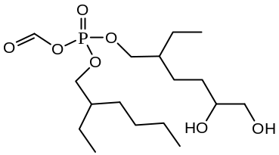
TEHP-22 | C₁₇H₃₃PO₇ | 380.20 | 403.19 | 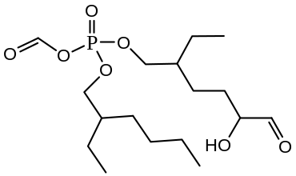
TEHP-23 | C₁₇H₃₁PO₇ | 378.18 | 401.17 | 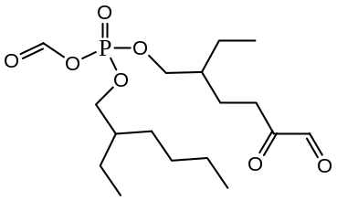
TEHP-24 | C₁₇H₃₅PO₆ | 366.22 | 389.21 | 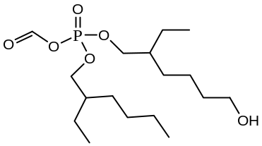
TEHP-25 | C₁₇H₃₃PO₆ | 364.20 | 387.19 | 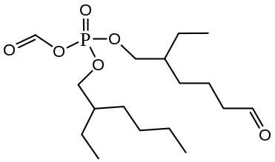
TEHP-26 | C₁₆H₃₁PO₆ | 350.19 | 373.18 | 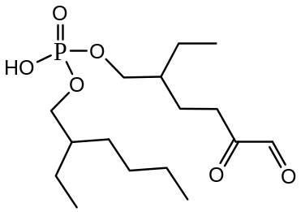
TEHP-27 | C₁₆H₃₃PO₅ | 336.21 | 359.20 | 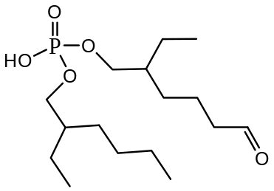
TEHP-28 | C₁₆H₃₁PO₅ | 334.19 | 357.18 | 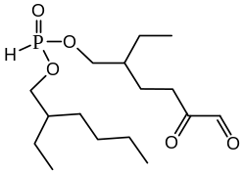
DPhP | C₁₂H₁₁PO₄ | 250.04 | 273.03 | 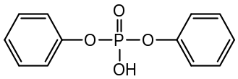
DPhP-1 | C₁₂H₁₁PO₅ | 266.03 | 289.02 | 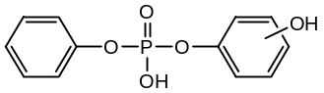
DPhP-2 | C₈H₇PO₆ | 230.00 | 252.99 | 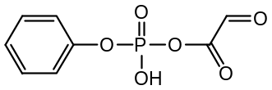
DPhP-3 | C₆H₇PO₄ | 174.01 | 197.00 | 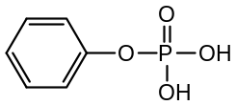
Note that these identified products could have isomers which are not shown in this table and EESI-TOFMS is unable to distinguish the isomers from each other.

Supplementary Table 2 | Detailed information for 27 identified OPFR transformation products in GAPS-MC and OFR samples.
ID | Chemical formulaª | Retention time (min) | Measured m/z | Isotopic pattern^{b} | Uncertainty (ppm) | Samples detected in
TCEP-1^{c} | C₆H₁₃PO₅Cl₂ | 1.975 | 266.999 | ★ | 11.648 | GAPS & OFR
TCEP-2^{c} | C₆H₁₁PO₅Cl₂ | 2.171 | 264.981 | ★ | 4.000 | OFR
TCEP-5 | C₆H₁₀PO₆Cl | 1.597 | 244.997 | ★ | -4.816 | OFR
TCEP-10 | C₄H₉PO₄Cl₂ | 2.171 | 222.969 | ★ | -2.601 | GAPS & OFR
TCEP-12 | C₄H₈PO₅Cl | 2.806 | 202.986 | ★ | -7.932 | OFR
TCEP-19 | C₄H₇PO₇Cl₂ | 2.342 | 268.935 | ★ | -12.903 | OFR
TCEP-21 | C₂H₆PO₄Cl | 2.167 | 160.976 | ★ | -9.007 | GAPS & OFR
TCEP-22 | C₂H₅PO₅ | 2.168 | 140.996 | ● | 5.036 | OFR
TCPP-2 | C₉H₁₇PO₅Cl₂ | 2.242 | 307.024 | ★ | -9.413 | OFR
TCPP-7 | C₉H₁₆PO₈Cl | 3.195 | 319.032 | ★ | 9.278 | OFR
TCPP-9 | C₉H₁₅PO₉ | 1.975 | 299.058 | ● | 15.750 | GAPS & OFR
TCPP-20 | C₈H₁₅PO₅Cl₂ | 2.806 | 293.008 | ★ | 11.058 | OFR
TCPP-21 | C₆H₁₃PO₄Cl₂ | 2.249 | 250.998 | ★ | -9.482 | GAPS & OFR
TCPP-23 | C₆H₁₂PO₅Cl | 2.242 | 231.018 | ★ | 3.939 | OFR
TCPP-25^{c} | C₆H₁₃PO₅Cl₂ | 1.975 | 266.999 | ★ | 11.648 | GAPS & OFR
TCPP-29^{c} | C₆H₁₁PO₅Cl₂ | 2.171 | 264.981 | ★ | 4.000 | OFR
TCPP-31 | C₆H₁₀PO₆Cl | 2.164 | 245.000 | ★ | 7.429 | OFR
TCPP-38 | C₃H₈PO₄Cl | 2.250 | 174.993 | ★ | 0.571 | GAPS & OFR
TDCPP-1 | C₉H₁₅PO₆Cl₆ | 3.391 | 459.876 | ★ | 4.914 | OFR
TDCPP-2 | C₉H₁₅PO₅Cl₆ | 3.391 | 444.895 | ★ | 18.769 | OFR
TDCPP-4 | C₉H₁₆PO₆Cl₅ | 2.168 | 426.925 | ★ | 10.447 | OFR
TDCPP-5 | C₉H₁₄PO₆Cl₅ | 3.027 | 423.904 | ★ | 16.372 | OFR
TDCPP-9 | C₉H₁₇PO₆Cl₄ | 2.460 | 391.952 | ★ | 0.791 | OFR
TDCPP-14 | C₆H₁₁PO₄Cl₄ | 3.391 | 318.923 | ★ | -0.721 | GAPS & OFR
TBEP-36 | C₁₂H₂₇PO₆ | 3.565 | 299.164 | ● | 5.515 | GAPS & OFR
TPhP-6 | C₁₈H₁₅PO₅ | 3.516 | 342.065 | ● | -1.491 | GAPS & OFR
TPhP-8 | C₁₂H₁₁PO₄ | 3.590 | 251.047 | ● | -1.673 | GAPS & OFR
ª Chemical structures are shown in Supplementary Table 1. ^{b} ★: Products were identified based upon retention times, m/z peaks, and isotopic patterns; ●: Products were identified based upon retention time, and m/z peaks. ^{c} TECP-1 and TCPP-25 are isomers, and TCEP-2 TCPP-29 are isomers.

Supplementary Table 3 | Detailed information for 9 unidentified OPFR transformation products in GAPS-MC field samples.
ID | Retention time (min) | Measured m/z | Posssible formulaª | Uncertainty (ppm) | Detection frequency (%) | Volume normalized signal intensity (counts m^{–3})^{b}
U₁ | 2.167 | 313.952 | C₇H₁₃PO₅Cl₃ | -40.45 | 50 | ND–0.12
U₂ | 2.249 | 279.989 | C₆H₁₁PO₆Cl₂ | 79.90 | 39 | ND–2.31
U₃ | 2.249 | 355.999 | C₁₀H₂₀PO₅Cl₃ | -35.66 | 94 | ND–17.23
U₄ | 2.250 | 371.992 | C₉H₁₆PO₇Cl₃ | 68.50 | 6 | ND–0.20
U₅ | 2.167 | 248.983 | C₆H₁₁PO₄Cl₂ | -6.95 | 100 | 0.05–3.74
U₆ | 2.249 | 215.025 | C₆H₁₂PO₄Cl | 4.65 | 94 | ND–5.55
U₇ | 3.383 | 457.882 | C₉H₁₃PO₆Cl₆ | 53.10 | 50 | ND–0.25
U₈ | 2.249 | 277.016 | C₈H₁₅PO₄Cl₂ | -1.08 | 89 | ND–2.38
U₉ | 2.249 | 291.029 | C₉H₁₇PO₄Cl₂ | -9.88 | 94 | ND–4.55
ª The proposed chemical formula of U₁–U₄ and U₇ is less certain (mass uncertainty > 20 ppm). ^{b} ND: Not detected.

Supplementary Table 4 | Detection frequency and volume normalized signal intensity of 11 identified OPFR transformation products in GAPS-MC samples.
ID | Detection frequency (%) | Volume normalized signal intensity (counts m^{–3})ª
TCEP-1 or TCPP-25 | 100 | 0.37–9.60
TCEP-10 | 100 | 0.26–14.0
TCEP-21 | 100 | 0.14–8.38
TCPP-9 | 100 | 0.06–1.54
TCPP-21 | 100 | 0.12–17.12
TCPP-38 | 100 | 0.11–14.95
TDCPP-14 | 94 | ND–7.09
TBEP-36 | 94 | ND–2.66
TPhP-6 | 100 | 0.03–2.07
TPhP-8 | 100 | 0.15–10.94
ª Volume normalized signal intensity = signal intensity of a species/sampling volume. ND: not detected.

Supplementary Table 5 | Comparison between model predictions and experimental observations for bioconcentration factor and oral rat LD50 of selected parent OPFRs.
Chemical | Bioconcentration factor (L/kg) |  | Oral rat LD50 (mg/kg/d)
Chemical | Prediction | Observation | Prediction | Observation
TCEP | 2.7 | 1–4.2 (1) | 318 | 1230 (5)
TCPP | 27 | 2.5–5.4 (1)  6.5–63 (2) | 532 | 1500 (5)
TDCPP | 311 | 6.3–35 (1)  14–83 (2)  18–66 (3) | 626 | 1851 (5)
TBEP | 390 | N.A. | 6497 | 3002 (5)
TPhP | 532 | 2.3–60.6 (1)  40–169 (2)  45–224 (3)  561–573 (4) | 2369 | 3496 (5)
EHDP | 2.8×10⁵ | 3.5–78.4 (1) | 4513 | N.A.
TCP | 8700 | 79–252 (2)  56–364 (3)  140–928(4) | 2005 | N.A.
TEHP | 1200 | 149–528 (2) | 2.6×10⁵ | 3.7×10⁵ (5)
DPhP | 3.5 | N.A. | 1828 | N.A.
Note: N.A. = Not available
(1) Values taken from Tang et al. (reference 49) for different tissues (muscle, liver, gonad, brain, gill, kidney, intestine, and serum) of common carp.
(2) Values taken from Bekele et al. (reference 50) for different tissues (intestine, liver, kidney, and muscle) of common carp.
(3) Values taken from Wang et al. (reference 51) for different tissues (intestine, liver, roe, brain, muscle, and gill) of zebrafish.
(4) Values taken from Muir et al. (reference 52) for rainbow trout and fathead minnows.
(5) Values taken from the training set of the TEST model.⁵⁷

Supplementary Table 6 | Predicted residence time of OPFRs in the atmosphere.
OPFR | k (×10^{–12} cm³ molecule⁻¹ s⁻¹) |  | Atmospheric residence time (h) (3)
OPFR |  |  |  | Particle concentration = 30 μg/m³ |  | Particle concentration = 300 μg/m³
OPFR | Particulate (1) | Gaseous (2) | Gaseous | Both | Change (gaseous/both) | Both | Change (gaseous/both)
TCEP | 0.72±0.10 | 29.0 | 9.9 | 9.9 | 1.0 | 9.9 | 1.0
TCPP | 0.88±0.09 | 23.5 | 12.2 | 12.2 | 1.0 | 12.3 | 1.0
TDCPP | 0.92±0.09 | 23.3 | 12.7 | 12.7 | 1.0 | 16.4 | 1.0
TBEP | 3.06±0.40 | 17.3 | 33.4 | 28.3 | 1.2 | 66.0 | 2.8
TPhP | 2.10±0.19 | 21.2 | 15.1 | 14.9 | 1.0 | 26.5 | 1.1
EHDP | 1.12±0.22 | 22.7 | 25.3 | 24.1 | 1.0 | 93.3 | 1.5
TCP | 2.75±0.38 | 16.5 | 34.1 | 29.4 | 1.2 | 70.8 | 2.6
TEHP | 2.70±0.63 | 17.4 | 31.8 | 27.8 | 1.1 | 69.5 | 2.5
DPhP | 2.33±0.14 | 50.8 | 6.3 | 6.2 | 1.0 | 11.3 | 1.1
“Gaseous”: assuming photooxidation occurs in the gas-phase only, i.e., photooxidation rate constant is 0 in the particle-phase. the column “gaseous”. “Both”: assuming photooxidation occurs in both gas- and particle-phases. Note: (1) Measured in this work; (2) Predicted using OPERA (see Methods); (3) Calculated using the global weighted-average lower atmospheric OH concentration of 9.7×10⁵ molecule cm⁻³.⁷⁹

