Table. 2 Key chemical structures of secondary compounds have been identified in Eucalyptus hybrids.
Compounds | Structure | Compounds | Structure
α-Pinene | 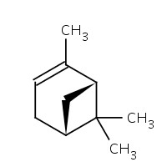 | Pinocarvone | 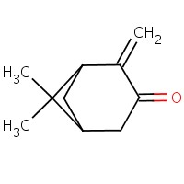
Camphene | 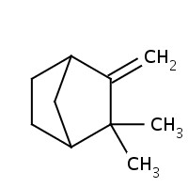 | Borneol | 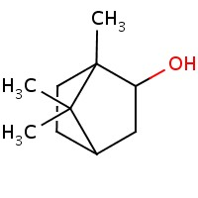
β-Pinene | 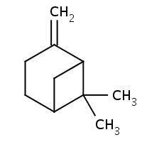 | α-Terpineol | 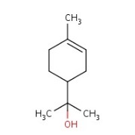
α-Phellandrene | 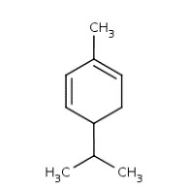 | γ-Terpineol | 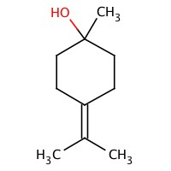
Isoamyl Isobutyrate | 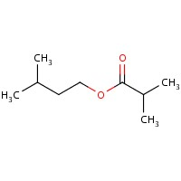 | (Z)-Carveol | 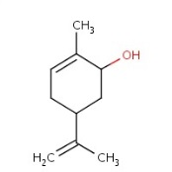
1,8 Cineol | 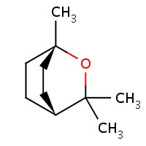 | α-Terpinyl acetate | 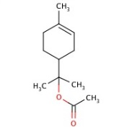
Y-Terpinene | 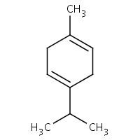 | (E)-Caryophyllene | 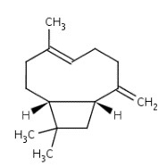
Source: Dantas 2019; Mohamed 2016; Naidoo et al. 2018

