Supplementary Material

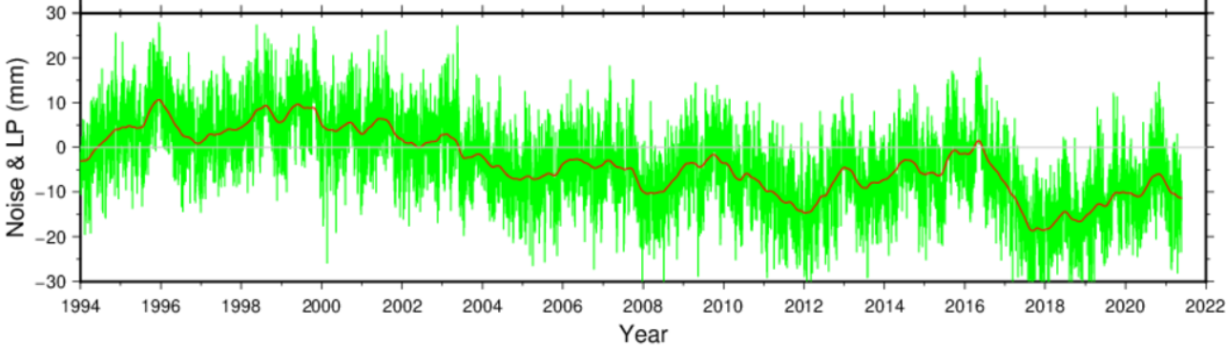
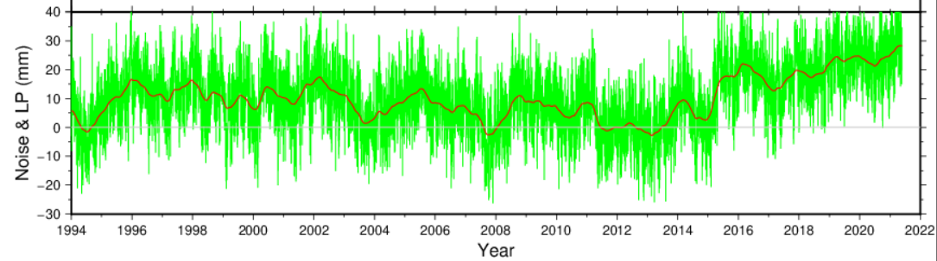
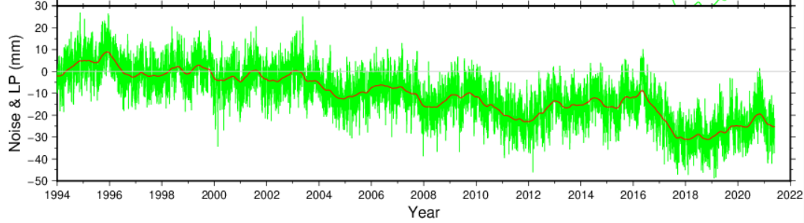
Figure S1: Examples of simulated noise time series (Top) Stationary colored noise consisting of 2.7 mm of white noise and 5 mm of power-law noise with spectral index of -0.9. This series was chosen (out of 100 similar ones) for display because it appears to be “nonstationary”. The green curve connects the simulated daily noise and the smoother red curve represents a low-pass filter of the noise (using an edge detection filter called “the weak elastic string”), added only to bring out the seemingly nonstationary shape of the series, but not used further in this paper; (Middle) Mildly nonstationary noise series structured as above except that the spectral index is -1.1. (Bottom) Mildly nonstationary noise as in the top plot but with the addition of 0.1 mm of random walk.

Figure S2: (Top) RMS of velocity bias (or estimation error) and velocity standard deviation based on a regression which ignores time correlations; (Bottom) Same as above but for minimal-entropy derived velocity. The RMS values are computed based on 100 simulated position time series, 10,000 days each. The dotted curves represent power functions fits to the discrete values. There are 4 curves in this figure, two represent minimal entropy velocity estimation when the underlying motion model is linear (i.e., ${P_{t} = P}_{0}+V∙\left(t- t_{0}\right)+ε\left(t\right)$ and two for the case when the underlying motion model is nonlinear, i.e., ${P_{t} = P}_{0}+V∙\left(t- t_{0}\right)+\frac{1}{2}∙a∙{\left(t -t_{N/2}\right)}^{2}+ ε\left(t\right)$ where a=0.3.

Figure S3: Average minimal entropy (based on 100 simulated colored noise series) as a function of the number of observations. It is a smooth, monotonic, slowly-changing, stable function that tends to plateau as the time series length increases.

Figure S4: Vertical velocity differences between the minimal entropy and CATS velocity solutions at 130 CORS which served more than 3 years and have no discontinuities.
S1) Entropy computation
We considered and compared two computation methods of nonparametric entropy. The first relies on replacing the pdf of equation (8) by histograms [18] [19] [20], which we construct using GMT [24]. The second is based on the method of M-spacings, i.e., on estimating the variability from differences between the individual members of the time series rather than their bins, which was pioneered by Vasicek [21]. This method was later modified and improved by multiple researchers, who improved its convergence properties for samples of small size [19], e.g., smaller than N=100. We ignore these modifications because our series are long containing hundreds to thousands of elements. Both histograms and M-spacings have one tricky detail, which we needed to understand before we could use it in our analysis and compare it to others. For binning, this detail is the effect of the bin size of the histogram and its relation to the entropy, as explained in section S1.1 below. Another aspect of histograms which we needed to understand is the fact that calculating entropy based on histograms (or equivalently, calculating probability based on relative frequency) underestimates its value. In the M-spacing method, we needed to understand the role of the depth of the differencing (i.e., the parameter M in equation (9) and (S4) in section S1.2 below), which does slightly affect the computed entropy value.

- Entropy from histograms
One way for computing entropy from equation (8) is by discretizing the integral by a sum and replacing the pdf by a histogram. However, equation (8) in that case is not reduced to:

$H\left(∆\right)= \sum_{i}{P_{i}∙\log\left(\frac{1}{P_{i}}\right)}$ (S1)

where $H\left(∆\right)$ stands for the value of the “discretized” entropy, the sum goes over all bins and $P_{i}$ is the probability of bin $i$. This is because while equation (8) depends on the actual value of the variable through the increment $dx,$ equation (S1) does not. In fact, if the entropy is computed by equation (S1), its numerical value would greatly depend on the bin size, $∆x$, and not only on the sample as it should. It can be shown [17]-[20] that the correct discretization of the integral in (8) leads to the following proper expression for the discretized entropy:

$H\left(∆\right)= \sum_{i}{[P_{i}∙\log\left(\frac{1}{P_{i}}\right))}] - log⁡(\frac{1}{∆x})$ (S2)

which values are practically independent of the bin size as the entropy of a continuous random variable should be. Finally, it can be shown that when probability is estimated from relative frequency, entropy is underestimated [18] as can be seen in Figure S7, which compares entropy values computed from histograms to those computed using an M-spacing method.

- Entropy based on M-spacings
Another straightforward method for computing nonparametric entropy is the so-called “M-Spacings” [19] [21], which is based on the variability within a sample of the RV. One of the first variations of M-spacings was developed by Vasicek in 1975 [21], who used the cumulative distribution function (cdf), $F\left(X\right)$, to reformulate the integral of the differential entropy in equation (8) as follows:

$H=\int_{-∞}^{∞}{f(x)∙log⁡(\frac{1}{f\left(x\right)}})∙dx = \int_{p=0}^{1}{log⁡\left\{\frac{d}{dp}F^{-1}(p)\right\}}dp$. (S3)

because:

$\frac{d}{dp}F^{-1}\left(p\right)= \frac{1}{f(F^{-1}(p))}$ (S4)

where $p$ is the probability, $f\left(F^{-1}\left(p\right)\right)≡f(X)$, and where the averaging operator of the entropy is computed over probability space. The derivative on the right-hand side of (S3) is replaced by numerical differencing while the cdf is replaced by the empirical cumulative distribution function (ecdf), $F_{N}(X)$, which is defined as follows:

$F_{N}\left(t\right)={(the number of elements in the sample which are ≤ t)}/N$ (S5)

where $N$ is the sample size. For example, if $x_{1}, x_{2}, ⋯, x_{N}$ is the available sample of the random variable (or residual time series in our case) and $x_{\left(1\right)}, x_{\left(2\right)}, ⋯, x_{\left(N\right)}$ are the order statistics of the sample, i.e., the elements of the sample after they are sorted in an ascending order, $x_{\left(1\right)}{<x}_{\left(2\right)} ⋯<x_{\left(N\right)}$, then according to definition (S5), $F_{N}(X_{\left(i-M\right)})= \frac{i-M}{N}$ and $F_{N}(X_{\left(i+M\right)})= \frac{i+M}{N}$. Thus, equation (8) can be discretized as:

$H_{MN}= \frac{1}{N}\sum_{i=1}^{N}{log⁡}\{\frac{X_{(i+M)}-X_{(i-M)} }{\frac{i+M}{N}- \frac{i-M}{N}}\}= \frac{1}{N} \sum_{i=1}^{N}{\log\left\{\frac{N}{2M}\left(x_{\left(i+M\right)}-x_{\left(i-M\right)}\right)\right\}}$ (S6)

where $M$ is a positive integer smaller than $N/2$. In equation (S6), we used $x_{\left(j\right)}= x_{\left(1\right)}$ when $j<1$ and $x_{\left(j\right)}= x_{\left(N\right)}$ when $j>N$. Vasicek proved the convergence of $H_{MN}$ to the true entropy for $N→∞, M→∞$and $M/N→0$.
If one thinks of the given sample as the discrete function values $\{\left(F_{N}\left(X_{\left(i\right)}\right), X_{\left(i\right)}\right) ; i=1, 2, 3, ⋯,N\}$, then the fraction of the middle term in equation (S6) is the slope of this function based on two points only, $(F_{N}(X_{\left(i+M\right)}, X_{\left(i+M\right)})$ and $(F_{N}(X_{\left(i-M\right)}, X_{\left(i-M\right)})$, although there are $2M+1$ elements of this function between $i+M$ and $i-M$. Several attempts to improve this slope of the original Vasicek estimator were made over the years [19], which did improve the performance of the estimator for small sample size, e.g., $N<100$. We ignored these improvements since the sizes of our GPS time series are much larger.
Theoretically, Vasicek’s estimator requires a large $N$ and $M$ to converge to the true entropy. On the other hand, the difference in equation (S6) is a finite difference approximation of a derivative, which gets more accurate as the value of $M$ decreases. Vasicek [21] used equation (S6) to design a test of normality considering that the normal distribution is the distribution that has the maximal entropy value among all distributions of the same variance. He concluded that values of $M$ between 2 and 4 lead to tests of maximal power when using small sample sizes (< 50). Figure (S5) presents the behavior of Vasicek’s entropy estimator (in one of our simulations) as a function of $M$, showing that significant and steep changes in the entropy stop and its value stabilized after about $M=10$. Figure S7 presents entropy values, for a typical simulated noise series, computed using both, histogram and Vasicek’s M-spacings methods with several values of $M$. The lowest curve (in dark blue) is computed from a histogram with a bin size of 0.01 mm.

Figure S5: The M-spacings estimated entropy as a function of the integer $M$. Notice that the steep parts of the function occur before $M=10.$

Using bin sizes of 0.02 to 0.10 mm changes this curve only very slightly. The other four curves in Fig. S7 are computed using M-spacings (equation 9 or S6) with $M=1, 2, 4$ and $10$. The underestimation of the value of entropy when using histograms, especially from short time series, is clear and decreases as the length of the time series increases. On the other hand, the M-spacings entropy values are fairly stable as a function of time series length and increase only very slightly with series length, but also increase with increasing $M$. However, the rate of increase of entropy as a function of M slows down rapidly as M increases. This increase of the value of entropy for increasing values of M does not affect the values of the estimated minimal-entropy derived velocity. However, it causes a slight increase in the value of the effective velocity standard deviation based on equations (20) and (22). Because of all the above, we used Vasicek’s M-spacings methods with $M=10$ throughout this paper.

Figure S6: Entropy values for a typical simulated noise series (2.7 mm white noise and 5 mm power-law noise of spectral index 0.9). The lowest (dark blue) curve is computed from a histogram with a bin size of 0.01 mm. The other four are computed using the M-spacings method with $M=1, 2, 4$ and $10$.

S2) The entropy of uncorrelated Gaussian random variable of variance $σ^{2}$ (and irrelevant mean $μ$)
When the pdf of an independent and identically distributed Gaussian random variable, $P\left(x\right)= \frac{1}{σ\sqrt{2π}}∙e^{-\frac{{\left(x-μ\right)}^{2}}{2σ^{2}}}$ is substituted in equation (8), and replacing (just for now) the base 2 by a natural logarithm, it leads to:

$H= -\int{P\left(x\right)∙\{ln\frac{1}{\sqrt{2πσ^{2}}}- \frac{{\left(x-μ\right)}^{2}}{2σ^{2}}\} }∙dx$
$$= \frac{1}{2}\ln\left(2πσ^{2}\right)+\frac{1}{2σ^{2}}\int{{\left(x-μ\right)}^{2}∙P\left(x\right)∙dx}$$
$$=\frac{1}{2}\ln\left(2πσ^{2}\right)+\frac{σ^{2}}{2σ^{2}}$$
$=\frac{1}{2}\ln\left(2πeσ^{2}\right) nats$ (S7)

To obtain the entropy in bits (rather than “nats”), the natural logarithm in (S7) is replaced by a base 2 logarithm. Thus, the entropy of an independent Gaussian noise in bits is given by:

$H=\frac{1}{2}\log_{2}\left(2πeσ^{2}\right)=\frac{1}{2}\log_{2}\left(2πe\right)+ \frac{1}{2}\log_{2}\left(σ^{2}\right)= 2.0471+ \log_{2}\left(σ\right) bits$ (S8)

Equation (S8) can be inverted easily to lead to $σ$ as a function of H: (see also equation (20)):

$σ = 2^{\left(H – 2.0471\right)}$ (S9)

S3) Velocity estimation by regression with a priori error covariance matrix
We used four simulated noise series in this short study, each consisting of 100 randomly generated series of 10,000 days.
- Series #1 consisted of stationary mixture of noise with 2.7 mm white (Gaussian) noise (WN) and 5 mm power-law noise of either spectral index of $k=-0.9$.
- Series #2 consisted of slightly nonstationary noise with 2.7 mm of WN and 5 mm of power-law noise with $k=-1.1$.
- Series #3 is also slightly nonstationary, similar to series #1 but with the addition of random walk (RW) of step size of s=0.1 mm.
- Series #4 is significantly nonstationary, as #3 but with RW of step size of s=0.5 mm.
Thus, the a priori covariance matrix for any of these four noise types can be described as [6]:

$C_{x}={\left(2.7 mm\right)}^{2}∙I_{N}+ {\left(5.0 mm\right)}^{2}∙R∙R^{T}+ s^{2}∙S∙S^{T}$ (S10)

where $I_{N}$ is the identity matrix of size N, the total number of observations, and:

$R= \left[\begin{aligned}ψ_{0} 0 0 0 ⋯ 0 \\ { ψ}_{1} ψ_{0} 0 0 ⋯ 0 \\ ψ_{2} ψ_{1} ψ_{0} 0 ⋯ 0 \\ ψ_{3} {{ ψ}_{2} ψ_{1} ψ}_{0} ⋯ 0 \\ ⋮ \\ ψ_{N} ψ_{N-1} { ψ}_{N-2} ⋯ ψ_{0}\end{aligned}\right]$ (S11)

where:

$ψ_{n}= \frac{Γ\left(n- κ/2\right)}{n! Γ({-κ}/{2)}}$ (S12)

where $κ$is the spectral index of the power-law noise ($κ=-0.9$ for series #1, #3 and #4 and $κ=-1.1$ for series #2) and $Γ$ is the gamma function. For large N (>100 in our computations), equation (S12) reduces to:

$ψ_{n}≅ \frac{n^{\left({-κ}/2 – 1\right)}}{Γ({-κ}/{2)}}$ . (S13)

The random walk step size, $s$, in equation S10 is zero for series #1 and #2, $0.1 mm$ for series #3 and $0.5 mm$ for series #4, and $S$ is the square root of the covariance matrix of the random walk, which is computed very similarly to $R$ of equation (S11) except that $κ=-2.0$.
Williams [6] reported that the triangular square-root matrices $R$ and $S$ should be scaled by ${Δt}^{\left(-κ/4\right)}$ before computing the covariance matrix in (S10), where $Δt$ is the sampling interval (1 day in our simulations). This scaling, however, distorted the estimated value of the variance of unit weight (i.e., the ${\hat{σ}}^{2}={e^{T}Pe}/{(n-2)}$ where $e$ is the regression residual vector). While without the scaling, the variance of unit weight in all 100 simulations was very close to a unit as it should be, when the noise covariance is accurately known, it was significantly different than a unit when the scaling (using$Δt=1/{365}$ years) was done. We therefore ignored the scaling (i.e., considered $Δt$ as 1.0 (day) and not as $1/{365}$ (years)).

