Direct Visualization of grain boundaries in quartzites using Atomic Force Microscopy: application to study of fluid percolation in continental crust
Ritabrata Dobe, Anuja Das, Rabibrata Mukherjee and Saibal Gupta

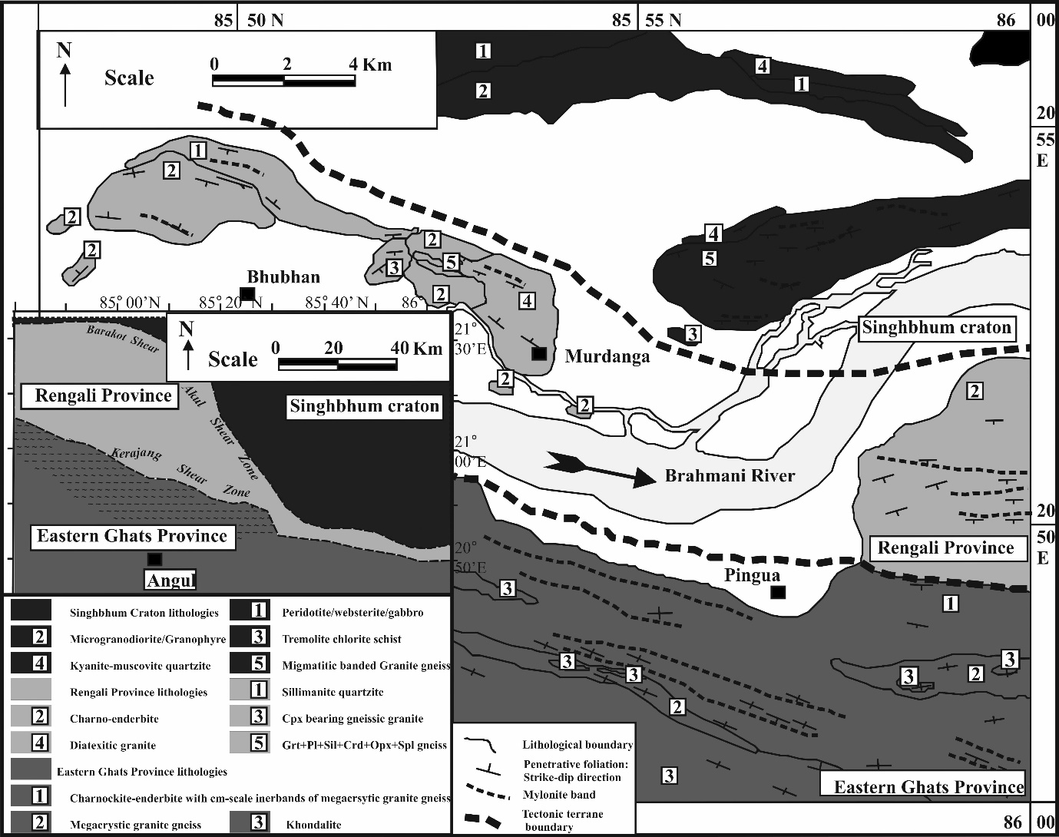

Supplementary Figure 1. (after Sawant, A. D., Gupta, S., Clark, C. and Misra, S. (2017). The Rauer-Rengali connection in the Indo-Antarctica amalgam: evidence from structure, metamorphism and geochronology. From: Pant, N. C. & Dasgupta, S. (eds.) Crustal Evolution of India and Antarctica: The Supercontinent Connection. Geological Society, London, Special Publications, v. 457, 171-196. https://doi.org/10.1144/SP457.9.)

