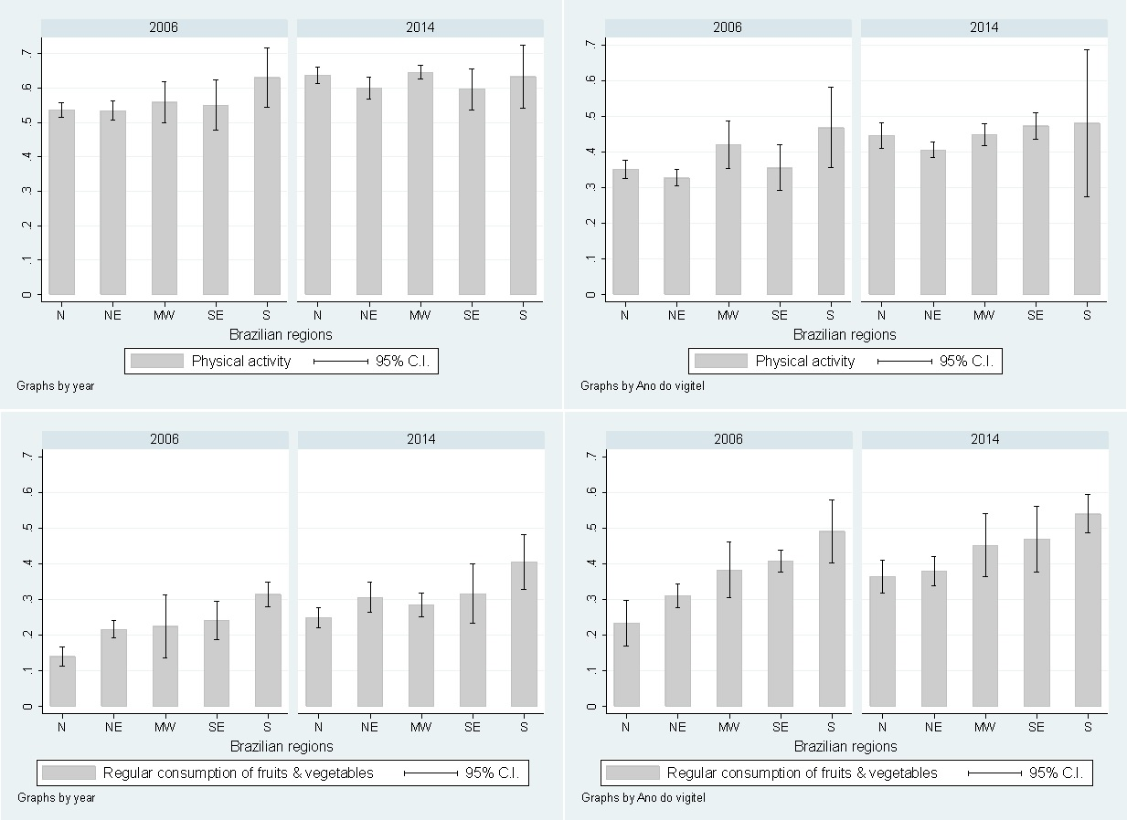
*p-value = 0.007
*p-value = 0.227
D
C
*p-value = 0.013
*p-value = 0.012
B
A
Supplementary figure 3. Prevalence of protective factors in Brazil according to geographical regions and stratified by gender (A - Prevalence of physical activity in men; B - Prevalence of physical activity in women; C - Prevalence of regular consumption of fruits and vegetables in men; D - Prevalence of regular consumption of fruits and vegetables in women).
*p-value for second order interaction between region and survey’s year.
N = North; NE = Northeast; MW = Midwest; SE = Southeast; S = South

