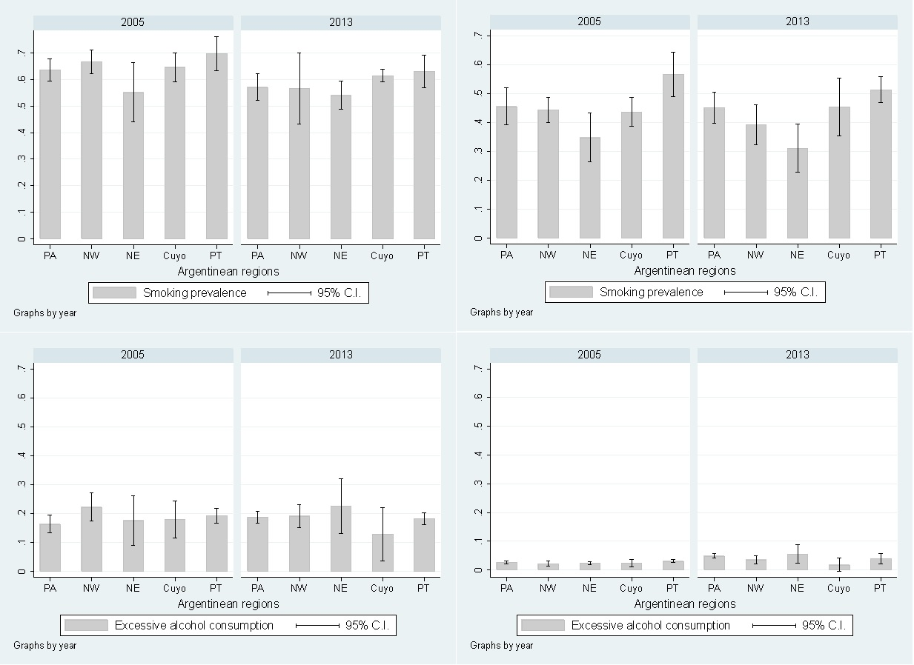
*p-value = 0.026
*p-value = 0.028
D
C
B
*p-value = 0.410
*p-value = 0.520
A
Supplementary figure 2. Prevalence of risk factors in Argentina according to geographical regions and stratified by gender (A - Prevalence of tobacco smoking in men; B - Prevalence of tobacco smoking in women; C - Prevalence of excessive alcohol consumption in men; D - Prevalence of excessive alcohol consumption in women).
*p-value for second order interaction between region and survey’s year.
PA = Pampeana; NW = Northwest; NE = Northeast; PT = Patagonica

