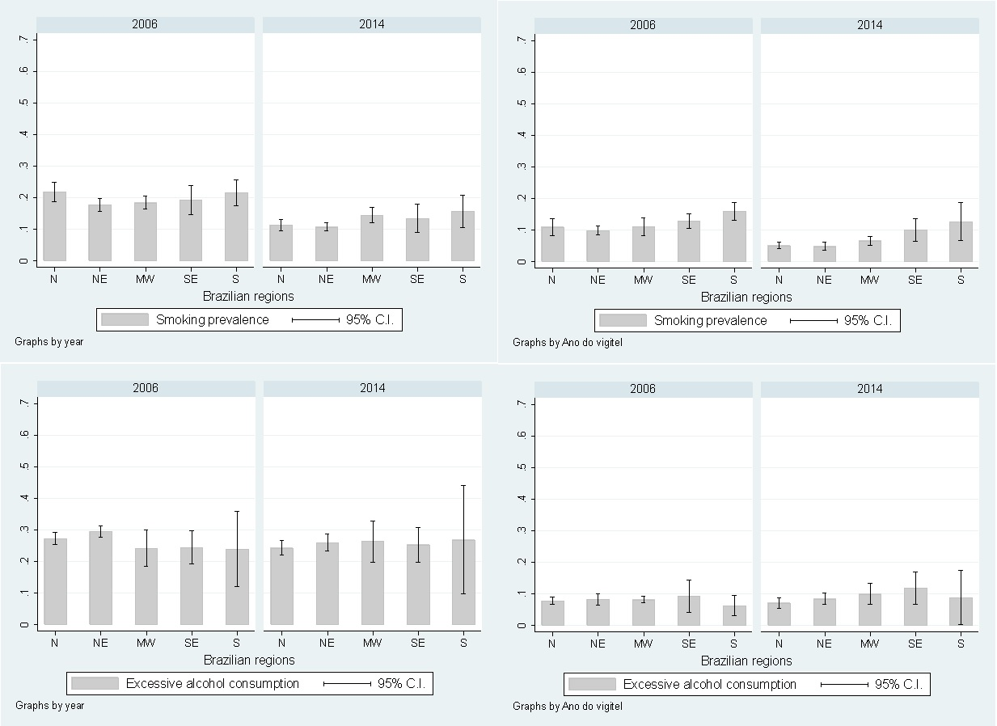
*p-value = 0.019
*p-value = 0.012
*p-value = 0.148
*p-value = 0.023
D
C
B
A
Supplementary figure 1. Prevalence of risk factors in Brazil according to geographical regions and stratified by gender (A - Prevalence of tobacco smoking in men; B - Prevalence of tobacco smoking in women; C - Prevalence of excessive alcohol consumption in men; D - Prevalence of excessive alcohol consumption in women).
*p-value for second order interaction between region and survey’s year.
N = North; NE = Northeast; MW = Midwest; SE = Southeast; S = South

