Supplementary Information for

Synergistic combination of information from ground observations, geostationary satellite, and air quality modeling towards improved PM_{2.5} predictability

Jinhyeok Yu, Chul H. Song, Dogyeong Lee, Sojin Lee, Hyun S. Kim, Kyung M. Han, Moongu Jeon, Seohui Park, Jungho Im, Soon-Young Park, Vincent-Henri Peuch, Pablo E. Saide, Gregory R. Carmichael, Jeeho Kim, Jhoon Kim, Chang-Keun Song, Jung-Hun Woo & Seong-Hyun Ryu

Correspondence: Chul H. Song; Email: chsong@gist.ac.kr
School of Earth & Environmental Engineering, Gwangju Institute of Science and Technology (GIST), Gwangju, 61005, Republic of Korea

This PDF file includes:

Supplementary Sections 1 to 12
Supplementary References
Supplementary Figures 1 to 15
Supplementary Tables 1 to 10

Section 1. Global and regional operational air quality prediction systems
Many countries have developed and operated their own short-term (or medium-range) air quality prediction systems. These operational air quality prediction systems are summarized in Supplementary Table 1, together with names of air quality models, organization that has developed the system, ambient species for predictions, horizontal resolutions, and techniques for data assimilation.

Section 2. K_ACheMS v2.0 (Korean Air Chemistry Modeling System v2.0)
The K_ACheMS v2.0 (Korean Air Chemistry Modeling System version 2.0) has been developed by GIST science team under the national strategic particulate matter project. Main elements of the K_ACheMS v2.0 were briefly introduced in the Materials and Methods. They are also summarized in Supplementary Table 2. Here, we will describe main elements of the K_ACheMS v2.0.
In the K_ACheMS v2.0, two meteorological models are used for producing meteorological fields. The first model is the WRF v4.1.5 (Weather Research and Forecasting version 4.1.5) model ¹. It is driven by the NOAA (National Oceanic and Atmospheric Administration) real-time GFS (Global Forecasting System) data. The NOAA GFS provides the WRF model with initial and boundary conditions. Outputs from WRF model runs are then converted into a CMAQ vG (Community Multi-scale Air Quality version G)-ready format using Meteorology-Chemistry Interface Processor (MCIP). The second meteorological model is the UM (Unified Model) developed by UK (United Kingdom) MET office ². The UM is currently the operational NWP (Numerical weather prediction) model at the KMA (Korean Meteorological Administration) in South Korea. To convert UM-generated meteorological fields into the CMAQ vG-ready format, a UM-MCIP pre-processor has also been developed by the GIST science team.
For air quality model simulations, the CMAQ vG model has been developed by the GIST science team based on the US EPA (United States Environmental Protection Agency) CMAQ v5.2 model ³. The CMAQ vG model mainly uses modified version of SAPRC07TC (Statewide Air Pollution Research Center 07) chemical mechanism with several important updates, including the following: (i) daytime HONO photo-chemistries ⁴; (ii) heterogeneous HO₂ reactions ⁵; (iii) gas- and aqueous-phase halogen chemistries ⁶; (iv) new yield data for SOA formation acquired from multiple smog chamber experiments conducted under typical conditions of northeast Asia ⁷; and (v) new convection (Kain-Fritsch) and advection (Trajectory-Grid) schemes ^{8,9}.
The K_ACheMS v2.0 also includes two data assimilation methods to construct initial conditions for CMAQ vG model simulations. The first method is 3-D VAR (3-Dimensional Variational) method ¹⁰ and the second one is the EnKF (Ensemble Kalman Filter) technique ¹¹. As discussed in the main text, two types of observation data can be utilized for data assimilation: ground observations and GEO/LEO satellite-retrieved observations. The way to collect ground observation data depends on the operation mode of the K_ACheMS v2.0. If it is operated in a diagnostic mode, data can be downloaded from the websites mentioned in the main text. If the operation mode is prognostic, then observations should be collected by the screen crawling technique. Further technical details of these two data assimilation methods will be described in Supplementary Section 13.
For the consideration of anthropogenic emissions over northeast Asia, KORUS v5.0 inventory has been developed. This anthropogenic emission inventory of the KORUS v5.0 was originally constructed to support the KORUS-AQ (Korea–United States Air Quality) campaign. This inventory is a mosaic inventory. It is composed of three emission datasets: (i) CREATE (Comprehensive Regional Emissions inventory for Atmospheric Transport Experiment) 2015 emissions for China and Japan; (ii) CAPSS (Clean Air Policy Support System) 2015 emission for South Korea; and (iii) SEAC4RS (Studies of Emissions and Atmospheric Composition, Clouds and Climate Coupling by Regional Surveys) 2012 for other regions in East Asia ¹². To take biogenic emissions into account, the MEGAN v2.1 (Model of Emissions of Gases and Aerosols from Nature version 2.1) model was run over the modeling domain shown in Fig. 1 ¹³. To run the MEGAN model, both PFT (Plant Functional Type) and LAI (Leaf Area Index) datasets are required. These datasets over the modeling domain were retrieved from the MODIS sensor. Considering pyrogenic (fire) emissions, FINN v1.5 (Fire Inventory from NCAR version 1.5) was used ¹⁴. All anthropogenic, biogenic, and pyrogenic emissions were then merged and post-processed to prepare the CMAQ vG-ready format.
The K_ACheMS v2.0 also contains two modules for ML (machine learning). The first ML module is DRNN LSTM (Deep Recurrent Neural Network Long-Short Term Memory) module, which has been developed for the role of ‘AI (Artificial Intelligence) forecaster’ ¹⁵. The second ML module is the ‘bias and error corrector’, which has been developed for correcting errors and biases of predictions made by prognostic CMAQ vG model simulations. A technique named XGBoost (eXtreme Gradient Boost) is selected for this ‘bias and error corrector’ in the K_ACheMS v2.0 ¹⁶.
The K_ACheMS v2.0 also has a policy-related module. Currently, a module named DDM-PIM (Direct Decoupled Method coupled with Path Integral Method) is being developed ¹⁷. After completion of developing this DDM-PIM module, the module will be used for calculating S-R relations (Source-Receptor relations).

Section 3. C-IFS (Integrated Forecasting System with Atmospheric Composition)
In this supplementary information, we will briefly explain what options and methods are utilized for meteorological, physical, photochemical and emission processes in C-IFS model simulations in comparison with the K_ACheMS v2.0.
The CAMS (Copernicus Atmosphere Monitoring Service) has been operated by the ECMWF (European Centre for Medium-Range Weather Forecasts) to monitor and forecast global atmospheric composition. For this purpose, the C-IFS (Integrated Forecasting System with Atmospheric Composition) model has been developed to simulate and predict atmospheric concentrations of trace gases and aerosols ¹⁸. Among several versions of the C-IFS models that have been developed, the version CY41R1 (Cycle41R1) of the C-IFS was operated for air quality forecasting during the period of the KORUS-AQ campaign. Therefore, this version of the model is described here. However, for further comparison, we will also introduce two recent versions of the C-IFS model (CY43R1 and CY47R3) in Supplementary Table 3.
In the C-IFS model, a modified version of Carbon Bond 05 (CB05) mechanism has been used to describe tropospheric gas-phase photochemistry ¹⁹. Because the modified CB05 chemical mechanism does not include stratospheric photochemistry, the stratospheric ozone photochemistry in the C-IFS model is parameterized implicitly through the Cariolle scheme ²⁰. The stratospheric mixing ratio of NO_{X} is determined using climatological ratio of HNO₃ to O₃ at 10 hPa. Considering aerosol processes, the CAMS bulk aerosol module was chosen. This CAMS bulk aerosol module is from the LOA/LMD-Z (Laboratoire d'Optique Atmosphérique/Laboratoire de Météorologie Dynamique-Zoom) model ²¹. It deals with five types of particles: sea-salt, dust, organic matter, black carbon, and sulfate. Formations of SOAs (secondary organic aerosols) from biogenic and anthropogenic VOCs (volatile organic compounds) are parameterized simply based on proportional scales to terpene ²² and CO emissions ²³, respectively.
Anthropogenic emissions used in the CY41R1 of the C-IFS were obtained from the MACCity (Monitoring Atmospheric Composition and Climate/CityZen EU projects) dataset ²⁴. Because the base year for MACCity emissions was 2010, yearly projected emissions based on the RCP (Representative Concentration Pathway) 8.5 scenario were used to update emissions after 2010. For biogenic emissions, MEGAN-MACC emissions were used except for isoprene emissions ²⁵. For isoprene emissions, POET (Precursors of Ozone and their Effects in the Troposphere) emissions were adopted to use ²⁶. Considering pyrogenic emissions, near-real time GFAS (Global Fire Assimilation System) v1.2 was applied ²⁷. Both sea-salt and dust emissions were computed in an on-line mode within the C-IFS model.

Section 4. Statistical analysis between observed and predicted PM_{2.5}
In Fig. 2, we only presented IOA (Index of Agreement) on the basis of comparison between observed and model-predicted PM_{2.5} at AIR KOREA stations located in South Korea. We believe that the IOA is a representative metric with which we can evaluate performances of experiments. Even so, we also decided to deliver further statistical details of our analyses. Supplementary Fig. 3 provides one-to-one plot analysis between observed and predicted PM_{2.5}, with RMSE (root mean square error), MB (mean bias), and R (Pearson correlation coefficient) for eight experiments we carried out. In Supplementary Fig. 3, panel numbering convention from a to h is the same as that in Fig. 2. Definitions of RMSE, MB, and R are described in Supplementary Section 10.
As shown in Supplementary Fig. 3, correlation coefficients (Rs) continued to increase from 0.52 to 0.62 from panel b to h, while RMSEs and MBs decreased from 16.81 to 15.07 and from –4.56 to –2.19, respectively, throughout panels b to h. Both increasing correlation and decreasing errors and biases clearly indicated that PM_{2.5} predictability was improved from panel b to h.
When statistical metrics were compared between CAMS and K_ACheMS products, we found that statistical metrics jumped from 0.51 to 0.78 (in the case of IOAs) and from 0.27 to 0.62 (in the case of Rs). RMSEs and MBs greatly diminished from 24.67 to 15.07 and from 7.11 to –2.19, respectively. All these statistical numbers indicate that K_ACheMS PM_{2.5} predictions are improved compared to CMAS PM_{2.5} predictions.
In the main text, we reported the percentages of improvements in the PM_{2.5} predictability throughout the seven experiments shown in Fig. 2. The percentage of improvements were calculated by Supplementary Eq. (1).
 | $Percentage of Improvement \left(\%\right)=\frac{{Metric}_{h}-{Metric}_{c}}{{Metric}_{c}}×100 (\%)$ | (1)
where, Metric_{h} and Metric_{c} indicate the statistical metrics from experiment h and c in Fig. 2, respectively.
In addition, unlike K_ACheMS PM_{2.5} predictions, CAMS_nrt PM_{2.5} showed positive mean biases that certainly indicated general over-predictions of PM_{2.5} by C-IFS model simulations. This was a quite different characteristic in the sense that all K_ACheMS v2.0 simulations presented negative mean biases, indicating under-predictions of PM_{2.5}. What actually caused these over- and under-predictions of PM_{2.5} in C-IFS and K_ACheMS PM_{2.5} predictions will be discussed further in the next section of Supplementary Section 5.

Section 5. Observed and modeled composition of PM_{2.5}
As shown in Fig. 2a and Supplementary Fig. 3a, CAMS PM_{2.5} products generally overestimated PM_{2.5} with large positive mean bias (MB = 7.11 in Supplementary Fig. 3a). To investigate main causes of these PM_{2.5} over-predictions, we compared observed concentrations of major PM_{2.5} constituents with predicted concentrations at six intensive measurement stations in South Korea. Supplementary Fig. 4 presents results of comparisons between predicted and observed concentrations for sulfate (panel a), organic aerosols (panel b), black carbon (panel c), and dust (panel d). As shown in Supplementary Fig. 4, sulfate, black carbon, and dust concentrations were all over-predicted by CAMS PM_{2.5} products. In actuality, these over-predictions must be related directly to over-predictions of CAMS PM_{2.5}. In case of organic aerosols (OAs), the K_ACheMS slightly over-predicted OA concentrations compared to observed OA concentrations, while the C-IFS tended to under-predict OA concentrations. OA concentrations have been generally under-predicted by global and regional chemistry-transport models ²⁸. To further investigate over-predictions of OAs by the K_ACheMS, we might need to check new SOA yields from smog chamber experiments as well as emission fluxes of active SOA precursors such as toluene, xylene, and monoterpenes in KORUS v5.0 and MEGAN model simulations.
Regarding the large over-predictions of concentrations of black carbon (BC) and sulfate (SO₄^{2–}), these over-predictions are certainly associated with the fact that MACCity BC and SO₂ emissions used in the C-IFS model simulations are larger than those in KORUS v5.0. Supplementary Figs. 5 and 6 present spatial distributions of emission fluxes of several primary atmospheric species over East Asia and South Korea, respectively. Total summed emissions are also shown at bottom-right corners of panels. As shown in these figures, BC emission fluxes in MACCity emissions were approximately 1.8 times and 3.2 times larger than those in the KORUS v5.0 over China and South Korea, respectively. Also, SO₂ emission fluxes in the MACCity emissions were approximately 1.9 times and 2.3 times larger than those in the KORUS v5.0 over China and South Korea, respectively. These large emission fluxes of BC and SO₂ in MACCity emissions might have caused over-predictions of BC and sulfate concentrations shown in Supplementary Fig. 4a, c. In addition, on-line mode (fugitive) dust scheme appears to generate larger amounts of dust as shown in Supplementary Fig. 4d.
In Supplementary Fig. 4, predicted concentrations denoted by solid lines generally have better agreements with observations. K_ACheMS model simulations appeared to better capture levels of atmospheric sulfate, organic aerosols, BC, and dust than C-IFS model simulations over South Korea or northeast Asia. These better performances might be associated with better emission fluxes (in case of BC and sulfate), better parameterizations for secondary formation (in case of OAs), and better physical generation scheme (in case of dust) in the K_ACheMS v2.0 over northeast Asia.

Section 6. Cloud contamination and sun-glint effect
Cloud contamination and sun-glint effect are two typical reasons by which we lose AOD data from LEO (low Earth orbit) satellite sensors. Supplementary Fig. 7 presents spatial distributions of AOD obtained from the MODIS sensor (panel a) and the GOCI sensor (panel b), respectively, at 02 UTC on 4 May, 2016. As shown in Supplementary Fig. 7, MODIS and GOCI AOD data were not available over North Korea, Manchuria (northeastern parts of China), eastern edge of Russia, and Hokkai island (northernmost island) in Japan due to the presence of clouds over these regions (i.e., cloud contamination). In addition, no MODIS AOD data was available over south ocean areas of Jeju or Kyushu Island due to the sun-glint effect. The sun-glint effect usually takes place over ocean regions due to the geometry between LEO satellite sensor and the Sun, as mentioned in the main text.
Collectively, averaged retrieval fractions of the AOD data from MODIS and GOCI sensors during the period of the KORUS-AQ campaign over the GOCI domain were ~14.0% and ~28.5%, respectively. Available data of the GOCI sensor are doubled compared to those of the MODIS sensor. These numbers indicate that there should be an advantage when we use AOD data from the ‘geostationary’ GOCI sensor in the data assimilation. In case of the MODIS AOD, the small fraction of data availability (~14%) strongly hampers effective corrections of initial states via data assimilation. Again, it should be noted that almost negligible differences were found between Fig. 2b, c due to the scarcity of AOD data from the MODIS sensor. Improved performances were achieved in Fig. 2d, e due to increased fraction of AOD data retrieved from the GOCI sensor.

Section 7. Conversion of GOCI AOD into surface PM_{2.5} via Random Forest (RF) technique
Several studies have shown a strong linear correlation (relationship) between AOD and concentration of ambient particulate matters ^{29,30}. Based on this strong linear correlation, there have been several attempts to empirically convert satellite AOD into surface PM_{2.5}. For example, Liu et al. ³¹ have developed an empirical regression model (formula) to convert AOD into surface PM_{2.5}. More recently, other studies have also used machine learning techniques to convert AOD into PM_{2.5} ^{32,33}. Among these studies, Random Forest (RF) method has shown the best performances in estimating PM_{2.5} from satellite-retrieved AOD ³³. The RF method is a machine learning algorithm that uses an ensemble of decision trees. These trees are trained with different parts of the same dataset, aiming to reduce variances. After training, the model takes an average of predictions from all individual regression trees ³⁴.
The K_ACheMS v2.0 has also employed the RF technique to convert GOCI AOD into surface PM_{2.5}. For this conversion, we constructed big data with 32 input features, including aerosol-related data, meteorological data, and land-use information. For aerosol-related data, the GOCI AOD at 550 nm, fine mode fraction (FMF) at 550 nm, single-scattering albedo (SSA) at 440 nm, and Ångstrom exponent (AE) at 440 and 870 nm data were used. All these aerosol products were retrieved via Yonsei aerosol retrieval (YAER) version 2 algorithm using GOCI Level 1 data ³⁵. For simulated and observed meteorological data, RH (relative humidity), PBLH (planetary boundary layer height), and surface pressure from the UM-RDAPS (Unified Model-Regional Data Assimilation and Prediction System) were utilized. For precipitations, MODIS GPM (Global Precipitation Measurement) 30-min precipitation data were accumulated to produce 24-hr data. Other non-atmospheric data such as MODIS NDVI (Normalized Difference Vegetation Index) were also included into the big data. The input dataset also contained emission data from Sparse Matric Operator Kernel Emissions (SMOKE). Hourly PM_{2.5} data collected from the AIR KOREA network at 13:00 KST (Korean Standard Time) for the period between 2015 and 2016 were also used as target data for RF model training ³⁶.
About 20% of the data were used for hindcast validation. Of the remaining data (80% of dataset), 80% were used for training and 20% were used for test. Due to an imbalanced distribution of PM_{2.5}, over-sampling and sub-sampling approaches were used to sample more high PM_{2.5} data and to produce a less biased training dataset ³⁶. The RF model trained with balanced training samples showed improvements in comparison with the original training samples, with R² for PM_{2.5} increased from 0.59 to 0.73 and with RMSE decreased from 10.53 μg/m³ to 8.25 μg/m³ ³⁶. These statistics agreed well with values from other studies ^{32,33}.
We have discussed four different types of observation data: ground PM_{2.5}, MODIS AOD, GOCI AOD, and RF-converted PM_{2.5}. All these observations are necessary for the application to data assimilation. To use observation data in the data assimilation, we also need to evaluate observation errors for these four different types of observation data. Supplementary Table 4 is a collection of error analysis of these four different types of observation data. In case of satellite data such as MODIS and GOCI AOD, errors were analyzed over the land and the ocean separately. Based on the formulae shown in Supplementary Table 4, relative standard deviations (RSDs) of errors for the four different types of observational data were estimated. Supplementary Fig. 8 presents ranges of RSDs of errors for the four different types of observations during the period of the KORUS-AQ campaign. As shown in Supplementary Fig. 8, ground PM_{2.5} observations had the smallest errors. As already discussed in the main text, the range of errors for RF-converted PM_{2.5} was smaller than that of MODIS AOD.

Section 8. PM₁₀ predictions
The main reason we used 3-D VAR technique in this study was that we completed the development of both BEC (background error covariance) and OEC (observation error covariance) matrices for all six Korean criteria air pollutants (PM_{2.5}, PM₁₀, ozone, NO₂, SO₂, and CO). We already discussed the construction of these OEC matrices for PM_{2.5} observations in Supplementary Section 7. We applied all these matrices to the 3-D VAR framework. This meant that although we focused on the predictability of PM_{2.5} in this study, the predictability of PM₁₀ (and ozone) could also be enhanced due to these updated initial states. Supplementary Fig. 2 shows an example of enhanced predictability of PM₁₀.
The KMA (Korean Meteorological Administration) of South Korea has been implementing operational dust forecasts and alarming system based on its own ADAM III (the third-generation Asian Dust Aerosol Model) simulations combined with information acquired from multiple satellite sensors. However, as discussed in the main text, satellite-derived information is often imperfect because dust plumes are up-drafted and then frequently transported behind cold frontal system that is usually accompanied by cold frontal clouds. Therefore, it is often difficult for satellite sensors to detect these dust plumes transporting together with cold frontal clouds.
Supplementary Fig. 2 presents a perfect example that satellite-derived data could not improve the predictability of dust-related PM₁₀ (refer to Supplementary Fig. 2c–e). During a dust episode that occurred between 6 and 7 May, neither the CAMS nor the K_ACheMS systems using either the MODIS AOD or the GOCI AOD could predict the peak of dust-associated PM₁₀. On the contrary, when we used ground observations, the peak of PM₁₀ that occurred at the end of 6 May was clearly predicted (see Supplementary Fig. 2f–h). This is again due to the fact that ground observations are never affected by the presence of clouds. Therefore, this can be a good example to show why we should return back to classical observation data (i.e., ground observations) to enhance the predictability of PM_{2.5} and PM₁₀.

Section 9. Six-month test-bed study between 1 November, 2016 and 30 April, 2017
As mentioned in the main text, to confirm our conclusions drawn from this study, we applied the same methodology to another time period from 1 November, 2016 to 30 April, 2017. This period was the period for the second test-bed in our research framework during which high PM_{2.5} events frequently took place in South Korea.
Supplementary Fig. 9 presents results from six experiments. Constructions of these six experiments were exactly the same as those presented in Fig. 2. Only an experiment of ‘without data assimilation’ in Fig. 2 (i.e., Fig. 2b) was omitted. From Supplementary Fig. 9, we again confirmed that conclusions drawn from the experiments for the KORUS-AQ campaign period were valid. The case in which applications of initial states corrected by the combination of ground observations with GOCI satellite data exhibited the best performances, with an IOA of 0.74.
Supplementary Fig. 10 shows two representative cases that are zoomed in. Sequential assimilations of ground observations and GOCI-derived data created synergistic effects. Two events occurred on 8 November, 2016 and 27 March, 2017, respectively, when the GOCI AOD data were available over North Korea (Region II in Fig. 1) and the Yellow Sea (Region I in Fig. 1), respectively. Again, these Regions I and II have been regarded as ‘blank areas of information’ to South Korea in terms of information on air quality. Also, in both events, these two regions were located in upwind areas to South Korea. Under situations in which GOCI-derived data were considered in addition to ground observations, the IOA increased from 0.60 to 0.64 in panel a and from 0.62 to 0.66 in panel b. These increases of IOA were certainly due to synergistic effects from sequential assimilations of ground and satellite observations.
Supplementary Fig. 11 demonstrates current capability of the K_ACheMS v2.0. Over the six-month period, comparisons between observed and predicted concentrations for PM_{2.5} constituents were made. Here, predicted concentrations were from the experiment f in Supplementary Fig. 9. As shown in Supplementary Fig. 11, nitrate (NO₃–) concentrations were generally over-predicted, while OA concentrations were under-predicted. These over- and under-predictions are relatively well-known phenomena ^{28,39}. Correcting concentrations of these two major PM_{2.5} constituents will be the main targets in the next stage of the development of the K_ACheMS v2.0. Regarding concentrations of other PM_{2.5} constituents such as sulfate (SO₄^{2–}), ammonium (NH₄⁺), and BC, there were relatively good agreements between observed and predicted concentrations.

Section 10. Scientific and administrative statistical metrics
Scientific statistical metrics frequently used to evaluate the performance of an air quality modeling system are shown below:
 | $$Index of Agreement (IOA)=1-\frac{\sum_{i=1}^{n}{{(M_{i}-O_{i})}^{2}}}{\sum_{i=1}^{n}{{(\left|M_{i}-\overline{O}\right|+\left|O_{i}-\overline{O}\right|)}^{2}}}$$ | (2)
 | $$Correlation Coefficeint (R)=\frac{1}{(n-1)}\sum_{i=1}^{n}{\left(\left(\frac{M_{i}-\overline{M}}{σ_{M}}\right)\left(\frac{O_{i}-\overline{O}}{σ_{O}}\right)\right)}$$ | (3)
 | $$Mean Bias (MB)=\frac{1}{n}\sum_{i=1}^{n}{\left(M_{i}-O_{i}\right)}$$ | (4)
 | $$Root Mean Square Error (RMSE)=\sqrt{\frac{\sum_{i=1}^{n}{{(M_{i}-O_{i})}^{2}}}{n}}$$ | (5)
where M and O represent modeled and observed concentrations of atmospheric species, respectively.
In the main text, we also mentioned HR (hit rate). Unlike scientific metrics, the HR can be classified into ‘administrative metrics’ because administration parties (like KMoE) are particularly interested in this metric. The HR is the most representative (popular) administrative metric in South Korea, although there are a couple of other administrative metrics such as ACC (ACCuracy) and FAR (False Alarm Rate). These metrics are defined based on the percentage of hitting category intervals of South Korean air quality standards. Supplementary Table 5 presents current standards of air quality in South Korea. There are four categories in the standards of air quality in South Korea: ‘Good’, ‘Moderate’, ‘Bad (unhealthy)’, and ‘Very bad (very unhealthy)’. ACC, HR, POD, and FAR are defined based on the percentage of successful hitting categories in South Korean standards of air quality (Supplementary Table 6). Definitions of these metrics are shown below:
 | $$Accuracy \left(ACC\right)=\frac{A1+B2+C3+D4}{I+II+III+IV}×100 (\%)$$ | (6)
 | $$Hit Rate \left(HR\right)=\frac{C3+D4}{III+IV}×100 (\%)$$ | (7)
 | $$Probability of Detection \left(POD\right)=\frac{IV}{III+IV}×100 (\%)$$ | (8)
 | $$False Alarm Rate \left(FAR\right)=\frac{II}{II+IV}×100 (\%)$$ | (9)

Section 11. Operational runs of K_ACheMS v2.0
As mentioned in the main text, the K_ACheMS v2.0 has been running in an operated mode since 1 January, 2022 for daily PM_{2.5} predictions over South Korea. In the meantime, performances of the operational runs of the K_ACheMS v2.0 have also been evaluated in comparison with PM_{2.5} observations from AIR KOREA, together with predictions from two PM_{2.5} prediction systems at the NIER and the ECMWF. In Fig. 4 of the main text, we made visual snapshot comparisons of the PM_{2.5} observations with three PM_{2.5} predictions (from K_ACheMS v2.0, NIER, and ECMWF) at noon on 10 Jan., 23 Jan., and 11 Feb., 2022. These three PM_{2.5} events in Fig. 4 were the highest ones among the high PM_{2.5} events that occurred over the six-month period, during which the K_ACheMS v2.0 was operated (from 1 Jan. to 30 June, 2022). This is presented in Supplementary Fig. 12 (see three blue arrows in Supplementary Fig. 12. Each blue arrow indicates the high PM_{2.5} event). Again, as mentioned in the main text, winter and spring are the main seasons of high PM_{2.5} events in Northeast Asia (or South Korea), which is also shown in Supplementary Fig. 12.
Supplementary Fig. 12 also presents comparisons between PM_{2.5} observations (black dashed line) and PM_{2.5} predictions from the K_ACheMS v2.0 (blue solid line) and CAMS (CY47R3) NRT products (yellow solid line) over the six-month test period of the K_ACheMS v2.0. It can be seen that the PM_{2.5} predictions from the K_ACheMS v2.0 exhibit higher accuracy than the PM_{2.5} predictions from the ECMWF (i.e., CAMS_nrt products). The NIER has released only prediction maps like the ones shown in Fig. 4, not the PM_{2.5} prediction values. Thus, it was impossible to incorporate their data into the comparison in Supplementary Fig. 12.
Supplementary Tables 7 and 8 present statistical analyses to evaluate the accuracy of two PM_{2.5} predictions (K_ACheMS v2.0 and CAMS_nrt) over the six-month test period. Supplementary Table 7 presents analysis of the scientific statistical metrics such as IOA, R, RMSE, and MB, while Supplementary Table 8 shows analysis of the administrative statistical metrics such as ACC, HR, POD, and FAR. As shown in two tables, the K_ACheMS v2.0 PM_{2.5} predictions produced better outputs than the CMAS PM_{2.5} predictions. For example, the IOA and HR produced by the K_ACheMS v2.0 are 0.78 and 67%, respectively. These numbers are higher than those produced by the ECMWF prediction system (IOA: 0.76 and HR: 54%).

Section 12. Error and bias corrections via XGBoost
There should always be a gap between observations (real values) and predicted values (virtual values). The extent of the gap between observed and predicted values can be described by statistical metrics such as errors and biases as discussed in Supplementary Section 10. These errors and biases can arise from an imperfect model, uncertain meteorological and emission fields, and inaccurate initial conditions. Whatever the sources, these errors and biases in theory can be corrected by employing machine learning (ML) techniques to take one more step closer to real world values (observations). In this supplementary information, we will explain some efforts made by us to develop a correction model based on XGBoost technique to minimize the gap between observations and predicted values.
The XGBoost is a decision-tree (DT) based gradient boosting method that is popularly being used to solve diverse scientific and engineering problems ⁴⁰. Although this method has exhibited powerful and robust capability to solve many diverse problems, whether the XGBoost or other DT-based techniques can work efficiently on highly complex and non-linear relationships between variables as in air quality model simulations has not been fully proven yet. In order to confirm this, first, we tested several bagging- and gradient boosting-based ML techniques such as CatBoost, AdaBoost, Light GBM, Random Forest, and XGBoost ^{41,42}.
For this test, we constructed 2.3-year big data for model training. Such big data mainly included outputs from WRF-CMAQ model simulations (without data assimilation) as well as PM_{2.5} observations (as true values) from the AIR KOREA network. We did not apply data assimilation to WRF-CMAQ model simulations to prevent compulsory perturbation of non-linear relationships between input parameters. The dataset constructed was then divided into two groups: 80% for model training and 20% for model validation. After model training and validation, all the above-mentioned ML techniques were applied to correct model biases and errors during the period of KORUS-AQ campaign. Supplementary Table 9 presents results from our screening tests to select the best technique. As shown in Supplementary Table 9, the XGBoost method showed the best correction performances in terms of IOA, R, RMSE, and MB. For example, the IOA with the XGBoost increased up to 0.66. Based on this screening test, we decided to choose the XGBoost-based method for the ‘bias and error corrector’ of WRF-CMAQ model simulations.
After choosing a model, we attempted to further improve the bias and error correction of the model. First, in the phase of model training, Bayesian optimization algorithm (BOA) was employed to find the optimal combination of model hyper-parameters. The BOA is an efficient and effective hyper-parameter tuning algorithm that can directly search the maximum and minimum values of the objective function (or cost function) ⁴³. Due to its high optimization performances, the BOA has found a wide range of applications ^{44–46}. In this study, the objective function of the BOA was set with Pearson correlation coefficient (R).
Second, data quality is one of the main factors that determine the performance of an ML algorithm. In particular, imbalance of the training dataset often deteriorates the performance of an ML model. The distribution of information of true value (observations) in the original training dataset is presented in Supplementary Fig. 13. As shown in Supplementary Fig. 13, the original training dataset was highly unbalanced (i.e., showing a skewed shape). For a better error and bias correction, the training dataset needs to be pre-processed through data balancing (DB). We compared three DB algorithms: (i) oversampling; (ii) Gaussian noise ³⁶; and (iii) SMOTEENN (Synthetic Minority Oversampling Technique + Edited Nearest Neighbor) ^{47,48}. Here, PM_{2.5} categories of South Korean air quality standards were used for decision boundaries to define minority and majority classes. Data samples above 100 μg/m³ were not oversampled to prevent excessive amplification of high PM_{2.5} data samples as well as overfitting. Results of performance comparisons between DB algorithms are summarized in Supplementary Table 10. The SMOTEENN-XGBoost combined model showed the best performance in PM_{2.5} correction, showing an IOA of 0.71 and a HR of 75.15%. Obviously, this HR of 75.15% is the highest one, even higher than HRs shown in Fig. 2. Note that the HR of Fig. 2h was only 67.88%. The SMOTEENN-XGBoost corrector appeared to be highly efficient in enhancing this administrative metric (HR). However, in terms of the IOA, the SMOTEENN-XGBoost corrector only increased the IOA up to 0.71, which was smaller than the IOA of 0.78 in Fig. 2g, h. Based on this result, we are now using the SMOTEENN-XGBoost corrector in a complementary way in K_ACheMS v2.0 PM_{2.5} forecasting. Bias and error corrector need further investigations in the future.

Section 13. Data assimilation techniques of K_ACheMS v2.0
Data assimilation is a technique to correct modeled state (also called ‘background state’) with observations. This corrected field, called ‘analysis state’, can be utilized as an initial state (or initial condition) for PM_{2.5} predictions. In this supplementary information, we will briefly introduce 3-D VAR techniques used in this study. As mentioned previously, two data assimilation methods are currently being developed under the framework of the K_ACheMS v2.0: 3-D VAR and EnKF. Here, we will only describe the 3-D VAR method. More details regarding the EnKF techniques can be found in Park et al. ¹¹.
In the 3-D VAR data assimilation, the analysis state can be estimated by minimizing the cost function (J(x)) as follows:
$$J\left(x\right)=\frac{1}{2}{\left(x-x_{b}\right)}^{T}B^{-1}\left(x-x_{b}\right)+\frac{1}{2}{\left(y_{o}-H(x)\right)}^{T}R^{-1}\left(y_{o}-H(x)\right)$$ | (10)
where x is the analysis state vector; x_{b} is the background (or model) state vector; y_{o} is the observation state vector; B is the background error covariance (BEC) matrix; R is the observation error covariance (OEC) matrix; and H is the observation operator. To minimize the cost function (objective function) shown above, the GSI v3.6 (Grid-point Statistical Interpolation version 3.6) system developed by the National Centers for Environmental Prediction (NCEP) was used.
To construct the BEC matrix (B), we employed the National Meteorological Center (NMC) method in our study ⁴⁹. This method has widely been used in vibrational data assimilation. In the NMC method, model errors presented in Supplementary Eq. (11) below are defined as differences between two different predictions verifying at the same time. In the K_ACheMS v2.0, monthly climatological B (i.e., static error covariance matrix) was constructed while using differences between 24-hr and 12-hr model simulations from a previous year:
$$B=\overline{{\left(x^{24h}-x^{12h}\right)\left(x^{24h}-x^{12h}\right)}^{T}}$$ | (11)
To construct the OEC matrix (R), we set upper and lower components of the OEC matrix to be all zero, with an assumption that all observations were independent or not correlated. As already discussed in Supplementary Section 7 and Supplementary Table 4, diagonal components of the OEC matrix were estimated based on Remer et al. ³⁸ for MODIS AOD, Choi et al. ³⁵ for GOCI AOD, Park et al. ³⁶ for RF-derived PM, and Elbern et al. ³⁷ for ground observations.
To update initial states, 3-D VAR data assimilations were carried out at every 00 UTC using both/either ground observations and/or satellite-borne observations. Supplementary Fig. 14 presents cycle of the data assimilations carried out in this study. Supplementary Fig. 15 illustrates procedures for 24-hr PM_{2.5} predictions of K_ACheMS v2.0 including the data assimilation.

Supplementary References

1. Skamarock, C. et al. A Description of the Advanced Research WRF Model Version 4.1. (2019) doi:10.5065/1dfh-6p97.
2. Brown, A. et al. Unified Modeling and Prediction of Weather and Climate: A 25-Year Journey. Bulletin of the American Meteorological Society 93, 1865–1877 (2012).
3. Byun, D. & Schere, K. L. Review of the Governing Equations, Computational Algorithms, and Other Components of the Models-3 Community Multiscale Air Quality (CMAQ) Modeling System. Appl. Mech. Rev 59, 51–77 (2006).
4. Zhang, L. et al. Potential sources of nitrous acid (HONO) and their impacts on ozone: A WRF-Chem study in a polluted subtropical region. Journal of Geophysical Research: Atmospheres 121, 3645–3662 (2016).
5. Macintyre, H. L. & Evans, M. J. Parameterisation and impact of aerosol uptake of HO₂ on a global tropospheric model. Atmospheric Chemistry and Physics 11, 10965–10974 (2011).
6. Sarwar, G. et al. Impact of Enhanced Ozone Deposition and Halogen Chemistry on Tropospheric Ozone over the Northern Hemisphere. Environ. Sci. Technol. 49, 9203–9211 (2015).
7. Babar, Z. B., Park, J.-H., Kang, J. & Lim, H. Characterization of a Smog Chamber for Studying Formation and Physicochemical Properties of Secondary Organic Aerosol. Aerosol Air Qual. Res. 16, 3102–3113 (2016).
8. Pouyaei, A. et al. Development and Implementation of a Physics-Based Convective Mixing Scheme in the Community Multiscale Air Quality Modeling Framework. Journal of Advances in Modeling Earth Systems 13, e2021MS002475 (2021).
9. Pouyaei, A., Choi, Y., Jung, J., Sadeghi, B. & Song, C. H. Concentration Trajectory Route of Air pollution with an Integrated Lagrangian model (C-TRAIL Model v1.0) derived from the Community Multiscale Air Quality Model (CMAQ Model v5.2). Geoscientific Model Development 13, 3489–3505 (2020).
10. Lee, S. et al. Impacts of uncertainties in emissions on aerosol data assimilation and short-term PM_{2.5} predictions over Northeast Asia. Atmospheric Environment 271, 118921 (2022).
11. Park, S.-Y. et al. Implementation of an ensemble Kalman filter in the Community Multiscale Air Quality model (CMAQ model v5.1) for data assimilation of ground-level PM_{2.5}. Geoscientific Model Development 15, 2773–2790 (2022).
12. Woo, J.-H. et al. Development of the CREATE Inventory in Support of Integrated Climate and Air Quality Modeling for Asia. Sustainability 12, 7930 (2020).
13. Guenther, A. B. et al. The Model of Emissions of Gases and Aerosols from Nature version 2.1 (MEGAN2.1): an extended and updated framework for modeling biogenic emissions. Geosci. Model Dev. 5, 1471–1492 (2012).
14. Wiedinmyer, C. et al. The Fire INventory from NCAR (FINN): a high resolution global model to estimate the emissions from open burning. Geoscientific Model Development 4, 625–641 (2011).
15. Kim, H. S. et al. Development of a daily PM₁₀ and PM_{2.5} prediction system using a deep long short-term memory neural network model. Atmospheric Chemistry and Physics 19, 12935–12951 (2019).
16. Ivatt, P. D. & Evans, M. J. Improving the prediction of an atmospheric chemistry transport model using gradient-boosted regression trees. Atmospheric Chemistry and Physics 20, 8063–8082 (2020).
17. Dunker, A. M. Path-integral method for the source apportionment of photochemical pollutants. Geoscientific Model Development 8, 1763–1773 (2015).
18. Flemming, J. et al. Tropospheric chemistry in the Integrated Forecasting System of ECMWF. Geoscientific Model Development 8, 975–1003 (2015).
19. Williams, J. E., van Velthoven, P. F. J. & Brenninkmeijer, C. a. M. Quantifying the uncertainty in simulating global tropospheric composition due to the variability in global emission estimates of Biogenic Volatile Organic Compounds. Atmospheric Chemistry and Physics 13, 2857–2891 (2013).
20. Cariolle, D. & Teyssèdre, H. A revised linear ozone photochemistry parameterization for use in transport and general circulation models: multi-annual simulations. Atmospheric Chemistry and Physics 7, 2183–2196 (2007).
21. Morcrette, J.-J. et al. Aerosol analysis and forecast in the European Centre for Medium-Range Weather Forecasts Integrated Forecast System: Forward modeling. Journal of Geophysical Research: Atmospheres 114, (2009).
22. Dentener, F. et al. Emissions of primary aerosol and precursor gases in the years 2000 and 1750 prescribed data-sets for AeroCom. Atmospheric Chemistry and Physics 6, 4321–4344 (2006).
23. Spracklen, D. V. et al. Aerosol mass spectrometer constraint on the global secondary organic aerosol budget. Atmospheric Chemistry and Physics 11, 12109–12136 (2011).
24. Granier, C. et al. Evolution of anthropogenic and biomass burning emissions of air pollutants at global and regional scales during the 1980–2010 period. Climatic Change 109, 163 (2011).
25. Sindelarova, K. et al. Global data set of biogenic VOC emissions calculated by the MEGAN model over the last 30 years. Atmospheric Chemistry and Physics 14, 9317–9341 (2014).
26. Oliver, J. et al. Present and future surface emissions of atmospheric compounds. POET Report #2 EU project EVK2-1999-00011, (2003).
27. Kaiser, J. W. et al. Biomass burning emissions estimated with a global fire assimilation system based on observed fire radiative power. Biogeosciences 9, 527–554 (2012).
28. Volkamer, R. et al. Secondary organic aerosol formation from anthropogenic air pollution: Rapid and higher than expected. Geophysical Research Letters 33, (2006).
29. Gupta, P. et al. Satellite remote sensing of particulate matter and air quality assessment over global cities. Atmospheric Environment 40, 5880–5892 (2006).
30. Wang, J. & Christopher, S. A. Intercomparison between satellite-derived aerosol optical thickness and PM_{2.5} mass: Implications for air quality studies. Geophysical Research Letters 30, (2003).
31. Liu, Y., Sarnat, J. A., Kilaru, V., Jacob, D. J. & Koutrakis, P. Estimating Ground-Level PM_{2.5} in the Eastern United States Using Satellite Remote Sensing. Environ. Sci. Technol. 39, 3269–3278 (2005).
32. Chen, G. et al. A machine learning method to estimate PM_{2.5} concentrations across China with remote sensing, meteorological and land use information. Sci Total Environ 636, 52–60 (2018).
33. Hu, X. et al. Estimating PM_{2.5} Concentrations in the Conterminous United States Using the Random Forest Approach. Environ. Sci. Technol. 51, 6936–6944 (2017).
34. Breiman, L. Random Forests. Machine Learning 45, 5–32 (2001).
35. Choi, M. et al. GOCI Yonsei aerosol retrieval version 2 products: an improved algorithm and error analysis with uncertainty estimation from 5-year validation over East Asia. Atmospheric Measurement Techniques 11, 385–408 (2018).
36. Park, S. et al. Estimation of ground-level particulate matter concentrations through the synergistic use of satellite observations and process-based models over South Korea. Atmospheric Chemistry and Physics 19, 1097–1113 (2019).
37. Elbern, H., Strunk, A., Schmidt, H. & Talagrand, O. Emission rate and chemical state estimation by 4-dimensional variational inversion. Atmospheric Chemistry and Physics 7, 3749–3769 (2007).
38. Remer, L. A. et al. The MODIS Aerosol Algorithm, Products, and Validation. Journal of the Atmospheric Sciences 62, 947–973 (2005).
39. Chen, L., et al. MICS-Asia III: multi-model comparison and evaluation of aerosol over East Asia. Atmospheric Chemistry and Physics 19, 11911–11937 (2019).
40. Chen, T. & Guestrin, C. XGBoost: A Scalable Tree Boosting System in Proceedings of the 22nd ACM SIGKDD International Conference on Knowledge Discovery and Data Mining, KDD ’16., (Association for Computing Machinery, 2016), pp. 785–794.
41. Breiman, L. Bagging predictors. Mach Learn 24, 123–140 (1996).
42. Friedman, J. H. Greedy function approximation: A gradient boosting machine. The Annals of Statistics 29, 1189–1232 (2001).
43. Snoek, J., Larochelle, H. & Adams, R. P. Practical Bayesian Optimization of Machine Learning Algorithms in Advances in Neural Information Processing Systems, (Curran Associates, Inc., 2012).
44. Zeng X. & Luo, G. Progressive sampling-based Bayesian optimization for efficient and automatic machine learning model selection. Health Inf Sci Syst 5, 2 (2017).
45. Cheng, H., Ding, X., Zhou, W. & Ding, R. A hybrid electricity price forecasting model with Bayesian optimization for German energy exchange. International Journal of Electrical Power & Energy Systems 110, 653–666 (2019).
46. Ma, J., et al. A Lag-FLSTM deep learning network based on Bayesian Optimization for multi-sequential-variant PM_{2.5} prediction. Sustainable Cities and Society 60, 102237 (2020).
47. Chawla, N. V., Bowyer, K. W., Hall, L. O. & Kegelmeyer, W. P. SMOTE: Synthetic Minority Over-sampling Technique. Journal of Artificial Intelligence Research 16, 321–357 (2002).
48. Luengo, J., Fernández, A., García, S. & Herrera, F. Addressing data complexity for imbalanced data sets: analysis of SMOTE-based oversampling and evolutionary undersampling. Soft Comput 15, 1909–1936 (2011).
49. Parrish, D. F. & Derber, J. C. The National Meteorological Center’s Spectral Statistical-Interpolation Analysis System. Mon. Wea. Rev. 120, 1747–1763 (1992).

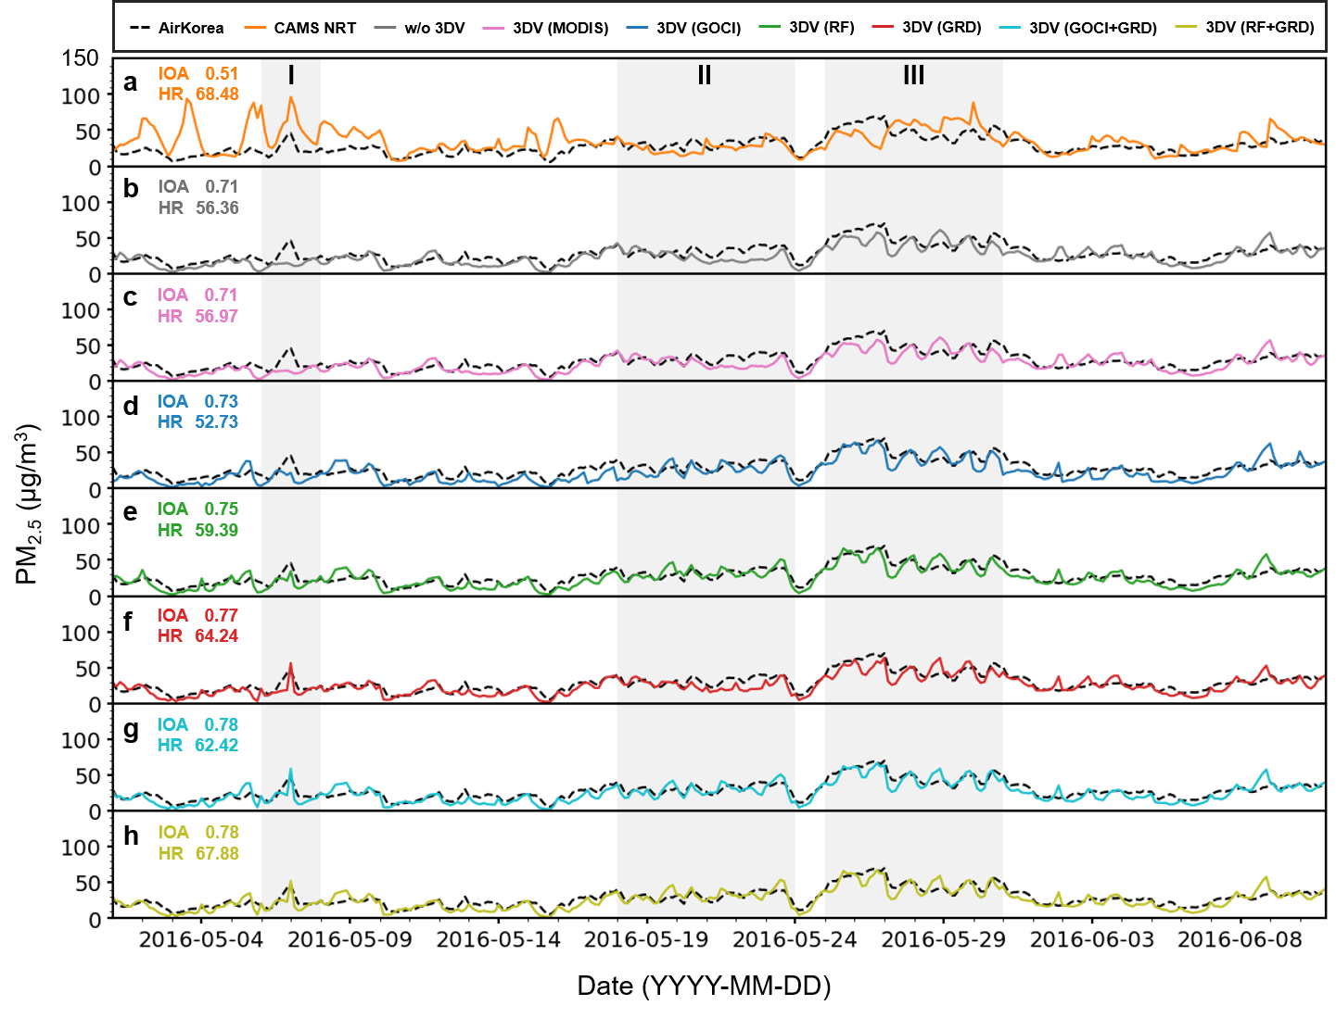

Supplementary Fig. 1 | The same as Fig. 2, except for hourly variations of ground-observed and predicted PM_{2.5} in South Korea.
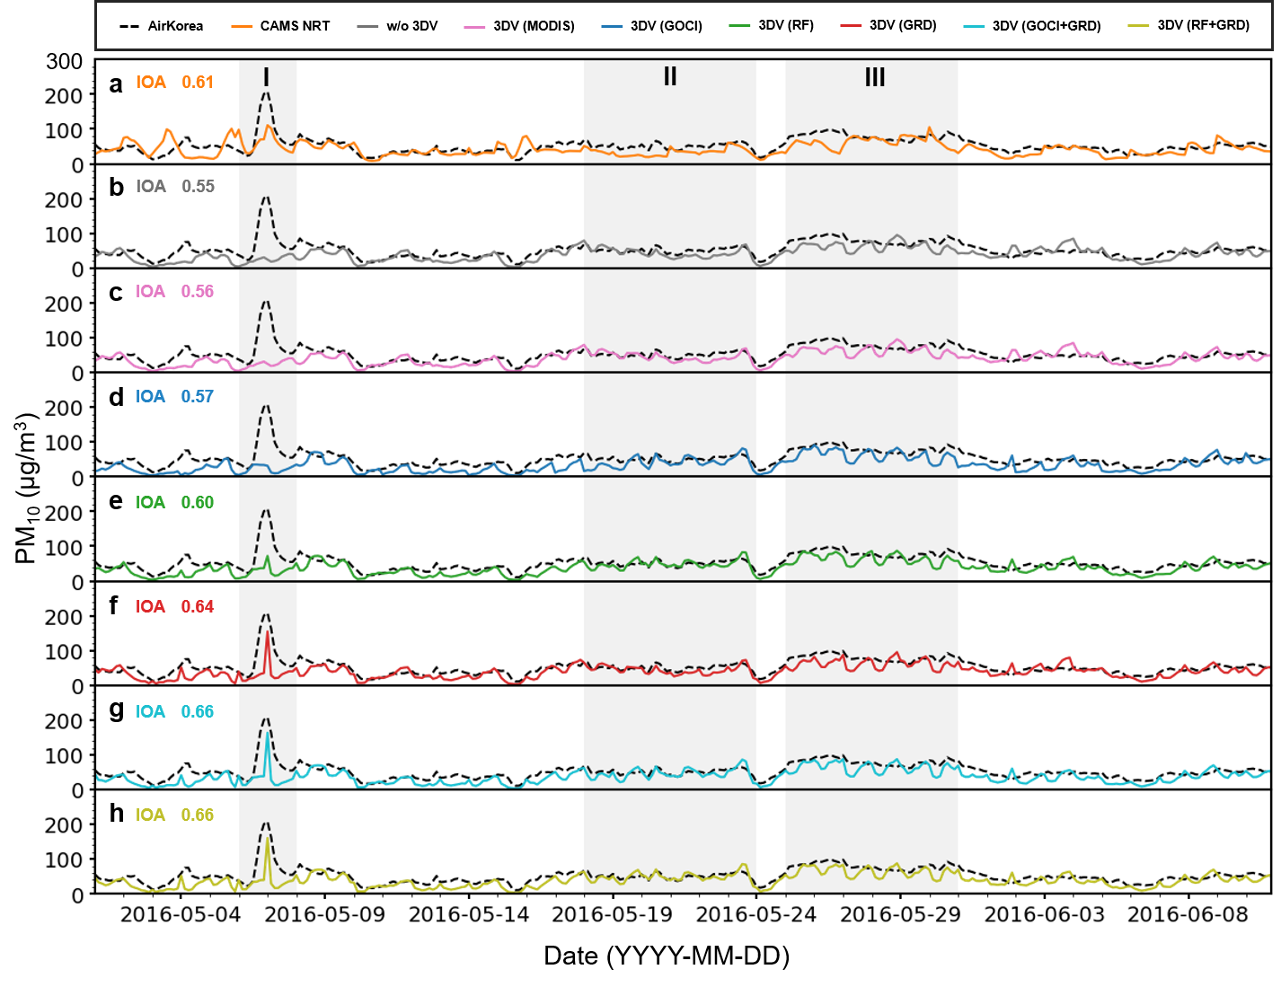

Supplementary Fig. 2 | The same as Fig. 2, except for hourly variations of ground-observed and predicted PM₁₀ in South Korea.
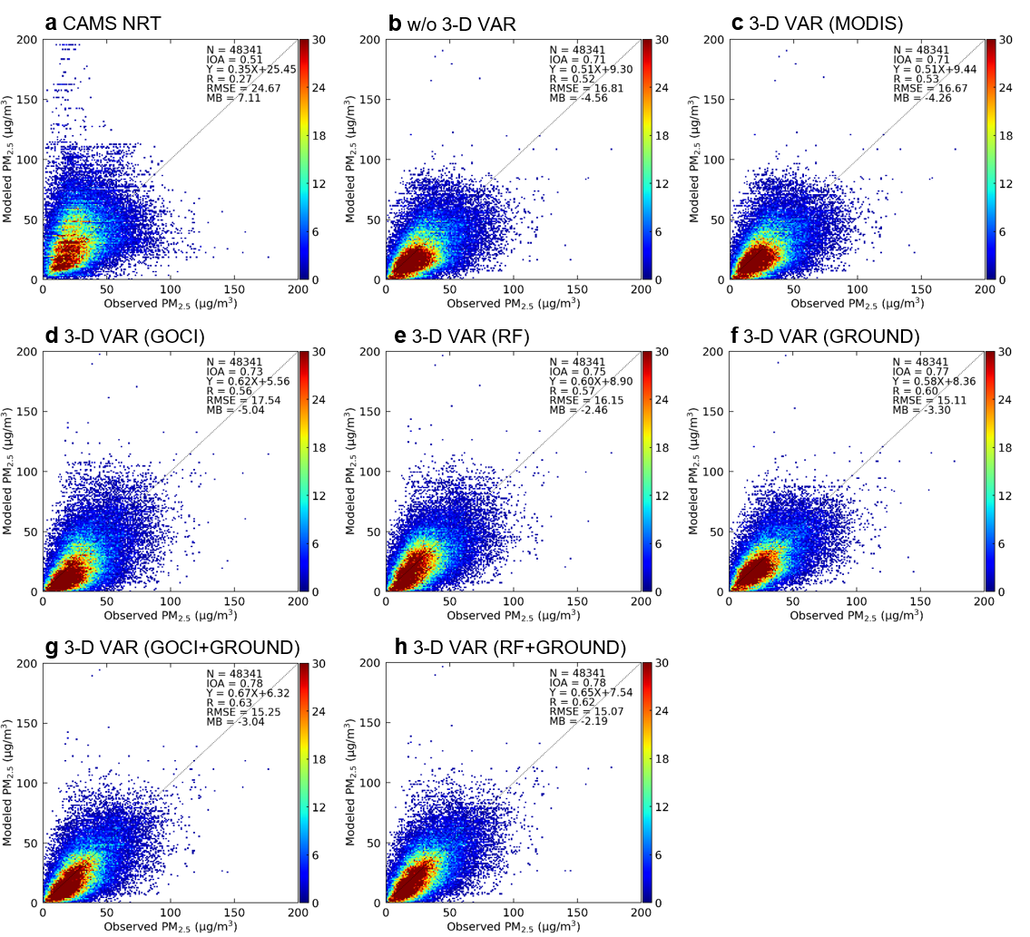

Supplementary Fig. 3 | Observed PM_{2.5} vs. predicted PM_{2.5} at AIR KOREA stations in South Korea. Statistical metrics for the eight cases are shown inside the plots.
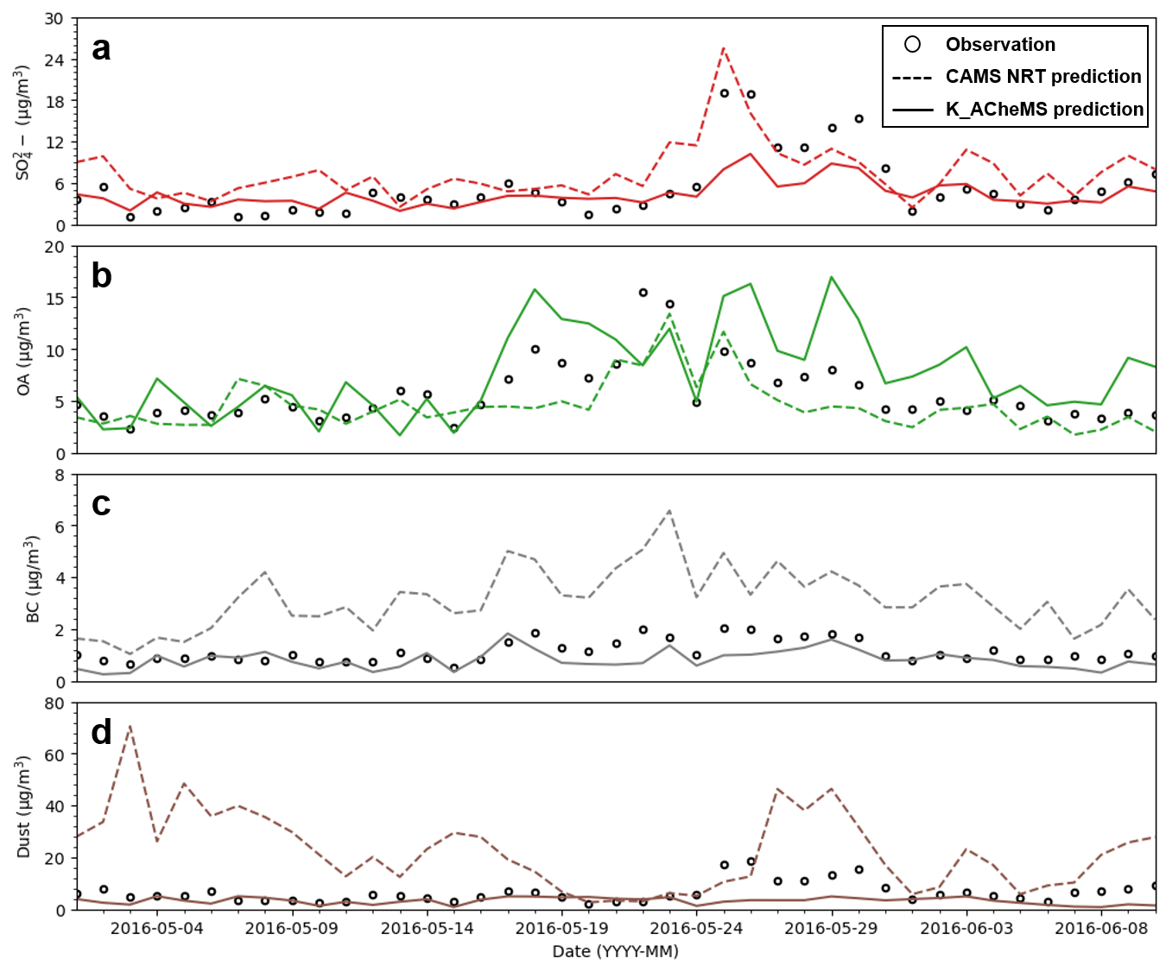

Supplementary Fig. 4 | Comparison between observed and predicted compositions of PM_{2.5} at six intensive measurement stations in South Korea. Solid and dashed lines represent concentrations predicted from the K_ACheMS and CAMS_nrt, respectively. Observed concentrations of OA (organic aerosol) were estimated via multiplying [OC] by 1.6.
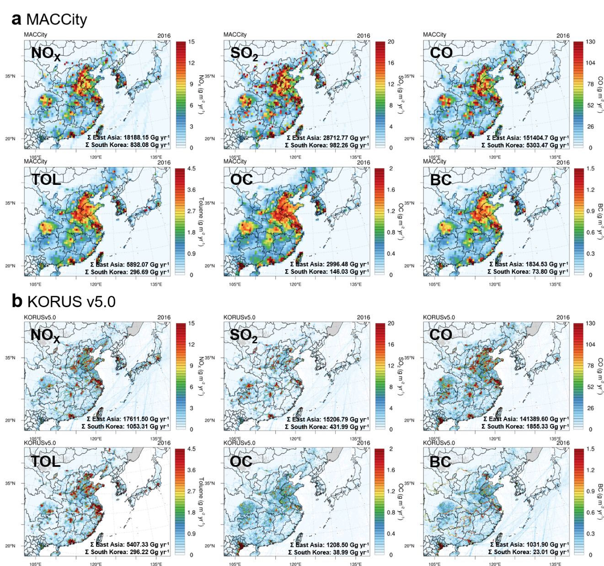

Supplementary Fig. 5 | Comparison of emission fluxes of several important species between MACCity and KORUS v5.0 inventories. Total emission fluxes in East Asia and South Korea are also shown inside the panels.
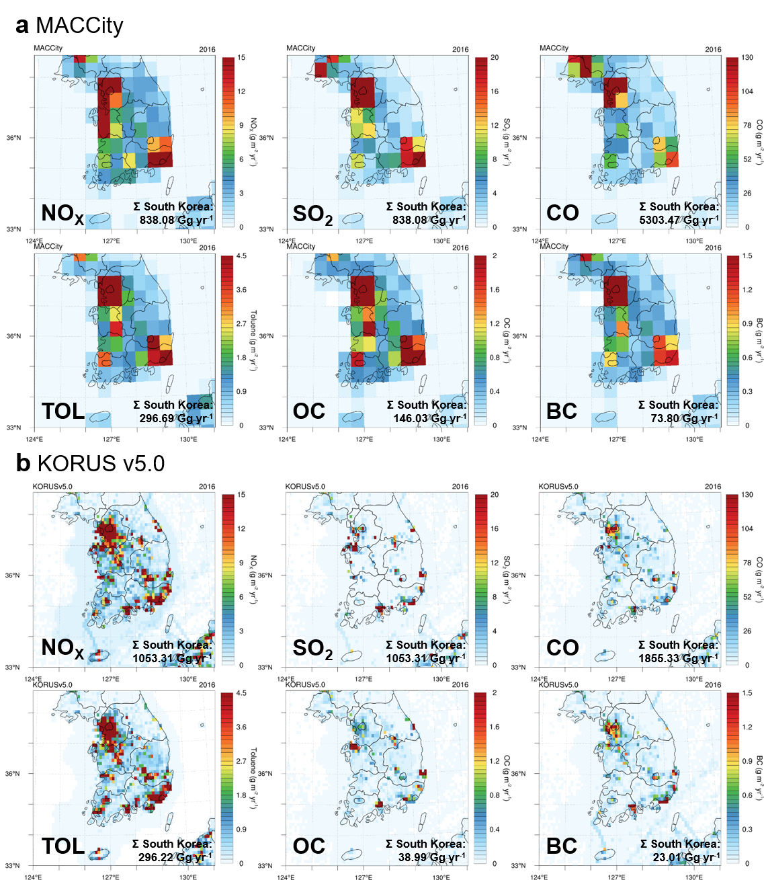

Supplementary Fig. 6 | The same as Supplementary Fig. 5, except for over South Korea.
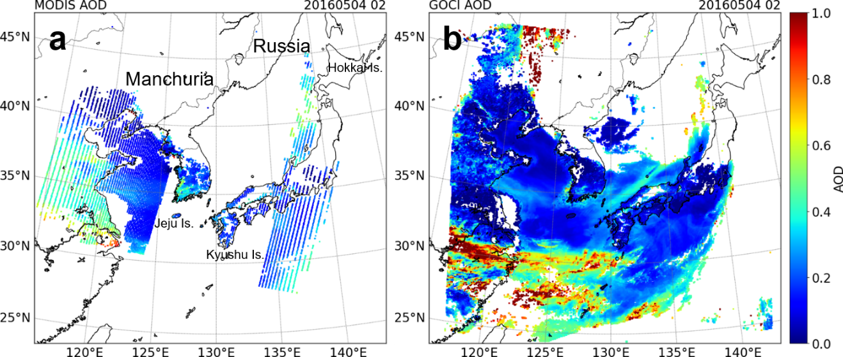

Supplementary Fig. 7 | a MODIS AOD and b GOCI AOD. Spatial distributions of two AOD products are presented over the domain of the GOCI sensor. As shown, no MODIS or GOCI AOD is available over North Korea, Manchuria in China, Eastern edge of Russia, or Hokkai Island in Japan due to the presence of clouds. In panel a, MODIS data are not available over south ocean areas of Jeju and Kyushu Island due to sun-glint effect. These two snapshots were obtained at 02 UTC on 4 May, 2016.
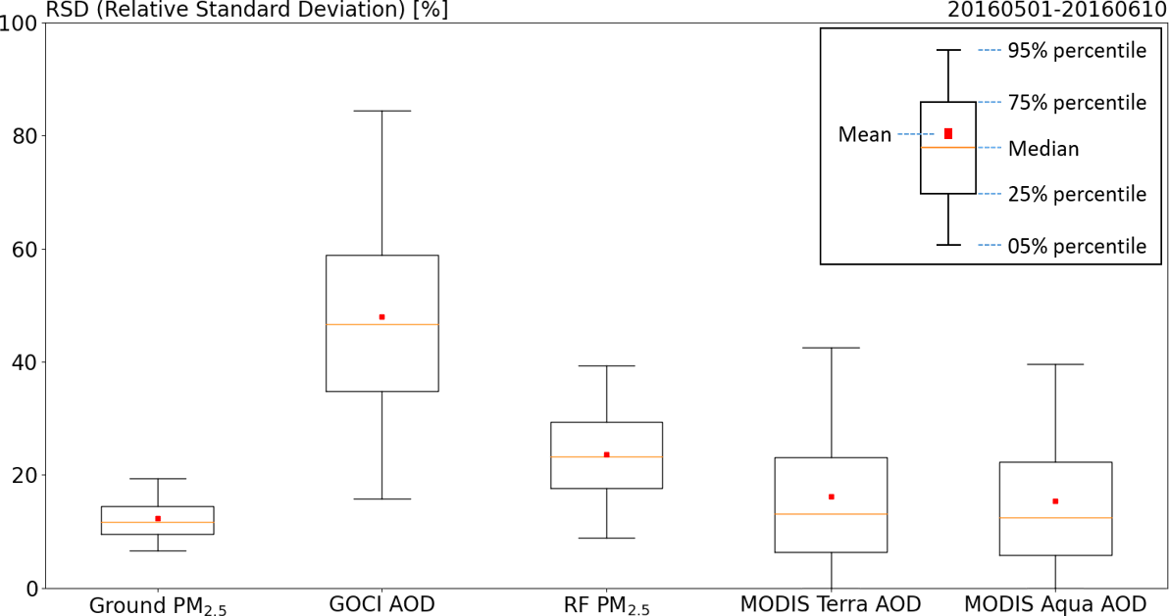

Supplementary Fig. 8 | Relative standard deviations (RSDs) of errors of ground-observed PM_{2.5}, GOCI AOD, PM_{2.5} estimated from RF method, and MODIS AOD products.
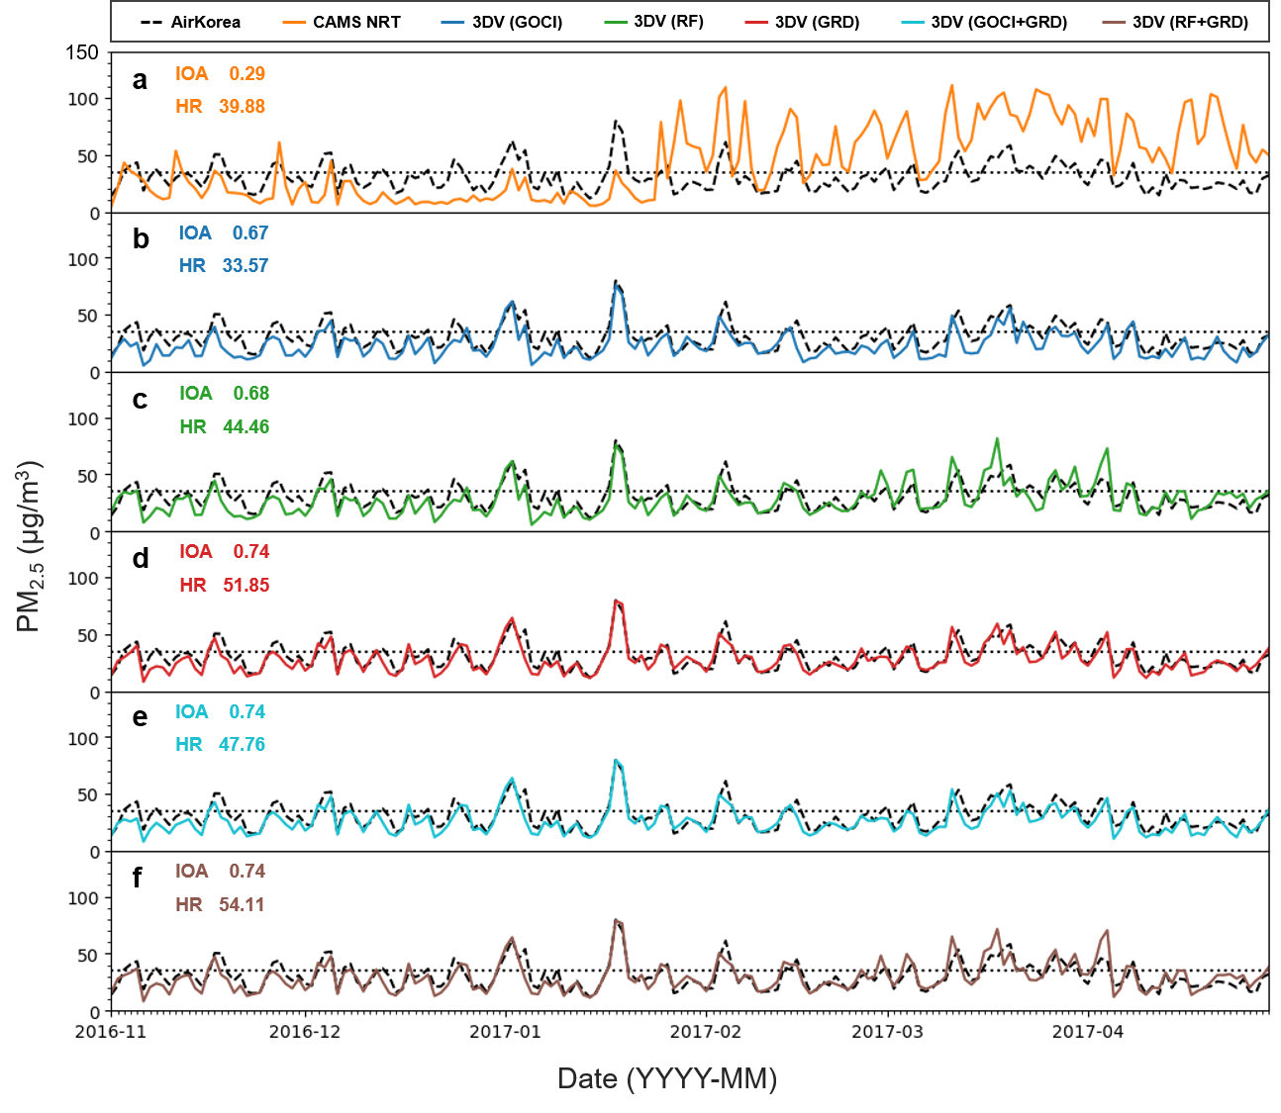

Supplementary Fig. 9 | The same as Fig. 2, except for experiment period between 1 November, 2016 and 30 April, 2017.
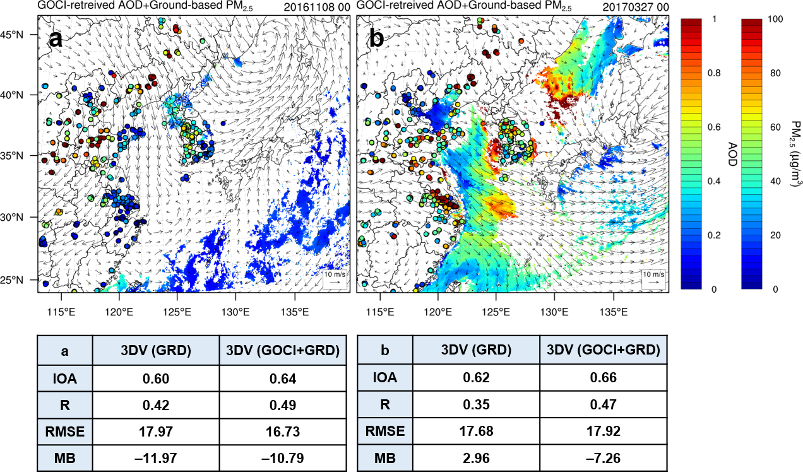

Supplementary Fig. 10 | Two representative plots showing how helpful geostationary satellite-derived information can be in order to enhance PM_{2.5} predictability in South Korea. Two events occurred on 8 November, 2016 and 27 March, 2017, respectively, when GOCI AOD data were available over North Korea (Region II in Fig. 1) and the Yellow Sea (Region I in Fig. 1), respectively. In both cases, GOCI AOD data were available over upwind areas of South Korea. Wind vectors shown with arrows were obtained at 850 hPa.
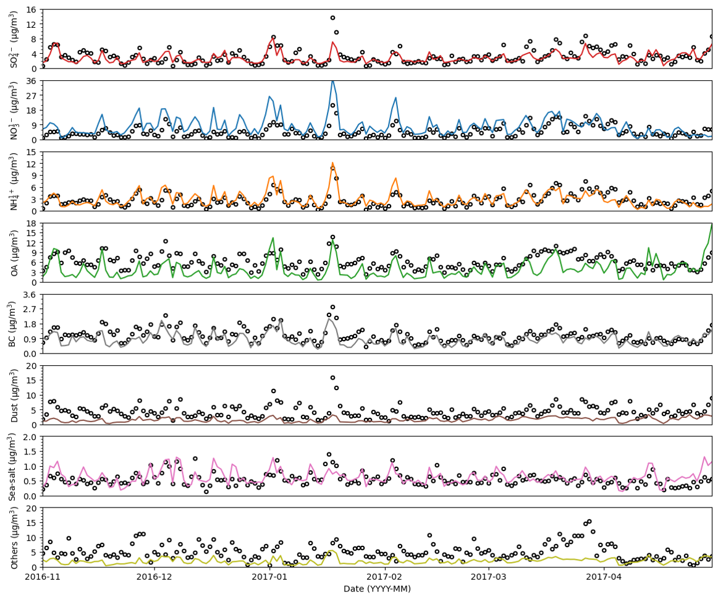

Supplementary Fig. 11 | Comparison between observed and predicted compositions of PM_{2.5} at six intensive measurement stations in South Korea between 1 November, 2016 and 30 April, 2017.
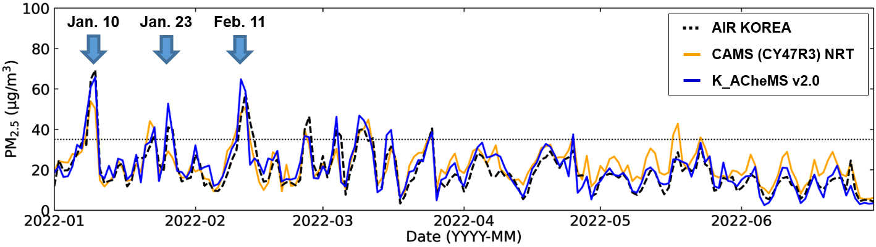

Supplementary Fig. 12 | Comparisons between PM_{2.5} observations (black dashed line) and two PM_{2.5} predictions from K_ACheMS v2.0 (blue solid line) and CAMS (CY47R3) NRT products (yellow solid line). All PM_{2.5} values inside South Korea are aggregated in the plots.
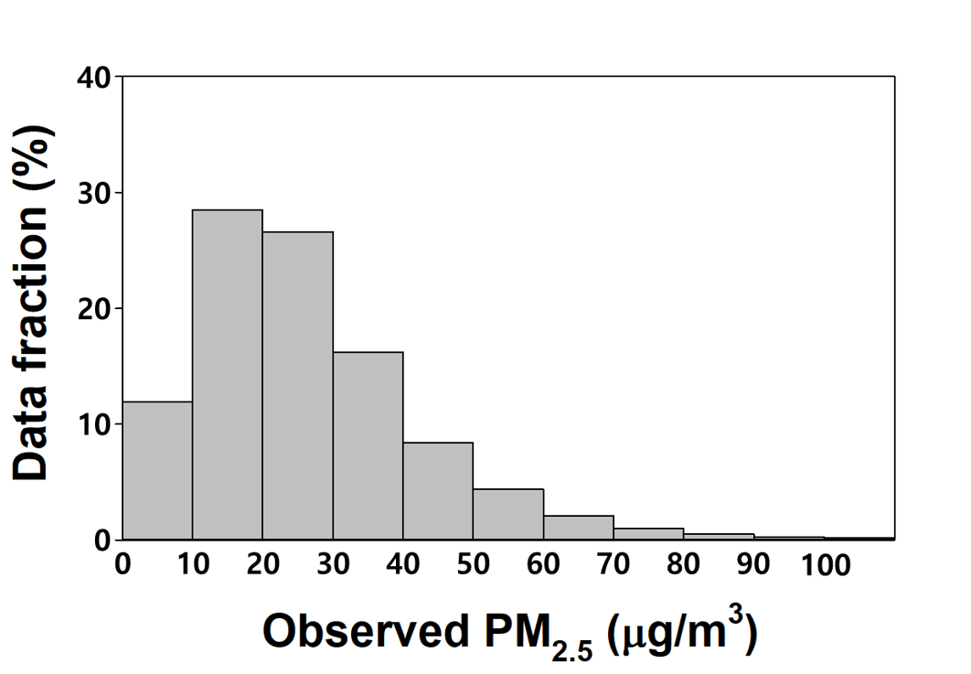

Supplementary Fig. 13 | Distribution of information in the original training dataset.
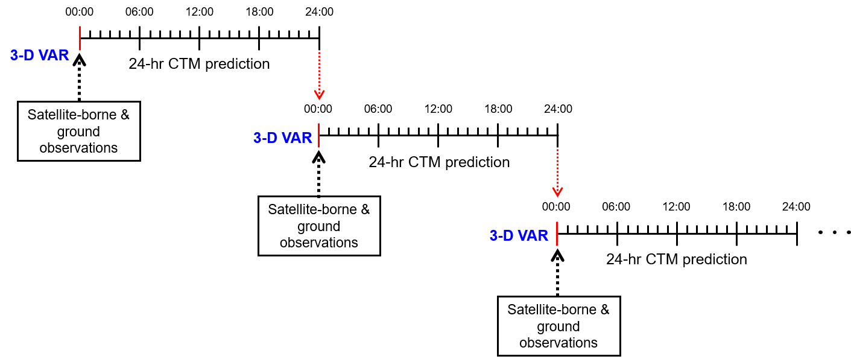

Supplementary Fig. 14 | Schematic diagram for cycle of data assimilations. To update initial conditions, data assimilations were carried out at every 00z with satellite-borne and/or ground observations.
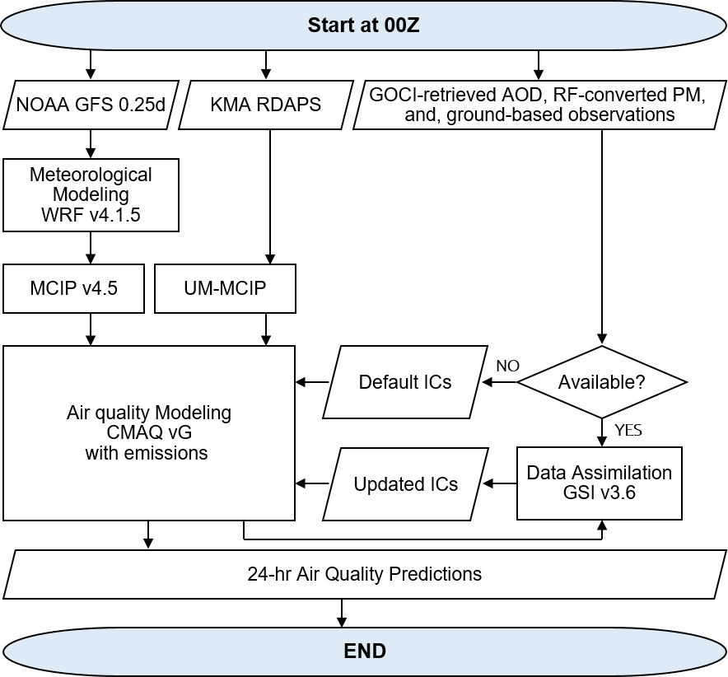

Supplementary Fig. 15 | Schematic diagram for procedures of 24-hr predictions using K_ACheMS v2.0.

Supplementary Table 1 | Global and regional operational air quality prediction systems.
Model name | Organization  (Country) | Species for prediction | Resolution | Data assimilation
C-IFS^{a,†} | ECMWF, CAMS^{n} (EU) | PM_{2.5,} AOD, CO, O₃, NO, NO₂, SO₂, desert dust, sea-salt, organic matter, BC, SO₄^{2–}, NH₄⁺, NO₃–, and etc. | 0.4°×0.4° | 4-D VAR
GEOS-Chem^{b,†} | NASA, GMAOº  (USA) | CO, NO₂, O₃, PM_{2.5}, and SO₂ | 0.25°×0.25° | -
CHIMERE^{c,‡} | INERIS, CNRS^{p} (France) | CO, NMVOCs, PM_{2.5}, PANs, NH₃, NO₂, PM₁₀, SO₂, NO, O₃, and EC | 0.1°×0.1° | Kriging-based analysis
EMEP^{d,‡} | MET Norway^{q}  (Norway) | CO, NMVOCs, PM_{2.5}, PANs, NH₃, NO₂, PM₁₀, SO₂, NO, O₃, and EC | 0.125°×0.0625° | 3-D VAR
EURAD-IM^{e,‡} | FZJ-IEK8^{r}  (Germany) | CO, NMVOCs, PM_{2.5}, PANs, NH₃, NO₂, PM₁₀, SO₂, NO, O₃, and EC | 9×9 km² | 3-D VAR
LOTOS-EUROS^{f,‡} | KNMI, TNO^{s} (Netherlands) | CO, NMVOCs, PM_{2.5}, PANs, NH₃, NO₂, PM₁₀, SO₂, NO, O₃, and EC | 0.1°×0.1° | EnKF
MATCH^{g,‡} | SMHI^{t}  (Sweden) | CO, NMVOCs, PM_{2.5}, PANs, NH₃, NO₂, PM₁₀, SO₂, NO, O₃, and EC | 0.1°×0.1° | 3-D VAR
MOCAGE^{h,‡} | Meteo-France^{u}  (France) | CO, NMVOCs, PM_{2.5}, PANs, NH₃, NO₂, PM₁₀, SO₂, NO, O₃, and EC | 0.1°×0.1° | 3-D VAR
SILAM^{i,‡} | FMI^{v}  (Finland) | CO, NMVOCs, PM_{2.5}, PANs, NH₃, NO₂, PM₁₀, SO₂, NO, O₃, and EC | 0.1°×0.1° | 3-D VAR
DEHM^{j,‡} | Aarhus University  (Denmark) | CO, NMVOCs, PM_{2.5}, PANs, NH₃, NO₂, PM₁₀, SO₂, NO, O₃, and EC | 18×18 km² | OI
GEM-AQ^{k,‡} | IEP-NRI^{w}  (Poland) | CO, NMVOCs, PM_{2.5}, PANs, NH₃, NO₂, PM₁₀, SO₂, NO, O₃, and EC | 0.1°×0.1° | OI
Ensemble*,‡ | ECMWF (EU) | CO, NMVOCs, PM_{2.5}, PANs, NH₃, NO₂, PM₁₀, SO₂, NO, O₃, and EC | 0.1°×0.1° | -
NAQFC^{l,‡} | NCEP, NOAA^{x} (USA) | O₃, smoke, dust, and PM_{2.5} | 12×12 km² | -
NAQPMS^{m,‡} | CAS, IAP^{y} (China) | PM₁₀, PM_{2.5}, CO, O₃, SO₂, and NO₂ | 15×15 km² | EnKF
ª Integrated Forecasting System with Atmospheric Composition
^{b} Goddard Earth Observing System with Chemistry
^{c} Modèle de chimie-transport
^{d} European Monitoring and Evaluation Programme
^{e} EURopean Air Pollution Dispersion-Inverse Model
^{f} LOng Term Ozone Simulation-EURopean Operational Smog
^{g} Mesoscale Atmospheric Transport and Chemistry Model
^{h} MOdèle de Chimie Atmosphérique de Grande Échelle
^{i} System for Integrated modeLing of Atmospheric coMposition
^{j} Danish Eulerian Hemispheric Model
^{k} Global Environmental Multiscale model with Air Quality processes
^{l} National Air Quality Forecasting Capability
^{m} Nested Air Quality Prediction Modeling System
^{n} European Centre for Medium-Range Weather Forecasts, Copernicus Atmospheric Monitoring Service
º National Aeronautics and Space Administration, Global Modeling and Assimilation Office
^{p} Institut national de l'environnement industriel et des risques, Centre national de la recherche scientifique
^{q} Norwegian Meteorological Institute
^{r} ForschungsZentrum Jülich - Institut für Energie und Klimaforschung (IEK-8)
^{s} Koninklijk Nederlands Meteorologisch Instituut
^{t} Swedish Meteorological and Hydrological Institute
^{u} French national meteorological service
^{v} Finnish Meteorological Institute
^{w} Institute of Environmental Protection - National Research Institute
^{x} National Centers for Environmental Prediction, National Oceanic and Atmospheric Administration
^{y} Chinese Academy of Science, Institute of Atmospheric Physics
* Ensemble prediction members over Europe are the CHIMERE, EMEP, EURAD-IM, LOTOS-EUROS, MATCH, MOCAGE, SILAM, DEHM, and GEM-AQ
† Global forecast system
‡ Regional forecast system

Supplementary Table 2 | Main elements of K_ACheMS v2.0.
Main modules |  | Elements
Input Data | Meteorology | WRF & UM
Input Data | Emissions | Anthropogenic Emission: KORUS vG  Biogenic Emission: MEGAN v2.1  Pyrogenic Emission: FINN v1.5
Input Data | Observations | Ground observations &  Satellite-derived AOD
Input Data | Data Assimilation | 3-D VAR and EnKF methods
Chemistry-Transport  model | Gaseous chemistry | SAPRC07TC with modifications
Chemistry-Transport  model | Aerosol module | AERO6 with modified SOA yields
Chemistry-Transport  model | Transport | KF scheme for convection  TG scheme for advection
Machine Learning  Modules | AI forecaster | DRNN LSTM module
Machine Learning  Modules | Bias and error corrector | XGBoost module
Policy Module | S-R relationship | DDM-PIM method

Supplementary Table 3 | Model configurations of K_ACheMS v2.0 and C-IFS.
Modeling system |  | K_ACheMS | C-IFS
Version |  | v2.0 | Cycle 41R1* |  | Cycle 43R1† | Cycle 47R3‡
Meteorological Fields |  | WRF v4.1.5  KMA RDAPS | IFS (Cycle 41R1) |  | IFS (Cycle 43R1) | IFS (Cycle 47R3)
Emissions | Anthropogenic | KORUS v5.0 | MACCity |  | MACCity | CAMS_GLOB_ANT v4.2
Emissions | Biogenic | MEGAN v2.1 | MEGAN-MACC  POET |  | MEGAN-MACC  POET | CAMS_GLOB_BIO v1.1
Emissions | Pyrogenic | FINN v1.5 | GFAS v1.2 |  | GFAS v1.2 | GFAS v1.4
Gas-phase chemistry |  | Modified SAPRC07TC | Modified CB05 with  Cariolle scheme (for stratospheric ozone photochemistry)
Aerosol Thermodynamics |  | ISORROPIA II | CAMS bulk aerosol model
SOA formation |  | Two product yield approach (or VBS) with new smog chamber data | SOA formation from natural VOCs based on scale factor to terpene emissions | SOA formation from natural and anthropogenic VOCs based on scale factors to terpene and CO emissions
* This version was used for a period between September 2015 and January 2017; † This version was used for a period between January 2017 and September 2017; ‡ This version has been used for a period between February 2022 and present time.

Supplementary Table 4 | Several formulae proposed to estimate relative standard deviations (RSDs) of errors of measured products.
Products | Land | Ocean | References
Ground PM | $${ ϵ}_{PM}=\sqrt{ϵ_{o}^{2}+ϵ_{r}^{2}}$$  $${ ϵ}_{o}=1.5+0.0075×x_{o}$$  $${ ϵ}_{r}=0.5ϵ_{o}\sqrt{\frac{Δx}{L}}$$ | - | Elbern et al. ³⁷
GOCI AOD | $$0.184×τ_{GOCI}+0.061$$ | $$0.206×τ_{GOCI}+0.030$$ | Choi et al. ³⁵
RF PM | $$0.341×C_{RF PM}$$ | - | Park et al. ³⁶
MODIS AOD | $$0.154×τ_{MODIS}+0.05$$ | $$0.05×τ_{MODIS}+0.03$$ | Remer et al. ³⁸
$ϵ_{o}$: Measurement error; $ϵ_{r}$: Representative error; $x_{o}$: Observed value;$Δx$: Grid spacing; $L$: Scaling factor; $τ_{GOCI}$: GOCI-retrieved AOD;$C_{RF PM}$: RF-derived PM; $τ_{MODIS}$: MODIS-retrieved AOD

Supplementary Table 5 | Air quality standards of South Korea.
 | Good | Moderate | Bad  (unhealthy) | Very Bad  (very unhealthy)
PM_{2.5}  (μg/m³) | 0–15 | 16–35 | 36–75 | > 76
PM₁₀  (μg/m³) | 0–30 | 31–80 | 81–150 | > 151
O₃  (ppm) | 0–0.03 | 0.031–0.09 | 0.091–0.15 | > 0.151
NO₂  (ppm) | 0–0.03 | 0.031–0.06 | 0.061–0.2 | > 0.201
CO  (ppm) | 0–2 | 2.1–9 | 9.1–15 | > 15.1
SO₂  (ppm) | 0–0.02 | 0.021–0.05 | 0.051–0.15 | > 0.151

Supplementary Table 6 | Categories of air pollution in South Korea.
Model | Very Bad | A4 | B4 | C4 | D4
Model | Bad | A3 | B3 | C3 | D3
Model | Moderate | A2 | B2 | C2 | D2
Model | Good | A1 | B1 | C1 | D1
 |  | Good | Moderate | Bad | Very Bad
 |  | Observation
I=A1+A2+B1+B2; II=C1+C2+D1+D2; III=A3+A4+B3+B4; IV=C3+C4+D3+D4.

Supplementary Table 7 | Comparison between CAMS (CY47R3) NRT and K_ACheMS v2.0 PM_{2.5} predictions in terms of scientific statistical metrics.
Models | IOA | R | RMSE* | MB*
CAMS (CY47R3) NRT | 0.76 | 0.61 | 12.86 | 2.95
K_ACheMS v2.0 | 0.78 | 0.62 | 13.80 | 1.35
* The unit is μg/m³.

Supplementary Table 8 | Comparison between CAMS (CY47R3) NRT and K_ACheMS v2.0 PM_{2.5} predictions in terms of administrative statistical metrics.
Models | ACC* | HR* | POD* | FAR*
CAMS (CY47R3) NRT | 67.70 | 54.08 | 56.46 | 46.28
K_ACheMS v2.0 | 72.25 | 66.78 | 70.89 | 36.70
* The unit is %.

Supplementary Table 9 | Correction accuracies from several different decision tree-based ensemble models.
Ensemble Model | Statistical parameter
Ensemble Model | IOA | R | RMSE* | MB*
CatBoost | 0.63 | 0.49 | 15.76 | 1.60
AdaBoost | 0.57 | 0.45 | 16.06 | 1.12
Light GBM | 0.61 | 0.48 | 15.39 | –0.17
Random Forest | 0.54 | 0.44 | 16.16 | 0.20
XGBoost | 0.66 | 0.51 | 14.53 | –0.39
* The unit is μg/m³.

Supplementary Table 10 | Performance comparisons between data balancing algorithms.
Data balancing algorithm | Statistical parameter |  |  |  | HR
Data balancing algorithm | IOA | R | RMSE* | MB* | HR
w/o data balancing | 0.66 | 0.51 | 14.53 | –0.39 | 47.88
Oversampling | 0.66 | 0.52 | 14.40 | 1.03 | 56.40
Gaussian noise | 0.67 | 0.52 | 14.05 | 0.07 | 55.76
SMOTEENN | 0.71 | 0.53 | 14.83 | 2.25 | 75.15
* The unit is μg/m³.

