SUPPORTING INFORMATION
Unravelling the anticancer potential of a square planar copper complex: toward non-platinum chemotherapy
Manzoor Ahmad Malik¹, Md Kausar Raza^{2†}, Arif Mohammed³, Mohmmad Younus Wani^{4*}, Athar Adil Hashmi¹*
¹Bioinorganic Lab., Department of Chemistry, Jamia Millia Islamia, New Delhi 110025, India.²Department of Inorganic and Physical Chemistry, Indian Institute of Science, Bangalore 560012, India.³University of Jeddah, College of Science, Department of Biology, Jeddah 21589, Saudi Arabia.⁴University of Jeddah, College of Science, Department of Chemistry, Jeddah 21589, Saudi Arabia. †Division of Chemistry and Chemical Engineering, California Institute of Technology, Pasadena, CA 91125, United States

Correspondence: mwani@uj.edu.sa (MYW); ahashmi@jmi.ac.in (AAH)

ORCID: https://orcid.org/0000-0002-1838-1337 (MYW)
https://orcid.org/0000-0002-7854-8290 (AAH)

Table of Contents
Scheme
Scheme S1. Synthetic scheme for the ligand (SB) and the complexes C1-C3.
Figures
Figure S1. IR spectrum of SB in solid phase
Figure S2. IR spectrum of complex C1 in solid phase
Figure S3. IR spectrum of complex C2 in solid phase
Figure S4. IR spectrum of complex C3 in solid phase
Figure S5. Mass spectrum of ligand SB in MeOH
Figure S6. Mass spectrum of complex C1 in MeOH
Figure S7. Mass spectrum of complex C2 in MeOH
Figure S8. Mass spectrum of complex C3 in MeOH
Figure S9. ¹HNMR spectrum of ligand SB in DMSO-d6
Figure S10. ¹³C NMR spectrum of ligand SB in DMSO-d6
Figure S11. TG curves of complexes C1-C3.
Figure S12. Unit cell packing diagram of ligand SB
Tables
Table T1. Selected crystallographic data and structure refinement for Ligand (SB).
Table T2. Selected bond distances (Å) and angles (°) for the ligand SB
Scheme S1. Synthesis of Schiff base ligand and its metal [Cu(C1), Ni(C2) and Co(C3)] complexes in 2:1 (L:M) ratio.

Fig. S1. IR spectrum of SB in solid phase
Fig. S2. IR spectrum of complex C1 in solid phase
Fig. S3. IR spectrum of complex C2 in solid phase
Fig. S4. IR spectrum of complex C3 in solid phase

Fig. S5. Mass spectrum of ligand SB
Fig. S6. Mass spectrum of complex C1 in MeOH

Fig. S7. Mass spectrum of complex C2 in MeOH

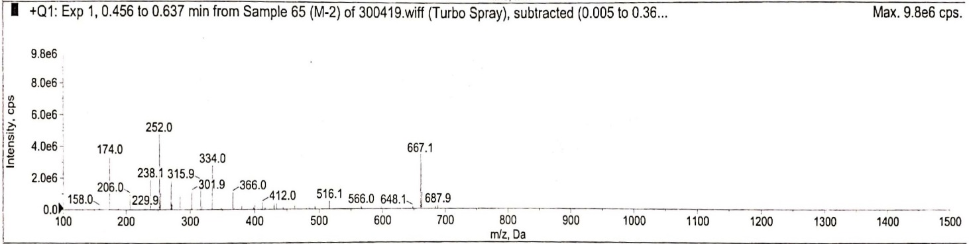
Fig. S8. Mass spectrum of complex C3 in MeOH.

Fig. S9. ¹H-NMR spectrum of the Schiff base (SB) ligand.

Fig. S10. ¹³C NMR spectrum of ligand SB

Figure S11. TG curves of complexes C1-C3.

Figure S13a. Unit cell packing diagram of the ligand SB without hydrogen.

Table T1. Selected crystallographic data and structure refinement for Ligand (SB).
Empirical formula  Formula weight  Temperature  Wavelength  Crystal system  Space group  a/ Å  b/ Å  c/ Å  α°  β°  γ°  Volume/Å ³  Z  T/K  Density_{calcd}/Mg m⁻³  Data/restraints/param  F(000)  GOF  Reflections collected  Largest diff peak, hole (e Å⁻³)  Final R indexes [I>=2σ (I)] | C₁₉H₁₅NO₃  305.11  296(2) K  0.71073 Å  Orthorhombic  P n a 21  21.472(4) Å  5.0739(10) Å  13.630(3) Å  90 °  90 °  90 °  1484.9(5)  4  296(2)K  1.361  1010/1/208  636  0.822  1010  0.094, -0.127  R₁₌0.0323, wR₂= 0.0862

Table T2. Bond distances (Å) and bond angles (°) for the Schiff base ligand (SB).
Bond distances (A°) | Bond angles (°)
O1 C10 1.377(9)  O1 C11 1.412(9)  O2 C13 1.363(8)  O2 C14 1.429(9)  O3 C15 1.324(10)  N1 C6 1.275(8)  N1 C7 1.412(9)  C1 C2 1.374(10)  C1 H1 0.9300  C5 C15 1.403(10)  C5 C6 1.420(10)  C6 H7 0.9300  C11 H3 0.9700  C11 H2 0.9700  C14 H5 0.9700  C14 H6 0.9700 | C10 O1 C11 112.9(7)  C6 N1 C7 122.1(7)  C1 C2 C3 120.1(7)  C2 C3 C17 121.5(10)  C3 C4 C5 120.5(9)  N1 C6 C5 124.6(8)  N1 C6 H7 117.7  C5 C6 H7 117.7  C12 C7 N1 124.2(8)  O1 C10 C9 117.2(9)  O1 C11 C14 113.2(6)  O1 C11 H3 108.9  O1 C11 H2 108.9  C7 C12 C13 121.4(8)  O2 C13 C10 122.5(9)  O3 C15 C5 123.6(8)

