Supplementary information
Title: Interaction between root exudates and rhizosphere microorganisms facilitates the expansion of poisonous plants in degraded grassland
Wenyin Wang^{1#}, Tianhua Jia^{1#}, Tianyun Qi¹, Shanshan Li², A. Allan Degen³, Jin Han¹, Yanfu Bai¹, Tao Zhang¹, Shuai Qi¹, Mei Huang¹, Zihao Li¹, Jianxin Jiao², Zhanhuan Shang^{1, 5, 6}*
1 State Key Laboratory of Grassland Agro-Ecosystems, School of Life Sciences, Lanzhou University, Lanzhou, 730000, China.
2 State Key Laboratory of Grassland Agro-Ecosystems, College of Pastoral Agriculture Science and Technology, Lanzhou University, Lanzhou 730020, China.
3 Desert Animal Adaptations and Husbandry, Wyler Department of Dryland Agriculture, Blaustein Institutes for Desert Research, Ben-Gurion University of the Negev, Beer Sheva 8410500, Israel.
4 Qinghai Provincial Key Laboratory of Restoration Ecology of Cold Areas, Northwest Institute of Plateau Biology, Chinese Academy of Science; Xining, 810008, China.
5 Qinghai Provincial Key Laboratory of Adaptive Management on Alpine Grassland, Qinghai Academy of Animal and Veterinary Science, Qinghai University, Xining 810016, China.
# equal contribution by authors
*Corresponding author: Zhanhuan Shang, E-mail: shangzhh@lzu.edu.cn (Z. Shang)
This file includes:
Figure S1 to S6
Table S1 to S6
Appendix S1

Appendix S1: The process of grassland degradation and some sampling plants
The emergence and spread of poisonous weeds are considered an early sign of grassland degradation [1]. The dense roots and vegetation litter in the turf layer form a mixture of humus with high nutrients and soil in the alpine meadow. The degradation progresses rapidly on the grass felt layer with the invasion of poisonous plants, forming lightly degraded native grassland (L). The grassland degrades further with the rapid propagation of poisonous plants [2, 3, 4]. Once the turf layer is displaced or removed, the underlying layer is equivalent to the bare soil layer. The formation and expansion of degraded patches are key characteristics of alpine meadow degradation [3]. This landscape is called bare land and is considered moderate degraded native grassland (M) [5]. Communities dominated by Gramineae and Cyperaceae are difficult to grow on bare land, while poisonous plant species grow well. The population of poisonous plants gradually increase and become the dominant plants [6], creating heavily degraded native grassland (H). A landscape of secondary vegetation of poisonous plants is present in the warm season, while it is completely bare in the cold season. The heavily degraded native grassland does not have the ability to restore itself. In recent years, restoration specialists have used a mixture of native plants, namely, Elymus nutans, Poa crymophila, Poa pratensis, and Leymus secalinus, to restore the extremely degraded grassland at high altitude areas of the Qinghai-Tibetan Plateau [5]. However, poisonous plants return after 3-4 years of mixed seeding, causing perennial sown grassland to rapidly degrade (degraded sown grassland, S) [5].
- Zhang ZC, Sun J, Liu M, Xu M, Wang Y, Wu GL, et al. Don’t judge toxic weeds on whether they are native but on their ecological effects. Ecol Evol. 2020;10(17):9014-9025.
- Chen JJ, Yi SH, Qin Y. The contribution of plateau pika disturbance and erosion on patchy alpine grassland soil on the Qinghai-Tibetan Plateau: Implications for grassland restoration. Geoderma. 2017;297:1-9.
- Lin L, Li YK, Xu XL, Zhang FW, Du YG, Liu SL, et al. Predicting parameters of degradation succession processes of Tibetan Kobresia grasslands. Solid Earth. 2015;6(4):1237-1246.
- Harris RB. Rangeland degradation on the Qinghai-Tibetan plateau: A review of the evidence of its magnitude and causes. J Arid Environ. 2010;74(1):1-12.
- Dong SK, Shang ZH, Gao JX, Boone RB. Enhancing sustainability of grassland ecosystems through ecological restoration and grazing management in an era of climate change on Qinghai-Tibetan Plateau. Agr Ecosyst Environ. 2020;287:106684.
- Ricciardi A, Blackburn TM, Carlton JT, Dick JTA, Hulme PE, Iacarella JC, et al. Invasion science: a horizon scan of emerging challenges and opportunities. Trends Ecol Evol. 2017;32(6):464-474.

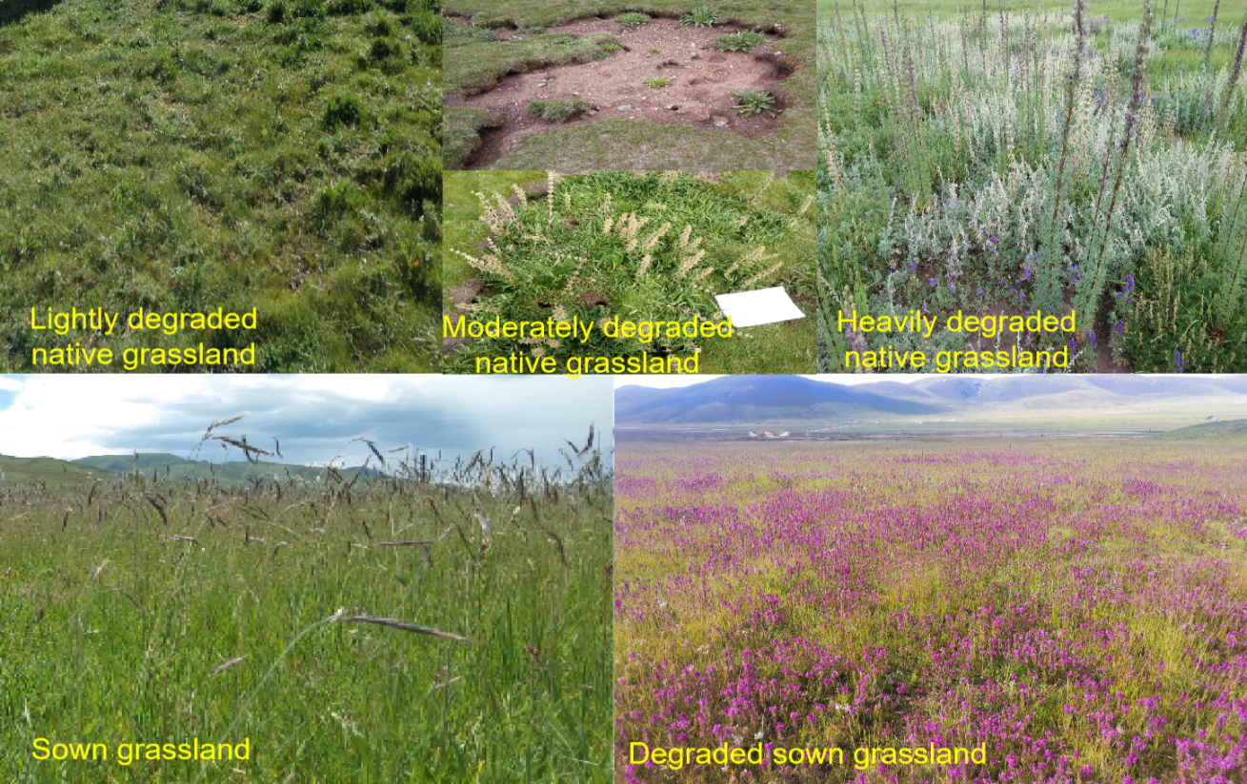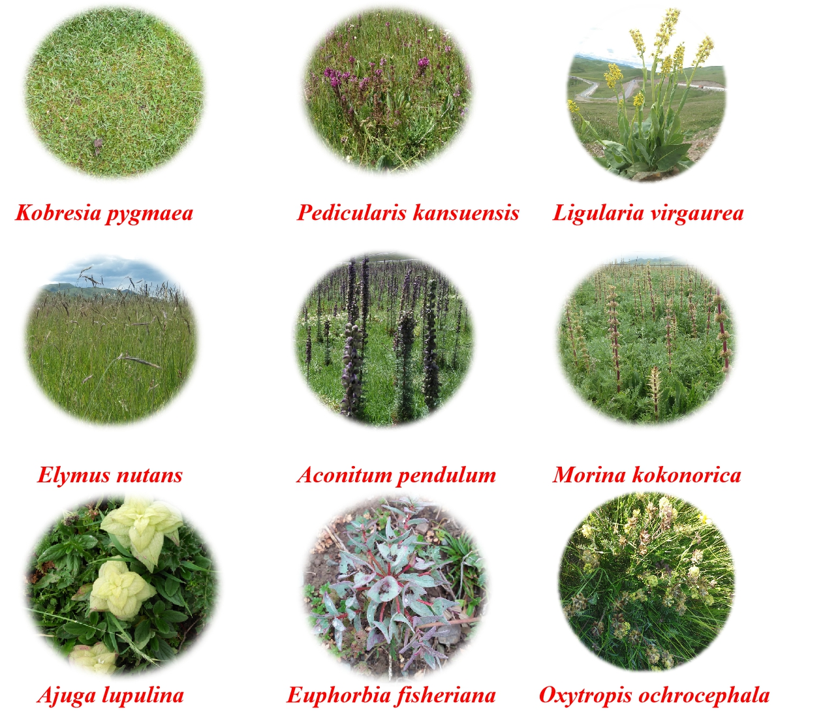
Extra Sampling habitats (Top) and some of the plant species (bottom)
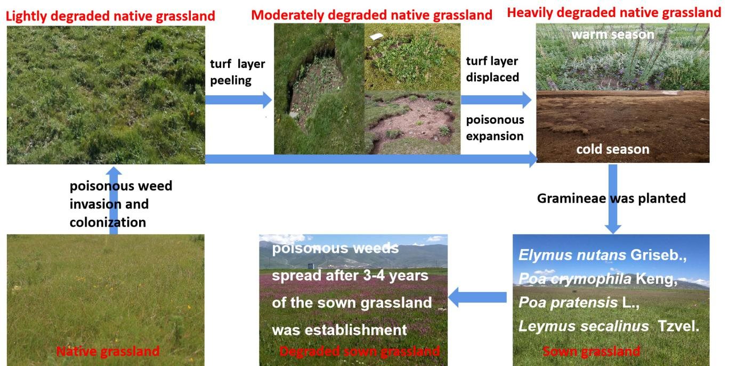
Figure S1. Sampling site and native grassland degraded process
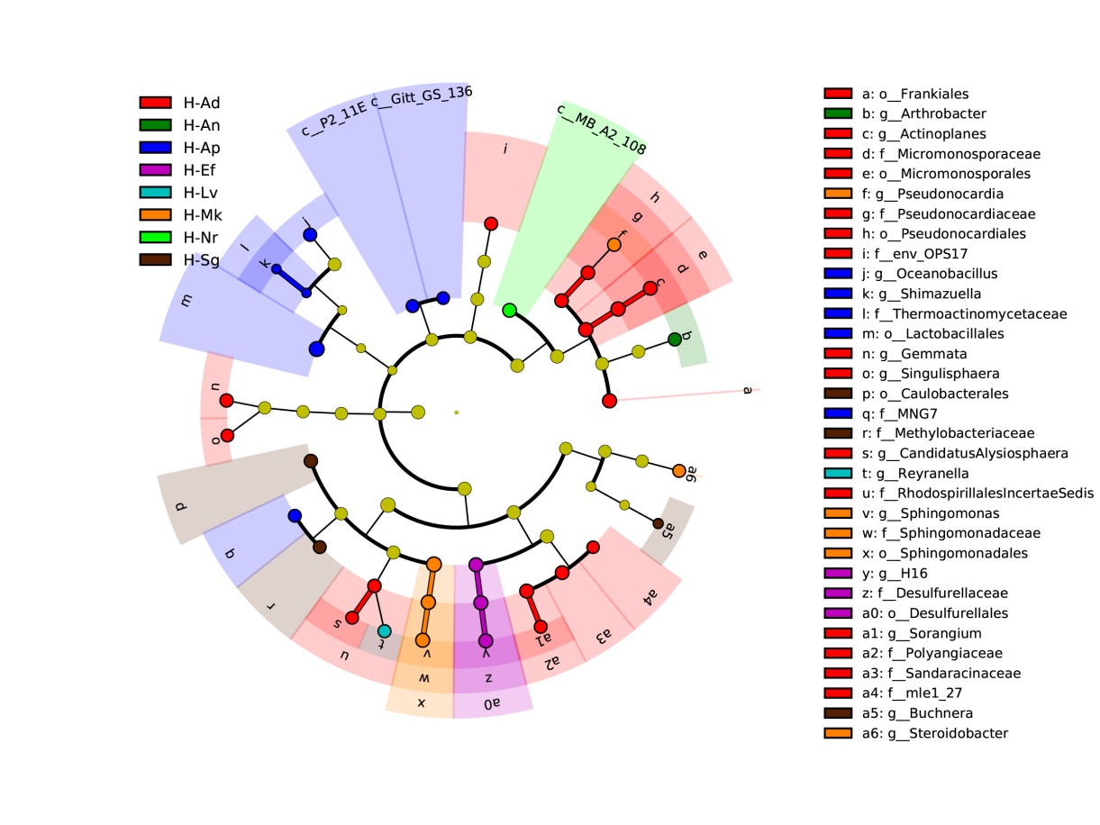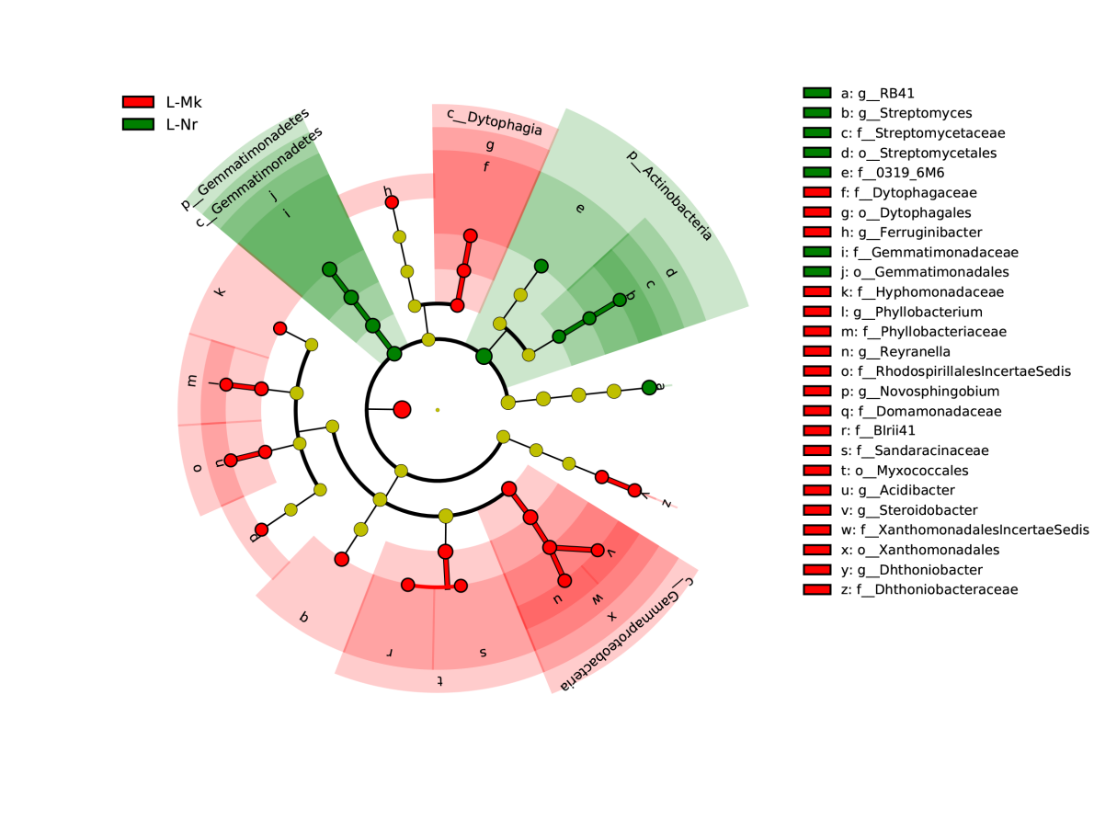
b
a
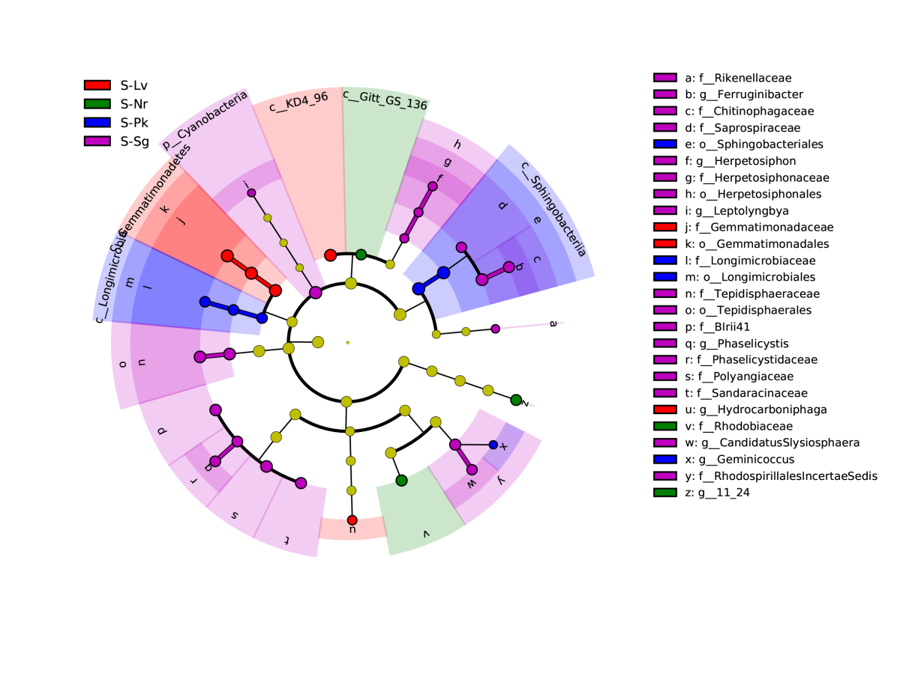
c
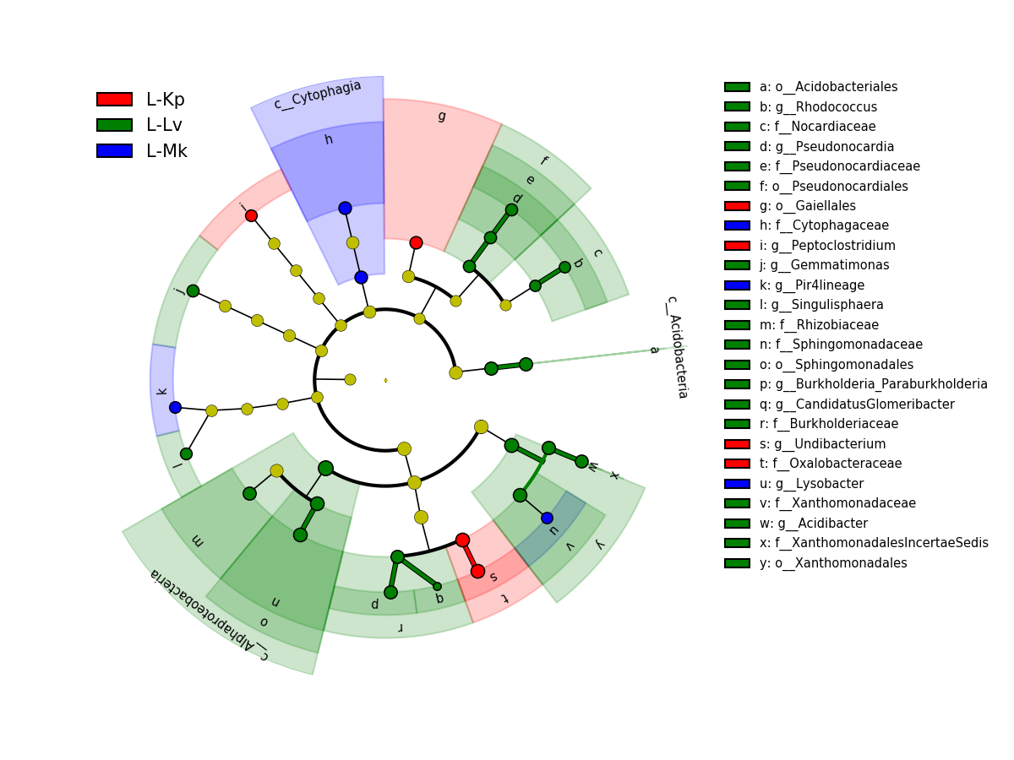
d
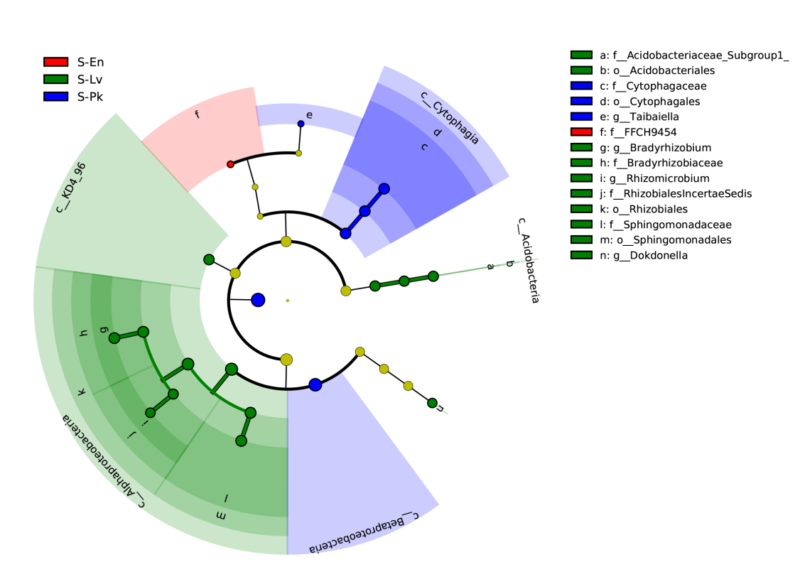
e
Figure S2. Lefse analysis of microbial abundance in different grasslands. a, heavily degraded grassland (H); b, lightly degraded grassland (L, 2017); c, degraded sown grassland (S, 2017); d, lightly degraded native grassland (L, 2018); e, degraded sown grassland (S, 2018). Nr, non-rhizosphere soil. Al, Ajuga lupulina; Ef, Euphorbia fischeriana; Sg, Sphallerocarpus gracilis; Oo, Oxytropis ochrocephala; Mk, Morina kokonorica; Pk, Pedicularis kansuensis; An, Artemisia nanschanica; Ad, Artemisia dubia; Ap, Aconitum pendulum; Lv, Ligularia virgaurea; En, Elymus nutans; Kp, Kobresia pygmaea.

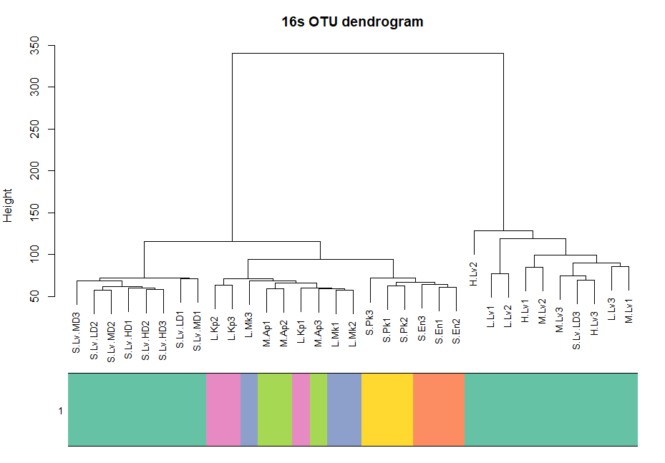
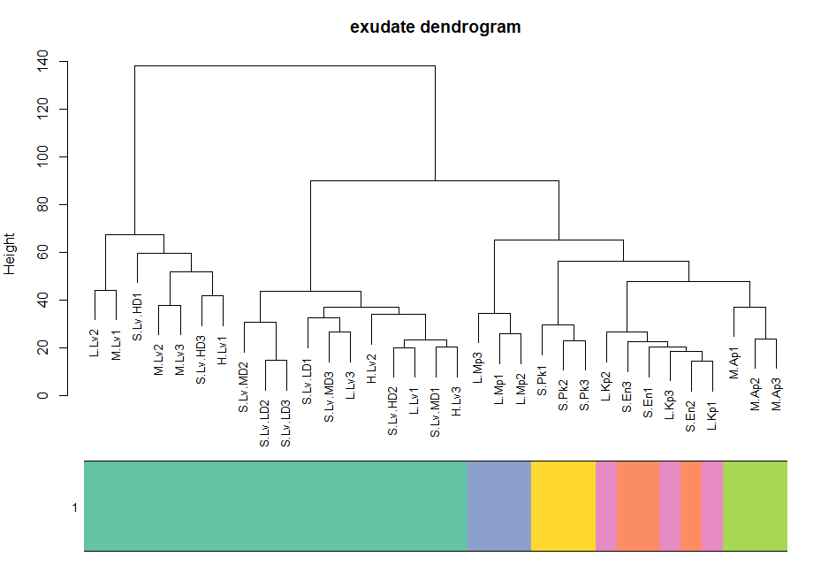
Figure S3. Microbial OTU (16s) and exudation dendrogram. L, lightly degraded grassland; M, moderately degraded grassland; H, heavily degraded grassland; S, degraded sown grassland. Nr, non-rhizosphere soil. Al, Ajuga lupulina; Ef, Euphorbia fischeriana; Sg, Sphallerocarpus gracilis; Oo, Oxytropis ochrocephala; Mk, Morina kokonorica; Pk, Pedicularis kansuensis; An, Artemisia nanschanica; Ad, Artemisia dubia; Ap, Aconitum pendulum; Lv, Ligularia virgaurea; En, Elymus nutans; Kp, Kobresia pygmaea. LD, MD and HD were the low, middle and high densities of L. virgaurea in degraded sown grassland, respectively.
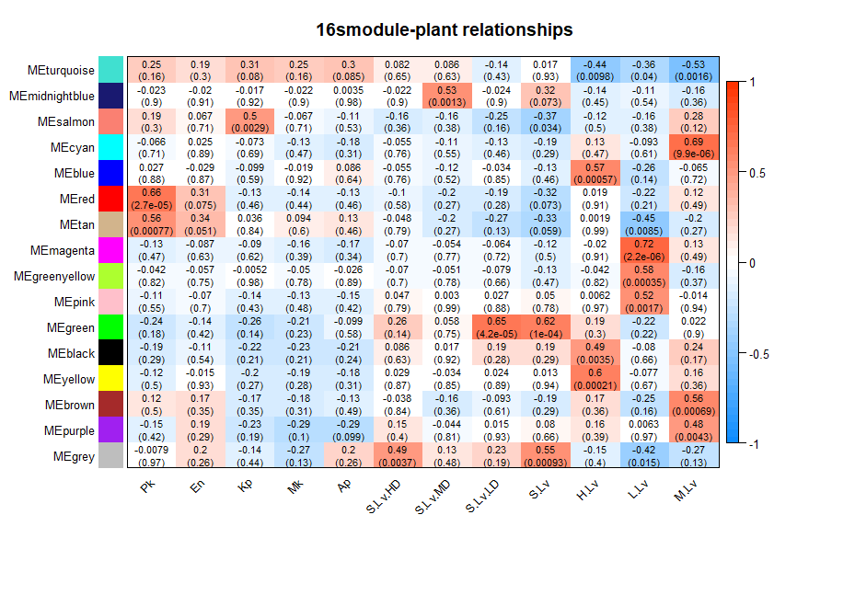
Figure S4. Correlation analysis heatmap of OTU module with poisonous plant species (horizontal axis). L, lightly degraded grassland; M, moderately degraded grassland; H, heavily degraded grassland; S, degraded sown grassland. Mk, Morina kokonorica; Pk, Pedicularis kansuensis; Ap, Aconitum pendulum; Lv, Ligularia virgaurea; En, Elymus nutans; Kp, Kobresia pygmaea. LD, MD and HD were the low, middle and high densities of L. Virgaurea in degraded sown grassland, respectively.

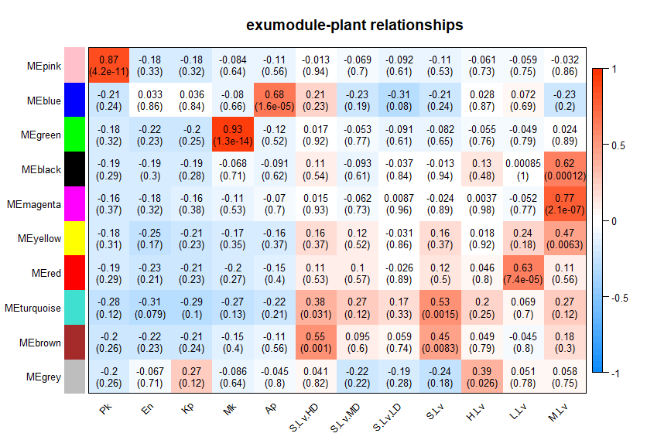
Figure S5. Correlation analysis heatmap of exudation with poisonous plant species (horizontal axis). L, lightly degraded grassland; M, moderately degraded grassland; H, heavily degraded grassland; S, degraded sown grassland. Mk, Morina kokonorica; Pk, Pedicularis kansuensis; Ap, Aconitum pendulum; Lv, Ligularia virgaurea; En, Elymus nutans; Kp, Kobresia pygmaea. LD, MD and HD were the low, middle and high densities of Ligularia virgaurea in degraded sown grassland, respectively.

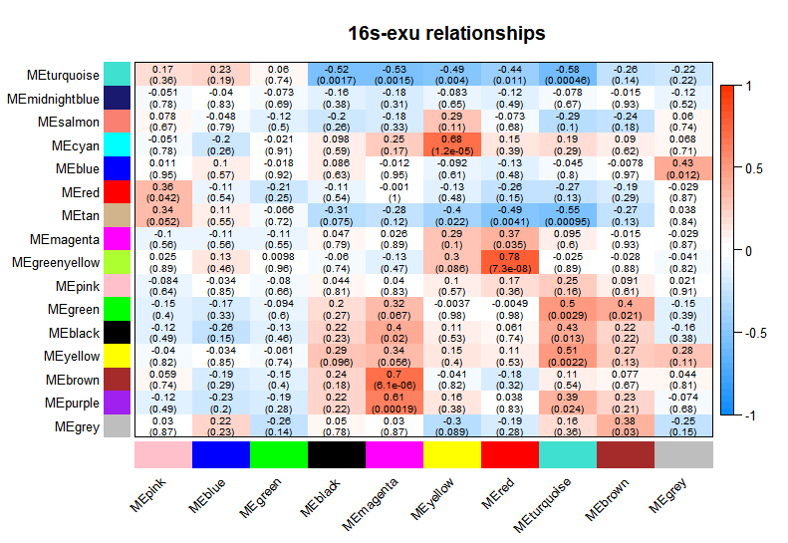
Figure S6. Correlation analysis heatmap of root exudate module (horizontal axis) and bacterial module (vertical axis)

Table S1. Summary and abbreviation of experimental samples
Habitat | Species | Family | Sample time |  | Frequency  in 2017
Habitat | Species | Family | 2017 | 2018 | Frequency  in 2017
Lightly degraded grassland (L) | Non-rhizosphere (Nr) | -- | √
Lightly degraded grassland (L) | Morina kokonorica Hao (Mk) | Dipsacaceae | √ | √ | 0.6
Lightly degraded grassland (L) | Kobresia pygmaea C.zheB.Clarke (Kp) | Cyperaceae |  | √ | 0.9
Lightly degraded grassland (L) | Ligularia virgaurea (Maxim.) Mattf. ex Rehd. & Kobus (Lv) | Compositae |  | √ | 0.2
Moderately degraded grassland (M) | Non-rhizosphere (Nr) | -- | √
Moderately degraded grassland (M) | Aconitum pendulum Busch (Ap) | Ranunculaceae | √ | √ | 0.9
Moderately degraded grassland (M) | Morina kokonorica Hao (Mk) | Dipsacaceae | √ |  | 0.9
Moderately degraded grassland (M) | Euphorbia fischeriana Steud. (Ef) | Euphorbiaceae | √ |  | 0.7
Moderately degraded grassland (M) | Ajuga lupulina Maxim. (Al) | Labiatae | √ |  | 0.6
Moderately degraded grassland (M) | Ligularia virgaurea (Maxim.) Mattf. ex Rehd. & Kobus (Lv) | Compositae | √ | √ | 0.7
Heavily degraded grassland (H) | Non-rhizosphere (Nr) | -- | √
Heavily degraded grassland (H) | Ajuga lupulina Maxim. (Al) | Labiatae | √ |  | 0.5
Heavily degraded grassland (H) | Euphorbia fischeriana Steud. (Ef) | Euphorbiaceae | √ |  | 0.2
Heavily degraded grassland (H) | Sphallerocarpus gracilis (Sg) | Apiaceae | √ |  | 0.5
Heavily degraded grassland (H) | Morina kokonorica Hao (Mk) | Dipsacaceae | √ |  | 0.5
Heavily degraded grassland (H) | Artemisia dubia Wall. ex Bess. (Ad) | Compositae | √ |  | 0.6
Heavily degraded grassland (H) | Artemisia nanschanica Krasch. (An) | Compositae | √ |  | 0.7
Heavily degraded grassland (H) | Aconitum pendulum Busch (Ap) | Ranunculaceae | √ |  | 0.6
Heavily degraded grassland (H) | Ligularia virgaurea (Maxim.) Mattf. ex Rehd. & Kobus (Lv) | Compositae | √ | √ | 0.8
Degraded sown grassland (S) | Non-rhizosphere (Nr) | -- | √
Degraded sown grassland (S) | Sphallerocarpus gracilis (Sg) | Apiaceae | √ |  | 0.1
Degraded sown grassland (S) | Oxytropis ochrocephala (Oo) | Leguminosae | √ |  | 0.8
Degraded sown grassland (S) | Pedicularis kansuensis (Pk) | Scrophulariaceae | √ | √ | 0.5
Degraded sown grassland (S) | Ligularia virgaurea (Maxim.) Mattf. ex Rehd. & Kobus (Lv) | Compositae | √ | √ | 0.5
Degraded sown grassland (S) | Elymus nutans Griseb. (En) | Gramineae |  | √ | 1
Notes:√ represented the collected samples.
Table S2. 31 carbon source distribution in Biolog Eco microplate
 | 1 | 2 | 3 | 4
A | Water | β-Methyl-D-Glucoside | D-Galactonic Acid y-Lactone | L-Arginine
B | Pyruvic Acid Methyl Ester | D-Xylose | D-Galacturonic Acid | L-Asparagine
C | Tween 40 | I-Erythritol | 2-Hydroxy Benzoic Acid | L-Phenylalanine
D | Tween 80 | D-Mannitol | 4-Hydroxy Benzoic Acid | L-Serine
E | α-Cyclodextrin | N-Acetyl-D-Glucosamine | γ-Hydroxybutyric Acid | L-Threonioe
F | Glycogen | D-Glucosaminic Acid | Itaconic Acid | Glycyl-L-Glutamic Acid
G | D-Cell obiose | Glucose-1-Phosphate | α-Ketobutyric Acid | Phenylethyl-amine
H | α-D-Lactose | D,L-a-Glycerol | D-Malic Acid | Putrescine
Note: Each carbon source was represented by its own location in Biolog-Eco plate.

Table S3. Correlation coefficients between main substrates and PC1
Category | location | Carbon source | Degraded sown grassland | Heavily degraded grassland | Lightly degraded grassland | Moderately degraded grassland
Carbohydrates | A2 | β-methyl-D-glucoside | 0.766 | 0.644
Carbohydrates | B2 | D-xylose |  | 0.63 | -0.842 | 0.674
Carbohydrates | C2 | I-erythritol |  |  |  | 0.805
Carbohydrates | E2 | N-acetyl-D-glucosamine | 0.854 | 0.802 |  | 0.946
Carbohydrates | F2 | D-glucosaminic acid |  | 0.75 |  | 0.729
Carbohydrates | G1 | D-cell obiose | 0.843 | 0.801
Carbohydrates | G2 | glucose-1-phosphate | 0.827 | 0.725 |  | 0.737
Amino acids | A4 | L-arginine | 0.652 | 0.675 | 0.931
Amino acids | B4 | L-asparagine | 0.499 | 0.715 | 0.95
Amino acids | C4 | L-phenylalanine | 0.795 | 0.679 | 0.849 | 0.693
Amino acids | D4 | L-serine | 0.567
Amino acids | F4 | glycyl-L-glutamic acid |  |  |  | 0.61
Carboxylic acids | B1 | pyruvic acid methyl ester |  |  | 0.672 | 0.596
Carboxylic acids | F3 | itaconic acid |  |  | 0.966
Carboxylic acids | G3 | α-ketobutyric acid |  |  | 0.748
Polymers | C1 | tween 40 |  |  | 0.918
Polymers | E1 | α-cyclodextrin | 0.743 | 0.842 |  | 0.709
Polymers | F1 | glycogen |  | 0.839 | 0.886 | 0.762
Phenolic acids | C3 | 2-hydroxy benzoic acid |  |  | 0.814
Phenolic acids | D3 | 4-hydroxy benzoic acid | 0.91 | 0.759 | 0.832 | 0.642
Amines | G4 | Phenylethylamine |  | 0.84 |  | 0.865

Table S4. Physical and chemical properties of soil
Habitat | Samples | pH | TOC (g/kg) | TN (g/kg) | TP (g/kg) | AP (mg/kg)
Lightly degraded grassland (L) | Nr | 6.55 | 75.0 bA | 2.69 | 0.46 | 11.1A
Lightly degraded grassland (L) | Mk | 6.95 | 110.3 a | 3.72 | 0.44 | 21.4
moderately degraded grassland (M) | Nr | 7.18 | 50.6 cC | 2.23 c | 0.51 | 3.9 cB
moderately degraded grassland (M) | Al | 7.39 | 65.9 abc | 2.66 ab | 0.58 | 8.5 b
moderately degraded grassland (M) | Ef | 7.13 | 84.1 a | 3.22 abc | 0.56 | 8.9 b
moderately degraded grassland (M) | Mk | 7.54 | 76.6 ab | 2.95 ab | 0.64 | 16.0 a
moderately degraded grassland (M) | Ap | 7.63 | 68.9 abc | 2.94 a | 0.53 | 8.5 b
moderately degraded grassland (M) | Lv | 7.44 | 62.1 bc | 2.50 bc | 0.64 | 7.5 bc
Heavily degraded grassland (H) | Nr | 7.22 | 64.0AB | 2.48 bc | 0.38 | 9.9 cA
Heavily degraded grassland (H) | Al | 7.39 | 63.9 | 2.24 c | 0.51 | 13.7 bc
Heavily degraded grassland (H) | Ef | 7.20 | 77.1 | 3.11 ab | 0.56 | 9.3 c
Heavily degraded grassland (H) | Sg | 7.22 | 70.7 | 2.75 abc | 0.47 | 15.7 bc
Heavily degraded grassland (H) | Mk | 7.53 | 82.5 | 3.10 ab | 0.43 | 17.9 bc
Heavily degraded grassland (H) | An | 7.38 | 57.0 | 2.35 c | 0.45 | 19.2 b
Heavily degraded grassland (H) | Ad | 7.08 | 99.3 | 2.72 abc | 0.59 | 30.2 a
Heavily degraded grassland (H) | Pk | 7.61 | 56.8 | 2.47 bc | 0.42 | 11.0bc
Heavily degraded grassland (H) | Lv | 7.12 | 80.9 | 3.29 a | 0.48 | 15.7 bc
Degraded sown grassland (S) | Nr | 7.27 | 57.5 bBC | 2.48 b | 0.57 | 4.6 cB
Degraded sown grassland (S) | Sg | 7.45 | 90.4 a | 3.60 a | 0.69 | 12.9 ab
Degraded sown grassland (S) | Oo | 7.00 | 67.5 b | 2.99 ab | 0.58 | 10.9 abc
Degraded sown grassland (S) | Pk | 7.29 | 86.9 a | 3.73 a | 0.67 | 18.2 a
Degraded sown grassland (S) | Lv | 7.37 | 65.3 b | 2.75 b | 0.6 | 8.3 bc
Note: TN, Total nitrogen. TP, Total phosphorus. TOC, Total organic carbon. AP, Available phosphorus. Values with different lowercase letters within a column represent are significantly from each other; capital letters represent significant difference among the bulk soils in different habitats (P <0.05). Al, Ajuga lupulina; Ef, Euphorbia fischeriana; Sg, Sphallerocarpus gracilis; Oo, Oxytropis ochrocephala; Mk, Morina kokonorica; Pk, Pedicularis kansuensis; An, Artemisia nanschanica; Ad, Artemisia dubia; Ap, Aconitum pendulum; Lv, Ligularia virgaurea.

Table S5. The number of OTUs in the module and the average connection degree
Modules | Number | Average connectivity (inside) | Total average connectivity
turquoise | 1769 | 39.25 | 43.86
blue | 338 | 14.32 | 19.38
brown | 172 | 5.81 | 14.19
yellow | 155 | 8.96 | 22.34
green | 129 | 4.80 | 13.49
red | 125 | 4.80 | 10.06
black | 118 | 4.23 | 19.35
pink | 106 | 7.89 | 21.10
magenta | 99 | 10.37 | 21.16
green yellow | 62 | 5.26 | 10.33
tan | 57 | 1.85 | 15.33
salmon | 55 | 2.22 | 6.57
cyan | 52 | 2.95 | 12.66
midnight blue | 46 | 8.30 | 10.38
grey | 242 | 0.28 | 2.0
purple | 88 | 2.30 | 16.65

Table S6. Operational taxonomic unit (OTU) and root exudation with significant positive correlations in the module (P <0.05)
Please see the excel file (Additional file 2).

