Supplementary Information

Brown bear skin-borne secretions display evidence of individuality and age-sex variation
Melanie Clapham*, Abbey E. Wilson*, Candace L. Williams & Agnieszka Sergiel
* Co-first authors

File includes:
Supplementary Table S1-S7
Supplementary Figure S1 and S2

Table S1. The variance across the different groups of interest (body site, individual, sex, and age class) for compounds identified in samples collected from brown bears was significantly different, indicating the need to use adonis function in vegan R package for the PERMANOVA.
 | Body site (ID(Sex)) | ID(Sex) | Sex | Age
Bray-Curtis | < 0.0001* | < 0.0001* | 0.039* | 0.0014*
Jaccard | < 0.0001* | < 0.0001* | 0.060 | 0.0017*
*Significant, P < 0.05, Betadisper with Bonferroni correction (R, vegan package).

Table S2. Compounds (mass@retention time) that contributed to the variation (≥2%) in the volatile profile within individuals nested within sex.
73.0@21.80 | 88.0@23.07 | 88.0@26.50
88.0@26.37 | 72.0@26.39 | 2,5-Dichlorobenzyl alcohol
74.0@24.95 | 88.0@24.87 | 62.0@25.27
72.0@1.97 | 74.0@24.96 | 84.0@21.14
88.0@26.36 | 60.0@14.51 | 86.0@24.84
Boric acid, trimethyl ester | 88.0@23.48 | Benzaldehyde
73.0@20.56 | 88.0@24.85 | 74.0@25.31
88.0@24.79 | 60.0@14.96

Table S3. P-values from both incidence and abundance generated by PERMANOVA for age-sex classes.
 | Mature Male |  | Mature Female |  | Young Male |  | Young Female
 | ID | Body site(ID) | ID | Body site(ID) | ID | Body site(ID) | ID | Body site(ID)
Bray- Curtis | >0.05 | >0.05 | 0.0004 | >0.05 | 0.0002 | >0.05 | 0.0196 | >0.05
Jaccard | >0.05 | >0.05 | 0.0004 | >0.05 | 0.0002 | >0.05 | 0.0218 | >0.05
*Significant, P < 0.05.

Table S4. Compounds (mass@retention time) that contributed to the variation (≥2%) in the volatile profile within age classes separated by individuals nested within sex.
 | Young: ID(Sex) |  | Mature: ID(Sex)
Compound | p-value | SIMPER% | p-value | SIMPER%
2,5-Dichlorobenzyl alcohol | > 0.05 | 2.1 | -- | --
72.0@26.39 | > 0.05 | 2.5 ± 0.08 | -- | --
Boric acid, trimethyl ester | > 0.05 | 2.7 ±0.22 | -- | --
73.0@20.56 | 0.018* | 2.6 ± 0.25 | -- | --
73.0@21.80 | < 0.001* | 4.7 ± 0.34 | -- | --
Benzaldehyde | -- | -- | > 0.05 | 2.0
62.0@25.27 | > 0.05 | 2.2 | > 0.05 | 2.1
88.0@26.50 | 0.014* | 2.2 | -- | --
60.0@14.51 | -- | n/a | > 0.05 | 2.2
88.0@26.36 | > 0.05 | 2.5 ± 0.14 | > 0.05 | 2.4
74.0@24.96 | -- | -- | > 0.05 | 2.5
74.0@24.95 | > 0.05 | 2.9 ± 0.16 | > 0.05 | 2.5
88.0@26.37 | -- | -- | > 0.05 | 3.2
84.0@21.14 | -- | -- | > 0.05 | 2.2
72.0@1.97 | > 0.05 | 2.6 ± 0.16 | > 0.05 | 3.2 ± 0.44
60.0@14.96 | > 0.05 | 2.2 ± 0.05 | -- | --
88.0@23.07 | > 0.05 | 2.1 | > 0.05 | 2.7 ± 0.26
88.0@23.48 | > 0.05 | 2.2 ± 0.05 | -- | --
88.0@24.79 | > 0.05 | 2.2 ± 0.06 | > 0.05 | 2.9 ± 0.14
88.0@24.87 | > 0.05 | 2.13 | > 0.05 | 2.4±0.30
*Significant, P < 0.05.

Table S5. Compounds (mass@retention time) present in number of samples with respect to age and body site within females. One unique (bolded), 21 signature dominant, and 5 dominant compounds were detected in samples collected from body sites within mature and young female bears.
 | Mature |  |  |  | Young
Compound | Cheek (n=4) | Flank (n=4) | Hump (n=4) | Pedes (n=4) | Cheek (n=3) | Flank (n=3) | Hump (n=3) | Pedes (n=3)
88.0@23.74 | 4 | 3 | 3 | 1 | 1 | 1 | 1 | 1
88.0@21.94 | 3 | 3 | 2 | 3 | 3 | 2 | 0 | 1
72.0@26.59 | 1 | 4 | 2 | 0 | 0 | 0 | 0 | 0
Benzaldehyde, 2,6-dichloro- | 1 | 0 | 0 | 2 | 2 | 3 | 1 | 0
104.0@1.68 | 0 | 1 | 1 | 0 | 0 | 3 | 2 | 0
62.0@24.95 | 2 | 2 | 3 | 0 | 2 | 3 | 2 | 2
59.0@24.98 | 0 | 2 | 3 | 1 | 2 | 3 | 1 | 0
59.0@1.55 | 1 | 0 | 0 | 1 | 0 | 3 | 2 | 2
62.0@1.96 | 1 | 0 | 2 | 2 | 1 | 3 | 2 | 0
60.0@25.34 | 1 | 0 | 2 | 0 | 1 | 3 | 0 | 2
93.0@1.49 | 0 | 1 | 1 | 2 | 1 | 3 | 1 | 1
57.0@25.59 | 0 | 0 | 0 | 1 | 1 | 3 | 1 | 2
62.0@2.63 | 0 | 0 | 0 | 0 | 0 | 3 | 0 | 0
92.0@4.53 | 0 | 0 | 0 | 0 | 0 | 3 | 1 | 0
62.0@2.30 | 0 | 1 | 0 | 0 | 0 | 0 | 3 | 0
92.0@3.33 | 1 | 0 | 0 | 0 | 0 | 0 | 3 | 0
88.0@22.60 | 3 | 2 | 2 | 4 | 2 | 2 | 0 | 2
72.0@1.97 | 1 | 2 | 1 | 4 | 2 | 2 | 2 | 1
59.0@1.79 | 2 | 2 | 1 | 3 | 1 | 2 | 0 | 3
88.0@25.02 | 2 | 2 | 1 | 0 | 1 | 2 | 0 | 3
104.0@2.66 | 0 | 0 | 0 | 2 | 1 | 0 | 0 | 3
88.0@23.30 | 3 | 4 | 2 | 3 | 3 | 2 | 2 | 2
88.0@29.18 | 0 | 2 | 4 | 2 | 3 | 1 | 1 | 2
88.0@23.15 | 1 | 4 | 3 | 4 | 3 | 2 | 2 | 1
88.0@23.59 | 4 | 4 | 3 | 3 | 2 | 3 | 3 | 2
88.0@22.72 | 1 | 4 | 2 | 4 | 3 | 2 | 1 | 3

Table S6. Compounds (mass@retention time) present in number of samples with respect to age and body site within males. Zero unique, 17 signature dominant, and 4 dominant compounds were found in samples collected from body sites within mature and young male bears.
 | Mature |  |  |  | Young
Compound | Cheek (n=3) | Flank (n=3) | Hump (n=3) | Pedes (n=3) | Cheek (n=10) | Flank (n=10) | Hump (n=9) | Pedes (n=8)
88.0@21.49 | 3 | 0 | 1 | 0 | 1 | 0 | 0 | 3
86.0@25.11 | 3 | 1 | 0 | 1 | 1 | 1 | 2 | 0
88.0@24.88 | 1 | 3 | 1 | 1 | 5 | 5 | 5 | 4
88.0@26.42 | 0 | 3 | 2 | 1 | 3 | 3 | 7 | 4
62.0@25.32 | 1 | 3 | 2 | 2 | 2 | 2 | 1 | 0
62.0@25.51 | 0 | 3 | 1 | 0 | 1 | 2 | 3 | 1
Benzaldehyde | 1 | 1 | 3 | 1 | 5 | 2 | 1 | 0
88.0@22.59 | 1 | 0 | 3 | 1 | 7 | 7 | 5 | 6
74.0@25.76 | 1 | 0 | 3 | 1 | 2 | 0 | 4 | 0
58.0@25.56 | 1 | 1 | 3 | 2 | 2 | 0 | 3 | 0
59.0@25.77 | 2 | 0 | 3 | 1 | 1 | 3 | 1 | 0
56.0@2.76 | 0 | 0 | 3 | 0 | 1 | 1 | 0 | 0
72.0@25.00 | 0 | 0 | 3 | 1 | 2 | 2 | 0 | 0
59.0@25.33 | 0 | 0 | 3 | 0 | 0 | 2 | 1 | 0
74.0@25.37 | 1 | 2 | 3 | 2 | 1 | 1 | 0 | 0
72.0@25.07 | 1 | 2 | 1 | 3 | 3 | 4 | 4 | 5
56.0@2.20 | 0 | 0 | 0 | 3 | 1 | 0 | 0 | 0
72.0@1.96 | 3 | 3 | 2 | 2 | 3 | 5 | 2 | 3
62.0@1.94 | 1 | 1 | 3 | 3 | 3 | 3 | 4 | 2
74.0@24.94 | 3 | 3 | 3 | 2 | 1 | 2 | 0 | 0
59.0@1.79 | 3 | 2 | 3 | 3 | 4 | 3 | 0 | 4

Table S7. Compounds (mass@retention time) present in number of samples with respect to individual. Zero unique, ten signature dominant, and one dominant compound were found across individuals.
Compound | Y742 (n=8) | Y743 (n=4) | Y860 (n=8) | Y861 (n=8) | Y862 (n=7) | Y863 (n=8) | Y864 (n=8) | Y865 (n=4) | Y866 (n=8) | Y867 (n=8) | Y868 (n=4)
74.0@24.94 | 8 | 1 | 0 | 0 | 0 | 0 | 1 | 0 | 2 | 4 | 3
59.0@24.99 | 2 | 4 | 2 | 4 | 4 | 3 | 6 | 2 | 1 | 5 | 2
60.0@25.24 | 1 | 4 | 0 | 0 | 0 | 0 | 0 | 0 | 1 | 1 | 2
88.0@23.29 | 2 | 1 | 8 | 7 | 6 | 6 | 7 | 3 | 4 | 6 | 1
88.0@23.57 | 2 | 0 | 8 | 7 | 3 | 4 | 6 | 3 | 4 | 6 | 0
88.0@24.81 | 3 | 1 | 8 | 6 | 2 | 7 | 3 | 3 | 3 | 1 | 0
86.0@25.01 | 6 | 0 | 3 | 2 | 3 | 1 | 3 | 1 | 3 | 6 | 4
59.0@1.79 | 6 | 0 | 3 | 1 | 0 | 6 | 2 | 1 | 5 | 5 | 4
74.0@25.24 | 4 | 1 | 0 | 0 | 0 | 0 | 0 | 0 | 2 | 7 | 4
74.0@25.37 | 4 | 3 | 0 | 0 | 0 | 0 | 0 | 0 | 1 | 2 | 4
72.0@1.96 | 6 | 1 | 5 | 3 | 0 | 3 | 3 | 4 | 5 | 5 | 4

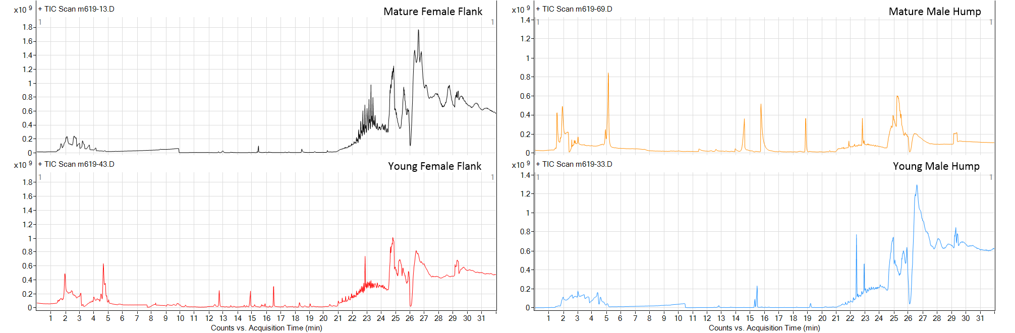
Figure S1. Representative total ion chromatograms of brown bear samples. The flank region in young females had the greatest number of signature compounds compared to all body sites and age classes within females. The hump region in mature males had the greatest number of signature compounds compared to all body sites and age classes within males.
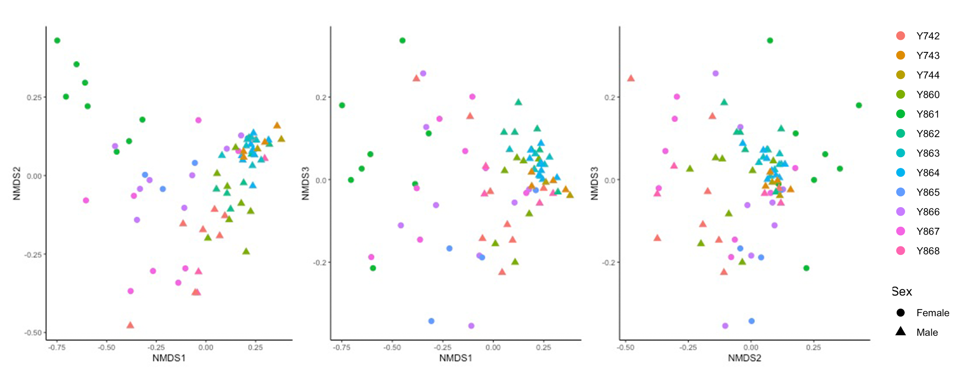
Figure S2. Nonmetric multidimensional scaling (nMDS) analysis displaying overall differences in volatile organic compounds as observed by mass spectrometry based on Bray-Curtis distances (stress: 0.13, Goodness of fit R²: 0.987).

