Additional file 1
for
BTK Inhibitor Orelabrutinib in Relapsed or Refractory Chronic Lymphocytic Leukemia/Small Lymphocytic Lymphoma Patients: Multicenter, Single-arm, Open-label, Phase 2 Study

Wei Xu#, Keshu Zhou#, Tingyu Wang, Shenmiao Yang, Lihong Liu, Yu Hu, Wei Zhang, Kaiyang Ding, Jianfeng Zhou, Sujun Gao, Bing Xu, Zunmin Zhu, Ting Liu, Huilai Zhan, Jianda Hu, Chunyan Ji, Shunqing Wang, Zhongjun Xia, Xin Wang, Yan Li, Yongping Song, Jianyong Li*.

#Co-first authors:
These authors contributed equally to this work.
Correspondence to: jianyong.lijsh@outlook.com

Additional file 1: Supplementary Text
IGHV mutational status is determined by amplifying the IGHV transcript by polymerase chain reaction (PCR), sequencing the gene through Sanger sequencing, and comparing the transcript to known germline genes available in immunoglobulin databases. Next-generation sequencing (NGS) targeted panel was used for TP53 mutation identification; Vysis TP53/CEP17 Kit was used for fluorescence in situ hybridization (FISH) to detect TP53 deletion. All tests were conducted by Guangzhou Kingmed Center for Clinical Laboratory Co., Ltd. following their standard operating procedures.

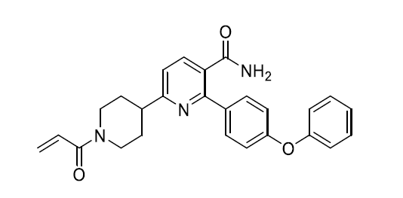

Additional file 1: Figure S1. Structure of orelabrutinib
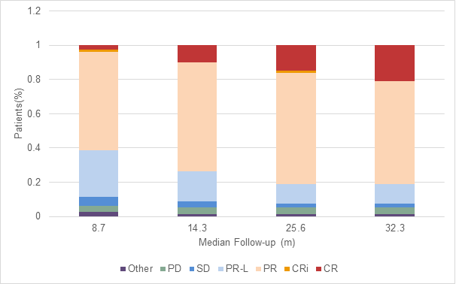

Additional file 1: Figure S2. Best overall response at different follow-up times (assessed by IRC)
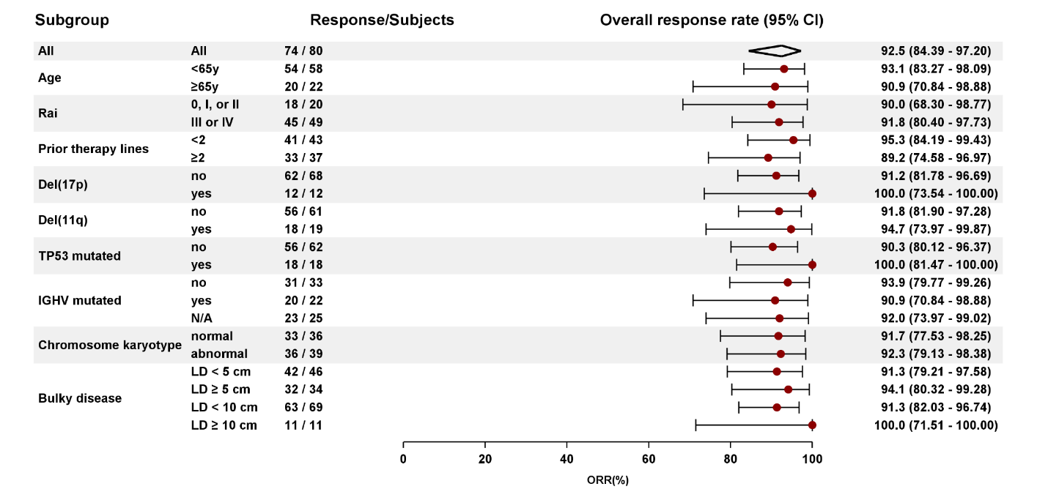

Additional file 1: Figure S3. Subgroup analysis of ORR (assessed by IRC)

Additional file 1: Table S1. TEAEs
PT | All grades  n (%) | ≥ Grade 3  n (%)
Patients with at least 1 TEAE | 79 (98.8) | 51 (63.8)
Neutropenia | 39 (48.8) | 26 (32.5)
Thrombocytopenia | 37 (46.3) | 11 (13.8)
Upper respiratory tract infection | 30 (37.5) | 6 (7.5)
Red blood cells urine positive | 27 (33.8) | 0
Lung infection | 27 (33.8) | 14 (17.5)
Hematuria | 23 (28.8) | 0
Hypokalemia | 21 (26.3) | 6 (7.6)
Weight gain | 21 (26.3) | 2 (2.5)
Anemia | 19 (23.8) | 8 (10.0)
White blood cell decreased | 18 (22.5) | 6 (7.5)
Purpura | 16 (20.0) | 0
Urinary tract infection | 16 (20.0) | 0
Pneumonitis | 15 (18.8) | 1 (1.3)
Rash | 15 (18.8) | 0
Hyperbilirubinemia | 14 (17.5) | 0
Hyperuricemia | 14 (17.5) | 0
Hyperglycemia | 14 (17.5) | 0
Cough | 13 (16.3) | 0
Herpes zoster | 12 (15.0) | 2 (2.5)
Hypocalcemia | 12 (15.0) | 0
Hypoalbuminemia | 11 (13.8) | 0
Petechiae | 11 (13.8) | 0
Alanine aminotransferase increased | 10 (12.5) | 1 (1.3)
Pyrexia | 9 (11.3) | 0
Gamma-glutamyl transferase increased | 8 (10.0) | 4 (5.0)
Diarrhea | 8 (10.0) | 1 (1.3)
Urobilinogen urine increased | 8 (10.0) | 0
Expectoration | 8 (10.0) | 0
Lymphocyte count decreased | 7 (8.8) | 4 (5.0)
Lymphadenitis | 2 (2.5) | 2 (2.5)
Note: Listed adverse events occurred in at least 10% of patients or for grade ≥ 3 in at least 2% of patients. PT = preferred term; SOC = system organ class; TEAE = treatment-emergent adverse event.

Additional file 1: Table S2. Serious TEAEs
PT | All subjects (N=80) | Number of total events
PT | n (%)
Patients with at least 1 SAE | 34 (42.5) | 55
Lung infection | 13 (16.3) | 16
Thrombocytopenia | 3 (3.8) | 3
Pleural effusion | 2 (2.5) | 4
Upper respiratory tract infection | 2 (2.5) | 2
Herpes zoster | 2 (2.5) | 2
Lymphadenitis | 2 (2.5) | 2
Cholecystitis | 2 (2.5) | 2
Oral candidiasis | 1 (1.3) | 1
Respiratory infection | 1 (1.3) | 1
Infection | 1 (1.3) | 1
Fungal infection | 1 (1.3) | 1
Tubercular meningitis | 1 (1.3) | 1
Appendicitis | 1 (1.3) | 1
Pancytopenia | 1 (1.3) | 1
Febrile neutropenia | 1 (1.3) | 1
Hemolytic anemia | 1 (1.3) | 1
Anemia | 1 (1.3) | 1
Acute cholecystitis | 1 (1.3) | 1
Hepatitis | 1 (1.3) | 1
Pyrexia | 1 (1.3) | 1
Death | 1 (1.3) | 1
Disease progression | 1 (1.3) | 1
Coronary artery disease | 1 (1.3) | 1
Supraventricular tachycardia | 1 (1.3) | 1
Diabetes | 1 (1.3) | 1
Spondylolisthesis | 1 (1.3) | 1
Cerebral hemorrhage | 1 (1.3) | 1
Vitreous hemorrhage | 1 (1.3) | 1
Hearing loss | 1 (1.3) | 1
Renal artery stenosis | 1 (1.3) | 1
Recurrent rectal cancer | 1 (1.3) | 1
Note: PT = preferred term; SOC = system organ class; TEAE = treatment-emergent adverse event; SAE = serious adverse event.

Additional file 1: Table S3. Summary of deaths
 | All subjects (N=80)
Adverse event, n(%) | n (%)
Deaths | 8
Causes of death
Disease progression | 1
Adverse events
Within 30 days of last dose
Infection¹ | 1
Lung infection² | 1
Cerebral hemorrhage³ | 1
Hepatitis⁴ | 1
Death⁵ | 1
After 30 days of last dose
Fungal infection⁶ | 1
Lung infection⁷ | 1
¹The subject was in an advanced age and was in a poor condition in general bulky disease (LDi >8cm). The subject had hypodynamia and anorexia after taking orelabrutinib for only 4 days. The investigator considered that the cause of death was infection (location of infection was not clear in screening period) and rapid disease progression, which finally developed into multiple system organ failure. The investigator assessed it was unlikely related to orelabrutinib.
²The subject had chronic lung infection during the screening period, which had been controlled temporarily. The subject developed repeated lung infections during the study. The investigator considered that the cause of death was the failure of effective control of lung infection, which was unlikely related to orelabrutinib.
³The subject had a number of risk factors for cerebral hemorrhage and hypertension without systematic treatment (hypertension history for 10 years, without medication). Cerebral hemorrhage occurred during the study, and possible adverse events of orelabrutinib included hemorrhagic events. The investigator considered that it was probably related to orelabrutinib.
⁴The subject had past medical history of repeated infection, suggesting that the subject's overall immune function was low. The subject developed tuberculous meningitis combined with anti-tuberculous drug therapy (the patient concealed this medical history and concomitant use of the anti-tuberculous drug with orelabrutinib). Hepatitis B virus reactivation resulted in death of severe hepatitis. The investigators considered that HBV reactivation might be caused by anti-tuberculosis drugs but was probably related to orelabrutinib as well.
⁵The subject had previous medical history of hypertension, coronary heart disease, cardiac insufficiency, and type 2 diabetes. The investigator considered that the cause of death was likely to be sudden cardiac death, which was related to previous medical history and unlikely related to orelabrutinib.
⁶The subject died 41 days after the last dose of the drug due to fungal infection and disease progression. The subject developed repeated lung infections during the study. The possibility of indirect infection due to decreased immune system function cannot be ruled out, and the investigator considered that fungal infection was probably related to orelabrutinib.
⁷The subject died 34 days after the last dose of the drug. The subject was in an advanced age, had hypodynamia, anemia, and chronic lung infection in the screening period, and had repeated lung infection during the study. The investigator considered the lung infection to be a result of immune suppression due to the original disease, which was unlikely related to orelabrutinib.

