Article type: Original Article
Amine-Functionalized Lignin as an Eco-Friendly Antioxidant for Rubber Compounds
June-Young Chung¹, Uiseok Hwang¹, Junyoung Kim², Na-Yeon Kim², Jeonghyeon Nam¹, Jinho Jung¹, Sung-Hoon Kim¹, Jung Keun Cho¹, Bumhee Lee², In-Kyung Park¹, Jonghwan Suhr^{1,3}, and Jae-Do Nam^{1,2, *}
¹Department of Polymer Science and Engineering, Sungkyunkwan University Suwon 16419, Republic of Korea
²Department of Energy Science, Sungkyunkwan University, Suwon 16419, Republic of Korea
³School of Mechanical Engineering, Sungkyunkwan University, Suwon 16419, Republic of
Korea
*Corresponding author: jdnam@skku.edu (Prof. J.-D. Nam)

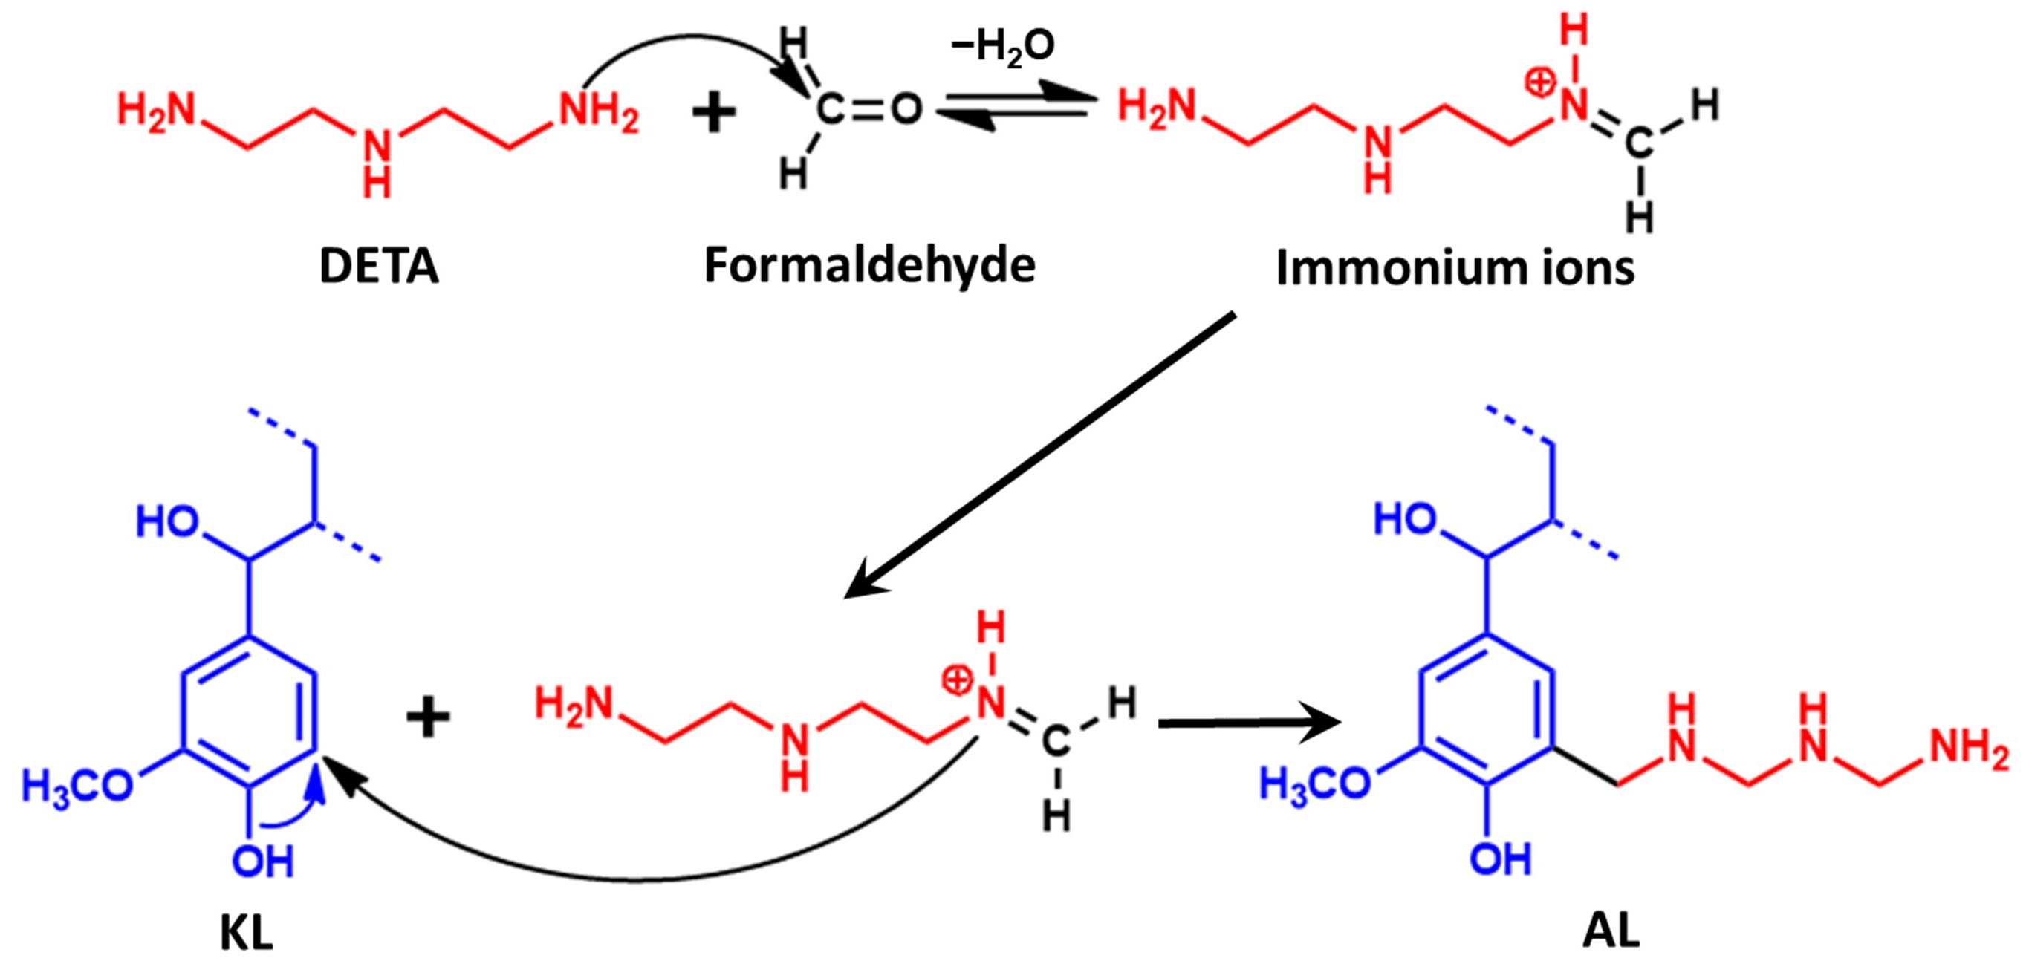
Scheme S1. Amination reaction between the KL and DETA, leading to the formation of phenolic C5 substituted lignin units.

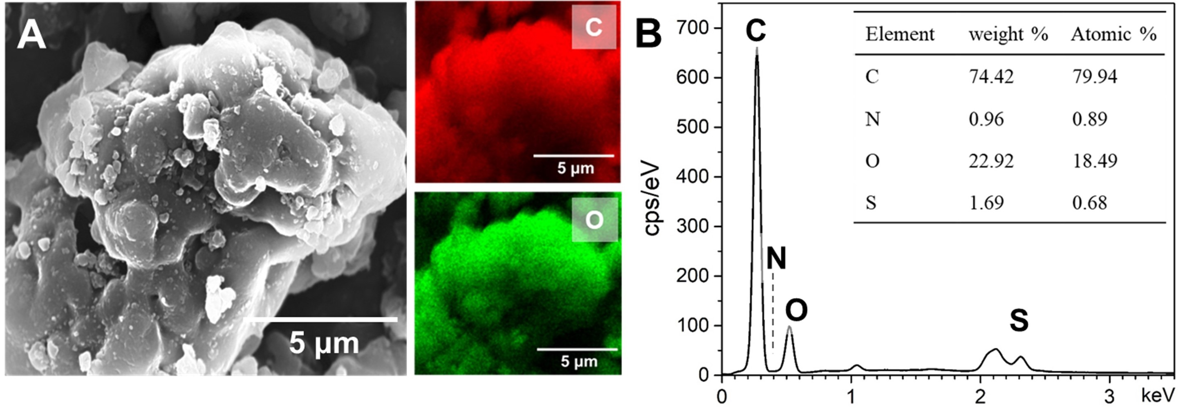
Fig. S1. (a) FE-SEM image and the corresponding EDS C and O elemental mapping images of KL particles. (b) EDS profile and elemental composition of KL.

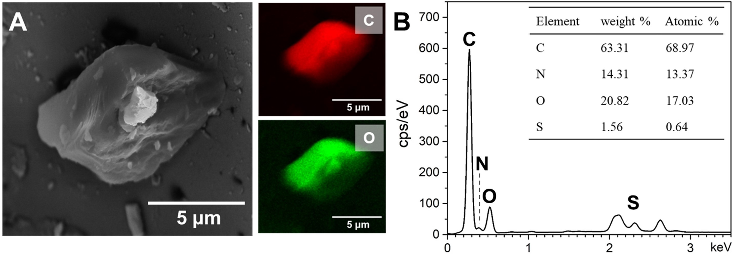
Fig. S2. (a) FE-SEM image and the corresponding EDS C and O elemental mapping images of AL particles. (b) EDS profile and elemental composition of AL.

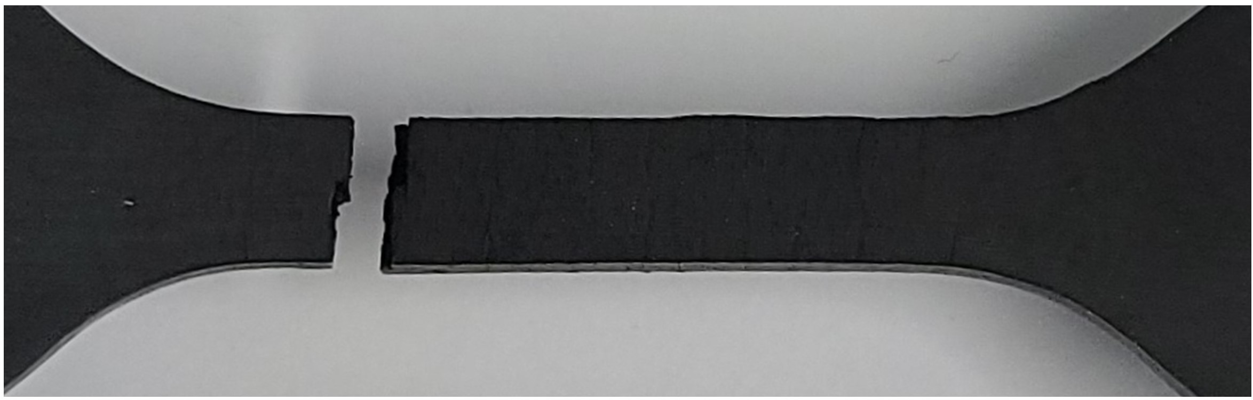
Fig. S3. Digital image of broken specimen of rubber compounds incorporated with KL particles after ozone aging under 20% stretching.

Table S1. Curing characteristics of NB compounds in terms of the antioxidant content.
Sample | Minimum torque  (ML, dNm) | Maximum torque  (MH, dNm) | Torque difference  (ΔMH, dNm) | ts₂  (min) | tc₉₀  (min) | CRI  (min⁻¹)
NB/6P-2 | 1.51 | 19.06 | 17.55 | 3.37 | 5.93 | 39.06
NB/KL-2 | 1.83 | 20.84 | 19.01 | 4.30 | 6.98 | 37.31
NB/AL-1 | 1.70 | 23.35 | 21.65 | 2.87 | 4.81 | 51.55
NB/AL-2 | 1.76 | 24.40 | 22.64 | 2.02 | 3.65 | 61.35
NB/AL-4 | 1.81 | 25.58 | 23.77 | 1.25 | 2.80 | 64.52
ts₂: scorch time; tc₉₀: optimum cure time; Torque difference (ΔMH), MH−ML; Cure rate index (CRI), 100/(tc₉₀-ts₂)

Table S2. Mechanical properties of NB compounds in terms of the antioxidant content and thermal aging at 120 °C for 24 h.
Sample |  | No aging |  |  |  |  | Aging at 120 °C /24 h |  |  |  |  | Degradation
 |  | Shore A  hardness  (S_{A}, HA) | Tensile  strength  (σ, MPa) | Elongation  at break  (ε, %) | 50 Modulus  (MPa) |  | Shore A  hardness  (S_{A}, HA) | Tensile  strength  (σ, MPa) | Elongation  at break  (ε, %) | 50 Modulus  (MPa) |  | Shore A  hardness  (△S_{A}, %) | Tensile  strength  (△σ, %) | Elongation  at break  (△ε, %) | 50 Modulus  (%)
NB/6P-2 |  | 50 | 20.1 ± 0.2 | 562.7 ± 5.3 | 1.06 ± 0.001 |  | 57 | 11.5 ± 0.3 | 282.8 ± 10.1 | 1.66 ± 0.001 |  | 13.0 | - 43.0 | - 49.7 | 57.5
NB/KL-2 |  | 51 | 20.2 ± 0.4 | 561.3 ± 10.0 | 1.14 ± 0.005 |  | 58 | 11.8 ± 0.4 | 294.1 ± 8.0 | 1.64 ± 0.003 |  | 12.8 | - 40.8 | - 47.6 | 43.9
NB/AL-1 |  | 54 | 18.6 ± 0.3 | 497.4 ± 3.4 | 1.25 ± 0.002 |  | 62 | 11.3 ± 0.2 | 257.6 ± 9.3 | 1.93 ± 0.001 |  | 13.9 | - 39.4 | - 48.2 | 54.4
NB/AL-2 |  | 55 | 19.0 ± 0.1 | 499.5 ± 2.1 | 1.36 ± 0.002 |  | 62 | 13.0 ± 0.4 | 268.4 ± 14.2 | 2.09 ± 0.010 |  | 11.8 | - 36.2 | - 46.9 | 51.5
NB/AL-4 |  | 57 | 19.9 ± 0.3 | 502.3 ± 4.2 | 1.53 ± 0.001 |  | 64 | 13.9 ± 0.4 | 267.3 ± 8.1 | 2.33 ± 0.003 |  | 11.8 | - 29.3 | - 43.7 | 54.2

Table S3. Swelling properties of NB compounds with different types and content of antioxidants.
Sample | Swelling index  (Q%, %) | Crosslink density  ($v$, × 10⁻⁴ mol/cm³) | Dissolution fraction  (s, %)
NB/6P-2 | 197.9 | 3.795 | 10.46
NB/KL-2 | 208.3 | 3.220 | 9.53
NB/AL-1 | 189.3 | 3.964 | 9.50
NB/AL-2 | 185.7 | 4.107 | 9.51
NB/AL-4 | 183.4 | 4.185 | 9.47

Table S4. Surface roughness parameter of NB compounds after ozone aging at 50 pphm/40 °C/72 h.
Sample | Crack size  (μm) |  |  | Arithmetical mean height  (Sa, μm) | Root mean square height  (Sq, μm) | Maximum height  (Sz, μm)
Sample | Depth | Width |  | Arithmetical mean height  (Sa, μm) | Root mean square height  (Sq, μm) | Maximum height  (Sz, μm)
NB/6P-2 | 162.05 | 56.90 |  | 4,737 | 13.199 | 213.217
NB/AL-2 | 67.76 | 22.26 |  | 2.077 | 4.047 | 115.138

