Supporting Information
Interfacial Chemical Bond and Internal Electric Field Modulated Z-Scheme Vs-ZnIn₂S₄/MoSe₂ Photocatalyst for Efficient Hydrogen Evolution
Xuehua Wang¹, Xianghu Wang², Jianfeng Huang⁴, Shaoxiang Li⁵, Alan Meng^{2,*}, Zhenjiang Li^{1,3,5*}
¹ College of Materials Science and Engineering, Qingdao University of Science and Technology, Qingdao 266042, Shandong, P. R. China
² Key Laboratory of Optic-electric Sensing and Analytical Chemistry for Life Science, MOE. College of Chemistry and Molecular Engineering, Qingdao University of Science and Technology, Qingdao 266042, Shandong, P. R. China.
³ College of Sino-German Science and Technology, Qingdao University of Science and Technology, Qingdao 266061, Shandong, P. R. China.
⁴ School of Material Science and Engineering, International S&T Cooperation Foundation of Shaanxi Province, Xi’an Key Laboratory of Green Manufacture of Ceramic Materials, Shaanxi University of Science and Technology, Xi’an 710021, China
⁵ Shandong Engineering Technology Research Center for Advanced Coating, Qingdao University of Science and Technology, Qingdao, 266042, P. R. China
* Corresponding author.
E-mail address:
zhenjiangli@qust.edu.cn (Z. J. Li); alanmengqust@163.com (A. L. Meng)
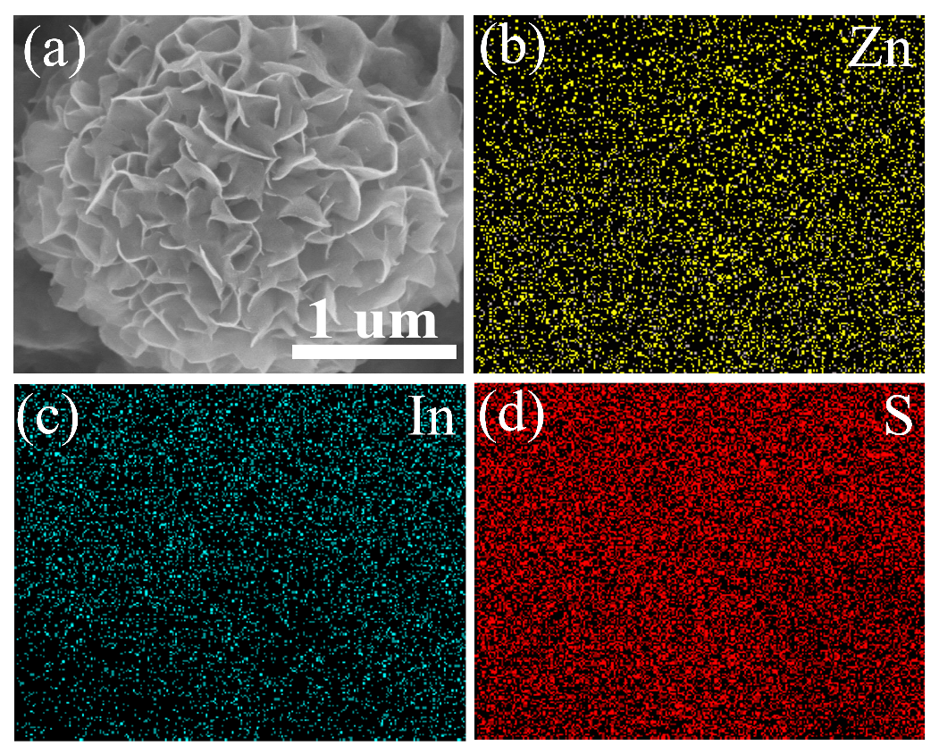
Fig. S1. Morphology characterizations of ZIS. a SEM, b-d the corresponding element mapping images of b Zn, c In and d S in ZIS

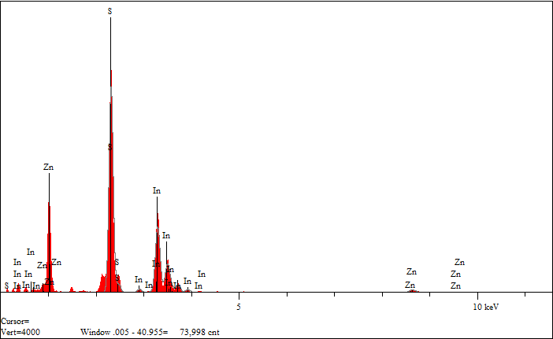
Fig. S2. EDS spectrum of ZIS.

Table S1. Elemental analyses of the ZIS photocatalyst by EDS.
Element | Atomic (%)
Zn | 14.33
In | 26.49
S | 59.18
Zn_{1.00}In_{1.85}S_{4.13}

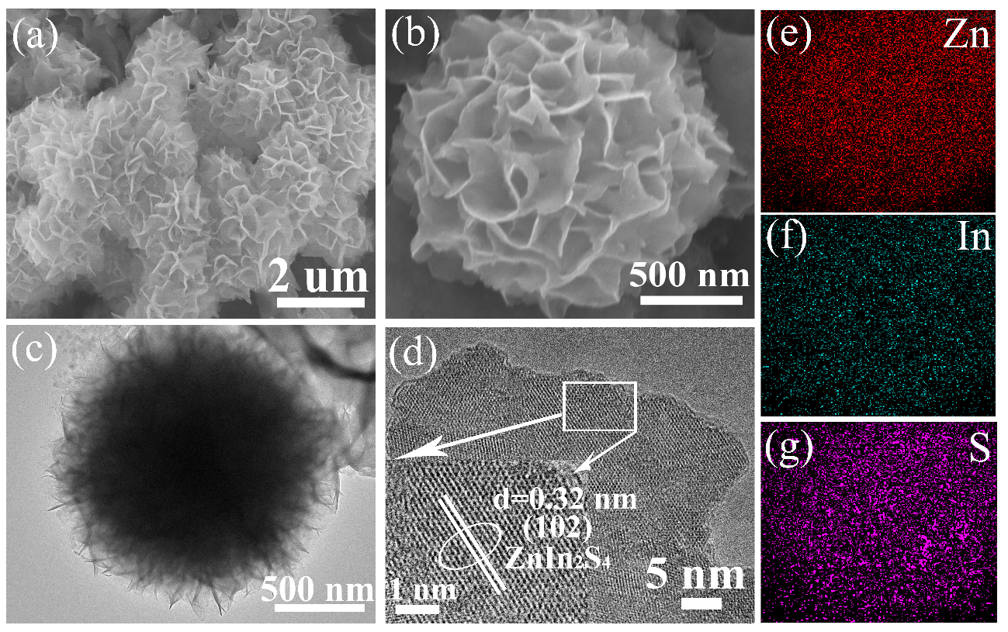
Fig.S3. Morphology characterizations of Vs-ZIS. a, b SEM, c, d TEM and HRTEM, e-g the corresponding element mapping images of c Zn, d In and e S.

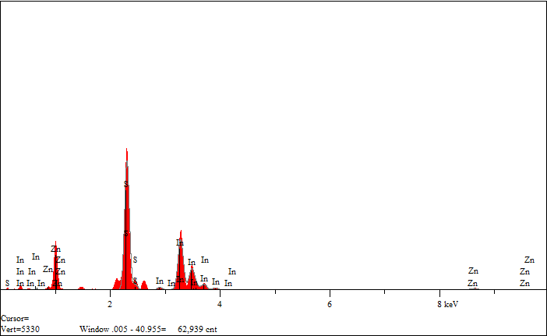
Fig. S4. EDS spectrum of Vs-ZIS.

Table S2. Elemental analyses of the Vs-ZIS photocatalyst by EDS.
Element | Atomic (%)
Zn | 15.95
In | 30.62
S | 53.43
Zn_{1.00}In_{1.92}S_{3.35}

Table S3. Elemental analyses of the Vs-ZIS/MoSe₂ photocatalyst by EDS.
Element | Weight (%) | Atomic (%)
Mo | 2.08 | 1.37
Se | 2.54 | 2.04
Zn | 16.43 | 15.89
In | 52.81 | 29.06
S | 26.14 | 51.64
Zn_{1.00}In_{1.83}S_{3.25}

Table S4. Elemental analyses of the Vs-ZIS/MoSe₂ photocatalyst by XPS.
Theoretical chemical formula | ZIS |  |  | Vs-ZIS |  |  | Vs-ZIS/MoSe₂
Element | Zn | In | S | Zn | In | S | Zn | In | S
Peak area ratio | 0.235 | 0.656 | 0.109 | 0.235 | 0.673 | 0.092 | 0.235 | 0.668 | 0.097
Atomic ratio | 0.042 | 0.090 | 0.163 | 0.042 | 0.093 | 0.138 | 0.042 | 0.090 | 0.141
Actual chemical formula | Zn_{1.00}In_{2.15}S_{3.87} |  |  | Zn_{1.00}In_{2.20}S_{3.29} |  |  | Zn_{1.00}In_{2.14}S_{3.36}

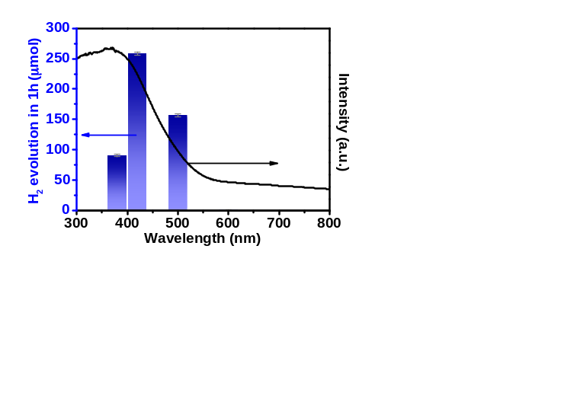
Fig. S5. Wavelength-dependent H₂ production rate in the presence of Vs-ZIS/5.0MoSe₂.

Table S5. The calculated AQE of Vs-ZIS/MoSe₂ photocatalyst at different wavelengths.
Wavelength | The mean H₂ production in 1 hour | Light power (Xe lamp) | AQE
380 nm | 90.46 μmol | 0.034 W | 93.08%
420 nm | 258.53 μmol | 0.107 W | 76.48%
500 nm | 156.66 μmol | 0.140 W | 29.70%
600 nm | 0.88 μmol | 0.134 W | 0.15%

The apparent quantum yield (AQY) was measured following the same reaction conditions as photocatalytic test except that the incident light was supplied by a 300W Xe lamp equipped with specific band-pass filters to get the desired monochromatic incident wavelength (λ＝380, 420, 500 and 600 nm). AQY was roughly calculated based on the following equation:
$$AQY=\frac{the number of reacted electrons}{the number of incident photons}×100\%=\frac{4×the number of H_{2} molecules}{the number of incident photons}×100\%=\frac{4×the number of H_{2} molecules}{N}×100\%$$
λ=380 nm:
$$N=\frac{Eλ}{hc}=\frac{0.034×3600×380×{10}^{-9}}{6.626×{10}^{-34}×3×{10}^{8}}=2.34×{10}^{20}$$
$$AQY=\frac{4×90.46×{10}^{-6}×6.02×{10}^{23}}{2.34×{10}^{20}}×100\%=93.08\%$$
λ=420 nm:
$$N=\frac{Eλ}{hc}=\frac{0.107×3600×420×{10}^{-9}}{6.626×{10}^{-34}×3×{10}^{8}}=8.14×{10}^{20}$$
$$AQY=\frac{4×258.53×{10}^{-6}×6.02×{10}^{23}}{8.14×{10}^{20}}×100\%=76.48\%$$
λ=500 nm:
$$N=\frac{Eλ}{hc}=\frac{0.140×3600×500×{10}^{-9}}{6.626×{10}^{-34}×3×{10}^{8}}=1.46×{10}^{21}$$
$$AQY=\frac{4×156.66×{10}^{-6}×6.02×{10}^{23}}{1.27×{10}^{21}}×100\%=29.70\%$$
λ=600 nm:
$$N=\frac{Eλ}{hc}=\frac{0.134×3600×600×{10}^{-9}}{6.626×{10}^{-34}×3×{10}^{8}}=1.46×{10}^{21}$$
$$AQY=\frac{4×0.88×{10}^{-6}×6.02×{10}^{23}}{1.46×{10}^{21}}×100\%=0.15\%$$
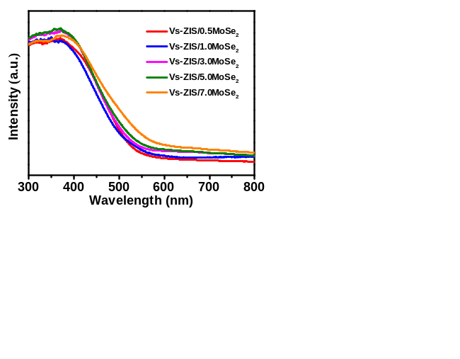
Fig. S6. UV–vis absorption spectra of Vs-ZIS/MoSe₂ with different mass ratio of MoSe₂ to ZIS.
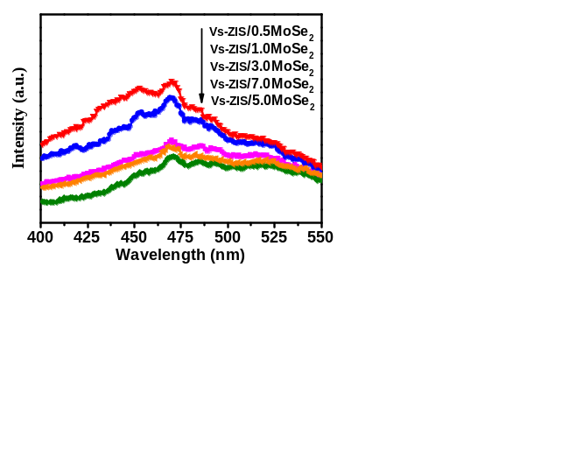
Fig. S7. Photoluminescence spectra (PL, excited at 375 nm) of Vs-ZIS/MoSe₂ with different mass ratio of MoSe₂ to ZIS.
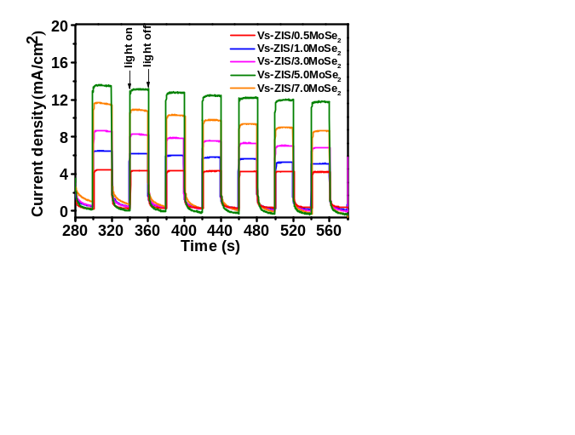
Fig. S8. Photocurrent response of Vs-ZIS/MoSe₂ with different mass ratio of MoSe₂ to ZIS.
Table S6. Comparison of representative ZnIn₂S₄-based photocatalysts for their H₂ evolution behavior recently.
Photocatalysts | Light source | H₂ evolution rate  (mmol·g⁻¹·h⁻¹) | AQE | Refs
Co₉S₈/ZnIn₂S₄ | 300 W Xe lamp (λ>400 nm) | 9.039 | 4.49% at 420 nm | ¹
Co₉S₈@ZnIn₂S₄ | 300 W Xe lamp, λ>400 nm | 6.250 | / | ²
ZnIn₂S₄-Ti₃C₂T_{X} (3 wt% Pt co-catalyst) | 300 W Xe lamp, λ>420 nm | 3.475 | 11.14 at 420 nm | ³
Zn₂In₂S₅/Ti₃C₂(O, OH) x (2 wt% Pt co-catalyst) | 300 W Xe lamp, λ>420 nm | 2.596 | 8.96% at 420 nm | ⁴
g-C₃N₄/Aminated-ZnIn₂S₄ (1 wt% Pt co-catalyst) | 300 W Xe lamp | 4.851 | / | ⁵
N-doped ZnIn₂S₄ | 300 W Xe lamp, λ>400 nm | 11.086 | 16.6% at 420 nm | ⁶
UiO-66-(COOH)₂/ZnIn₂S₄/MoS₂ | 300 W Xe lamp | 18.794 | / | ⁷
AgxAu1-x/ZnIn₂S₄ | 300 W Xe lamp, λ>420 nm | 5.401 | 8.06% at 420 nm | ⁸
Zn₃In₂S₆/FCN (2 wt% Pt co-catalyst) | 300 W Xe lamp, λ>420 nm | 0.510 | / | ⁹
ZnIn₂S₄/1%MoSe₂ | 300 W Xe lamp, λ>400 nm | 6.454 | / | ¹⁰
Co/NGC@ZnIn₂S₄ | 300 W Xe lamp, λ>400 nm | 11.270 | 5.07% at 420 nm | ¹¹
NiS/Vs-ZnIn₂S₄/WO₃ | 300 W Xe lamp, λ>400 nm | 11.090 | 72% at 420 nm | ¹²
ultra-thin ZnIn₂S₄/protonated g-C₃N₄ | 300 W Xe lamp, λ>400 nm | 8.601 | 0.92% at 400 nm | ¹³
Ni₂P/ZnIn₂S₄ | 300 W Xe lamp, λ>420 nm | 2.066 | 7.7% at 420 nm | ¹⁴
ZnIn₂S₄@NH₂-MIL-125(Ti) | 300 W Xe lamp, λ>420 nm | 2.204 | 4.3% at 420 nm | ¹⁵
Cubic/hexagonal ZnIn₂S₄ heterophase junctions | 300 W Xe lamp, λ>420 nm | 3.806 | 18.67% at 420 nm | ¹⁶
ZnIn₂S₄/MoSe₂ | 300 W Xe lamp, λ>420 nm | 2.228 | 21.39% at 420 nm | ¹⁷
2D/2D g-C₃N₄ nanosheet@ZnIn₂S₄ | 300 W Xe lamp, λ>420 nm | 2.780 | / | ¹⁸
Hydrogenated ZnIn₂S₄ | 300 W Xe lamp, λ>320 nm | 0.215 | 13.2% at 420 nm | ¹⁹
MoS₂/ZnIn₂S₄ | 300 W Xe lamp, λ>400 nm | 8.898 | / | ²⁰
Half-unit-cell ZnIn₂S₄ | 300 W Xe lamp, λ>400 nm | 13.478 | 53.68% at 365 nm | ²¹
Zn_{m}In₂S_{m+3}@In₂S₃ | 300 W Xe lamp, λ>420 nm | 3.300 | / | ²²
Vs-ZnIn₂S₄/MoSe₂ | 300 W Xe lamp, λ>420 nm | 63.21 | 76.48% at 420 nm | ^{This work}

References
1. Zhang, G. et al. Construction of Hierarchical Hollow Co₉S₈/ZnIn₂S₄ Tubular Heterostructures for Highly Efficient Solar Energy Conversion and Environmental Remediation. Angew. Chem. Int. Ed. 59, 8255-8261 (2020).
2. Wang, S. Guan, B. Wang, X. & Lou, X. Formation of Hierarchical Co₉S₈@ZnIn₂S₄ Heterostructured Cages as an Efficient Photocatalyst for Hydrogen Evolution. J. Am. Chem. Soc. 140, 15145-15148 (2018).
3. Zuo, G. et al. Ultrathin ZnIn₂S₄ Nanosheets Anchored on Ti₃C₂T_{X} MXene for Photocatalytic H₂ Evolution. Angew. Chem. Int. Ed. 59, 11287-11292 (2020).
4. Wang, H. et al. Electrical promotion of spatially photoinduced charge separation via interfacial-built-in quasi-alloying effect in hierarchical Zn₂In₂S₅/Ti₃C₂(O,OH)_{x} hybrids toward efficient photocatalytic hydrogen evolution and environmental remediation. Appl. Catal. B: Environ. 245, 290-301 (2019).
5. Gao, Z. et al. Aminated flower-like ZnIn₂S₄ coupled with benzoic acid modified g-C₃N₄ nanosheets via covalent bonds for ameliorated photocatalytic hydrogen generation. Appl. Catal. B: Environ. 268, 118462 (2020).
6. Du, C. Yan, B. Lin, Z. & Yang, G. Enhanced carrier separation and increased electron density in 2D heavily N-doped ZnIn₂S₄ for photocatalytic hydrogen production. J. Mater. Chem. A. 8, 207-217 (2020).
7. Mu, F. et al. Construction of 3D hierarchical microarchitectures of Z-scheme UiO-66-(COOH)₂/ZnIn₂S₄ hybrid decorated with non-noble MoS₂ cocatalyst: A highly efficient photocatalyst for hydrogen evolution and Cr(VI) reduction. Chem. Eng. J. 384, 123352 (2020).
8. An, H. Li, M. Liu, R. Gao, Z. & Yin, Z. Design of Ag_{x}Au_{1−x} alloy/ZnIn₂S₄ system with tunable spectral response and Schottky barrier height for visible-light-driven hydrogen evolution. Chem. Eng. J. 382, 122953 (2020).
9. Wu, Y. et al. Construction of hierarchical 2D-2D Zn₃In₂S₆/fluorinated polymeric carbon nitride nanosheets photocatalyst for boosting photocatalytic degradation and hydrogen production performance. Appl. Catal. B: Environ. 233, 58-69 (2018).
10. Yang, M. et al. Self-surface charge exfoliation and electrostatically coordinated 2D hetero-layered hybrids. Nat. Commun. 8, 14224 (2017).
11. Wang, S. et al . Supporting Ultrathin ZnIn₂S₄ Nanosheets on Co/N‐Doped Graphitic Carbon Nanocages for Efficient Photocatalytic H₂ Generation. Adv. Mater. 31, 1903404 (2019).
12. Li, Z. et al. Two-dimensional Janus heterostructures for superior Z-scheme photocatalytic water splitting. Nano Energy. 59, 537-544 (2019).
13. Yang, H. et al. Constructing electrostatic self-assembled 2D/2D ultra-thin ZnIn₂S₄/protonated g-C₃N₄ heterojunctions for excellent photocatalytic performance under visible light. Appl. Catal. B: Environ. 256, 117862 (2019).
14. Li, X. et al. Fabrication of two-dimensional Ni₂P/ZnIn₂S₄ heterostructures for enhanced photocatalytic hydrogen evolution. Chem. Eng. J. 353, 15-24 (2018).
15. Liu, H. Zhang, J. & Ao, D. Construction of heterostructured ZnIn₂S₄@NH₂-MIL-125(Ti) nanocomposites for visible-light-driven H₂ production. Appl. Catal. B: Environ. 221, 433-442 (2018).
16. Wang, J. et al. Cubic quantum dot/hexagonal microsphere ZnIn₂S₄ heterophase junctions for exceptional visible-light-driven photocatalytic H₂ evolution. J. Mater. Chem. A. 5, 8451-8460 (2017).
17. Zeng, D. et al. Hierarchical ZnIn₂S₄ /MoSe₂ Nanoarchitectures for Efficient Noble-Metal-Free Photocatalytic Hydrogen Evolution under Visible Light. ChemSusChem, 10, 4624-4631 (2017).
18. Lin, B. et al. Preparation of 2D/2D g-C₃N₄ nanosheet@ZnIn₂S₄ nanoleaf heterojunctions with well-designed high-speed charge transfer nanochannels towards high-efficiency photocatalytic hydrogen evolution. Appl. Catal. B: Environ. 220, 542-552 (2018).
19. Zhu, Y. Wang, L. Liu, Y. Shao, L. & Xia, X. In-situ hydrogenation engineering of ZnIn₂S₄ for promoted visible-light water splitting. Appl. Catal. B: Environ. 241, 483-490 (2019).
20. Li, W. Lin, Z. & Yang, G. A 2D self-assembled MoS₂/ZnIn₂S₄ heterostructure for efficient photocatalytic hydrogen evolution. Nanoscale. 9, 18290-18298 (2017).
21. Du, C. et al. Half-unit-cell ZnIn₂S₄ monolayer with sulfur vacancies for photocatalytic hydrogen evolution. Appl. Catal. B: Environ. 48, 193-201 (2019).
22. Li, Y. Han, P. Hou, Y. Peng, S. & Kuang, X. Oriented ZnmIn₂S_{m+3}@In₂S₃ heterojunction with hierarchical structure for efficient photocatalytic hydrogen evolution. Appl. Catal. B: Environ. 244, 604-611 (2019).

