Appendix: Supplementary materials
Acute adverse effects of metallic nanomaterials on cardiac and behavioral changes in Daphnia magna
Jihoon Park^{1,2}, Chang Gyun Park¹, Baeckkyoung Sung^{1,3}, Yong Oh Lee¹,
Chang Seon Ryu¹, Ja Young Park¹*, Young Jun Kim^{1,3}
¹ Korea Institute of Science and Technology Europe Forschungsgesellschaft mbH, 66123 Saarbrücken, Germany
² Accident Response Coordination Division, National Institute of Chemical Safety, Ministry of Environment, 28164 Cheongju, Republic of Korea
³ Division of Energy & Environment Technology, University of Science & Technology, 34113 Daejeon, Republic of Korea
*Correspondence: Dr. Jayoung Park
Environmental Safety Group, Korea Institute of Science and Technology Europe Forschungsgesellschaft mbH, 66123 Saarbrücken, Germany
E-mail: pjy0404@gmail.com; Tel: +49-0681-9382-340; Fax: +49-0681-9382-319

List of contents
FIGURE A1. Temporal variation of swimming speed by titanium dioxide (TiO₂) level and exposure duration A1
FIGURE A2. Temporal variation of swimming speed by silver nanoparticles (AgNPs) level and exposure duration A2
FIGURE A3. Temporal variation of swimming speed by silver ion (Ag +) level and exposure duration A3

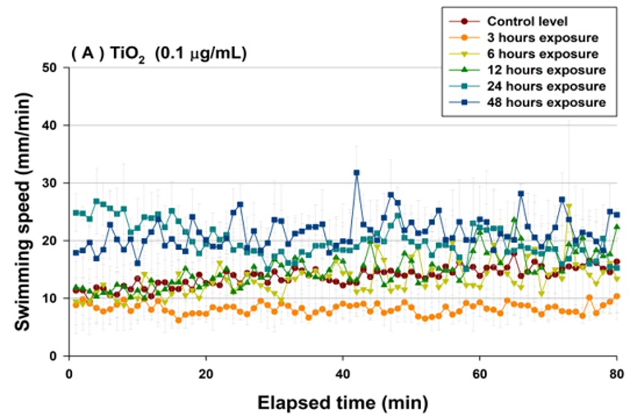
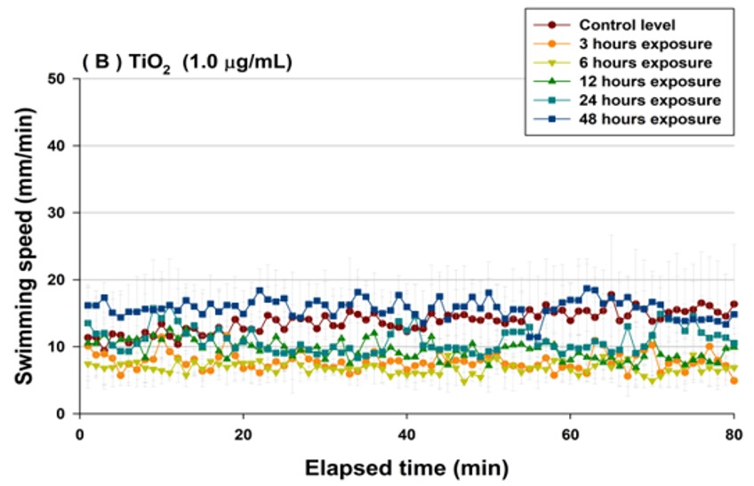
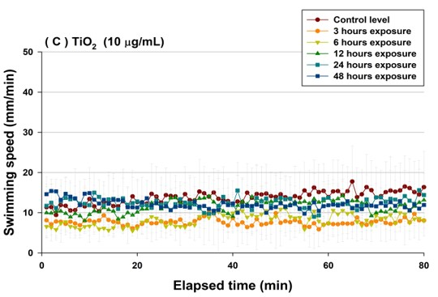
Figure A1. Temporal variation of swimming speed by titanium dioxide level (TiO₂) and exposure duration.
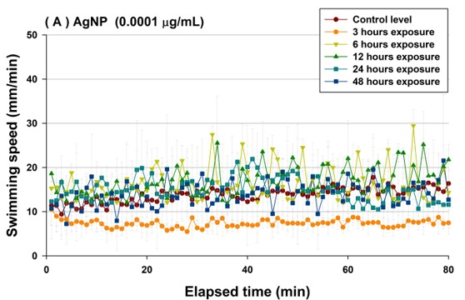
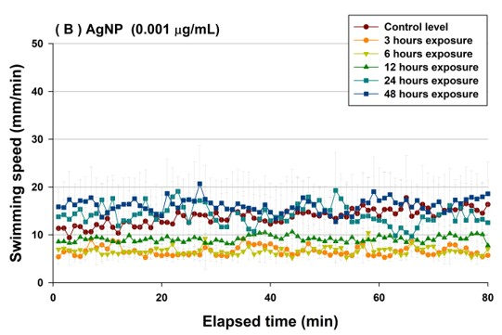
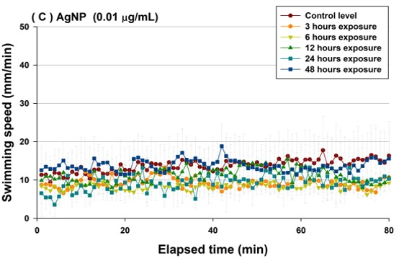
Figure A2. Temporal variation of swimming speed by silver nanoparticles (AgNPs) level and exposure duration.
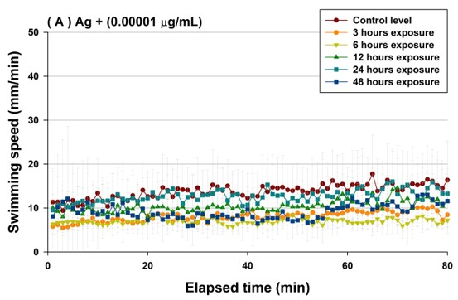
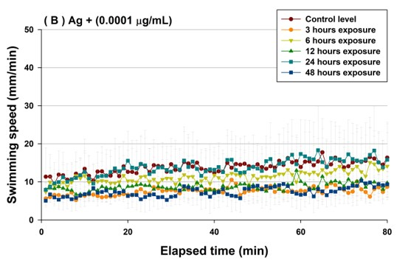
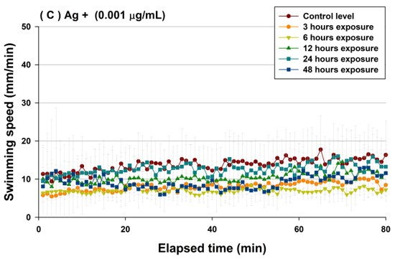
Figure A3. Temporal variation of swimming speed by silver ion (Ag +) level and exposure duration.

