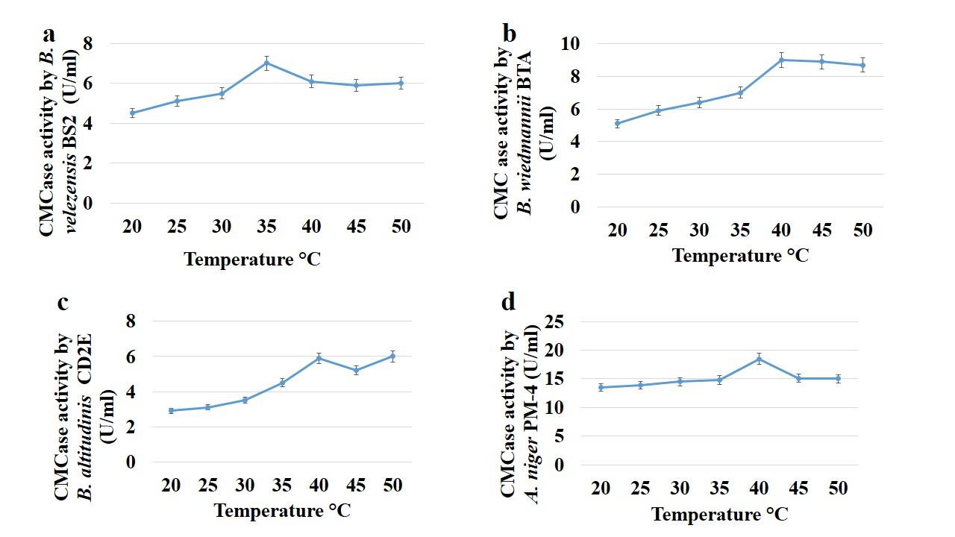
Fig S1: Effect of Temperature (20-50C⁰) for CMCase production in submerged fermentation of 48 hour. (a) CMCase activity by B. velezensis BS2; (B) CMCase activity by B. wiedmannii BTA; (c) CMCase activity by B. altitudinis CD2E (d) CMCase activity by A. niger PM-4. The means and standard deviations of triplicates are used to calculate the values.

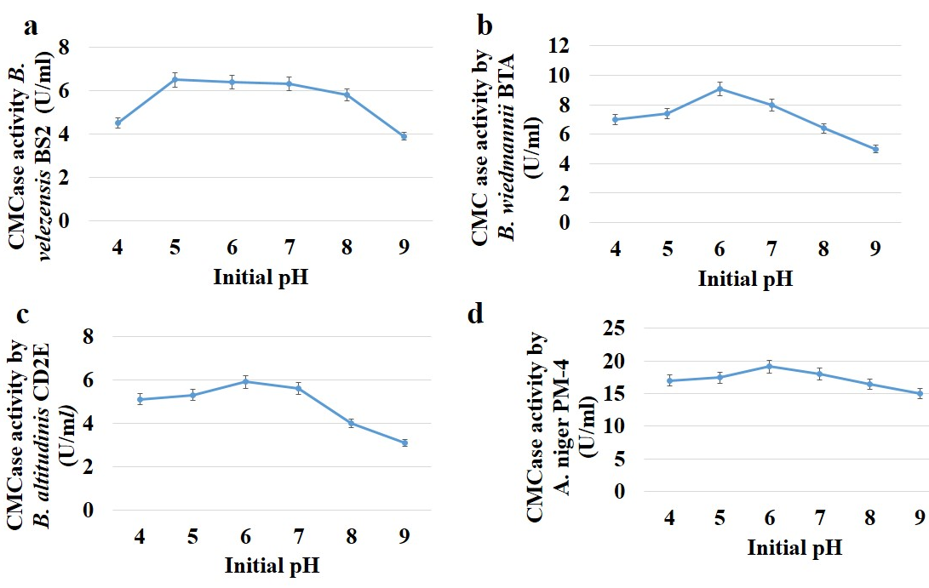
Fig S2: Effect of initial pH (4-9) for CMCase production in submerged fermentation for 48 hour. (a) CMCase activity by B. velezensis BS2; (B) CMCase activity by B. wiedmannii BTA; (c) CMCase activity by B. altitudinis CD2E (d) CMCase activity by A. niger PM-4. The means and standard deviations of triplicates are used to calculate the values.

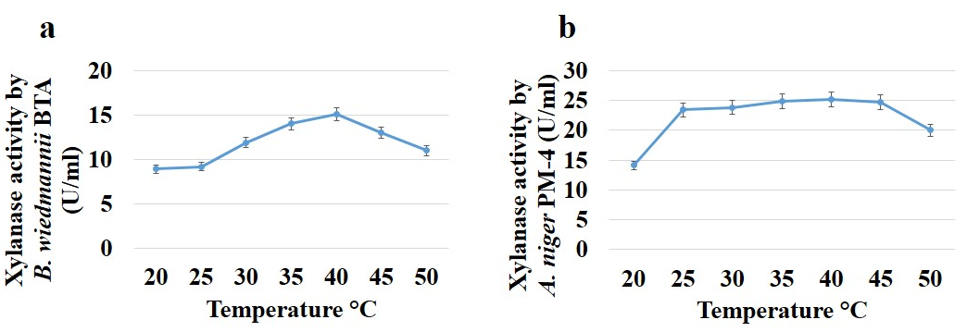

Fig S3: Effect of Temperature (20-50C⁰) for xylanase production in submerged fermentation of 48 hour. (a) Xylanase activity by B. wiedmannii BTA; (b) Xylanase activity by A. niger PM-4. The means and standard deviations of triplicates are used to calculate the values.

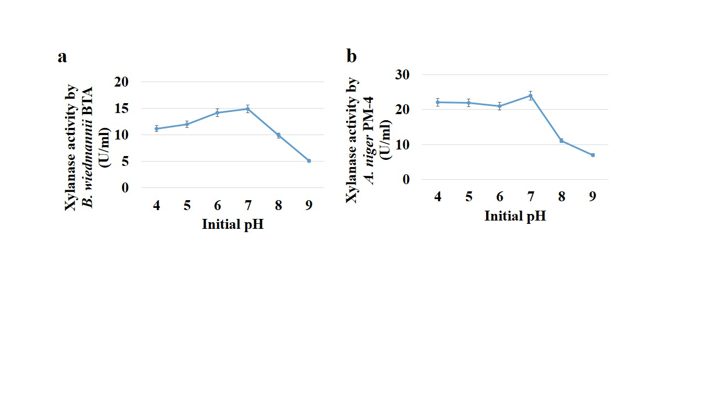
Fig S4: Effect of initial pH (4-9) for xylanase production in submerged fermentation of 48 hour. (a) Xylanase activity by B. wiedmannii BTA; (b) Xylanase activity by A. niger PM-4. The means and standard deviations of triplicates are used to calculate the values.

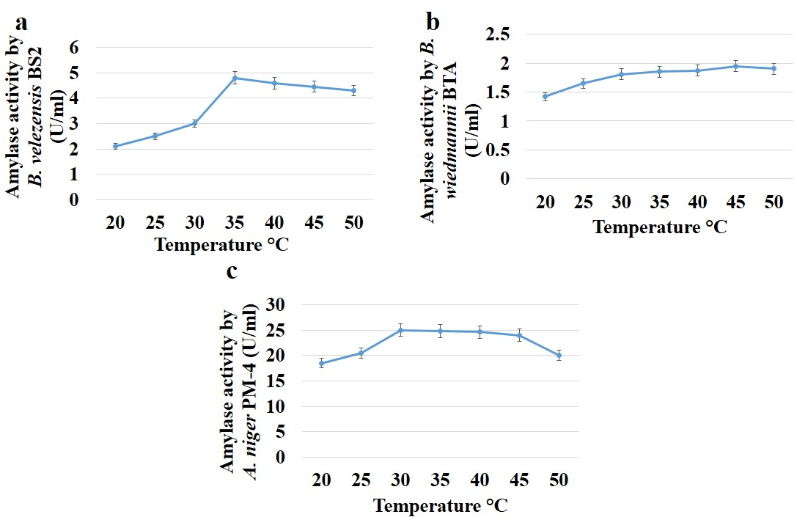
Fig S5: Effect of Temperature (20-50C⁰) for amylase production in submerged fermentation of 48 hour. (a) Amylase activity by B. velezensis BS2; (b) Amylase activity by B. Wiedmannii BTA; (c) Amylase activity by A. niger PM-4. The means and standard deviations of triplicates are used to calculate the values.

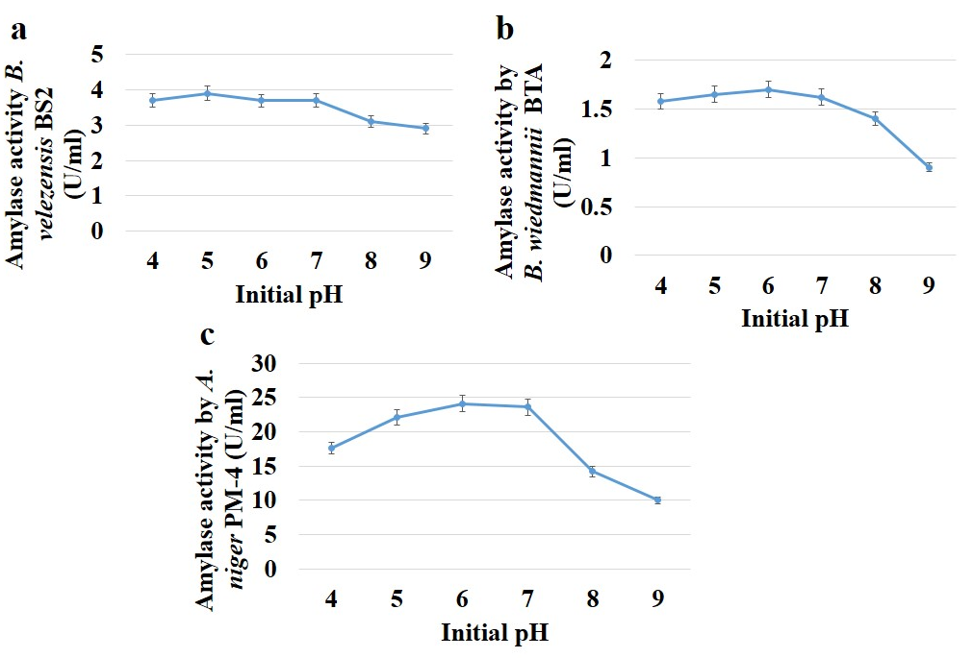
Fig S6: Effect of initial pH (4-9) for amylase production in submerged fermentation of 48 hour. (a) Amylase activity by B. velezensis BS2; (b) Amylase activity by B. Wiedmannii BTA; (c) Amylase activity by A. niger PM-4. The means and standard deviations of triplicates are used to calculate the values.

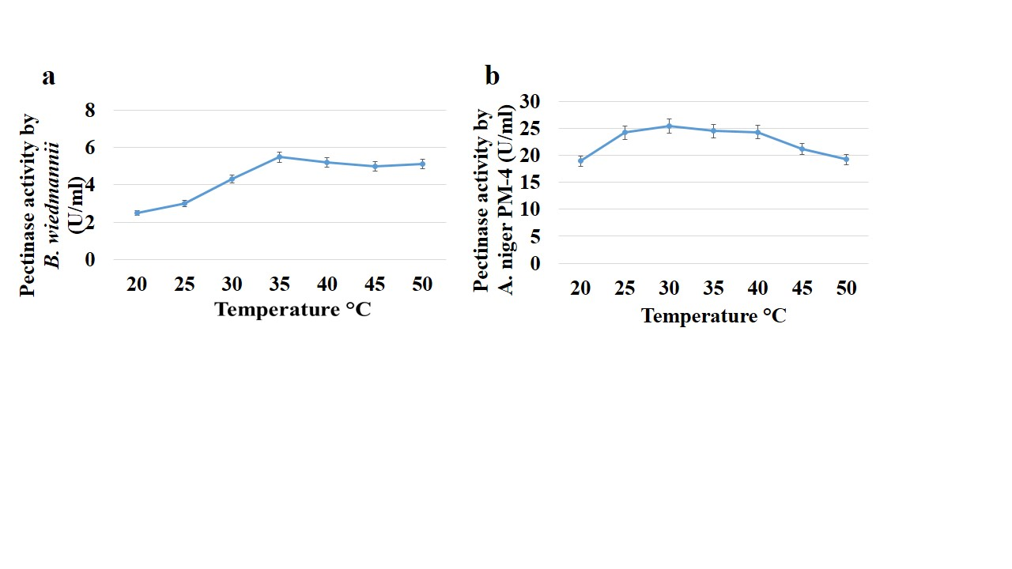
Fig S7: Effect of Temperature (20-50C⁰) for pectinase production in submerged fermentation of 48 hour. (a) Pectinase activity B. wiedmannii BTA; (b) Pectinase activity by A. niger PM-4. The means and standard deviations of triplicates are used to calculate the values.

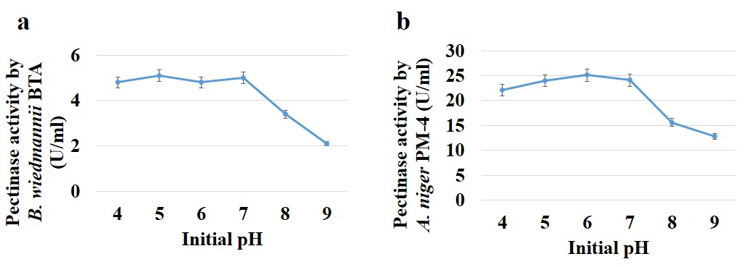
Fig S8: Effect of Initial pH (4-9) for pectinase production in submerged fermentation of 48 hour. (a) Pectinase activity by B. wiedmannii BTA; (b) Pectinase activity by A. niger PM-4. The means and standard deviations of triplicates are used to calculate the values.

