Supplementary Figures

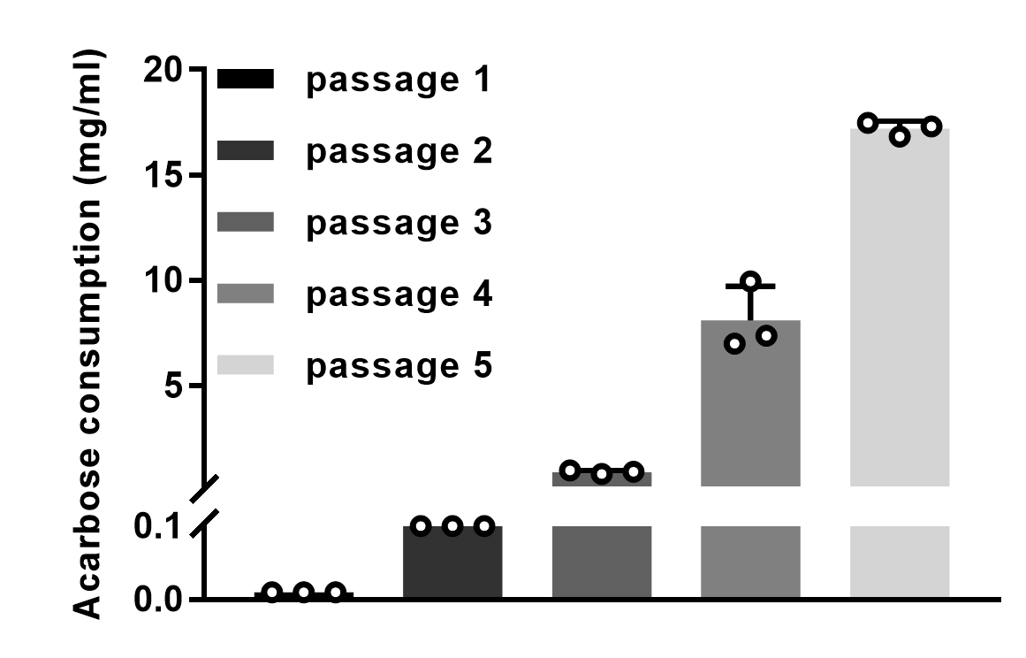

Supplementary Figure 1. Increased acarbose consumption of intestinal microbiota by enrichment using acarbose as the stress. The concentration of acarbose used in the enrichment experiment were 0.01, 0.1, 1, 10, and 20 mg/mL for passage 1, 2, 3, 4, and 5, respectively. Data are represented as mean ± SD (n = 3). Error bars show SDs.

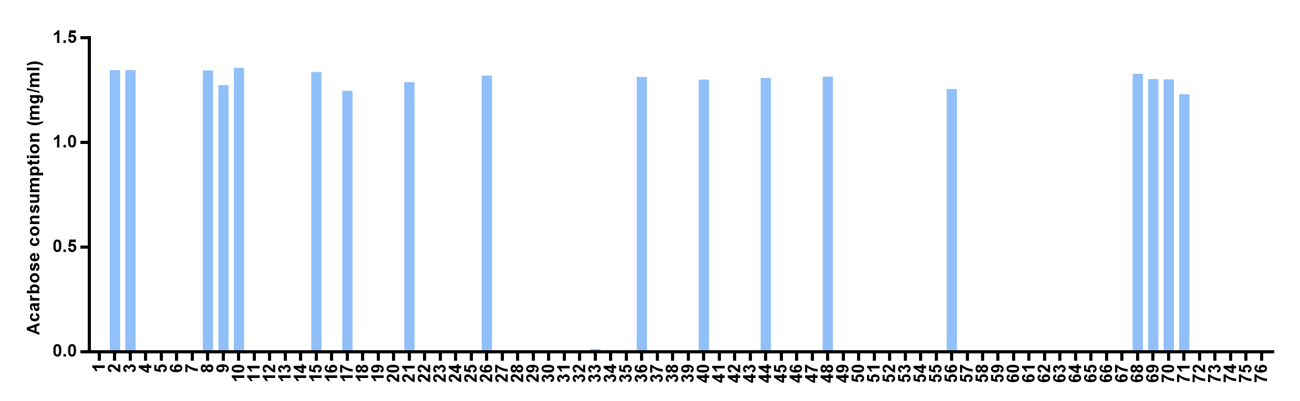
Supplementary Figure 2. Identification of isolates capable of metabolizing acarbose from human stool sample. These strains were cultivated in the mGAM medium supplemented with acarbose (1.5 mg/mL) for 24 h anaerobically. Among the 76 tested isolates, 18 were found to efficiently metabolize acarbose and then identified as K. grimontii strains.

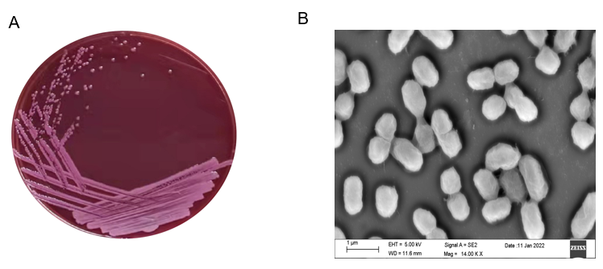

Supplementary Figure 3. Morphological characteristics of K. grimontii TD1 strains. The micro-structure of the K. grimontii TD1 strain was obtained using scanning electron microscope.
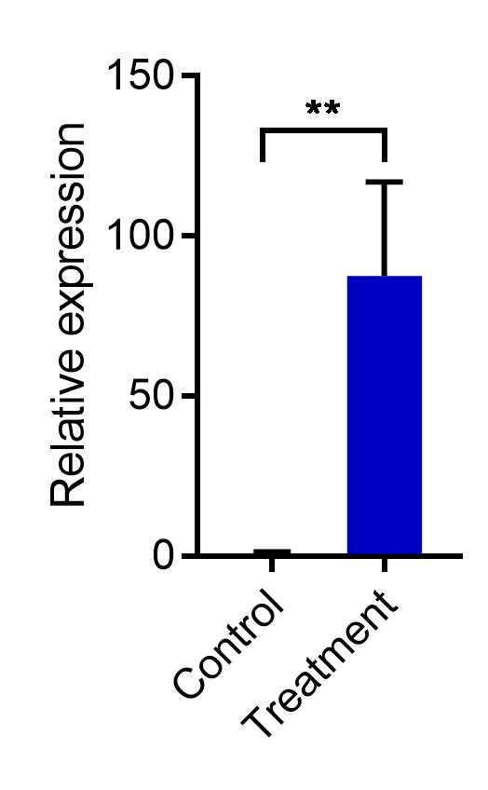

Supplementary Figure 4. Comparison of the transcript levels of apg (L5654_01665) with and without the supplementation of acarbose in the MS medium. Samples were collected from Klebsiella grimontii TD1 grown in MS medium with (treatment) or without acarbose (control) after 24 h of cultivation. Total RNA was subjected to real-time qRT-PCR analysis. The relative transcript level of apg was normalized to gapA (L5654_11535, an internal control). The relative fold changes of gene transcription were determined by the 2^{−ΔΔCT} method. Error bars represent the standard deviations (SD) from three biological replicates. Statistical analysis was performed by a two-tailed Student’s t-test. **p < 0.01,

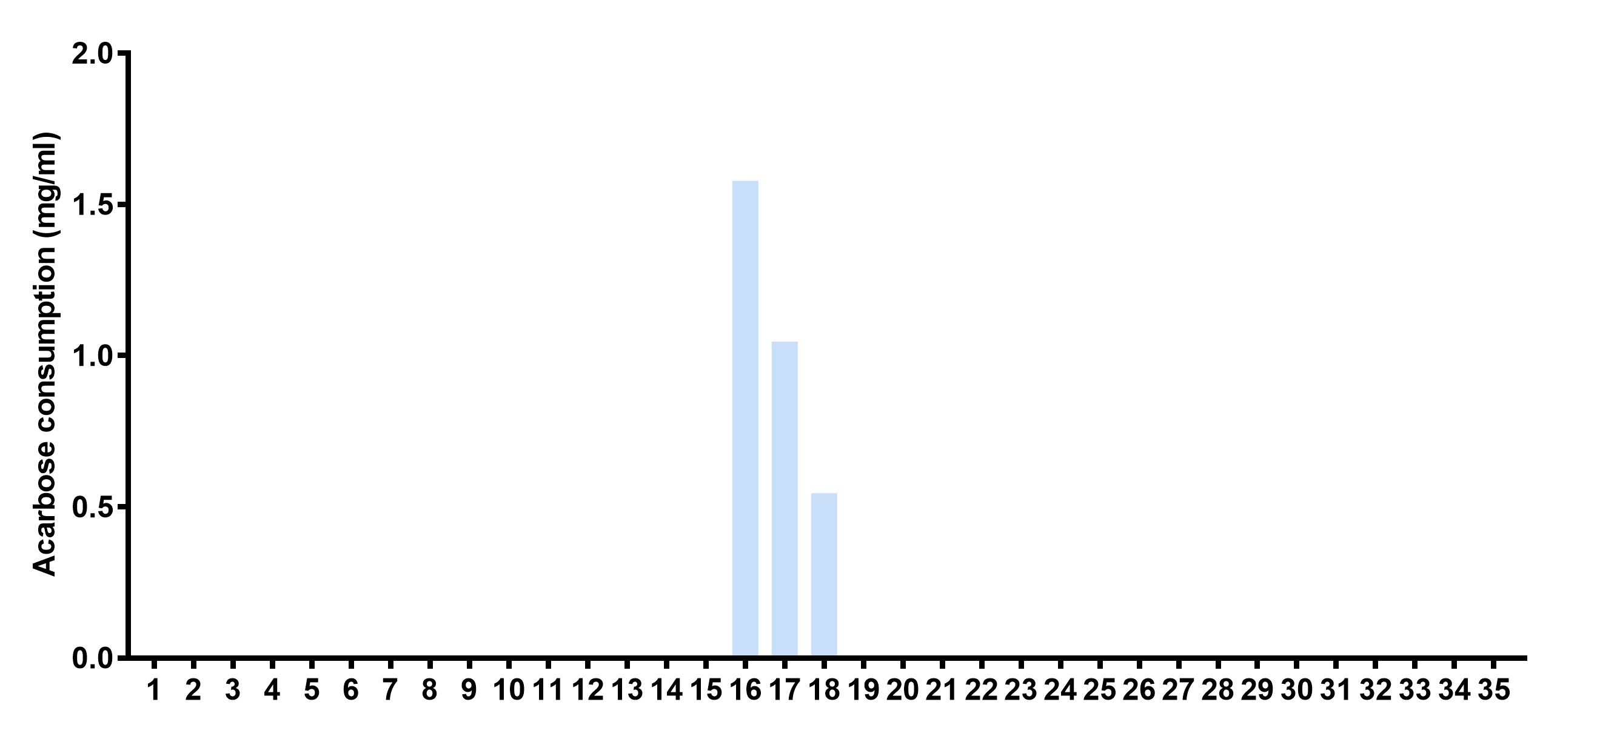
a

b

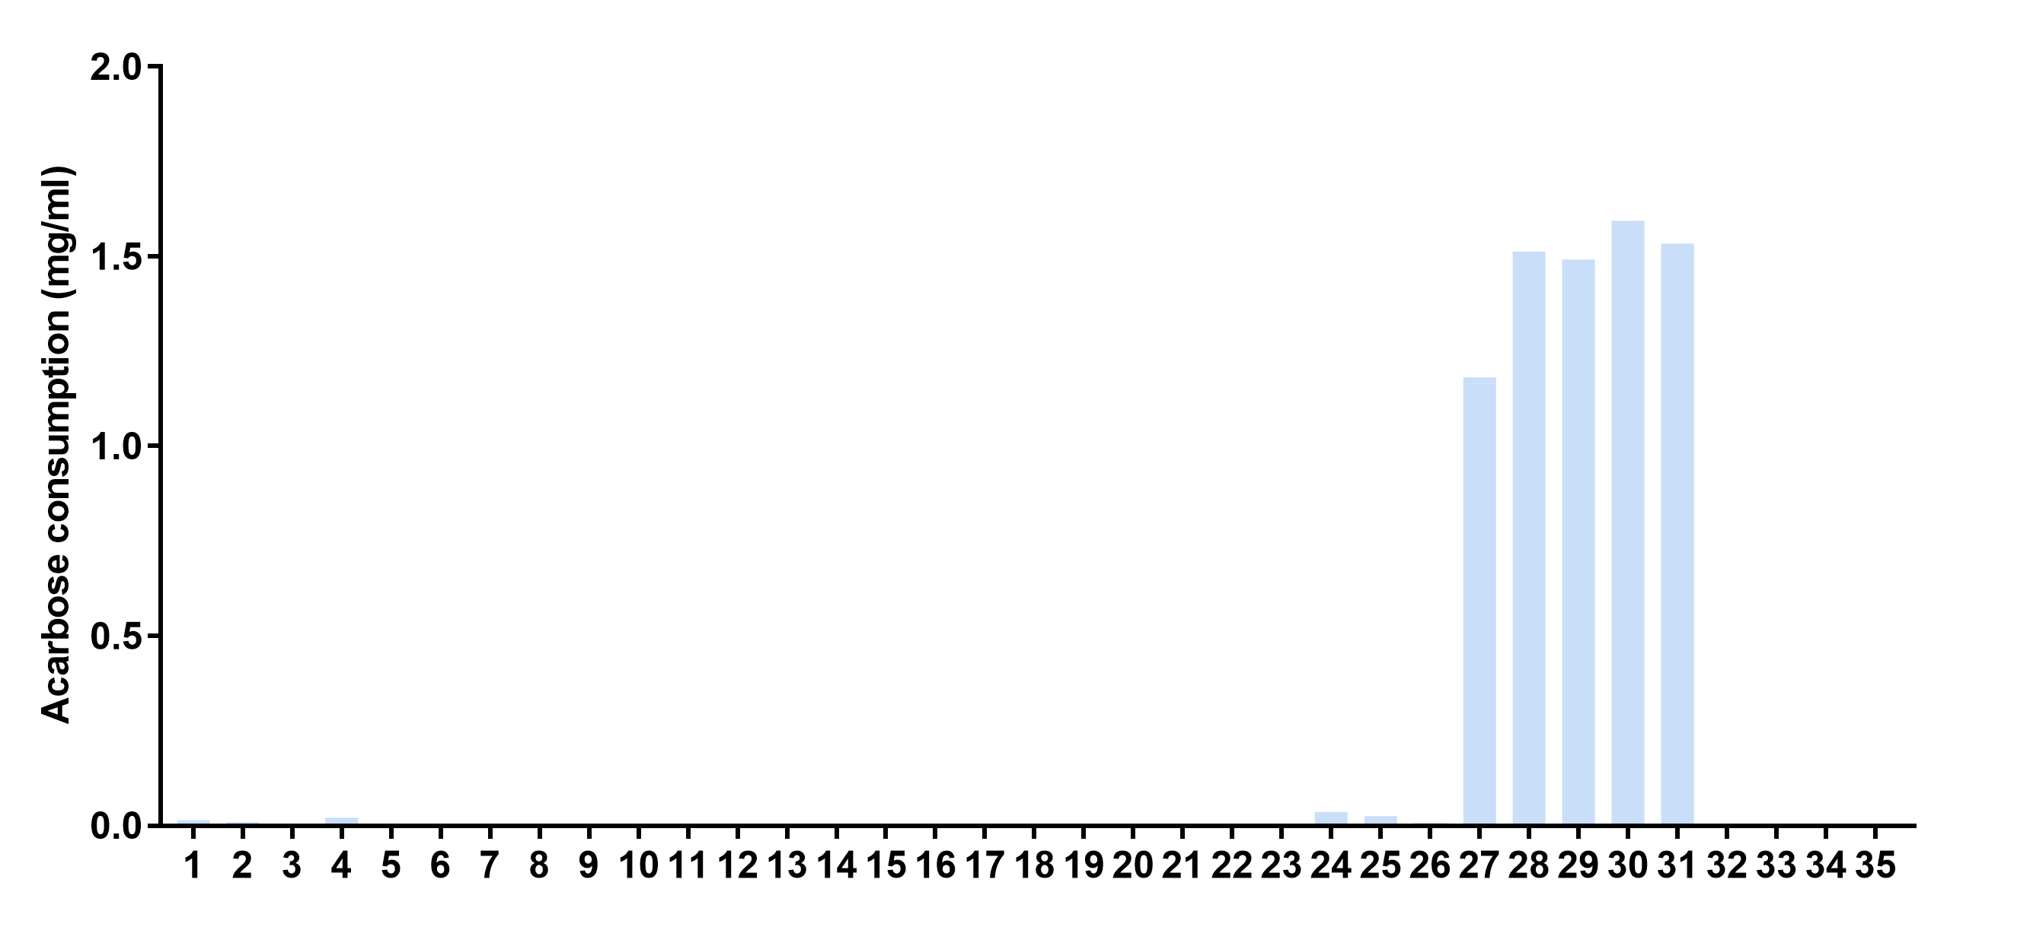

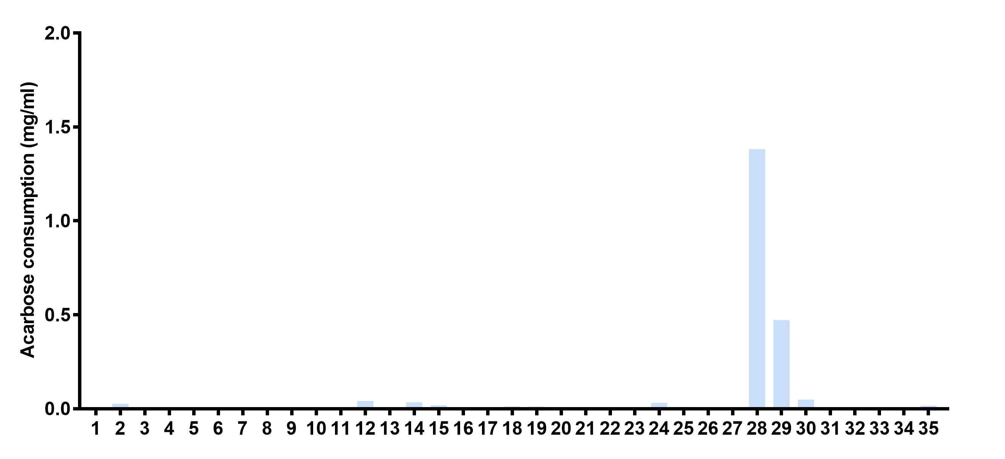
c

Supplementary Figure 5. Separation and purification of enzymes responsible for acarbose degradation from K. grimontii TD1 cell lysates by Fast Protein Liquid Chromatography (FPLC). a, Separation of total proteins using HitrapTM Q HP. b, Separation of a mixture of the fraction 16, 17, and 18 (a) that showed catalytic activity towards acarbose using HitrapTM SP HP. c, Separation of a mixture of the fractions 27‒31 (b) that showed catalytic activity towards acarbose using Hiload 16/600 Superdex 200. Each fraction separated from FPLC was incubated with acarbose at 37 ℃ for 6 hours. Then, the concentration of acarbose in the reaction mixture was assayed by HPLC.

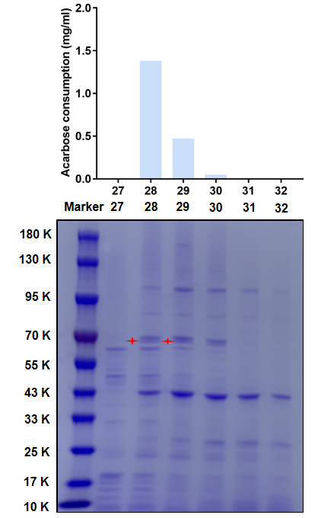

Supplementary Figure 6. SDS-PAGE analysis of the fractions (from size exclusion chromatography) with acarbose-consuming activities. The fractions 27‒32 (Supplementary Figure 4c) were analyzed by SDS-PAGE. The faction 28 and 29 exhibited obvious catalytic activity towards acarbose. The red asterisks indicated the protein components that showed a specific high content in the faction 28 and 29. The fraction 28 was used for proteomic assay.

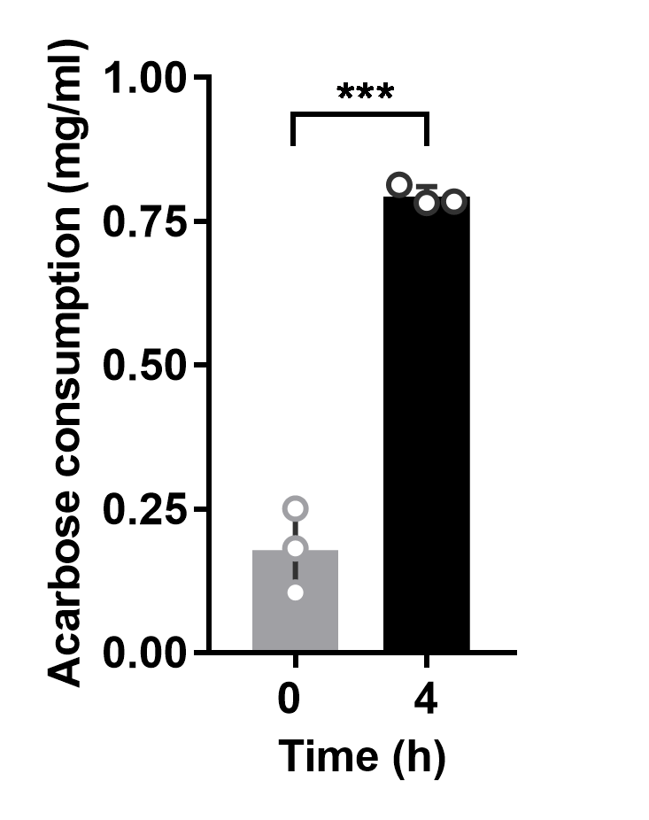
Supplementary Figure 7. Confirmation of the in vivo activity of Apg in E. coli. The E. coli strain that expressed apg was anaerobically cultivated at 37 ℃ for 4 h with the supplementation of 1.8 mg/mL of acarbose. The initial (0 h) and residual (4 h) acarbose concentration were determined. Data are represented as the mean ± SD (n = 3). Statistical analysis was performed by a two-tailed Student’s t-test. ***p < 0.001.

b
a
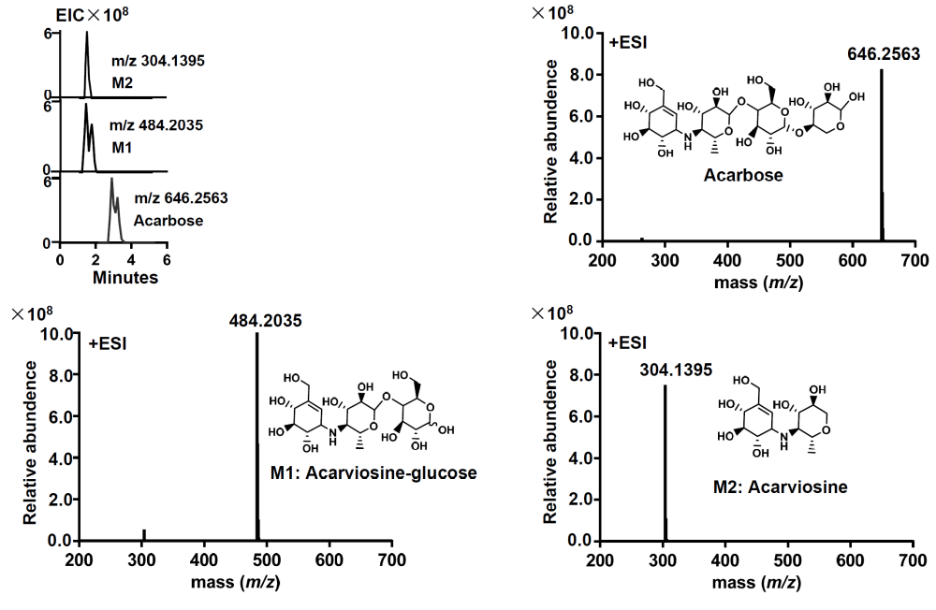

c

d

Supplementary Figure 8. Identification of acarbose-degrading products mediated by Apg using mass spectrometry. a, LC-MS detection of the acarbose degradation products. The reaction system containing 0.00087 μM Apg, 2 mg/mL acarbose and 200 μL of reaction buffer was incubated at 37 ℃ for 30 min anaerobically. Experiments were repeated at least three times with similar results. b, Tandem mass spectrometry analysis of the standard of acarbose. c, d, Tandem mass spectrometry analysis of the fraction M1 (c) and M2 (d).

a
b

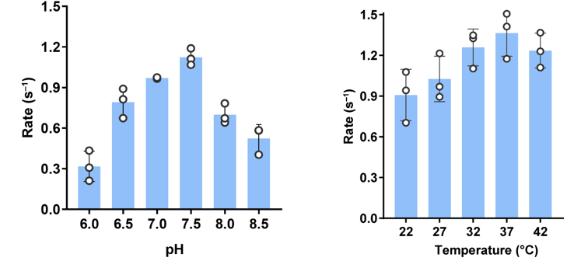

Supplementary Figure 9. Determination of the optimum pH value and reaction temperature for steady-state kinetic analysis of Apg using acarbose as the substrate. a, The optimum pH value. b, The optimum reaction temperature. Data are represented as the mean ± SD (n = 3).

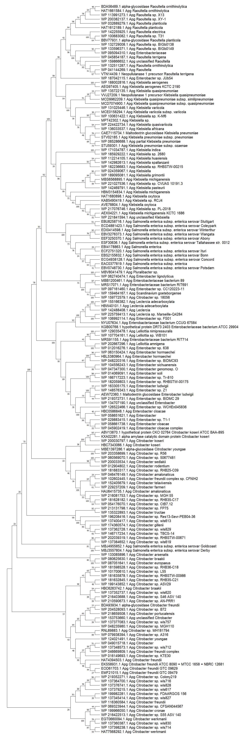

Supplementary Figure 10. A full maximum likelihood phylogenetic tree of Apg homologues across different species and genera. The numbers on the branches indicate bootstrap supports.
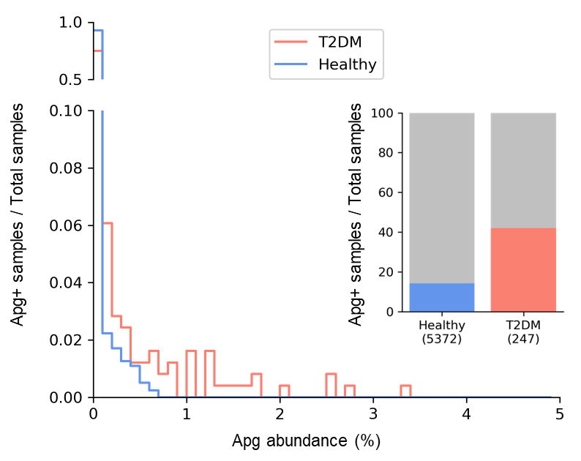
Supplementary Figure 11. Abundance analysis of apg homologs. Prevalence and abundance of apg homologs in the intestinal microbiota of healthy human (ranging form 0 to 0.7% with an average abundance of 0.02%) and patients with T2DM (ranging form 0 to 3.3% with an average abundance of 0.2%) (from GMrepo, healthy samples N = 5, 372 and acarbose treatment T2DM samples N = 247).

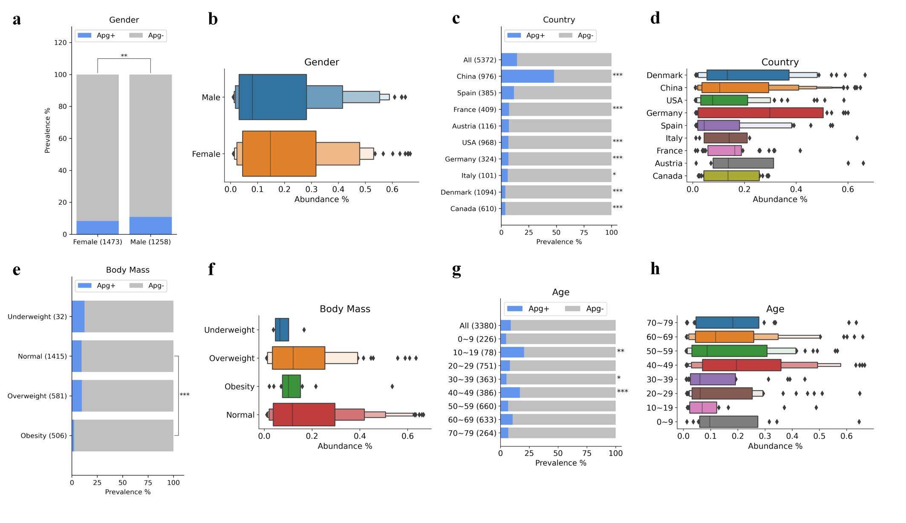

Supplementary Figure 12. The prevalence and abundance of Apg⁺ bacteria among healthy human populations of different gender, country, body mass, and age groups. a, The prevalence of Apg⁺ bacteria in male and female samples. Fisher exact test was performed between the two gender groups. b, The abundance of Apg⁺ bacteria in positive samples of male and female. c, The prevalence of Apg⁺ bacteria among different countries. Fisher exact tests were performed between a specific country and the general ratio derived from all samples. d, The abundance of Apg⁺ bacteria in positive samples from different countries. e, The prevalence of Apg⁺ bacteria among groups of different body mass. Fisher exact tests were performed between the normal group and each abnormal group. f, The abundance of Apg⁺ bacteria in positive samples with different grades of body mass. The body mass categories are defined by the BMI as suggested by the Centers for Disease Control and Prevention of the United States. Underweight: BMI < 18.5, normal: BMI of 18.5~24.9, overweight: BMI of 25.0~29.9, and obesity: BMI >= 30. g, The prevalence of Apg⁺ bacteria among different age groups. Fisher exact tests were performed between a specific age group and the general ratio derived from all samples. h, The abundance of Apg⁺ bacteria in positive samples from different age groups. In a, c, e, and g, Apg⁺ is defined as the abundance of apg homolog containing bacteria greater than 0.01%. Embraced numbers indicate the sample size of the categories. In b, d, f, and h, the vertical line in the middle of each distribution indicates the median value. The diamond dots indicate outliers. * p < 0.05, ** p < 0.01, *** p < 0.001.
Supplementary Tables
Supplementary Table 1 The significantly (≥ 20-fold) upregulated genes after adding acarbose (2 mg/mL) to the medium
Gene_id | Gene description | Fold change (treatment/control) | P value | FDR
L5654_02325 | efflux RND transporter periplasmic adaptor subunit | 125.333 | 9.9E-108 | 1.1E-106
L5654_15585 | DUF1127 domain-containing protein | 81.802 | 2.13E-09 | 5.97E-09
L5654_08675 | multidrug/biocide efflux PACE transporter | 71.849 | 7.3E-07 | 1.79E-06
L5654_01895 | S-methylmethionine permease | 58.134 | 4.1E-150 | 6.2E-149
L5654_01665 | maltodextrin glucosidase | 55.966 | 2.6E-192 | 4.8E-191
L5654_22835 | cystathionine gamma-synthase | 55.48 | 2.7E-304 | 7.7E-303
L5654_01770 | MFS transporter | 54.718 | 1.4E-241 | 3.3E-240
L5654_11180 | anthranilate synthase component 1 | 54.058 | 1.63E-78 | 1.48E-77
L5654_05290 | aldo/keto reductase family oxidoreductase | 50.896 | 1.6E-214 | 3.2E-213
L5654_01715 | nucleoside phosphorylase | 41.392 | 5.47E-28 | 2.62E-27
L5654_10650 | ribulose-phosphate 3-epimerase | 36.895 | 2.19E-06 | 5.22E-06
L5654_19015 | methionine adenosyltransferase | 35.351 | 0 | 0
L5654_00070 | carbohydrate kinase | 35.337 | 2.4E-174 | 4.1E-173
L5654_22370 | HTH-type transcriptional regulator MetR | 34.288 | 4.4E-117 | 5.4E-116
L5654_07130 | tautomerase PptA | 33.434 | 0.000493 | 0.000994
L5654_05135 | putative selenium delivery protein YdfZ | 33.272 | 0.00012 | 0.000256
L5654_22815 | methylenetetrahydrofolate reductase | 31.61 | 0 | 0
L5654_22830 | bifunctional aspartate kinase/homoserine dehydrogenase II | 30.474 | 0 | 0
L5654_07525 | MarR family transcriptional regulator | 29.81 | 3.18E-39 | 1.84E-38
L5654_05275 | HlyD family secretion protein | 29.714 | 1.91E-22 | 8.01E-22
L5654_17985 | methionine ABC transporter ATP-binding protein MetN | 28.109 | 1.2E-142 | 1.8E-141
L5654_00965 | monooxygenase | 27.169 | 1.18E-36 | 6.54E-36
L5654_01630 | peroxiredoxin | 26.137 | 4.05E-91 | 4.04E-90
L5654_00075 | methylthioribulose 1-phosphate dehydratase | 25.697 | 1.9E-107 | 2.2E-106
L5654_00110 | MFS transporter | 25.297 | 5.56E-29 | 2.7E-28
L5654_01205 | maltoporin | 25.167 | 0 | 0
L5654_23485 | exo-alpha-sialidase | 23.216 | 2.95E-10 | 8.56E-10
L5654_21665 | aspartate-ammonia ligase | 23.122 | 0 | 0
L5654_08825 | TerC family protein | 22.671 | 7.95E-05 | 0.000172
L5654_05420 | alpha-amylase | 21.692 | 0 | 0
L5654_01225 | ABC transporter permease | 21.44 | 0.004861 | 0.008878
L5654_12080 | DNA-3-methyladenine glycosylase 2 | 21.192 | 0.001609 | 0.003098

Supplementary Table 2 Proteomics-based identification of proteins from the size exclusion chromatography fractions with higher acarbose-degrading activities.
Accession | Description | AAs | MW [kDa] | Abundances
WP_004104469.1 | MULTISPECIES: IMP dehydrogenase | 488 | 52 | 1.33E+08
QLU25376.1 | glucans biosynthesis protein MdoG | 517 | 58.6 | 1.04E+10
QLT64389.1 | pyruvate kinase PykF | 470 | 50.6 | 8.27E+08
QLU26696.1 | leucyl aminopeptidase | 503 | 54.8 | 1.59E+08
QTV83340.1 | transcription termination factor Rho | 419 | 47 | 18368038
WP_023320167.1 | glucose-6-phosphate isomerase | 549 | 61.3 | 24026020
WP_123754692.1 | MULTISPECIES: pyruvate kinase PykF | 470 | 50.6 | 1485037
QLX87819.1 | glucose-6-phosphate dehydrogenase | 491 | 56.1 | 21527563
QLT65407.1 | ribonuclease E | 1082 | 120.1 | 6408103
QLU23651.1 | NAD-dependent DNA ligase LigA | 674 | 74.4 | 26177002
WP_195908820.1 | glucan biosynthesis protein G | 517 | 58.6
QTV82350.1 | endopeptidase La | 784 | 87.4 | 15828506
QLX87191.1 | NAD-dependent DNA ligase LigA | 674 | 74.3
WP_004136452.1 | MULTISPECIES: histidine--tRNA ligase | 424 | 47 | 42578499
QLT62629.1 | maltodextrin phosphorylase | 796 | 90.1 | 57437587
WP_000729117.1 | MULTISPECIES: chaperonin GroEL | 548 | 57.3 | 3450536
QLT63989.1 | UDP-glucose 6-dehydrogenase | 388 | 43.6 | 1379540
QLX90394.1 | molecular chaperone DnaK | 638 | 69.1 | 9333116
QLU25095.1 | transcriptional regulator TyrR | 513 | 57.3 | 48771663
WP_110274507.1 | MULTISPECIES: chaperonin GroEL | 548 | 57.3 | 635235.4
QLU25847.1 | alkyl hydroperoxide reductase subunit F | 521 | 56 | 8668406
Q9ZF28.1 | RecName: Full=Translation initiation factor IF-2 | 896 | 98 | 16828301
QLT67112.1 | 5-methyltetrahydropteroyltriglutamate--homocysteine S-methyltransferase | 753 | 84.3 | 17650591
WP_174510685.1 | maltodextrin phosphorylase | 796 | 90 | 139213.9
QLW89163.1 | bifunctional acetaldehyde-CoA/alcohol dehydrogenase | 891 | 96.1 | 10090063
WP_154022484.1 | aldehyde dehydrogenase family protein, partial | 486 | 51.9 | 145388.2
QLU24126.1 | pyruvate kinase | 480 | 51.4 | 6011140
QLU25715.1 | urocanate hydratase | 316 | 34.6 | 2514407
QLX90839.1 | excinuclease ABC subunit UvrA | 941 | 104 | 9075883
WP_000847559.1 | MULTISPECIES: 50S ribosomal protein L13 [Gammaproteobacteria] | 142 | 16 | 7662093
WP_004136811.1 | MULTISPECIES: tyrosine--tRNA ligase | 424 | 47.2 | 1581329
WP_004139920.1 | MULTISPECIES: tRNA 4-thiouridine(8) synthase ThiI | 482 | 54.7 | 4311539
QLT67089.1 | elongation factor Tu | 394 | 43.2 | 2904933
WP_000301864.1 | MULTISPECIES: 50S ribosomal protein L2 | 273 | 29.8 | 3312940
CAA0280324.1 | Bifunctional purine biosynthesis protein PurH | 529 | 57.3 | 707990.3
QLU25768.1 | ADP-forming succinate--CoA ligase subunit beta | 388 | 41.5 | 1147479
QLU24488.1 | malate dehydrogenase (quinone) | 551 | 60.5 | 2409052
QTV83267.1 | 50S ribosomal protein L7/L12 | 122 | 12.4
QLU25592.1 | ATP-dependent Clp protease ATP-binding subunit ClpA | 760 | 84.3 | 331966.2
WP_004097644.1 | MULTISPECIES: 50S ribosomal protein L10 | 165 | 17.8 | 1853987
QLU27130.1 | dihydroxy-acid dehydratase | 616 | 65.5 | 271408.1
QLT62612.1 | oxidoreductase | 345 | 38.9 | 597041.3
QLU23032.1 | DNA topoisomerase IV subunit A | 752 | 83.8 | 5055413
QLW90756.1 | succinate--CoA ligase subunit alpha | 289 | 29.8 | 809614.6
QLT65603.1 | L,D-transpeptidase | 597 | 65.6
CAA0306459.1 | Methionine--tRNA ligase | 680 | 76.4 | 419080.1
WP_001295647.1 | MULTISPECIES: flagellar transcriptional regulator FlhD | 116 | 13.3 | 1237309
QLU25804.1 | glutamine--tRNA ligase | 555 | 63.6 | 3193717
QRU53900.1 | transketolase | 667 | 72.3 | 504066.6
QLT66263.1 | maltodextrin glucosidase | 605 | 68.9 | 4273383
QLU27042.1 | DNA-directed RNA polymerase subunit beta | 1342 | 150.6 | 1640288
QLX87968.1 | DNA-binding transcriptional regulator H-NS | 135 | 15.3
WP_123755678.1 | MULTISPECIES: tRNA 4-thiouridine(8) synthase ThiI | 482 | 54.8 | 1108500
QLT63689.1 | bifunctional tRNA (5-methylaminomethyl-2-thiouridine)(34)-methyltransferase MnmD/FAD-dependent 5-carboxymethylaminomethyl-2-thiouridine(34) oxidoreductase MnmC | 662 | 73.5 | 2064897
QTV83927.1 | 30S ribosomal protein S11 | 129 | 13.8
WP_187416134.1 | hypothetical protein, partial | 36 | 3.7 | 445617.6
WP_123756533.1 | MULTISPECIES: transketolase | 663 | 71.9
CAA0301875.1 | Uncharacterised protein | 597 | 65.4 | 1022047
QLX86271.1 | ribonuclease G | 489 | 55.6 | 493721.1
QLU26442.1 | 2-isopropylmalate synthase | 523 | 57.5 | 1355140
CAA0160395.1 | Dihydrolipoyl dehydrogenase | 474 | 50.5 | 490758.8
WP_000059466.1 | MULTISPECIES: 30S ribosomal protein S15 | 89 | 10.3 | 2090835
WP_064342982.1 | MULTISPECIES: FGGY-family carbohydrate kinase | 535 | 56.8 | 770823.5
WP_001216676.1 | MULTISPECIES: 30S ribosomal protein S6 | 131 | 15.2 | 547468.9
WP_074187519.1 | DUF1983 domain-containing protein, partial | 529 | 57.7 | 11078606
WP_000867149.1 | MULTISPECIES: phosphate ABC transporter substrate-binding protein PstS | 346 | 37 | 119634.1
QLX89095.1 | LemA family protein | 180 | 20.9 | 1206957
QTV83928.1 | 30S ribosomal protein S4 | 206 | 23.5 | 1218150
WP_006378803.1 | MULTISPECIES: TrbC/VirB2 family protein [Proteobacteria] | 128 | 13.4 | 431517.2
QLU23440.1 | carboxymuconolactone decarboxylase family protein | 143 | 15.9
WP_001198386.1 | MULTISPECIES: trigger factor | 432 | 48.2
WP_064410583.1 | MULTISPECIES: murein hydrolase activator EnvC | 423 | 46.8 | 180885.1
QTV81657.1 | aminopeptidase N | 871 | 98.7 | 12021012
WP_123755607.1 | MULTISPECIES: phosphonate ABC transporter substrate-binding protein | 313 | 33.7 | 1.24E+08
WP_200781187.1 | GDP-mannose mannosyl hydrolase, partial | 124 | 14.4 | 276856.9
WP_040088272.1 | MULTISPECIES: succinylglutamate-semialdehyde dehydrogenase | 492 | 52.5
WP_154681503.1 | glutamine-hydrolyzing GMP synthase | 525 | 58.7 | 800220.7
QLU26843.1 | fumarate reductase subunit FrdD | 119 | 13.1 | 21802899
CAA0304145.1 | Uncharacterised protein | 206 | 23.6
WP_049129139.1 | sn-glycerol-3-phosphate ABC transporter substrate-binding protein UgpB | 438 | 48.2 | 568396.8
WP_001025939.1 | MULTISPECIES: DNA-binding transcriptional regulator OxyR | 305 | 34.3
QLU23540.1 | serine hydroxymethyltransferase | 417 | 45.5 | 1503258
WP_000511017.1 | MULTISPECIES: phage shock protein PspA | 222 | 25.5 | 2143670
QMG00222.1 | HNH endonuclease | 363 | 41.4 | 11507304
WP_174507942.1 | polysaccharide biosynthesis tyrosine autokinase | 723 | 80.1 | 1867809
QLW90403.1 | bifunctional aconitate hydratase 2/2-methylisocitrate dehydratase | 866 | 94.8 | 36472954
QTV84272.1 | phosphoglycerate kinase | 387 | 41.1 | 5866702
WP_123756804.1 | MULTISPECIES: recombinase RecA | 354 | 37.9 | 227906.2
AYZ53868.1 | pyruvate dehydrogenase complex dihydrolipoyllysine-residue acetyltransferase | 630 | 66 | 601842.1
AYZ54023.1 | TRAP transporter substrate-binding protein | 347 | 38.4 | 487556
WP_174509199.1 | gluconokinase | 177 | 19.3
QLT68223.1 | hypothetical protein HV202_31125 (plasmid) | 143 | 15.5
AYZ52325.1 | phage tail tape measure protein | 813 | 85.7 | 372072.5
WP_114499475.1 | MULTISPECIES: NADP-dependent phosphogluconate dehydrogenase | 468 | 51.4 | 1456459
WP_151458160.1 | hypothetical protein | 463 | 52.8 | 1258759
WP_004176753.1 | MULTISPECIES: recombinase family protein | 213 | 24 | 408370
WP_154681636.1 | DNA-binding protein StpA | 133 | 15.1 | 926368.4
WP_110273473.1 | YcjF family protein | 353 | 39.2 | 333084.1
WP_210846281.1 | hypothetical protein | 194 | 22 | 414940.1
QLU22463.1 | sulfate ABC transporter substrate-binding protein | 329 | 36.5
WP_001235102.1 | MULTISPECIES: ATP-dependent chaperone ClpB | 857 | 95.5
QLT62402.1 | NAD-dependent DNA ligase LigB | 558 | 63.1 | 169687.5
QLU27580.1 | phage tail protein (plasmid) | 400 | 45.8
QLU05456.1 | Gfo/Idh/MocA family oxidoreductase | 307 | 34.2 | 950693.3
QLT62361.1 | Polarity suppression protein | 188 | 21.7
QLT64859.1 | LacI family DNA-binding transcriptional regulator | 344 | 37.7
WP_174508024.1 | aspartate--tRNA ligase | 595 | 66.1 | 2423707
WP_001596183.1 | MULTISPECIES: CDP-glycerol glycerophosphotransferase family protein | 1173 | 138.7 | 1493184

Supplementary Table 3 Proteins with higher abundance among the candidates listed in Supplementary Table 2
Accession | Description | AAs | MW [kDa] | Abundances
QLU25376.1 | glucans biosynthesis protein MdoG | 517 | 58.6 | 1.04E+10
QLT64389.1 | pyruvate kinase PykF | 470 | 50.6 | 8.27E+08
QLU26696.1 | leucyl aminopeptidase | 503 | 54.8 | 1.59E+08
WP_004104469.1 | MULTISPECIES: IMP dehydrogenase | 488 | 52 | 1.33E+08
WP_123755607.1 | MULTISPECIES: phosphonate ABC transporter substrate-binding protein | 313 | 33.7 | 1.24E+08
QLT62629.1 | maltodextrin phosphorylase | 796 | 90.1 | 57437587
QLU25095.1 | transcriptional regulator TyrR | 513 | 57.3 | 48771663
WP_004136452.1 | MULTISPECIES: histidine--tRNA ligase | 424 | 47 | 42578499
QLW90403.1 | bifunctional aconitate hydratase 2/2-methylisocitrate dehydratase | 866 | 94.8 | 36472954
QLU23651.1 | NAD-dependent DNA ligase LigA | 674 | 74.4 | 26177002
WP_023320167.1 | glucose-6-phosphate isomerase | 549 | 61.3 | 24026020
QLU26843.1 | fumarate reductase subunit FrdD | 119 | 13.1 | 21802899
QLX87819.1 | glucose-6-phosphate dehydrogenase | 491 | 56.1 | 21527563
QTV83340.1 | transcription termination factor Rho | 419 | 47 | 18368038
QLT67112.1 | 5-methyltetrahydropteroyltriglutamate--homocysteine S-methyltransferase | 753 | 84.3 | 17650591
Q9ZF28.1 | RecName: Full=Translation initiation factor IF-2 | 896 | 98 | 16828301
QTV82350.1 | endopeptidase La | 784 | 87.4 | 15828506
QTV81657.1 | aminopeptidase N | 871 | 98.7 | 12021012
QMG00222.1 | HNH endonuclease | 363 | 41.4 | 11507304
WP_074187519.1 | DUF1983 domain-containing protein, partial | 529 | 57.7 | 11078606
QLW89163.1 | bifunctional acetaldehyde-CoA/alcohol dehydrogenase | 891 | 96.1 | 10090063
QLX90394.1 | molecular chaperone DnaK | 638 | 69.1 | 9333116
QLX90839.1 | excinuclease ABC subunit UvrA | 941 | 104 | 9075883
QLU25847.1 | alkyl hydroperoxide reductase subunit F | 521 | 56 | 8668406
WP_000847559.1 | MULTISPECIES: 50S ribosomal protein L13 | 142 | 16 | 7662093
QLT65407.1 | ribonuclease E | 1082 | 120.1 | 6408103
QLU24126.1 | pyruvate kinase | 480 | 51.4 | 6011140
QTV84272.1 | phosphoglycerate kinase | 387 | 41.1 | 5866702
QLU23032.1 | DNA topoisomerase IV subunit A | 752 | 83.8 | 5055413
WP_004139920.1 | MULTISPECIES: tRNA 4-thiouridine (8) synthase ThiI | 482 | 54.7 | 4311539
QLT66263.1 | maltodextrin glucosidase | 605 | 68.9 | 4273383
WP_000729117.1 | MULTISPECIES: chaperonin GroEL | 548 | 57.3 | 3450536
WP_000301864.1 | MULTISPECIES: 50S ribosomal protein L2 [Bacteria] | 273 | 29.8 | 3312940
QLU25804.1 | glutamine--tRNA ligase | 555 | 63.6 | 3193717
QLT67089.1 | elongation factor Tu | 394 | 43.2 | 2904933
QLU25715.1 | urocanate hydratase | 316 | 34.6 | 2514407
WP_174508024.1 | aspartate--tRNA ligase | 595 | 66.1 | 2423707
QLU24488.1 | malate dehydrogenase (quinone) | 551 | 60.5 | 2409052
WP_000511017.1 | MULTISPECIES: phage shock protein PspA | 222 | 25.5 | 2143670
WP_000059466.1 | MULTISPECIES: 30S ribosomal protein S15 | 89 | 10.3 | 2090835
QLT63689.1 | bifunctional tRNA (5-methylaminomethyl-2-thiouridine)(34)-methyltransferase MnmD/FAD-dependent 5-carboxymethylaminomethyl-2-thiouridine(34) oxidoreductase MnmC | 662 | 73.5 | 2064897
WP_174507942.1 | polysaccharide biosynthesis tyrosine autokinase | 723 | 80.1 | 1867809
WP_004097644.1 | MULTISPECIES: 50S ribosomal protein L10 | 165 | 17.8 | 1853987
QLU27042.1 | DNA-directed RNA polymerase subunit beta | 1342 | 150.6 | 1640288
WP_004136811.1 | MULTISPECIES: tyrosine--tRNA ligase | 424 | 47.2 | 1581329
QLU23540.1 | serine hydroxymethyltransferase | 417 | 45.5 | 1503258
WP_001596183.1 | MULTISPECIES: CDP-glycerol glycerophosphotransferase family protein | 1173 | 138.7 | 1493184
WP_123754692.1 | MULTISPECIES: pyruvate kinase PykF | 470 | 50.6 | 1485037
WP_114499475.1 | MULTISPECIES: NADP-dependent phosphogluconate dehydrogenase | 468 | 51.4 | 1456459
QLT63989.1 | UDP-glucose 6-dehydrogenase | 388 | 43.6 | 1379540
QLU26442.1 | 2-isopropylmalate synthase | 523 | 57.5 | 1355140
WP_151458160.1 | hypothetical protein | 463 | 52.8 | 1258759
WP_001295647.1 | MULTISPECIES: flagellar transcriptional regulator FlhD | 116 | 13.3 | 1237309
QTV83928.1 | 30S ribosomal protein S4 | 206 | 23.5 | 1218150
QLX89095.1 | LemA family protein | 180 | 20.9 | 1206957
QLU25768.1 | ADP-forming succinate--CoA ligase subunit beta | 388 | 41.5 | 1147479
WP_123755678.1 | MULTISPECIES: tRNA 4-thiouridine(8) synthase ThiI | 482 | 54.8 | 1108500
CAA0301875.1 | Uncharacterised protein | 597 | 65.4 | 1022047

Supplementary Table 4 The templates selected for homology modeling of Apg using SWISS-MODEL
Template | 5BN7 | 1J0J*
Resolution | 3.70Å | 2.80Å
Ligand | None | Maltotetraose
Name | Maltodextrin glucosidase | Neopullulanase (E357Q)
Species | Escherichia coli K-12 | Geobacillus stearothermophilus
Sequence identity | 78.64% | 35.83%
Sequence similarity | 0.56 | 0.39
GMQE | 0.72 | 0.6
QMEANDisCo Global | 0.76 ± 0.05 | 0.61 ± 0.05
*To better focus on the catalytic domain, Apg residues 111-530 were used as the input sequence.

Supplementary Table 5 Primers used in this work
Names | Sequences (5'-3') | Description
27-F | AGAGTTTGATCCTGGCTCAG | Forward primer for 16s rDNA identification
1492-R | GGTTACCTTGTTACGACTT | Reverse primer for 16s rDNA identification
L5654_01665-F | ATCACAGCAGCGGCCTGGTGCCGCGCGGCAGCCATATGATGTTGAAGGCATGGCACCTC | Forward primer for cloning the L5654_01665 gene
L5654_01665-R | AGCAGCCGGATCTCAGTGGTGGTGGTGGTGGTGCTCGAGCTAACGGCTAAACCACACGC | Reverse primer for cloning the L5654_01665 gene
gapA-F | ACGAAGTGGGTGTTGACGTT | Forward primer for gapa RT-PCR
gapA -R | GCGGTGATGTGTTTACGAGC | Reverse primer for gapa RT-PCR
L5654_01665-F | ATATCGCCGGCATTACCCAG | Forward primer for L5654_01665 RT-PCR
L5654_01665-R | GGCGGTATCGTGGCTATCAA | Reverse primer for L5654_01665 RT-PCR

Supplementary Table 6 Strains and plasmids used in this work
Strains or plasmids | Genotypes |  | Sources
Bacterial strains
E. coli BL21 (DE3) | Strain used for protein expression |  | Invitrogen
Klebsiella grimontii TD1 | Gut bacterium capable of degrading acarbose |  | This study
Plasmids
pET28a | Km^{r}; T7 promoter |  | Novagen
pET28a_L5654_01665 | Vector for expressing the L5654_01665 gene; Km^{r}; T7 promoter, |  | This study

