Supplementary Information for

Disparate geochemical and fungal controls over decomposition of lignin, litter, and soil organic carbon at the continental scale

Wenjuan Huang¹†, Wenjuan Yu¹†*, Bo Yi¹, Erik Raman², Jihoon Yang², Kenneth E. Hammel^{3,4}, Vitaliy I. Timokhin⁵, Chaoqun Lu¹, Adina Chuang Howe², Samantha R. Weintraub-Leff⁶, Steven J. Hall¹

¹ Department of Ecology, Evolution, and Organismal Biology, Iowa State University, Ames, Iowa, USA.
² Department of Agricultural and Biosystems Engineering, Iowa State University, Ames, Iowa, USA.
³ U.S. Forest Products Laboratory, Madison, Wisconsin, USA.
⁴ Department of Bacteriology, University of Wisconsin, Madison, Wisconsin, USA.
⁵ Department of Biochemistry, Wisconsin Energy Institute, University of Wisconsin, Madison, Wisconsin, USA.
⁶ National Ecological Observatory Network, Battelle, Boulder, Colorado, USA.

* Corresponding author, Email: wjyu@iastate.edu
† These authors contributed equally to this work.

This supplementary file includes:
Supplementary information 1: Preparation of litter and lignin mixture
Supplementary information 2: Partitioning of decomposed C sources in the lab incubation
Supplementary information 3: Lignin C decomposition in the field incubation
References
Supplementary Figs. S1 to S11
Supplementary Tables S1 to S3
1. Preparation of litter and lignin mixture
Synthetic guaiacyl (softwood type) lignin with either a ¹³C label (99 atom%) or natural abundance C at the C_{β} position of each C₉ substructure were prepared as described in Kirk and Brunow ¹. Lignins were fractionated by gel permeation chromatography to obtain a molecular mass greater than 1000 Da. The synthetic lignins were dissolved in acetone/water (4:1) and added to finely ground litter of Andropogon gerardi (big bluestem, a C₄ grass) in a 1:25 mass ratio of lignin to litter. The mixture was evaporated in a fume hood, which allows lignins to precipitate on the litter surface. Each subunit of the synthetic lignin had a molecular mass of 197, so the ¹³C label represented 13/197 of total lignin mass. The mineralization of C_{β} to CO₂ is a conservative diagnostic of lignin degradation as scission of the lignin polymer is required for the release of C_{β}. The lignin concentration in A. gerardi is 20% by mass, as measured by solid-state ¹³C nuclear magnetic resonance (NMR) spectroscopy and a molecular mixing model ².The total lignin mass in the litter (naturally occurring lignin + added synthetic lignin) for each soil sample was 23.1%. More details on preparation and characterization are given in Hall et al. ³ and Huang et al. ⁴.

2. Partitioning of decomposed C sources in the lab incubation
We used a two-source mixing model to determine the fractional contribution of the added C₄ litter-derived C to total C mineralization (f_{litter}) from each soil sample ^{4,5}.
$f_{litter}=\frac{x{({}_{ }^{13}{\text{C)}}}_{soil+litter}-x{({}_{ }^{13}{\text{C)}}}_{soil}}{x{({}_{ }^{13}{\text{C)}}}_{litter}-x{({}_{ }^{13}{\text{C)}}}_{soil}}$ (1)
Here, x(¹³C)_{soil+litter} is the measured atom fraction ¹³CO₂ from the soil + litter + unlabeled lignin treatment; x(¹³C)_{soil} is the measured atom fraction ¹³CO₂ from the soil alone (control); x(¹³C)_{litter} is -10.6‰, accounting for a ~2‰ enrichment of carbohydrates relative to the bulk leaf tissue (-12.6‰) ⁶. This assumption was strongly supported by the evidence from our previous study ², where the same litter used here was incubated with two soils according to the same protocol used in our current study. The δ¹³C of CO₂ produced from decomposing litter C agreed closely with the assumed δ¹³C values of carbohydrate, and carbohydrates were shown to be the main source of decomposed C (>70% of C loss), as indicated by ¹³C NMR data ². Because decomposition of the synthetic lignins accounted for < 0.1 % of total decomposed C, the influence of unlabeled synthetic lignin on δ¹³C of respired C can be neglected in the soil + litter + unlabeled lignin treatment. Rather, the unlabeled lignin was included to account for any effects of the added synthetic lignin on litter decomposition. The C decomposition from the litter was calculated by multiplying f_{litter} by the mean CO₂ produced from the samples in the soil + litter + unlabeled lignin and soil + litter + ¹³C_{β}-labeled lignin treatments for each sample.
We used another two-source mixing model to determine the fractional contribution of the ¹³C_{β}-labeled lignin to total C decomposition (f_{lignin}):
$f_{lignin}=\frac{x{({}_{ }^{13}{\text{C)}}}_{soil+litter+13C lignin}-x{({}_{ }^{13}{\text{C)}}}_{soil+litter}}{x{({}_{ }^{13}{\text{C)}}}_{lignin}-x{({}_{ }^{13}{\text{C)}}}_{soil+litter}}$ (2)
Here, x(¹³C)_{soil+litter+13C lignin} is the measured atom fraction ¹³CO₂ of samples from the soil + litter + ¹³C_{β}-labeled lignin treatment; x(¹³C)_{soil+litter} is as described above; and x(¹³C)_{lignin} is 0.99. The C decomposition from the ¹³C_{β}-labeled lignin was calculated by multiplying f_{lignin} by the mean CO₂ produced from the soil + litter + unlabeled lignin and soil + litter + ¹³C_{β}-labeled lignin treatments for each sample.

3. Lignin C decomposition in the field incubation
After about 1 y of field incubation, we found that the total C concentration in some samples was higher than the initial values, which might be due to the growth of fungal hyphae or other C inputs, such as dissolved organic C, into the mesh bags during the field incubation. Indeed, visible hyphal growth into the bags was observed in several cases. This violates the assumptions of the simple two-source mixing models described above, so we accounted for these new C inputs as follows. We first determined the mean increase in soil C in samples from each site by calculating the difference between measurements of the initial soil C and soil C remaining in the samples from the unlabeled lignin treatment. Then, we subtracted this value from the mean total C remaining measured in samples from both treatments (i.e., soil+litter+unlabeled lignin and soil+litter+¹³C_{β}-lignin) at each site, which we defined as the corrected total C remaining. Using the corrected total C value in subsequent calculations occasionally led to implausibly large values of lignin mass, so we compared these values to total C remaining measured in the individual samples in the labeled lignin treatment. If the mean corrected total C remaining was smaller than the measured total C remaining in the labeled lignin, we used this value in subsequent calculations; otherwise, we used the measured value from the individual sample.
The soil C remaining in the soil + litter + unlabeled lignin samples was determined using a two-source mixing model as described in equation (1), where f_{litter} represents the fraction of litter-derived organic C to total C remaining; x(¹³C)_{soil+litter} represents atom fraction ¹³C in samples from the unlabeled lignin treatment; x(¹³C)_{soil} is the mean value of the atom fraction ¹³C in samples from the four points that were used for the lab incubation; and x(¹³C)_{litter} is 0.010916 measured by isotope ratio mass spectrometry at Iowa State University. The fractional contribution of the ¹³C_{β}-labeled lignin to total C was determined by equation (2), where f_{lignin} is the fraction of lignin C to total C remaining; x(¹³C)_{soil+litter+13C lignin} is the atom fraction ¹³C in the samples from the labeled lignin treatment; x(¹³C)_{soil+litter} is atom fraction ¹³C in the samples from the unlabeled lignin treatment; and x(¹³C)_{lignin} is the atom fraction ¹³C in the ¹³C_{β}-labeled synthetic lignin. The x(¹³C)_{lignin} (equal to 11.2) was calculated empirically based on C isotope mixing models as described below, and is equivalent to the above-mentioned x(¹³C)_{lignin} of 0.99 for the ¹³C_{β} position of the lignin subunit when the whole lignin unit has the molar mass of 197 and C concentration of 59.6%.
$$f_{lignin_in_litter}=\frac{x{({}_{ }^{13}{\text{C)}}}_{litter+13C lignin}-x{({}_{ }^{13}{\text{C)}}}_{litter}}{x{({}_{ }^{13}{\text{C)}}}_{lignin}-x{({}_{ }^{13}{\text{C)}}}_{litter}}$$
Here, f_{lignin_in_litter} (equal to 0.0377) is the fraction of synthetic lignin C to total C in the mixture of litter and lignin (25:1) with litter C of 39.9% and 39.1% C in the soil+litter+¹³C_{β}-lignin sample. The x(¹³C)_{litter} and x(¹³C)_{litter+13Clignin} measured 0.010916 and 0.0147237, respectively, by an elemental analyzer (Elementar Analysensysteme GmbH, Hanau, Germany) and continuous flow isotope ratio mass spectrometer (Sercon Ltd., Cheshire, UK) at the UC Davis Stable Isotope Facility. The lignin C remaining after the 1-y field incubation was calculated by multiplying f_{lignin} by total C concentration in the samples of soil+litter+¹³C_{β}-labeled lignin or the corrected value after accounting for new C input as described above.

References
1. Kirk, T. K. & Brunow, G. Synthetic 14C-labeled lignins. in Methods in Enzymology vol. 161 65–73 (Academic Press, MA, 1988).
2. Huang, W., Ye, C., Hockaday, W. C. & Hall, S. J. Trade-offs in soil carbon protection mechanisms under aerobic and anaerobic conditions. Glob. Chang. Biol. 26, 3726–3737 (2020).
3. Hall, S. J., Silver, W. L., Timokhin, V. I. & Hammel, K. E. Lignin decomposition is sustained under fluctuating redox conditions in humid tropical forest soils. Glob. Chang. Biol. 21, 2818–2828 (2015).
4. Huang, W. et al. Enrichment of lignin-derived carbon in mineral-associated soil organic matter. Environ. Sci. Technol. 53, 7522–7531 (2019).
5. Hall, S. J., Huang, W. & Hammel, K. E. An optical method for carbon dioxide isotopes and mole fractions in small gas samples: Tracing microbial respiration from soil, litter, and lignin. Rapid Commun. Mass Spectrom. 31, 1938–1946 (2017).
6. Bowling, D., Pataki, D. & Randerson, J. Carbon isotopes in terrestrial ecosystem pools and CO₂ fluxes. New Phytol. 178, 24–40 (2008).
Fig. S1 Scatter and box plots of N-related (a), geochemical (b), microbial (c) predictors for the lab C decomposition and field lignin decomposition across 20 NEON sites. Predictors correspond to those in Supplementary Table S2. In the boxplots, thick lines represent the median, boxes represent the interquartile range, whiskers represent points within 1.5 times the interquartile range, and dots represent raw data.

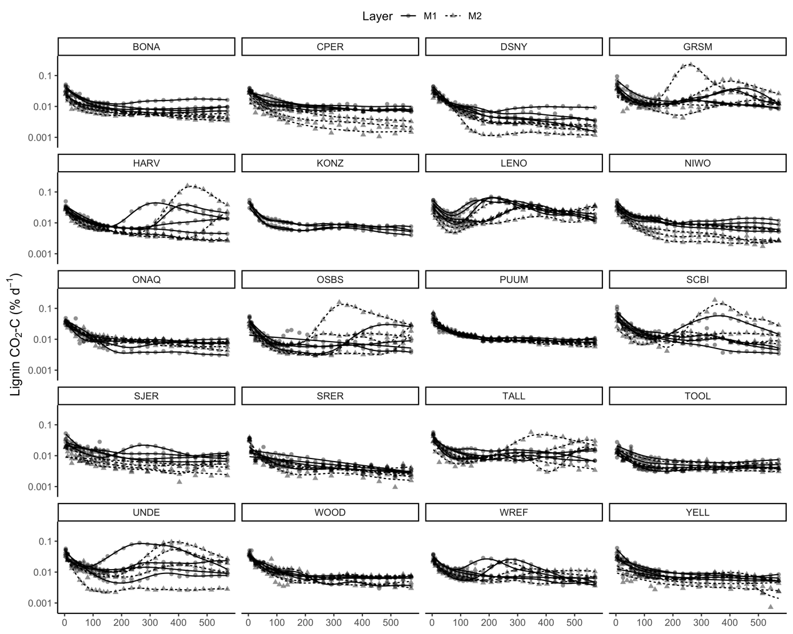
Fig. S2 Decomposition rate from synthetic lignin C in each lab incubated sample at 20 NEON sites. Lines are fit by generalized additive mixed models (GAMMs). M1 and M2 denote mineral soil samples from 0-15 cm and 15-30 cm depths, respectively.
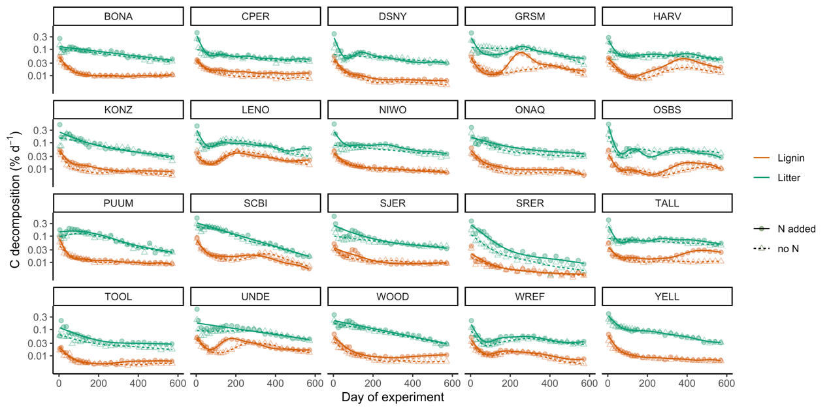
Fig. S3 Effects of N addition on C decomposition from synthetic lignin and litter in lab-incubated samples from 20 NEON sites, expressed as a percentage of the initial C mass in each pool. Note that the base-10 logarithmic y-axis scale for C decomposition rate. Lines are fit by generalized additive mixed models (GAMMs). Each point represents mean decomposition rate from four sampling points at each site. This experiment only included samples from 0-15 cm depth.
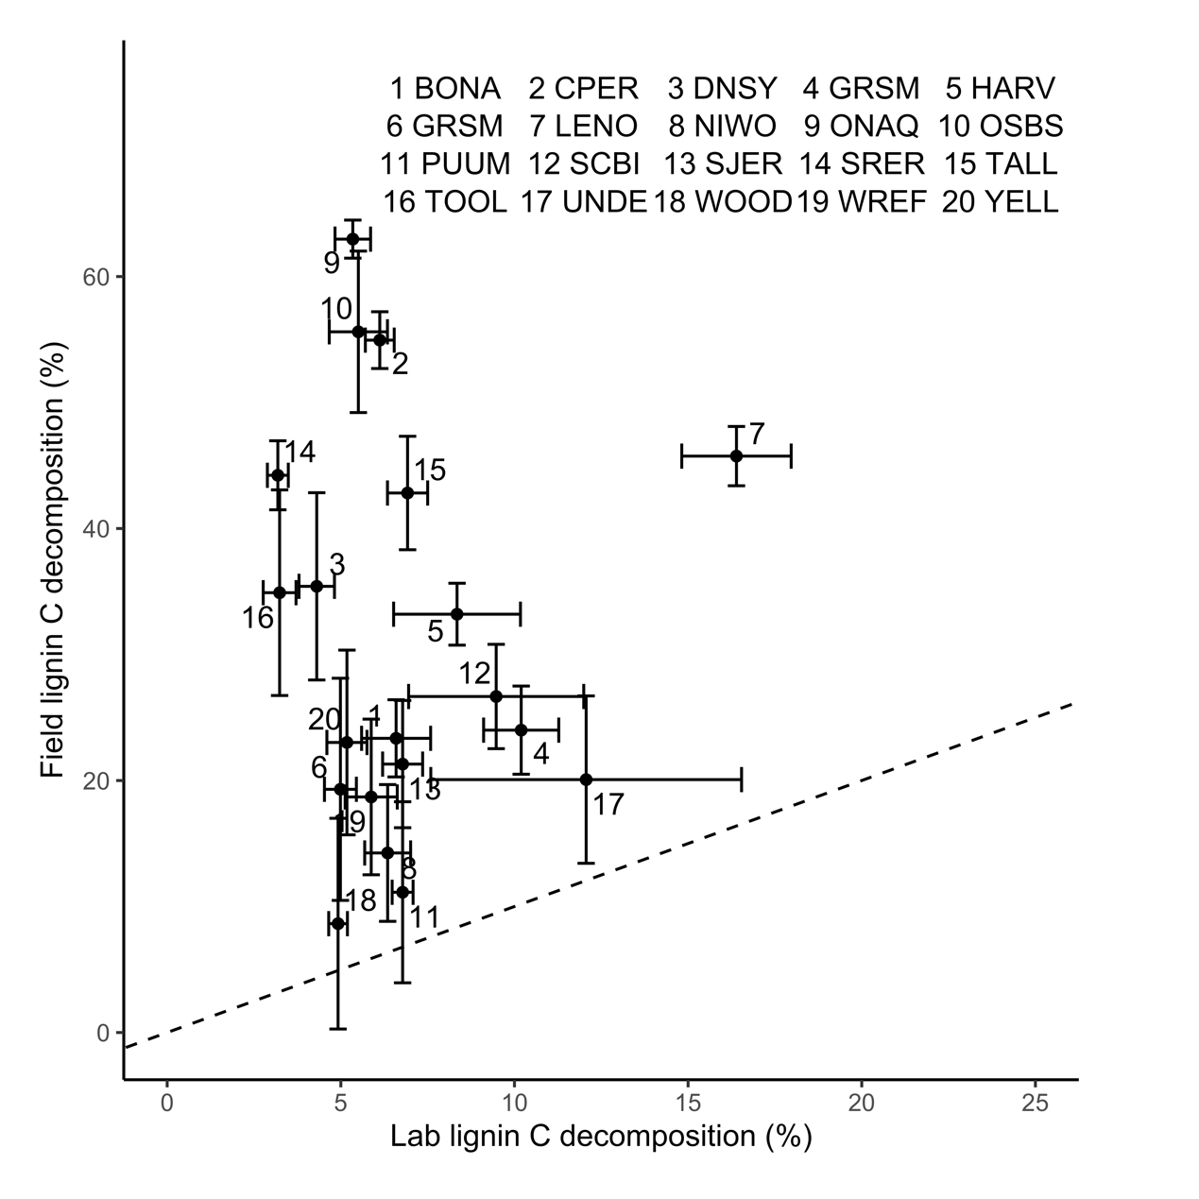
Fig. S4 Cumulative lignin C decomposition as a percent of initial mass in samples incubated in the field and lab at 20 NEON sites. The error bars indicate standard errors. Note different x-axis and y-axis scales. The four letters represent the site ID (Fig. 1 and Supplementary Table S1).
Fig. S5 Fungal and bacterial quantities and principal coordinate analysis of fungal community composition. (a) Fungal and bacterial quantities (log10 scale on both y-axis and x-axis); (b) Principal coordinate analysis based on Hellinger distance of species abundance demonstrating similarities in overall fungal community composition between the field incubation and lab incubation and over different time periods in the lab.

Fig. S6 Pairwise correlations of cumulative C decomposition from lignin, litter and SOC after 18, 12, and 6 months with climatic, N-related, geochemical and microbial predictors. Fungal composition was represented by PC1 and PC2. Significant (P < 0.05) variables are shown in circles. Circle size and darkness indicates relationship strength; circle color indicates relationship direction (blue is positive, red is negative).
Fig. S7 Effects of predictors on cumulative lab lignin (left), litter (middle) and SOC decomposition after 18 (black), 12 (blue), and 6 (orange) months estimated from multiple regression models. Linear regression models (as opposed to linear mixed models) were used for this comparison because the random effect of site was uninformative for the 6 and 12 month datasets. For lignin decomposition, R²_{18 m} = 0.44, R²_{12 m} = 0.47, R²_{6 m} = 0.47; for litter decomposition, R²_{18 m} = 0.51, R²_{12 m} = 0.58, R²_{6 m} = 0.60; for SOC decomposition, R²_{18 m} = 0.45, R²_{12 m} = 0.45, R²_{6 m} = 0.45. Error bars represent confidence intervals (± 2 standard error) of standardized regression coefficients. Variables were removed from the models according to AIC using stepwise backward selection. Inorganic N variables were not important for the lab incubation.

Fig. S8 The marginal effects of predictors on the predicted lab lignin decomposition in partial dependence (PD) plots of the random forest model (RFM). Plots are ordered in a descending order of %IncMSE values (Fig. 5).
Fig. S9 The marginal effects of predictors on the predicted field lignin decomposition in partial dependence (PD) plots of the random forest model (RFM). Plots are ordered in a descending order of %IncMSE values (Fig. 5).
Fig. S10 The marginal effects of predictors on the predicted litter decomposition in partial dependence (PD) plots of the random forest model (RFM). Plots are ordered in a descending order of %IncMSE values (Fig. 5).
Fig. S11 The marginal effects of predictors on the predicted SOC decomposition in partial dependence (PD) plots of the random forest model (RFM). Plots are ordered in a descending order of %IncMSE values (Fig. 5).
Table S1. Soil, ecosystem, and climatic attributes of 20 NEON sites.
Site ID | Plot ID* | Soil order | NLCD class | Latitude  (º) | Longitude  (º) | MAT  (ºC) | MAP  (mm) | O horizon†  (cm) | SOC in  0–15 cm‡  (mg g⁻¹) | SOC in  15–30 cm  (mg g⁻¹)
BONA | 004 | Inceptisols | Evergreen Forest | 65.19 | -147.54 | -3 | 262 | 12 | 88 | 15
CPER | 006 | Alfisols | Grassland/Herbaceous | 40.81 | -104.75 | 8.6 | 344 | 0 | 10 | 6
DSNY | 023 | Entisols | Woody Wetlands | 28.09 | -81.42 | 22.4 | 1213 | 0 | 35 | 19
GRSM | 001 | Inceptisols | Deciduous Forest | 35.68 | -83.53 | 11.3 | 1657 | 0 | 51 | 21
HARV | 015 | Inceptisols | Deciduous Forest | 42.54 | -72.18 | 8 | 1210 | 7 | 34 | 20
KONZ | 001 | Mollisols | Grassland/Herbaceous | 39.08 | -96.56 | 12.4 | 869 | 0 | 44 | –
LENO | 006 | Inceptisols | Woody Wetlands | 31.81 | -88.19 | 18.1 | 1383 | 0 | 20 | 14
NIWO | 041 | Inceptisols | Grassland/Herbaceous | 40.05 | -105.58 | 0.3 | 971 | 1 | 42 | 24
ONAQ | 004 | Aridisols | Shrub/Scrub | 40.19 | -112.47 | 8.7 | 380 | 0 | 13 | 10
OSBS | 002 | Entisols | Evergreen Forest | 29.70 | -81.96 | 20.9 | 1306 | 0 | 9 | 5
PUUM | 017 | Entisols | Evergreen Forest | 19.57 | -155.32 | 12.7 | 2657 | 3 | 251 | 175
SCBI | 004 | Alfisols | Deciduous Forest | 38.90 | -78.15 | 11.9 | 1076 | 0 | 48 | 16
SJER | 045 | Mollisols | Evergreen Forest | 37.12 | -119.73 | 16.8 | 508 | 0 | 15 | 10
SRER | 002 | Aridisols | Shrub/Scrub | 31.87 | -110.86 | 18.8 | 399 | 0 | 5 | 4
TALL | 004 | Ultisols | Evergreen Forest | 32.96 | -87.43 | 17.2 | 1376 | 0 | 25 | 11
TOOL | 002 | Gelisols | Dwarf Scrub | 68.63 | -149.35 | -9 | 316 | 21 | 48 | 44
UNDE | 006 | Spodosols | Deciduous Forest | 46.25 | -89.51 | 4.3 | 799 | 0 | 27 | 17
WOOD | 003 | Mollisols | Grassland/Herbaceous | 47.12 | -99.24 | 4.9 | 494 | 0 | 39 | 26
WREF | 071 | Andisols | Evergreen Forest | 45.82 | -121.96 | 8.6 | 2488 | 2 | 28 | 19
YELL | 006 | Mollisols | Shrub/Scrub | 44.97 | -110.56 | 1.3 | 829 | 1 | 41 | 30
MAT, mean annual temperature; MAP, mean annual precipitation; SOC, soil organic carbon measured from the 4 sampling points for lab incubation.
*Plot ID refers to the specific “distributed base plot” in the NEON sampling design which was sampled for our study.
†The depth in O horizon represents the mean value of organic horizon depth from the 16 sampling points (note that only the mineral soil horizons were incubated in our study).
‡Depth is with respect to the beginning of the mineral horizon (i.e., the organic horizon is not included)
Table S2. Description of biogeochemical predictors used in this study, arranged by conceptual category.
Category | Variable | Unit | Note
C decomposition | Lignin CO₂ | % | Lignin C decomposition incubated in the lab relative to initial added lignin C mass
C decomposition | Litter CO₂ | % | Litter C decomposition incubated in the lab relative to initial added litter C mass incubated in the
C decomposition | Soil CO₂ | % | Soil C decomposition incubated in the lab relative to initial soil organic C mass
C decomposition | Field lignin C decomposition | % | Lignin C decomposition incubated in the field relative to initial added lignin C mass
Geochemical | pH | – | –
Geochemical | Silt+Clay (%) | % | Summed percentage of silt- and clay-sized particles
Geochemical | Al_{ox} | mg g⁻¹ soil | Short-range-ordered (SRO) phases of Al and/or organo-Al complexes extracted by ammonium oxalate
Geochemical | Fe_{ox} | mg g⁻¹ soil | Short-range-ordered (SRO) phases of Fe and/or organo-Fe complexes extracted by ammonium oxalate
Geochemical | Fe_{cd-ox} | mg g⁻¹ soil | Crystalline phases of Fe (the difference between Fe extracted by citrate/dithionite and ammonium oxalate)
Geochemical | Fe_{HCl} | mg g⁻¹ soil | Dissolved and adsorbed Fe(II) as well as dissolved, organically-complexed Fe(III), and a reactive fraction of Fe(III) minerals extracted by HCl
Geochemical | Mn_{cd} | mg g⁻¹ soil | Short-range-ordered (SRO) phases of Mn and organo-Mn complexes extracted by citrate/dithionite
Geochemical | Ca_{cd} | mg g⁻¹ soil | Exchangeable Ca and Ca in organo-Fe associations extracted by citrate/dithionite
Microbial | Fungal composition | – | Principal components (PC2 and PC1) of principal coordinate analysis based on Hellinger distance of fungal species abundance at 14 month for lignin/litter and soil C decomposition, respectively.
Microbial | Fungal Chao1 richness | – | Residual of ASV Chao1 index in relation to the square root of the number of total sequences within each sample at 14 month
Microbial | Fungal  quantity | gene copies g⁻¹ soil | ITS rRNA gene copy number in soil at 0 month
Microbial | Bacterial quantity | gene copies g⁻¹ soil | 16S rRNA gene copy number in soil at 0 month
Microbial | Fungal-to-bacterial ratio | – | ITS rRNA gene copy number divided by 16S rRNA gene copy number at 0 month
N-related | Total N | mg g⁻¹ soil | Soil total N
N-related | C/N | – | Ratio of soil organic carbon (SOC) to total soil N
N-related | Ammonium | μg N g⁻¹ soil | Soil ammonium concentrations in soil + litter mixture samples after 1, 9, and 18 months
N-related | Nitrate | μg N g⁻¹ soil | Soil nitrate concentrations in soil + litter mixture samples after 1, 9, and 18 months
N-related | Inorganic N | μg N g⁻¹ soil | Soil inorganic N concentrations (sum of ammonium and nitrate concentrations) in soil + litter mixture samples after 1, 9, and 18 months
Climatic | MAT | ºC | Mean annual temperature
Climatic | MAP | mm | Mean annual precipitation

Table S3. Fungal genera occurring in more than 10 samples that had significant (P < 0.05) correlations with lab lignin decomposition.
Correlation  coefficient | Phylum | Class | Order | Family | Genus | No. of samples
0.22 | Ascomycota | Dothideomycetes | Pleosporales | Melanommataceae | Pleotrichocladium | 21
-0.16 | Ascomycota | Eurotiomycetes | Chaetothyriales | Herpotrichiellaceae | Cladophialophora | 42
-0.18 | Ascomycota | Leotiomycetes | Helotiales | Dermateaceae | Pseudofabraea | 105
-0.16 | Ascomycota | Leotiomycetes | Helotiales | Helotiaceae | Glarea | 10
0.34 | Ascomycota | Leotiomycetes | Thelebolales | Pseudeurotiaceae | Geomyces | 24
0.17 | Ascomycota | Sordariomycetes | Sordariales | Chaetomiaceae | Trichocladium | 50
0.26 | Basidiomycota | Agaricomycetes | Agaricales | Tricholomataceae | Mycena | 10
0.25 | Basidiomycota | Agaricomycetes | Polyporales | Podoscyphaceae | Hypochnicium | 16
0.17 | Basidiomycota | Tremellomycetes | Filobasidiales | Piskurozymaceae | Solicoccozyma | 127
0.28 | Mortierellomycota | Mortierellomycetes | Mortierellales | Mortierellaceae | Mortierella | 142

